LINUX-23-07-24

TASK1: Simple Signal Handler:

Write a C++ program that handles the SIGINT signal (Ctrl+C) gracefully by printing a custom message before exiting.

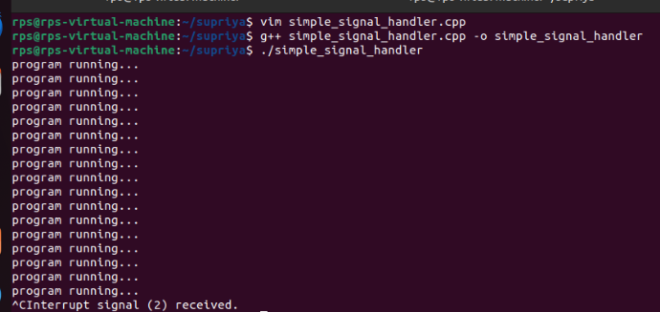

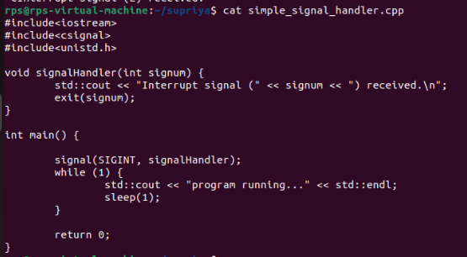

TASK2: Multiple Signal Handling:

Create a program that handles both SIGINT and SIGTERM signals, printing a different message for each.

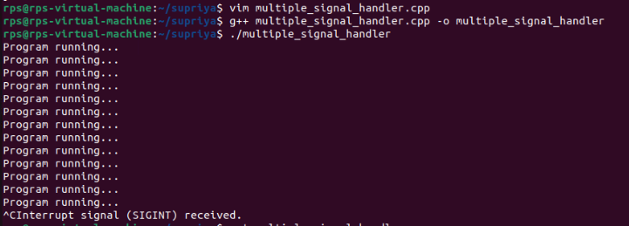

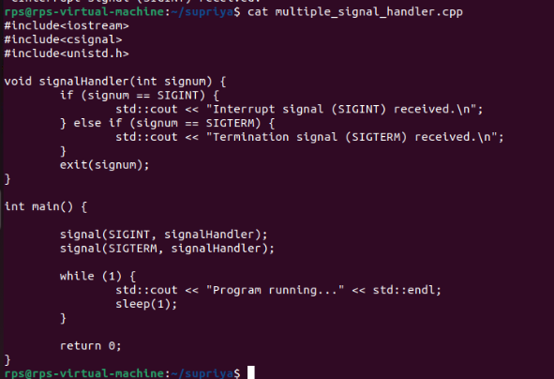

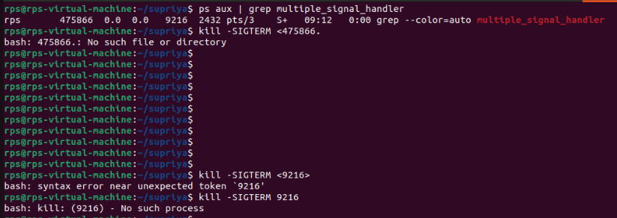

TASK3: Ignoring Signals:

Develop a program that ignores the SIGTERM signal and continues execution even after it's sent.

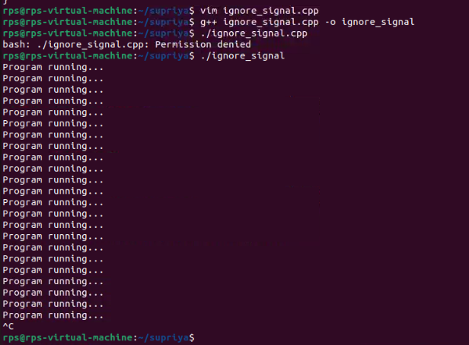

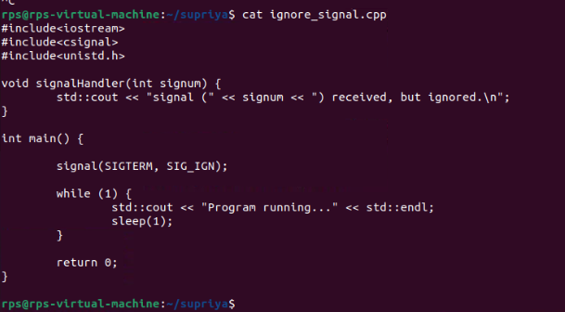

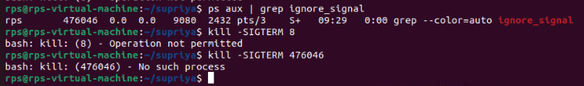

SIG_mask code :

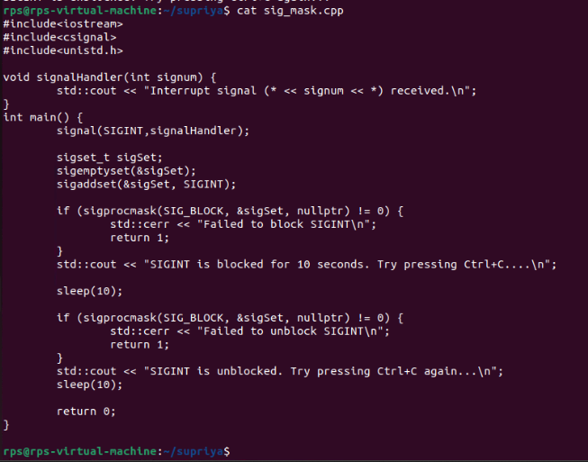

Output:



SIG_mask1 code:

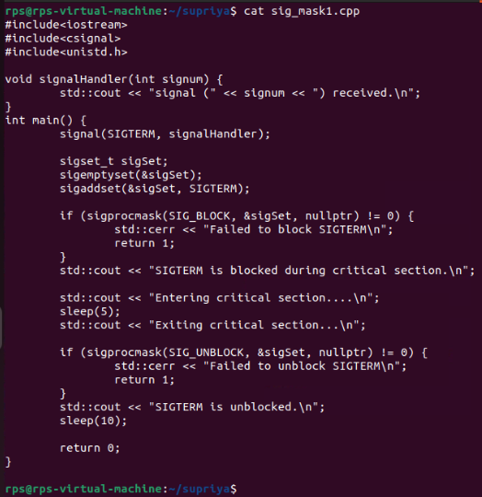

OUTPUT:

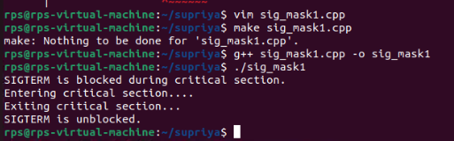

write a code where you handle signals from 1-9 as: and try to mask few and handle others and test

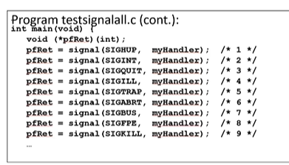

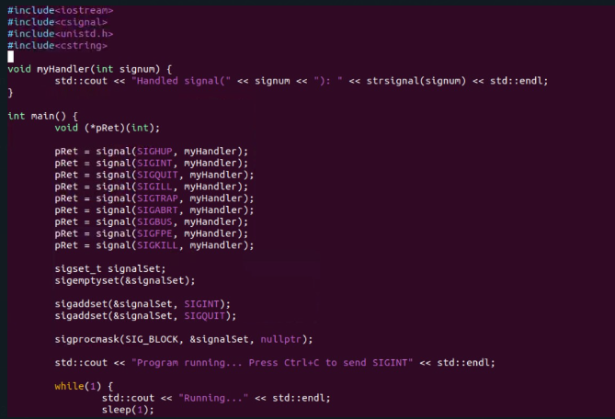

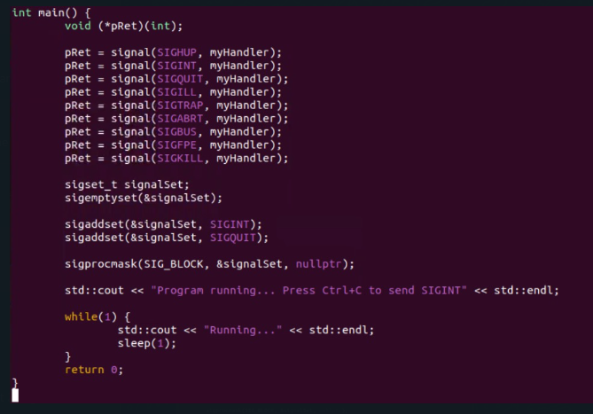

Output:

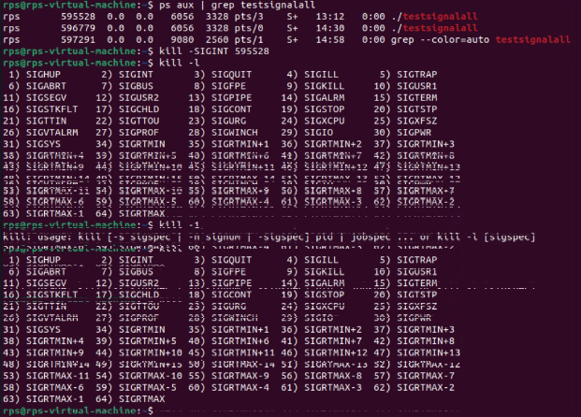

AFTERNOON TASKS1:

Problem Statement 2: Signal Masking and Unmasking for Graceful Shutdown

Problem: Develop a C++ application that gracefully handles termination signals (e.g., SIGTERM, SIGINT) by masking specific signals during critical operations and unmasking them afterwards. Implement a clean shutdown procedure that ensures all resources are released before the process exits.

Key Challenges:

Determining the appropriate signals to mask during critical operations.

Ensuring timely unmasking of signals to avoid process hangs.

Implementing a robust shutdown mechanism that handles unexpected interruptions.

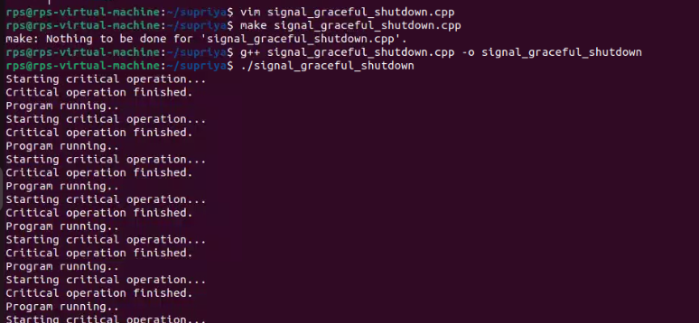

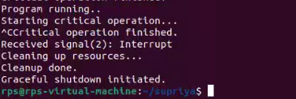

Task2:

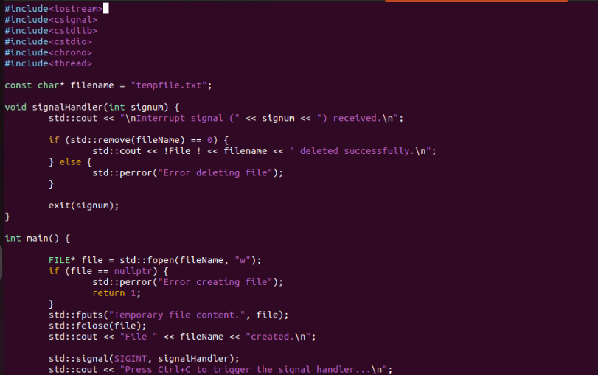

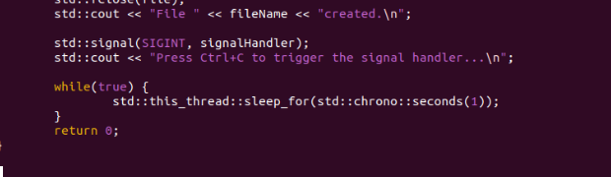

Second code :

