|  |
| --- |
| Task one  DAY 1: Supriya_wipro_training_satinnder(3) |
| NAME: Supriya Bodapati  EMAIL:supriyabodapati8690@gmail.com |

*Differences between Dual core and Quad core :*

**1. Number of Cores:**

* **Dual-Core:** Has two cores.
* **Quad-Core:** Has four cores.

**2. Performance:**

* **Dual-Core:** Can handle two tasks simultaneously, offering good performance for basic computing tasks.
* **Quad-Core:** Can handle four tasks simultaneously, providing better performance, especially for multitasking and demanding applications like gaming or video editing.

**3. Power Consumption:**

* **Dual-Core:** Generally uses less power, making it more suitable for devices where battery life is a concern, like laptops.
* **Quad-Core:** Uses more power because it has more cores, but it can still be efficient with modern power management techniques.

**4. Heat Generation:**

* **Dual-Core:** Generates less heat due to fewer cores.
* **Quad-Core:** Generates more heat, but modern cooling systems can manage this effectively.

**5. Application Suitability:**

* **Dual-Core:** Ideal for everyday tasks like browsing the internet, word processing, and light gaming.
* **Quad-Core:** Better for heavy multitasking, professional applications like video editing, 3D rendering, and modern gaming.

**6. Cost:**

* **Dual-Core:** Typically less expensive, making it a budget-friendly option.
* **Quad-Core:** Usually more expensive due to the additional cores and higher performance.

**7. Example Use Cases:**

* **Dual-Core:** Suitable for general users who need reliable performance for standard applications.
* **Quad-Core:** Suited for power users, gamers, and professionals who need extra computing power.

***Differences Between Intel i5 and i7 Processors***

**1. Performance:**

* **Intel i5:** Offers good performance for everyday tasks, gaming, and basic multitasking.
* **Intel i7:** Provides higher performance, better suited for more intensive tasks like video editing, 3D rendering, and heavy multitasking.

**2. Core Count and Threads:**

* **Intel i5:** Typically has 4-6 cores and 8-12 threads, depending on the generation.
* **Intel i7:** Usually has 6-8 cores and 12-16 threads, allowing for better multitasking and parallel processing.

**3. Clock Speed:**

* **Intel i5:** Has a lower base and turbo boost clock speed compared to i7.
* **Intel i7:** Features higher base and turbo boost clock speeds, resulting in faster processing times for demanding applications.

**4. Cache Size:**

* **Intel i5:** Generally has a smaller cache (6-9MB) which affects how much data the processor can store temporarily.
* **Intel i7:** Comes with a larger cache (8-12MB), allowing it to handle more data at once, improving overall efficiency and speed.

**5. Hyper-Threading:**

* **Intel i5:** May or may not support Hyper-Threading (depends on the specific model and generation).
* **Intel i7:** Almost always supports Hyper-Threading, which allows each core to handle two threads simultaneously, improving performance in multi-threaded applications.

**6. Integrated Graphics:**

* **Intel i5:** Comes with integrated graphics suitable for everyday use and light gaming.
* **Intel i7:** Features better-integrated graphics, although for serious gaming or graphics work, a dedicated GPU is recommended.

**7. Power Consumption:**

* **Intel i5:** Typically consumes less power, making it more suitable for laptops and devices where battery life is important.
* **Intel i7:** Uses more power due to higher performance capabilities, which can result in shorter battery life on laptops.

**8. Cost:**

* **Intel i5:** More affordable, offering a good balance of performance and cost for general users.
* **Intel i7:** More expensive due to the higher performance and additional features, aimed at power users and professionals.

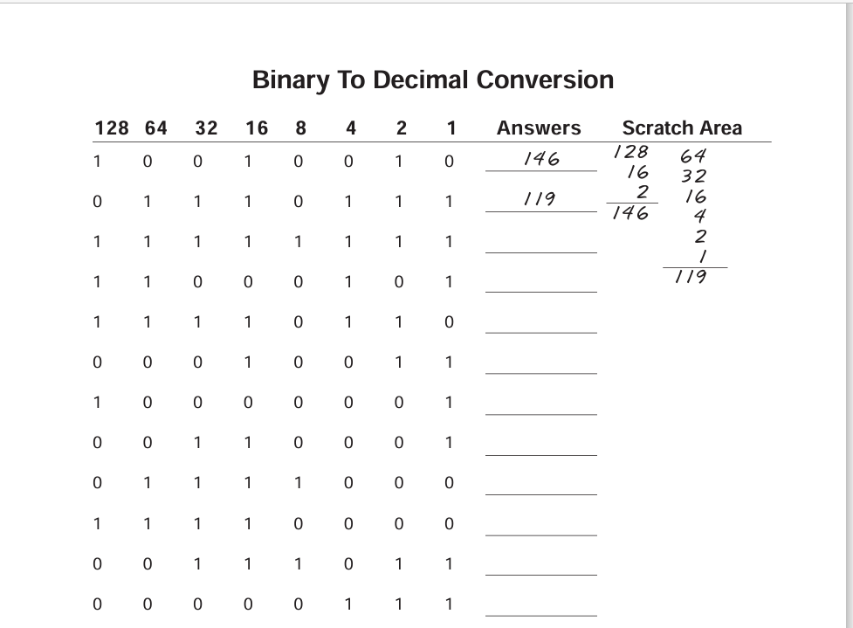

Answers:

255

197

246

019

129

120

115

240

007

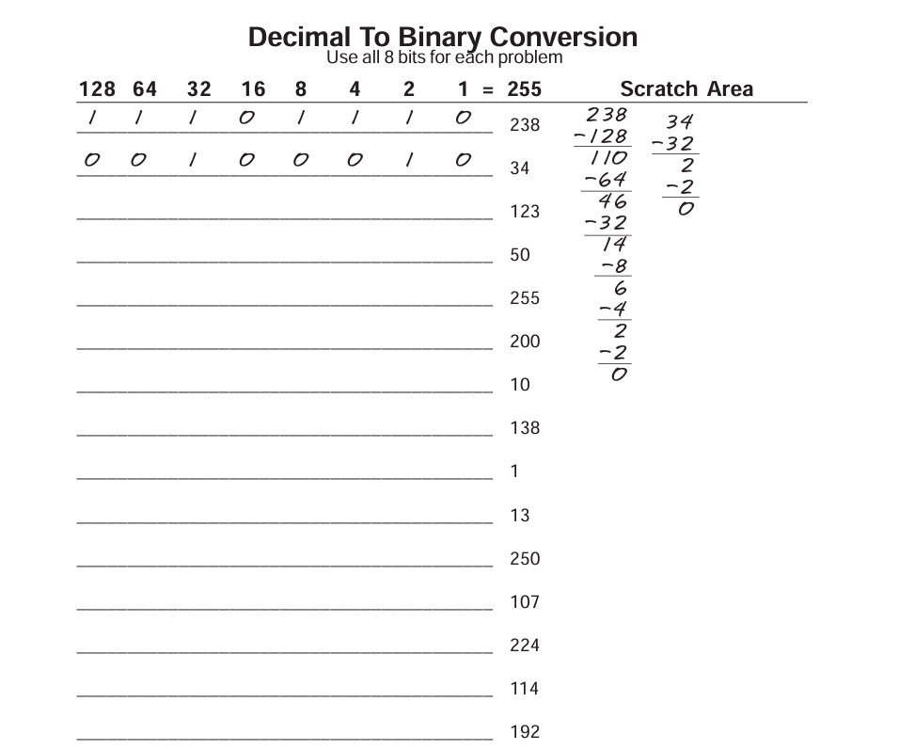

ANSWERS:

1111011

0110010

111111

11001000

1010

10001010

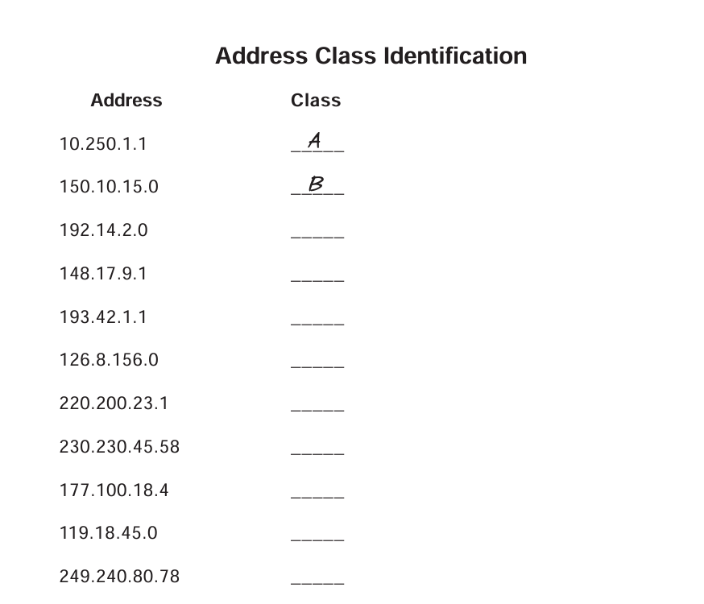

Answers:

C

B

C

A

C

D

B

A

E



Answers:

C

B

C

A

C

D

B

A

E

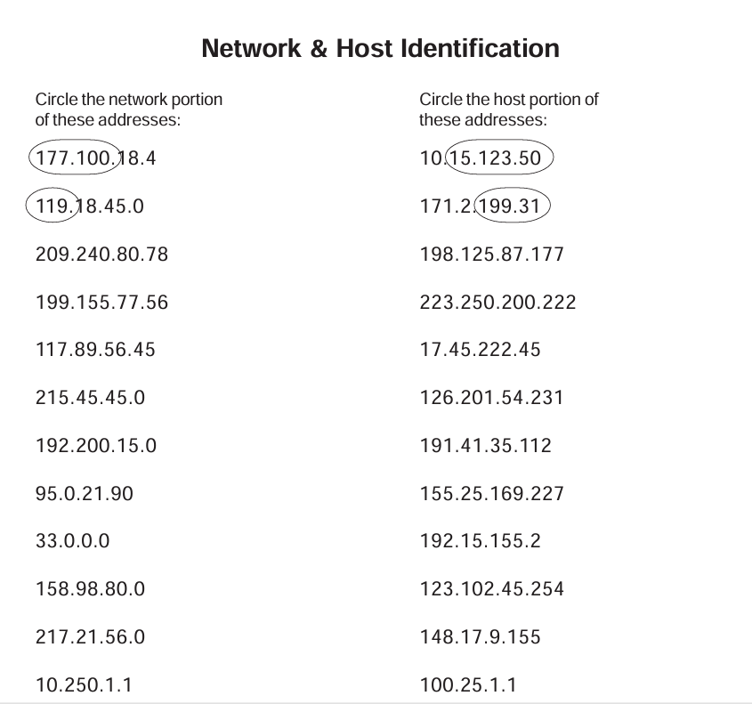

Answers:

209.240.80 177

199.155.77 222

117 45.222.45

215.45.45 201.54.231

192.200.15 35.112

95 169.227

33 2

158.98 102.45.245

217.21.56 9.155

10 25.1.1

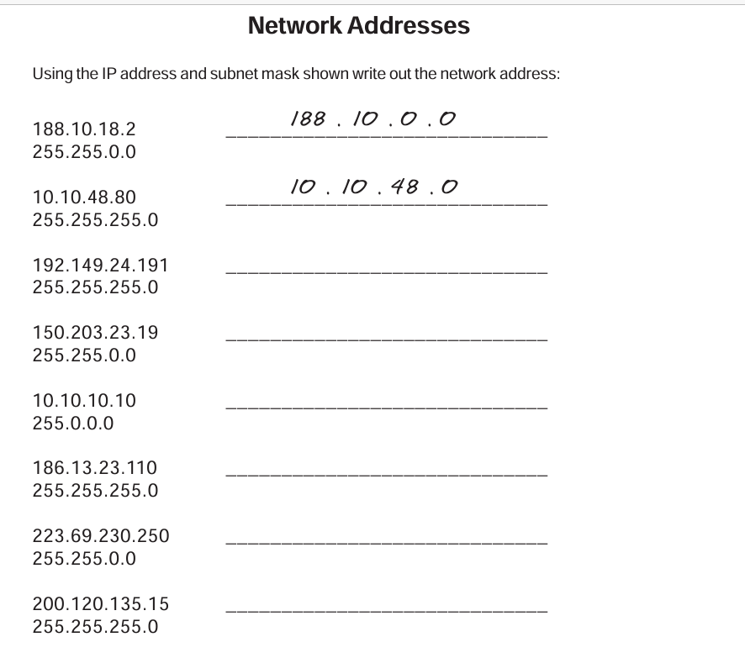

Answers:

192.149.24.0

150.203.0.0

10.0.0.0

186.13.23.0

223.69.0.0

200.120.135.0

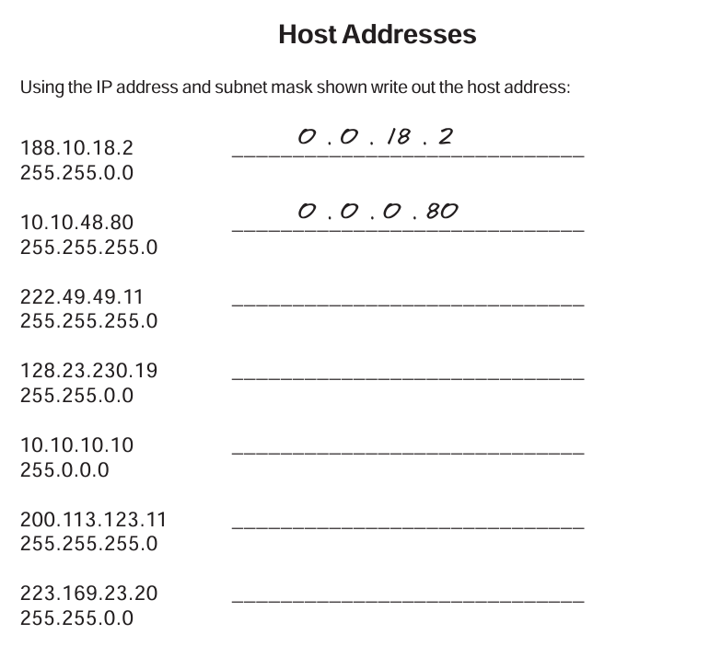

Answers:

0.0.0.11

0.0.230.19

0.10.10.10

0.0.0.11

0.0.23.20

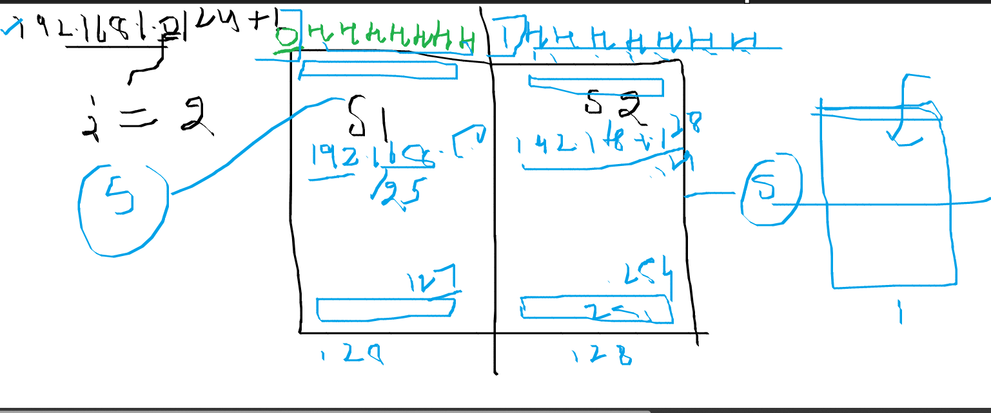

SUBNET 1 IP-

192.168.1.1

192.168.1.2

192.168.1.3

192.168.1.4

192.168.1.5

Top of Form

Bottom of Form

1.Connect two routers

2.Connect Router with a Switch

3.Connect Router with PC

4.Connect PC with a switch

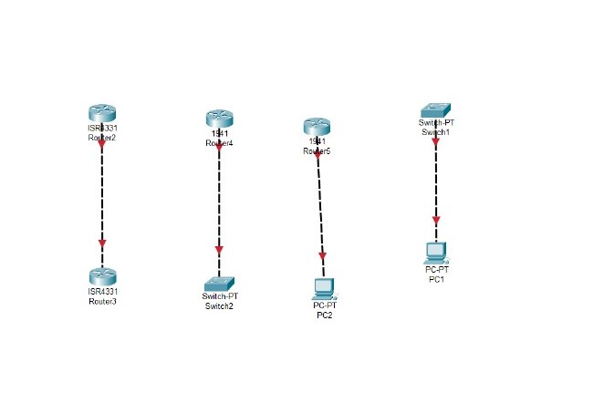

FIRST CONNECTION:

3rd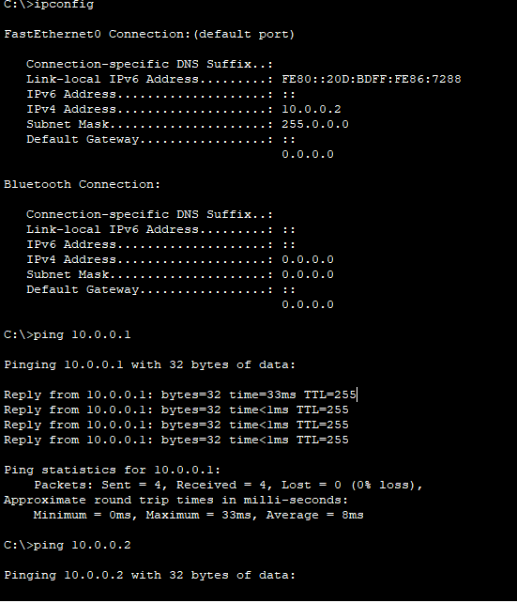

2rd task:



3rd:

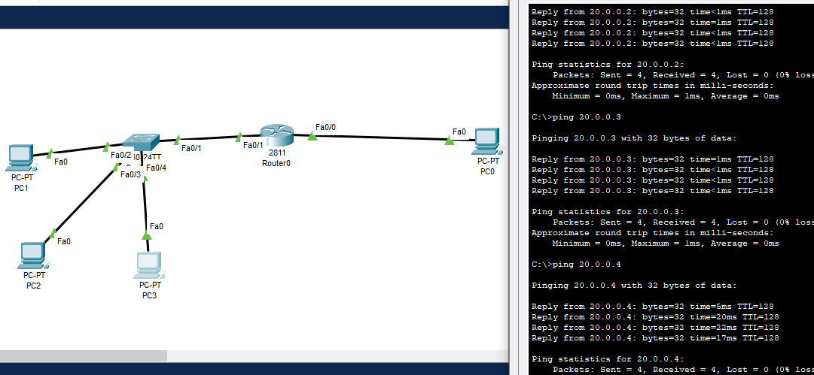

4th task :

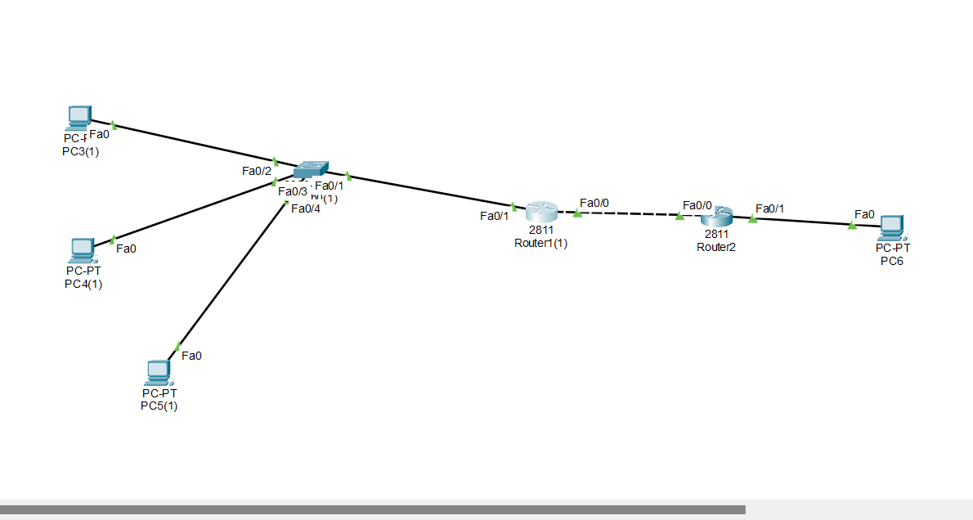

Task 1:

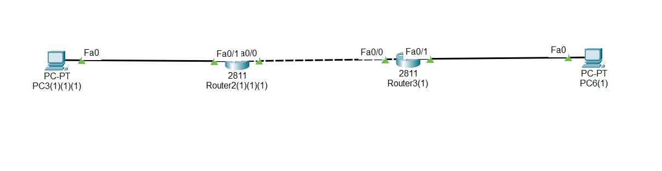

Simple explanation:

For reference !!!!!!!!!!!!!!!!!!!!!!!!!!!!.........

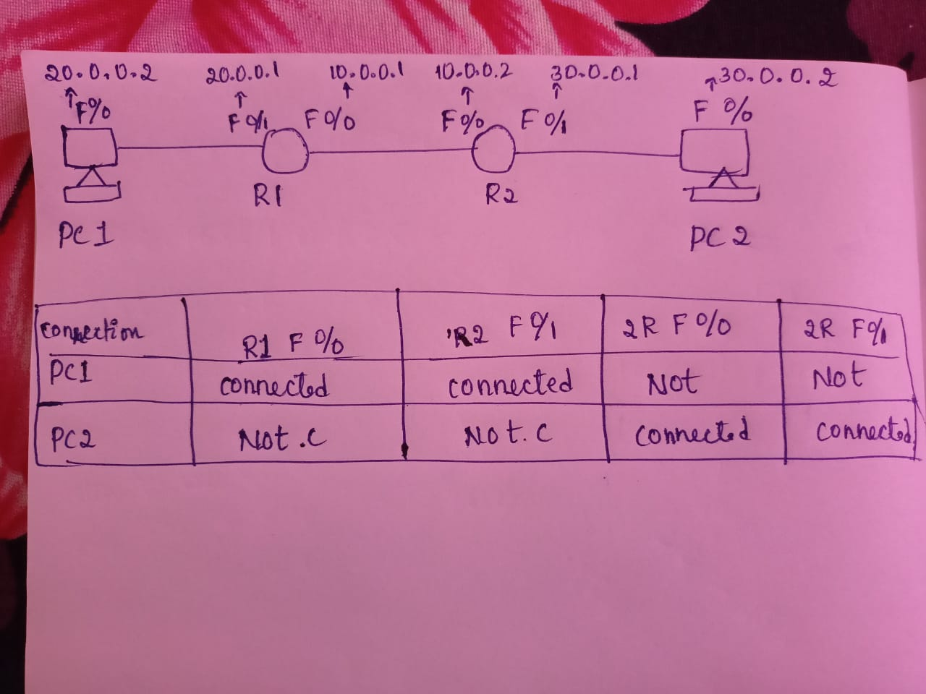

Task 3:

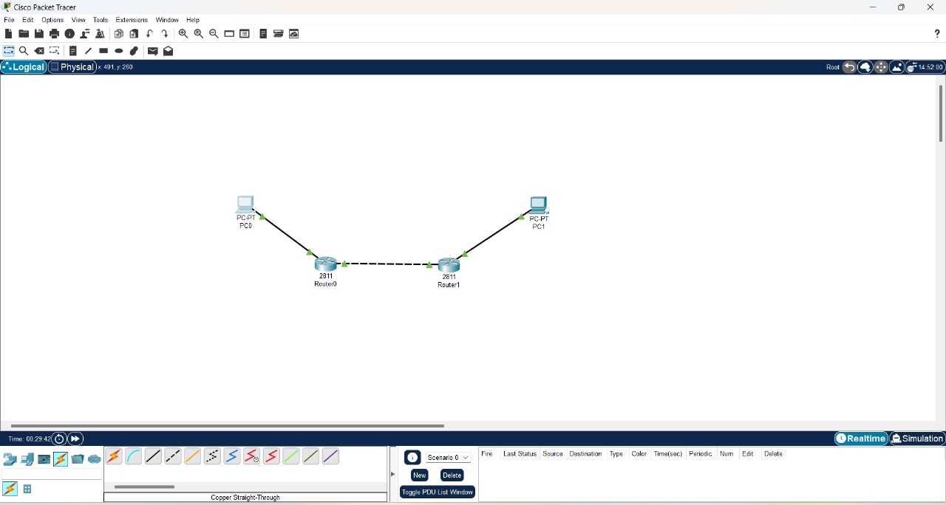

Task 4:

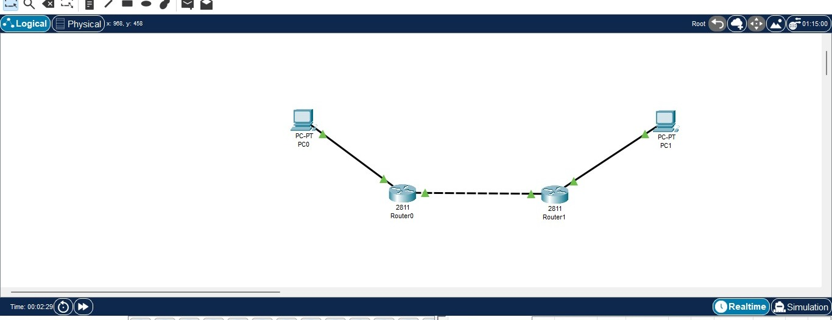

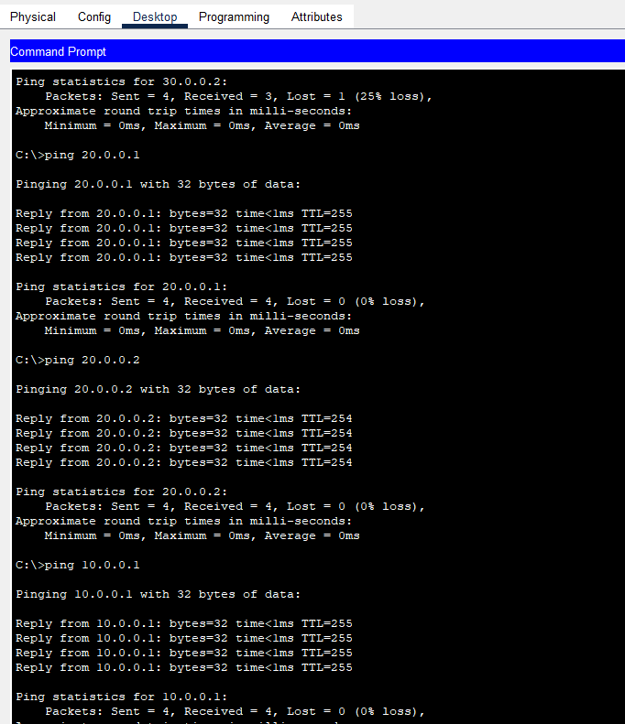

Static routing:

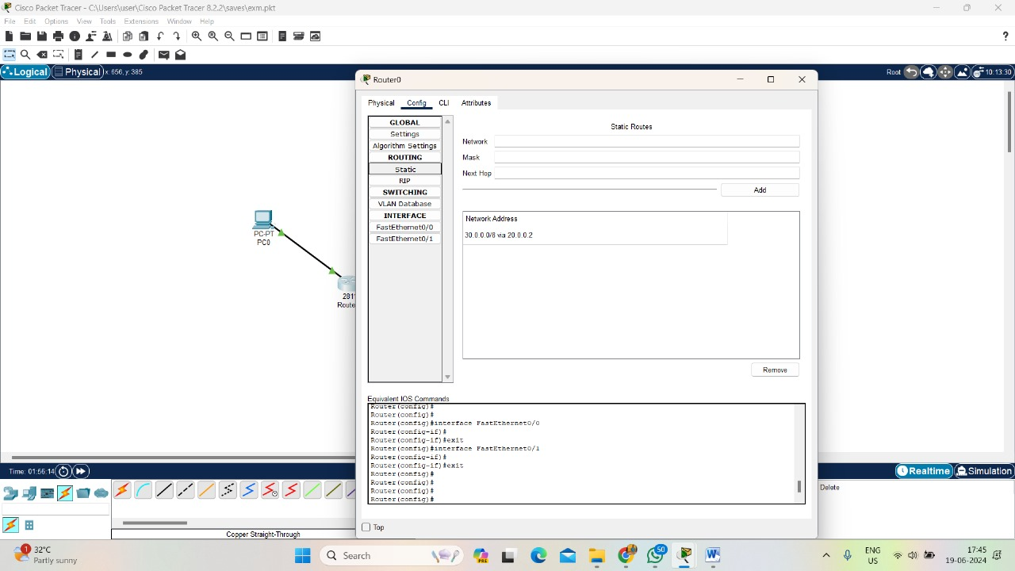

Task one: osi

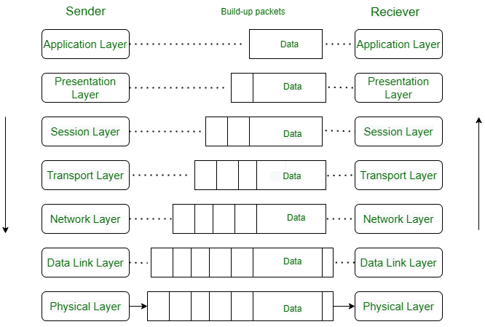

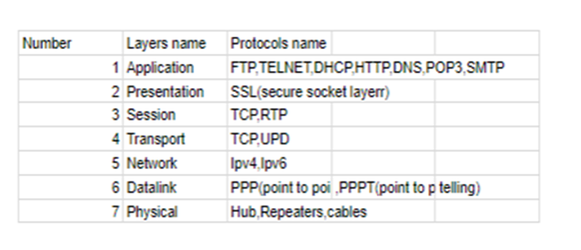

Tcp/ip:

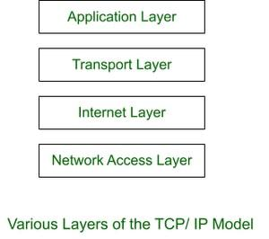

Differences between osi and tcp/ip:

| **Parameters** | **OSI Model** | **TCP/IP Model** |
| --- | --- | --- |
| **Full Form** | OSI stands for Open Systems Interconnection. | TCP/IP stands for Transmission Control Protocol/Internet Protocol. |
| **Layers** | It has 7 layers. | It has 4 layers. |
| **Usage** | It is low in usage. | It is mostly used. |
| **Approach** | It is vertically approached. | It is horizontally approached. |
| **Delivery** | Delivery of the package is guaranteed in OSI Model. | Delivery of the package is not guaranteed in TCP/IP Model. |
| **Replacement** | Replacement of tools and changes can easily be done in this model. | Replacing the tools is not easy as it is in OSI Model. |
| **Reliability** | It is less reliable than TCP/IP Model. | It is more reliable than OSI Model. |

Task 4:

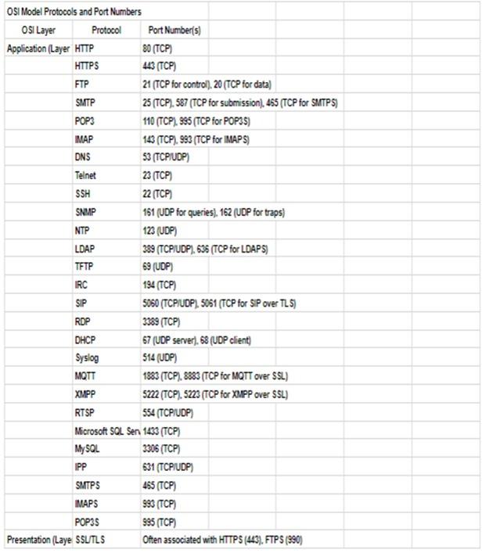

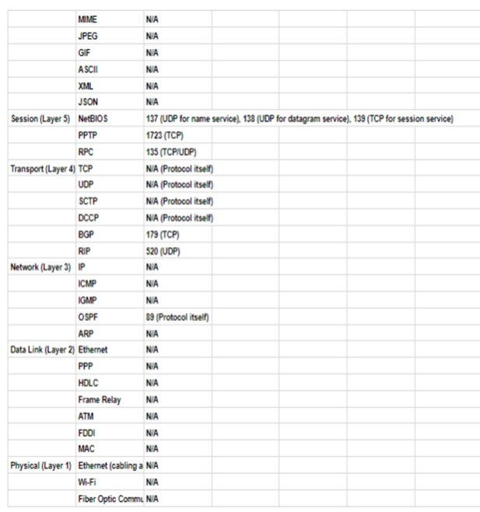

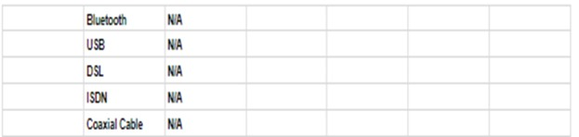

Task 5:

IP Natting :

