**PROGRAM 14**

**Find Minimum Cost Spanning Tree of a given undirected graph using Prim’s algorithm.**

**Code:**

#include<stdio.h>

#include<conio.h>

#include<time.h>

int a,b,u,v,n,i,j,ne=1;

int visited[10]= {0},min,mincost=0,cost[10][10];

void main()

{

double time;

clock_t start,end;

printf("PRIM'S ALGORITHM\n");

printf("\n Enter the number of nodes:");

scanf("%d",&n);

printf("\n Enter the weighted adjacency matrix:\n");

for (i=1;i<=n;i++)

for (j=1;j<=n;j++)

{

scanf("%d",&cost[i][j]);

if(cost[i][j]==0)

cost[i][j]=999;

}

visited[1]=1;

printf("\n");

start=clock();

while(ne<n) {

for (i=1,min=999;i<=n;i++)

for (j=1;j<=n;j++)

if(cost[i][j]<min)

if(visited[i]!=0)

{

min=cost[i][j];

a=u=i;

b=v=j;

}

if(visited[u]==0 || visited[v]==0)

{

printf("\n Edge %d:(%d %d) cost:%d",ne++,a,b,min);

mincost+=min;

visited[b]=1;

}

cost[a][b]=cost[b][a]=999;

}

end=clock();

time = ((double)(end - start))/CLOCKS_PER_SEC;

printf("\n Minimun cost=%d\n",mincost);

printf("Time taken to find the minimum cost using the Prims algorithm is:%lf\n",time);

getch();

}

**Graph:**

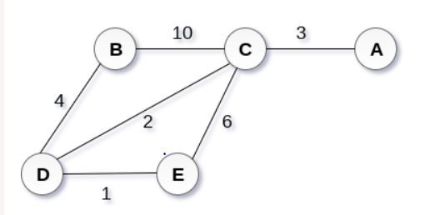

**Adjacency matrix**

A B C D E

A 0 0 3 0 0

B 0 0 10 4 0

C 3 10 0 2 6

D 0 4 2 0 1

E 0 4 2 0 1

**Output:**

