VISVESVARAYA TECHNOLOGICAL UNIVERSITY
“JnanaSangama”, Belgaum -590014, Karnataka.


LAB REPORT
on
Object Oriented Modelling and Design Lab(20CS6PCOMD)

Submitted by
Supriya M Lingdal(1BM20CS415)

in partial fulfillment for the award of the degree of
BACHELOR OF ENGINEERING
in
COMPUTER SCIENCE AND ENGINEERING


B.M.S. COLLEGE OF ENGINEERING
(Autonomous Institution under VTU)
BENGALURU-560019
April-2022 to July-2022
B. M. S. College of Engineering,
Bull Temple Road, Bangalore 560019
(Affiliated To Visvesvaraya Technological University, Belgaum)
Department of Computer Science and Engineering


CERTIFICATE

This is to certify that the Lab work entitled “Object Oriented Modeling and Design Lab” carried out by Supriya M Lingdal(1BM20CS415), who is bonafide student of B. M. S. College of Engineering. It is in partial fulfillment for the award of Bachelor of Engineering in Computer Science and Engineering of the Visvesvaraya Technological University, Belgaum during the academic year 2021-2022. The Lab report has been approved as it satisfies the academic requirements in respect of a Object Oriented Modelling and Design Lab-(20CS6PCOMD) work prescribed for the said degree.

Name of the Lab-Incharge Dr. Jyothi S Nayak
Designation Professor and Head
Department of CSE Department of CSE
BMSCE, Bengaluru BMSCE, Bengaluru

Index Sheet

Sl.  No. | Experiment Title | Page No.
1 | College Information System
2 | Hostel management System
3 | Stock management System
4 | Coffee Vending Machine
5 | Online Shopping System
6 | Railway Management System
7 | Graphical Editor

Course Outcome
Ability to conduct practical experiment to solve a given problem using Unified Modeling language.

CO4

Exercise 1:
- Write SRS
- Draw the advanced class diagram
- Draw the advanced state diagram
  - Give a description of the scenario considered for developing the model
- Draw the advanced use case diagram
  - Give a description of the scenario considered for developing the model
- Draw the advanced sequence diagram
  - Give a description of the scenario considered for developing the model
- Draw the advanced activity diagram
  - Give a description of the scenario considered for developing the model
Note: For each of the diagrams mentioned above, upload hand- drawn diagram you’re your observation as well the starUML
snapshot.
THE SAME STEPS ARE TO BE FOLLOWED FOR ALL EXERCISES.

Exercise1
College Information System
Advanced Class Diagram of College Information System

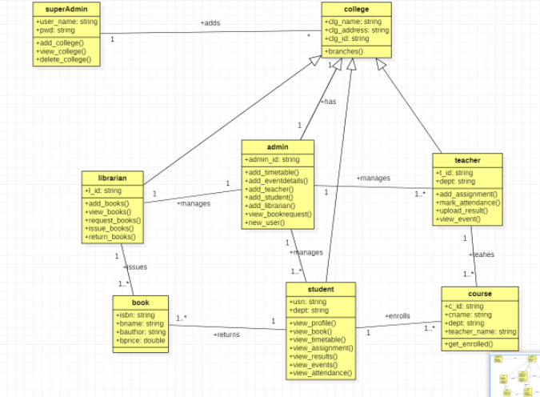

Advanced State Diagram of College Information System

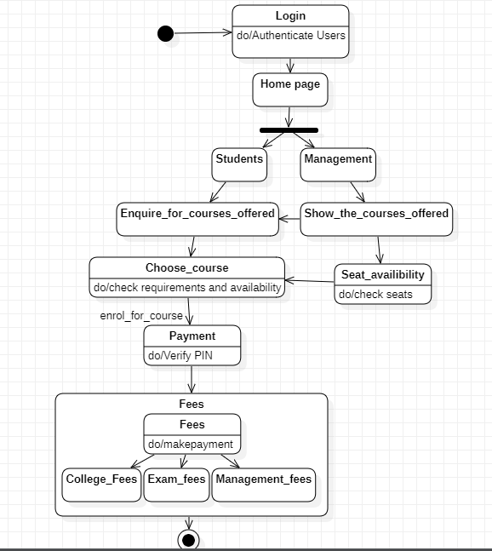

Advanced Use case Diagram of College Information System

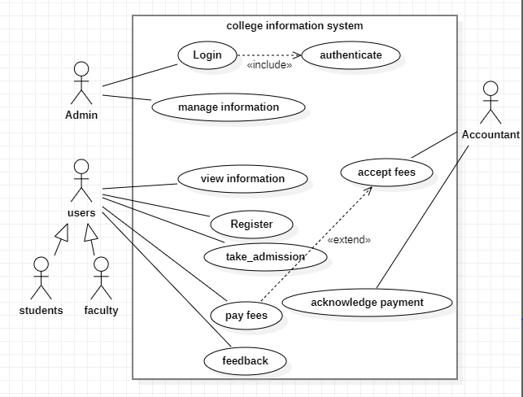

Advanced Sequence Diagram of College Information System

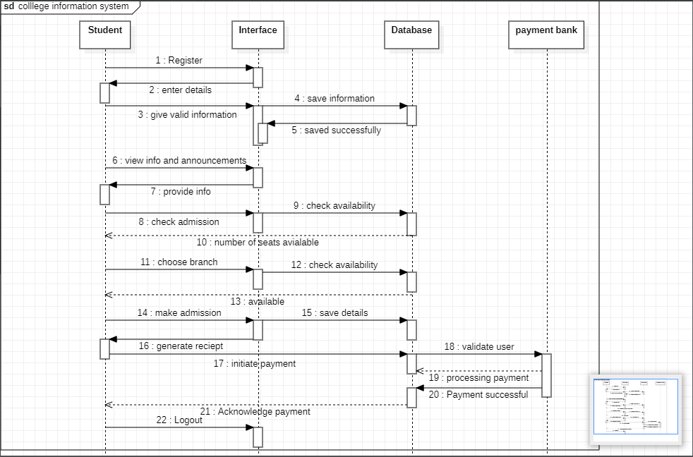

Advanced Activity Diagram of College Information System

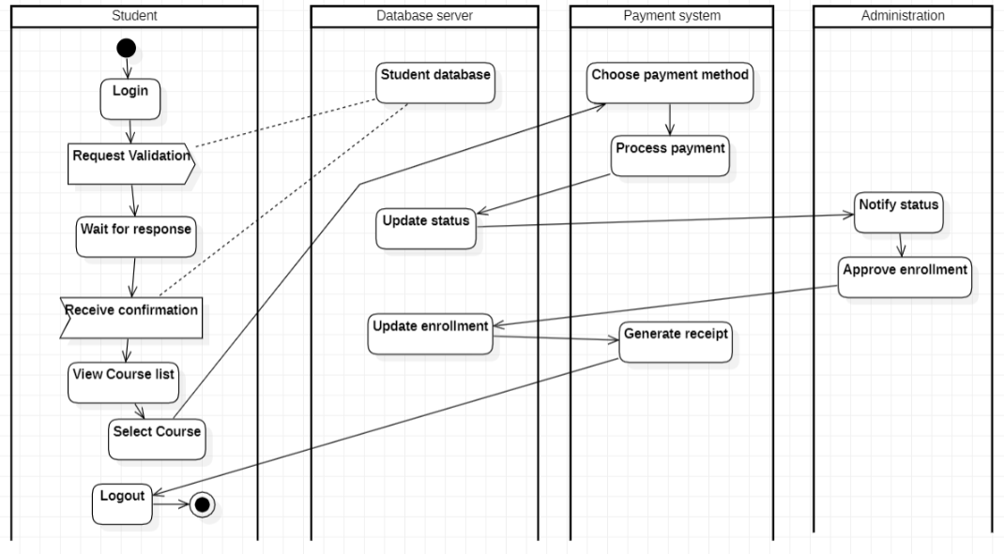

LAB 2
Hostel Management System
Advanced Class diagram of Hostel Management System

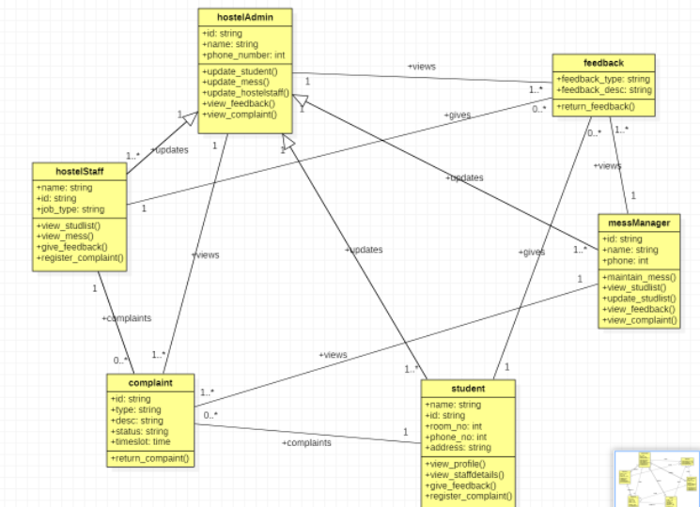

Advanced State Diagram of Hostel Management System

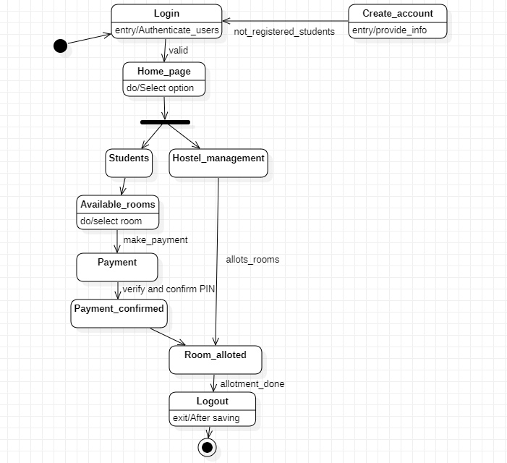

Advanced Use case Diagram of Hostel Management System

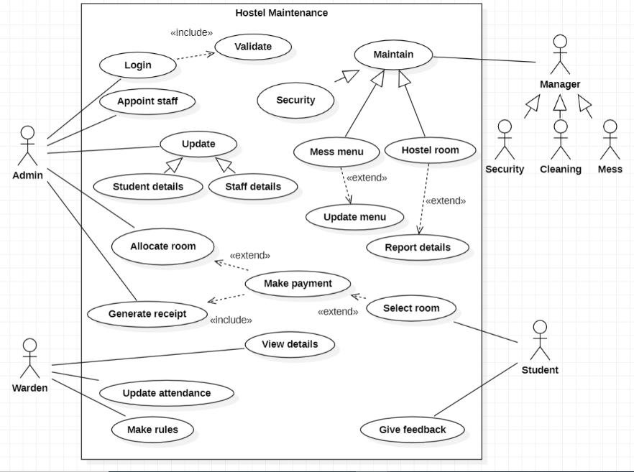

Advanced Sequence Diagram of Hostel Management System

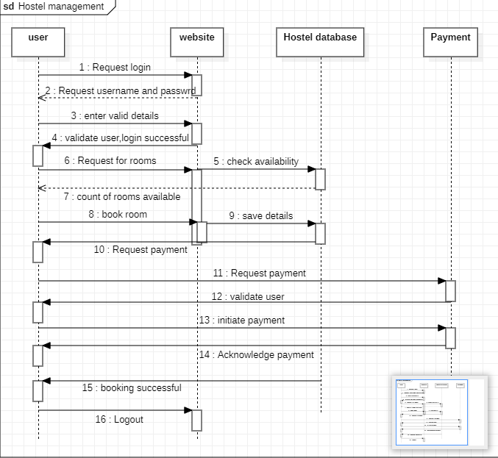

Advanced Activity Diagram of Hostel Management System

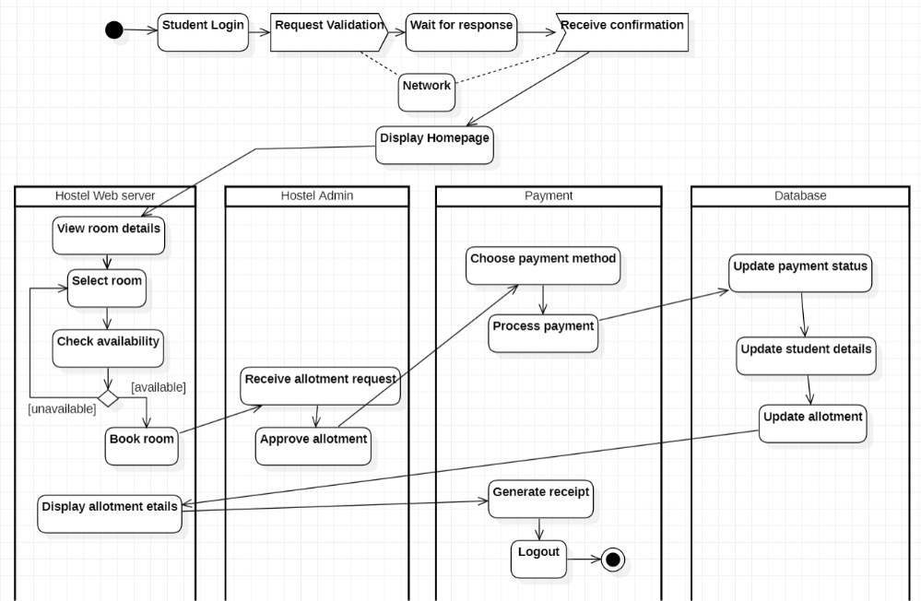

LAB 3
Stock Management System
Advanced Class Diagram of Stock Management System

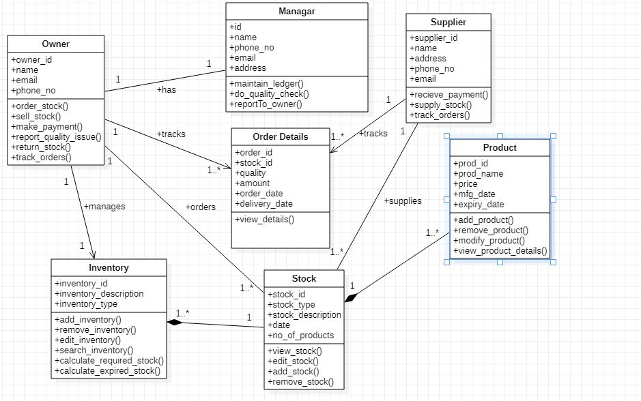

Advanced State Diagram of Stock Management System

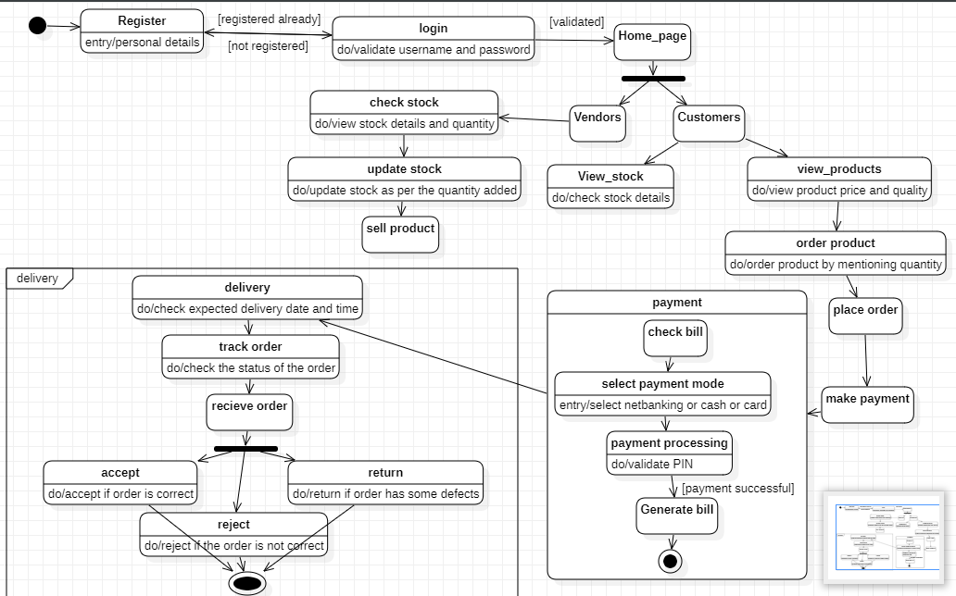

Advanced Use case Diagram of Stock Management System

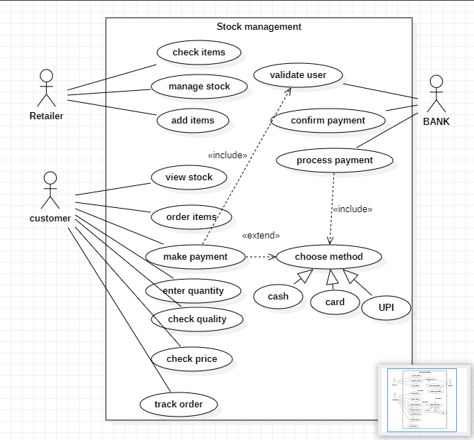

Advanced Sequence Diagram of Stock Management System

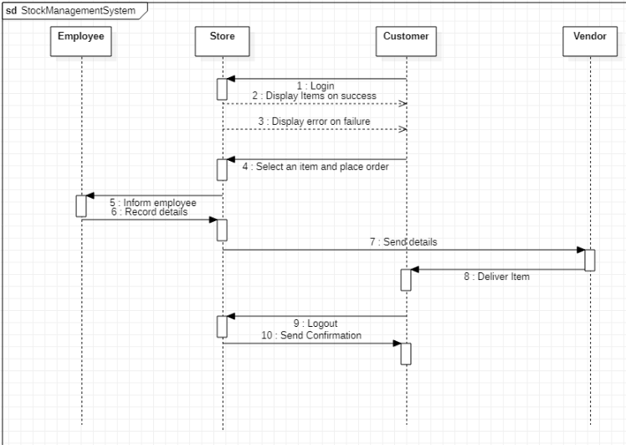

Advanced Activity Diagram of Stock Management System

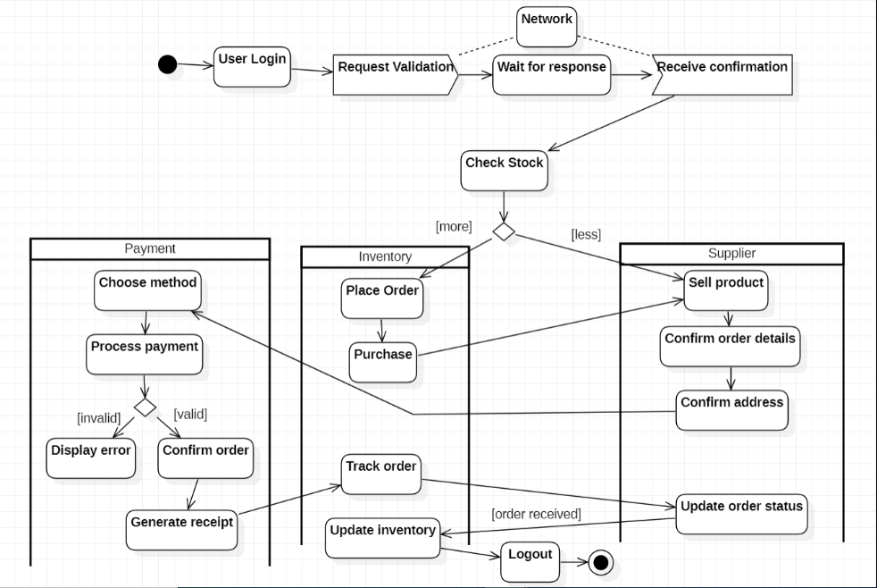

LAB 4
Coffee Vending Machine
Advanced Class Diagram of Coffee Vending Machine

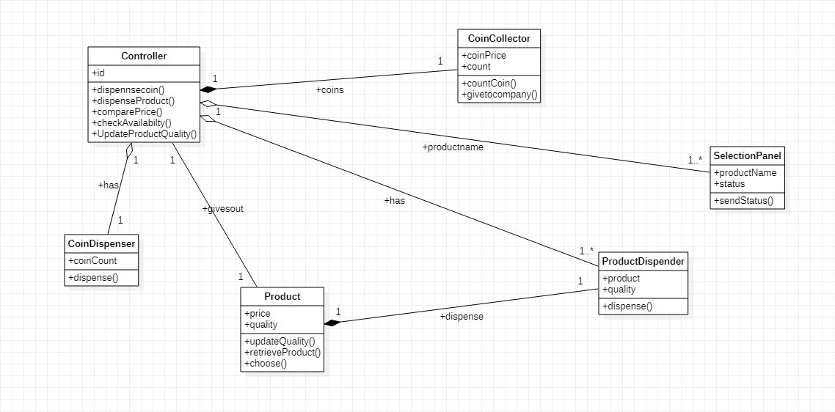

Advanced State Diagram of Coffee Vending Machine

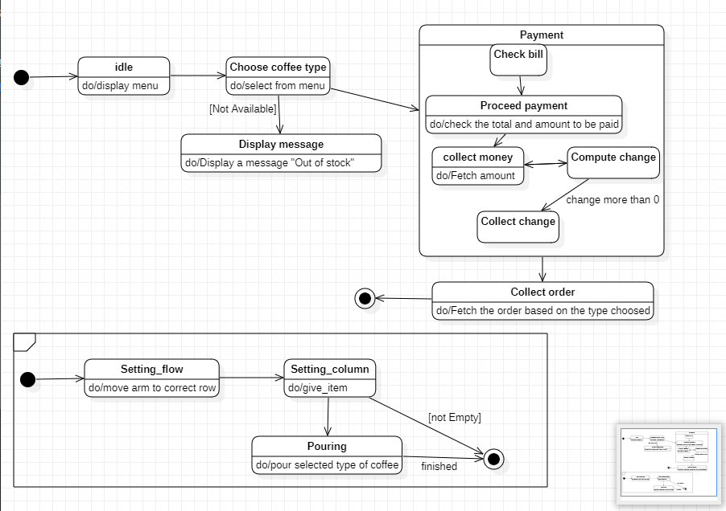

Advanced Use case Diagram of Coffee Vending Machine

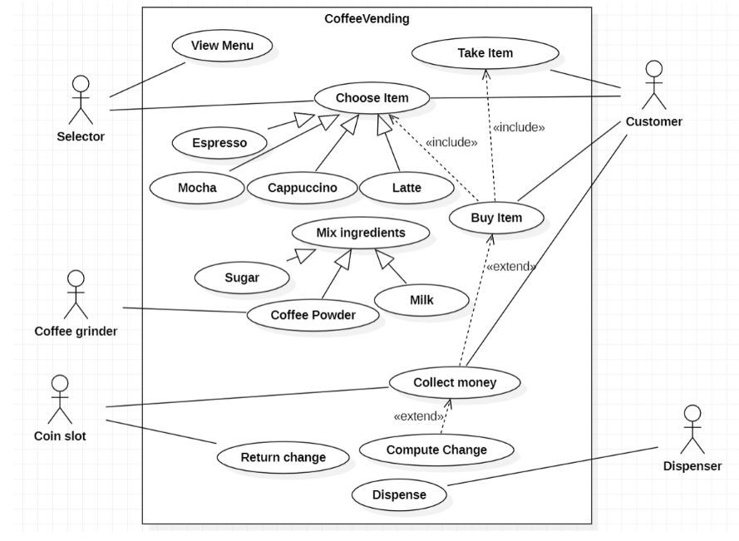

Advanced Sequence Diagram of Coffee Vending Machine

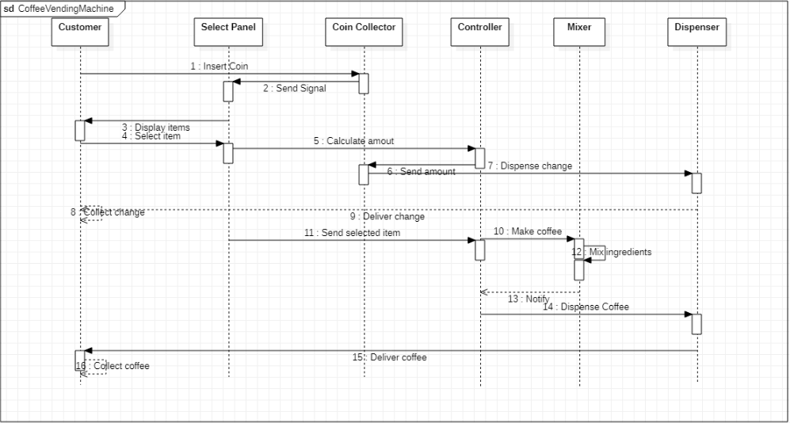

Advanced Activity Diagram of Coffee Vending Machine

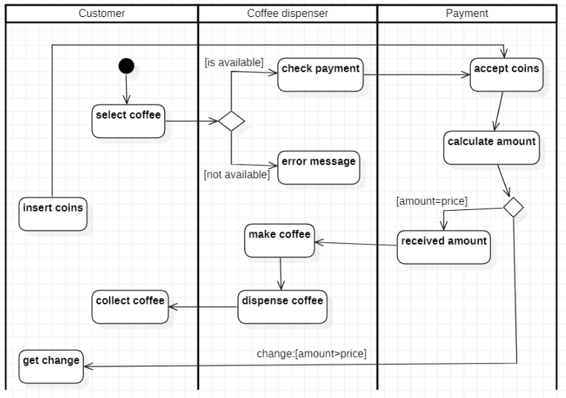

LAB 5
Online Shopping System
Advanced Class Diagram of Online Shopping System

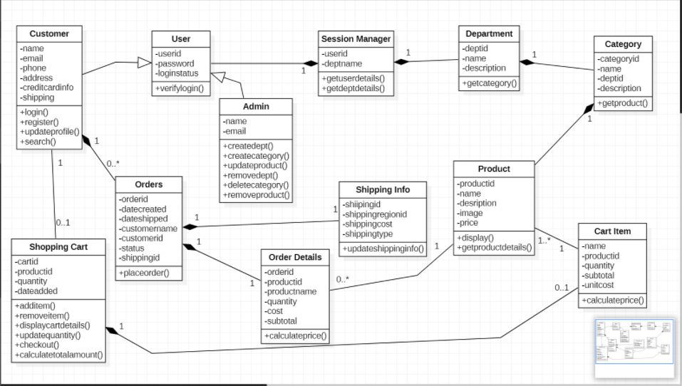

Advanced State Diagram of Online Shopping System

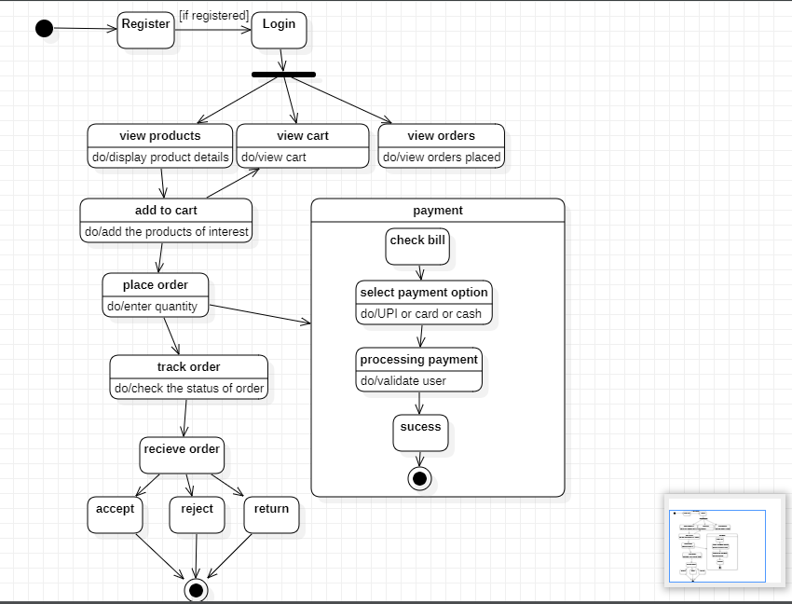

Advanced Use case Diagram of Online Shopping System

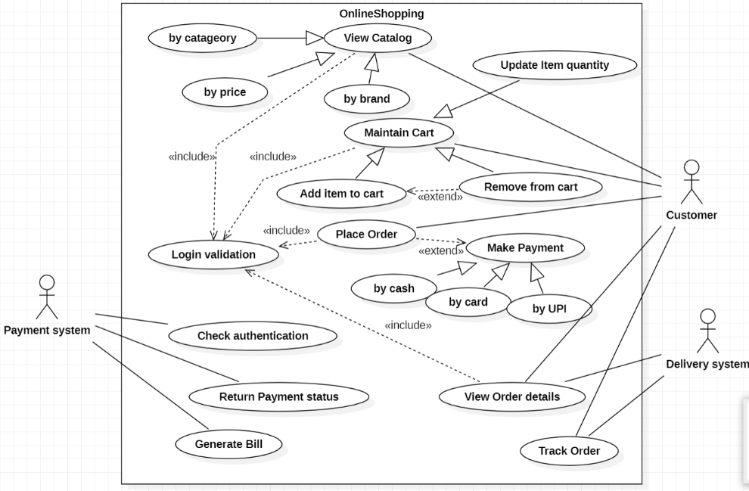

Advanced Sequence Diagram of Online Shopping System

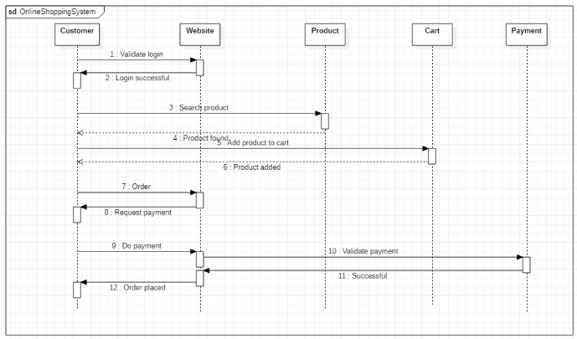

Advanced Activity Diagram of Online Shopping System

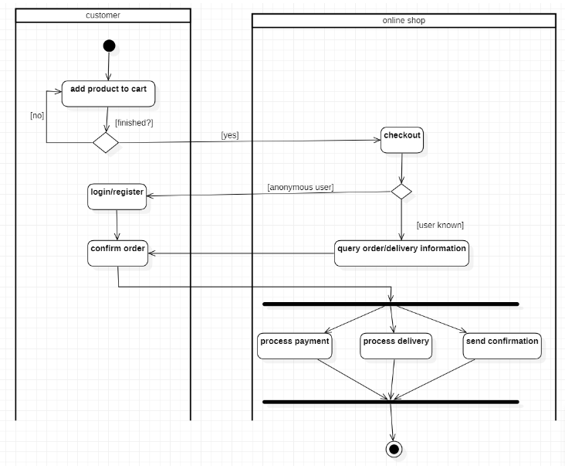

LAB 6
Railway Reservation System
Advanced Class Diagram of Railway Reservation System

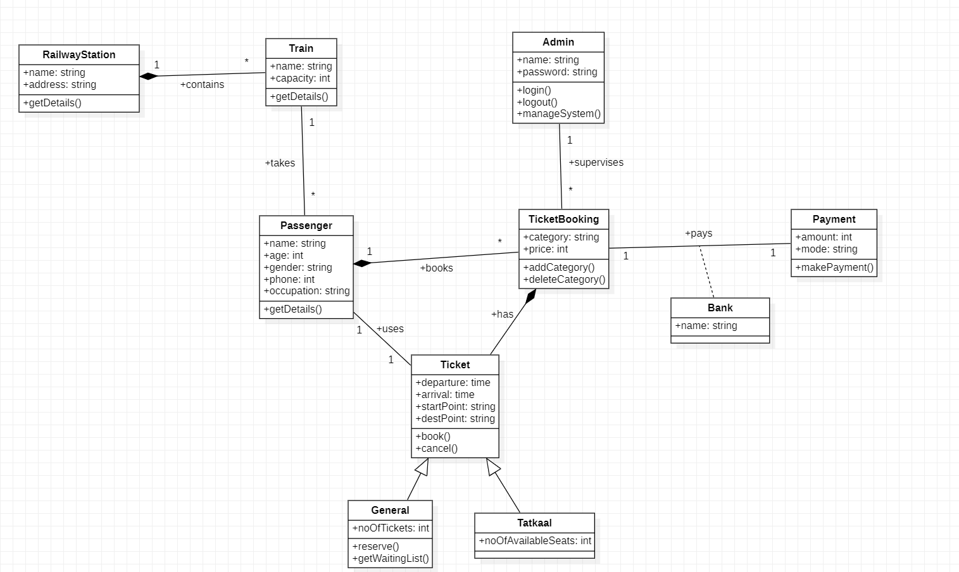

Advanced State Diagram of Railway Reservation System

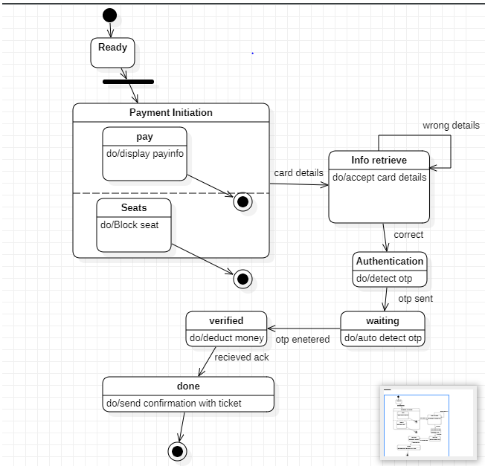

Advanced Use case Diagram of Railway Reservation System

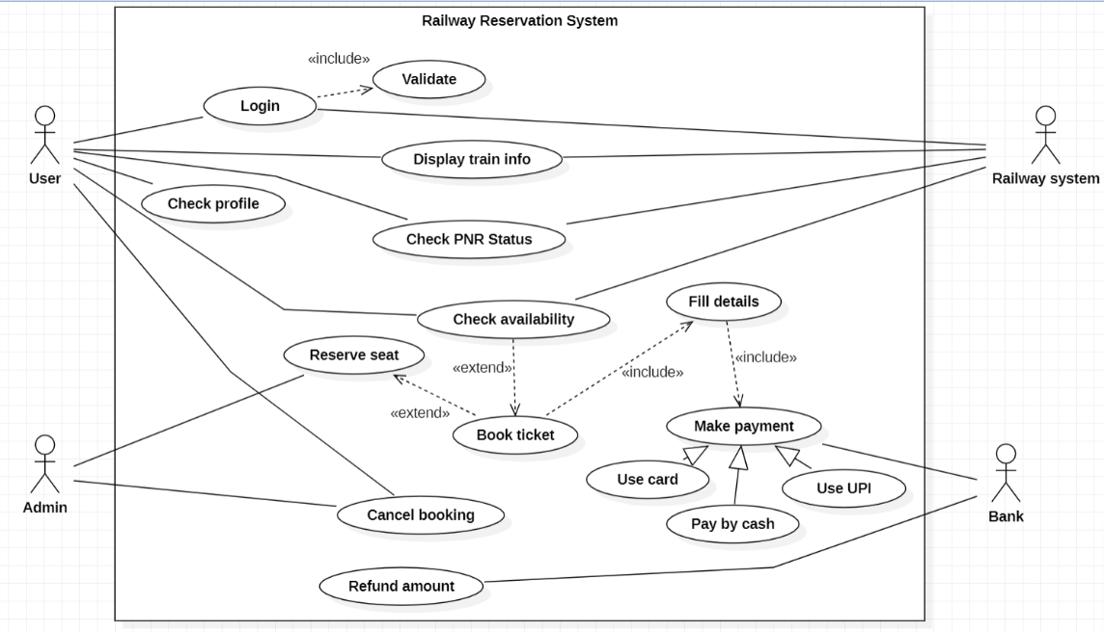

Advanced Sequence Diagram of Railway Reservation System

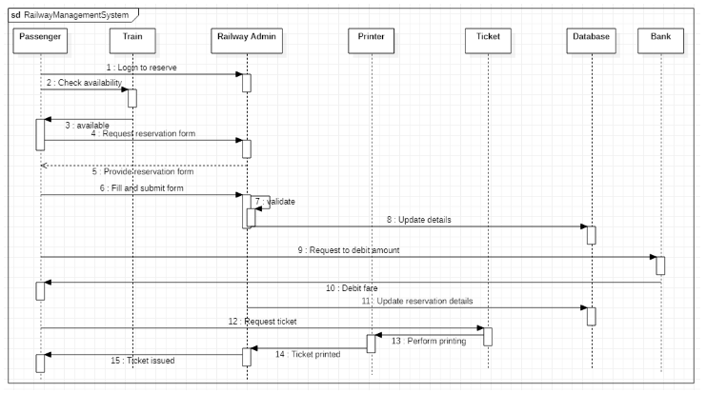

Advanced Activity Diagram of Railway Reservation System

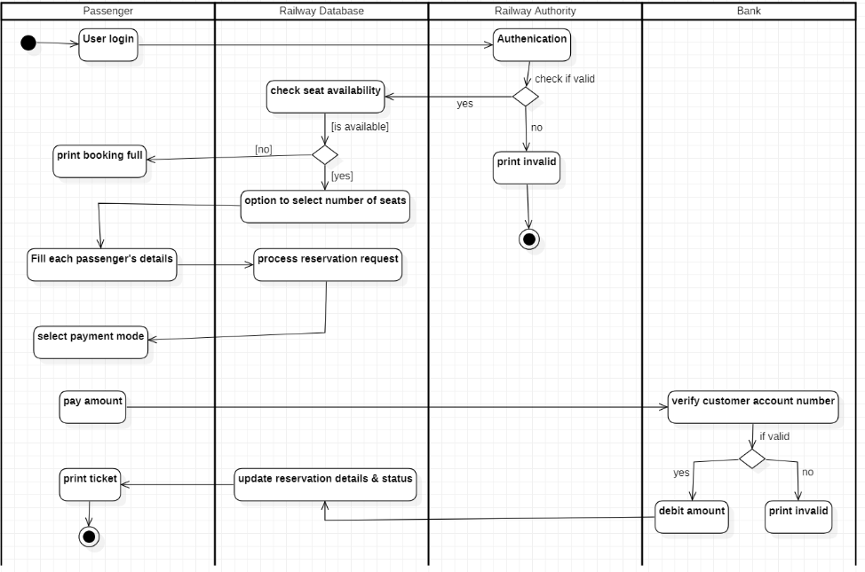

LAB 7
Graphical Editor
Advanced Class Diagram of Graphical Editor
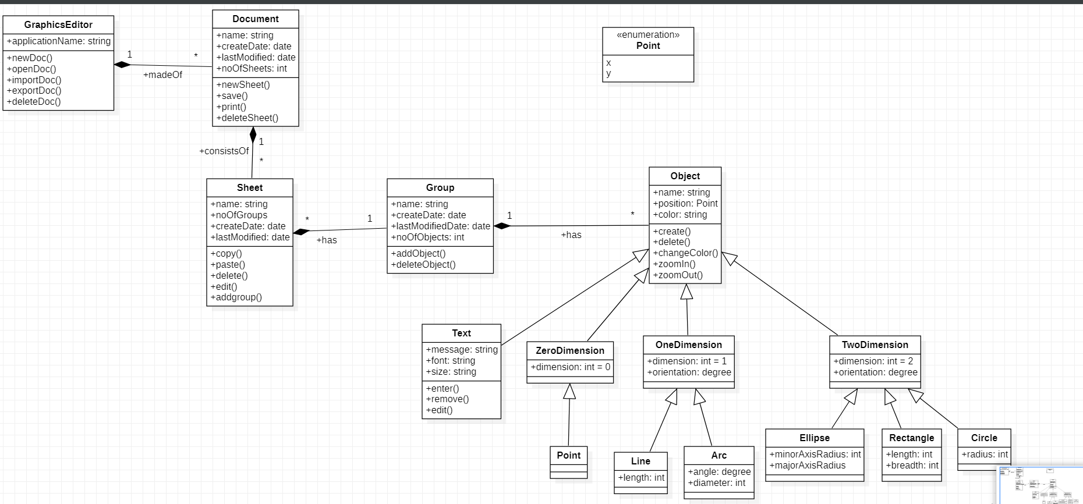

Advanced State Diagram of Graphical Editor

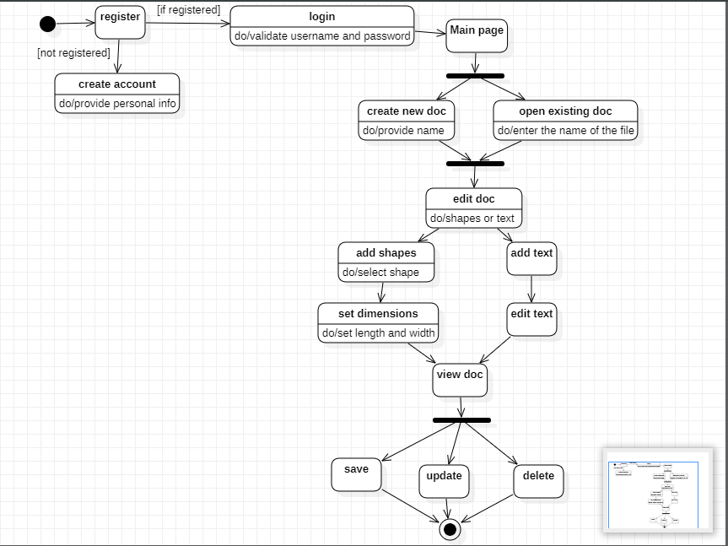

Advanced Use case Diagram of Graphical Editor

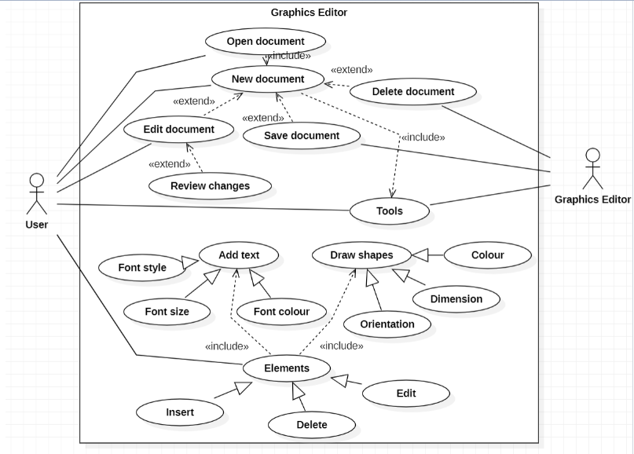

Advanced Sequence Diagram of Graphical Editor

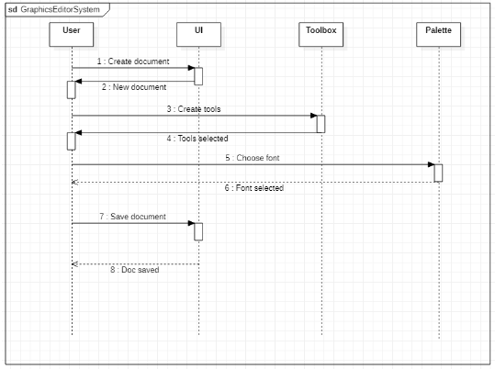

Advanced Activity Diagram of Graphical Editor

