Project Name: SportCourtConnect

Index

Sr. No. | Title | Page No.
1 | Introduction
2 | Problem Definition & Scope
2.1 | Problem Definition
2.2 | Goals & Objectives
2.3 | Major Constraints& Outcomes
3 | Software Requirement Specification
3.1 | Purposed System
3.2 | Scope
4 | System Modules
5 | Performance-Requirements
5.1 | H/W Requirements & S/W Requirements
6 | UML Diagram
6.1 | DFD
6.2 | ERD
6.3 | Use case diagram
6.4 | Class Diagram
6.5 | Sequence diagram
6.6 | Activity Diagram
6.7 | Deployment diagram
6.8 | System Architecture
7 | Test Cases
8 | Screenshots
9 | References

Introduction:
In today’s time people find it difficult to play games to have fun because they do not time ,required amount of people and sport accessories
In our platform we are providing them right people ,right accessories at right time
Turf playground are used to play various sports like football, rugby, tennis, cricket, etc. People enjoy playing on the turf, it has vibrant environment and very safe to play. Many school teams and clubs prefer turf playground for practice and training purpose. Sometime it becomes difficult to book turf playground because of timing issue or the slot getting booked previously. This sports ground booking website is proposed for booking the turf in an easy and efficient way. It has three modules namely, Admin, head of turf (sport zone complex) ,User
We are also providing sports Marketplace, advertisement and membership to user
Users can check the availability of the turf, select timings, fill personal details, can pay by providing bank details or card details and user can generate event on their own and can buy sport accessories .
Sport complex zone can also register, login and generate events and buy products from sport marketplace
Admin controls the website ie he/she views events generated, payment, sport marketplace

2.Problem definition and scope:
2.1 Problem definition:
In today’s time people find it difficult to play games to have fun because they do not time ,required amount of people and sport accessories
In our platform we are providing them right people ,right accessories at right time
2.2 Goals and Objectives:.

Goals:
- Enhanced User Experience:
  - Objective: Improve accessibility and usability of turf facilities through intuitive interfaces and convenient booking systems.
2. Community Engagement and Satisfaction:
- Objective: Foster a sense of community by promoting events, gathering user feedback, and encouraging participation in turf-related activities.
3.Data-Driven Decision Making:
- Objective: Utilize data analytics to optimize resource allocation, improve maintenance efficiency, and predict turf performance trends.

Objectives:
- User Engagement and Participation:
  - Objective: Increase user participation in turf activities by providing easy access to information, online booking capabilities, and interactive features.
- Personalized User Experience:
  - Objective: Customize user experiences based on preferences and feedback, enhancing satisfaction and loyalty.
3.Feedback Mechanisms:
- Objective: Establish effective feedback mechanisms to gather user insights, address concerns promptly, and continuously improve service delivery.
4.Community Building and Events:
- Objective: Organize community events, tournaments, and social gatherings to promote turf use and strengthen community bonds.
5. Performance Monitoring and Evaluation:
- Objective: Monitor turf performance metrics, user satisfaction levels, and operational KPIs to evaluate project success and identify areas for improvement.
6. Continuous Improvement:
- Objective: Foster a culture of continuous improvement by adapting to changing user needs, technological advancements, and best practices in turf management.

  - Major Constraints & Outcomes

Constraints:
- Budget Constraints: Limited financial resources may restrict the selection of turf materials, installation methods, or ongoing maintenance options.
- Time Constraints: The project may need to adhere to strict timelines, such as completion before a sports season begins or before a facility opening.
- Regulatory Compliance: Compliance with local, regional, or national regulations regarding turf materials, environmental impact, and safety standards can constrain project decisions.
- Environmental Impact: Balancing the desire for high-performance turf with sustainable practices, such as water usage, chemical exposure, and turf lifecycle management.
- User Expectations: Addressing diverse user needs and preferences, including different sports requirements (e.g., traction, ball bounce) and accessibility considerations.
6.Maintenance Requirements: Determining the level of maintenance needed to keep the turf in optimal condition without disrupting user activities or exceeding operational budgets.

Potential Outcomes:
- Improved User Experience: Enhanced playing conditions that meet or exceed user expectations, leading to increased satisfaction and utilization of the facility.
- Enhanced Safety: Reduced injury risk due to appropriate turf selection and installation, meeting safety standards for impact absorption and slip resistance.
- Community Engagement: Increased community involvement and satisfaction through inclusive design processes that consider user input and feedback.
- Operational Efficiency: Streamlined maintenance operations and reduced downtime for repairs, maximizing the availability of the facility for users.
- Financial Viability: Cost-effective solutions that balance initial investment with long-term maintenance costs, ensuring the project's economic sustainability.

- Software Requirement Specification

  - Proposed System:

1. Needs Assessment and Requirements Gathering
- Stakeholder Analysis: Identify and engage stakeholders including players, coaches, facility managers, and community representatives.
- User Requirements: Conduct surveys, interviews, and workshops to gather insights into user preferences, performance expectations, and safety concerns.

2. Design and Specification
- Turf Specifications: Define the technical specifications of the turf based on user needs, sport requirements, and environmental factors.
- Material Selection: Choose turf materials (e.g., synthetic grass types, infill materials) that align with performance, durability, and sustainability goals.
- Accessibility Considerations: Ensure the design meets accessibility standards for users with disabilities.

3. Implementation and Construction
- Project Planning: Develop a detailed project plan including timelines, budget allocation, and resource management.
- Construction Management: Oversee the installation process to ensure quality control, safety compliance, and adherence to design specifications.
- Quality Assurance: Conduct testing and inspections throughout the construction phase to verify turf performance and safety standards.

6. User Engagement and Feedback
- Continuous Feedback Loop: Maintain open communication channels with users to gather feedback on turf performance and user experience.
- Adaptation and Improvement: Use user feedback to make continuous improvements to the turf system, addressing any issues or suggestions raised.

7. Monitoring and Evaluation
- Performance Monitoring: Implement systems to monitor turf performance metrics such as wear and tear, shock absorption, and surface consistency.
- Evaluation: Regularly evaluate the system's success in meeting user needs, safety standards, and sustainability goals.

8. Documentation and Reporting
- Documentation: Maintain comprehensive documentation of project plans, specifications, construction processes, and maintenance records.
- Reporting: Provide regular reports to stakeholders on project progress, performance metrics, and compliance with objectives.

9. Community Engagement and Outreach
- Community Involvement: Foster community engagement through open forums, events, and educational programs related to the turf system.
- Public Relations: Promote positive community relations by highlighting the benefits and successes of the integrated turf system.

10. Long-term Planning and Adaptation
- Future-proofing: Consider future needs and advancements in turf technology to ensure the system remains relevant and effective over the long term.
- Flexibility: Design the system with flexibility to accommodate changes in user demographics, sports trends, and environmental conditions.

3.2 Scope of project:
The scope of a turf management system project typically encompasses a range of objectives and functionalities aimed at efficiently managing and maintaining turf areas, such as sports fields

User Experience Enhancement:
- Accessibility: Ensure easy access to information about turf conditions, playing schedules, and availability.
- User Interface Design: Develop intuitive interfaces for users to interact with the system, reserve playing slots, and provide feedback on turf conditions.
Booking and Reservation System:
- Online Booking: Implement a system for users to reserve playing times or events on the turf.
- Availability Management: Provide real-time updates on turf availability and conditions to facilitate informed booking decisions.
Personalization:
- User Profiles: Enable users to create profiles to track their usage history, preferences, and feedback.
Community Engagement and Feedback:
- Surveys and Feedback: Conduct surveys to gather feedback on user experiences and suggestions for improvement.
- Community Events: Promote community events or tournaments through the system to encourage engagement.
Feedback Loop: Establish a feedback loop between users, management, and maintenance teams to continuously refine and enhance the integration of turf and user experiences.

4. System Modules:
The project basically has three modules:

1) ADMINISTRATOR MODULE

2) CUSTOMER OR USER MODULE
3) sport zone complex(turf)

Functional Modules

1) User Authentication Module:
The registration and Login system has been added so that only authenticated users (Admin & Customer) can perform their functionalities.

2) Customer Module:
Register, Login, and View all Customers.

3) Ground Module:
Add Ground, View all Grounds, Delete Ground.

4) Turf Booking Module:
Book Turf, View My Bookings, View All Customer Bookings, Cancel Booking, Update the Booking Status.

5) Payment Module:
View Customer Wallet, Add Money in Wallet, Pay from Wallet after Booking.

5. Performance-Requirements
H/W Requirements & S/W Requirements

H/W Requirements:
Server Infrastructure:
- Purpose: Host and manage the central software application and database.
- Examples: Servers (physical or virtual), storage devices, backup systems.

S/W Requirements:

1. STS (Spring Tool Suite)

For developing our backend, task management system project using Spring Boot, we have used STS (Spring Tool Suite) or Eclipse Ide. But yes, we can use other IDEs also like Intellij Idea, NetBeans, etc.

2. VS Code (Visual Studio Code)

For developing our frontend, task management system project using react js, we have used VS Code (Visual Studio Code).

3. MySQL Workbench

For efficient querying and manipulation of our Project's information, we have used MySQL Workbench.

Technologies used:
Frontend:
React:
React is a JavaScript-based UI development library. Although React is a library rather than a language, it is widely used in web development.
Backend:
Spring Boot:
Java Spring Framework (Spring Framework) is a popular, open source, enterprise-level framework for creating stand-alone, production-grade applications that run on the Java virtual machine (JVM).
Database:
MySQL:
MySQL is an open-source Relational Database Management System (RDBMS) that enables users to store, manage, and retrieve structured data efficiently

6.UML diagram:
6.1 DFD(Data Flow Diagram):
Level 0 and Level 1 DFD:
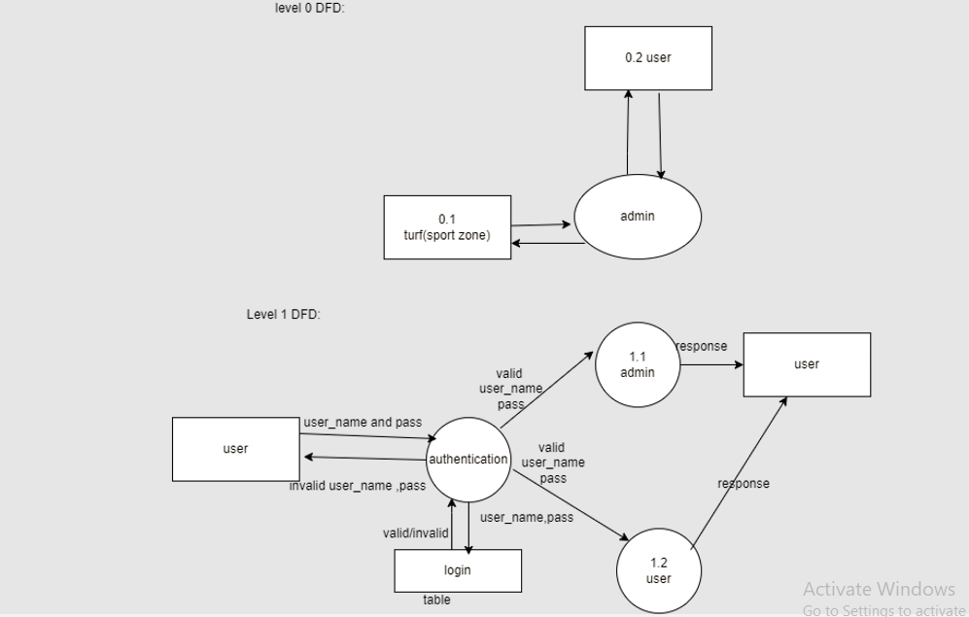

Level 2 DFD :
For Admin:
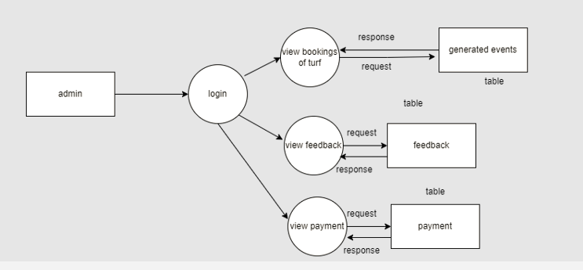

For User:
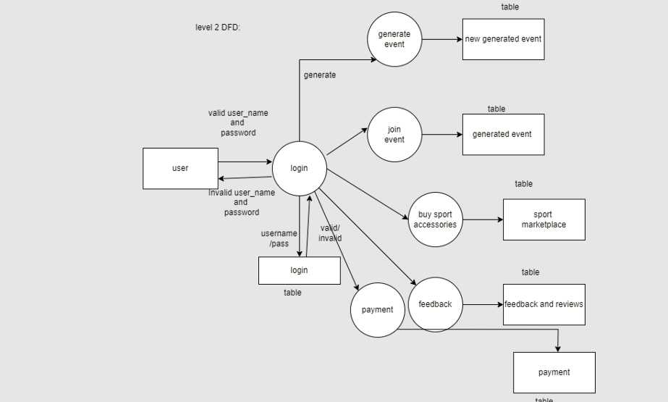

For Turf(Sport Zone Complex):
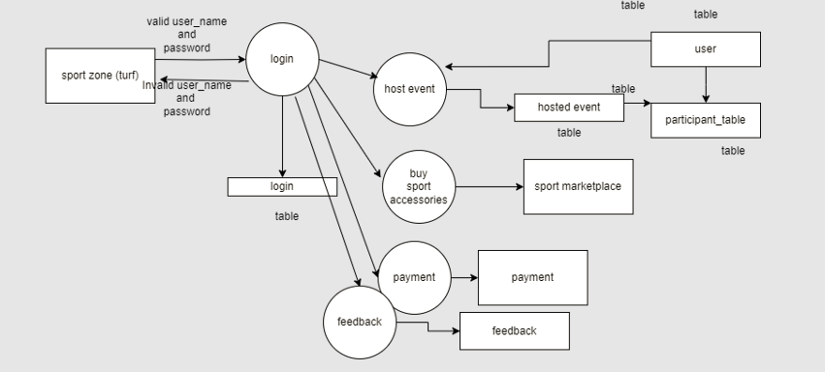

6.2 Entity-Relationship diagram:

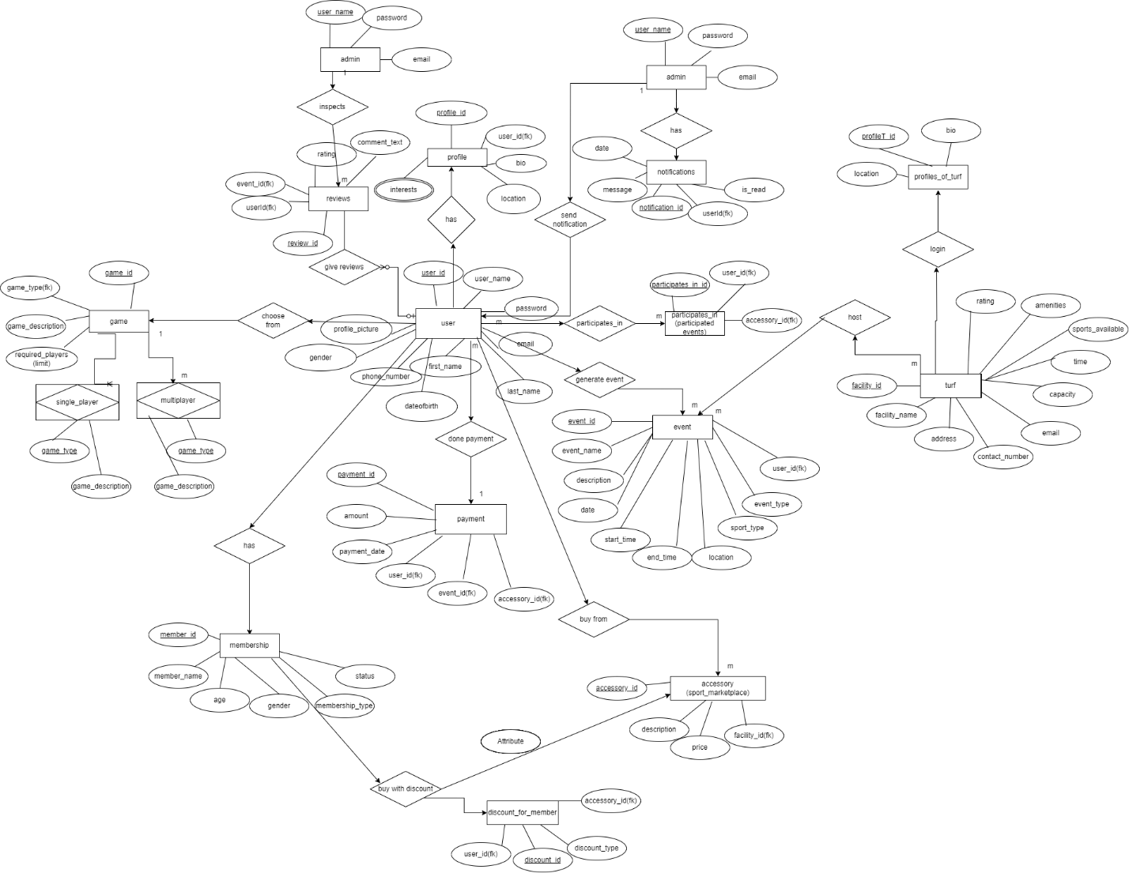

Future Scopes:

