**PROBLEM STATEMENT :**

1. Create a private bucket in AWS. Upload a file and check by reassigned URL whether you can access the file or not.

***Bucket creation and checking for access-***

1. Sign up for an AWS account, search for ‘S3’ then click on it.

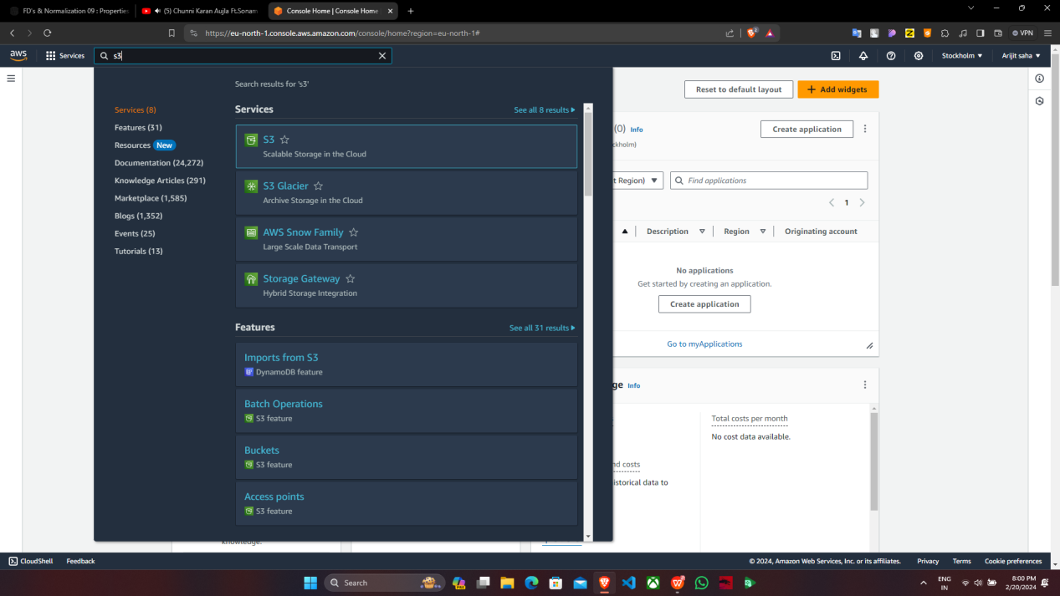

1. Click on ‘Create bucket’.

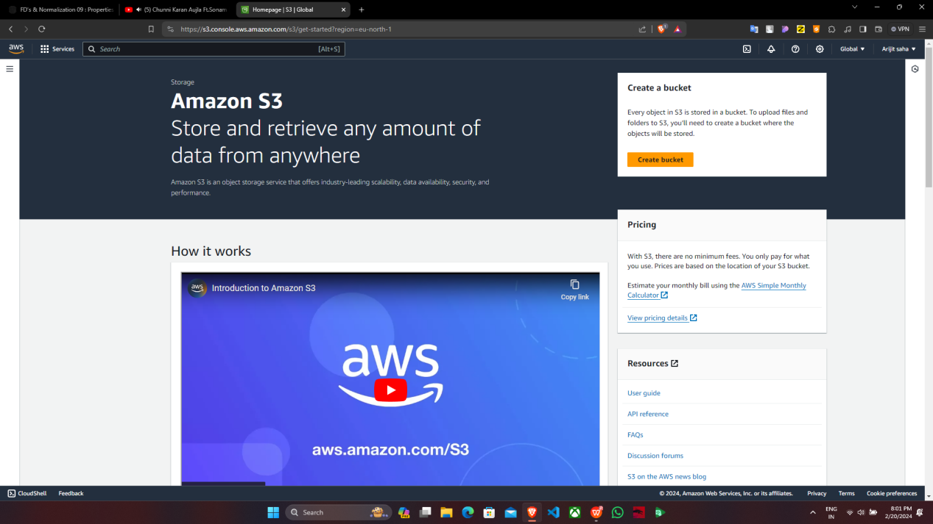

3. Fill up the required details->’AWS region’ , ‘Bucket name’ then we have to do ‘ALC disabled’ because we are creating a private bucket and check the other configuration as per the snapshots then click on ‘Create bucket’.

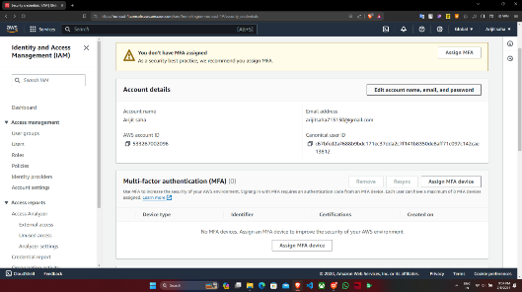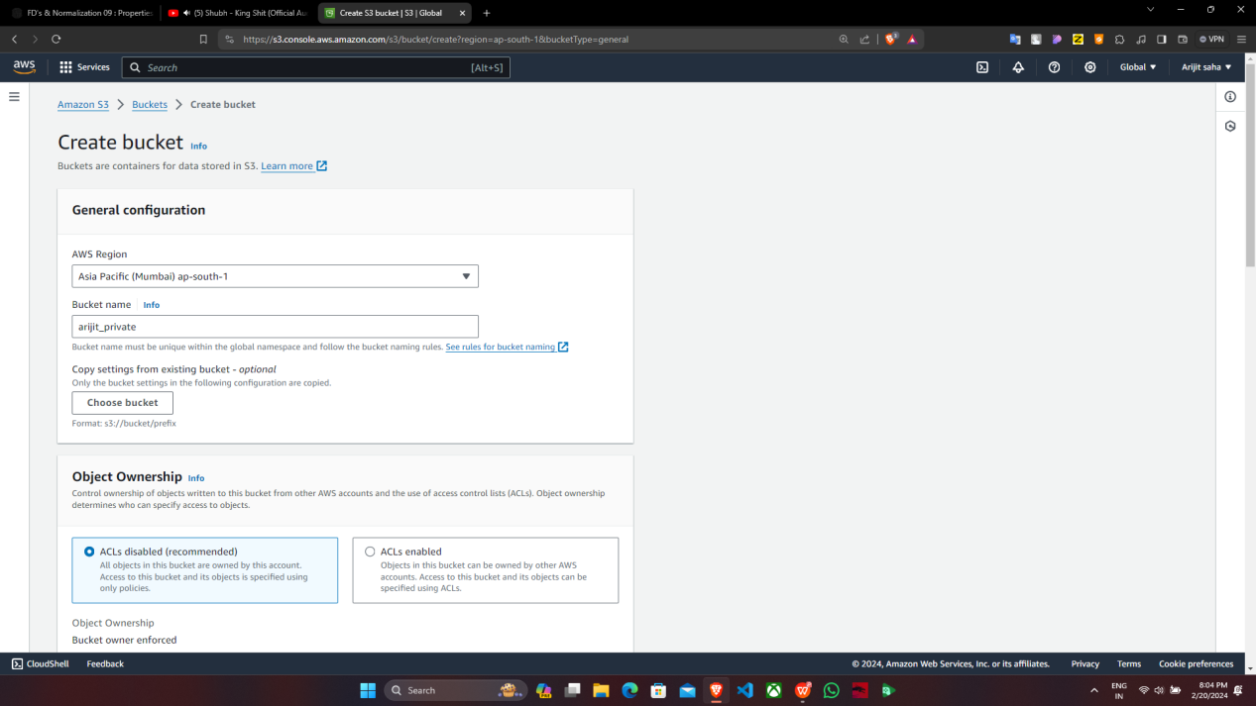

Supriyo_private

4.‘supriyo_private’ bucket is created successfully then click on name->‘supriyo_private’.

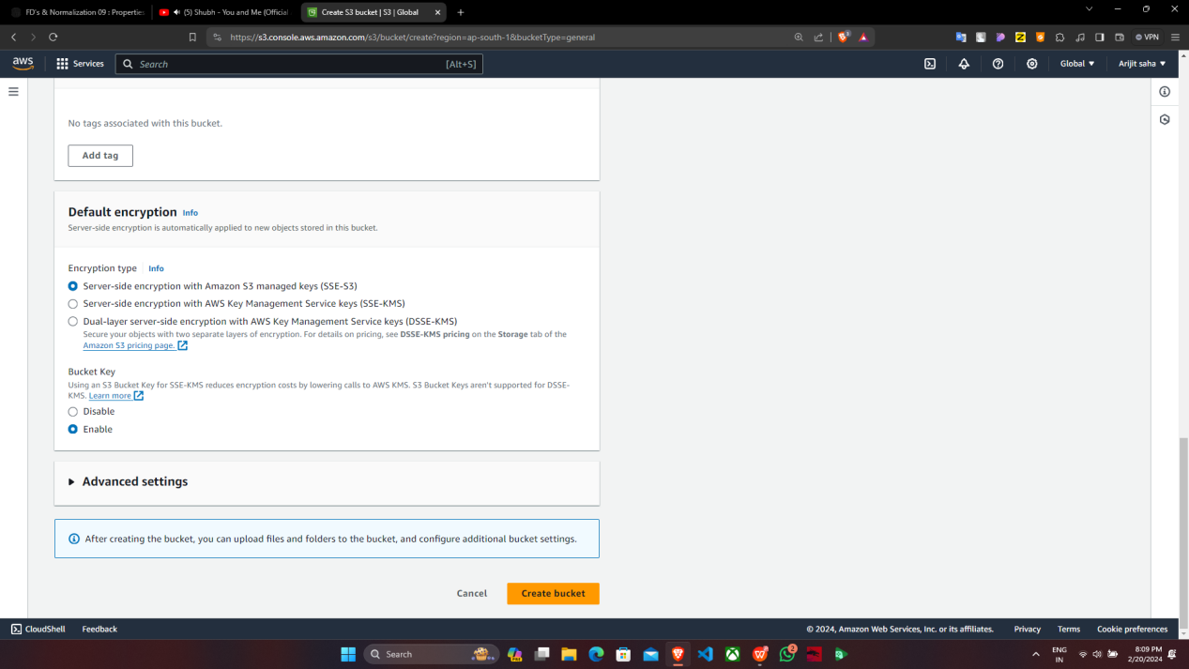

5.Under ‘supriyo_private’, click on ‘Upload’ then choose a file of your choice .

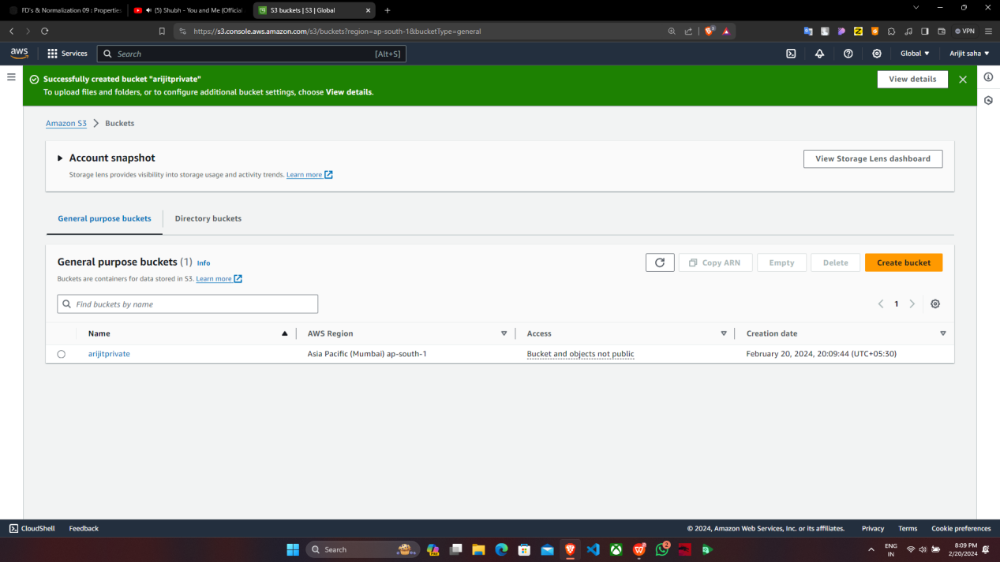

supriyoprivate

6. Click on ‘Add files’ then tick off the ‘Name’ of the file and click on

‘Upload’.

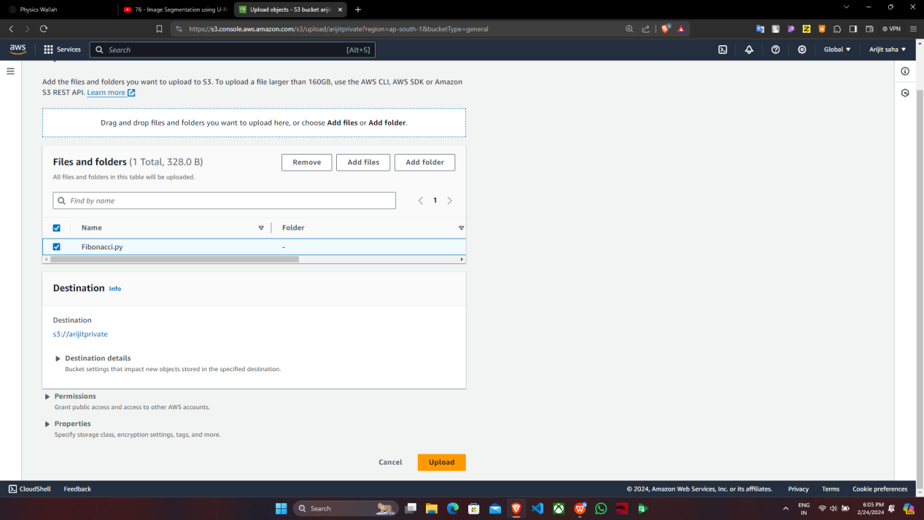

1. File is uploaded successfully , tap on ‘Close’ and click on ‘Name’.

8. Under ‘supriyoprivate’, tick off any one of the files(checkbox) and click on that

file.

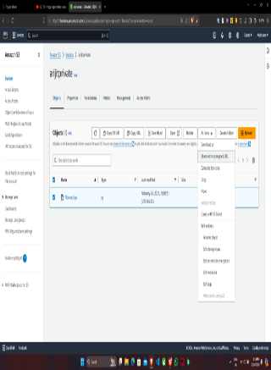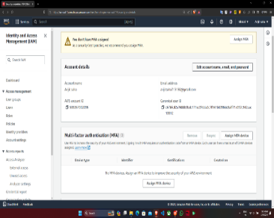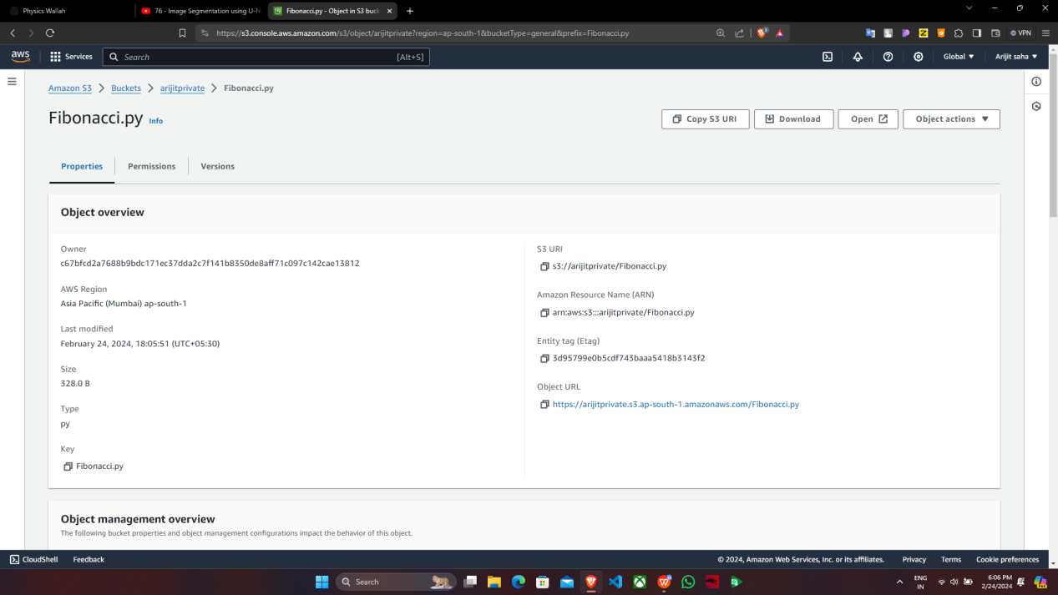

supriyoprivate

supriyoprivate

supriyoprivate

9.Copy the ‘Object URL’.

10. Now open the ‘Incognito mode’ and paste the ‘Object URL’. We will see

that the file cannot be accessed as it was a private bucket.

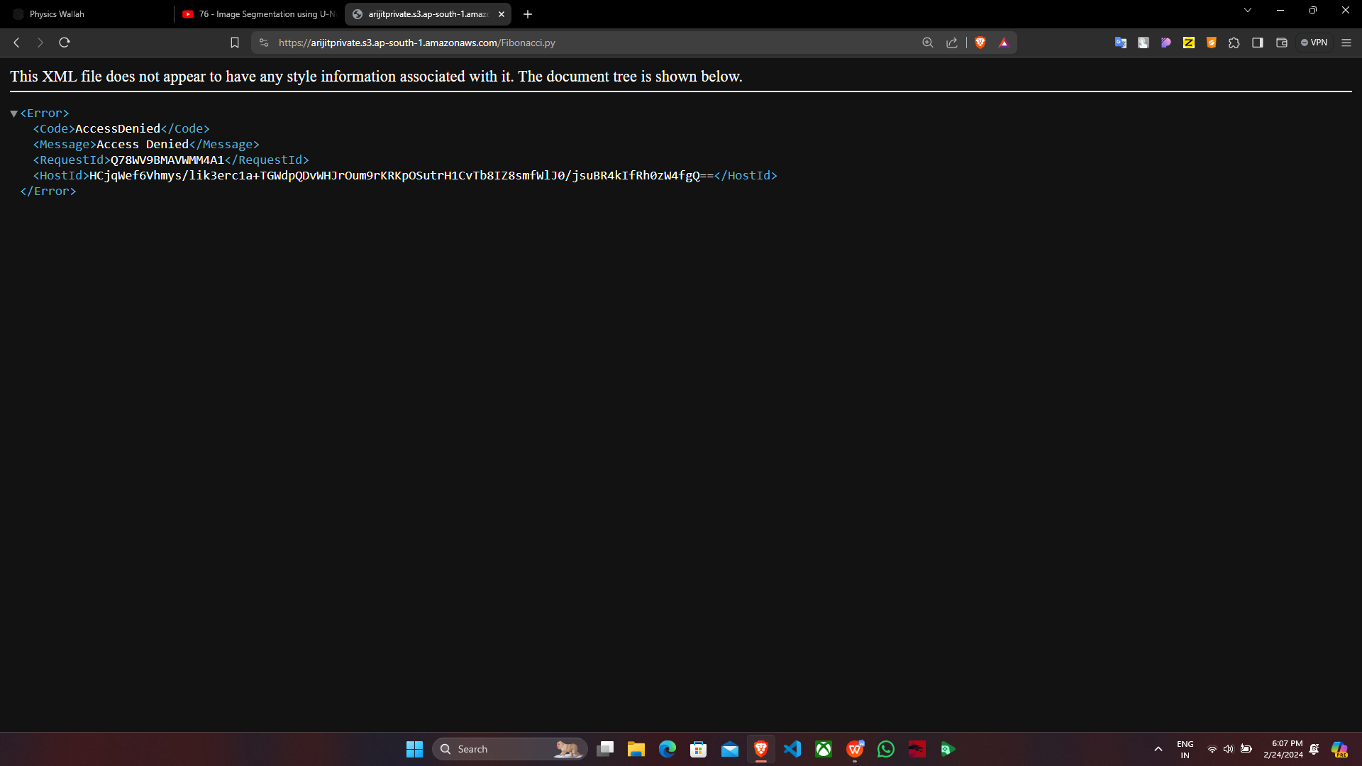

***To give access to the file , follow the steps given below.***

11. Go back to AWS account , select the bucket(supriyoprivate) then go to ‘Actions’

and from there select ‘Share with a presigned URL’.

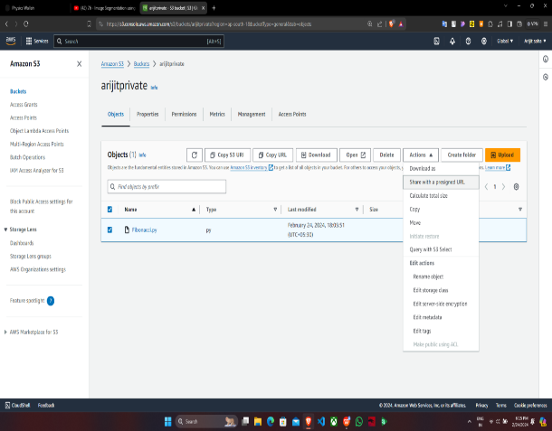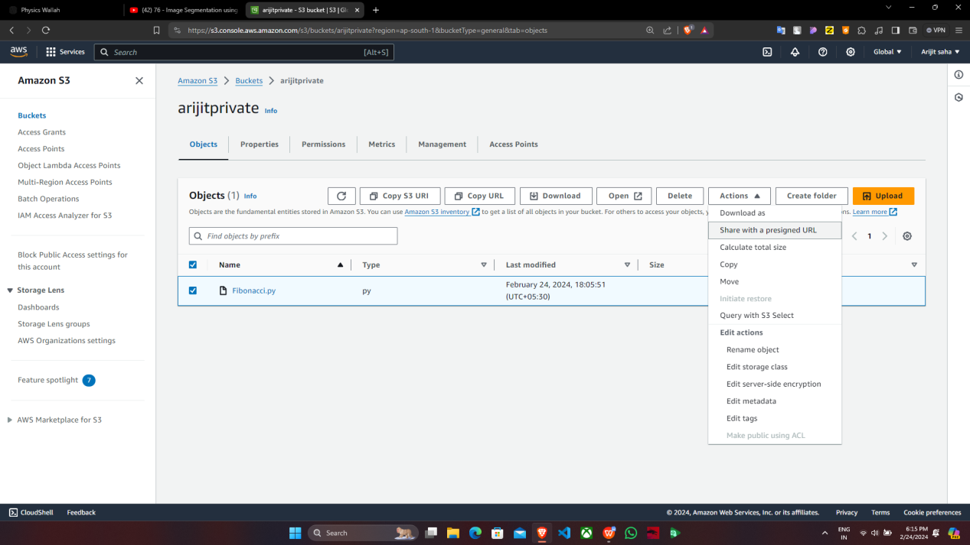

supriyoprivate

**supriyoprivate**

12. Now according to our choice select either ‘Minutes’ or ‘Hours’ then give the number and click on ‘Create presigned URL’ so that the file can be accessed via presigned URL.

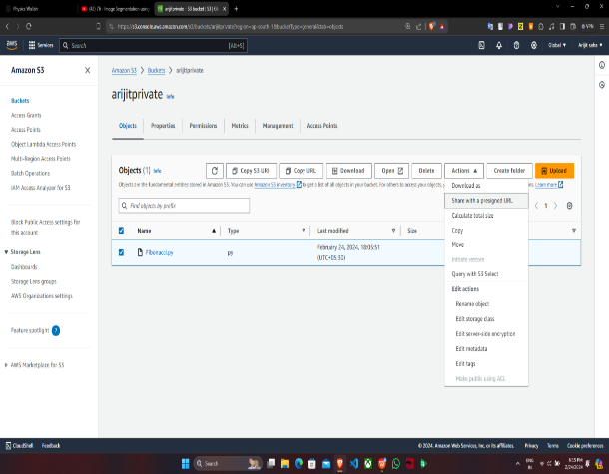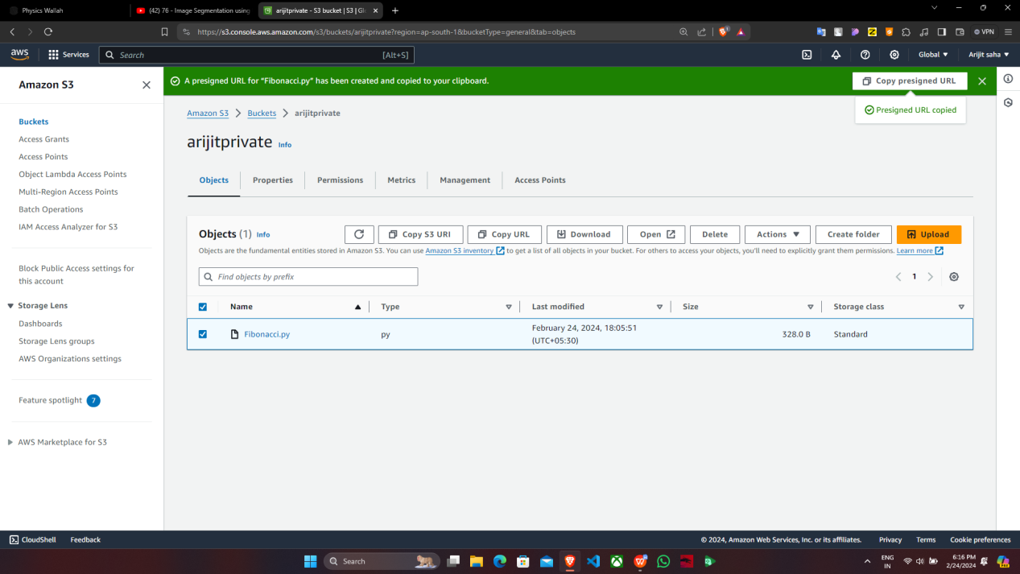

**supriyoprivate**

supriyoprivate

13. A presigned URL is created then copy the URL and paste it on ‘Incognito

mode’.

14. Now paste the presigned URL in the ‘Incognito mode’ then we can

notice that the file can be accessed for 10 minutes.

