**PROBLEM STATEMENT :**

10) Deploy a project from GitHub to EC2 by creating a new security group and user data.

***Steps to deploy project from GitHub to EC2 by creating new security group:***

1. Sign up for an AWS account, search for ‘EC2’ then click on it.

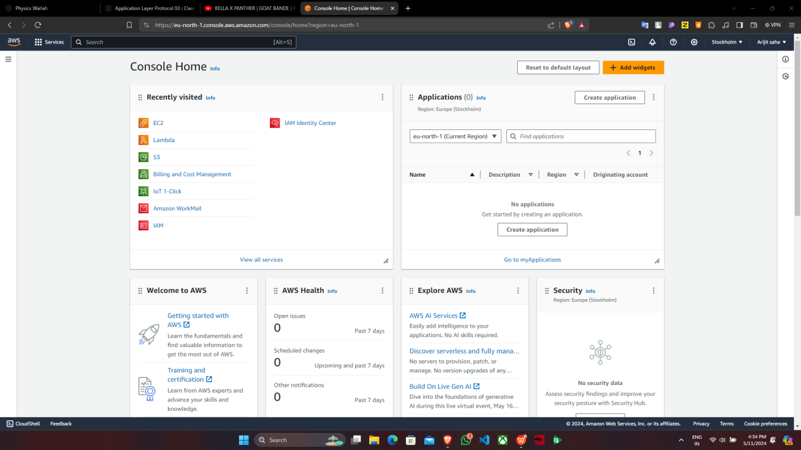

1. Click on security group.

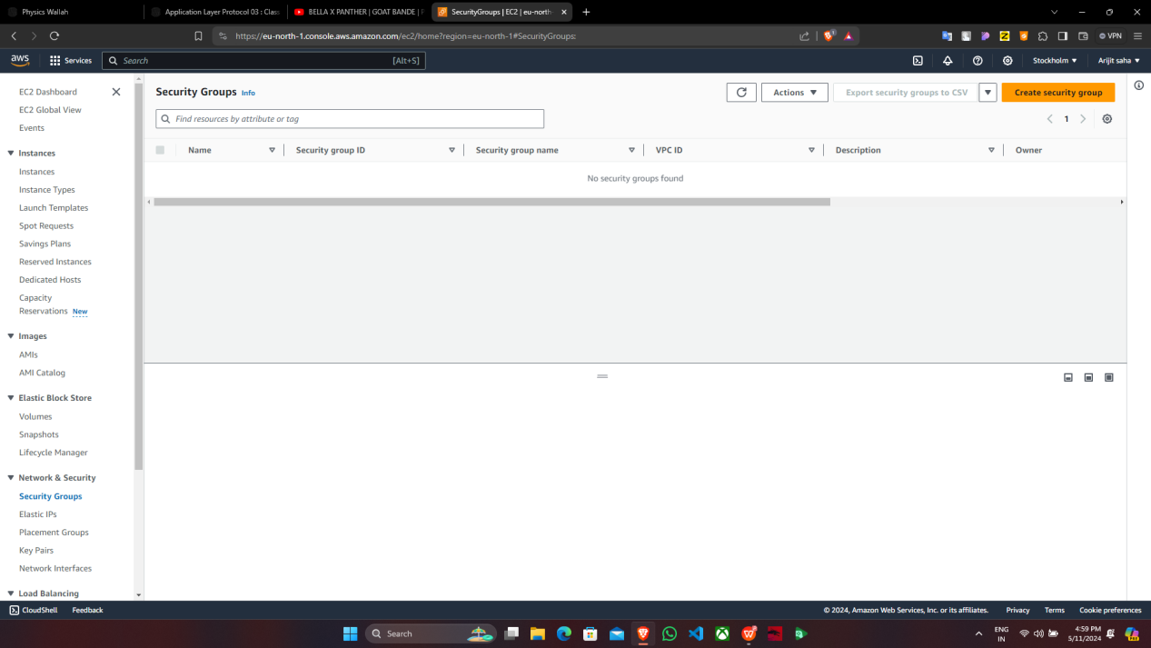

1. Click on “Create security group”.

4. Under “Create security group”, give the name & in “Inbound rules” click on “Add

rule”.

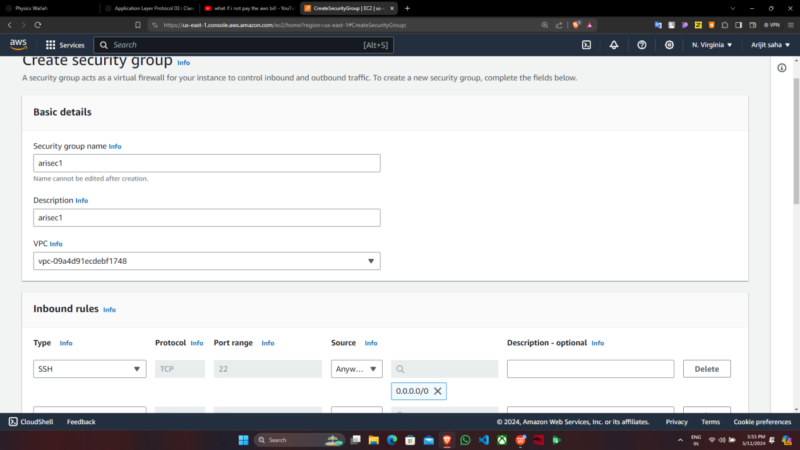

5. In “Inbound rules” give the four rules given below & in all the rules, the source

address of 0.0.0.0/0 and Port range of 4000 to Custom TCP.

1. Now click on “Create security group”.
2. “arisec1” is successfully created & then get back to “EC2 dashboard”.

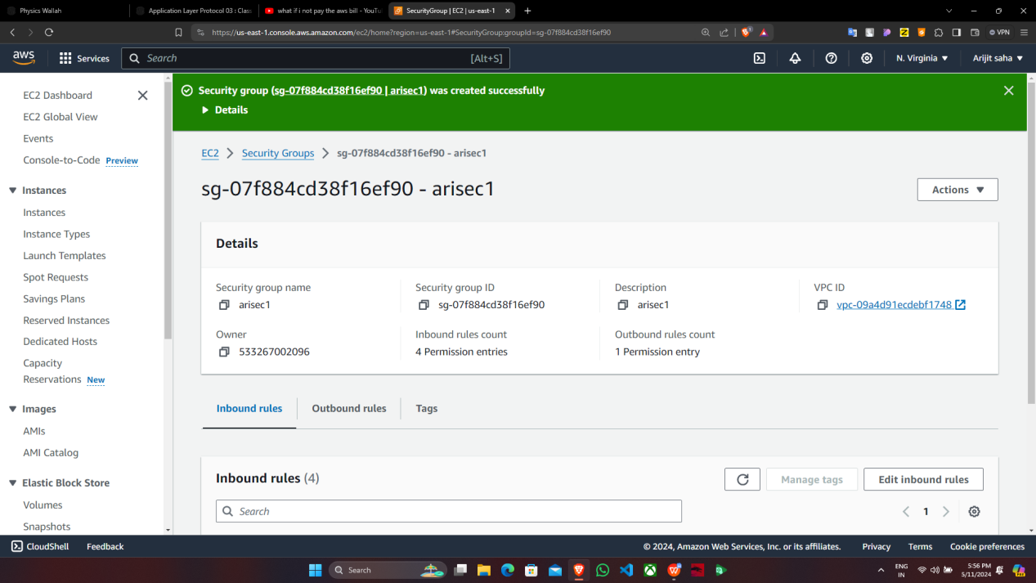

1. Click on “Launch Instance”.

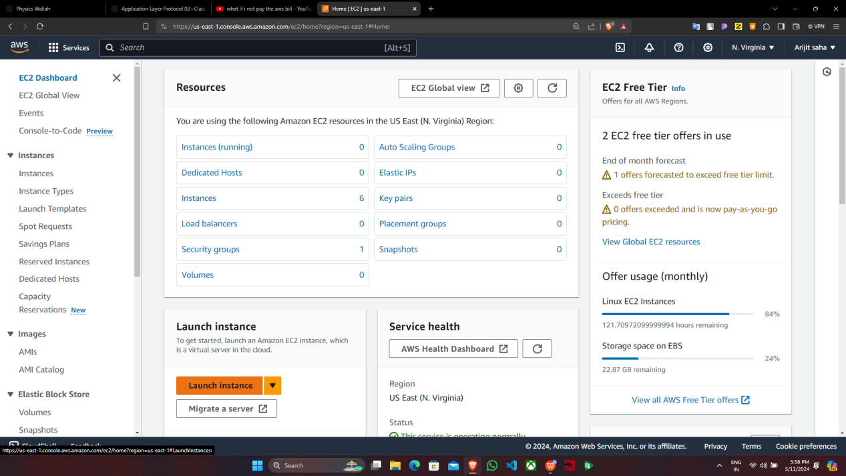

9. Under “Launch instance”, give the name, click on “ubuntu”, select the key_pair, click

on “Select existing security group” & select the newly created security group.

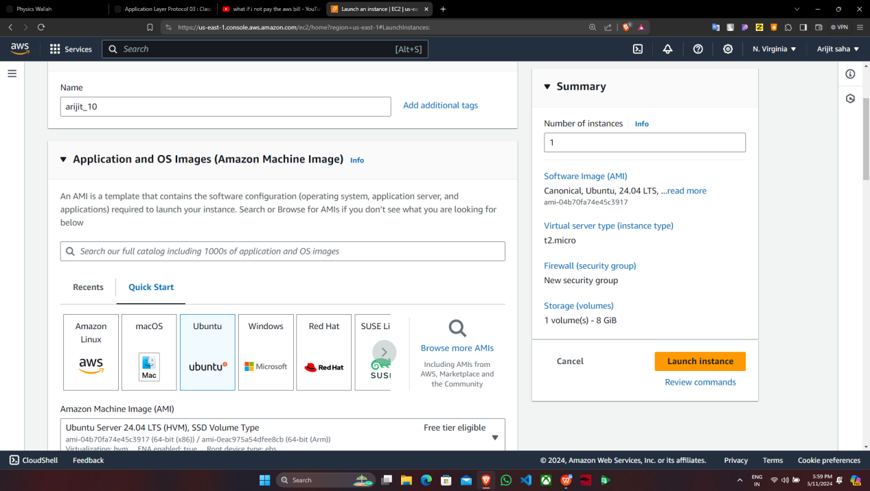

Expand the Advanced Details & scroll down to the bottom, in the bash console type the

following commands, give the address & repository name from GitHub. Then click on

“Launch Instance”.

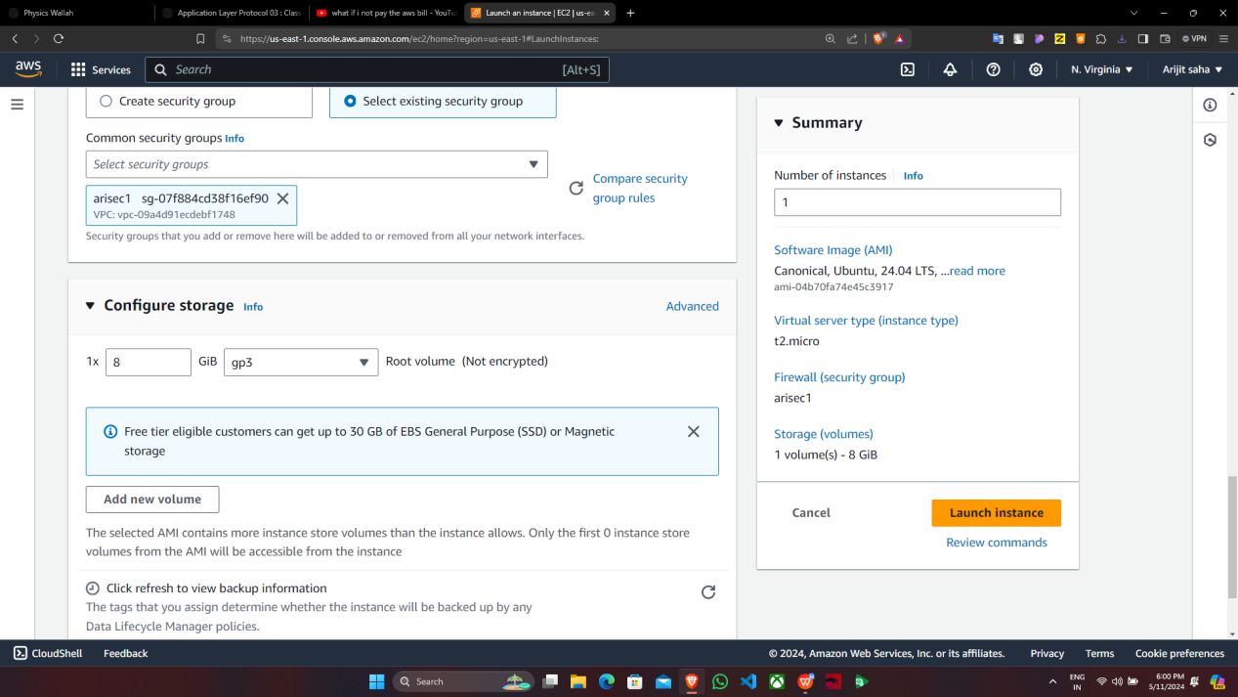

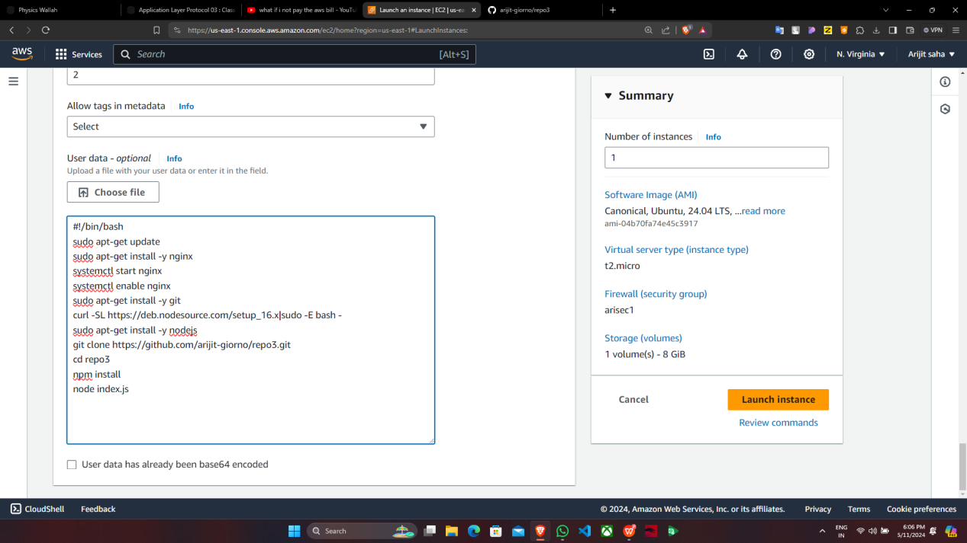

10.Instance is successfully launched.

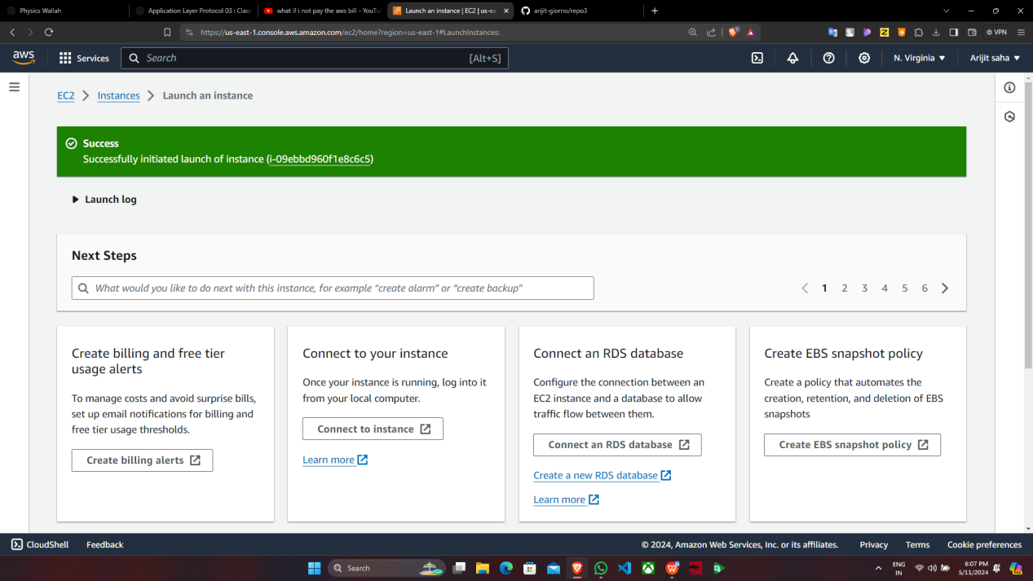

11.Click on instance id to enter into the instance.

12.Now copy the “Public IPv4 address”.

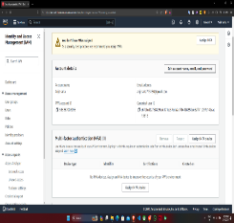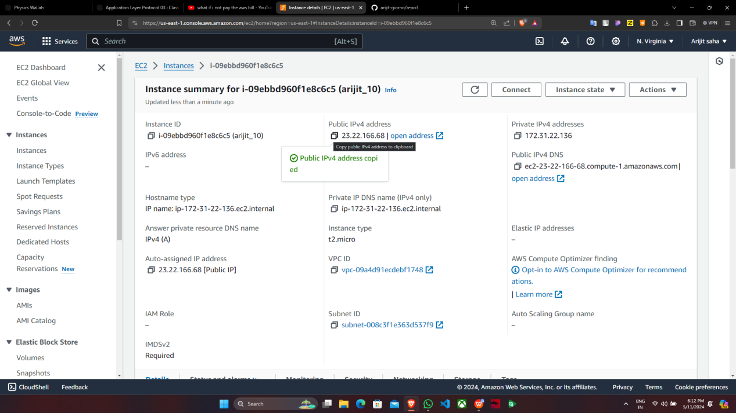

**supriyo_02**

13.Paste the address in a new Window.



14. Now add “:4000” at the end of the IPv4 address and press enter.

