**PROBLEM STATEMENT :**

10) Deploy and run the project in AWS without using the port.

***Steps to deploy and run the project without using the port:***

1. Sign up for an AWS account, search for ‘EC2’ then click on it.
2. Now click on security group.

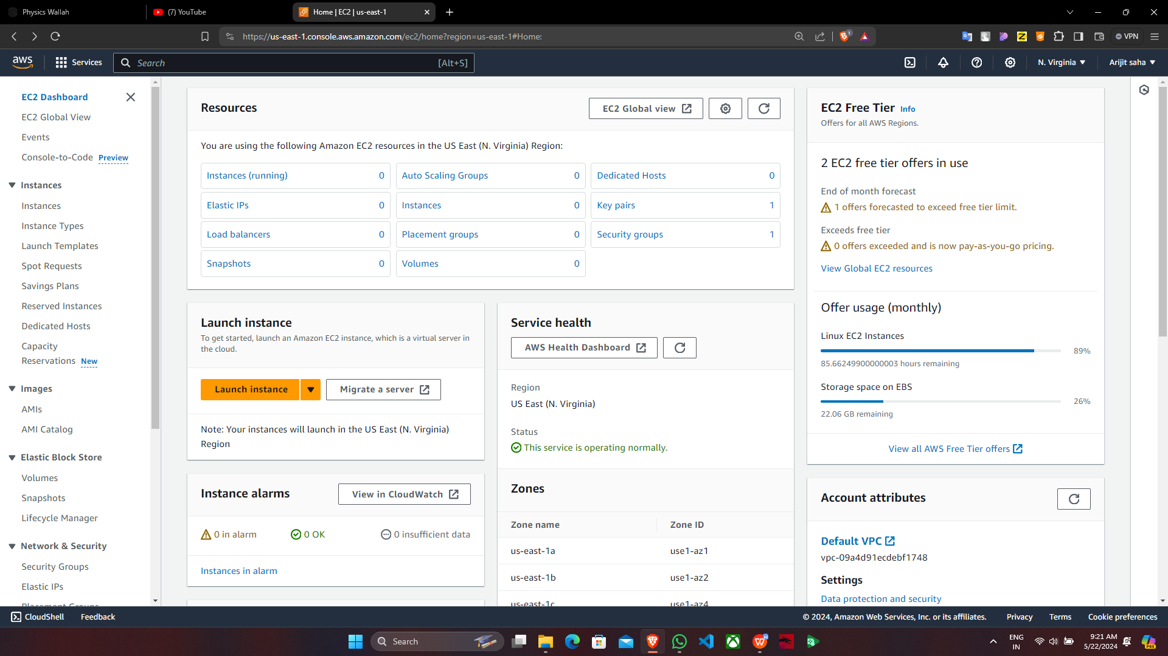

1. Click on “Create security group”.

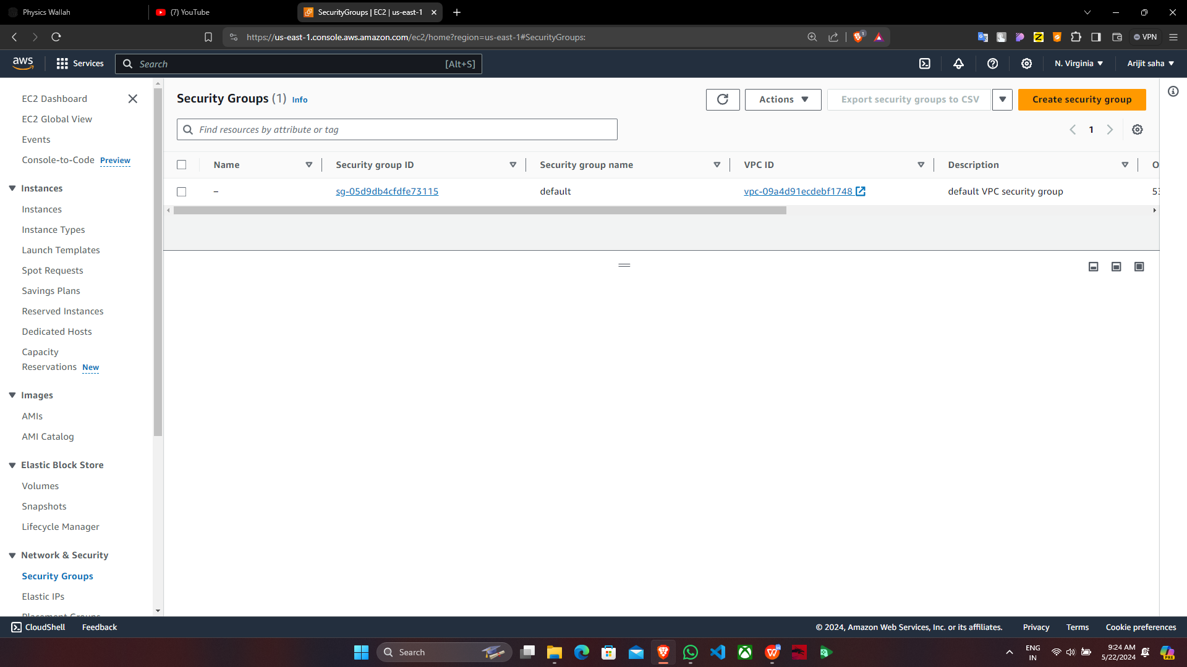

1. Give the name then in “Inbound rules” click on “Add rule” & add SSH,HTTP,HTTPS,CUSTOM TCP protocol and then click on “Create security group”.

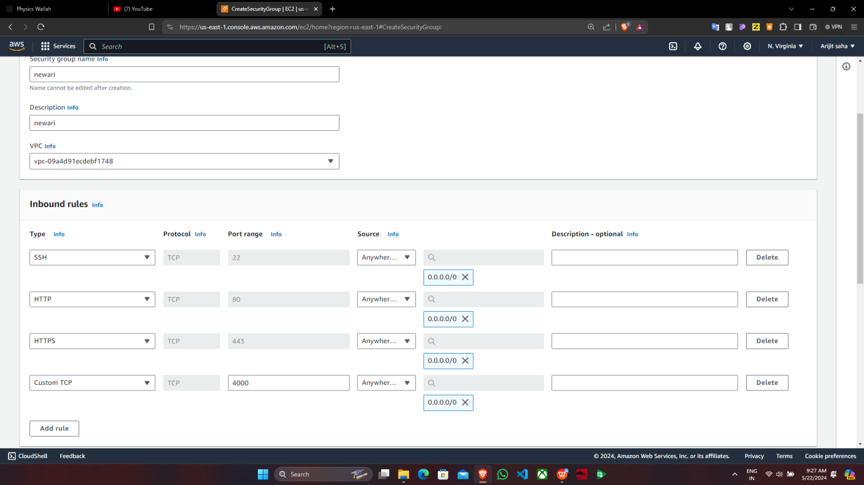

1. Security2 is successfully created.

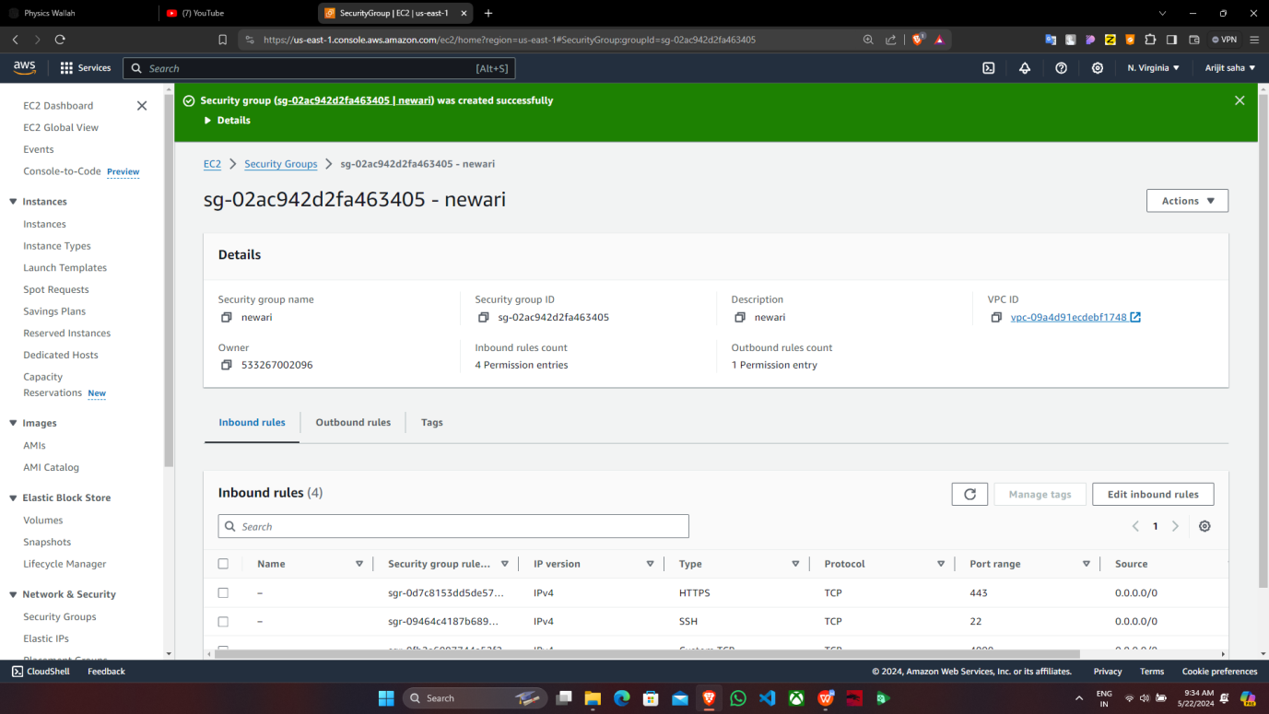

1. Now go back to EC2 dashboard & click on “Launch Instance”.

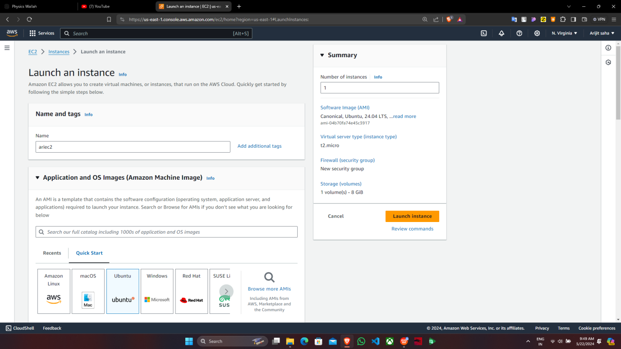

1. Now write the name, choose the platform, keypair and click on “Select existing security group” that is newari.Then finally click on “Launch Instance”.

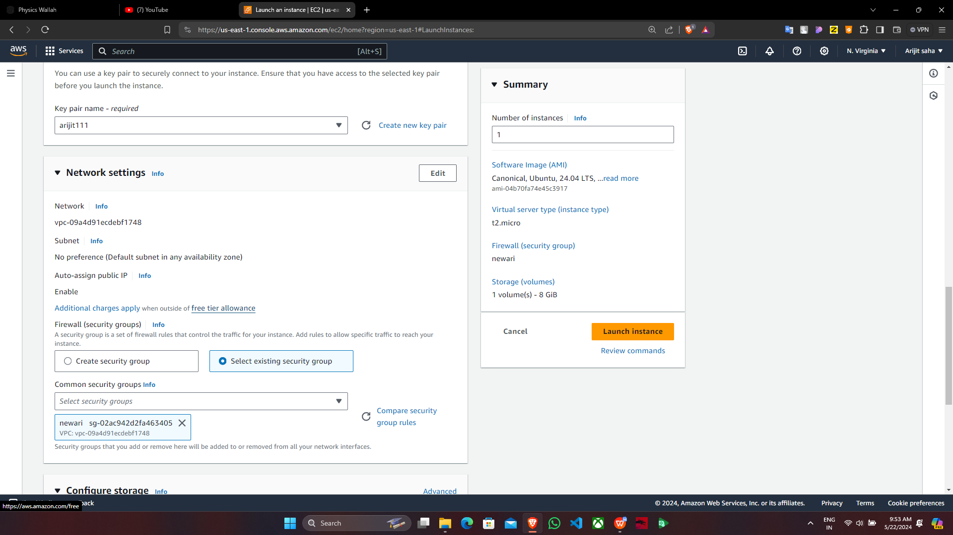

1. The instance is successfully created and select it then copy the Public IPv4 address & paste it in Bitvise.

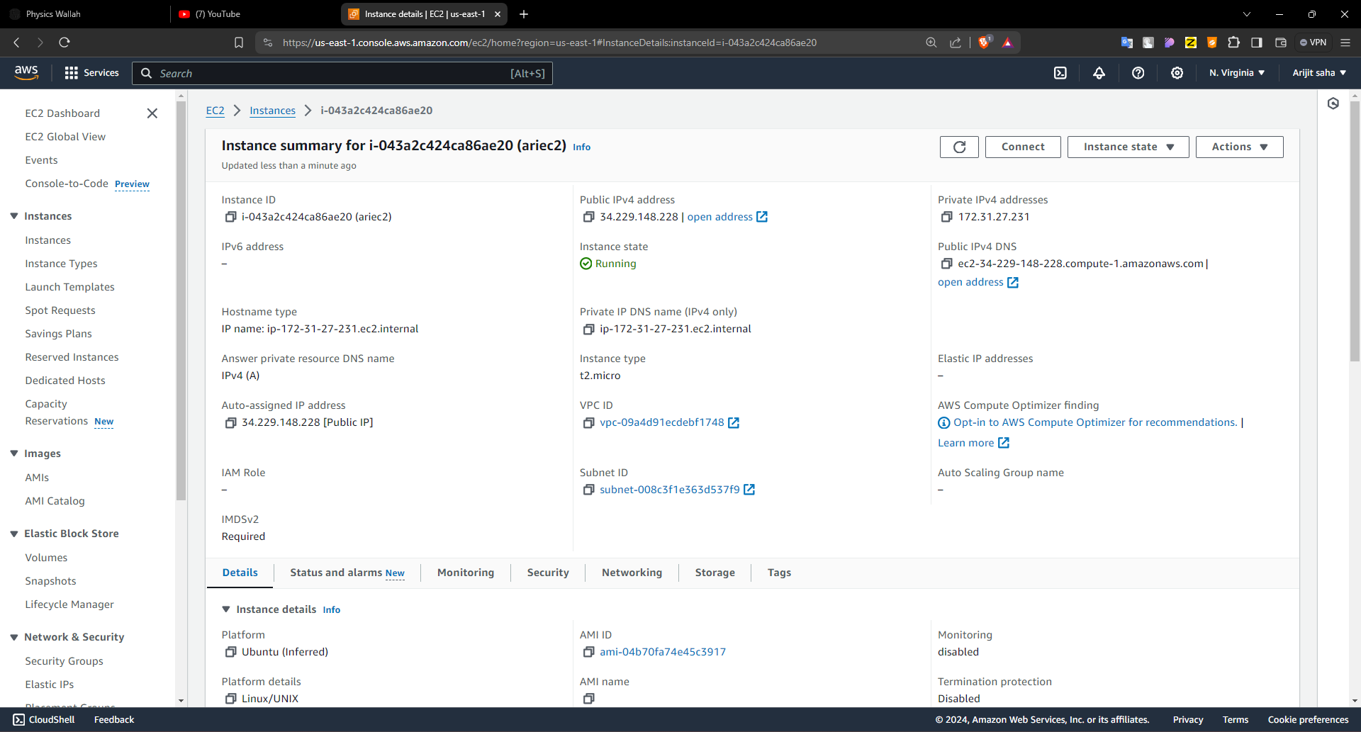

1. Now In Bitvise paste it and import the key from Client key manager then click on “Log in”.

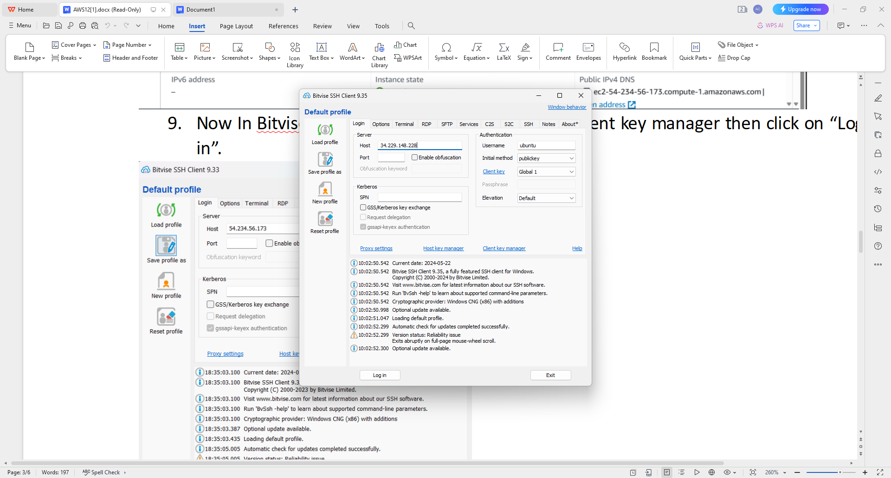

1. After successful log in click on “New terminal console” and write the following commands.

sudo apt-get update

sudo apt-get upgrade

sudo apt-get install nginx

curl -SL https://deb.nodesource.com/setup_16.x|sudo -E bash -

sudo apt install nodejs

nodejs -v

git clone <https://github.com/supriyo02/repo3.git>

cd Repo1

npm install

node index.js

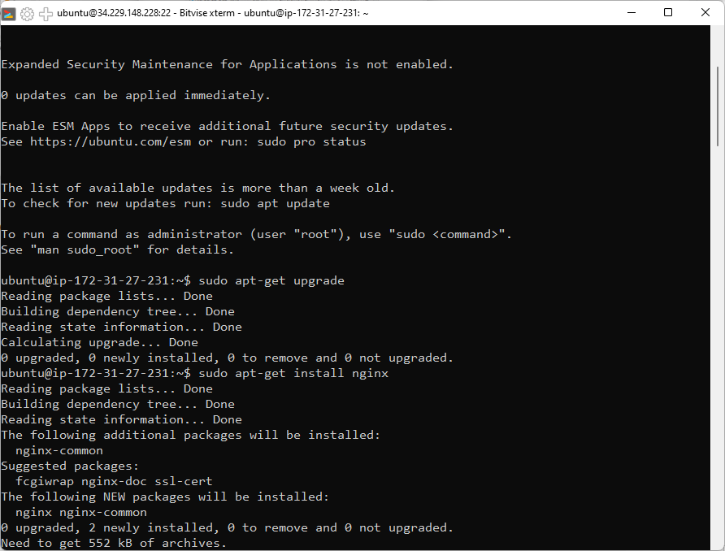

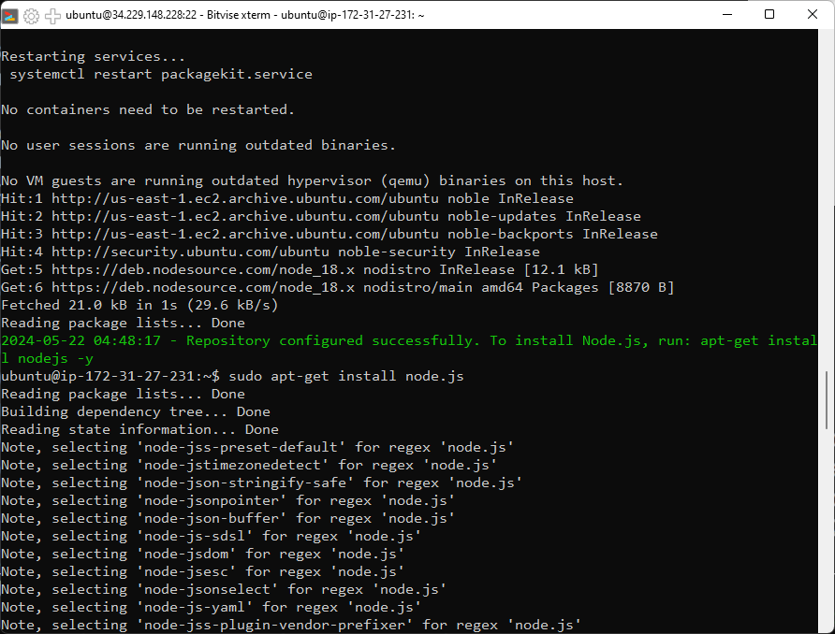

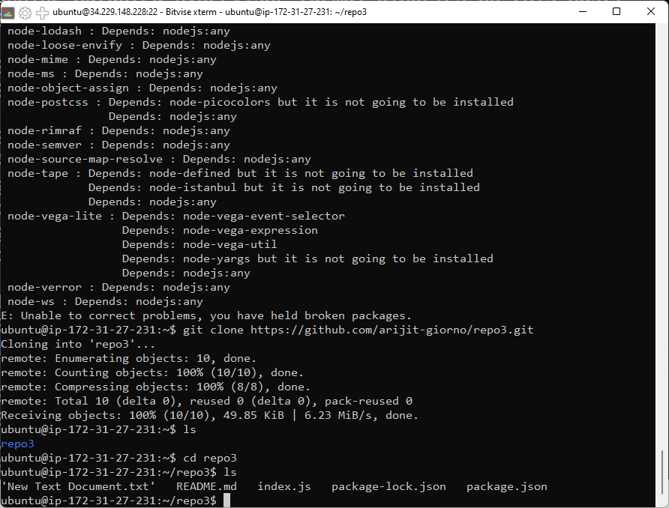

1. Then stop the server and open another “New terminal console’ & write the following commands.

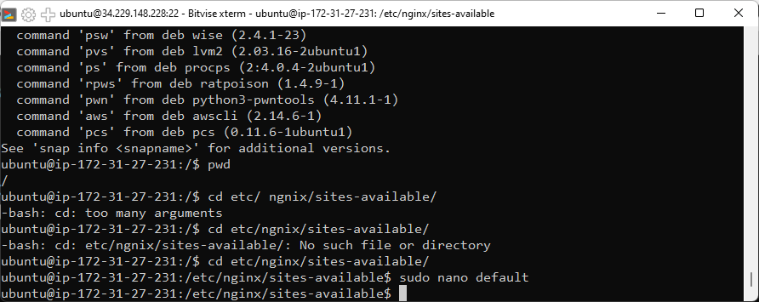

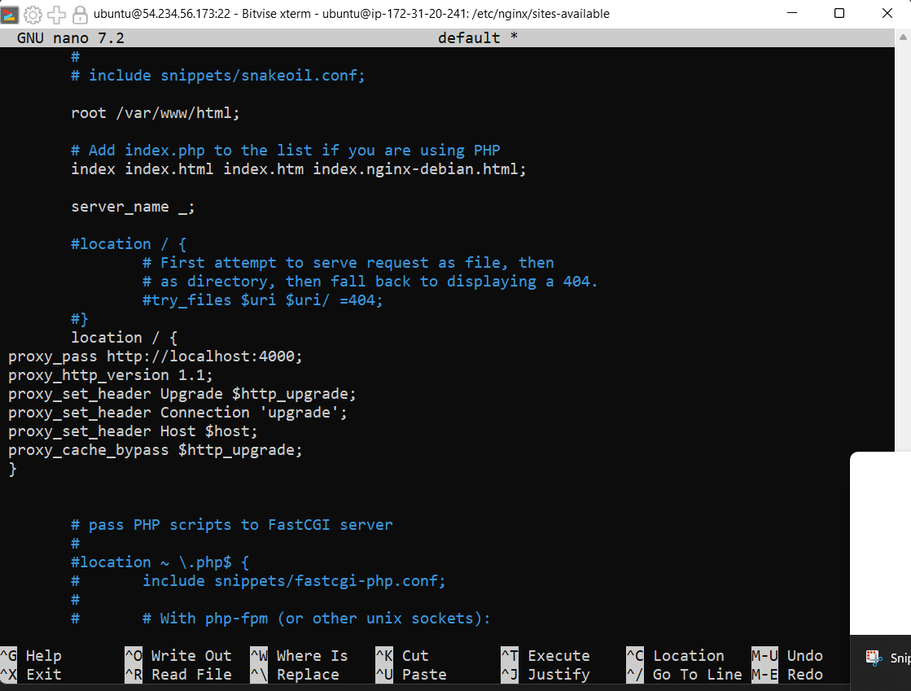

Then on the another terminal start the server by “node index.js”.

1. Paste the IPv4 in the browser to host the file.

