**PROBLEM STATEMENT :**

13) Create a workmail for your organization.

***Steps to create workmail for organization:***

1. Sign up for an AWS account, search for ‘Amazon Workmail’ then click on it.

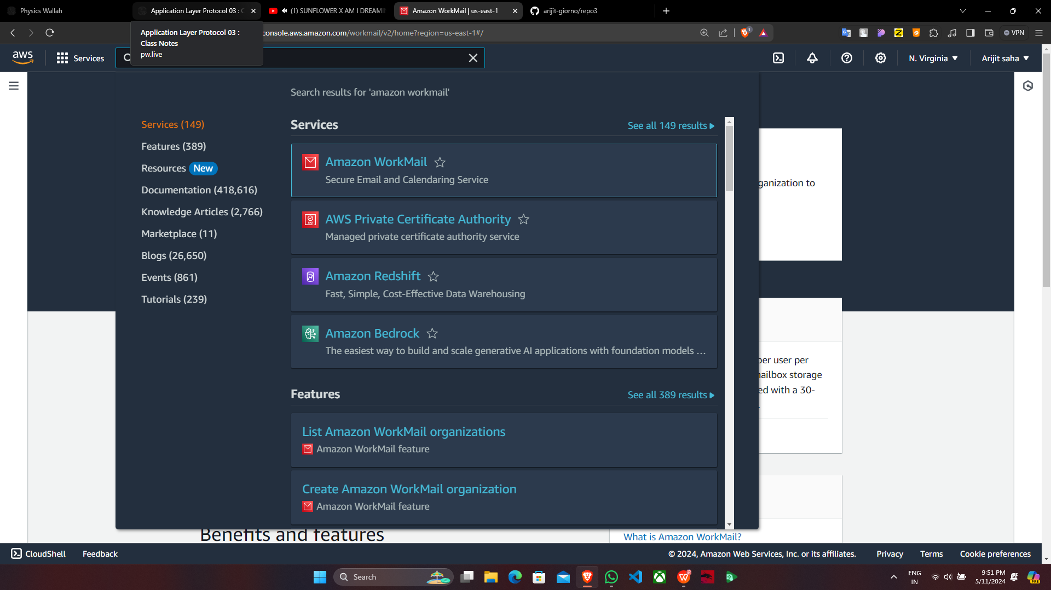

2. After clicking on ‘Amazon Workmail’,click on “Create organization”.

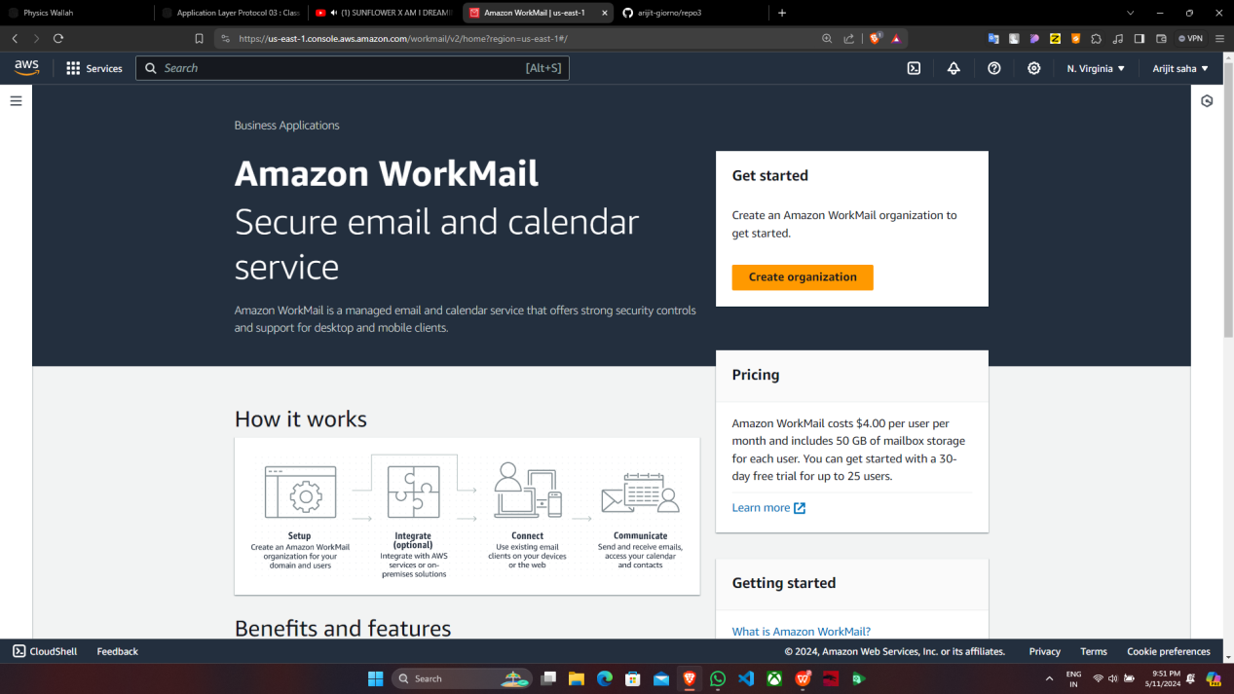

1. Under “Create organization”, choose “Free test domain” & give the name on “Alias”.

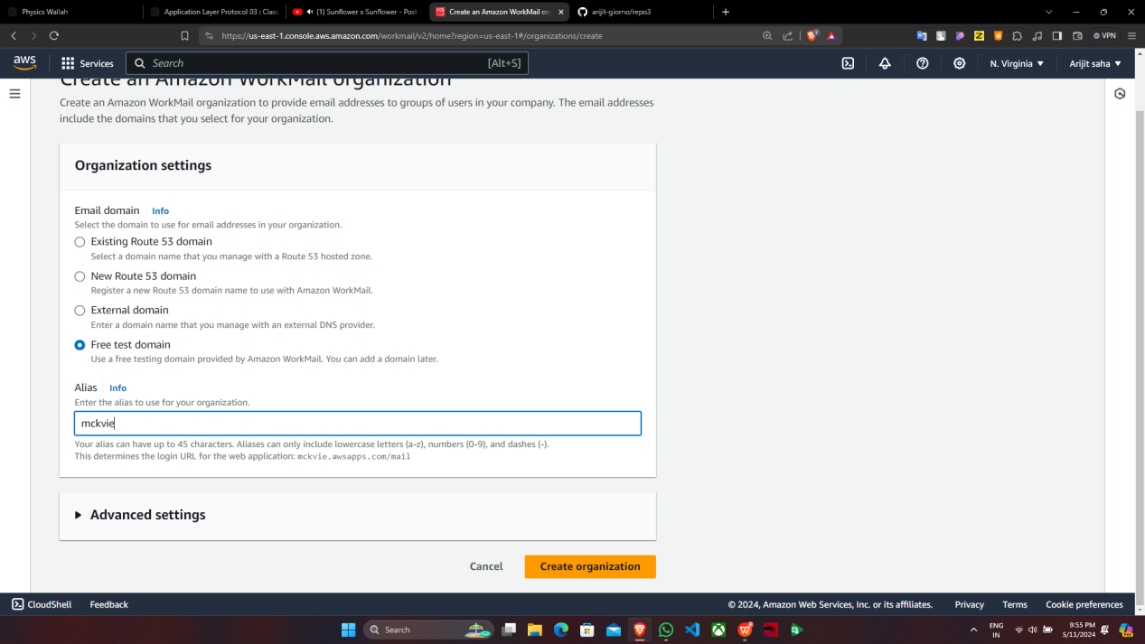

4. Our Amazon workmail has been successfully created & click on “mckvie”.

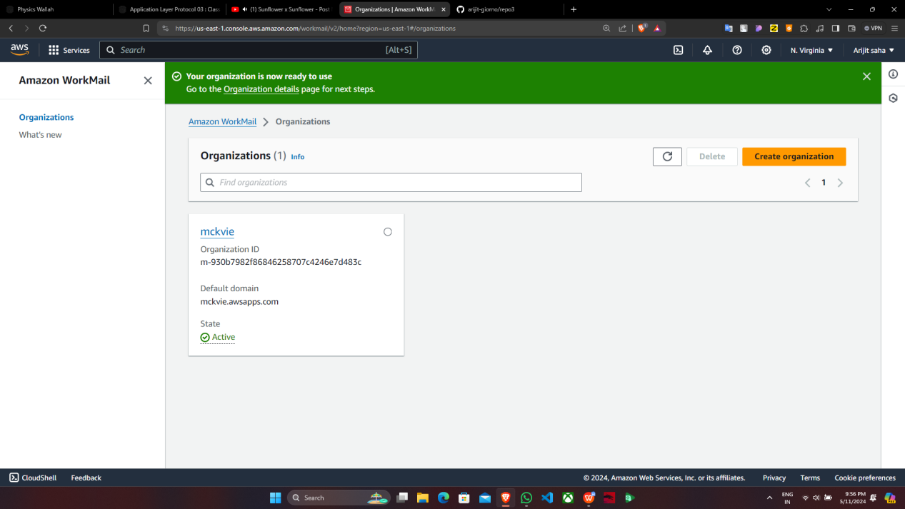

1. Now on the left panel under “Organization” click on “Users”.

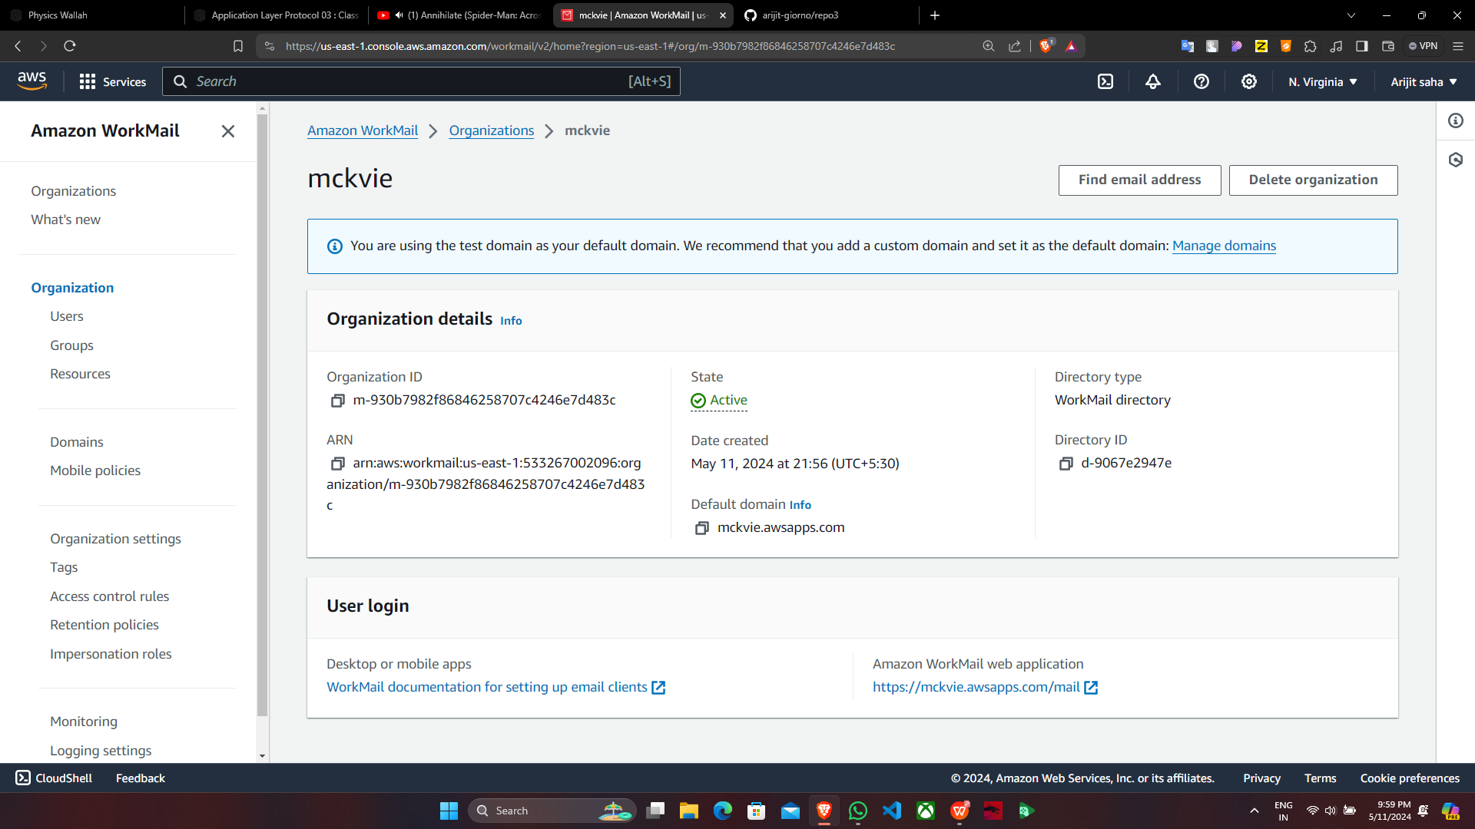

1. Then click on “Add user”.

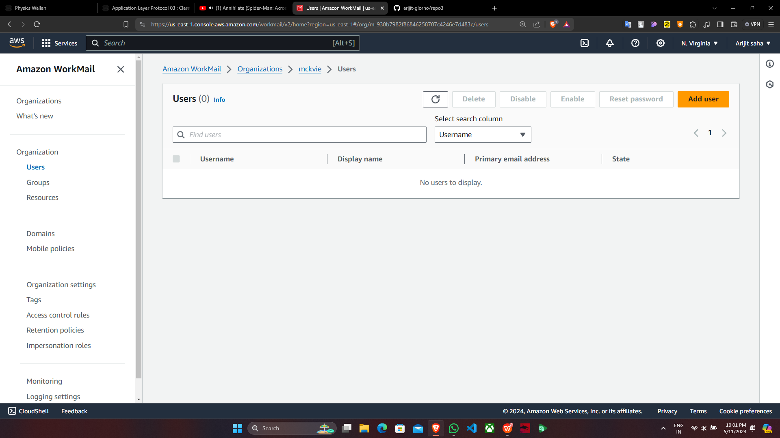

7. Now give the username ,firstname,lastname then select “Show in global..” ,give

password and click on “Add user”.

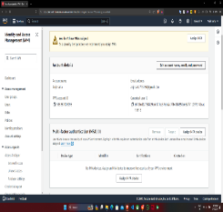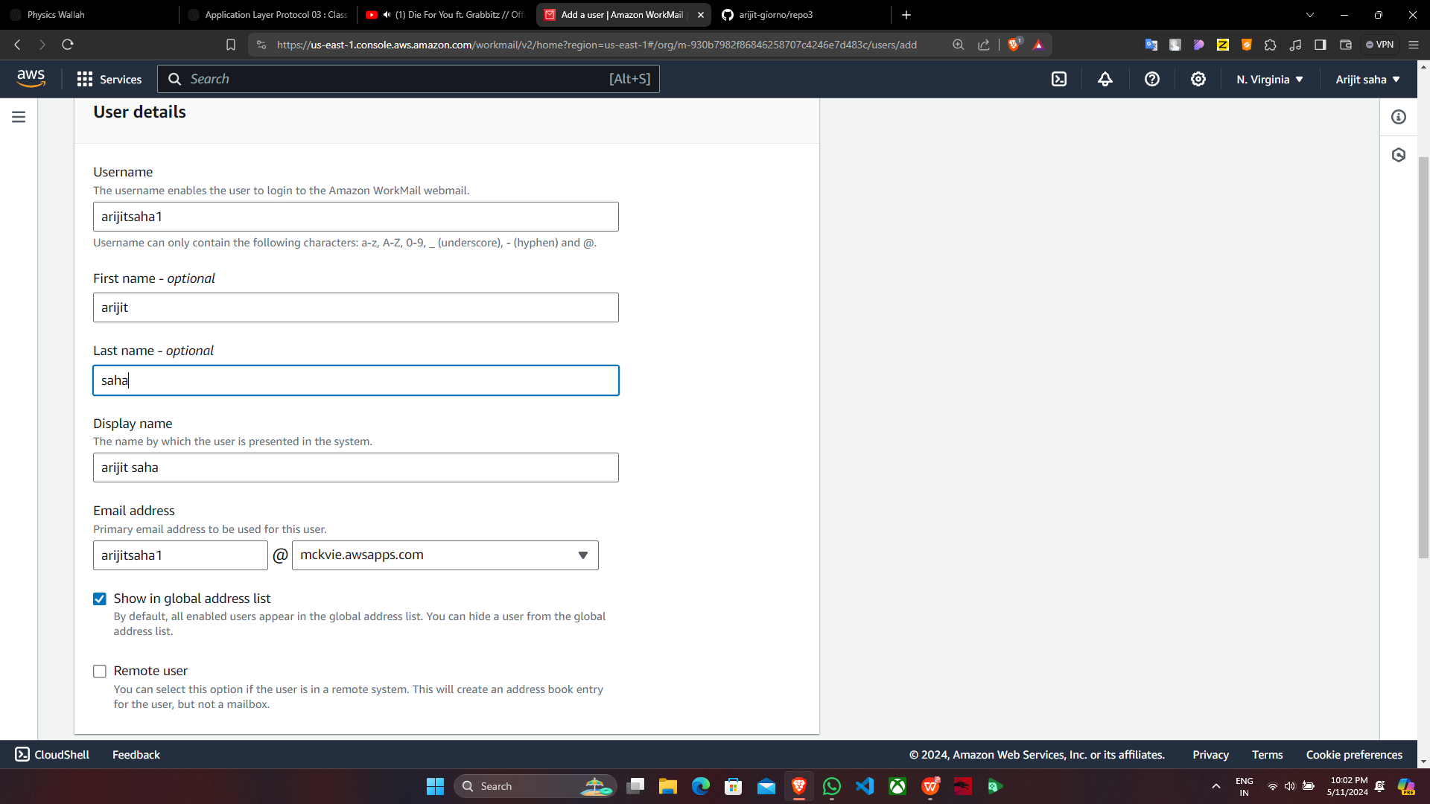

supriyo1

Supriyo Ghosh

Ghosh

Supriyo

supriyo02

1. User is successfully added & click on “Organization”.

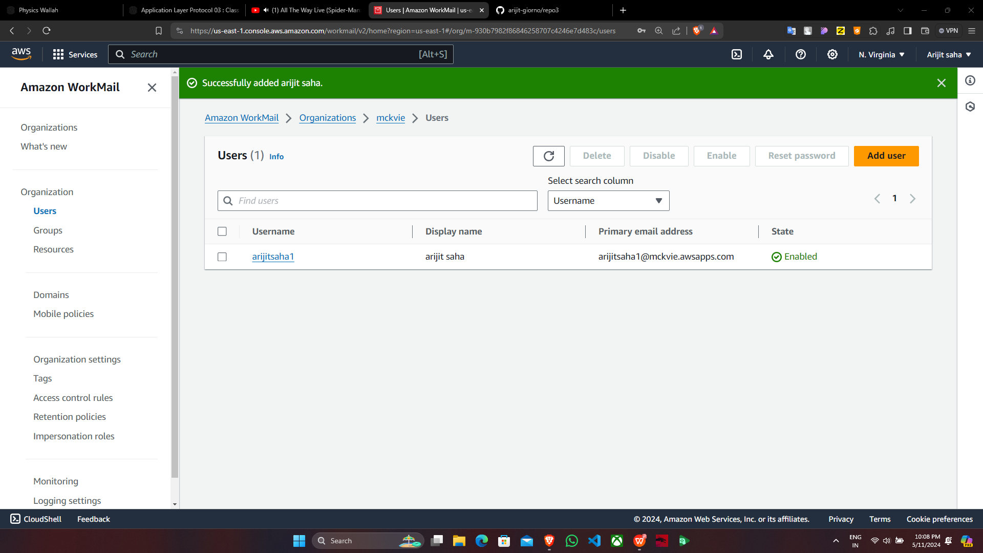

Supriyo Ghosh

supriyo1

supriyo1

1. Click on “mckvie”.10. In “User login”, click on “Amazon WorkMail web application”.

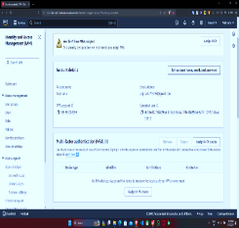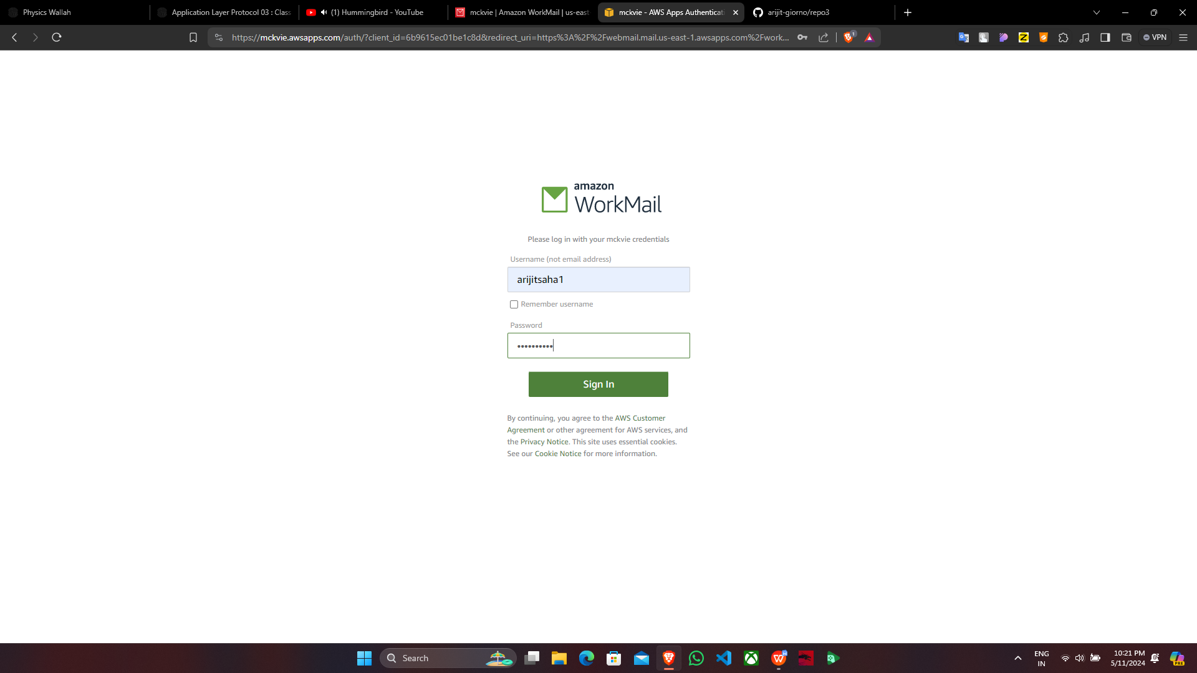

supriyo1

11.Sign in using valid credentials.

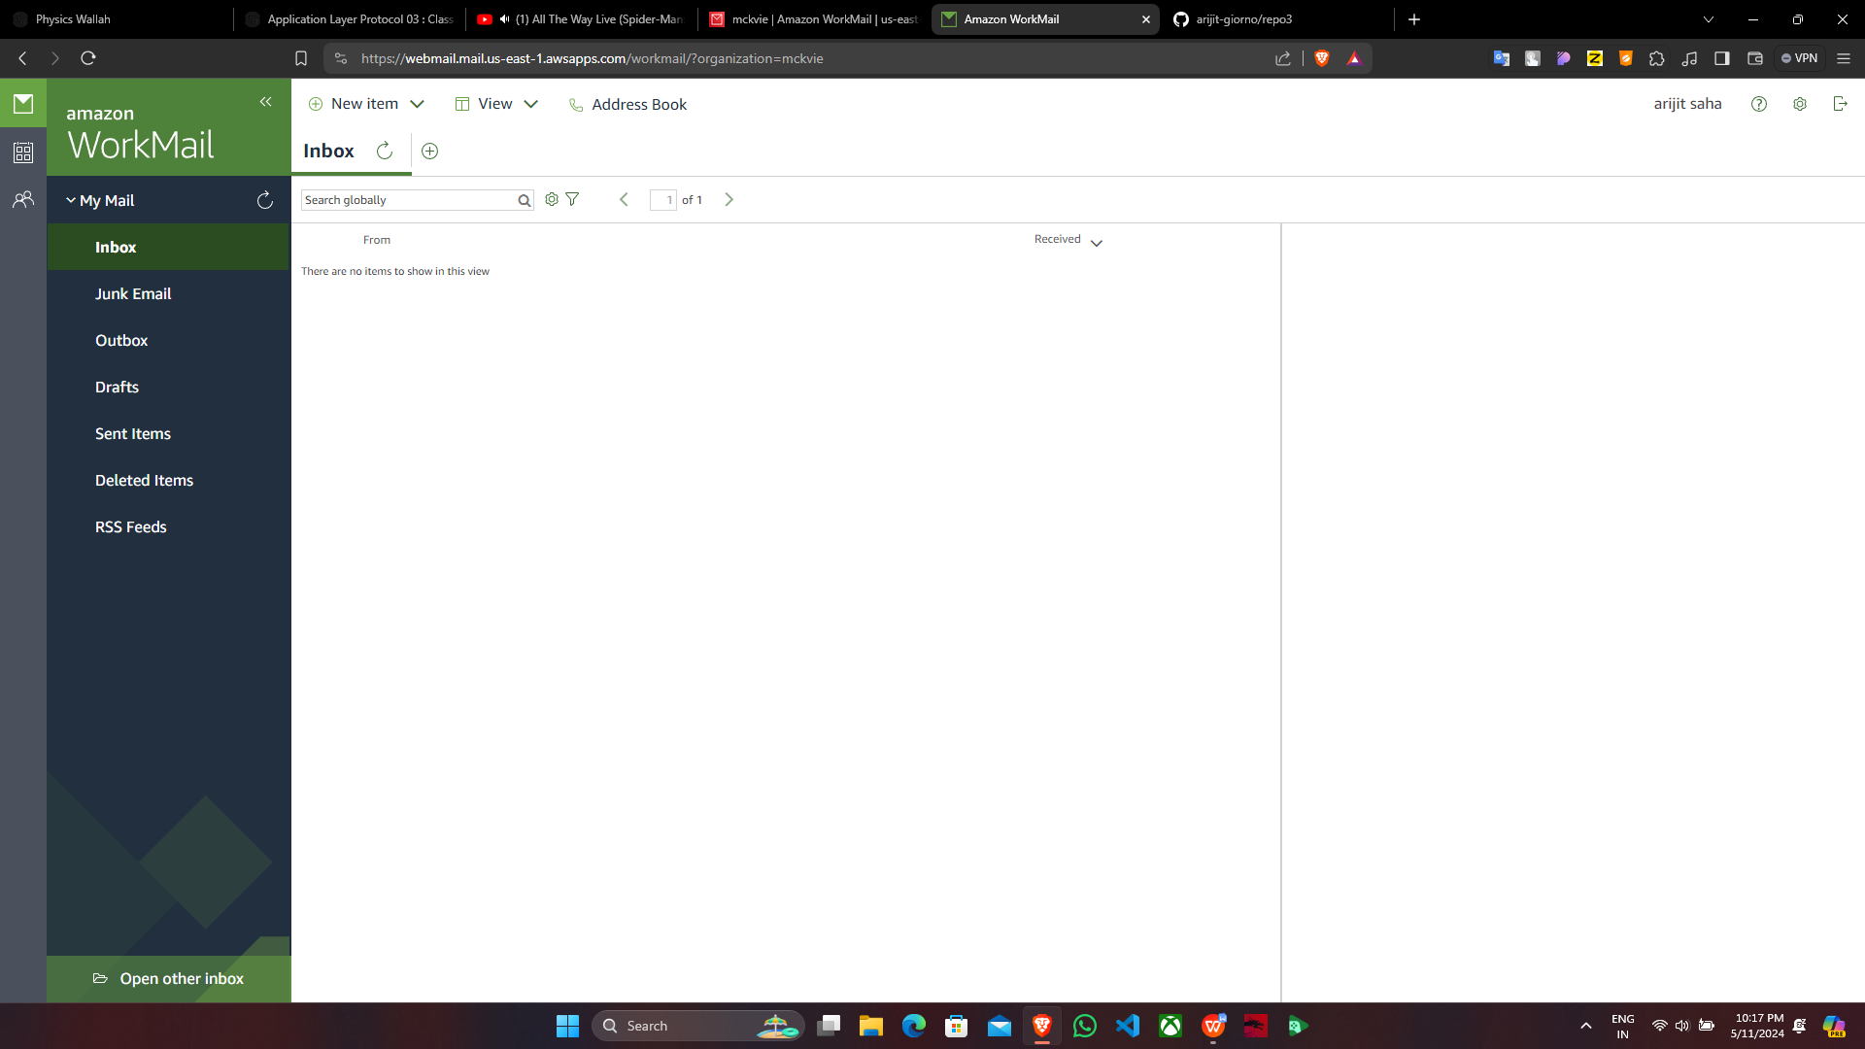

Supriyo Ghosh

12. Amazon WorkMail is now activated.

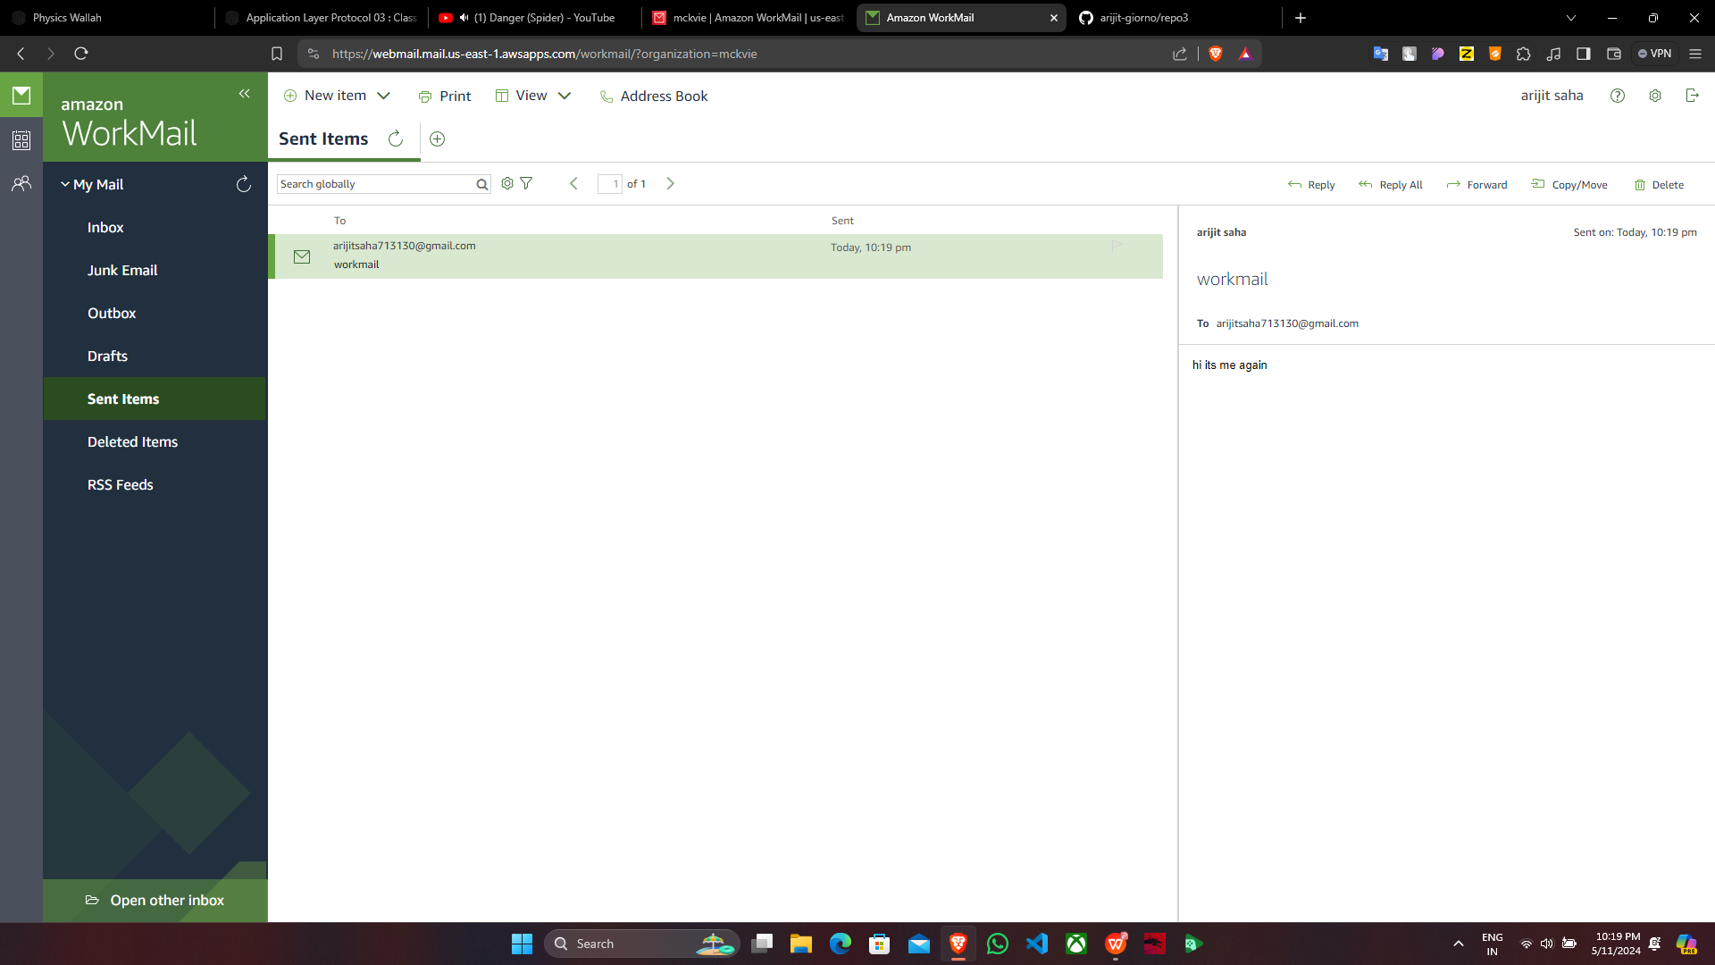

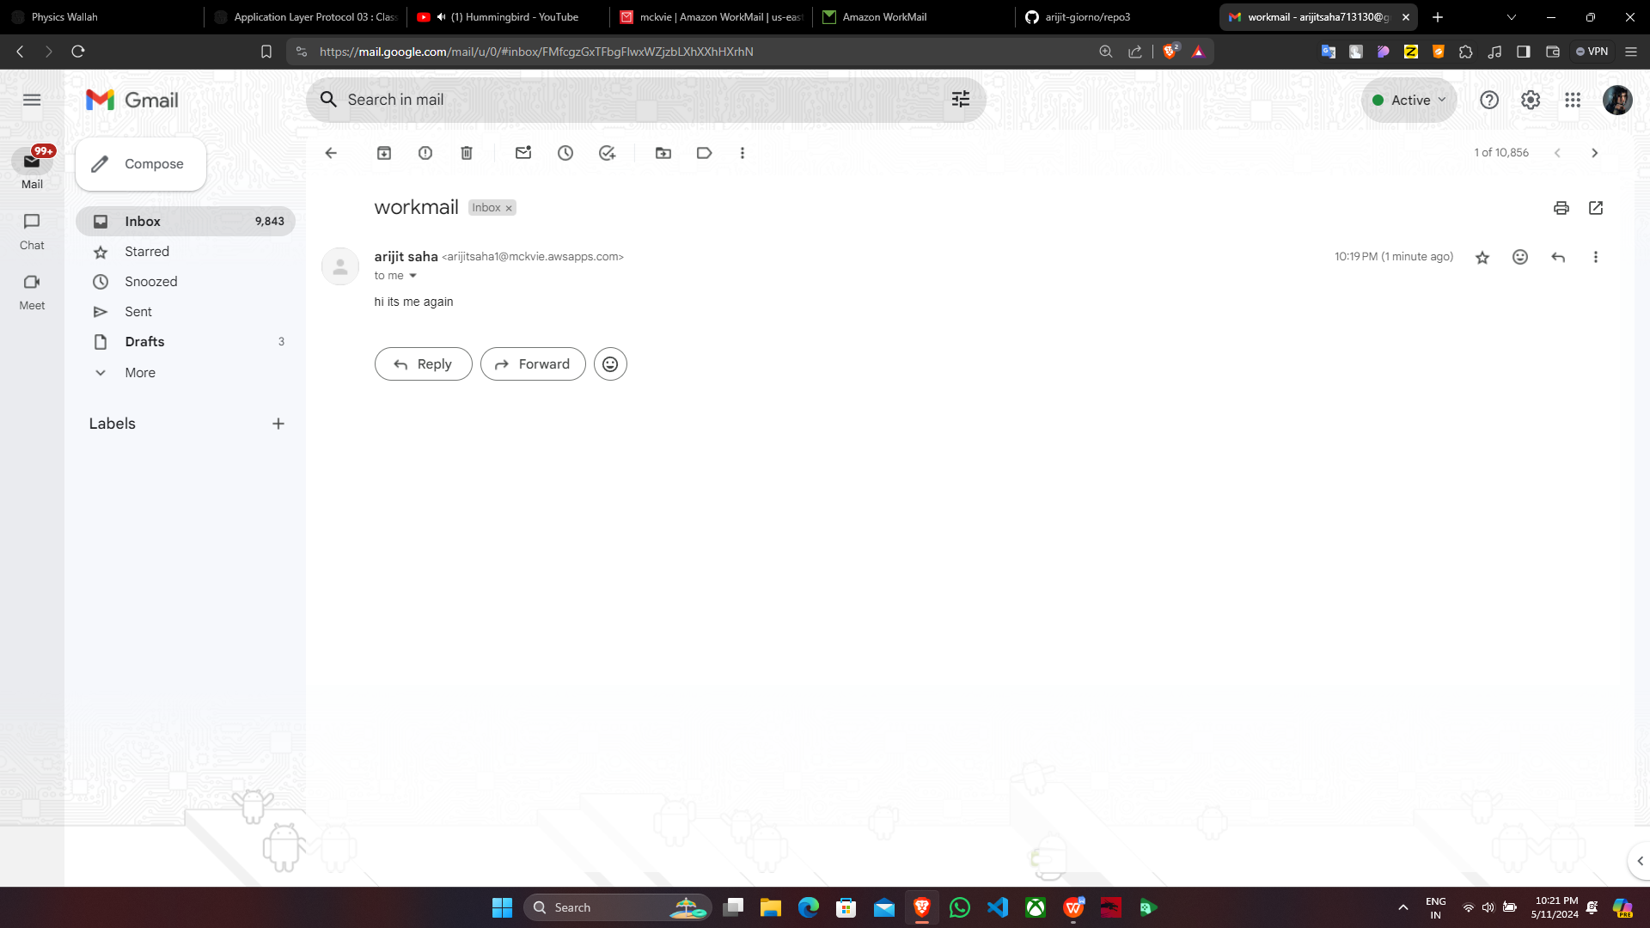

Supriyo Ghosh