**PROBLEM STATEMENT :**

5)Create a public bucket in AWS. Upload a file and check by reassigned URL

whether you can access the file or not.

***Bucket creation and checking for access->***

1. Sign up for an AWS account, search for ‘S3’ then click on it.

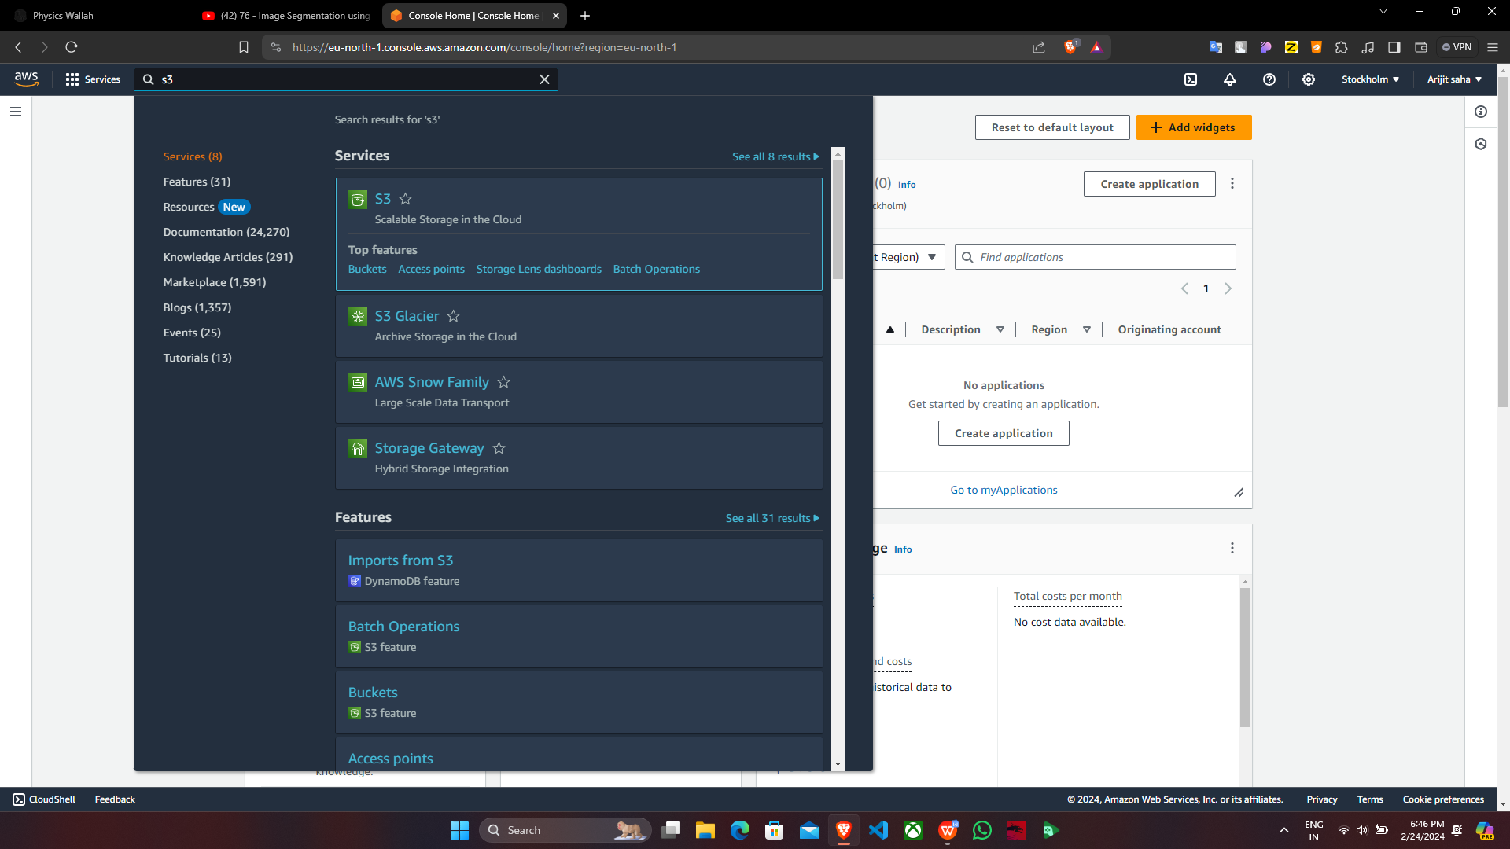

1. Click on ‘Create bucket’.

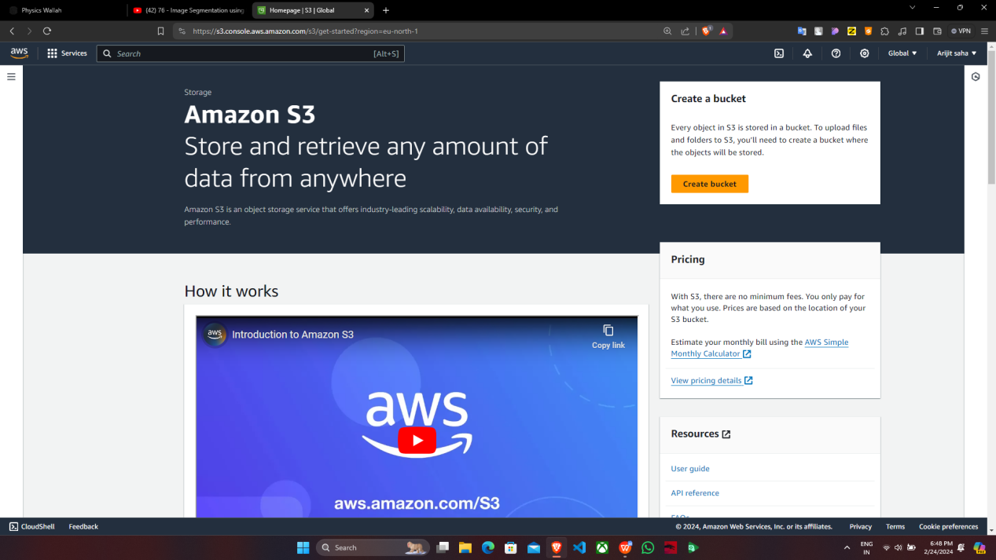

3. Fill up the required details->’AWS region’,‘Bucket name’, click on ‘ACLs

enabled’, uncheck ‘Block all public access’ , tick off ‘I acknowledge….’ and

click on ‘Create bucket’.

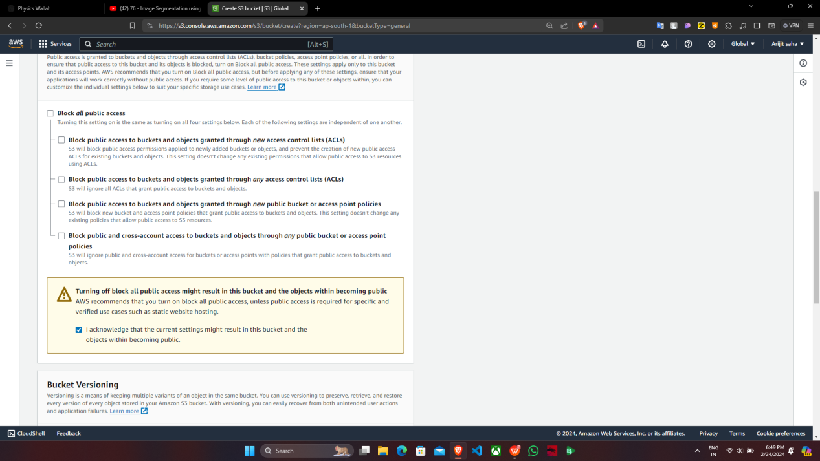

4. ‘supriyopublic’ bucket is created successfully then click on the bucket name

‘supriyopublic’.

5. Under ‘supriyopublic’, click on ‘Upload’ then choose a file of your choice and

upload it.

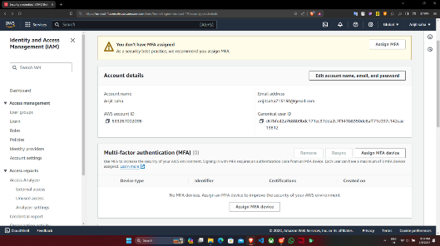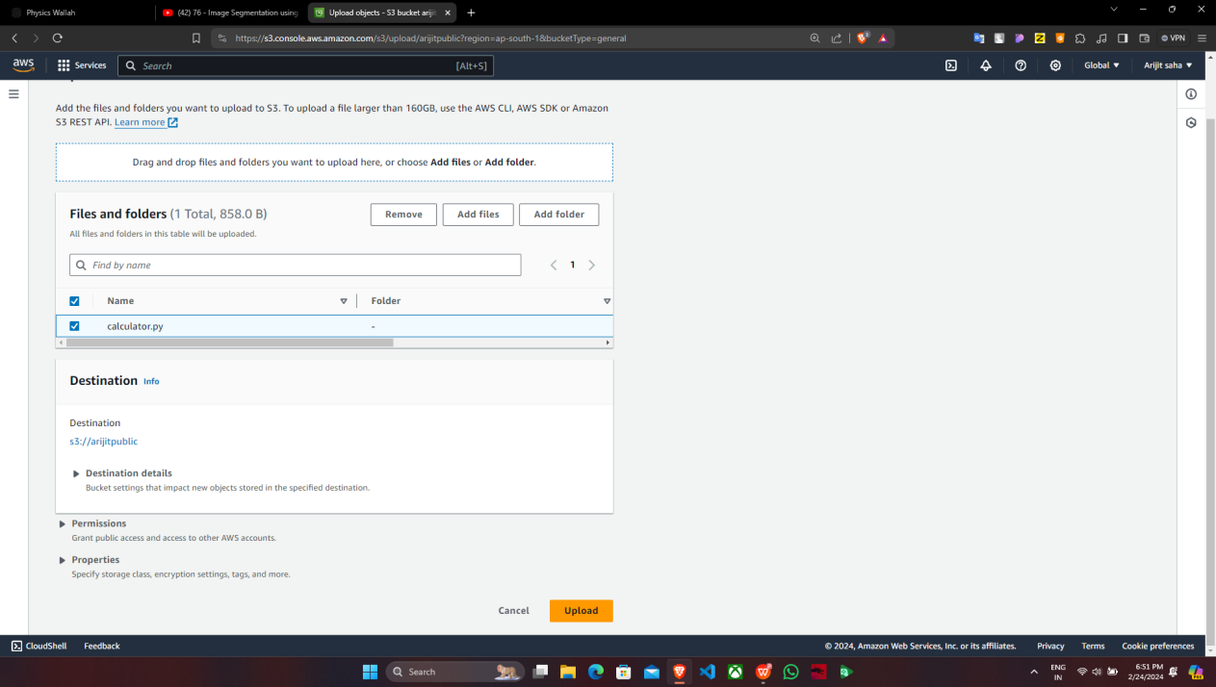

supriyopublic

6. Click on ‘Add files’ then tick off the ‘Name’ of the file and click on ‘Upload’.

7. File is uploaded successfully , tap on ‘Close’ and click on ‘Name’.

8. Under ‘supriyopublic’, tick off any one of the file(checkbox) and click on the file.

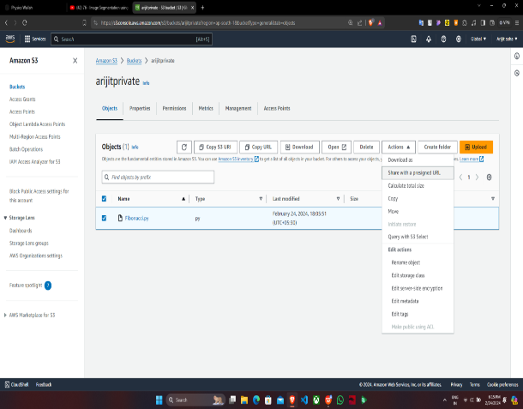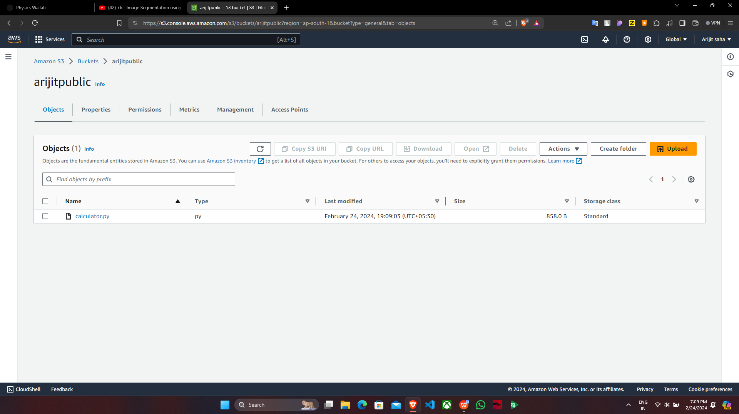

supriyopublic

**supriyopublic**

1. Copy the ‘Object URL’.

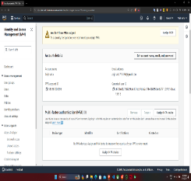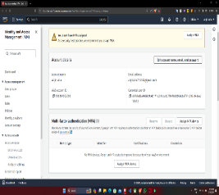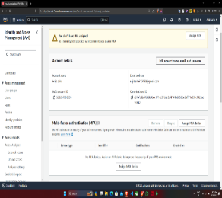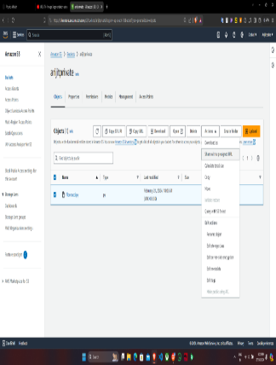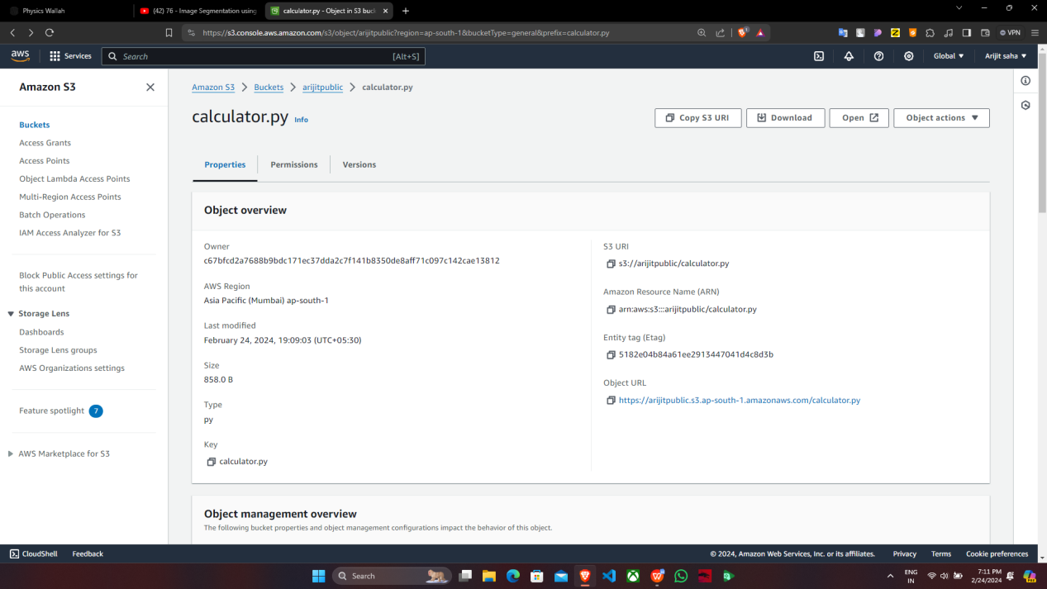

supriyopublic

**supriyopublic**

**supriyopublic**

supriyopublic

10. Now open the ‘Incognito mode’ and paste the ‘Object URL’. You will see

that the file cannot be accessed

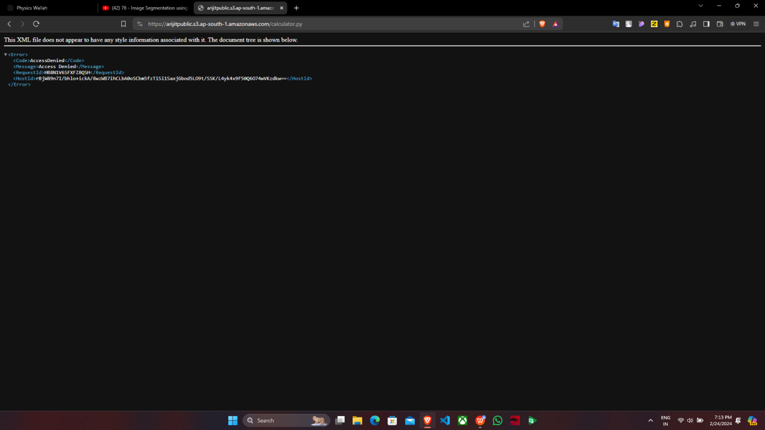

***To give access to the file , follow the steps given below.***

11. In the file info. click on ‘Permissions’ and then click on ‘Edit’ beside

‘Access control list(ACL)’.

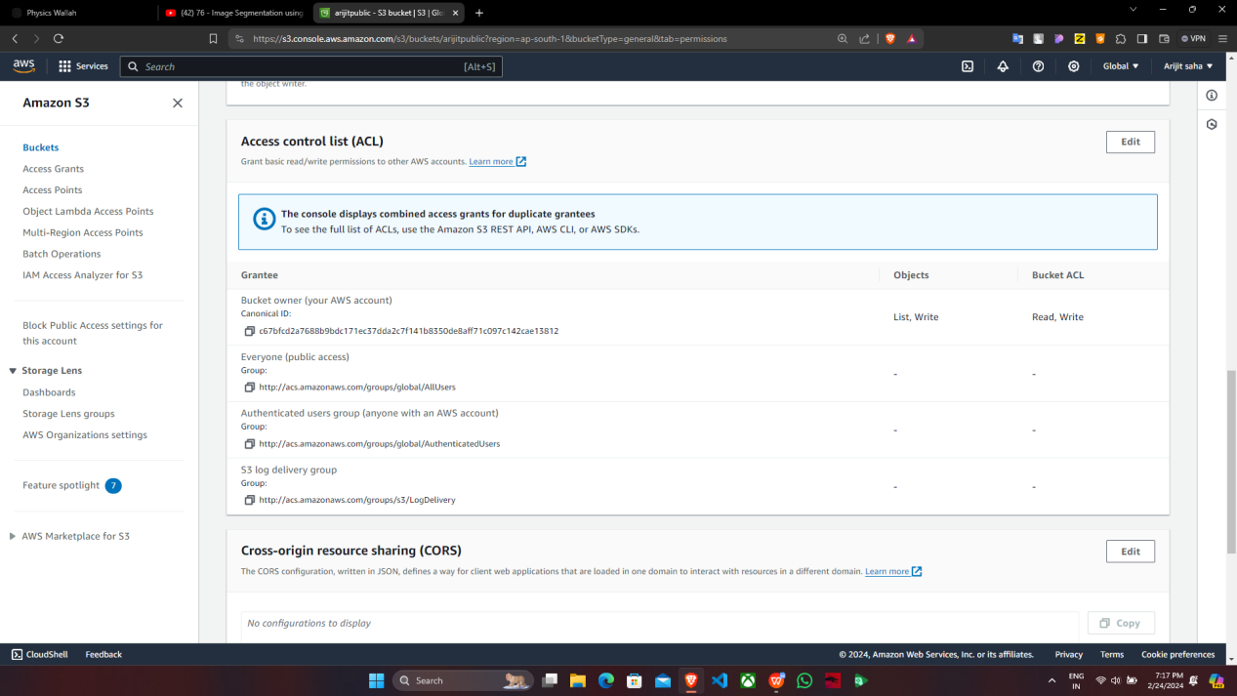

12. Now, tick off the Read checkboxes of ‘Everyone(public access)’, then tick

off the checkbox ‘I understand….’ and click on ‘Save changes’

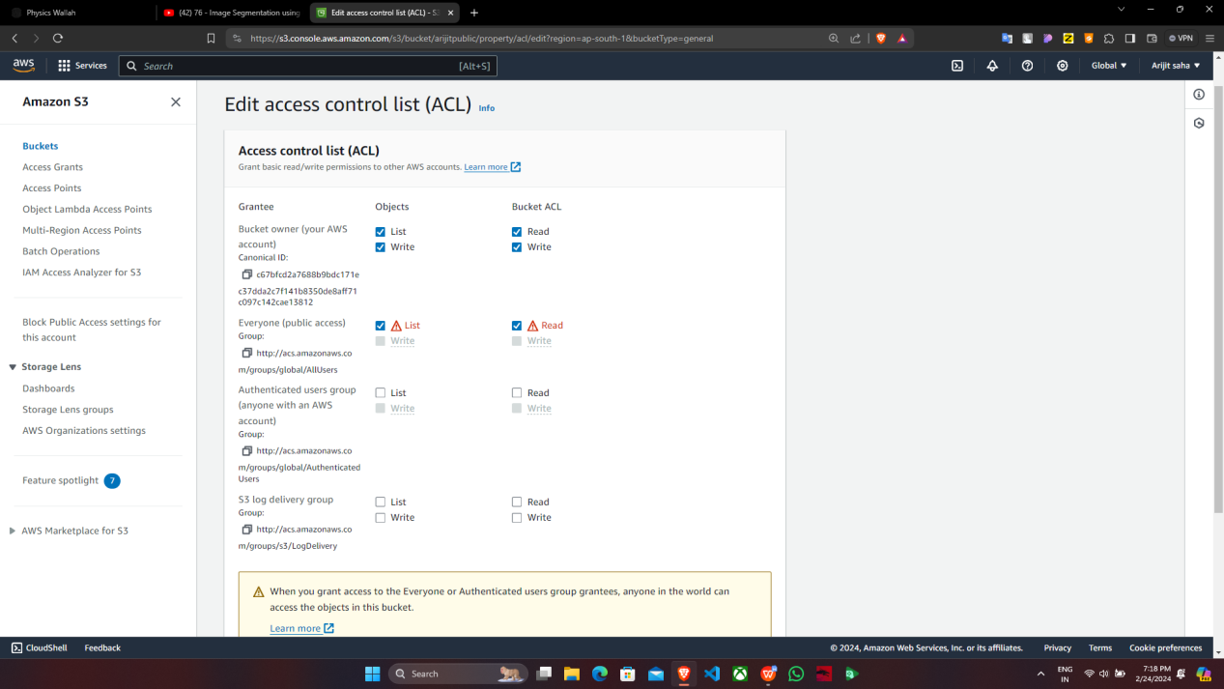

13. Now, again copy the Object URL.

14.In the ‘Incognito mode’, paste the Object URL. We find that now the file

can be accessed publicly.

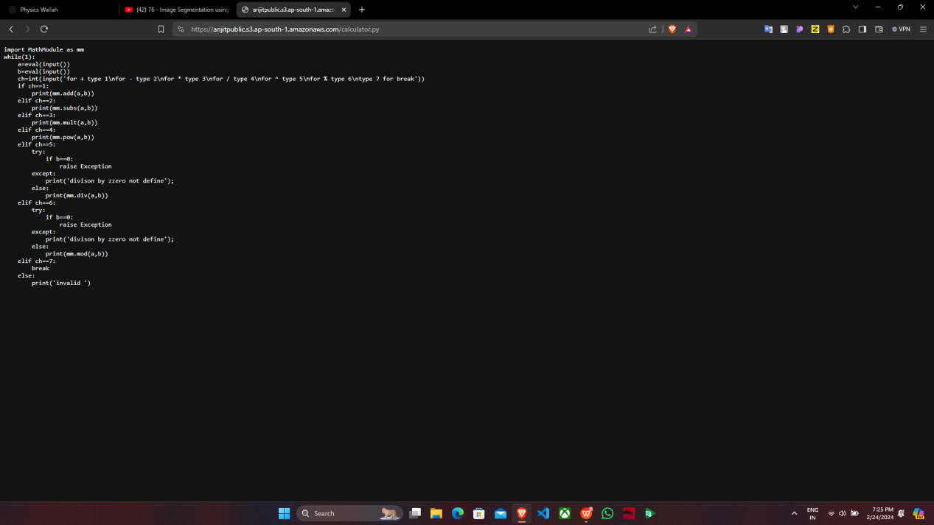

**supriyopublic**