**PROBLEM STATEMENT :**

9) Deploy a project from GitHub to EC2.

***Steps to deploy project :***

1. Sign up for an AWS account, search for ‘EC2’ then click on it.
2. Click on ‘Launch instance’.

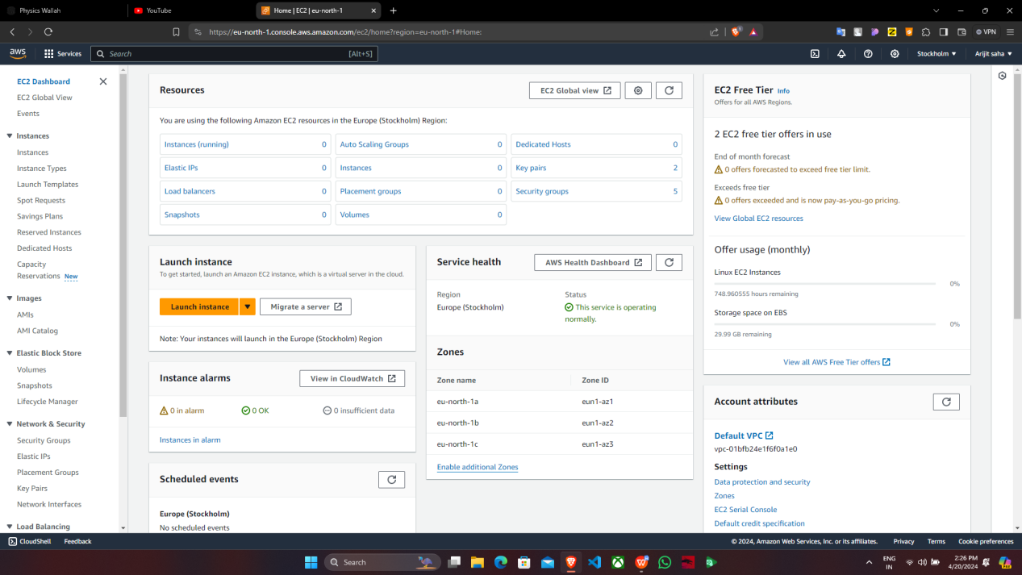

1. Fill up the required details->’Name’, in ‘Application and OS Images’ select ‘ubuntu’.In ‘Key pair(login)’, click on ‘Create new key pair’, give ‘key pair name’ and click on ‘Create key pair’. Under ‘Network settings’, tick off all the three checkboxes then click on ‘Launch instance’.

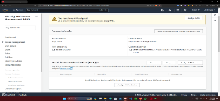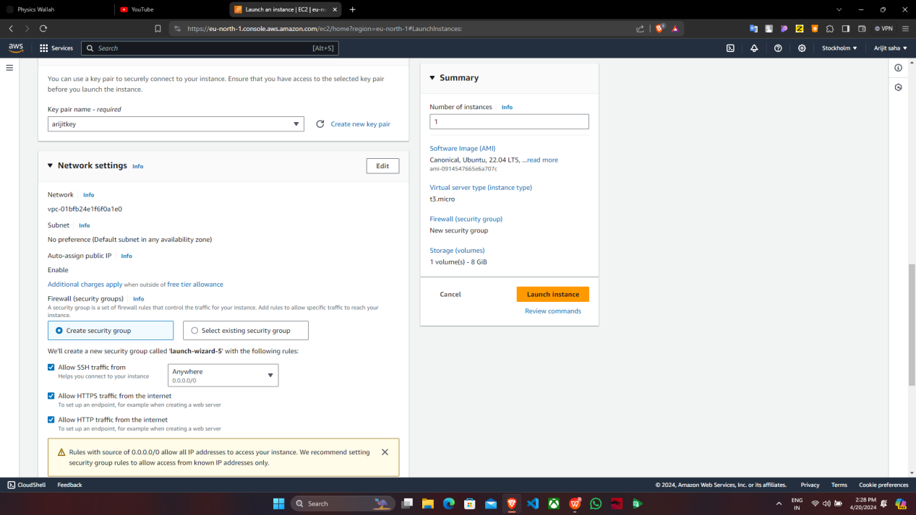

supriyokey

1. “ariweb” instance is successfully created and then click on ‘Instances’.

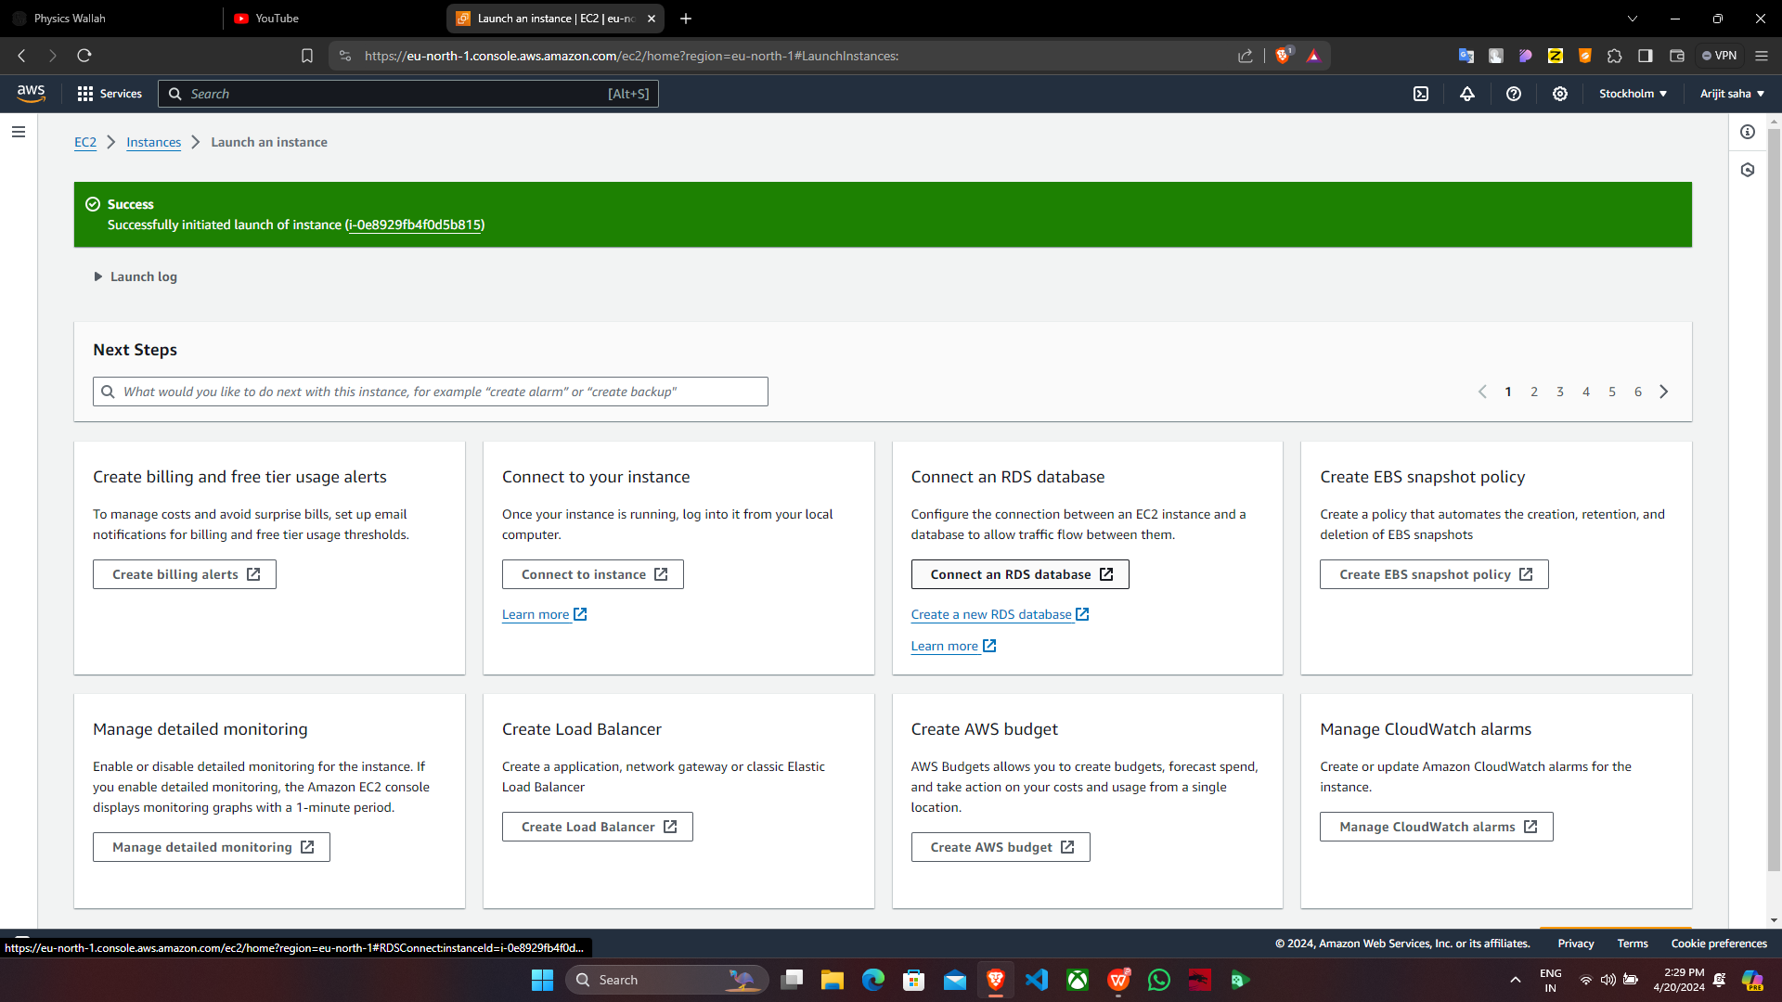

1. Now check whether “Dynamicp_EC2”is running or not then click on “Instance ID”.

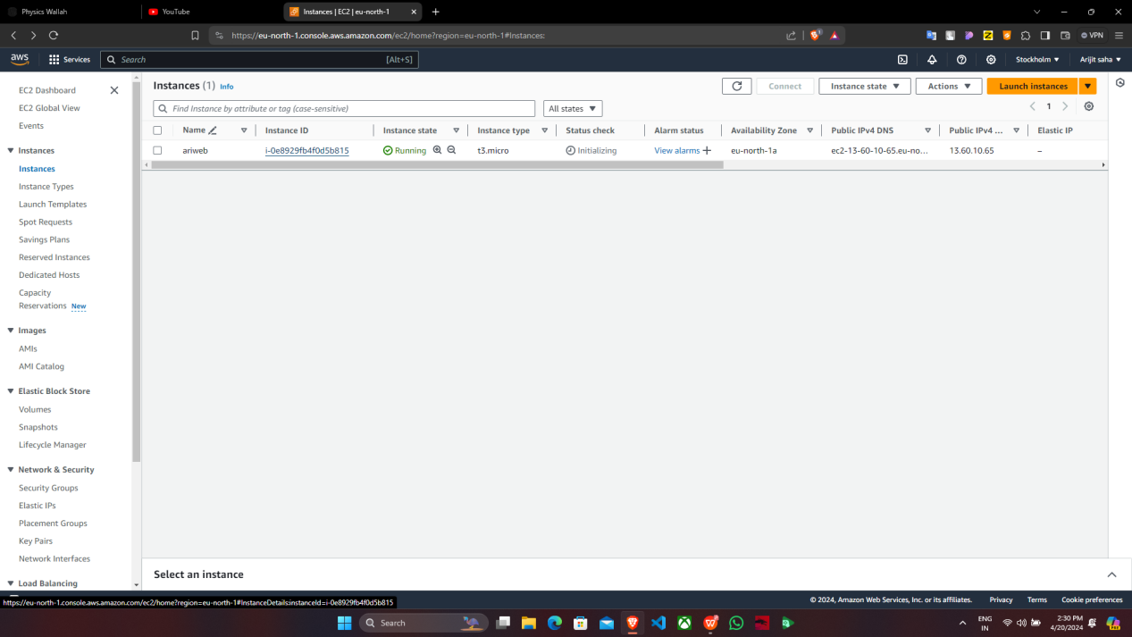

6. Then go to “Security” and click on “Security groups” to get the edit option.

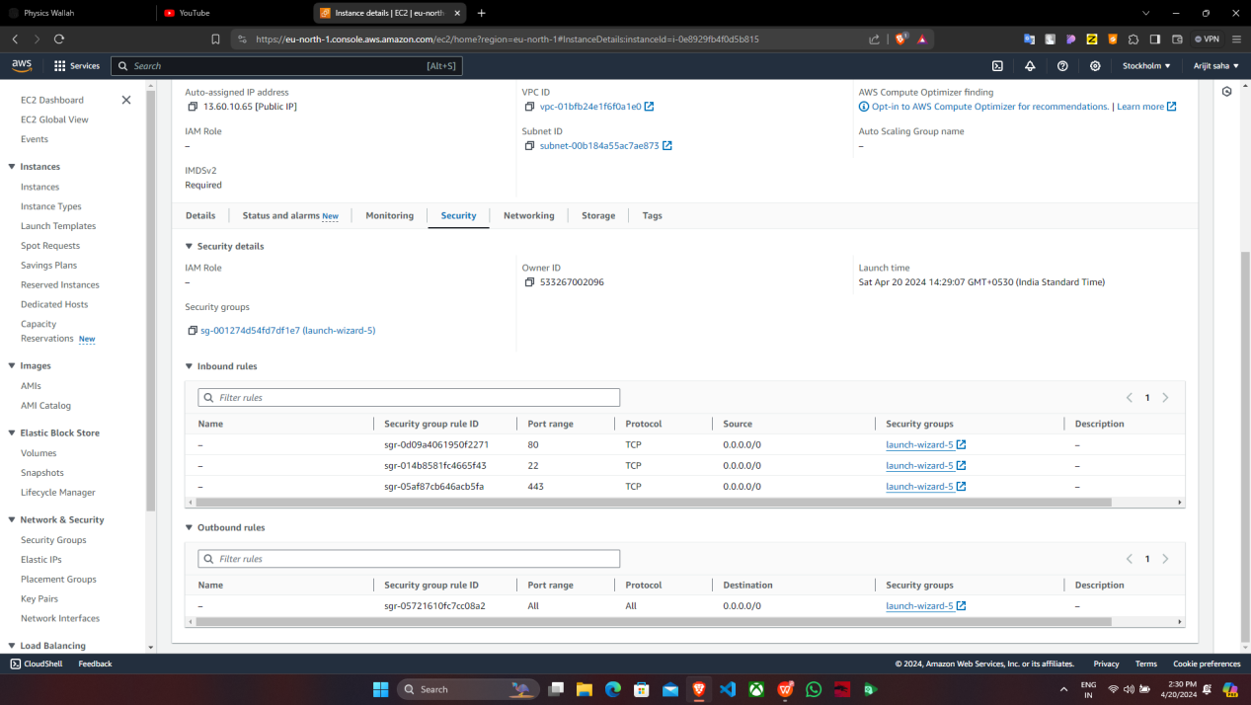7.Then in “Inbound rules”, click on “Edit inbound rules”.

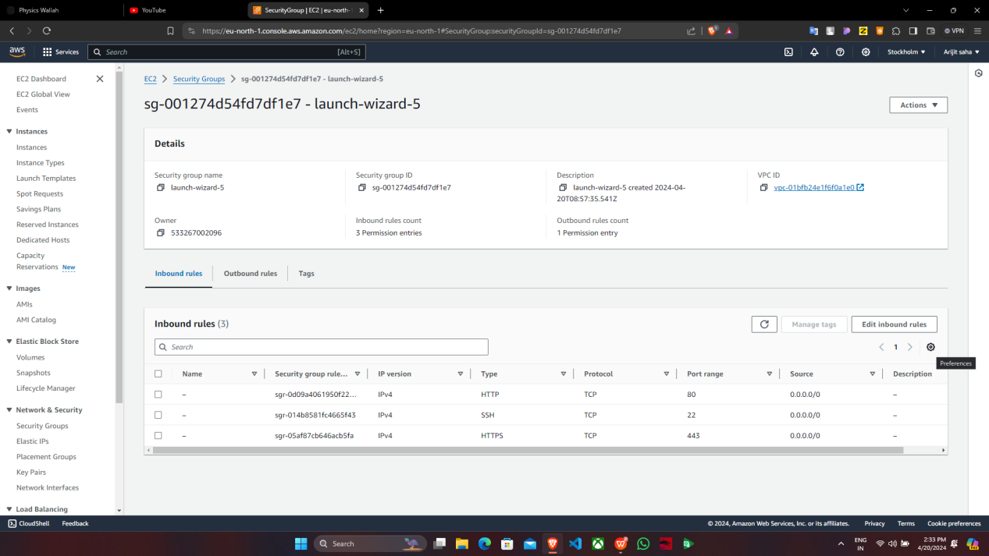

8. Click on “Add rule”.

9. Set the “Port range” to 4000 , in “Source” set “0.0.0.0/0” & click on “Save rules”.

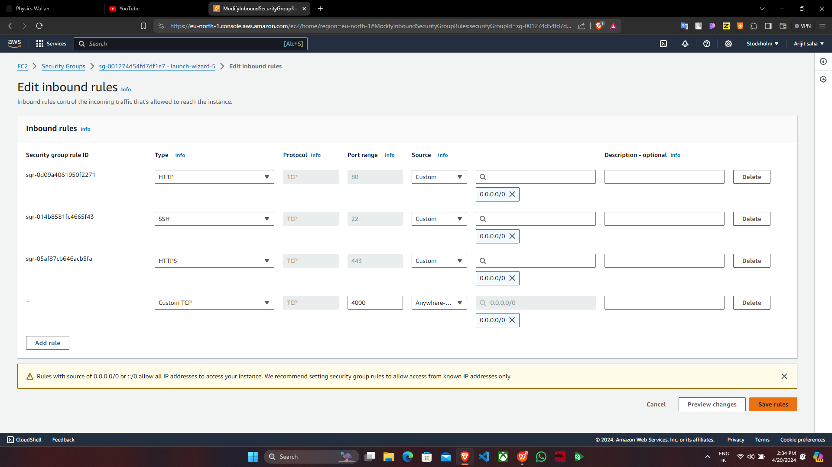

1. Rule have been successfully saved.

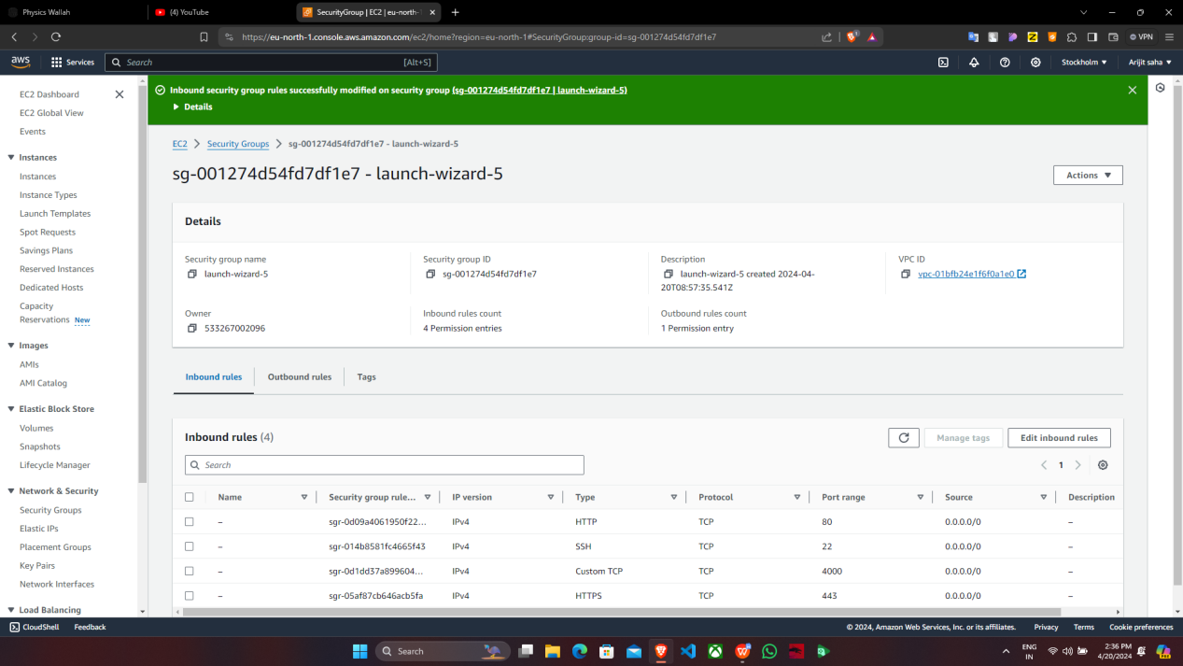

11. Go back to the Instance, copy the “Public IPv4 address”.

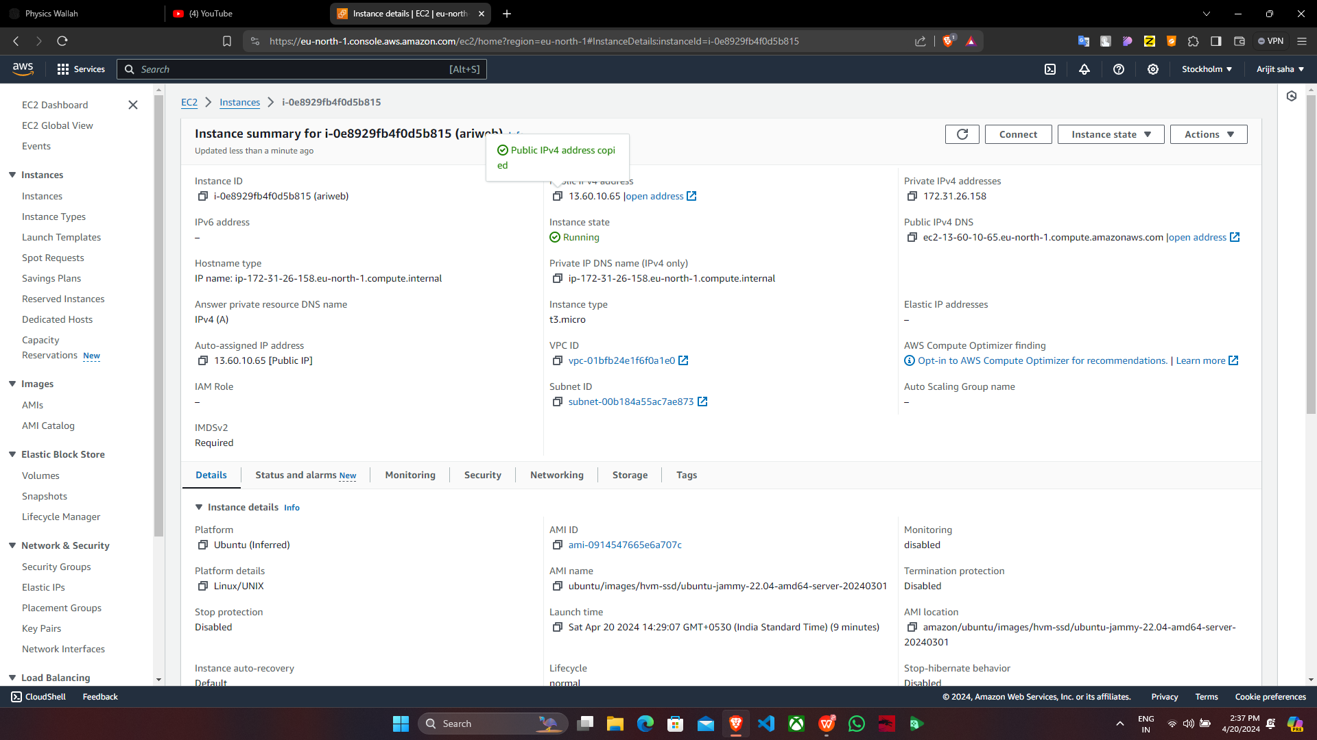

12. In “Bitvise SSH Client”, paste the “Public IPv4 address” in “Host” and under

“Authentication tab” give the username as Ubuntu. Then click on “Client Key

Manager”.

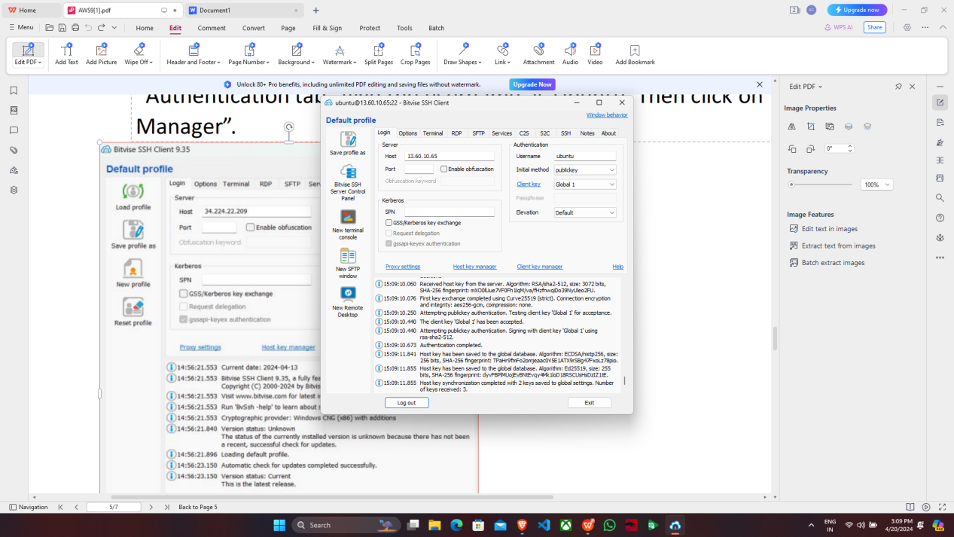

13. Remove any previously selected key if any, then click on “Import” & select the key

which instance was created.

14. In “Bitvise SSH Client”, click on “Log in”.

1. After successful “Log in” open a “New Terminal Console”.
2. In the console, type the following commands in sequential order.

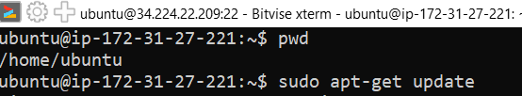

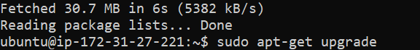

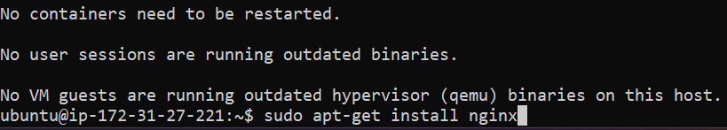

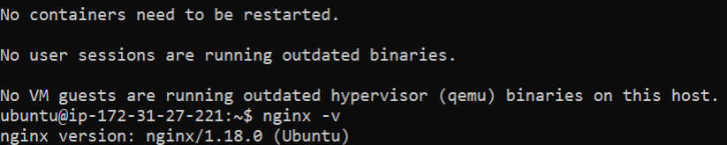



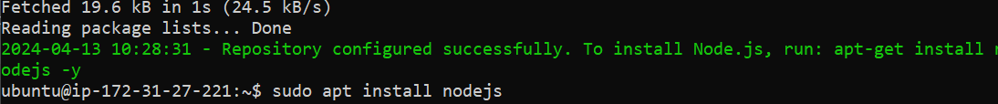

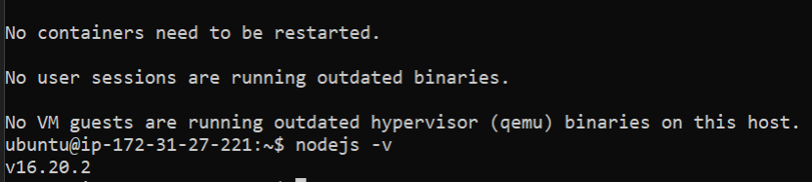

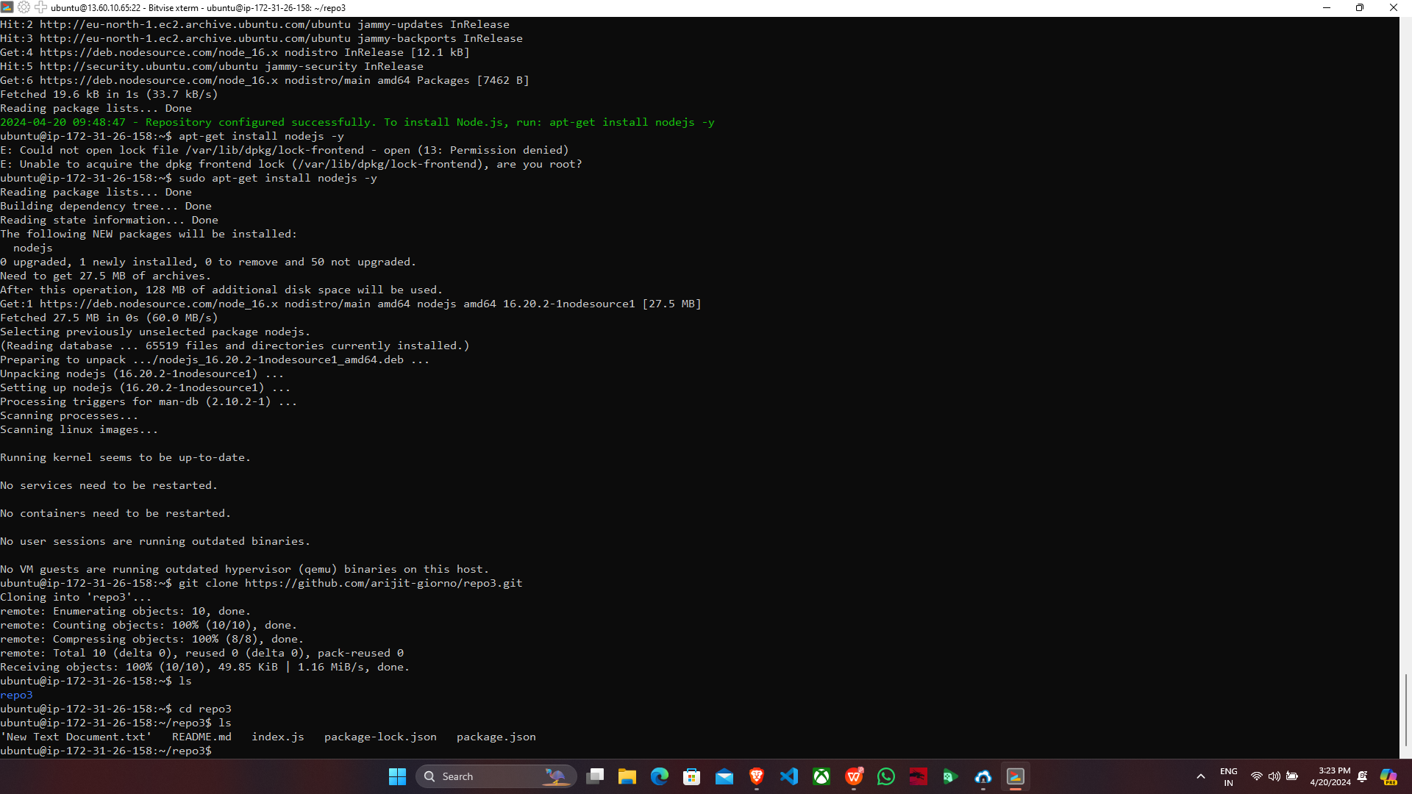

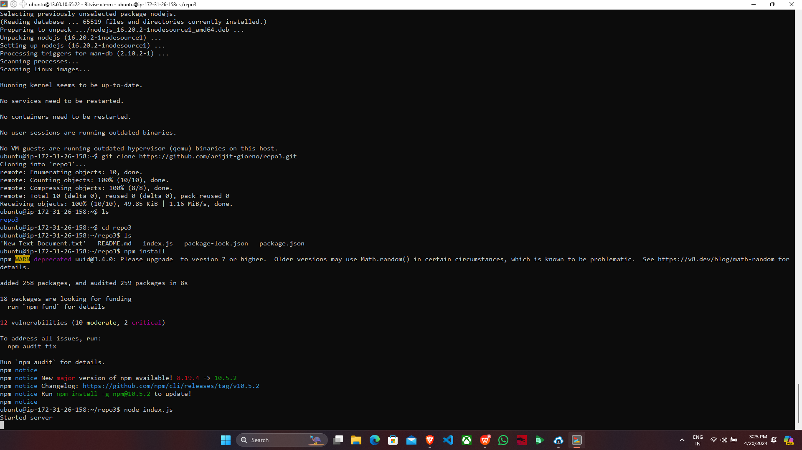

1. Now copy the “Public IPv4 address” & paste it on a new tab.

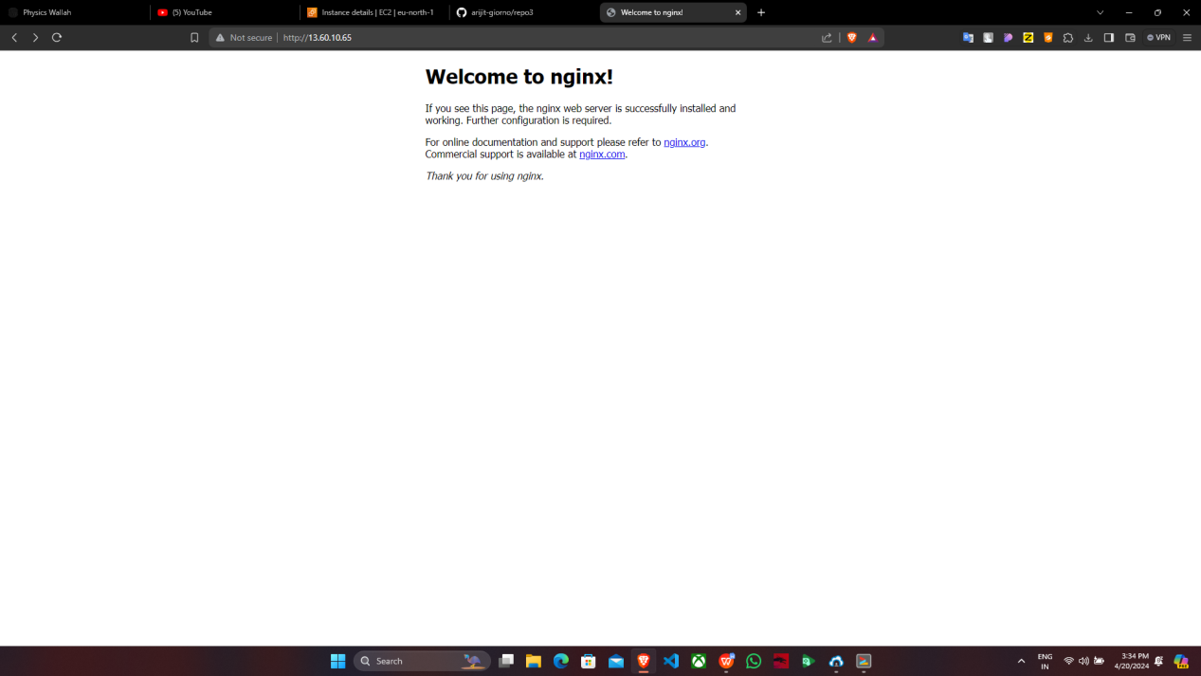

18. Now add “:4000” at the end of the “Public IPv4 address”.

