**A PROJECT REPORT**

**ON**

**COPY TRADE MANAGEMENT USING C++**

**SUBMITTED BY: SUPRIYO CHOWDHURY**

**Roll No. – 18P31A0599**

**Computer Science And Engineering**

**Aditya College Of Engineering And Technology**

**ACKNOWLEDGEMENT**

**I** thank God for his overall support and guidance for completing this project successfully.

I am grateful to everyone who had helped us in every possible manner during the course of our project.

I wish to express our sincere thanks to our parents and our dear friends who has supported us spiritually, mentally, and financially for the effort which I have taken.

|  |  |
| --- | --- |
| **TITLE** | **PAGE NUMBER** |
| **OVERVIEW OF C++** | **4-5** |
| **SUMMARY** | **6** |
| **HARDWARE REQUIREMENTS** | **7** |
| **SOFTWARE REQUIREMENTS** | **8** |
| **HEADER FILES USED** | **10** |
| **CLASS AND OBJECT USED** | **11** |
| **FUNCTIONS USED** | **12-13** |
| **SOURCE CODE** | **14-25** |
| **SCREEN SHOTS**  **(OUTPUTS)** | **26-36** |
| **CONCLUSION** | **37** |
| **BIBLIOGRAPHY** | **38** |

**INDEX**

**OVERVIEW OF C++**

**C++** is a statically typed, free-form, multi­paradigm, compiled, general purpose programming language. It is regarded as a "middle-level" language, as it comprises a combination of both high-level and low-level language features. It was developed by **Bjarne Stroustrup** starting in 1979 at AT&T Bell Labs as an enhancement to the C language and originally named C with Classes. It was renamed C++ in 1983.

As one of the most popular programming languages ever created, C++ is widely used in the software industry. Some of its application domains include systems software, application software, device drivers, embedded software, high ­performance server and client applications, and entertainment software such as video games. Several groups provide both free and proprietary C++ compiler software, including the GNU Project, Microsoft, Intel and Borland. C++ has greatly influenced many other popular programming languages, most notably C# and Java.

C*++* is also used for hardware design, where design is initially described in C++, then analyzed, architecturally constrained, and scheduled to create a register transfer level hardware description language via high-level synthesis.

The language began as enhancements to C, first adding classes, then virtual functions, operator overloading, multiple inheritance, templates, and exception handling among other features. After years of development, the C++ programming language standard was ratified in 1998 as ISO/IEC 14882: 1998. That standard is still current, but is amended by the 2003 technical corrigendum, ISO/IEC 14882:2003. The next standard version (known informally as C++Ox) is in development.

**SUMMARY**

**T**his project is mainly used for keeping a compressed record of the number of copies imported and exported in business centre. We can add copies and delete them any time we want by simple ‘Add Copies’ and ‘Delete Copies’ functions. We can also modify the copies ‘Company’, ‘Alignment’ and the ‘Number of Initial Copies’. It also have a total table which views all types of copies in one place and also it have individual show section that can be accessed by unique copy number. This program is made user-friendly so that the user doesn’t face difficulties.

**HARDWARE REQUIREMENTS**

Minimum Hardware Requirements:

|  |  |
| --- | --- |
| **Processor** | Intel Pentium( P4) or Higher |
| **RAM** | 256 MB or Higher |
| **CD-ROM** | 32 X or Higher |
| **Hard Disk Capacity** | 40 GB or Higher |
| **Display Device** | 15” inch Monitor or Higher |
| **Keyboard** | Standard Keyboard. |
| **Mouse** | Standard 2 Button Mouse |

**SOFTWARE REQUIREMENTS**

|  |  |
| --- | --- |
| **Operating System** | Windows Xp or Higher |
| **Compiler Used** | Turbo C++/Dev C++ |

**HOW TO RUN THE PROGRAM**

* Copy the program file to folder C:\TCC\Disk\Bin from the CD/Pen-drive.
* Go to Desktop, Open Turbo C++.
* Click File in Menu Bar, then click Open……
* After that browse the file from folder TCC.
* Then click ok.
* Click Compile from menu bar.
* Then RUN the Program.

**HEADER FILES USED**

**#include<stdio.h>**- It is basically used as input/output header file in C, but here it is used to run functions like remove(), rename()….. in the program.

**#includes<iostream.h>** - to declare basic C++ stream I/O routines such as cin, cout, etc…………. in the program

**#include<conio.h>** - to declare various functions used in I/O routines.

**#includes<fstream.h>** - It is an input-output file stream class. It provides support for simultaneous input and output operations that is to write, read, open the text files in the program.

**#include<iomanip.h>-** It defines the manipulator functions resetiosflags() , setiosflags() , setbase() , setfill() , setprecision() , and setw() . These functions may be conveniently used by **C++** programs to affect the state of iostream objects.

**#include<ctype.h>-** it contains functions for character handling (“**ctype**” stands for “character type”).

**CLASSES AND OBJECTS USED**

**CLASS USED**

**Class acc-** This class is used in this program to declare all the necessary member functions, objects, user defined functions to run this program.

**OBJECTS USED**

* **ac**  - It is an object of type class acc.

**FUNCTIONS USED**

Functions used in the class acc are:

* **void create_acc()** - It is used to create a new account for the copies.
* **void show_acc()** - It is used to print the present data in the created account.
* **void modify()** - It is used to modify the account.
* **void adep(int)** - It is used to add new copies.
* **void draw(int)** - It is used to delete copies.
* **void report()** - It is used to print the total copies in order.
* **int retano()** - It is used to return Account Number.
* **int retdep()** - It is used to return Department.
* **char qtype()** - It is used to return account type.

User Defined Functions used in this program are:

* **void write_acc()** - to add new account. It access void create_acc().
* **void display_sp(int)** - to display if something is not found.
* **void modify_acc(int)** - to modify created account.
* **void delete_acc(int)** - to delete existing account.
* **void display_all()**  - to display all the account in a table.
* **void dep_withdraw(int,int)** - to deposit and withdraw copies.
* **void intro()**  - to show the introduction of the program.

**SOURCE CODE**

/*A C++ Program To make a Copy Trade Management System*/

#include<stdio.h>

#include<iostream.h>

#include<conio.h>

#include<fstream.h>

#include<iomanip.h>

#include<ctype.h>

class acc

{

int ano;

char name[100];

int dep;

char type;

char size;

public:

void create_acc();

void show_acc() const;

void modify();

void adep(int);

void draw(int);

void report() const;

int retano() const;

int retdep() const;

char qtype() const;

};

void acc::create_acc()

{

cout<<"\nENTER THE COPY NUMBER:";

cin>>ano;

cout<<"\n\nENTER NAME OF THE COPY:";

cin.ignore();

cin.getline(name,100);

cout<<"\nENTER TYPE OF COPY(Ruled(r)/White(w)/Math(m)/English(e)/science(s)):";

cin>>type;

cout<<"\nENTER THE SIZE OF COPY(Very Long(v)/Long(l)/Medium(m)/Short(s))";

cin>>size;

cout<<"\nENTER THE INITIAL NUMBER OF COPIES:";

cin>>dep;

cout<<"\n\n\nCONGRATS ACCOUNT HAS BEEN CREATED:";

}

void acc::show_acc() const

{

cout<<"\nCOPY NUMBER:"<<ano;

cout<<"\nCOPY COMPANY:";

cout<<name;

cout<<"\nTYPE OF COPY:"<<type;

cout<<"\nSIZE OF COPY:"<<size;

cout<<"\nNUMBER OF COPIES:"<<dep;

}

void acc::modify()

{

cout<<"\nCOPY NUMBER:"<<ano;

cout<<"\nMODIFY COPY NAME:";

cin.ignore();

cin.getline(name,100);

cout<<"\nMODIFY TYPE OF COPY:";

cin>>type;

cout<<"\nMODIFY SIZE OF COPY:";

cin>>size;

cout<<"\nMODIFY NUMBER OF COPIES:";

cin>>dep;

}

void acc::adep(int x)

{

dep+=x;

}

void acc::draw(int x)

{

dep-=x;

}

void acc::report() const

{

cout<<" "<<ano<<setw(10)<<" "" "<<name<<setw(10)<<" "" "<<type<<setw(6)<<" "<<size<<setw(12)<<""<< dep<<endl;

}

int acc::retano() const

{

return ano;

}

int acc::retdep() const

{

return dep;

}

char acc::qtype() const

{

return type;

}

void write_acc();

void display_sp(int);

void modify_acc(int);

void delete_acc(int);

void display_all();

void dep_withdraw(int,int);

void intro();

int main()

{

char ch;

int num;

clrscr();

intro();

do

{

clrscr();

cout<<"\n\n\n\tACTION MENU";

cout<<"\n\n\t01. NEW ACCOUNT";

cout<<"\n\n\t02. ADD COPIES";

cout<<"\n\n\t03. WITHDRAW";

cout<<"\n\n\t04. ENQUIRY";

cout<<"\n\n\t05. COMPLETE ENQUIRY";

cout<<"\n\n\t06. CLOSE AN ACCOUNT";

cout<<"\n\n\t07. MODIFY AN ACCOUNT";

cout<<"\n\n\t08. EXIT";

cout<<"\n\n\tSelect Your Option(1-8)";

cin>>ch;

clrscr();

switch(ch)

{

case'1':

write_acc();

break;

case'2':

cout<<"\n\n\tENTER THE COPY NUMBER:";cin>>num;

dep_withdraw(num,1);

break;

case'3':

cout<<"\n\n\tENTER THE COPY NUMBER:";cin>>num;

dep_withdraw(num,2);

break;

case'4':

cout<<"\n\n\tENTER THE COPY NUMBER:";cin>>num;

display_sp(num);

break;

case'5':

display_all();

break;

case'6':

cout<<"\n\n\tENTER THE COPY NUMBER:";cin>>num;

delete_acc(num);

break;

case'7':

cout<<"\n\n\tENTER THE COPY NUMBER:";cin>>num;

modify_acc(num);

break;

case'8':

cout<<"\n\n\tTHANKS FOR VISITING OUR SOFTWARE!";

break;

default: cout<<"\a";

}

cin.ignore();

cin.get();

}

while(ch!='8');

return 0;

}

void write_acc()

{

acc ac;

ofstream x;

x.open("info.dat",ios::binary|ios::app);

ac.create_acc();

x.write((char *) &ac, sizeof(acc));

x.close();

}

void display_sp(int n)

{

acc ac;

int flag=0;

ifstream x;

x.open("info.dat",ios::binary);

if(!x)

{

cout<<"File Could Not Be Opened!! Press Any Key To Exist.......";

return;

}

cout<<"\nBALANCE DETAILS\n";

while(x.read((char *) (&ac), sizeof(acc)))

{

if (ac.retano()==n)

{

ac.show_acc();

flag=1;

}

}

x.close();

if(flag==0)

cout<<"\n\nAccount Number does not Exists";

}

void modify_acc(int n)

{

int found=0;

acc ac;

fstream x;

x.open("info.dat",ios::binary|ios::in|ios::out);

if(!x)

{

cout<<"File could not be open!! Press any key.......";

return;

}

while(!x.eof()&&found==0)

{

x.read((char *)(&ac), sizeof(acc));

if(ac.retano()==n)

{

ac.show_acc();

cout<<"\n\nENTER THE NEW DETAILS OF THE ACCOUNT"<<endl;

ac.modify();

int pos=(-1)* sizeof(acc);

x.seekp(pos,ios::cur);

x.write((char *) &ac, sizeof(acc));

cout<<"\n\n\tRECORD UPDATED";

found=1;

}

x.close();

if(found==0)

cout<<"\n\nRECORD NOT FOUND";

}

}

void delete_acc(int n)

{

acc ac;

ifstream x;

ofstream y;

x.open("info.dat",ios::binary);

if(!x)

{

cout<<"File could not be open!! Press any key.....";

}

y.open("temp.dat",ios::binary);

x.seekg(0,ios::beg);

while(x.read((char *)(&ac),sizeof(acc)))

{

if(ac.retano()!=n)

{

y.write((char *)(&ac),sizeof(acc));

}

}

x.close();

y.close();

remove("info.dat");

rename("temp.dat","info.dat");

cout<<"\n\n\tRECORD DELETED.....";

}

void display_all()

{

acc ac;

ifstream x;

x.open("info.dat",ios::binary);

if(!x)

{

cout<<"File could not be open!! Press any key.......";

return;

}

cout<<"\n\n\t\t FULL ACCOUNT LIST\n\n";

cout<<" ==============================================================\n";

cout<<" COPY NO. NAME TYPE SIZE QUANTITY \n";

cout<<" ==============================================================\n";

while(x.read((char *)(&ac),sizeof(acc)))

{

ac.report();

}

}

void dep_withdraw(int n,int option)

{

int amt;

int found=0;

acc ac;

fstream x;

x.open("info.dat",ios::binary|ios::in|ios::out);

if(!x)

{

cout<<"File could not be open!! Press any key.......";

return;

}

while(!x. eof() &&found==0)

{

x.read((char *)(&ac),sizeof(acc));

if(ac.retano()==n)

{

ac.show_acc();

if(option==1)

{

cout<<"\n\n\tTo add Quantity";

cout<<"\n\nEnter the Quantity to be added";

cin>>amt;

ac.adep(amt);

}

if(option==2)

{

cout<<"\n\n\tTo withdraw Quantity";

cout<<"\n\nEnter The Quantity To Withdraw";

cin>>amt;

int bal=ac.retdep()-amt;

if((bal<1&&ac.qtype()=='r') || (bal<1&&ac.qtype()=='w') || (bal<1&&ac.qtype()=='m') || (bal<1&&ac.qtype()=='e') || (bal<1&&ac.qtype()=='s'))

cout<<"Insufficient Balance";

else

ac.draw(amt);

}

int pos=(-1)* (sizeof(ac));

x.seekp(pos,ios::cur);

x.write((char *) &ac,sizeof(acc));

cout<<"\n\n\tRECORD UPDATED";

found=1;

}

}

x.close();

if(found==0)

cout<<"\n\nRecord not Found";

}

void intro()

{

textcolor(14);gotoxy(24,30);

cout<<"\n\n\n\tWELCOME TO CHOWDHURY PRINTERS MANAGEMENT SYSTEM";gotoxy(26,32);

cout<<"\n\nA C++ CODE BY SUPRIYO CHOWDHURY";

cout<<"\nPRESS ENTER TO CONTINUE........";

cin.get();

}

**SCREEN SHOTS**

**AND**

**OUTPUTS**

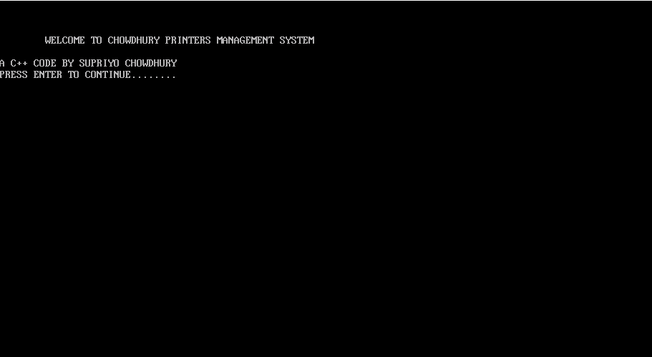

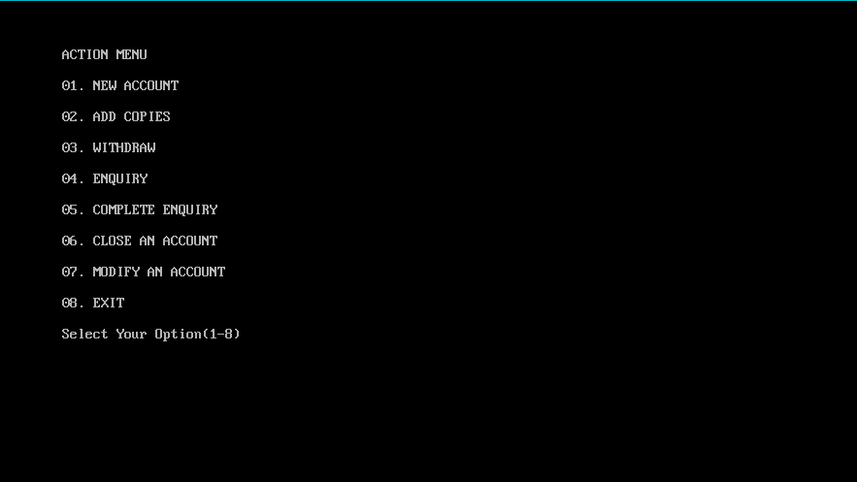

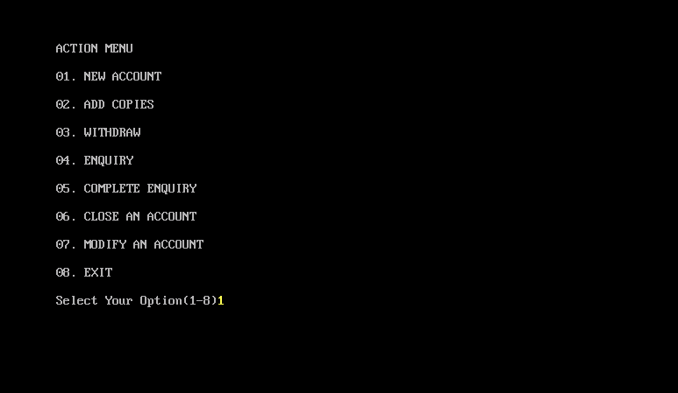

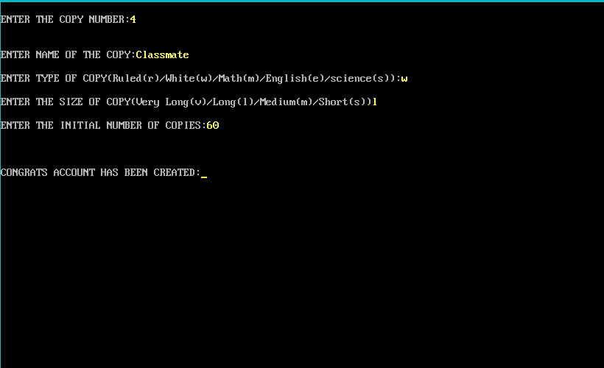

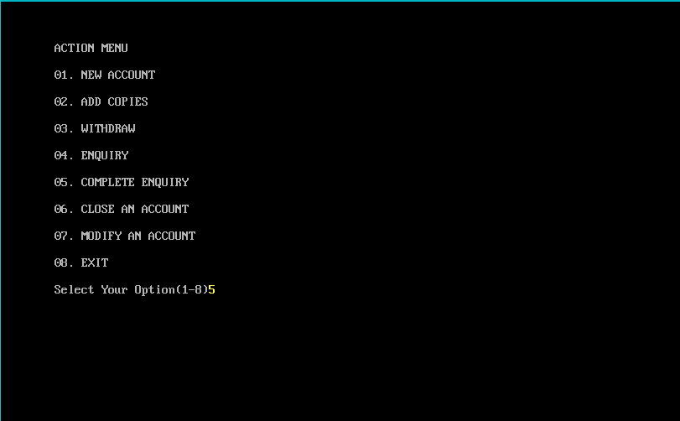

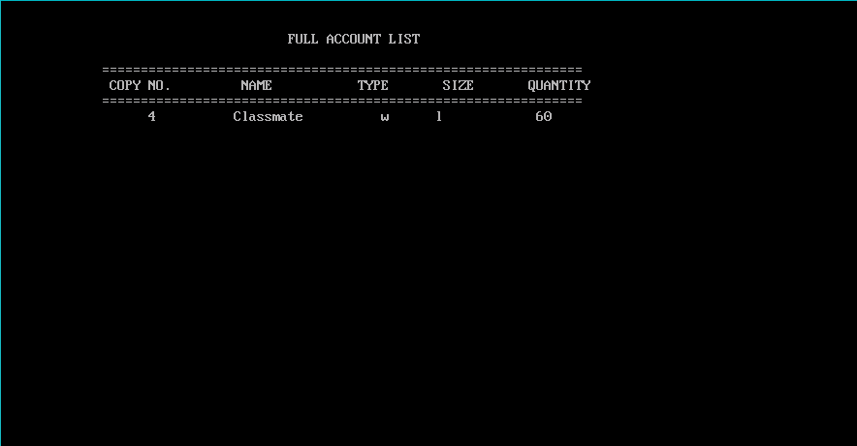

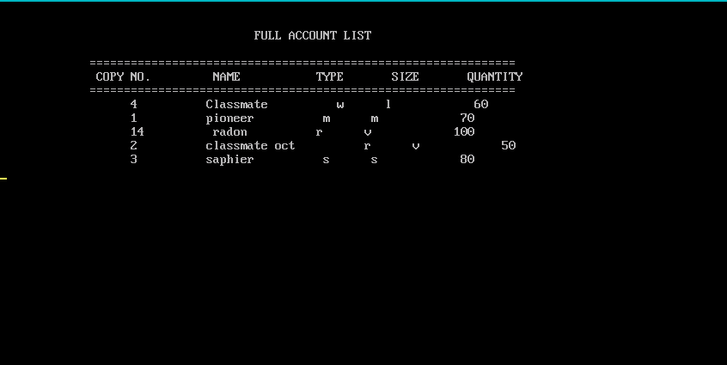

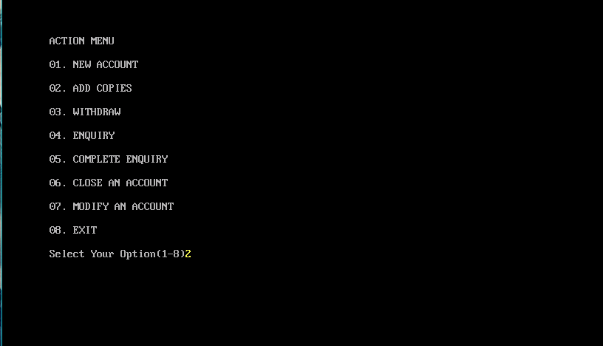

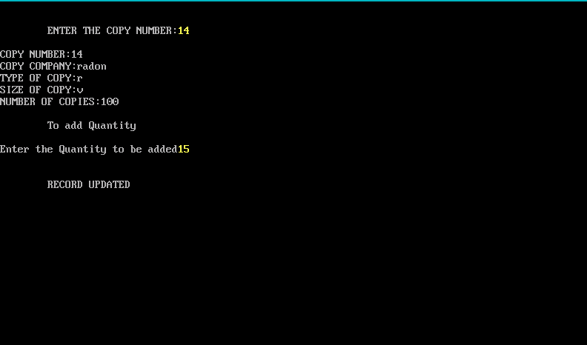

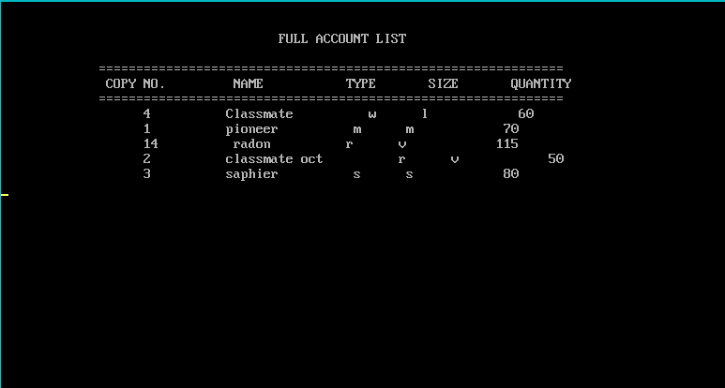

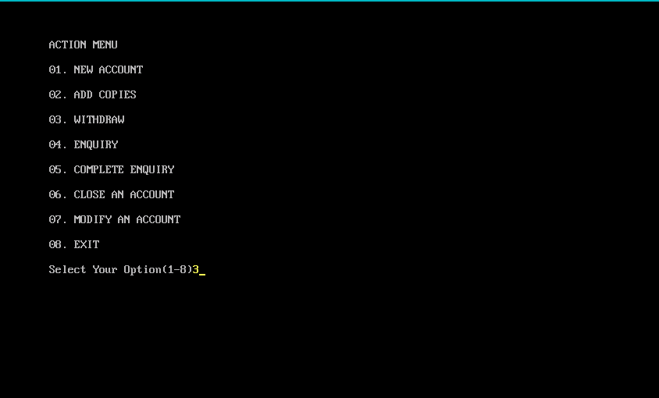

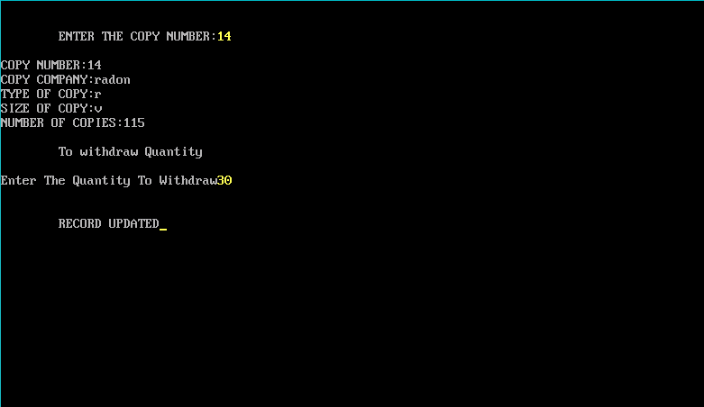

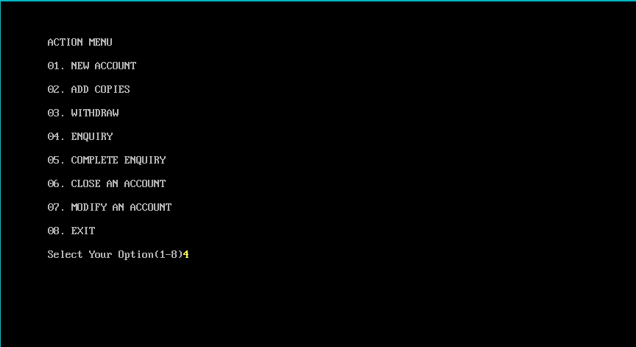

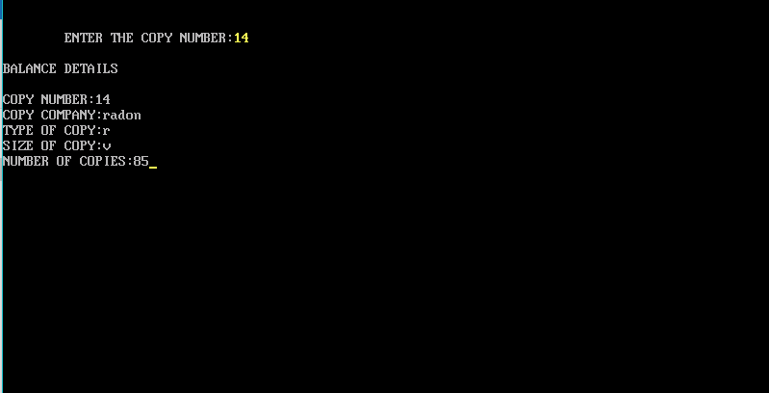

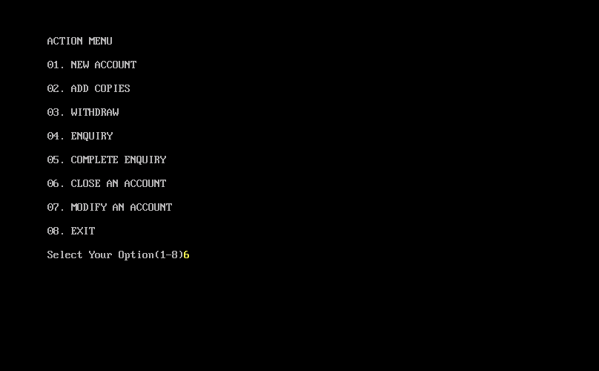

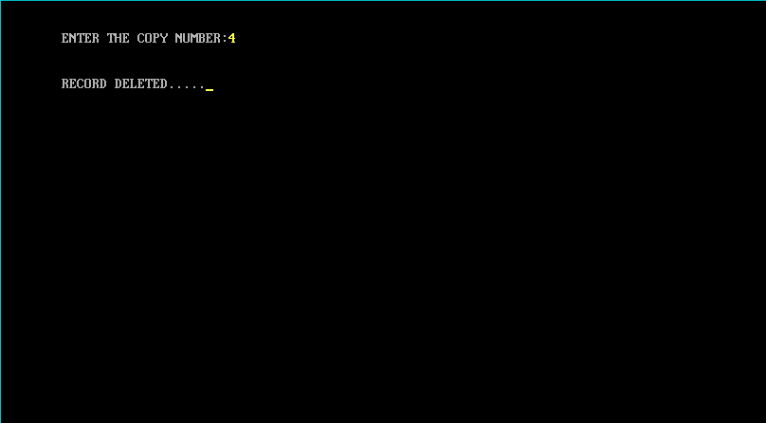

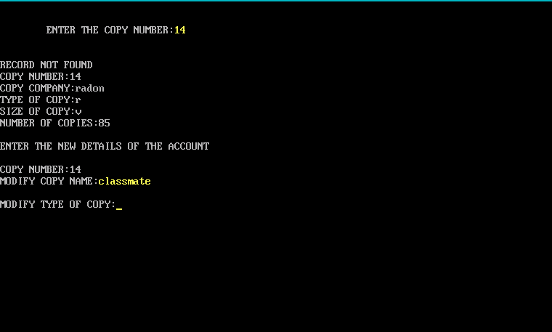

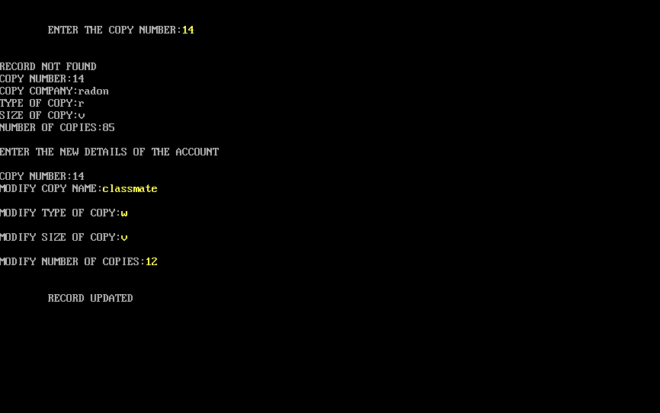

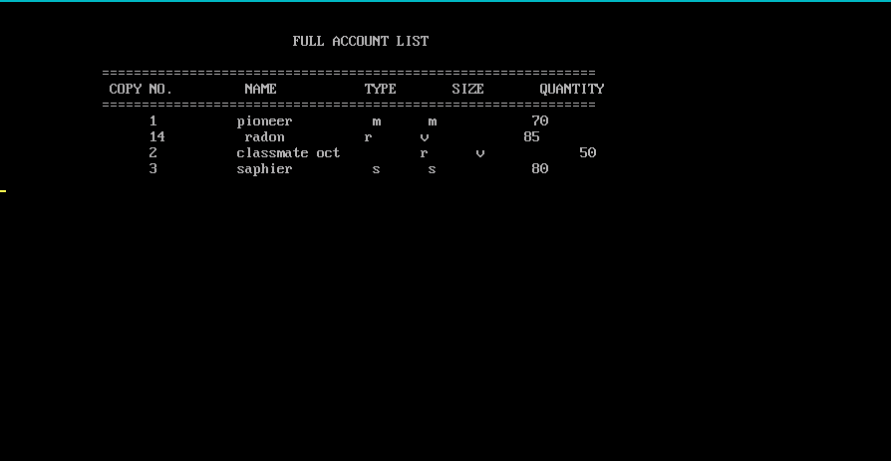

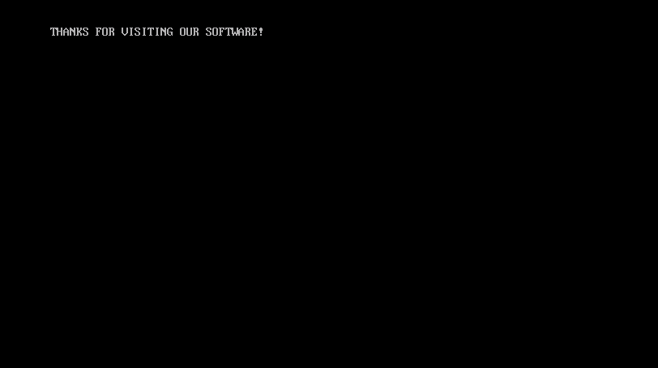

**CONCLUSION**

This software has successfully achieved the following goals:

This project makes the system more feasible and flexible. Minimize the risk of data loss and illegibility. It makes to store copy data quite efficiently and safe. Its user-friendly GUI helps the user to understand the current situation easily.

The Project finally helped me in enhancing and polishing my C++ skills and get a proper dept over them.

**BIBLIOGRAPHY**

In order to complete my project with complete success some of the books the websites helped me as a reference:

1. Bjarne_Stroustrup_-_The_C++_Programming_Language_3rd_Ed
2. www.geeksforgeeks.com
3. [www.wikipedia.com](http://www.wikipedia.com)