Midterm Project: Displaying Five Cards with Score

Problem Description:
The image icons used in the assignment can be obtained from the book source code file under the image folder (i.e., image/card/1.png) or from the course website.

Display a window that contains five labels. Each label displays a card, as shown in the figure below. The card image files are named b1fv (back), 1.png, 2.png, ..., 54.png (front) and stored in the image/card directory. All five front cards are distinct and selected randomly.

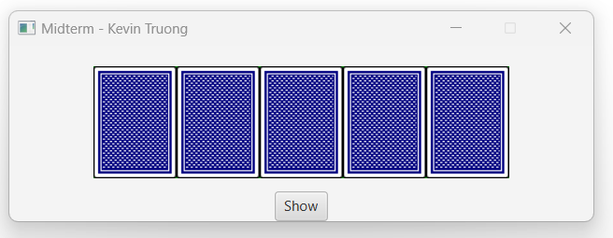

The title of the windows should reflect your CCC full name.

The score calculation: those cards such as the 10, Jack, Queen, King regardless of color are counted as 0. Sum all other cards and if it is greater than 9 then mod 10 and the final value is the score.

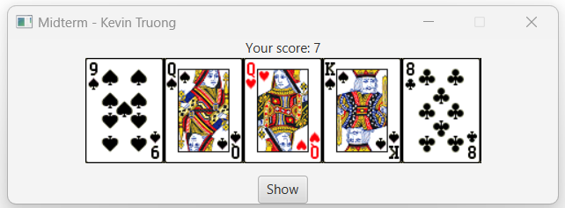
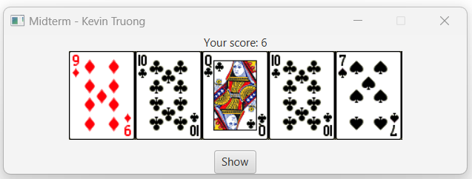
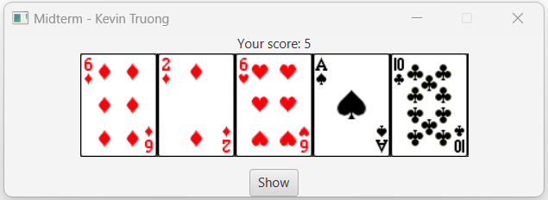

Your Code:

package demojavafx;
import javafx.application.Application;
import javafx.scene.Scene;
import javafx.scene.control.Button;
import javafx.scene.control.Label;
import javafx.scene.image.Image;
import javafx.scene.image.ImageView;
import javafx.scene.layout.HBox;
import javafx.scene.layout.VBox;
import javafx.stage.Stage;
import java.util.*;
public class Midterm_Project extends Application {
private static final int NUM_CARDS = 5;
private static final String CARD_PATH = "/image/card/";
private final ImageView[] cardViews = new ImageView[NUM_CARDS];
private final Label scoreLabel = new Label("Score: ");
@Override
public void start(Stage primaryStage) {
// Initialize 5 card backs
for (int i = 0; i < NUM_CARDS; i++) {
Image backImage = new Image(getClass().getResource(CARD_PATH + "b1fv.png").toExternalForm());
cardViews[i] = new ImageView(backImage);
cardViews[i].setFitHeight(150);
cardViews[i].setFitWidth(100);
}
// Buttons
Button btnShow = new Button("Show Cards");
Button btnExit = new Button("Exit");
btnShow.setOnAction(e -> showRandomCards());
btnExit.setOnAction(e -> primaryStage.close());
// Layouts
HBox cardBox = new HBox(10, cardViews);
HBox buttonBox = new HBox(10, btnShow, btnExit);
VBox root = new VBox(15, cardBox, scoreLabel, buttonBox);
Scene scene = new Scene(root, 650, 300);
primaryStage.setTitle("Midterm Project - Ahmad Hejjih");
primaryStage.setScene(scene);
primaryStage.setResizable(false);
primaryStage.show();
}
private void showRandomCards() {
List<Integer> deck = new ArrayList<>();
for (int i = 1; i <= 54; i++) deck.add(i);
Collections.shuffle(deck);
int total = 0;
for (int i = 0; i < NUM_CARDS; i++) {
int cardNum = deck.get(i);
Image cardImage = new Image(getClass().getResource(CARD_PATH + cardNum + ".png").toExternalForm());
cardViews[i].setImage(cardImage);
total += getCardValue(cardNum);
}
int score = total % 10;
scoreLabel.setText("Score: " + score);
}
private int getCardValue(int cardNum) {
int rank = ((cardNum - 1) % 13) + 1;
if (rank >= 10 && rank <= 13) return 0;
return rank;
}
public static void main(String[] args) {
launch(args);
}
}

Name your program Midterm_Project and copy the code here.

Screen shots:
Include four screen shots here:

Screen 1: the initial screen with the back cover.

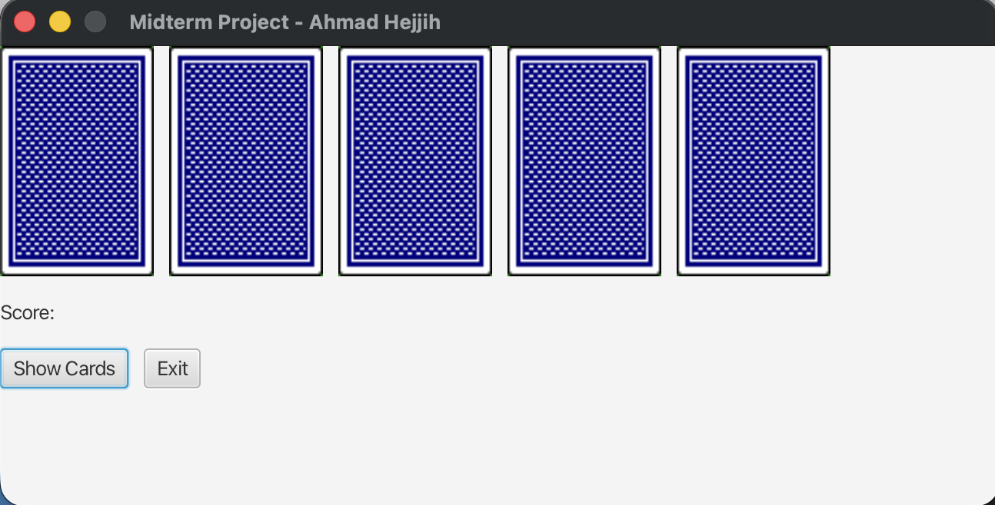

Screen 2: Show randomized cards with the score.

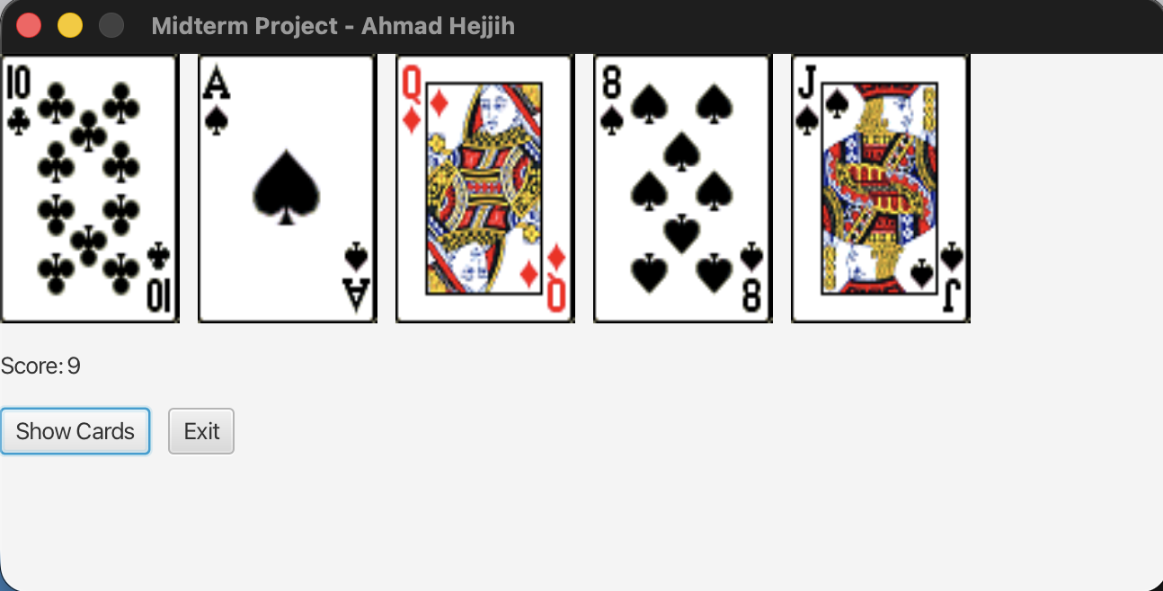

Screen 3: Show randomized cards with the score.

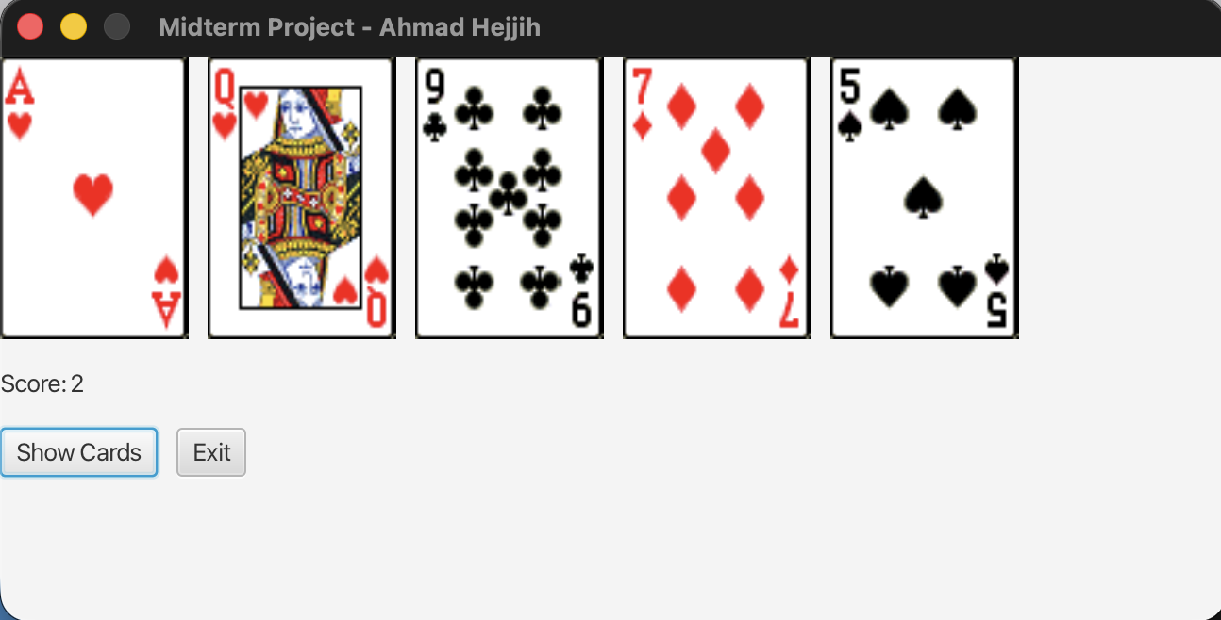

Screen 4: Show randomized cards with the score.

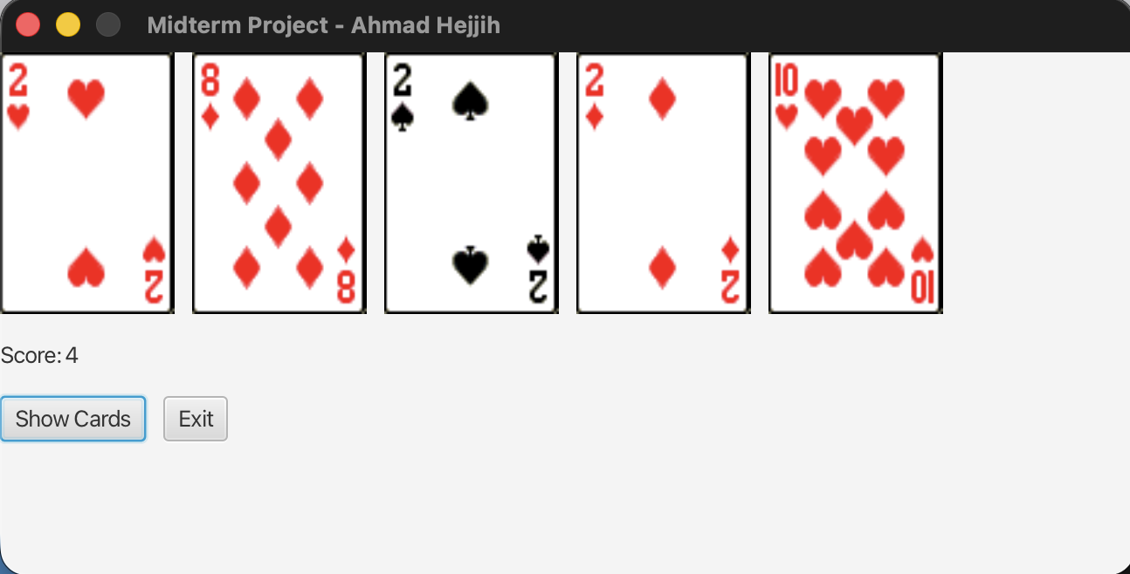

Submit the following items:

1. Compile and Submit the java file, the class file and this report document to our course site as the Midterm_Project (you must submit the program regardless whether it complete or incomplete, correct or incorrect)

2. Fill in self-evaluation:

- Can your program create the UI? _________yes______
- Can your program display five cover images correctly? _____yes__________
- Can your program display five randomized images correctly? ________yes_______
- Can your program display score correctly? _____yes__________

