RM Reports Migration & Modernization
.NET MVC 5 → .NET Core 8 & Angular

Project progress report submitted
to

MANIPAL ACADEMY OF HIGHER EDUCATION

For Partial Fulfillment of the Requirement for the
Award of the Degree
of

Bachelor of Technology
in
Information Technology

by

[Student Name]
Reg. No. [Roll Number]

Under the guidance of

Dr. Rajashree Krishna Mrs. Bhargavi A V
Associate Professor – Senior Scale Full Stack Developer Manager
School of Computer Engineering GIS – MGS
Manipal Institute of Technology MUFG Global Service Private Limited
Manipal, India Bengaluru, Karnataka – 560064

March 2026

1 Introduction
The rapid evolution of enterprise software platforms has led to fundamental changes in how organizations manage internal reporting and data presentation. Legacy systems built on older frameworks such as ASP.NET MVC 5 and jQuery often accumulate significant technical debt over time, becoming difficult to test, maintain, and extend. Modern software engineering principles — including Separation of Concerns, Dependency Injection, and strong typing — are frequently absent in such systems, making even minor feature changes risky and prone to regression.
The RM Reports module historically operated as a tightly coupled, monolithic subsystem relying on Razor views, jQuery, DataTables, jQuery UI, and the legacy Infragistics Excel engine. Over a decade of incremental enhancements had resulted in a codebase that lacked clear architectural boundaries, had no unit test coverage, and depended on libraries incompatible with modern .NET runtimes.
This project undertakes a complete architectural transformation of the RM Reports subsystem. The backend is re-platformed from ASP.NET MVC 5 / WebAPI 2 to .NET Core 8, while the frontend transitions from a jQuery-driven Razor view to a fully modular Angular Single Page Application. The migration also replaces the legacy Infragistics Excel engine with EPPlus and modernizes background job processing through Dependency Injection–managed Hangfire jobs, delivering a highly testable, maintainable, and platform-independent reporting subsystem.

2 Literature Survey
The modernization of legacy enterprise applications has been widely studied in software engineering literature. Pressman and Maxim emphasize that large-scale software migration efforts benefit from phased, iterative methodologies combined with strict separation of concerns, enabling teams to manage risk while progressively improving system quality [9]. The application of these principles directly informs the layered migration strategy adopted in this project.
The adoption of .NET Core as a cross-platform successor to the .NET Framework has been extensively documented by Microsoft. The .NET Core 8 platform introduces significant performance improvements, native Dependency Injection, and long-term support, making it the recommended target for modernizing legacy ASP.NET applications [1]. The transition from a split MVC/WebAPI routing model to unified REST-only controllers is a well-established best practice for building consistent, testable API surfaces [2].
Angular, as a component-based SPA framework with TypeScript, provides strong typing, reactive data flows, and modular architecture — capabilities that directly address the maintainability limitations of jQuery-based frontends [3]. NgRx, inspired by the Redux pattern, provides predictable, observable state management for Angular applications, replacing ad-hoc approaches such as sessionStorage and global JavaScript variables [4]. AG-Grid has been identified as a high-performance data grid for Angular, capable of handling large datasets efficiently with TypeScript-native column definitions [7].
For server-side Excel generation, EPPlus provides a modern, .NET Core–compatible API that replaces legacy libraries such as Infragistics. EPPlus supports advanced formatting, table creation, freeze panes, and conditional formatting, and is actively maintained with strong community support [5]. The migration from Infragistics to EPPlus is motivated by platform compatibility requirements and the significant reduction in output file size and generation time demonstrated in practical benchmarks.
Background job processing with Hangfire is well-documented as a reliable mechanism for managing long-running tasks in .NET applications [6]. Migrating static Hangfire job methods to DI-managed classes enables full unit testing and consistent dependency resolution, addressing a critical testability gap in the legacy system. Dapper, as a lightweight micro-ORM, provides efficient SQL execution while supporting strongly-typed result mapping, directly replacing the legacy pattern of dynamic result sets that exposed stored procedure schemas directly to the UI layer [8].
The reviewed literature collectively supports the architectural decisions adopted in this project: a layered backend with DI, a modular Angular frontend, EPPlus-based report generation, Hangfire-managed async jobs, and Dapper-based typed data access — each grounded in established software engineering principles and actively maintained open-source ecosystems.

3 Problem Definition
The RM Reports module currently relies on a fragmented, legacy technology stack that presents multiple critical barriers to maintenance, testing, and future development. The split routing model — mixing ASP.NET MVC 5 controllers with WebAPI 2 endpoints — produces inconsistent API contracts and serialization behavior, making the system unpredictable and difficult to reason about. Client-side state is managed through sessionStorage and global JavaScript variables, creating brittle, order-dependent execution flows that are nearly impossible to unit test.
The UI logic is deeply entangled with jQuery DOM manipulation in a monolithic god-script (ConcentrationReports.js), coupling business logic directly to HTML element IDs and browser events. On the backend, all service classes depend on static utility methods rather than dependency-injected interfaces, making mocking and isolation testing infeasible. The absence of typed domain models means that stored procedure result sets are handled as dynamic objects throughout the pipeline, introducing runtime errors and reducing code clarity.
The most critical technical blocker is the Infragistics Excel generation engine, which is incompatible with the .NET Core runtime and therefore prevents any migration to a modern platform. This single dependency effectively locks the entire subsystem to the legacy .NET Framework. The research problem under this project is therefore the design and implementation of a fully modernized RM Reports subsystem — with a RESTful .NET Core 8 backend, a modular Angular frontend, EPPlus-based Excel generation, and DI-managed async processing — that preserves all existing reporting functionality while eliminating all legacy platform dependencies.

4 Objective
The primary objectives of this project are:
- To migrate the backend from ASP.NET MVC 5 / WebAPI 2 to a unified REST-only .NET Core 8 API with full Dependency Injection across all layers.
- To rebuild the Razor + jQuery frontend as a modular Angular Single Page Application with reactive forms, AG-Grid data grid, and NgRx-managed global state.
- To replace the Infragistics Workbook Excel engine with EPPlus, achieving .NET Core compatibility, improved performance, and a cleaner formatting API.
- To introduce strongly-typed DTOs throughout the data pipeline, replacing all dynamic result sets from stored procedures with explicitly defined domain models.
- To refactor Hangfire background jobs from static methods into DI-managed AsyncReport classes that support full unit testing and isolated error handling.
- To standardize and document all API contracts by normalizing legacy query parameter names, adopting consistent RESTful conventions, and issuing deprecation notices for old endpoints.
- To gain practical experience in enterprise-scale .NET Core and Angular development, software migration strategies, and modern CI/CD deployment practices.

5 Methodology
The project follows a structured, phase-by-phase modernization approach. Each phase produces deliverables that are validated before the next phase begins, ensuring quality and reducing migration risk. The system design is supported by architectural, functional, and data flow diagrams.

1. Legacy Analysis
The initial phase involved a comprehensive audit of the existing system to understand its structure, dependencies, and failure points.
- Reviewed MVC view structure (cabhtml page) and inline JavaScript event handlers
- Analysed ConcentrationReports.js: a god-script managing DOM, AJAX, DataTables, and state
- Mapped backend routing split: MVC ActionResult controllers vs WebAPI 2 controllers
- Documented BAO/DAO pattern: dynamic result sets, no typed models, static utility classes
- Profiled Infragistics pipeline: workbook generation, format strings, drawable font dependencies
- Identified email notification pipeline: hard-coded template paths, deprecated SmtpClient
Result: Complete component mapping and gap analysis forming the migration blueprint.

2. System Architecture
The new system follows a strict layered architecture as shown in Figure 1. The Angular SPA serves as the presentation layer. The .NET Core 8 REST API provides the application layer with Controller, Manager, and AsyncReport sub-layers. The data access layer uses Dapper with typed models, and EPPlus handles all Excel workbook generation. Hangfire manages long-running report generation jobs as DI-managed classes.
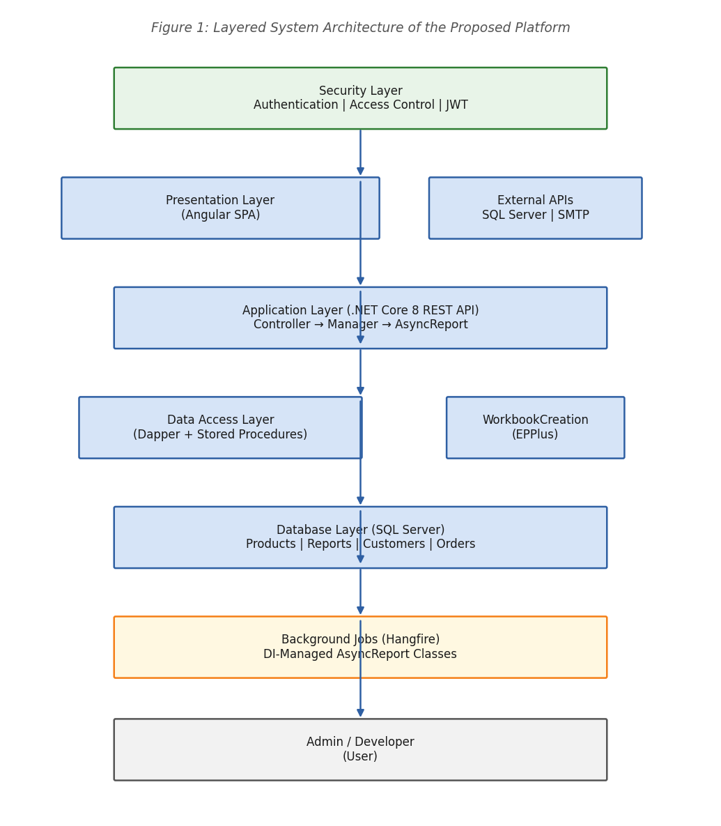
Figure 1: Layered System Architecture of the Proposed Platform

3. Functional Module Design
The system is decomposed into independent functional modules as illustrated in Figure 2. Each module has a single, well-defined responsibility and is independently testable, allowing components to be developed, tested, and deployed without impacting others.
- Backend Migration: .NET Core 8 REST controllers, Manager layer, DI services
- Frontend Migration: Angular components (container, filter, grid), NgRx store, RmreportService
- Data Layer: Dapper ORM, stored procedure mapping, strongly-typed DTOs
- Async Jobs: Hangfire AsyncReport classes, EPPlus workbook generation, SMTP email
- API Contracts: RESTful endpoint design, parameter normalization, versioning
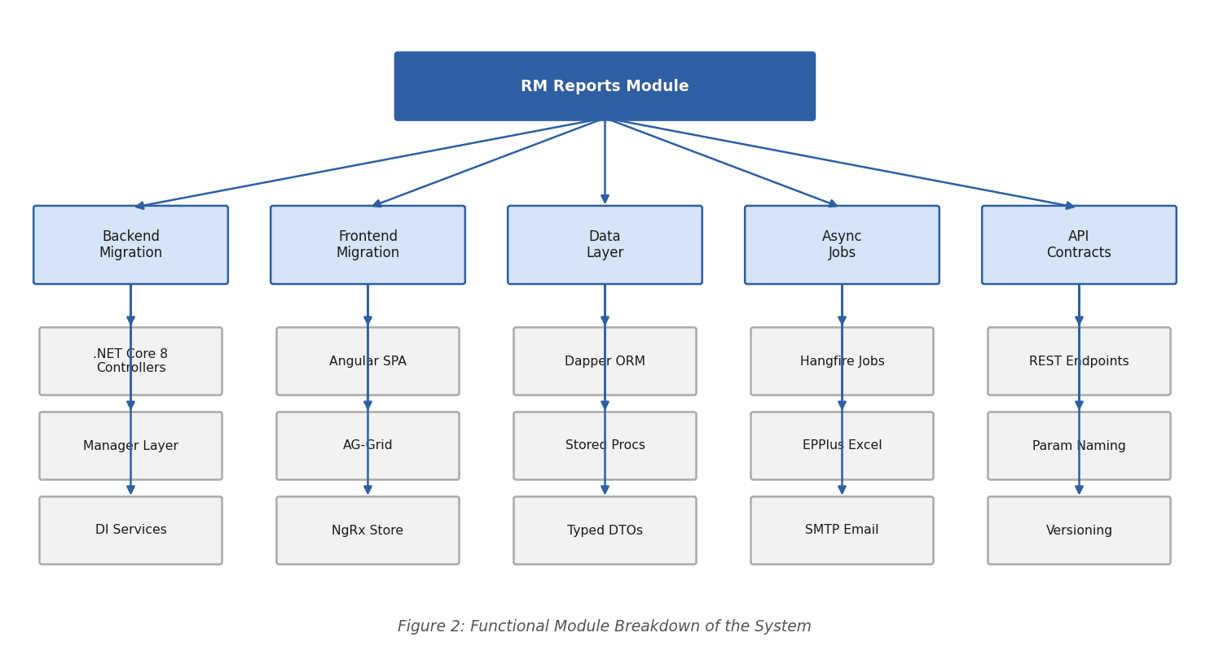
Figure 2: Functional Module Breakdown of the System

4. Data Flow Model
When the user accesses the Angular SPA, filter selections are passed to the .NET Core 8 REST API. The Controller delegates to the Manager layer, which invokes the Data Access layer via Dapper to execute stored procedures against SQL Server. For Excel reports, results are passed to EPPlus-based WorkbookCreation classes and the generated file is stored on the server. The user receives a download link and the file is streamed back to the browser. This flow preserves data integrity and clear module separation throughout.
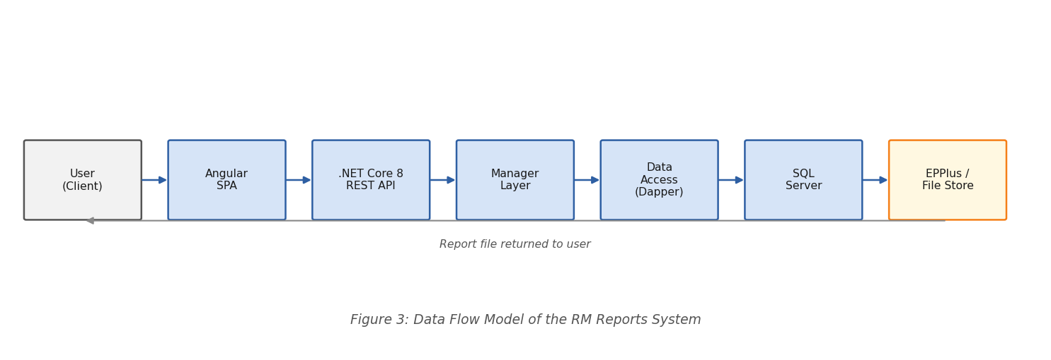
Figure 3: Data Flow Model of the RM Reports System

5. Development Lifecycle
The project follows an iterative development lifecycle as illustrated in Figure 4, with periodic reviews after each phase to evaluate progress and guide subsequent iterations:
- Legacy Analysis
Audit existing system, produce component mapping and gap analysis.
- Architecture Design
Define layered backend and Angular component hierarchy; specify DTOs and API contracts.
- Backend Migration
Implement .NET Core 8 controllers, Manager, AsyncReport, Dapper DataAccess, EPPlus.
- Frontend Migration
Build Angular RmreportComponent, FilterComponent, GridComponent, and RmreportService.
- Integration & Validation
Side-by-side Excel output comparison, DTO schema review, regression testing.
- API Cutover & Deployment
Deprecation notices, parallel deployment, controlled consumer cutover.
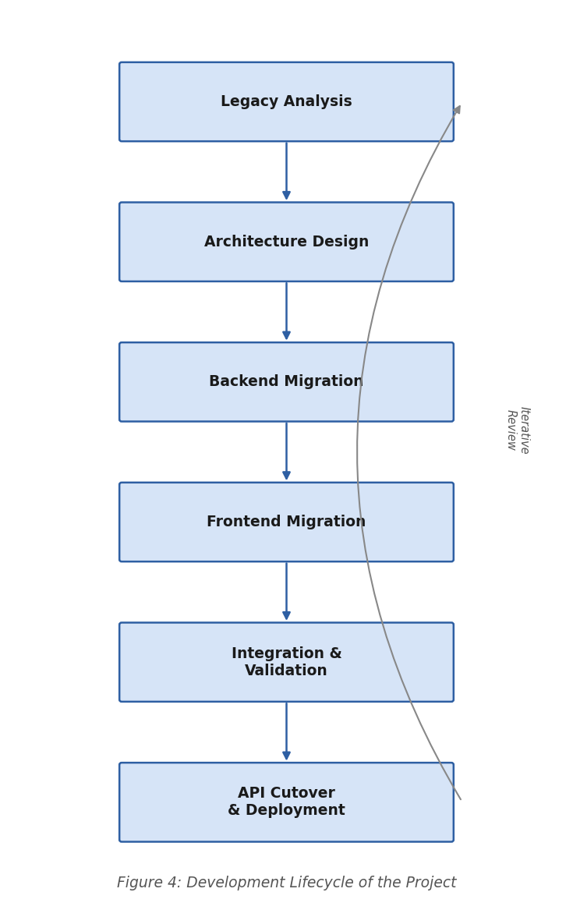
Figure 4: Development Lifecycle of the Project

6. Testing Strategy
Validation of functional correctness is performed at each phase:
- Unit tests for Controller, Manager, AsyncReport, DataAccess, and WorkbookCreation layers independently
- Side-by-side Excel output validation: EPPlus vs Infragistics formatting, column widths, number formats, freeze panes
- Angular component testing: reactive form state, AG-Grid column definitions, NgRx action/reducer correctness
- API contract testing: normalized parameter names, typed response shapes, RESTful convention adherence
- Regression testing across all report generation flows before each phase cutover
This testing approach ensures each module operates correctly in isolation and in the integrated environment, enabling safe, incremental delivery of the migrated system.

6 Work Done So Far
The migration project is being executed in a phased and modular manner. The following activities have been successfully completed as of the midterm review:

- 1. Legacy Analysis and System Understanding
- Induction into the GIS team at MUFG Global Services and orientation to the existing RM Reports codebase
- Detailed review of the monolithic cabhtml Razor view: inline CSS, inline JavaScript, jQuery UI tabs, hard-coded element IDs
- Full audit of ConcentrationReports.js: DOM event handlers, AJAX call construction, DataTables initialization, sessionStorage state management
- Mapping of split MVC/WebAPI routing: identified inconsistent serialization rules and non-RESTful patterns
- Profiled Infragistics workbook generation pipeline and confirmed .NET Core incompatibility
- Documented BAO/DAO layer: dynamic result sets, manual mapping, no typed domain models
Result: Complete component mapping and gap analysis document produced, forming the migration blueprint.

- 2. Architecture Design
- Designed layered backend architecture: Controller → Manager → AsyncReport → DataAccess / WorkbookCreation
- Defined Angular component hierarchy: RmreportComponent (container), RmreportFilterComponent, RmreportGridComponent, RmreportService
- Specified all DTO schemas (RMReportRevenueData, RMReportDepositData, RMFacilityData, TRMScorecardData, etc.) aligned to stored procedure result shapes
- Documented all API endpoint contracts: /api/rmreports/dropdowns, /api/rmreports/generate, /api/rmreports/async-files, /api/rmreports/download
- Defined parameter normalization rules: legacy ddlReportTypes → reportType, ddlBusinessLines → businessLine
Result: Full architecture design document approved by Architecture Board, Backend Lead, and Frontend Lead.

- 3. Backend Migration – Controller and Manager Layer
- Implemented RMReportsController with RESTful endpoints, stateless design, external authentication, and validated query parameters
- Built RMReportsManager as the business logic boundary: dropdown loading, hub name resolution, file discovery, DTO population
- Replaced all static utility class calls with DI-injected interfaces across the service layer
- Migrated IDataAccess: multi-result-set stored procedure mapping, explicit parameter typing, fully typed models — no dynamic objects
Result: All backend controller and manager endpoints operational and returning strongly-typed responses.

- 4. EPPlus-Based WorkbookCreation
- Replaced Infragistics Workbook engine with EPPlus ExcelPackage → MemoryStream → File pipeline
- Implemented number formatting templates, conditional formatting rules, and FreezePanes for all report types
- Validated EPPlus output files side-by-side against legacy Infragistics output for formatting parity
- Confirmed smaller output file sizes and significantly faster generation times with EPPlus
Result: Excel generation pipeline fully migrated to EPPlus with validated output parity.

- 5. Hangfire AsyncReport Refactoring
- Converted static Hangfire job methods into DI-managed AsyncReport classes with injected dependencies
- Implemented execution flow: load SP results → map to DTOs → load Excel schema → build EPPlus workbook → write file → send SMTP email
- Added centralized error logging and email-on-failure notification
Result: Async report generation pipeline operational with full DI support and isolated error handling.

- 6. Angular Frontend – Initial Implementation
- Scaffolded RmreportComponent (container) managing filter state, refresh actions, and grid reload triggers
- Implemented RmreportFilterComponent with reactive forms, Angular-controlled dropdowns, and event emitters (filtersChange, getReport, reset, refresh)
- Developed RmreportService: all HTTP calls, DTO normalization, string/date formatting, mapping to backend parameters
- Eliminated all jQuery logic; replaced with typed Angular service layer and reactive form bindings
Result: Angular SPA filter and service layers operational; grid integration in progress.

7 Remaining Work
Although significant progress has been made across backend migration, Excel generation, async job refactoring, and Angular frontend scaffolding, the following key activities remain to be completed before project finalization:

- AG-Grid Integration
Complete RmreportGridComponent with AG-Grid: data retrieval from /async-files endpoint, file download handling, auto-size behavior, and TypeScript column definitions with built-in sorting, filtering, and resizing.
- NgRx State Management
Implement NgRx store for global state management: replace remaining sessionStorage usage with predictable, observable NgRx actions, reducers, and selectors.
- API Versioning & Deprecation
Issue formal deprecation notices for all legacy WebAPI endpoints. Deploy .NET Core 8 API in parallel alongside the legacy system and coordinate a controlled consumer cutover with monitoring.
- Full Regression Testing
Execute comprehensive regression testing across all report types: functional equivalence, Excel output parity, API contract consistency, and Angular reactive form correctness.
- Performance Validation
Benchmark AG-Grid performance with large datasets, validate EPPlus generation speed improvements, and confirm Hangfire async job throughput under load.
- Documentation and Final Report
Prepare system documentation including API reference, component hierarchy guide, DTO schema reference, and final project report with comparative architectural analysis.
Upon completion of all remaining tasks, the system will be fully migrated, validated, and documented — delivering a testable, maintainable, and platform-independent RM Reports subsystem on .NET Core 8 and Angular.

8 Scope
The modernized RM Reports platform has significant practical and academic scope across organizational, industrial, and research dimensions.

1. Organizational Benefits
The primary beneficiary is the GIS team at MUFG Global Services. The modernized system enables the organization to:
- Eliminate all .NET Framework dependencies, achieving full .NET Core 8 runtime compatibility
- Independently test every layer of the system through Dependency Injection and mockable interfaces
- Safely extend the reporting subsystem with new report types by adding DTOs and handlers — without cross-stack changes
- Improve Excel report generation speed and output quality through EPPlus
- Manage background report jobs with full observability through the Hangfire dashboard

2. Industrial Applicability
The migration patterns established in this project — layered .NET Core 8 architecture, Angular SPA modernization, EPPlus Excel generation, and DI-managed Hangfire jobs — are applicable to any organization migrating legacy ASP.NET MVC systems to modern platforms. The project serves as a replicable blueprint for enterprise modernization initiatives across the financial services and technology sectors.

3. Future Extensions
The modernized system can be further extended to include:
- Integration with automated CI/CD pipelines for continuous deployment of report updates
- Machine learning–based anomaly detection in financial report data
- Extended multi-currency and multi-region report generation support
- Real-time report status notifications via WebSockets or SignalR
- Containerization using Docker and orchestration via Kubernetes for scalable deployment
The project thus delivers immediate enterprise value while establishing a scalable, modern foundation for future growth in the GIS team's reporting capabilities.

References
[1] Microsoft, ".NET Core 8 Documentation," Microsoft Docs, 2024. [Online]. Available: https://learn.microsoft.com/en-us/dotnet/core/whats-new/dotnet-8
[2] Microsoft, "ASP.NET Core — Dependency Injection," Microsoft Docs, 2024. [Online]. Available: https://learn.microsoft.com/en-us/aspnet/core/fundamentals/dependency-injection
[3] Angular Team, "Angular Architecture Guide," Angular.io, 2024. [Online]. Available: https://angular.io/guide/architecture
[4] NgRx Community, "NgRx Store Documentation," ngrx.io, 2024. [Online]. Available: https://ngrx.io/guide/store
[5] EPPlus Software, "EPPlus — Create Advanced Excel Spreadsheets," GitHub, 2024. [Online]. Available: https://github.com/EPPlusSoftware/EPPlus
[6] Hangfire, "Background Processing in .NET and .NET Core," Hangfire.io, 2024. [Online]. Available: https://www.hangfire.io/
[7] AG-Grid, "AG-Grid Angular Documentation," ag-grid.com, 2024. [Online]. Available: https://www.ag-grid.com/angular-data-grid/
[8] Stack Overflow / Sam Saffron, "Dapper — a simple object mapper for .NET," GitHub, 2024. [Online]. Available: https://github.com/DapperLib/Dapper
[9] R. Pressman and B. Maxim, Software Engineering: A Practitioner’s Approach, 9th ed. McGraw-Hill Education, 2019.

