**Step 1:**

Screenshot of summary report for 3 requests in 1 second.

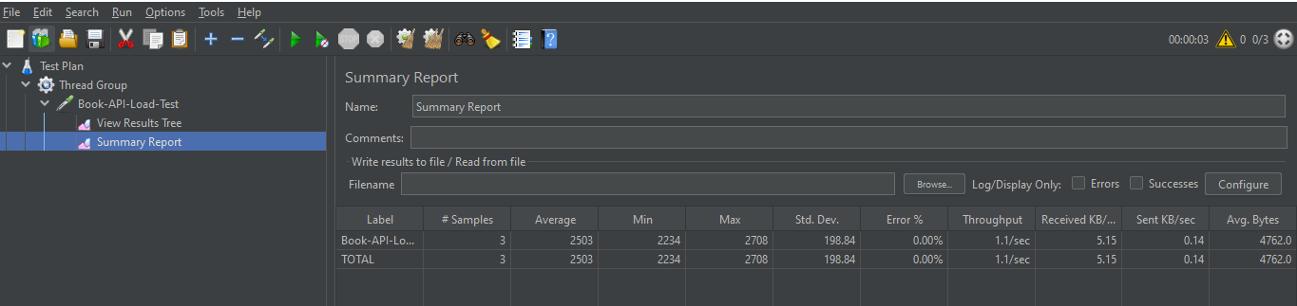

**Step 2:**

Screenshot of summary report for 167 requests in 60 seconds.

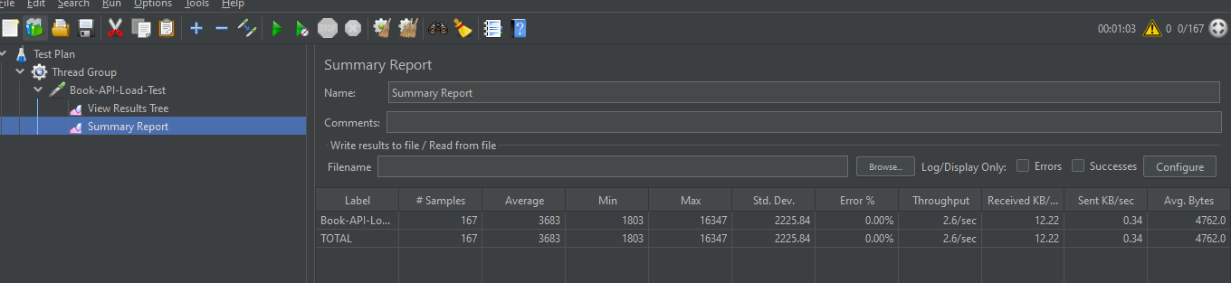

**Step 3:**

Screenshot of summary report for 833 requests in 300 seconds.

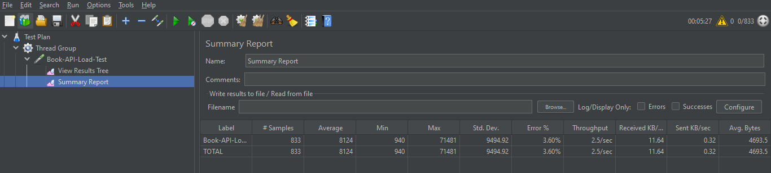

**Step 4:**

Screenshot of summary report for 833 requests in 350 seconds.

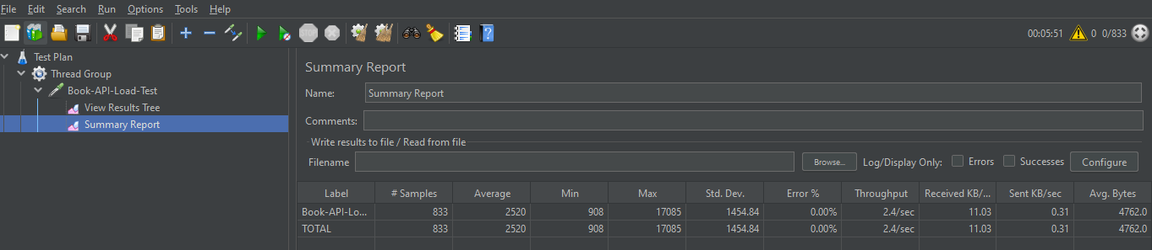

**Step 5:**

Screenshot of summary report for 1667 requests in 600 seconds.

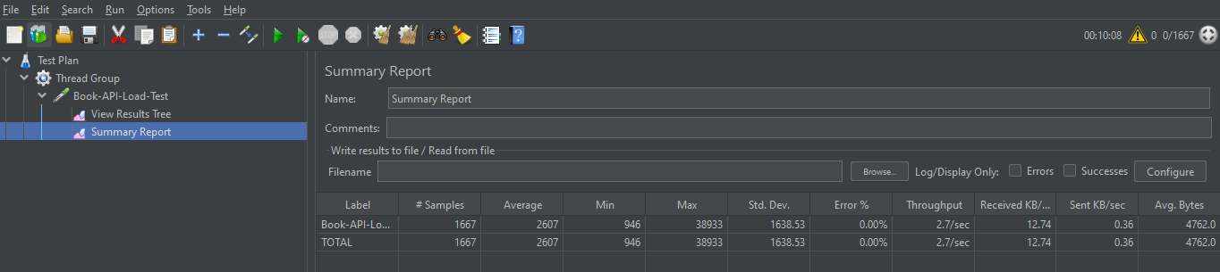

**Step 6:**

Screenshot of summary report for 2500 requests in 900 seconds.

