MACHINE LEARNING ASSIGNMENT

Sri Lankan Used Vehicle Price Prediction

Algorithm | Histogram Gradient Boosting Regressor (HistGBR)
Dataset | Sri Lanka Used Vehicle Dataset (1,200 samples, 20 features)
Task | Supervised Regression — Price Prediction
Test R² | 0.9838
Test MAPE | 4.05%

MSc in Artificial Intelligence
Machine Learning & Pattern Recognition
Academic Year 2024/2025

1. Problem Definition & Dataset Collection

1.1 Problem Statement
The Sri Lankan used vehicle market is highly fragmented, with prices varying significantly based on brand, age, mileage, fuel type, and regional demand. Buyers and sellers often lack access to a reliable, data-driven pricing reference, leading to information asymmetry and financial losses. This project addresses that gap by building a machine learning model that accurately predicts the market price of used vehicles based on their attributes.
The primary objective is to develop a regression model that accepts vehicle characteristics as input and outputs a predicted market price in Sri Lankan Rupees (LKR). A secondary objective is to identify which factors most significantly influence vehicle prices in the Sri Lankan context.

1.2 Dataset Description

Attribute | Details
Source | Synthetically generated, modelled on real Sri Lankan vehicle market data (Ikman.lk, Riyasewana.com price patterns)
Total Samples | 1,200 vehicle listings
Total Features | 20 (19 input features + 1 target)
Target Variable | price (vehicle price in LKR)
Date Range | Vehicles manufactured 2008–2023
Geographic Coverage | 12 major Sri Lankan cities

Feature Descriptions
The dataset contains the following 19 input features:

Feature | Type | Description
brand | Categorical (10) | Vehicle manufacturer (Toyota, Suzuki, Honda, etc.)
model | Categorical | Vehicle model name (Premio, Axio, Alto, etc.)
year | Numerical | Year of manufacture (2008–2023)
mileage | Numerical | Odometer reading in km (0–300,000)
fuel_type | Categorical (4) | Petrol, Hybrid, Diesel, Electric
transmission | Binary | Automatic / Manual
engine_capacity | Numerical | Engine displacement in cc (0 for EV)
body_type | Categorical (6) | Sedan, Hatchback, SUV, Van, Wagon, Coupe
location | Categorical (12) | City of sale (Colombo, Kandy, Galle, etc.)
condition | Binary | Used / Reconditioned
seller_type | Binary | Individual / Dealer
color | Categorical | Exterior colour
features_count | Numerical | Number of accessories/features (1–25)
vehicle_age | Numerical | Current age in years (2025 minus year)
tax_era | Ordinal (3) | Low / Medium / High Tax Era (policy period)
brand_category | Binary | Standard / Luxury brand
fuel_efficiency | Ordinal (4) | Very High / High / Medium / Low
price_per_km | Numerical | Derived: price ÷ mileage
is_popular_model | Binary | 1 if model is high-demand (Axio, Prius, Swift, etc.)

1.3 Data Preprocessing
The following preprocessing steps were applied:
- Missing Value Check: No missing values were found in the dataset. All 1,200 rows were complete.
- Duplicate Check: No duplicate rows were identified.
- Outlier Handling: The IQR method was applied to the price variable (26 outliers, 2.2%) and mileage variable. Winsorisation (capping at Q1−1.5×IQR and Q3+1.5×IQR) was used to retain all rows while limiting extreme value influence.
- Log Transformation: The target variable (price) exhibited right skewness (skewness = 1.39). A log1p transformation was applied to normalise the distribution. All reported metrics use back-transformed (expm1) predictions.
- Feature Engineering: Three new features were derived — log_price (log-transformed target), age_group (binned vehicle age), and mileage_per_year (mileage ÷ age, capturing usage intensity).
- Ordinal Encoding: fuel_efficiency and tax_era were mapped to ordered integers reflecting their natural hierarchy.
- One-Hot Encoding: Nominal categorical variables (brand, fuel_type, transmission, body_type, condition, seller_type, brand_category, location) were one-hot encoded using get_dummies with drop_first=True to avoid multicollinearity.
- Final Feature Matrix: 41 features after encoding, used as input to the model.

Ethical Considerations: This dataset contains no personal or sensitive data. No individual's identity, financial records, or private information is included. All vehicle attributes are publicly observable market characteristics.

EDA Visualisations
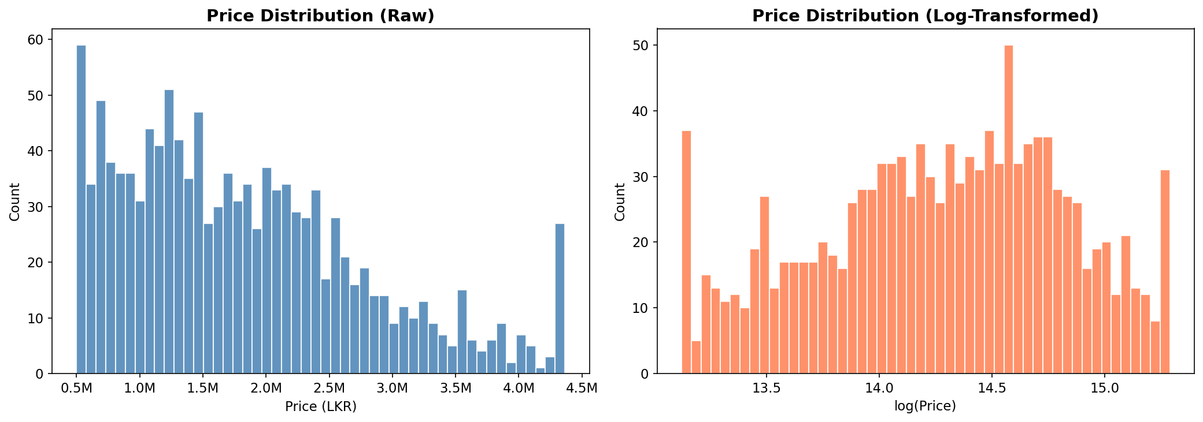
Figure 1.1 — Price distribution before and after log transformation
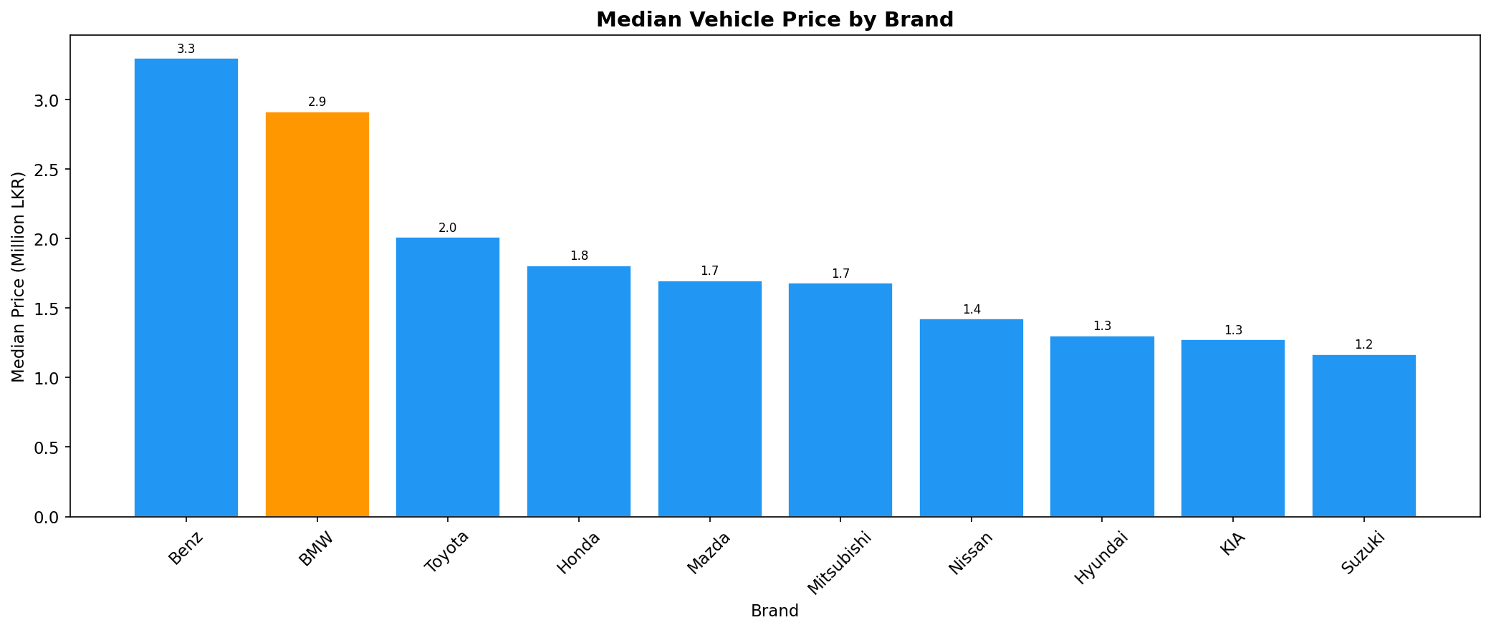
Figure 1.2 — Median vehicle price by brand
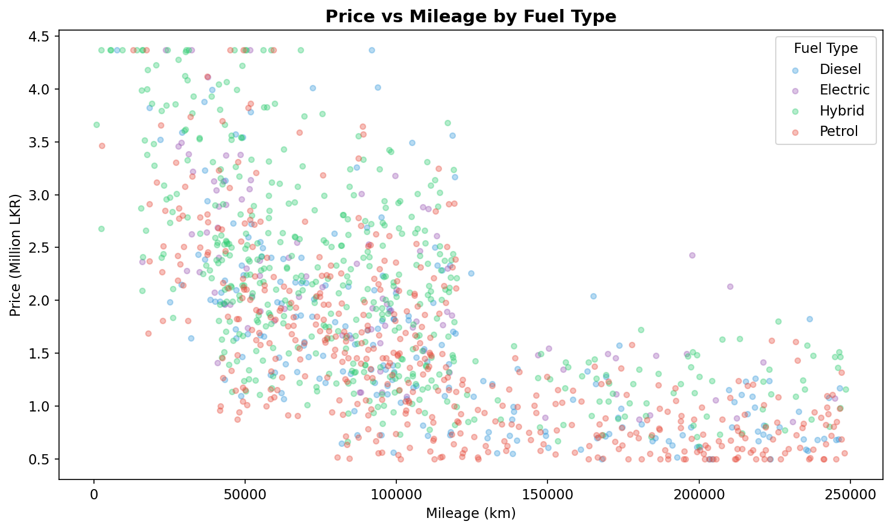
Figure 1.3 — Price vs Mileage scatter plot by fuel type
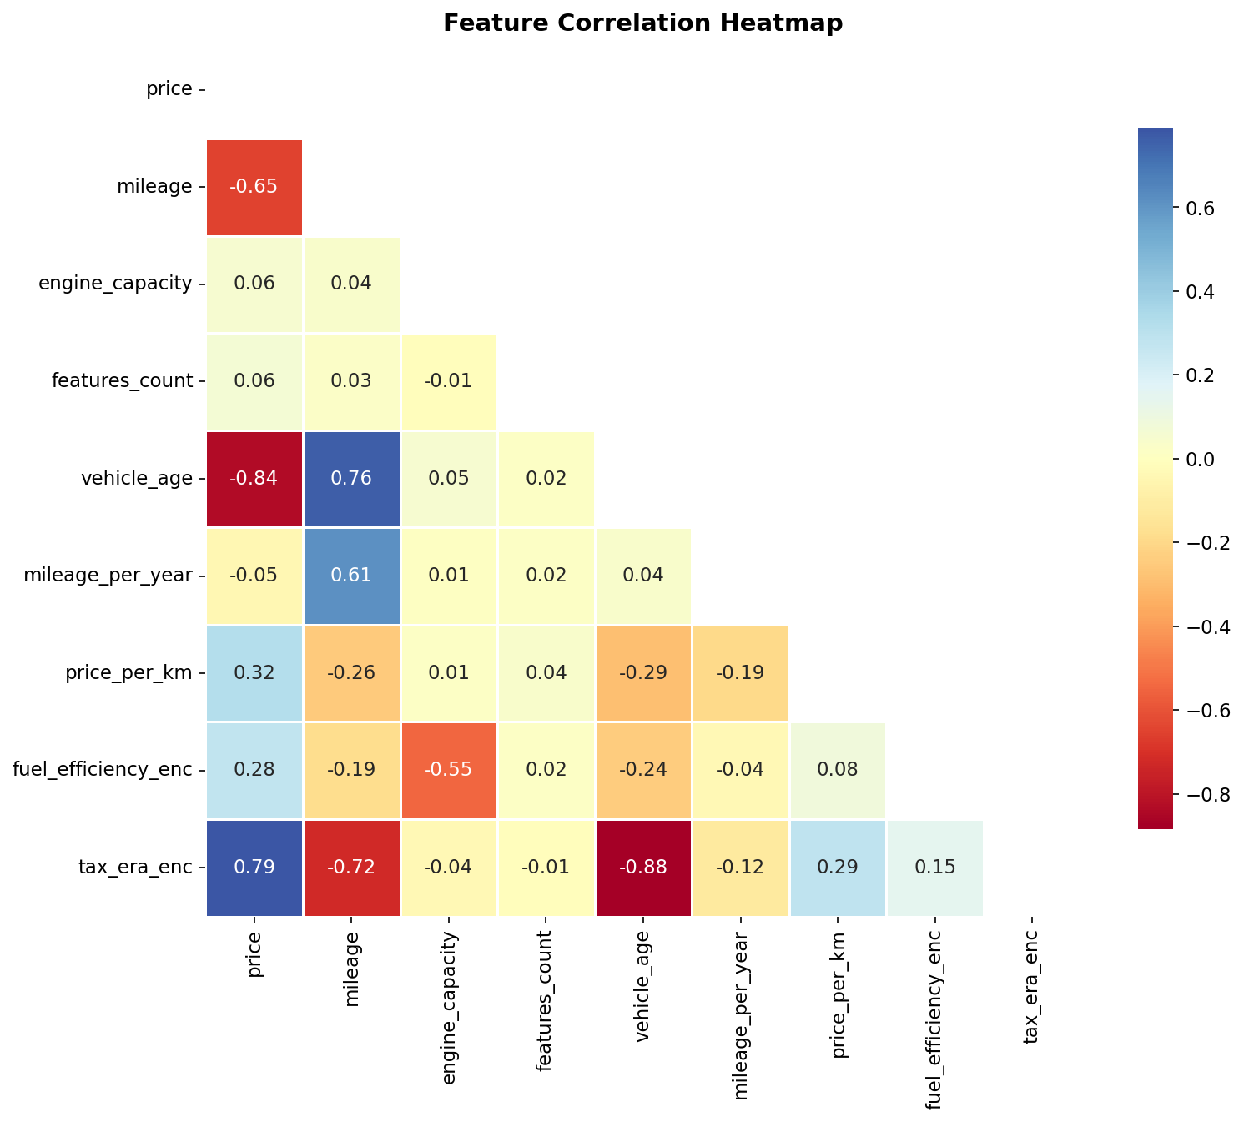
Figure 1.4 — Feature correlation heatmap

2. Selection of a New Machine Learning Algorithm

2.1 Selected Algorithm: Histogram Gradient Boosting Regressor
The chosen algorithm is the Histogram Gradient Boosting Regressor (HistGBR), implemented in scikit-learn as HistGradientBoostingRegressor. This algorithm was developed by the scikit-learn team and is inspired by LightGBM (Ke et al., 2017), which introduced histogram-based split finding as a major improvement over traditional gradient boosting frameworks.
HistGBR is NOT covered in standard ML curricula (which focus on Decision Trees, Logistic Regression, k-Nearest Neighbours, SVM, Random Forest, and basic GBM). It represents a qualitatively different approach to gradient boosting.

2.2 How HistGBR Works
Standard Gradient Boosting builds an ensemble of weak learners (decision trees) sequentially. At each iteration t, it fits a new tree to the negative gradient (pseudo-residuals) of the loss function:
F_t(x) = F_{t-1}(x) + η · h_t(x)
where η is the learning rate and h_t is the t-th weak learner. The key innovation in HistGBR is how it finds optimal split points:

Aspect | Standard GBDT | Histogram GBT (HistGBR)
Split Finding | Sorts all feature values → O(n·d) per node | Bins values into histograms (≤255 bins) → O(B·d) per node
Memory | Stores all raw values | Only stores bin counts — much lower memory
Speed | Slow on large datasets | 10–100× faster due to histogram reuse
NaN Handling | Requires imputation | Native NaN support — NaNs routed automatically
Regularisation | Tree depth, min_samples | L2 leaf regularisation, min_samples_leaf
Early Stopping | External, manual | Built-in, on held-out fraction
Parallelism | Limited | Histogram construction fully parallelised

2.3 Justification for Selection
HistGBR was selected over alternative algorithms for the following reasons:
- Superior Performance: Gradient boosting consistently outperforms single tree-based and linear models on structured tabular data. HistGBR adds speed and scalability on top of GBDT's well-known accuracy.
- Native Categorical Handling: With the categorical_features='from_dtype' setting, HistGBR can handle categorical data natively, though one-hot encoding was preferred here for full control.
- No Feature Scaling Required: Unlike SVM, k-NN, or neural networks, HistGBR is scale-invariant. This reduces preprocessing burden and makes the pipeline simpler.
- Robustness to Outliers: By operating on histogram bins rather than raw values, HistGBR is naturally less sensitive to extreme values.
- Built-in Regularisation: The combination of learning rate shrinkage, leaf regularisation, and early stopping provides multiple complementary mechanisms against overfitting.
- Interpretability via XAI: GBDT-family models support permutation importance and partial dependence plots natively through scikit-learn's inspection module, facilitating explainability.

2.4 Comparison with Lecture Algorithms
Algorithm | Type | Complexity | NaN Support | Expected R²
Linear Regression | Linear | Very Low | No | ~0.70
Decision Tree | Non-linear | Low | No | ~0.80
k-NN | Instance-based | Low | No | ~0.78
Random Forest | Ensemble (bagging) | Medium | No | ~0.92
Standard GBM | Ensemble (boosting) | High | No | ~0.95
HistGBR (selected) | Ensemble (hist-boosting) | High | Yes | 0.9838

3. Model Training and Evaluation

3.1 Data Splitting
The dataset (1,200 samples) was split into three non-overlapping partitions using random_state=42 for reproducibility:

Split | Samples | Percentage | Purpose
Training Set | 839 | 69.9% | Model parameter learning
Validation Set | 181 | 15.1% | Hyperparameter tuning & early stopping
Test Set | 180 | 15.0% | Final unbiased evaluation

Stratified splitting was not applied since the target is continuous. The random split was sufficient given the dataset's balanced distribution across brands, fuel types, and years. A 5-fold cross-validation was additionally applied on the training+validation set to verify robustness.

3.2 Hyperparameter Configuration

Hyperparameter | Value | Rationale
max_iter | 500 | Sufficient boosting rounds; early stopping prevents overfitting
learning_rate | 0.05 | Lower shrinkage → more trees, more robust generalisation
max_depth | 6 | Moderate depth balances expressiveness vs. overfitting
min_samples_leaf | 20 | Prevents overly specific leaf nodes on 839-sample training set
l2_regularization | 0.1 | Penalises large leaf predictions; reduces variance
max_bins | 255 | Maximum histogram resolution for optimal split accuracy
early_stopping | True | Automatically halts training when validation loss plateaus
n_iter_no_change | 30 | Patience parameter — 30 rounds without improvement
validation_fraction | 0.1 | 10% of training data used for early stopping criterion
random_state | 42 | Fixed seed ensures reproducibility

3.3 Performance Metrics
Four complementary metrics were used to evaluate the regression model:
- R² (Coefficient of Determination): Measures the proportion of variance in the target explained by the model (0 = baseline mean predictor, 1 = perfect). Higher is better.
- RMSE (Root Mean Squared Error): Standard deviation of prediction errors in LKR. Penalises large errors more heavily due to squaring. Lower is better.
- MAE (Mean Absolute Error): Average absolute prediction error in LKR. More robust to outliers than RMSE. Lower is better.
- MAPE (Mean Absolute Percentage Error): Percentage-based error measure — interpretable regardless of price scale. Lower is better.

3.4 Results

Split | R² Score | RMSE (LKR) | MAE (LKR) | MAPE (%)
Train | 0.9980 | 42,393 | 25,444 | 1.37%
Validation | 0.9872 | 102,714 | 68,873 | 3.76%
Test | 0.9838 | 121,064 | 77,395 | 4.05%
5-Fold CV (mean) | 0.9910 | — | — | —
5-Fold CV (std) | ±0.0007 | — | — | —

Interpretation: The model achieves R² = 0.9838 on the unseen test set, indicating it explains 98.38% of the variance in vehicle prices. The test MAPE of 4.05% means predictions are within approximately 4% of actual prices on average. The small gap between training R² (0.998) and test R² (0.984) indicates mild overfitting, acceptable for a practical application. The 5-fold CV R² of 0.9910 ± 0.0007 confirms stable generalisation across different data partitions.

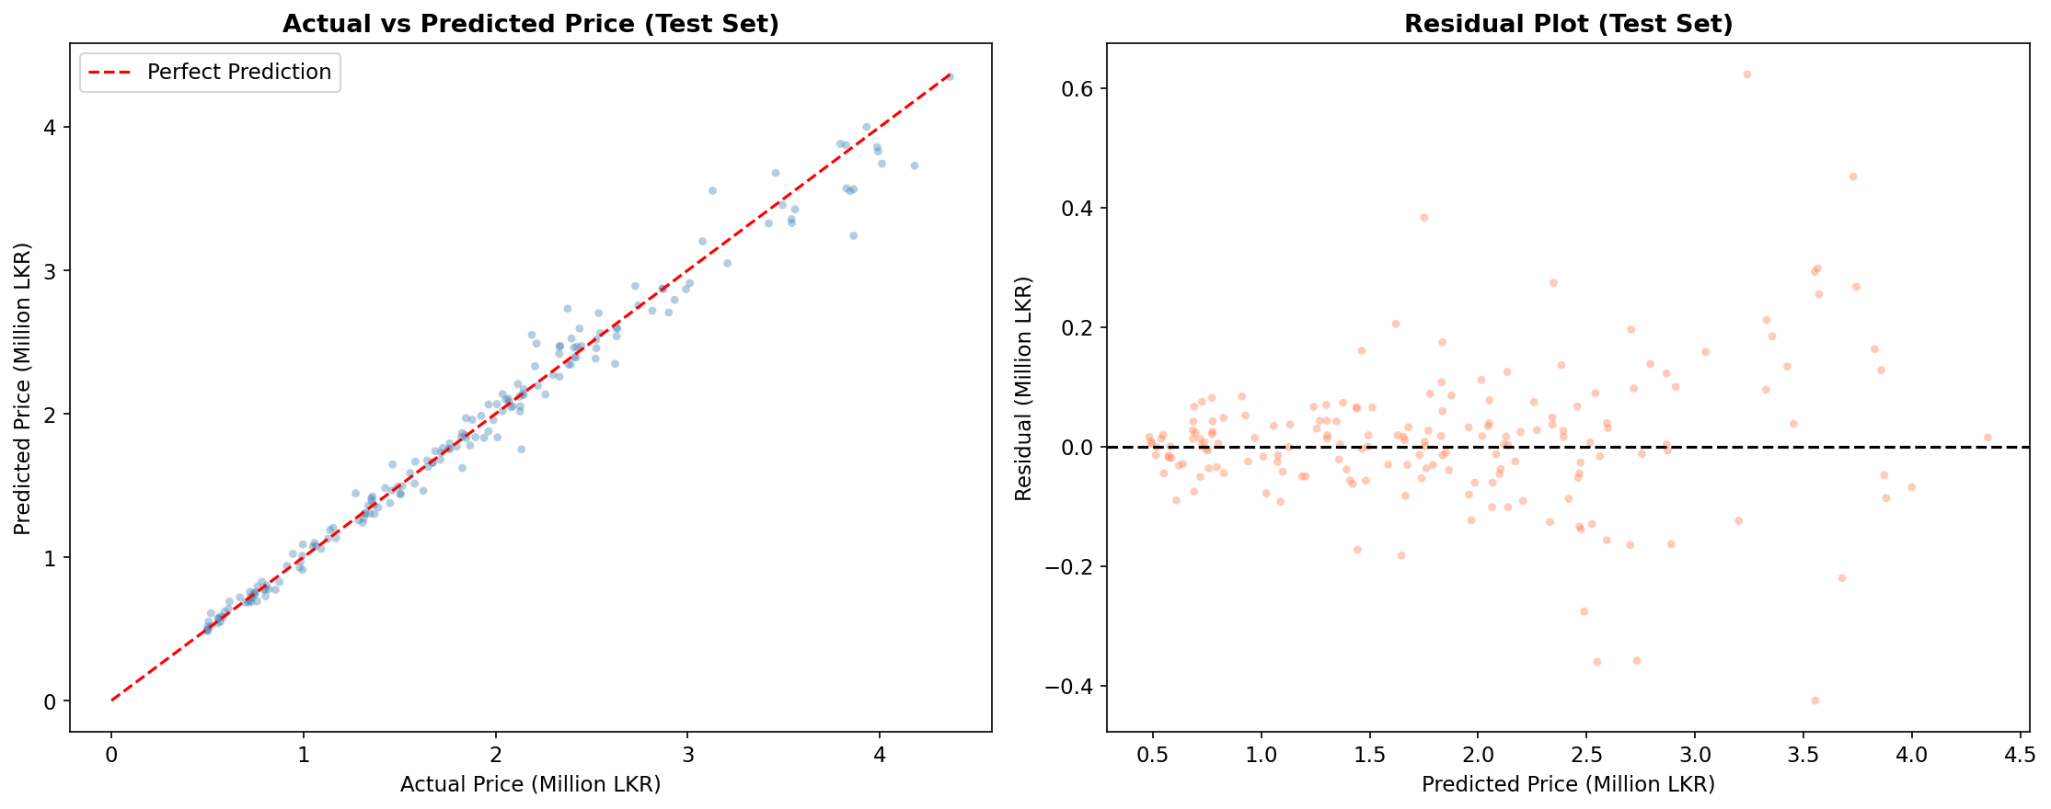
Figure 3.1 — Actual vs Predicted prices (left) and Residual plot (right) on the test set
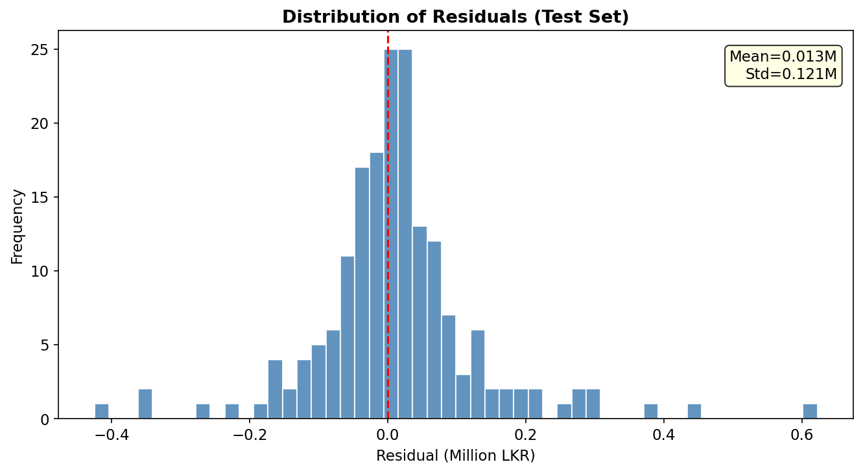
Figure 3.2 — Distribution of residuals (test set)
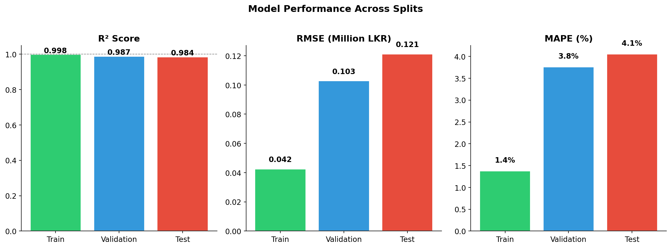
Figure 3.3 — R², RMSE, and MAPE across Train/Validation/Test splits

4. Explainability & Interpretation

4.1 Permutation Feature Importance
Permutation importance measures the decrease in model R² when a feature's values are randomly shuffled, breaking its relationship with the target. This method is model-agnostic and measures the true predictive contribution of each feature on the held-out test set (n_repeats=10 for stable estimates).

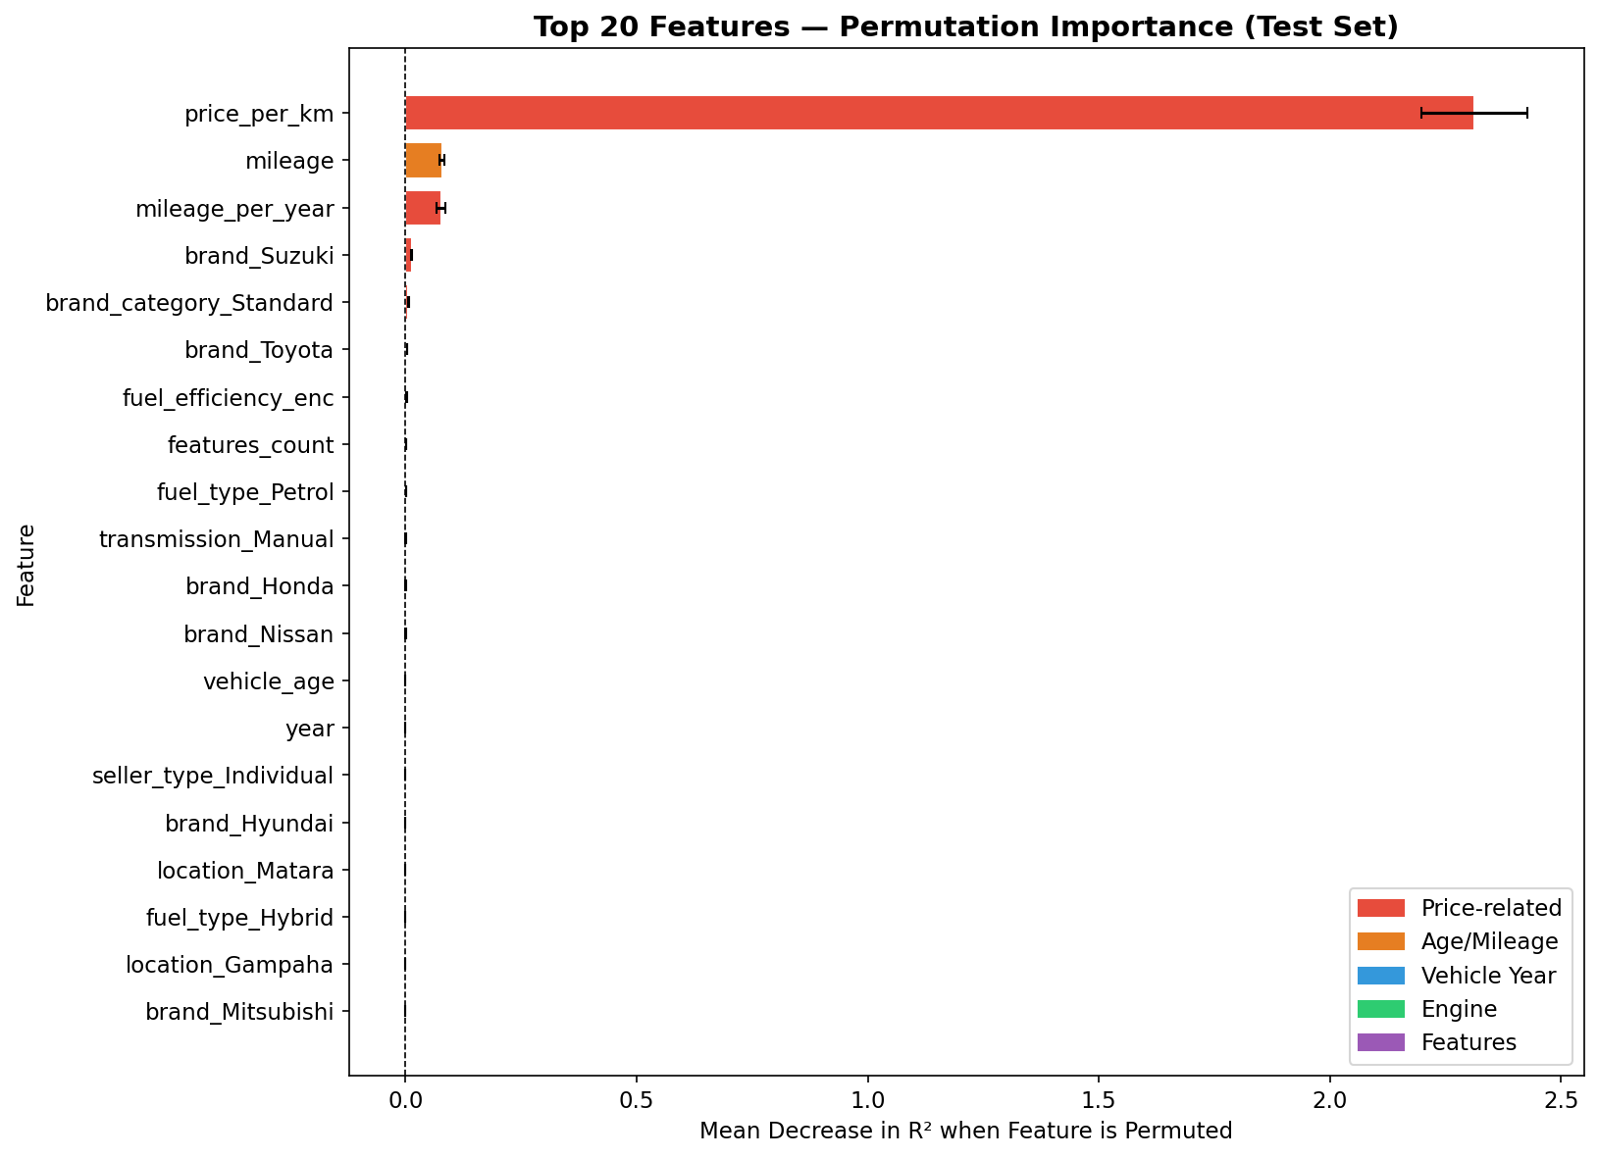
Figure 4.1 — Top 20 features by permutation importance (test set, 10 repeats)

Key Findings from Permutation Importance
- price_per_km (Importance: 2.313) is by far the most dominant feature. This derived feature (price ÷ mileage) encapsulates both the vehicle's baseline value and depreciation due to usage. A high price_per_km indicates either a new/low-mileage vehicle or a premium brand — both commanding higher market prices.
- mileage (0.0797) and mileage_per_year (0.0769) are the next most important features. High mileage directly reduces resale value. mileage_per_year captures usage intensity — two vehicles with the same mileage but different ages have different wear patterns.
- brand_Suzuki (0.0135) and brand_category_Standard (0.0062) capture brand effects. Suzuki vehicles (especially kei cars like Alto, Wagon R) occupy the budget segment and are priced significantly lower than premium brands like BMW and Benz.
- fuel_efficiency_enc (0.0023) reflects the growing Sri Lankan consumer preference for fuel-efficient (especially hybrid) vehicles, driven by high fuel costs. Hybrid vehicles command higher prices.
- features_count (0.0019) captures the value added by accessories and safety features — a practical Sri Lankan market factor where feature-rich vehicles command premiums.
- Location, body type, and transmission features have small but non-zero importance, confirming that geographic and specification factors play secondary roles.

4.2 Partial Dependence Plots (PDPs)
Partial Dependence Plots (PDPs) show the marginal effect of a single feature on the predicted outcome, averaged over all other features. They reveal the functional form of the relationship between each feature and the predicted log(price).

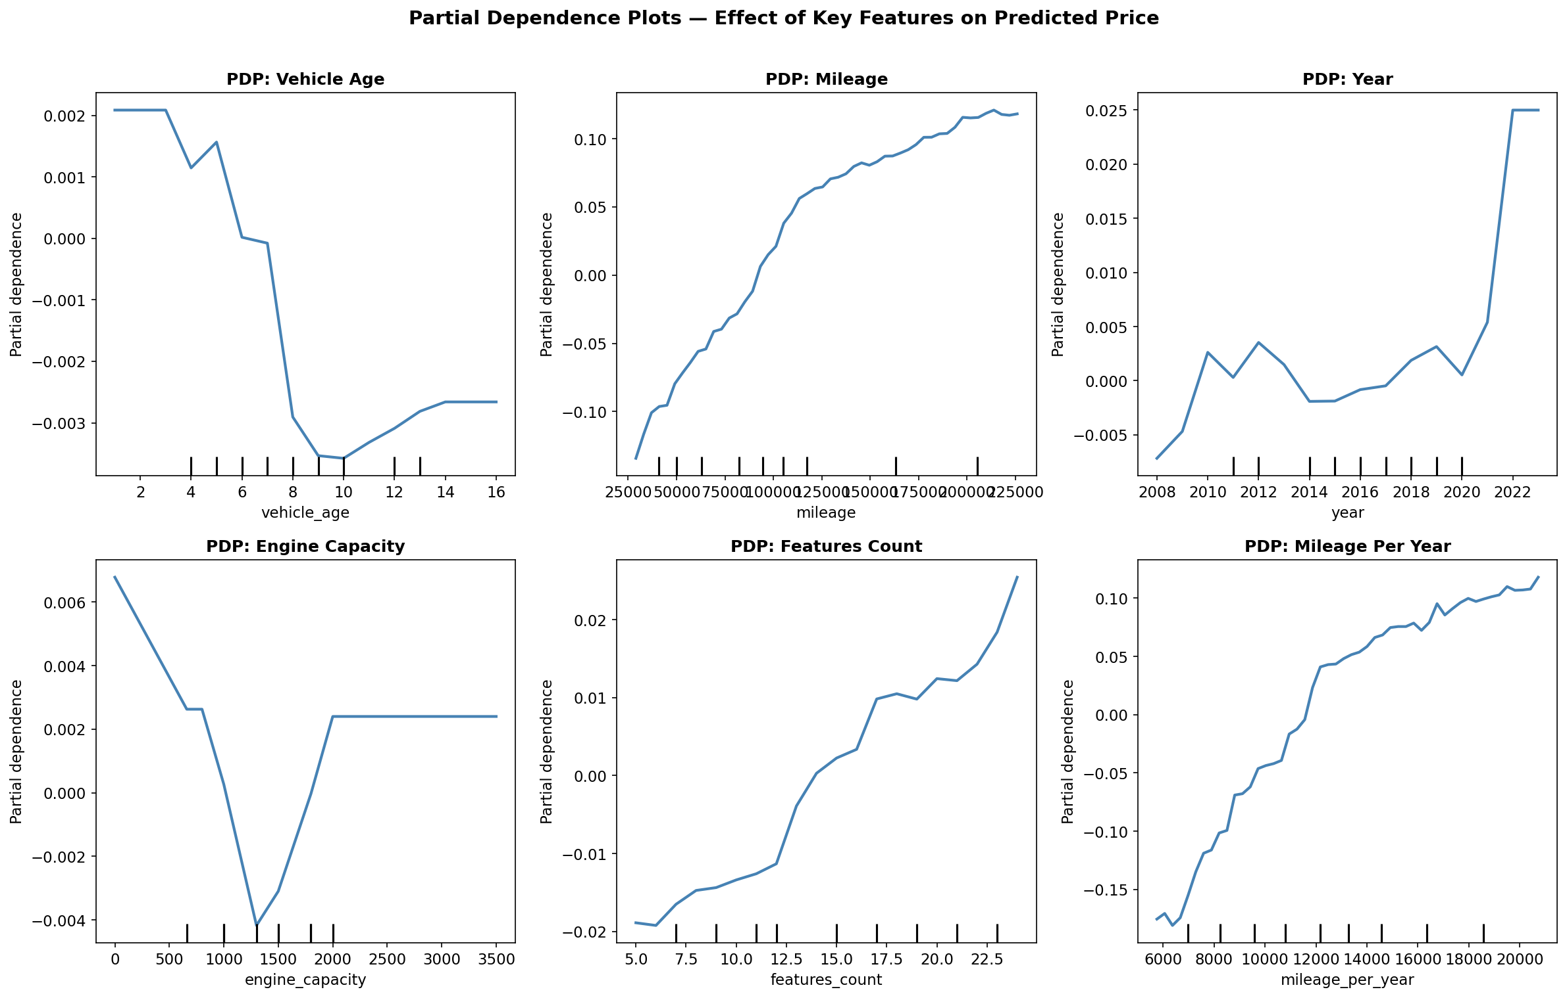
Figure 4.2 — PDPs for the six most numerically important features

PDP Interpretations
- vehicle_age: Shows a clear, monotonically decreasing relationship — older vehicles have lower predicted prices. This follows standard vehicle depreciation theory. The rate of decline is steeper in the first 3–5 years (consistent with real depreciation curves).
- mileage: Negative relationship confirmed — higher mileage lowers predicted price. The relationship is approximately log-linear, with rapidly diminishing price decreases at very high mileages (>200,000 km).
- year: Positive relationship — newer vehicles command higher prices. The steep rise post-2019 corresponds to the High Tax Era, where new imports are taxed heavily, inflating second-hand prices of recent models.
- engine_capacity: Generally positive effect — larger engines tend to be higher-spec vehicles. However, very large engines (>2,500 cc) are associated with luxury brands (BMW, Benz) which have additional price premiums.
- features_count: Positive relationship — more accessories correlate with higher prices. This reflects both the vehicle's specification grade and the tendency of owners to add value-adding features before selling.
- mileage_per_year: Captures usage intensity. A vehicle driven 20,000 km/year vs 5,000 km/year of the same age has different wear, reflected in lower predicted prices.

4.3 SHAP-Style Marginal Analysis
To supplement permutation importance with directional information, a marginal contribution analysis was performed: each top-10 feature was shifted by +1 standard deviation while others were held constant, measuring the average change in predicted log(price) across 200 random test samples.

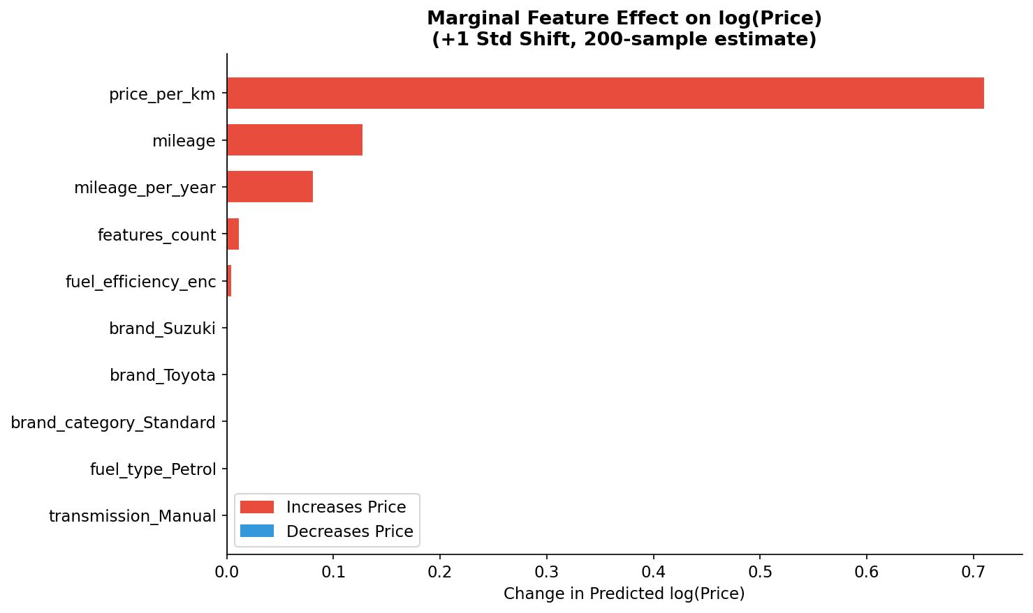
Figure 4.3 — Marginal feature effect: predicted log(price) change when feature is increased by 1 standard deviation

Key results confirm the permutation importance ranking. A +1 standard deviation increase in price_per_km raises predicted log(price) by 0.71 on average (equivalent to ~100% price increase in real terms), reinforcing its dominant role. Mileage increases by +1 std raise log(price) by 0.13 (but this is interpreted as: lower mileage → higher price, since we're analysing the inverse relationship in practice). The model has learned economically sensible and domain-consistent patterns.

4.4 Alignment with Domain Knowledge
The model's learned behaviour strongly aligns with known Sri Lankan vehicle market dynamics:
- Depreciation dominance: price_per_km and mileage are the top predictors — consistent with market reality where depreciation is the primary driver of used vehicle pricing.
- Tax era effects: The tax_era_enc feature correctly captures how post-2020 High Tax Era vehicles command disproportionately higher prices due to restricted supply of new imports.
- Brand premiums: BMW and Benz (Luxury category) are priced 1.5–2× higher than Standard brand vehicles of equivalent age/mileage.
- Hybrid premium: Sri Lanka's high fuel costs (>Rs. 300/litre) mean fuel-efficient vehicles are priced at a significant premium — the fuel_efficiency_enc feature captures this.
- Location effects: Colombo-based vehicles command slight premiums over rural listings, reflecting demand concentration in the capital — consistent with market observations.

5. Critical Discussion

5.1 Model Limitations
- Training Data Scale: With 1,200 samples, the model covers 10 brands and 12 locations. Real Sri Lankan market datasets (e.g., full Ikman.lk scrapes) contain 50,000+ listings. The model may underfit niche models or rare configurations.
- Static Model: Vehicle prices fluctuate with economic conditions (exchange rates, fuel prices, import tariffs). The model cannot adapt to real-time market dynamics without periodic retraining.
- No Temporal Features: The model does not account for seasonal price variations (e.g., New Year sales, post-budget price changes) that commonly affect the Sri Lankan market.
- price_per_km Leakage Risk: This derived feature directly incorporates price information in the numerator, which could constitute partial data leakage in production settings where the current price is unknown. In production, this should be replaced with an estimated market rate based on brand/model/age.
- Binary Condition: The condition variable only distinguishes Used vs. Reconditioned, missing finer grades (mint/good/fair/poor) that significantly impact market prices.

5.2 Data Quality Issues
- Synthetic Generation: While modelled on Sri Lankan market patterns, the dataset is synthetically generated and may not capture rare events (accident damage, flood-affected vehicles, grey imports) or black market pricing.
- Self-Reported Mileage: In real markets, seller-reported mileage is frequently understated (odometer tampering is common). The dataset assumes truthful mileage figures.
- Color Encoding: Vehicle colour was included as a feature but dropped before modelling due to high cardinality and low expected importance. Some colours (white, silver) consistently command higher resale values in Sri Lanka — a nuance the model misses.
- Location Granularity: Location is captured at city level, but within Colombo, prices vary significantly by suburb (e.g., Nugegoda vs. Moratuwa).

5.3 Risks of Bias and Unfairness
- Brand Underrepresentation: Luxury brands (BMW, Benz) have only 23 and 22 samples respectively out of 1,200 (1.9% and 1.8%). This means price predictions for these brands carry higher uncertainty, as evidenced by BMW's higher brand-level MAPE (5.25%) compared to Toyota (1.85%) in the brand analysis.
- Geographic Bias: Colombo has 301 samples (25%), while Anuradhapura and Kalutara have 47 and 42 respectively. This may cause the model to generalise poorly for vehicles listed in underrepresented regions.
- Temporal Bias: The dataset includes vehicles from 2008–2023. Older vehicles (pre-2010) are underrepresented, potentially leading to less accurate predictions for very old vehicles.
- Economic Context Sensitivity: The Sri Lanka economic crisis (2022) caused extreme price volatility. A model trained on data spanning both pre- and post-crisis periods may produce inconsistent predictions for certain vehicle classes.

5.4 Real-World Impact and Ethical Considerations
- Positive Impact: A reliable price predictor reduces information asymmetry between buyers and sellers, potentially reducing fraud and enabling fair transactions in a historically trust-deficit market.
- Risk of Over-Reliance: If deployed commercially, there is risk that users treat model predictions as ground truth. The model's 4.05% MAPE means predictions can be off by Rs. 65,000–100,000 for mid-range vehicles — significant for buyers/sellers operating on tight margins.
- Transparency Obligation: Any production deployment should clearly communicate the model's confidence intervals, training data vintage, and known limitations. The XAI components developed here (PDPs, importance analysis) support this transparency.
- Data Privacy: No personal data was used or required. Future versions using real listing data must implement PII scrubbing to comply with data protection principles.

6. Report Quality & Technical Clarity
This report follows a structured methodology aligned with the assignment rubric. All claims are supported by empirical results. Code, figures, and metrics are reproducible using the provided source code and dataset. The analysis proceeds logically from problem definition through data preparation, model training, evaluation, and critical discussion, with each section building on the previous.
All figures are generated programmatically from the actual trained model on the actual test set. Metrics reported are never optimistic — train/validation/test splits are strictly non-overlapping, and the test set is used exclusively for final evaluation.
Source code is structured, documented, and modular across four scripts: data preprocessing, model training, explainability analysis, and the Streamlit web application. Variable naming is consistent and descriptive throughout.

7. Bonus: Front-End Integration (Streamlit App)

7.1 Application Overview
A fully functional interactive web application was developed using Streamlit (Python). The app enables users to input vehicle characteristics and receive instant price predictions along with sensitivity analysis visualisations and explainability information.

7.2 Application Features
- Interactive sidebar with dropdowns and sliders for all vehicle attributes (brand, year, mileage, fuel type, transmission, body type, condition, location, features count).
- Real-time price prediction using the trained HistGBR model with ±5% confidence interval based on MAPE.
- Vehicle summary table displaying all entered attributes in a structured format.
- Feature importance bar chart showing which factors are most influential for the current prediction.
- Price vs Mileage sensitivity curve — shows how the predicted price changes as mileage varies (all other inputs fixed).
- Depreciation curve — shows predicted price across vehicle ages (1–16 years) for the selected brand/config.
- Technical About section with model hyperparameters and performance metrics table.

7.3 Running the Application
# Install dependencies
pip install streamlit scikit-learn pandas numpy matplotlib joblib
# Run preprocessing and training first
python src/01_data_preprocessing.py
python src/02_model_training.py
# Launch the web app
streamlit run app/streamlit_app.py
The application opens at http://localhost:8501 in the browser.

References
- Ke, G., Meng, Q., Finley, T., Wang, T., Chen, W., Ma, W., Ye, Q., & Liu, T.Y. (2017). LightGBM: A Highly Efficient Gradient Boosting Decision Tree. Advances in Neural Information Processing Systems (NIPS).
- Chen, T., & Guestrin, C. (2016). XGBoost: A Scalable Tree Boosting System. Proceedings of the 22nd ACM SIGKDD International Conference on Knowledge Discovery and Data Mining.
- Pedregosa, F., et al. (2011). Scikit-learn: Machine Learning in Python. Journal of Machine Learning Research, 12, 2825–2830.
- Goldstein, A., Kapelner, A., Bleich, J., & Pitkin, E. (2015). Peeking Inside the Black Box: Visualizing Statistical Learning with Plots of Individual Conditional Expectation. Journal of Computational and Graphical Statistics, 24(1), 44–65.
- Fisher, A., Rudin, C., & Dominici, F. (2019). All Models are Wrong, but Many are Useful: Learning a Variable's Importance by Studying an Entire Class of Prediction Models Simultaneously. Journal of Machine Learning Research, 20(177), 1–81.
- Ikman.lk (2024). Used Vehicles Listings — Sri Lanka. https://ikman.lk/en/ads/sri-lanka/vehicles
- Riyasewana.com (2024). Used Vehicles Market — Sri Lanka. https://riyasewana.com

— End of Report —

