**Task 2.a: Changing Enrolment Details**

1. **Changing Course (section) details**

**Relevant Procedures and Test scripts available under Task2.a=>a folder**

i. Enrolment table must be amended (updated) with the new section details (section ID)

Test case 01:Happy path: student without any assignment done

Test data:

**INSERT** **INTO** enrollment **VALUES** **(**102**,**90**,TO_DATE(**'30-JAN-2007 10:18:00'**,**'DD-MON-YYYY HH24:MI:SS'**),NULL,**'JAYCAF'**,TO_DATE(**'03-NOV-2007 00:00:00'**,**'DD-MON-YYYY HH24:MI:SS'**),**'CBRENNAN'**,TO_DATE(**'12-DEC-2007 00:00:00'**,**'DD-MON-YYYY HH24:MI:SS'**));**

**commit;**



After procedure call: changing section 90 to 91.



Test Case 02: student already completed any assignment of section

Error message:



ii. Enrolment log table must have entries detailing the sections they were enrolled on and the new sections with appropriate details and messages to indicate the changes

Enrollment log table



1. **Withdraw from a Course**

**Scripts available under Task2.a=>b folder**

1. Enrolment details must be removed from the original enrolment table.

Test case 01: happy path: student only enrolled to one course and not take any assignment.

-- Testing student only enrolled to one course

**INSERT** **INTO** student **VALUES** **(**400**,**'Mr.'**,**'Test'**,**'Crocitto'**,**'101-09 120th St.'**,**'11419'**,**'718-555-5555'**,**'Albert Hildegard Co.'**,**'22-JAN-07'**,**'BROSENZWEIG'**,TO_DATE(**'19-JAN-2007 00:00:00'**,**'DD-MON-YYYY HH24:MI:SS'**),**'BROSENZW'**,TO_DATE(**'22-JAN-2007 00:00:00'**,**'DD-MON-YYYY HH24:MI:SS'**));**

**INSERT** **INTO** enrollment **VALUES** **(**400**,**91**,TO_DATE(**'30-JAN-2007 10:18:00'**,**'DD-MON-YYYY HH24:MI:SS'**),NULL,**'JAYCAF'**,TO_DATE(**'03-NOV-2007 00:00:00'**,**'DD-MON-YYYY HH24:MI:SS'**),**'CBRENNAN'**,TO_DATE(**'12-DEC-2007 00:00:00'**,**'DD-MON-YYYY HH24:MI:SS'**));**

**COMMIT;**





After procedure call:

Student and enrollment relevant rows deleted.





Test case 02: Student completed one or more assignment



1. Student details must be removed from the Student table if they are not enrolled for any other courses.



1. Student and Enrolment log table must have the necessary details with appropriate details and messages to indicate the changes.

Log table updated: enrollment_log and student_log tables





1. **Suspension of Studies**

**Scripts available under Task2.a=>c folder**

1. Student details and Enrolment details must be removed from the original tables depending on whether they have any other courses and whether they have awarded any Grades.

Test case 01: Happy path: student has taken single course and single assessment.

Test data:

--test case 1

**INSERT** **INTO** student **VALUES** **(**400**,**'Mr.'**,**'Test'**,**'Test'**,**'101-09 120th St.'**,**'11419'**,**'718-555-5555'**,**'Albert Hildegard Co.'**,**'22-JAN-07'**,**'BROSENZWEIG'**,TO_DATE(**'19-JAN-2007 00:00:00'**,**'DD-MON-YYYY HH24:MI:SS'**),**'BROSENZW'**,TO_DATE(**'22-JAN-2007 00:00:00'**,**'DD-MON-YYYY HH24:MI:SS'**));**

**INSERT** **INTO** enrollment **VALUES** **(**400**,**86**,TO_DATE(**'30-JAN-2007 10:18:00'**,**'DD-MON-YYYY HH24:MI:SS'**),NULL,**'JAYCAF'**,TO_DATE(**'03-NOV-2007 00:00:00'**,**'DD-MON-YYYY HH24:MI:SS'**),**'CBRENNAN'**,TO_DATE(**'12-DEC-2007 00:00:00'**,**'DD-MON-YYYY HH24:MI:SS'**));**

**INSERT** **INTO** grade **VALUES** **(**400**,**86**,**'FI'**,**1**,**85**,NULL,**'CBRENNAN'**,TO_DATE(**'11-FEB-2007 00:00:00'**,**'DD-MON-YYYY HH24:MI:SS'**),**'JAYCAF'**,TO_DATE(**'11-FEB-2007 00:00:00'**,**'DD-MON-YYYY HH24:MI:SS'**));**

**COMMIT;**







After procedure call:

Grade, enrollment and student table relevant rows deleted.







Test Case 02:Student already completed assignments

select * from grade where student_id =202;

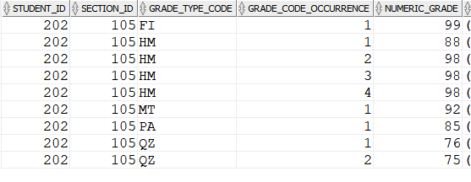



Test Case 03: Student Not attended any assignment:



1. Student and Enrolment log table must have the necessary details with appropriate details and messages to indicate the changes.

Student log updated.



Enrollment log updated.



iii. Start date and end date of the suspension and the course/section they are suspending must be recorded

STUDENT_COURSE_SUSPENSION table updated.



Test Case 04: Student not allowed to suspend more than two years



**Task 2.b: Grade Report:**

**Scripts available at Task2.b folder**

Create appropriate PL/SQL Procedure to produce the above listed reports. Please ensure that all necessary details are included and displayed in the report.

Reports will be output to student_final_mark and course_stats tables.

**BEGIN**

PROC_GENERATE_REPORTS**();**

--rollback;

**END;**

**/**

**select** **\*** **from** student_final_mark**;**

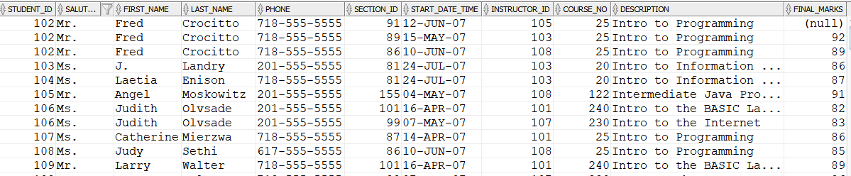

**select** **\*** **from** course_stats**;**

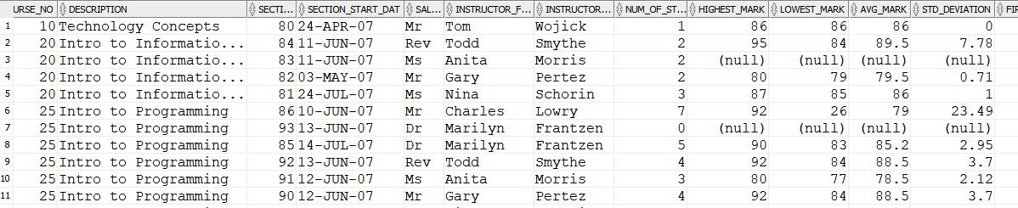

**Task 2.c: Active Rules Using Triggers**

**Scripts available at Task2.c folder**

i.The University student data centre that is responsible for entering student details and enrolment details, works from Monday 9.00 am – Friday 5.00 pm. It is important that the system is protected (don’t allow any changes on appropriate tables) and only allow minimum operations from Friday 5.00 pm to Monday 8:00 am. For example students’ details or enrolment details are only added or amended during office hours. Database activities are monitored all the time, create an active rule to stop such activities and display appropriate messages

-- change sysdate to off working hour

**ALTER** SYSTEM **SET** fixed_date**=**'2020-05-08-17:00:00'**;**

**INSERT** **INTO** enrollment **VALUES** **(**102**,**85**,TO_DATE(**'30-JAN-2007 10:18:00'**,**'DD-MON-YYYY HH24:MI:SS'**),NULL,**'JAYCAF'**,TO_DATE(**'03-NOV-2007 00:00:00'**,**'DD-MON-YYYY HH24:MI:SS'**),**'CBRENNAN'**,TO_DATE(**'12-DEC-2007 00:00:00'**,**'DD-MON-YYYY HH24:MI:SS'**));**

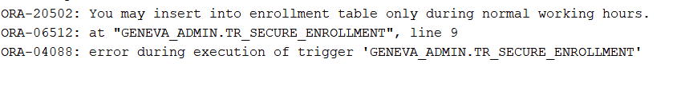

**UPDATE** student

**SET** first_name **=** 'JAYCAF'

**WHERE** student_id **=** 202**;**

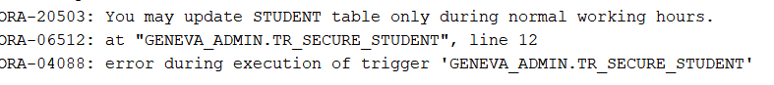

ii.University can only accommodate a limited number of students for each section. Create an active rule to display an appropriate message on the screen to warn the DBA while the enrolment is nearing to its capacity and also when it has reached the capacity limit.

--consider section 101 which has 10 capacity

--delete available data

**delete** **from** grade **where** section_id **=** 101**;**

**delete** **from** enrollment **where** section_id **=** 101**;**

**select** **count(*)** **from** enrollment **where** section_id **=** 101**;**



**INSERT** **INTO** enrollment **VALUES** **(**102**,**101**,TO_DATE(**'30-JAN-2007 10:18:00'**,**'DD-MON-YYYY HH24:MI:SS'**),**92**,**'JAYCAF'**,TO_DATE(**'03-NOV-2007 00:00:00'**,**'DD-MON-YYYY HH24:MI:SS'**),**'CBRENNAN'**,TO_DATE(**'12-DEC-2007 00:00:00'**,**'DD-MON-YYYY HH24:MI:SS'**));**

**INSERT** **INTO** enrollment **VALUES** **(**103**,**101**,TO_DATE(**'30-JAN-2007 10:18:00'**,**'DD-MON-YYYY HH24:MI:SS'**),NULL,**'JAYCAF'**,TO_DATE(**'03-NOV-2007 00:00:00'**,**'DD-MON-YYYY HH24:MI:SS'**),**'CBRENNAN'**,TO_DATE(**'12-DEC-2007 00:00:00'**,**'DD-MON-YYYY HH24:MI:SS'**));**

**INSERT** **INTO** enrollment **VALUES** **(**104**,**101**,TO_DATE(**'30-JAN-2007 10:18:00'**,**'DD-MON-YYYY HH24:MI:SS'**),NULL,**'JAYCAF'**,TO_DATE(**'03-NOV-2007 00:00:00'**,**'DD-MON-YYYY HH24:MI:SS'**),**'CBRENNAN'**,TO_DATE(**'12-DEC-2007 00:00:00'**,**'DD-MON-YYYY HH24:MI:SS'**));**

**INSERT** **INTO** enrollment **VALUES** **(**105**,**101**,TO_DATE(**'30-JAN-2007 10:18:00'**,**'DD-MON-YYYY HH24:MI:SS'**),NULL,**'JAYCAF'**,TO_DATE(**'03-NOV-2007 00:00:00'**,**'DD-MON-YYYY HH24:MI:SS'**),**'CBRENNAN'**,TO_DATE(**'12-DEC-2007 00:00:00'**,**'DD-MON-YYYY HH24:MI:SS'**));**

**INSERT** **INTO** enrollment **VALUES** **(**106**,**101**,TO_DATE(**'30-JAN-2007 10:18:00'**,**'DD-MON-YYYY HH24:MI:SS'**),NULL,**'JAYCAF'**,TO_DATE(**'03-NOV-2007 00:00:00'**,**'DD-MON-YYYY HH24:MI:SS'**),**'CBRENNAN'**,TO_DATE(**'12-DEC-2007 00:00:00'**,**'DD-MON-YYYY HH24:MI:SS'**));**

**INSERT** **INTO** enrollment **VALUES** **(**107**,**101**,TO_DATE(**'30-JAN-2007 10:18:00'**,**'DD-MON-YYYY HH24:MI:SS'**),NULL,**'JAYCAF'**,TO_DATE(**'03-NOV-2007 00:00:00'**,**'DD-MON-YYYY HH24:MI:SS'**),**'CBRENNAN'**,TO_DATE(**'12-DEC-2007 00:00:00'**,**'DD-MON-YYYY HH24:MI:SS'**));**

**INSERT** **INTO** enrollment **VALUES** **(**108**,**101**,TO_DATE(**'30-JAN-2007 10:18:00'**,**'DD-MON-YYYY HH24:MI:SS'**),NULL,**'JAYCAF'**,TO_DATE(**'03-NOV-2007 00:00:00'**,**'DD-MON-YYYY HH24:MI:SS'**),**'CBRENNAN'**,TO_DATE(**'12-DEC-2007 00:00:00'**,**'DD-MON-YYYY HH24:MI:SS'**));**

**INSERT** **INTO** enrollment **VALUES** **(**109**,**101**,TO_DATE(**'30-JAN-2007 10:18:00'**,**'DD-MON-YYYY HH24:MI:SS'**),NULL,**'JAYCAF'**,TO_DATE(**'03-NOV-2007 00:00:00'**,**'DD-MON-YYYY HH24:MI:SS'**),**'CBRENNAN'**,TO_DATE(**'12-DEC-2007 00:00:00'**,**'DD-MON-YYYY HH24:MI:SS'**));**



**DBMS OUTPUT**



**INSERT** **INTO** enrollment **VALUES** **(**110**,**101**,TO_DATE(**'30-JAN-2007 10:18:00'**,**'DD-MON-YYYY HH24:MI:SS'**),NULL,**'JAYCAF'**,TO_DATE(**'03-NOV-2007 00:00:00'**,**'DD-MON-YYYY HH24:MI:SS'**),**'CBRENNAN'**,TO_DATE(**'12-DEC-2007 00:00:00'**,**'DD-MON-YYYY HH24:MI:SS'**));**

**INSERT** **INTO** enrollmnt **VALUES** **(**111**,** 101**,TO_DATE(**'30-JAN-2007 10:18:00'**,**'DD-MON-YYYY HH24:MI:SS'**),NULL,**'JAYCAF'**,TO_DATE(**'03-NOV-2007 00:00:00'**,**'DD-MON-YYYY HH24:MI:SS'**),**'CBRENNAN'**,TO_DATE(**'12-DEC-2007 00:00:00'**,**'DD-MON-YYYY HH24:MI:SS'**));**

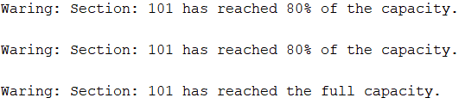

**INSERT** **INTO** enrollment **VALUES** **(**112**,**101**,TO_DATE(**'02-FEB-2007 10:18:00'**,**'DD-MON-YYYY HH24:MI:SS'**),NULL,**'JAYCAF'**,TO_DATE(**'03-NOV-2007 00:00:00'**,**'DD-MON-YYYY HH24:MI:SS'**),**'CBRENNAN'**,TO_DATE(**'12-DEC-2007 00:00:00'**,**'DD-MON-YYYY HH24:MI:SS'**));**

