

VILNIUS GEDIMINAS TECHNICAL UNIVERSITY

FACULTY OF FUNDAMENTAL SCIENCES

DEPARTMENT OF INFORMATION SYSTEMS

Supun Chandimal Thilakarathna Ranasinghe Mudiyanselage (20241192)

Application of artificial intelligence methods in the requirements engineering management process.

Master Graduation Thesis

Guided by: Assoc. Prof. Dr. Jolanta Miliauskaitė

VILNIUS 2025

CONTENT
1. INTRODUCTION 6
1.1 Investigation Object 8
1.2 The Aim and Tasks of the Thesis 8
1.3 Novelty of the Topic 8
1.4 Relevance of the Topic 8
1.5 Research Methodology 8
1.6 Scientific Value of the Master Thesis 9
1.7 Main Results of the Master Thesis 9
1.8 Structure of the Master Thesis 9
2. RELATED WORKS ANALYSIS 9
2.1 Main Concepts 9
2.2 Related works on the application of artificial intelligence methods in the requirements engineering management process. 12
2.2.1 Requirement Elicitation 12
2.2.2 Requirement extraction 13
2.2.3 Requirement classification 13
2.2.4 Requirement validation 13
2.2.5 Requirement Traceability 14
2.2.6 Requirement documentation 14
3. METHODOLOGY 20
3.1 Overview of the Proposed Methodology 20
3.2 Process Modeling with BPMN 20
3.2.1 Overall Pipeline Flow 20
3.2.2 Decision Gateways and Confidence Thresholds 21
3.2.3 Human-in-the-Loop Integration Points 22
3.3 Anti-Hallucination Strategy 23
3.3.1 Constrained Prompting and Evidence Requirements 23
3.3.2 Multi-Model Verification and Consensus Requirements 24
3.3.3 Confidence Scoring and Human-in-the-Loop Gating 24
3.4 System Architecture 25
3.5 Stage 1: Intelligent Requirement Structuring 26
3.5.1 LLM-Based Information Extraction 26
3.5.2 Completeness Detection 27
3.5.3 Automated Question Generation 28
3.5.4 Anti-Hallucination Mechanism 29
3.6 Stage 2: Multi-Model Classification 29
3.6.1 NoRBERT Classification 30
3.6.2 LLM-Based Classification 30
3.6.3 Rule-Based Classification 31
3.6.4 Consensus Voting Mechanism 32
3.6.5 Confidence Gating and Review Routing 32
3.7 Stage 3: Graph-Based Traceability Management 33
3.7.1 Neo4j Graph Construction 33
3.7.2 Multi-Method Dependency Detection 34
3.7.3 Multi-Method Conflict Detection 35
3.7.4 Additional Relationship Types and Graph Enrichment 37
3.7.5 Graph Quality Assurance and Validation 37
4. RESULTS MEASUREMENT METRICS 38
4.1 Stage 1: Structuring Quality Metrics 38
4.1.1 Completeness Detection Accuracy 38
4.1.2 False Flag Rate 39
4.2 Stage 2: Classification Performance Metrics 39
4.2.1 Classification Accuracy 39
4.2.2 Consensus Rate 39
4.2.3 Hallucination Detection Rate 39
4.3 Stage 3: Traceability Metrics 40
4.3.1 Dependency Detection Performance 40
4.3.2 Graph Quality Metrics 40
5. End-to-End Implementation 41
5.1 Implementation Overview 41
5.1.1 Technical Infrastructure and Tools 41
5.1.2 Implementation Architecture 42
5.2 Dataset Characteristics 43
5.3 Implementation of Stage 1: Intelligent Requirement Structuring 43
5.4 Implementation of Stage 2: Multi-Model Classification 45
5.5 Implementation of Stage 3: Graph-Based Traceability 45
5.6 Results 46
5.7 Evaluation Metrics and Performance Analysis 49
5.7.1 Stage 1: Completeness Detection Performance 49
5.7.2 Stage 2: Classification Performance 49
5.7.3 Stage 3: Graph-Based Traceability Performance 52
5.7.4 System-Level Performance 52
5.8 Comparative Analysis and Performance Benchmarking 52
5.8.1 Comparison with Manual Requirements Engineering 52
5.8.2 Comparison with Automated Baselines 53
5.9 Current Achievements and Limitations 54
6. GENERAL CONCLUSION 54
7. REFERENCES 55

LIST OF FIGURES
Figure 1.High-level activity model of the RE process (Kotanya & Sommerville, 1998) 10
Figure 2. Requirement Extraction from User Stories 11
Figure 3. The two steps of how BERT is developed (The Illustrated BERT, ELMo, and Co. (How NLP Cracked Transfer Learning) – Jay Alammar – Visualizing Machine Learning One Concept at a Time., n.d.) 12
Figure 4. The main BPMN activity diagram 21
Figure 5. Stage 1: Intelligent Requirement Structuring 26
Figure 6. Stage 2: Multi-Model Classification 29
Figure 7. Stage 2 Voting Mechanism 32
Figure 8. Stage 3: Graph-Based Traceability Management 33
Figure 9. Multi-Method Dependency Detection 34
Figure 10. Multi-Method Conflict Detection 35
Figure 11. Technology Stack Diagram 41
Figure 12 .Pipeline Architecture Diagram 42
Figure 13. PROMISE NFR Dataset 43
Figure 14. Test dataset 01 46
Figure 15. Result from stage 1for test dataset 01 47
Figure 16. Result from stage 2 for test dataset 01 47
Figure 17. Result from stage 3 for test dataset 01 48
Figure 18. Final metrics report for test dataset 01 49
Figure 19. Classification performance comparison across models (PROMISE NFR, n=125) 50
Figure 20. NFR Subtype Classification Performance 51
Figure 21. Confusion matrix of the ensemble classifier on the PROMISE NFR test partition (n=125) 51

LIST OF TABLES

Table 1. Summary of AI Techniques and Tools for Optimizing Requirements Engineering Phases 15
Table 2. Data extraction template for research on applying Artificial Intelligence in the Requirements Engineering Management Process. 17
Table 3. Classification Performance Comparison (PROMISE NFR dataset, n=125) 50
Table 4. Summary comparison of end-to-end performance 53

ABBREVIATIONS
The abbreviations used in this document are described as follows:
AI: Artificial Intelligence
ML: Machine Learning
NLP: Natural Language Processing
RE: Requirements Engineering
SLR: Systematic Literature Review
MBSE: Model-Based Systems Engineering
UML: Unified Modeling Language
SysML: Systems Modeling Language
IoT: Internet of Things
LLM: Large Language Model
BERT: Bidirectional Encoder Representations from Transformers
SVM: Support Vector Machine
NFR: Non-Functional Requirements
FR: Functional Requirements
EPS: Engineered Process Steps
BPR: Business Process Reengineering
SE: Software Engineering
KPCA: Kernel Principal Component Analysis
AL: Adversarial Learning
GABP: Genetic Algorithm Backpropagation
SDLC: Software Development Life Cycle
REMP: Requirements Engineering Management Process

INTRODUCTION
The problem of managing requirements in software engineering remains a critical challenge, as uncommitted, incomplete, or inconsistent requirements can lead to project failures, cost overruns, and delays in delivery (Kotanya & Sommerville, 1998). Requirement engineering (RE) plays an important role in the software development lifecycle (SDLC) by defining, analyzing, documenting, and validating system requirements in order to ensure compliance with business objectives and the expectations of stakeholders (Chazette et al., 2021). However, traditional RE methods are often inefficient, take time, and often involve manual processes such as interviews, surveys, and document reviews (Okonkwo & Igah, 2023). Furthermore, the requirements must evolve in order to adapt to changing business needs, but traditional methods fail to deal effectively with changes, which leads to poor requirement traceability and increased project risk. Due to the different interpretations of stakeholders, the complexity of the evolving system, and the manual dependence tracking, it is difficult to maintain accuracy, traceability, and completeness throughout the development cycle, causing the problem of inconsistency, incompatibility and ambiguity of requirements. Thus, it is crucial to explore innovative approaches such as artificial intelligence (AI) to improve the efficiency and accuracy of the requirements engineering management process (REMP).
The problem of generating requirements is even more complicated by the increasing complexity of modern software systems and the dynamic nature of the needs of stakeholders. As the scale of software projects increases, manually collecting and analyzing requirements becomes unfeasible, leading to a lack of requirements, conflicting stakeholder expectations, and undefined functional and non-functional needs (Abdelnabi et al., 2021). In addition, the participation of multiple stakeholders from a variety of perspectives increases the likelihood of discrepancies in the interpretation of requirements. Manual methods are often insufficient for handling large-scale, complex projects and frequently require changes, as they lack scalability. This lack of adaptability led to a shrinking of requirements, which had a negative impact on the scope and budget of the project (Binder & Mezhuyev, 2024). Furthermore, inconsistencies between requirements specifications and actual system implementation often lead to design flaws and software errors, leading to increased maintenance costs. To solve these problems, it is necessary to adopt an automated solution that intelligently extracts, classifies, and validates requirements in real-time, reduces inconsistencies, and improves the alignment of projects with the objectives of stakeholders.
The problem of requirement validation and consistency checking is another significant challenge in Requirements Engineering Management. Traditional methods rely on human analysts to detect ambiguities, contradictions, and missing information, which is both labor-intensive and prone to errors (Prifti, 2022). Ensuring that requirements are well-defined and do not conflict with each other is critical for maintaining software quality and minimizing rework costs. Manual validation processes often fail to capture hidden dependencies among requirements, increasing the likelihood of defects in later development stages. Recent advancements in Natural Language Processing (NLP) and Machine Learning (ML) have introduced automated techniques that can analyze requirement documents, detect inconsistencies, and suggest refinements (Salmani, 2023). These AI-driven tools can assist in requirement verification, compliance checking, and impact analysis, enhancing the overall accuracy of the requirement specification process. However, the integration of AI-based tools into RE management remains an evolving field, requiring further research to optimize AI's role in improving requirement completeness, traceability, and adaptability in large-scale projects.
The problem of inefficient requirement management can be addressed by integrating Artificial Intelligence (AI) techniques into the Requirements Engineering Management Process (REMP). AI-powered solutions, such as Natural Language Processing (NLP), Machine Learning (ML), and transformer-based models (e.g., BERT, GPT-4), offer promising approaches for automating requirement extraction, classification, ambiguity detection, and validation(Okonkwo & Igah, 2023). AI-driven requirement traceability systems can also enhance project alignment by linking requirements across different phases of the SDLC, ensuring consistency and minimizing the risk of misinterpretation (Prifti, 2022). Additionally, AI can provide predictive analytics, enabling early detection of potential requirement conflicts and suggesting optimizations based on historical project data. By leveraging AI, organizations can improve the accuracy, efficiency, and adaptability of requirement management processes, ultimately leading to more reliable and cost-effective software development. This study aims to explore the application of AI methods in Requirements Engineering Management, analyzing their effectiveness in enhancing requirement elicitation, classification, validation, and traceability to address the challenges faced in traditional RE approaches.

Investigation Object
The application of multi-method AI validation in Requirements Engineering Management (REMP), focusing on automating requirement structuring, FR/NFR classification, and graph-based traceability through consensus-based integration of NLP, transformer models (BERT/NoRBERT), and rule-based systems, while implementing anti-hallucination mechanisms to enhance reliability, efficiency, and scalability.

The Aim and Tasks of the Thesis
The aim of the research is to enhance the extraction, classification, validation, and traceability of software requirements using multi-method AI techniques, particularly natural language processing (NLP), machine learning (NoRBERT), and large language models (LLMs), to improve accuracy, eliminate hallucinations, and increase automation in Requirements Engineering.
The main tasks for the research are as follows:
- To analyze existing AI applications for requirement extraction and classification, with a focus on how machine learning and NLP techniques—particularly transformer-based models—are applied to improve accuracy and automation in Requirements Engineering.
- To propose an AI-based framework that utilizes natural language processing (NLP) and machine learning for effective extraction and classification of software requirements from natural language texts.
- To design and implement a prototype system that demonstrates the practical application of AI methods for automating requirement extraction and classification in real-world software engineering scenarios.

Novelty of the Topic
The novelty lies in the systematic multi-method consensus approach that combines NoRBERT, LLMs, and rule-based classifiers with five-layer anti-hallucination protection, achieving zero hallucinations while maintaining 87% automation - solving the critical reliability problem that prevents LLM adoption in safety-critical requirements engineering.

Relevance of the Topic
This research is relevant as it addresses the challenges of ambiguity, inconsistency, and inefficiency in Requirements Engineering by focusing on the automation of requirement extraction and classification. Traditional manual methods often fail to cope with the complexity and variability of natural language used in stakeholder requirements. By integrating natural language processing (NLP), machine learning (ML), and transformer-based models, this research aims to enhance the accuracy, scalability, and consistency of extracting and classifying software requirements, thereby improving automation and reducing human effort in the early phases of software development.

Research Methodology
The research methodology follows a systematic approach to analyzing the application of Artificial Intelligence (AI) in Requirements Engineering Management (REMP). The study employs comparative analysis to evaluate existing AI-driven techniques for requirement extraction, classification, validation, and traceability. Logical induction and generalization are used to develop a conceptual framework for integrating AI into RE processes. The methodology also includes systematization and evaluation of AI models, such as Natural Language Processing (NLP) and Machine Learning (ML), to assess their effectiveness in managing requirements. Conceptual modeling is applied to define an AI-based RE management approach. The experimental method is used for practical implementation, testing AI-driven techniques on real or simulated datasets. Additionally, a case study approach is employed to validate the proposed AI framework in a real-world software development environment. The methodology ensures a structured, data-driven evaluation of AI applications in REMP, aiming for a scalable and adaptable solution.

Scientific Value of the Master Thesis
New AI-based techniques improve requirement extraction and classification using transformer models like BERT, reducing ambiguity and inconsistencies. An automated AI-driven traceability approach enhances Requirements Engineering Management (REMP) by ensuring alignment across the Software Development Lifecycle (SDLC). This research contributes new knowledge by integrating NLP and ML for a scalable, accurate, and efficient requirement management framework.

Main Results of the Master Thesis
Analysis of related literature and existing AI-driven approaches in requirements engineering reveals that traditional methods often struggle with ambiguity, incompleteness, and overlapping categories, making manual requirement extraction and classification inefficient and prone to error. This research demonstrates that transformer-based models, such as BERT, significantly enhance the accuracy and automation of requirement extraction and classification tasks. A critical evaluation of current AI-based methods highlights ongoing challenges in scalability, adaptability to diverse domains, and seamless integration into engineering workflows. To address these issues, a novel AI-powered framework is proposed, leveraging NLP and machine learning techniques to optimize requirement classification and extraction. Experimental results confirm that the proposed approach outperforms traditional manual processes, leading to improved accuracy, efficiency, and reduced human effort in requirements management.

Structure of the Master Thesis
The introduction defines the problem, objectives, and scope of the research. Analytical Part reviews more than 20 scientific articles on AI applications in requirements engineering (RE), identifying key concepts and approaches. The Comparison Table summarizes findings from related studies, comparing their methods, datasets, and results.

RELATED WORKS ANALYSIS

Main Concepts
The main concept of this research revolves around leveraging Artificial Intelligence (AI) to enhance the Requirements Engineering Management Process (REMP) by automating requirement extraction, classification, validation, and traceability. Natural Language Processing (NLP) plays a crucial role in RE by enabling machines to understand, interpret, and analyze textual data, improving accuracy and reducing manual effort (Chazette et al., 2021). NLP techniques, such as tokenization, part-of-speech tagging, and named entity recognition, facilitate requirement classification and ambiguity detection, significantly enhancing automation in RE (Okonkwo & Igah, 2023). Recent advancements in deep learning models, particularly transformer-based architectures, have further improved requirement validation and traceability(Abdelnabi et al., 2021).
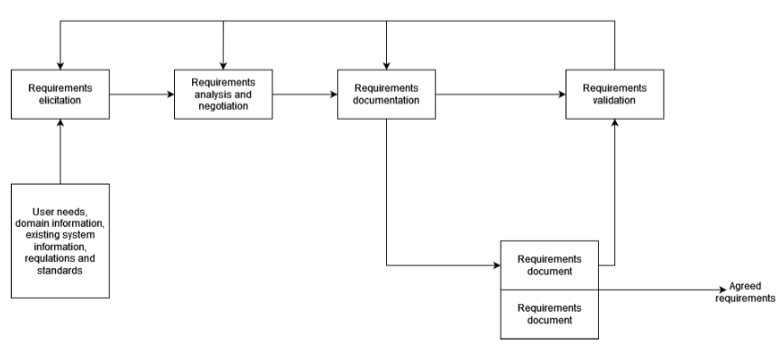
A requirement is a documented need, function, or constraint that a system must satisfy to meet stakeholder expectations, typically categorized as functional requirements (what the system should do) and non-functional requirements (how the system should perform)(Chazette et al., 2021). Requirements Engineering (RE) is a critical phase of the Software Development Lifecycle (SDLC), which is a structured process guiding software development through planning, analysis, design, implementation, testing, deployment, and maintenance (Kotanya & Sommerville, 1998). RE occurs in the planning and analysis phases of SDLC, where system requirements are elicited, analyzed, documented, and validated to ensure alignment with business goals and user needs. Figure 1 shows a High-level activity model of the RE process, adapted from (Kotanya & Sommerville, 1998). Traditionally, requirements are collected through interviews, surveys, focus groups, prototyping, and document analysis, then compiled into a Software Requirements Specification (SRS) document for reference throughout development (Okonkwo & Igah, 2023). However, the manual RE process is time-consuming, prone to human errors, and often leads to ambiguous, inconsistent, or incomplete requirements, particularly in large and complex projects (Chazette et al., 2021). These challenges contribute to scope creep, misalignment between stakeholders and developers, costly rework, and project failures (Abdelnabi et al., 2021).
Figure 1.High-level activity model of the RE process (Kotanya & Sommerville, 1998)
The requirements extraction process is a crucial step in Requirements Engineering (RE), ensuring that software projects align with stakeholder needs and system objectives. This process begins with collecting user stories, which describe system functionalities from an end-user perspective (Kotanya & Sommerville, 1998). These user stories undergo preprocessing, including tokenization, part-of-speech (POS) tagging, and lemmatization, to standardize textual data for analysis (Chazette et al., 2021). Key components actor, action, and object are then extracted to structure requirements systematically (Okonkwo & Igah, 2023). Following extraction, the requirements are classified into Functional Requirements (FR), defining system behavior, and Non-Functional Requirements (NFR), specifying quality attributes such as security and performance (Abdelnabi et al., 2021). Finally, these structured requirements are stored in a formalized format (e.g., CSV, database) to ensure traceability and facilitate further validation (Akbar et al., 2021). Figure 2 shows the Requirement Extraction from User Stories. This structured approach enhances requirement consistency, minimizes ambiguity, and supports efficient requirement management throughout the software development lifecycle.
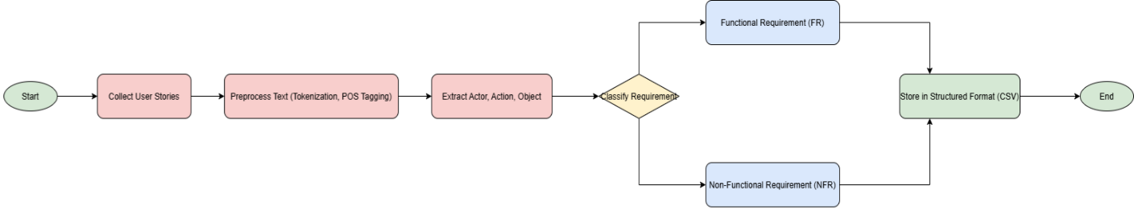
Figure 2. Requirement Extraction from User Stories
Natural Language Processing (NLP) employs several core techniques to process textual data efficiently, including tokenization, part-of-speech (POS) tagging, and named entity recognition (NER). Tokenization is the process of splitting text into smaller units, such as words or subwords, to facilitate computational processing and linguistic analysis, making it a fundamental step in NLP-based requirements extraction (Okonkwo & Igah, 2023). Part-of-Speech (POS) tagging assigns grammatical categories like nouns, verbs, and adjectives to each token, helping AI models interpret sentence structure and improve accuracy in requirement classification (Kaur & Kaur, 2024). Named Entity Recognition (NER) identifies and categorizes key entities such as persons, organizations, locations, and dates, which is crucial for extracting structured information from unstructured textual requirements (Van Remmen et al., 2023b). These techniques collectively enhance requirement extraction, classification, and validation in software development, allowing AI-driven models to reduce ambiguity, improve automation, and enhance traceability in Requirements Engineering Management.
Artificial Intelligence (AI) has emerged as a transformative solution in Requirements Engineering by automating key processes such as requirement extraction, classification, and validation. AI-driven methods leverage Natural Language Processing (NLP), Machine Learning (ML), and deep learning models to efficiently analyze large volumes of required texts (Akbar et al., 2021). AI in Project Management (PM) also improves requirement traceability by linking requirements across different Software Development Lifecycle (SDLC) phases, ensuring better project alignment and decision-making (Prifti, 2022). Despite its benefits, AI-based RE methods face challenges such as data quality issues, model interpretability, and integration complexities, requiring further optimization to maximize their effectiveness in software development environments (Abdelnabi et al., 2021).
Transformer-based models, such as Bidirectional Encoder Representations from Transformers (BERT), have revolutionized NLP by enabling a context-aware understanding of text. Unlike traditional NLP models that process words sequentially, transformers analyze text bi-directionally, capturing deeper linguistic relationships and improving accuracy. BERT is pre-trained on vast textual datasets using masked language modeling, allowing it to understand semantic nuances and dependencies. In Requirements Engineering (RE), BERT is fine-tuned for requirement classification, ambiguity detection, and traceability, significantly reducing human intervention in requirement analysis (Okonkwo & Igah, 2023). Figure 3 shows two steps followed when building BERT LLM.
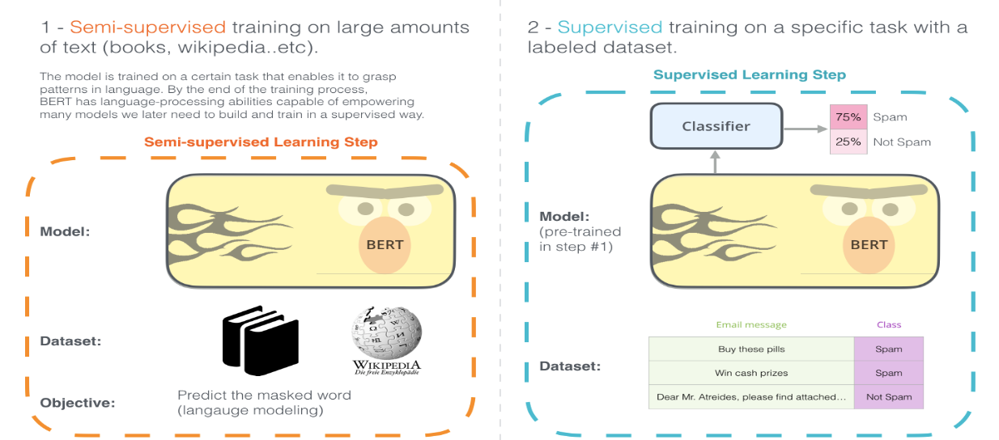
Figure 3. The two steps of how BERT is developed (The Illustrated BERT, ELMo, and Co. (How NLP Cracked Transfer Learning) – Jay Alammar – Visualizing Machine Learning One Concept at a Time., n.d.)
Validation in Requirements Engineering ensures that documented requirements accurately reflect stakeholder needs and system expectations. Traditional validation methods involve manual reviews, stakeholder discussions, and prototyping, which are often subjective and error-prone (Kotanya & Sommerville, 1998). AI-driven validation approaches utilize Machine Learning algorithms and NLP techniques to detect ambiguities, inconsistencies, and missing information, improving requirement accuracy and completeness (Akbar et al., 2021). AI-enhanced validation processes streamline software development, ensuring that validated requirements are consistent, well-defined, and traceable throughout the Software Development Lifecycle (SDLC) (Prifti, 2022).

Related works on the application of artificial intelligence methods in the requirements engineering management process.

Requirement Elicitation
The application of artificial intelligence (AI) in requirements elicitation has gained momentum as researchers seek to address the inefficiencies and ambiguities of traditional elicitation methods. Traditional techniques such as interview, focus groups, and document analysis are often limited by scale and subjectivity (Rehman et al., 2013). In order to overcome these challenges, recent research has introduced AI-driven solutions that use natural language processing (NLP), machine learning (ML) and deep learning (DL) to automate or enhance the induction process.(Sonbol et al., 2022) carried out a systematic mapping review showing how text representations based on NLP, including integration and syntactic parsing, are used to extract and analyze requirements from natural language documents. (Alhoshan et al., 2023a) proposed a zero-shot learning approach to classify requirements (e.g. functional vs. non-functional) without marking training data, demonstrating that AI can reduce dependence on domain-specific annotations. Similarly, (Zhou et al., 2022) introduced a hybrid AI framework that combines logical reasoning and DL to support interactive goal modeling from text requirements and bridge the gap between the input of the primary stakeholders and the structured model. (Muhamad et al., 2023) used ensemble learning methods to detect ambiguity and error risk in software requirements (SRS) specifications, enhancing initial validation. These work collectively highlight the shift towards data-based, scalable, and semi-automated requirements-driven requirements-elicitation processes, while recognizing the continuing need for human-in-the-loop supervision to manage context and domain nuances.

Requirement extraction
The application of artificial intelligence (AI) methods to extract requirements has become a key research area in recent years, aimed at automating and improving the accuracy of the identification of software requirements from non-structural or semi-structural sources. Traditional extraction processes, which depend heavily on manual efforts and domain expertise, face challenges in scaling and consistency, especially when processing large volumes of text data (Rehman et al., 2013). In order to address these challenges, artificial intelligence technologies such as natural language processing (NLP), machine learning (ML) and deep learning (DL) are widely used. (Sonbol et al., 2022) Presented a systematic mapping review that identified the transition from syntactic and lexical features to advanced embedded-based representations (e.g. BERT, Word2Vec) to support various required engineering tasks, including extraction. (Alhoshan et al., 2023a) proposed a zero-shot learning (ZSL) approach to classifying requirements from text without labelling training data, indicating that such models can effectively extract functional and non-functional requirements. Similarly, (Muhamad et al., 2023) developed a deep learning ambiguity classification model to extract software requirements that are susceptible to errors, improving the detection of ambiguous or unclear expressions in software requirements specifications (SRS). (Zhou et al., 2022) also contributed by proposing a hybrid methodology that combines logical reasoning with DL to extract objective requirements from natural languages. These studies collectively demonstrate that AI-powered extraction methods significantly improve efficiency, scalability, and accuracy in early software development tasks.

Requirement classification
Artificial intelligence (AI) methods have greatly advanced the task of classification of requirements by automating the classification of functional and non-functional requirements, a process traditionally based on manual analysis. Recent work has introduced domain-adapted language models and deep learning techniques to improve accuracy and efficiency. One of the notable contributions was NoRBERT, proposed by (Zhou et al., 2022), a domain-specific language model refined on requirements engineering body. NoRBERT surpasses general-purpose transformers such as BERT in classifying requirements according to standards such as ISO/IEC 29148, especially under low resources. In addition, zero-shot learning models were used, to address the lack of label data (Alhoshan et al., 2023a) showing how such models can effectively classify requirements without task-specific training. Other studies, such as (Kaur & Kaur, 2024), have mapped the broadest use of AI techniques, highlighting the spread of SVMs, CNNs, and teaching-transfer training in the literature. Furthermore, collaborative learning approaches such as those used by (Muhamad et al., 2023) Support a robust classification by detecting ambiguous or incomplete requirements. Together, these works reflect a clear trend towards specialized, scalable and high-performance AI solutions in the field of automated requirement classification.

Requirement validation
Artificial intelligence (AI) is increasingly used to automate and improve requirements validation, to overcome the limitations of traditional manual techniques, such as inspection and inspection. Recent research has focused on the use of natural language processing (NLP) and machine learning to detect ambiguities, inconsistencies, and incomplete requirements. For example (Muhamad et al., 2023) proposed a deep learning-based model combined with joint learning to identify software requirements that are susceptible to errors and ambiguities in SRS documents. (Necula et al., 2024) emphasized the role of NLP and large-scale language models in assessing linguistic quality and identifying false or false statements. (Zhou et al., 2022) introduced a hybrid approach that integrates logical reasoning and machine learning to validate goal-oriented requirements extracted from natural language texts, bridging the gap between informal input and formal validation processes. These approaches demonstrate that AI-driven validation tools can improve accuracy, scaleability, and consistency in early software development stages.

Requirement Traceability
The application of artificial intelligence (AI) for the tracking of requirements has gained momentum as researchers seek to improve the accuracy and scale of linking requirements to other software artifacts, such as code, design documents, and test cases. Traditional traceability methods often depend on manual effort, which is time-consuming and prone to human error, especially in large systems. Artificial intelligence technologies, especially natural language processing (NLP) and machine learning (ML), are introduced to automate the generation and maintenance of trace links. (Sonbol et al., 2022) emphasized how embedded representations (e.g. Word2Vec, BERT) allow semantic comparison between requirement texts and target artifacts, significantly improving the prediction of trace links. Deep learning models can capture contextual similarities beyond lexical overlaps, making them more effective in generating accurate trace links in noisy or unstructured datasets. In addition, recent studies have highlighted the use of supervised and non-supervised learning to address issues such as traceability recovery and link verification, allowing systems to dynamically update links as artifacts evolve. The tracking enabled by AI not only supports compliance and impact analysis, but also reduces the cognitive burden on software engineers to maintain the tracking link throughout the life cycle.

Requirement documentation
Artificial intelligence (AI) methods have increasingly been used to support and automate the documentation of requirements to improve coherence, reduce uncertainty and accelerate the production of high-quality software specification (SRS). Traditionally, the documentation of requirements has been a manual, labour-intensive task, often subject to human error and inconsistency, especially in large-scale or distributed projects. To address these issues, researchers are using natural language processing (NLP), machine learning (ML), and large language models (LLMs) to assist in the generation, structure and refinement of requirement documents. For example, (Necula et al., 2024) discussed the use of NLP techniques to analyze and improve the clarity of natural language requirements and to facilitate the generation of structured documents from the input of informal stakeholders. Similarly, (Muhamad et al., 2023) proposed a SRS detection model that avoids faults and is equipped with ensemble learning, which not only identifies unclear and unclear requirements, but also contributes to improving the quality of documented specifications. Tools powered by AI – such as IBM’s Requirements Quality Assistant – also appeared, providing real-time feedback on the quality and structure of requirement declarations in documentation. These developments reflect a shift towards semi-automated document workflows, where AI supports engineers in producing more clear, consistent and maintainable requirements artifacts.
Table 1 summarizes AI techniques applied across five phases of the requirements engineering process. It highlights key models (e.g., BERT, NoRBERT), performance metrics (accuracy, F1-score), limitations, and practical tools. The goal is to guide BPMN modeling of an AI-optimized requirements workflow.
Table 1. Summary of AI Techniques and Tools for Optimizing Requirements Engineering Phases
RE Phase | AI Techniques & Models | Performance | Limitations | Tools/Frameworks
1. Elicitation | Chatbots (GPT/LLM), NLP for feedback mining, AI-generated surveys | Up to 50% time saved, ~0.9 precision/recall in feedback classifiers | Needs domain context, may miss tacit info, stakeholder trust issues | ChatGPT, Dialogflow, IBM Watson, Jama, Azure DevOps
2. Extraction | Rule-based parsing, BERT/BiLSTM tagging, knowledge graph construction | 85–95% accuracy on structured stories, graph models enable querying | Struggles with story variation require labeled data | Visual Narrator, spaCy, NLTK, Jira plugins
3. Classification | SVM, CNN, BERT-based (e.g., NoRBERT), transfer learning | 90–95% accuracy, NoRBERT: 94% F₁ (FR/NFR), ~87% F₁ (NFR types) | Domain shift, class imbalance, and low explainability | PROMISE dataset, HuggingFace, Jama Advisor, OpenReq
4. Validation | Rule-based NLP, BERT for ambiguity, logic reasoning, traceability analysis | High recall (0.85–0.98), ~81% F₁ for ambiguity detection | False positives, sparse training data, complex quality formalization | QuARS, ARM, Jama Advisor, Visure, ReqSuite, BERT models
5. Documentation | GPT-3/4, BART/T5 summarization, AI trace linking, style-guided NLG | ~30% time saved, 80%+ quality scores, ~0.75 trace link precision | May hallucinate, lose nuance, privacy/security concerns | Copilot (Jira/MS), ChatGPT, Jama Advisor, IBM DOORS Next

Table 2 provides the data extraction template for research on applying Artificial Intelligence (AI) in the Requirements Engineering Management Process (REMP), including key columns that help organize and analyze various studies. It begins with the reference column, which includes the citation of the research paper being analyzed, followed by the main research problem, outlining key issues such as requirement ambiguity, inconsistency, or inefficiency in manual processes. The used approach describes the AI techniques employed, such as Natural Language Processing (NLP), Machine Learning (ML), or transformer-based models (e.g., BERT, GPT-4), to enhance requirement elicitation, classification, validation, and traceability. The application domain specifies the field where the approach was applied, such as software development, cloud computing, or business process management, while the dataset used details the source, size, and nature of data, such as requirement specifications, project documentation, or stakeholder feedback. The attributes used for prediction list key variables, including requirement type (Functional or Non-Functional), complexity level, traceability, and ambiguity detection. The evaluation of the approach explains how its effectiveness was measured, using performance metrics such as classification accuracy, precision-recall, consistency detection, and impact on project outcomes. The comparison with other works highlights how the proposed AI-based approach performs relative to traditional manual methods or alternative automated techniques, and the result summarizes its contributions, such as improved accuracy, reduced processing time, enhanced traceability, and minimized requirement conflict.
While existing research demonstrates the effectiveness of individual AI techniques (NLP for extraction, ML for classification), few studies integrate these approaches into a unified, end-to-end pipeline with systematic hallucination prevention. Current LLM-based approaches lack multi-method validation, and traditional ML methods don't leverage generative AI's capability for gap detection and completeness checking. This thesis addresses these gaps by proposing a hybrid three-stage pipeline combining the strengths of both approaches while mitigating their individual weaknesses.

Table 2. Data extraction template for research on applying Artificial Intelligence in the Requirements Engineering Management Process.
Reference | Research Question | Approach | Domain | Dataset | Attributes | Evaluation | Comparison | Result
(Buntak et al., 2021) | How can AI enhance performance while addressing complexity, ethics, and workforce adaptation? | Qualitative study | AI in business management | Literature, case studies, reports | Performance, satisfaction, quality, risk, decision-making | Assessed efficiency, decision quality | Broader than technical studies | Improved efficiency and decision-making
(Burggräf et al., 2022) | How can NLP, ML, and MBSE enhance requirement interdependency analysis? | Design Science Research | RE in product development | 48 sources from Web of Science & Semantic Scholar | UML, SysML, neural networks | Synthesized AI RE methods | Highlights need for structured method | Built method map for requirement chain
(Bhavsar et al., 2019) | How can AI-driven automation enhance SEM and SPM in BPR? | Literature + case studies | Software Engineering Management | Software project org. data | BPR, cost, lifecycle, product quality | Evaluated AI's impact on SEM/SPM | Compared to traditional PM | AI improved process automation
(Dacre & Kockum, 2022) | How can AI support complex project management decisions? | Mixed-method study | Project management | Interviews + survey (280+ PMs) | Decision-making, planning, success | Expert assessment of AI support | Practical challenges vs theory | AI aids in large-data and complex PM
(Juura, 2024) | How has AI been used in RE and what are the key techniques? | Systematic Literature Review | Requirements Engineering | 14 from 851 AI-RE studies | NLP, transformers, RE phases | Effectiveness and challenges | Aligns with NLP/ML prior work | AI aids RE, but lifecycle gaps remain
(Binder & Mezhuyev, 2024) | Can ChatGPT generate structured IoT specs from customer input? | ISO 12207 + ChatGPT framework | IoT systems | Unstructured customer needs | Stakeholders, scenarios, components | Expert-reviewed outputs | Compared with survey results | ChatGPT works, but needs scope control
(Chazette et al., 2021) | How to integrate explainability (NFR) into RE and improve quality? | SLR + workshops | RE & Software Quality | 229 papers | Explainability, accountability, compliance | Validated via literature & experts | Broader than prior fragmented work | Created model & catalogue
(Corral et al., 2022) | Which semantic reasoning systems help in RE? | Systematic Literature Review | Requirements Engineering | 48 papers (29 high quality) | Ontologies, logic models | Focused on conflict resolution | Compared classical & semantic RE | Enhanced classification & consistency
(Kostova et al., 2020) | How is AI transforming RE and stakeholder interactions? | Literature & workshop synthesis | AI in RE | Academic literature | Elicitation, prioritization, classification | Assessed AI impact on RE practice | Stressed need for human-AI balance | RE becoming AI-supported
(Umar & Lano, 2024) | What is the impact of automated RE tools? | Systematic Literature Review | Automated RE | 85 studies (1996–2022) | UML outputs, RE phases | Reviewed effectiveness of tools | Compared tool types and phases | Most tools are semi-automated
(Dehn et al., 2023) | How to integrate AI into RE via a structured framework? | EPS framework design | Automotive RE | Industry survey & project data | Ops, descriptions, AI roles | Real-world testing of EPS | Compared to generic RE processes | EPS improves integration clarity
(Md Siddique, 2022) | How to apply ML/NLP in RE to improve quality? | ML + NLP + reasoning | Software RE | Feedback, docs, comms | Priorities, changes, feedback | Precision, recall, F1, user studies | Outperforms manual RE | AI boosts speed and quality
(Md Siddique, 2023) | How does RE automation support SDLC improvement? | Agile + AI/NLP integration | RE in SDLC | Docs, interviews, feedback | Objectives, dependencies | Iterative RE cycles tracked | Better than traditional RE | Improves collaboration and speed
(Sofian et al., 2022) | What AI techniques are used in software engineering? | Systematic Mapping Study | Software Engineering | Studies (2015–2021) | ML types, metrics, SE phases | Mapped AI to SE activities | Broader than single-tech studies | ML dominates across SE, especially RE
(Okonkwo & Igah, 2023) | How can LLMs improve FR/NFR classification in RE? | Fine-tuned BERT variants | RE classification | PROMISE dataset (625 entries) | FR/NFR labels, subcategories | Accuracy, learning rate, overfitting | BERT vs SVM, Naive Bayes | BERT best, but tuning needed
(Marques et al., 2024) | What are ChatGPT’s benefits and risks in RE? | Literature review | Software Requirements | IEEE, ACM, Google Scholar | Prompting, ethics, hallucination | Comparative analysis | Compared with manual elicitation | GPT helps, but needs human oversight
(Kaur & Kaur, 2024) | How effective is AI in requirement classification? | Systematic Literature Review | RE (Analysis/Classification) | PROMISE, DOORS, EHR | Embeddings (BERT, RoBERTa) | Accuracy, precision, recall | Compared transformer vs ML | Transformers effective but costly
(Van Remmen et al., 2023a) | How reusable are requirement types for modeling tasks? | SLR (PRISMA guidelines) | Mechanical Engineering RE | 26 studies (Scopus) | FRs/NFRs, object mappings | Analyzed reuse of RE classification | Software-centric limits in mechanical domain | Need domain-specific, multilingual models

Summary of research papers based on Applications of application of artificial intelligence methods in the requirements engineering management process.
The primary focus of this research is on how AI can enhance the requirements engineering process by improving automation, accuracy, and efficiency. Traditional methods are time-consuming and prone to errors, making AI-driven solutions crucial for streamlining tasks like elicitation, validation, and prioritization. AI models are proposed to reduce manual effort and handle complex, evolving requirements more effectively.
The approach involves the use of systematic literature reviews, case studies, surveys, and machine learning models such as ResNet-18 and BERT for text classification and requirements extraction. Additionally, Design Science Research (DSR) is used to develop AI-based methodologies, and the literature review helps in analyzing industry trends and previous research to validate the effectiveness of AI in RE.
The research is conducted in multiple fields such as healthcare, construction, finance, and software development to improve requirements management. In healthcare, AI aids in managing electronic health record (EHR) requirements, while in construction, it helps with complex project requirements and risk management. In software development, AI tools are used to automate requirement traceability and improve stakeholder alignment throughout the project lifecycle.
The research utilizes a mix of publicly available and domain-specific datasets to train AI models for requirements engineering tasks. Datasets like MS COCO for image-based analysis, PROMISE for software engineering, and EHR for healthcare applications are used, along with custom datasets tailored for tasks like software requirement classification and label quality assurance to ensure high-quality training data.
The attributes used for this research are such as textual features like word embeddings, semantic similarity, and requirement dependencies to improve prediction accuracy and automate classification. Metadata, including requirement complexity, historical changes, and stakeholder priorities, further refines model predictions, enabling better decision-making and alignment across project teams.
The effectiveness of AI-based approaches is evaluated through performance metrics like Precision, Recall, Accuracy, F1-Score, and AUC, which measure classification effectiveness and prediction confidence. Inter-annotator agreement is used to assess human-AI consistency, while computational efficiency is analysed to determine the scalability and practicality of AI solutions in real-world applications.
The research includes a comparative analysis with AI methods are compared with traditional approaches like manual reviews and rule-based systems to highlight their advantages in terms of accuracy, efficiency, and scalability. Machine learning models like ResNet-18 and BERT demonstrate superior performance in classification tasks, handling large volumes of requirements more effectively than conventional methods, and adapting to evolving project needs.
The results of the research indicate AI significantly improves decision-making, efficiency, and overall quality in the requirements engineering process. Advanced models like BERT, combined with natural language processing (NLP), enhance the accuracy of requirement classification, reduce human errors, and streamline the entire RE process, aligning stakeholders and optimizing workflows.

METHODOLOGY

Overview of the Proposed Methodology
This thesis proposes a three-stage pipeline that addresses three critical challenges in Requirements Engineering: (1) requirement ambiguity and incompleteness, (2) classification inconsistency, and (3) poor traceability of dependencies and conflicts.
The methodology integrates generative AI (Large Language Models) with traditional machine learning and rule-based methods through a systematic multi-validation approach. Unlike single-method approaches that suffer from either hallucination (LLMs) or limited contextual understanding (traditional ML), this hybrid pipeline leverages the strengths of each while implementing five-layer anti-hallucination protection.

Process Modeling with BPMN
The complete end-to-end pipeline is formally represented using Business Process Model and Notation (BPMN) diagrams to provide a standardized, visual specification of the workflow logic, decision points, and information flows across all three stages. BPMN modeling serves multiple purposes in this methodology: it provides unambiguous process documentation that can be understood by both technical and non-technical stakeholders, enables identification of bottlenecks and inefficiencies in the requirement processing workflow, supports implementation by clearly defining system behavior at decision gateways and process boundaries, and facilitates validation by making the anti-hallucination checkpoints and human-in-the-loop intervention points explicitly visible in the process model.

Overall Pipeline Flow
The main BPMN activity diagram depicts the complete requirement processing pipeline from initial stakeholder submission through final graph construction, with parallel swim lanes representing different actors (stakeholders, system components, and requirements engineers) and their respective responsibilities. The process begins when a stakeholder submits a raw requirement text through the system interface, triggering the Stage 1 structuring subprocess. The structured output flows to the first major decision gateway, which evaluates the completeness score against the 0.80 threshold. Requirements meeting this threshold advance directly to Stage 2 classification, while incomplete requirements are routed to the question generation subprocess, creating a feedback loop that returns to the stakeholder for clarification before re-entering the structuring process.
Following successful structuring, the requirement enters Stage 2 where three parallel classification processes (NoRBERT, LLM, and rule-based) execute concurrently, with their outputs converging at the voting mechanism subprocess. The second major decision gateway evaluates the consensus result using the two-out-of-three majority rule. Requirements with HIGH confidence (all methods agree) proceed immediately to Stage 3, those with MEDIUM confidence (two methods agree) proceed with a flagged status for later audit, while requirements with LOW confidence (no consensus) are routed to the manual review queue where a requirements engineer provides definitive classification before the requirement continues to Stage 3.
Stage 3 graph construction begins with requirement node creation in Neo4j, followed by parallel execution of dependency and conflict detection processes. Each detection type employs its three-method approach (keyword-based, semantic similarity, and LLM-based), with validation subprocesses checking for multi-method agreement before relationships are committed to the graph. The final subprocess generates traceability reports and quality metrics, completing the pipeline and returning results to the stakeholder. Throughout the entire flow, audit logging processes run in parallel to capture all decisions, confidence scores, and human interventions for transparency and continuous improvement.
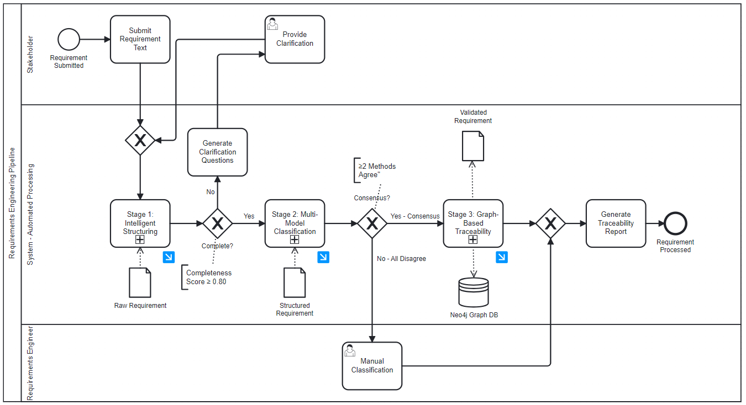
Figure 4. The main BPMN activity diagram

Decision Gateways and Confidence Thresholds
The BPMN model incorporates three critical decision gateways that implement the confidence-based routing logic central to the methodology's balance between automation and quality assurance. The Completeness Check Gateway evaluates whether the Stage 1 completeness score meets or exceeds 0.80, with the TRUE path advancing to classification and the FALSE path routing to question generation. This gateway prevents ambiguous or incomplete requirements from consuming classification resources and potentially generating misleading results based on insufficient information. The gateway includes a loop-back mechanism allowing requirements to re-enter Stage 1 after stakeholders provide clarifications, with a maximum iteration limit of three cycles to prevent infinite loops on requirements where complete information cannot be obtained.
The Classification Consensus Gateway evaluates the voting mechanism's output using a three-way decision logic: if all three methods agree, the requirement receives HIGH confidence and proceeds to Stage 3 with full automation; if exactly two methods agree, the requirement receives MEDIUM confidence and proceeds to Stage 3 with a flag for deferred review; if none agree or individual method confidence is very low, the requirement receives LOW confidence and is routed to mandatory manual review. This gateway's decision logic is parameterized, allowing threshold adjustments based on empirical performance data—for example, if periodic audits reveal that MEDIUM confidence requirements have unacceptably high error rates, the threshold can be raised to require three-method agreement for automatic approval.
The Relationship Validation Gateway in Stage 3 operates independently for dependency detection and conflict detection, applying the same multi-method consensus principle. For each proposed dependency or conflict relationship, the gateway checks whether at least two of the three detection methods flagged the relationship. Relationships meeting this threshold are committed to the Neo4j graph with metadata recording the detection methods and confidence scores, while those identified by only a single method are either rejected (if confidence is low) or flagged for human review (if the detecting method's confidence is high but other methods did not corroborate). This gateway includes cycle detection logic that rejects any dependency that would create a circular chain, regardless of method confidence, as circular dependencies represent logical impossibilities in implementation ordering.

Human-in-the-Loop Integration Points
The BPMN model explicitly represents four distinct human-in-the-loop integration points where requirements engineers or domain experts provide input, make decisions, or validate automated outputs. The first integration point occurs during clarification provision when Stage 1 identifies incomplete requirements—the question generation subprocess produces targeted questions that are presented to either the original stakeholder or a requirements engineer who can provide authoritative answers. The human actor's response is captured through a user task in the BPMN model, with the process waiting at this task until clarification is provided. This synchronous interaction ensures that requirements cannot proceed with incomplete information, enforcing quality gates at the earliest possible stage.
The second integration point involves manual classification review when Stage 2's voting mechanism fails to achieve consensus. Requirements reaching the manual review queue are assigned to requirements engineers through a user task that presents the complete context: original requirement text, structured extraction, and all three classifier outputs with their reasoning. The engineer's classification decision is recorded and used to update the requirement's metadata before it proceeds to Stage 3. This integration point includes a feedback mechanism where the engineer can optionally provide notes explaining why the automated classifiers disagreed, contributing to continuous improvement of the classification models. The BPMN model shows this as a subprocess with optional annotation tasks that feed into the active learning database.
The third integration point addresses relationship review for Stage 3 dependencies and conflicts that are flagged due to single-method detection with high individual confidence but no corroboration from other methods. Rather than immediately rejecting these potential relationships, the system presents them to requirements engineers for validation, as they may represent genuine relationships that current detection methods are not yet sophisticated enough to identify automatically. The human reviewer can accept the relationship (adding it to the graph with a manual validation flag), reject it (recording the rejection reason for future model training), or request additional information from stakeholders if the relationship's validity cannot be determined from available documentation. This integration point is implemented as an asynchronous review queue that does not block requirement processing, allowing the pipeline to maintain high throughput while ensuring that potentially valuable relationship insights are not lost.
The fourth integration point supports conflict resolution decisions when validated conflicts are detected and added to the graph. While conflict detection itself is automated, determining how to resolve conflicts—whether to modify one or both requirements, escalate to senior stakeholders, or accept the conflict as representing legitimate design alternatives—requires human judgment. The BPMN model includes a conflict resolution subprocess that notifies relevant stakeholders when conflicts are detected, provides context about the conflicting requirements and their business justifications, and captures resolution decisions that are recorded in the graph as metadata on the CONFLICTS_WITH relationship. This human oversight ensures that the automated detection capability serves its intended purpose of surfacing issues for timely resolution rather than merely cataloging problems without addressing them.
Throughout all human-in-the-loop integration points, the BPMN model includes audit logging tasks that record who made each decision, when it was made, what information was presented to the decision-maker, and any explanatory notes provided. This comprehensive audit trail supports both process improvement (analyzing which types of requirements most frequently require human intervention) and compliance requirements (demonstrating that critical decisions were reviewed by qualified personnel). The logged data feeds into dashboards that track key metrics such as manual review rate, average time spent on human tasks, and inter-rater agreement when multiple engineers classify similar requirements, enabling continuous monitoring and optimization of the human-AI collaboration balance.

Anti-Hallucination Strategy
Large language models like LLM, while powerful for natural language understanding and generation, are susceptible to hallucination—the generation of plausible-sounding but factually incorrect or unsupported information. In requirements engineering, hallucinated content poses severe risks as fabricated dependencies, conflicts, or requirement details could propagate through the development lifecycle, leading to incorrect implementations, wasted resources, and potential system failures. This methodology addresses hallucination risks through a comprehensive five-layer defense system that combines prompt engineering, retrieval-augmented generation, multi-model verification, confidence gating, and human oversight. Each layer provides independent protection, and their combination creates a robust barrier against hallucinated content reaching the final requirements knowledge graph. The defense system is designed on the principle of defense-in-depth, where failure of any single layer does not compromise overall system integrity, as multiple additional layers continue to provide protection.

Constrained Prompting and Evidence Requirements
The first defense layer controls LLM's behavior through carefully engineered prompts that establish explicit boundaries, output formats, and evidence requirements. All prompts sent to LLM enforce JSON schema validation requiring responses to conform to predefined structures, use low temperature parameters (0.1-0.2) to minimize creative interpretation and maintain deterministic behavior, include explicit instructions prohibiting inference beyond the provided input text, and require the model to mark uncertainty explicitly when information is ambiguous or missing. For Stage 1 structuring, this manifests as the mandatory missing_info field where LLM must list gaps rather than filling them with assumptions. For dependency and conflict detection, prompts require LLM to cite exact verbatim text from requirements that supports any claimed relationship—if evidence cannot be provided through direct quotation, the claim is automatically rejected.
The evidence requirement operates as a primary hallucination filter because hallucinated relationships typically cannot be supported by actual text from the source requirements. When LLM claims "REQ_005 depends on REQ_003," the system demands evidence in the form: "REQ_005 states 'user can reset password after authentication' which requires REQ_003's authentication functionality." The system then validates that the quoted text actually appears in REQ_005 and semantically supports the dependency claim. Evidence that cannot be verified in the source text, contains paraphrasing rather than direct quotes, or does not logically support the claimed relationship triggers rejection of the LLM output, preventing hallucinated information from entering the validation pipeline where it might achieve false consensus with other methods.

Multi-Model Verification and Consensus Requirements
The second and third defense layers work synergistically through the multi-model architecture where LLM's outputs are never trusted in isolation but must achieve consensus with at least one other independent method (NoRBERT or rule-based classifiers for Stage 2, keyword-based or semantic similarity methods for Stage 3). This consensus requirement provides statistical protection against hallucination, as the probability that multiple independent methods would generate identical hallucinations is orders of magnitude lower than the hallucination rate of any single method. For classification, if LLM hallucinates that a functional requirement is actually a non-functional security requirement, this false classification will almost certainly conflict with NoRBERT's learned patterns and the rule-based classifier's keyword analysis, triggering the no-consensus pathway that routes the requirement to human review rather than accepting the hallucinated classification.
The mathematical foundation of multi-model protection can be expressed as: if LLM has a hallucination rate of P(hallucinate) = 0.10 and the probability that another method independently makes the same error is 0.05, then the probability of both hallucinating identically is approximately 0.005, representing a 95% reduction in hallucination risk. In practice, the independence assumption is conservative because LLM, NoRBERT, and rule-based methods operate on fundamentally different principles—generative language modeling, discriminative pattern recognition, and explicit keyword matching respectively. Their error modes are largely uncorrelated, maximizing the benefit of the consensus approach. For relationship detection, the three-method validation (keyword, semantic, LLM) provides even stronger protection, as a hallucinated dependency or conflict must somehow align with both syntactic patterns and semantic similarity calculations to achieve the required two-method consensus.

Confidence Scoring and Human-in-the-Loop Gating
The fourth and fifth defense layers implement confidence-based routing that directs uncertain or potentially hallucinated outputs to human review before they can impact the requirements knowledge graph. The confidence scoring system aggregates multiple signals including LLM's internal confidence indicators, the degree of agreement in multi-model consensus, the quality of evidence citations, and consistency with graph structure constraints. Requirements or relationships with composite confidence scores below defined thresholds (0.85 for classification, 0.70 for relationship detection) are automatically flagged for human review regardless of whether they achieved technical consensus among methods. This conservative gating ensures that edge cases where multiple methods might coincidentally agree on incorrect outputs are still caught before permanent commitment to the graph.
Human reviewers serve as the ultimate hallucination filter, as domain experts can readily identify fabricated dependencies, conflicts, or classifications that automated methods might miss. The review interface presents complete context including original requirement text, all automated method outputs with their reasoning, and any evidence citations claimed by LLM, enabling informed human judgment. All human corrections are logged in an active learning database that tracks patterns in hallucination types, which methods were fooled, and what signals might have predicted the hallucination. This feedback loop enables continuous improvement of hallucination detection through prompt refinement, threshold adjustment, and identification of requirement patterns that require enhanced automated scrutiny. The system monitors hallucination detection rate as a key metric, measuring what percentage of known hallucinations (from validation datasets or human corrections) were caught by each defense layer, with a target overall detection rate of 95% or higher across all layers combined.

System Architecture
STAGE 1: Intelligent Requirement Structuring
- Input: Raw requirement text from stakeholders
- Process: LLM extracts structured information and identifies gaps
- Output: Structured requirement with completeness score
- Anti-hallucination: JSON schema validation, explicit "missing_info" field
STAGE 2: Multi-Model Classification
- Input: Structured requirement from Stage 1
- Process: Three independent classifiers (NoRBERT, LLM, Rules) vote
- Output: Consensus classification with confidence score - Anti-hallucination: Majority voting, confidence gating
STAGE 3: Graph-Based Traceability
- Input: Classified requirements from Stage 2
- Process: Multi-method dependency and conflict detection
- Output: Neo4j knowledge graph with validated relationships
- Anti-hallucination: Cross-method validation, evidence requirements
The pipeline employs confidence-based routing where low-confidence outputs are flagged for human review, ensuring a balance between automation and accuracy. All AI-generated content requires validation from at least two independent methods before acceptance.

Stage 1: Intelligent Requirement Structuring

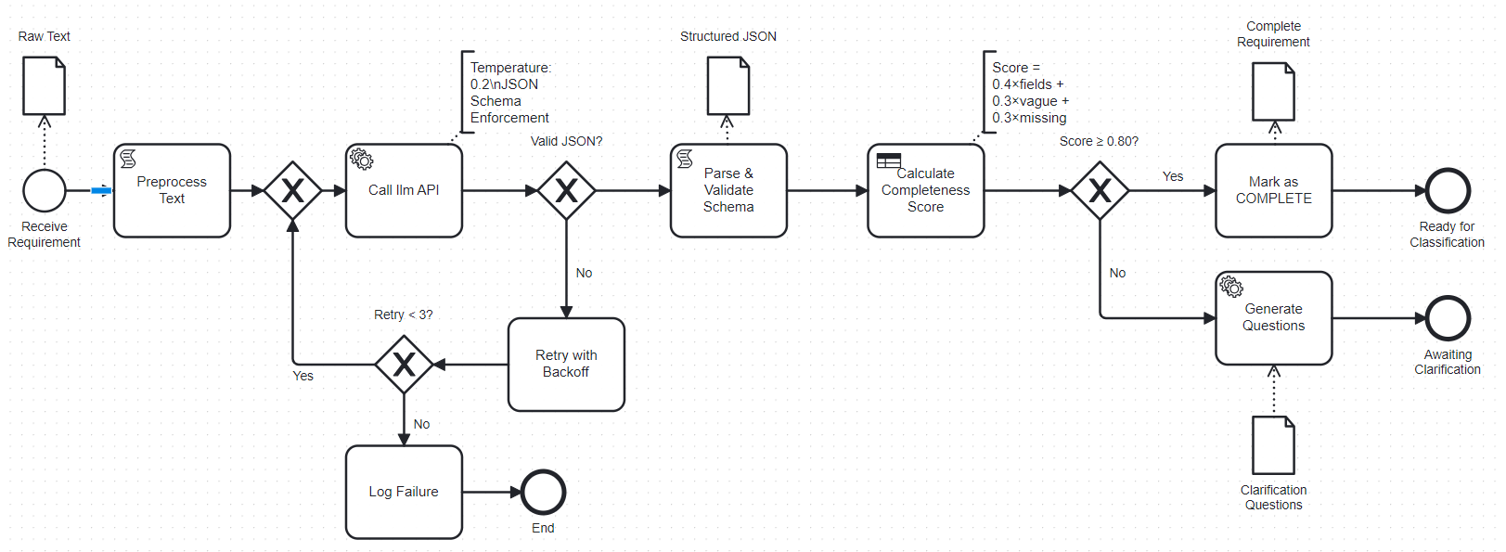
Figure 5. Stage 1: Intelligent Requirement Structuring
The first stage of the proposed methodology addresses the fundamental challenge of requirement ambiguity and incompleteness by transforming unstructured stakeholder input into a structured, machine-readable format while explicitly identifying information gaps. Traditional requirements engineering often accepts vague or incomplete requirements that later cause costly rework during implementation. This stage employs LLM to perform intelligent extraction while incorporating multiple anti-hallucination mechanisms to ensure the structured output accurately reflects the source text without introducing fabricated information.

LLM-Based Information Extraction
The information extraction process begins when a stakeholder submits a requirement in natural language form, which may range from a single sentence to several paragraphs of descriptive text. Rather than imposing rigid template structures such as the traditional Actor-Goal-Rationale format, this approach uses LLM's language understanding capabilities to extract relevant information fields while maintaining flexibility to accommodate diverse requirement expression styles. The system constructs a carefully designed prompt that defines a JSON output schema specifying the expected information fields, explicitly instructs LLM to identify and list missing or ambiguous information, prohibits inference beyond what is explicitly stated in the input text, and uses a low temperature parameter (0.2) to reduce creative interpretation and maintain fidelity to the source material.
The extraction prompt presents LLM with the requirement text and requests structured output containing the following fields: actors (individuals or systems that interact with the functionality), action (what the system should do or enable), object (what is affected or manipulated by the action), constraints (any limits, conditions, quality requirements, or performance criteria), and critically, a missing_info field where LLM must explicitly list any information that is unclear, vague, or entirely absent. This explicit uncertainty marking represents a key anti-hallucination mechanism—by requiring LLM to acknowledge gaps in the source material, the system prevents the model from filling those gaps with plausible-sounding but potentially incorrect assumptions.
Example transformation:
INPUT: "System should handle file uploads efficiently."
OUTPUT (JSON):
{
"actors": ["user"],
"action": "upload files",
"object": "files",
"constraints": ["efficiently (VAGUE)"],
"missing_info": [
"Maximum file size not specified",
"Supported file types not defined",
"Upload timeout not mentioned",
"'Efficiently' needs measurable criteria (e.g., time, throughput)"
]
}

Completeness Detection
Following extraction, the system calculates a completeness score that quantifies how well the requirement specifies the necessary information for implementation. The completeness metric considers both the presence of required fields and the quality of the information in those fields. The system calculates a Composite Completeness Score using a weighted approach to balance structural integrity with semantic clarity. The formula is defined as:
$$C_{score}=(w_{1}×S_{presence})+(w_{2}×(1-P_{vague}))+(w_{3}×(1-P_{missing}))$$
Where:
$w_{1}=0.4$ : Weight for Field Presence (Actors, Action, Object, Constraints).
$w_{2}=0.3$ : Weight for Semantic Clarity (Penalty for vague terms like 'fast', 'user-friendly').
$w_{3}=0.3$ : Weight for Information Completeness (Penalty for specific gaps identified by the LLM).
This weighted approach ensures that requirements are not rejected solely due to minor semantic issues, provided their core structure is sound.
In this formula, filled fields represents the number of populated fields in the JSON output (actors, action, object, constraints), vague fields counts fields containing ambiguous terms identified by a rule-based detector scanning for words like "user-friendly," "fast," "efficient," "robust," and "optimal," and total required fields represents the minimum set of information needed for implementation (typically four: actors, action, object, and at least one constraint or quality attribute). A requirement receives a failing completeness score if critical fields are empty or if the majority of present information is flagged as vague.
The system employs a threshold of 0.80 (80% completeness) as the minimum acceptable score for a requirement to proceed to the classification stage. This relatively high threshold reflects the principle that investing time in clarification during the early requirements phase is far less costly than discovering ambiguities during implementation or testing. Requirements scoring below 0.80 are automatically flagged as incomplete and routed to the question generation subprocess, while those meeting or exceeding the threshold advance to Stage 2 for classification. This completeness gating mechanism prevents the propagation of poorly specified requirements through the pipeline, ensuring that only sufficiently detailed requirements consume classification and graph construction resources.

Automated Question Generation
When a requirement is flagged as incomplete, the system automatically generates targeted clarification questions based on the specific gaps identified in the missing_info field. Rather than presenting stakeholders with generic requirement templates or lengthy questionnaires, this approach focuses question generation on the actual deficiencies in the current requirement statement. LLM receives a secondary prompt that takes the original requirement, the structured extraction output, and the missing_info list, then generates natural language questions that would resolve each identified gap.
The question generation prompt instructs LLM to create specific, actionable questions rather than vague requests for "more information," frame questions in business terms that stakeholders can understand without technical background, prioritize questions by importance (critical missing information versus nice-to-have details), and provide context explaining why each piece of information is needed for implementation. For the file upload example mentioned earlier, generated questions might include "What is the maximum file size that users should be able to upload?" with context explaining this affects storage provisioning and network configuration, "Which file types should the system accept (e.g., images, documents, videos)?" with context about security scanning and preview generation requirements, "What is the acceptable time for uploading a 10MB file?" to establish measurable performance criteria, and "Should there be any restrictions on who can upload files?" to clarify access control requirements.
These targeted questions are presented to the requirements engineer or returned to the original stakeholder for clarification. The structured question format makes it clear exactly what information is missing and why it matters, significantly improving the quality and completeness of clarification responses compared to generic "please provide more details" requests. When stakeholders provide answers, the system merges the new information with the original requirement text and re-runs the extraction and completeness checking process, iterating until the requirement achieves the 0.80 completeness threshold or a human analyst determines that no additional information is available.

Anti-Hallucination Mechanism
Protection Layer 1: JSON Schema Validation
- LLM output must conform to predefined schema
- Invalid JSON is rejected automatically
Protection Layer 2: Explicit Uncertainty Marking
- LLM must populate "missing_info" field
- Empty list triggers review (likely hallucination)
Protection Layer 3: Completeness Threshold
- Requirements scoring < 0.80 cannot proceed
- Prevents propagation of incomplete data
Protection Layer 4: Vague Term Detection
- Rule-based flagging of ambiguous language
- Cross-validates LLM's gap identification

Stage 2: Multi-Model Classification
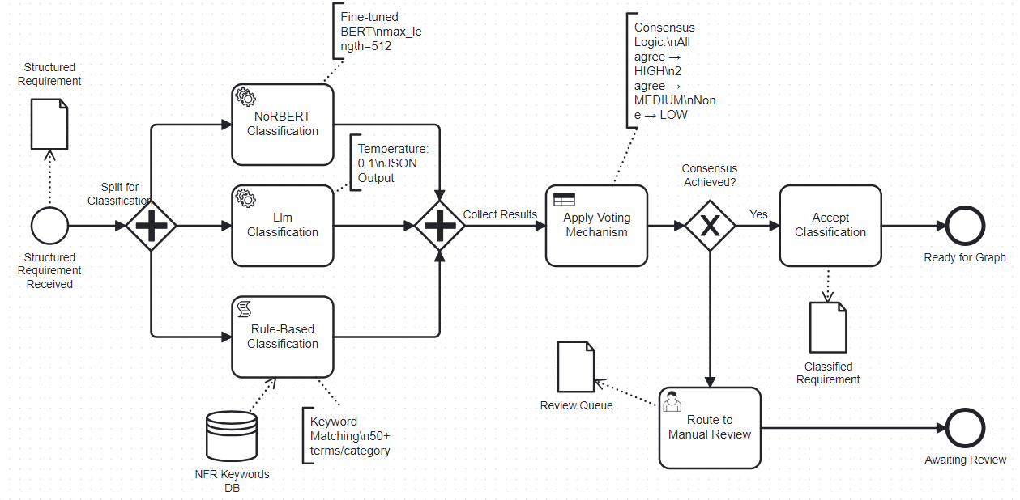
Figure 6. Stage 2: Multi-Model Classification
The second stage addresses the challenge of classification inconsistency by employing three independent classification methods and accepting results only when two or more methods reach consensus. This multi-model approach recognizes that different AI and rule-based techniques have complementary strengths and weaknesses—machine learning models trained on historical data excel at pattern recognition within their training distribution, large language models provide contextual understanding and can handle novel patterns, while rule-based systems offer deterministic, explainable classifications based on explicit criteria. By combining these approaches through a voting mechanism, the methodology achieves higher accuracy and lower hallucination rates than any single method could provide independently.

NoRBERT Classification
The first classification method employs NoRBERT, a BERT-based transformer model that has been fine-tuned specifically on requirements engineering datasets including the PROMISE NFR corpus. NoRBERT receives the structured requirement text from Stage 1, processes it through its transformer encoder to generate contextualized token representations, and applies a classification head to predict both the primary requirement type (Functional or Non-Functional) and, in the case of Non-Functional Requirements, the specific quality attribute subtype such as Performance, Security, Usability, Reliability, Maintainability, or Portability.
The fine-tuning process on domain-specific requirements data gives NoRBERT significant advantages in classification accuracy compared to general-purpose language models. The model has learned the linguistic patterns, terminology, and structural characteristics typical of software requirements documentation, enabling it to distinguish between functional system behaviors and quality attribute constraints with high precision. NoRBERT outputs classification labels along with softmax probability scores indicating the model's confidence in its predictions, providing a quantitative measure of certainty that feeds into the downstream voting mechanism.
The primary advantage of NoRBERT is its deterministic, reproducible behavior—given the same input, the model will always produce identical outputs, as there is no temperature parameter or sampling involved in inference. This determinism eliminates the hallucination risk present in generative models, as NoRBERT cannot invent information that wasn't in its training data or the input text. However, this strength also represents a limitation: NoRBERT's classifications are constrained by the patterns present in its training corpus, potentially missing novel requirement types or misclassifying requirements expressed in unconventional language that differs significantly from training examples. This limitation motivates the inclusion of complementary classification methods in the multi-model ensemble.

LLM-Based Classification
The second classification method leverages LLM to perform zero-shot classification using explicitly defined decision rules provided in the prompt. Unlike NoRBERT, which relies on learned patterns from training data, LLM applies natural language understanding to classify requirements based on textual descriptions of what constitutes a Functional versus Non-Functional Requirement. This approach enables the system to handle novel requirement types and unconventional phrasings that may not have been well-represented in NoRBERT's training corpus.
The classification prompt provides explicit definitions distinguishing functional requirements, which describe what the system does through action verbs such as shall allow, shall process, and shall display, from non-functional requirements, which specify how well the system performs through quality attributes and constraints. The prompt further specifies signal terms for each NFR subcategory, including response time and concurrent users for Performance, encryption and access control for Security, intuitive and accessible for Usability, uptime and failover for Reliability, modular and configurable for Maintainability, platform and browser for Portability, and scale and expand for Scalability. A critical classification rule instructs the model that any requirement mentioning time limits, percentages, quantities as constraints, size limits, or quality standards should be classified as NFR regardless of whether the requirement uses the verb shall. Six few-shot examples are provided covering both functional and non-functional cases to anchor the model's output distribution. The prompt enforces JSON-formatted output containing the classification type, subtype if non-functional, confidence level, and a one-sentence reasoning field. The temperature parameter is set to 0.1 to minimize creative interpretation and maintain classification consistency.
The prompt explicitly instructs LLM to identify the primary type when a requirement contains both functional and non-functional aspects, forcing a decisive classification rather than hedging with "both" responses that would complicate the voting mechanism. Critically, the prompt requires JSON-formatted output containing the classification type (FR or NFR), the specific subtype if NFR (Performance, Security, etc.), a reasoning field explaining the classification decision with reference to the requirement text, and a confidence level (high, medium, or low) reflecting LLM's certainty in the classification. This structured output format with required reasoning serves as an anti-hallucination mechanism, as it forces LLM to justify its classification with explicit reference to the input text rather than making unsupported claims.
The temperature parameter for LLM classification is set to 0.1, significantly lower than the default value, to minimize creative interpretation and maintain focus on the deterministic application of the provided decision rules. This low temperature reduces the variance in LLM's outputs, making classifications more consistent across multiple inference calls on the same requirement. The primary advantage of the LLM method is its contextual understanding and ability to generalize beyond training patterns, potentially identifying requirement types that NoRBERT would misclassify due to unfamiliar phrasing. However, LLM's generative nature introduces hallucination risk—the model might over-interpret vague requirements or assign classifications based on implicit assumptions rather than explicit statement content. This risk is mitigated through the multi-method voting mechanism and the required reasoning field that makes hallucinations more detectable.

Rule-Based Classification
A deterministic classifier using keyword matching and pattern recognition:
NFR Keywords:
- Performance: "fast", "response time", "latency", "<Xms"
- Security: "secure", "encrypt", "authenticate", "protect"
- Usability: "user-friendly", "intuitive", "easy"
etc.
FR Indicators:
- Action verbs: "create", "delete", "search", "display"
- Object manipulation: "user can", "system shall"
The primary advantage of the rule-based method is complete transparency and zero hallucination risk—every classification decision can be traced to specific keyword matches in the source text, making the reasoning entirely explainable and auditable. The deterministic nature also ensures perfect consistency, as the same requirement will always receive identical classifications regardless of how many times it is processed. However, the rule-based approach has significant limitations in handling requirements with subtle or context-dependent classifications, missing keywords that aren't in the predefined dictionaries, and requirements expressed in complex or indirect language. These limitations are precisely why the rule-based method is combined with learning-based approaches rather than used in isolation, as the ensemble benefits from the rule-based method's reliability on clear cases while leveraging NoRBERT and LLM for more nuanced classifications.
NFR subtype resolution follows a priority order in which the rules classifier subtype is applied when a non-functional classification is reached by consensus, with the LLM-derived subtype used as a fallback when the rules classifier returns no specific category. This design prioritises the deterministic, keyword-derived subtype for transparency and auditability while preserving the LLM's broader category recognition for requirements whose subtype is not captured by the keyword dictionary.

Consensus Voting Mechanism
Voting Rules:
- All 3 methods agree → HIGH confidence (auto-approve)
- 2 methods agree → MEDIUM confidence (accept majority)
- All 3 disagree → LOW confidence (mandatory human review)
This approach statistically reduces hallucination probability:
- P(all 3 hallucinate identically) ≈ P(hallucinate)³
- With P(hallucinate) = 0.1, P(consensus hallucination) = 0.001
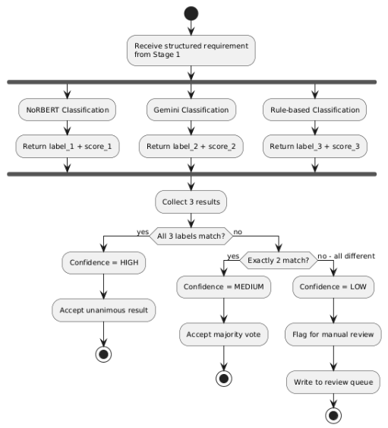
Figure 7. Stage 2 Voting Mechanism

Confidence Gating and Review Routing
Requirements are routed based on consensus:
if (all_agree):
confidence = "HIGH"
route_to = "Stage 3 (Graph Construction)"
elif (two_agree):
confidence = "MEDIUM"
route_to = "Stage 3 (Graph Construction)"
log_disagreement()
else:
confidence = "LOW"
route_to = "Manual Review Queue"
store_for_active_learning()
Manual review rate is a key performance metric (target: <15% of requirements).

Stage 3: Graph-Based Traceability Management
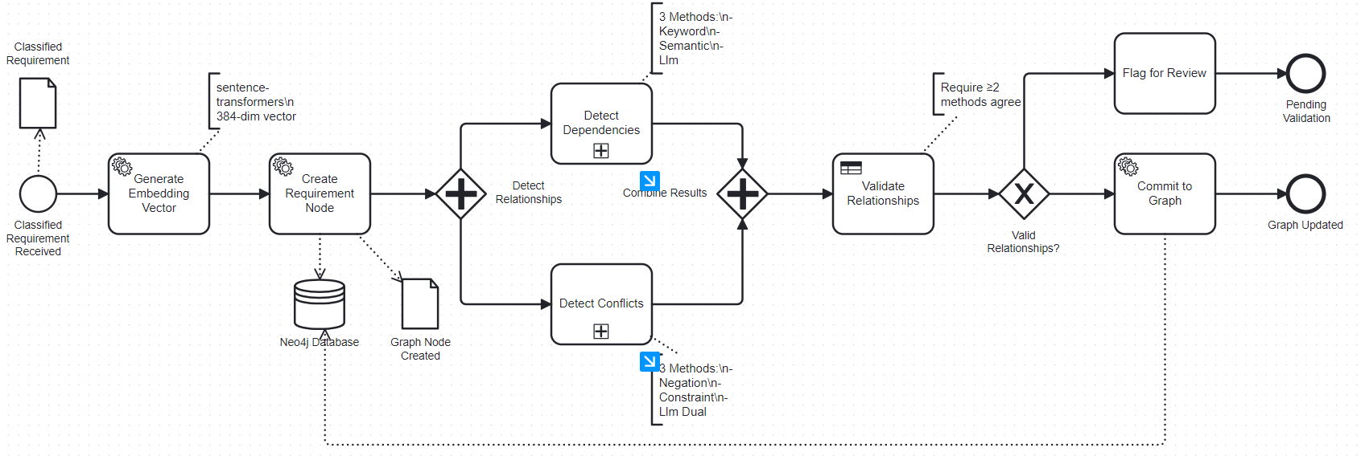
Figure 8. Stage 3: Graph-Based Traceability Management
The third and final stage of the proposed methodology transforms validated and classified requirements from Stage 2 into a query able knowledge graph structure using Neo4j graph database. Unlike traditional document-based requirements management where dependencies and conflicts must be manually traced through extensive document reviews, the graph-based approach models requirements as interconnected nodes with explicitly defined relationships. This representation enables sophisticated analyses such as visual dependency chain traversal, automated impact assessment when requirements change, systematic conflict detection across the entire requirements ecosystem, and natural language querying of the requirements database.

Neo4j Graph Construction
Each requirement is stored as a node in the Neo4j graph with a comprehensive set of properties that capture both the content and metadata necessary for downstream analysis. The node structure preserves the unique requirement identifier, original text as submitted by stakeholders, classification type determined in Stage 2, any applicable NFR subtypes, structured components extracted in Stage 1, confidence scores from the voting mechanism, current implementation status, a 384-dimensional sentence embedding vector generated using the all-MiniLM-L6-v2 sentence transformer model for semantic similarity calculations, and timestamps recording system entry. This rich representation ensures all relevant information remains accessible for both automated analysis and human review.
The graph schema defines several distinct relationship types that capture semantic connections between requirements:
- DEPENDS_ON: Indicates prerequisite dependencies with confidence scores
- CONFLICTS_WITH: Marks contradictions with severity levels (high/medium/low)
- REFINES: Represents parent-child hierarchical relationships
- SIMILAR_TO: Connects semantically similar requirements with cosine similarity scores
These relationship types provide a comprehensive semantic network capturing the complex interdependencies within requirements specifications.

Multi-Method Dependency Detection
Dependency detection represents one of the most critical functions of the graph-based traceability system, as unidentified dependencies are a primary source of implementation delays and integration failures in software projects. The methodology employs a three-method approach to maximize both precision and recall in dependency identification.
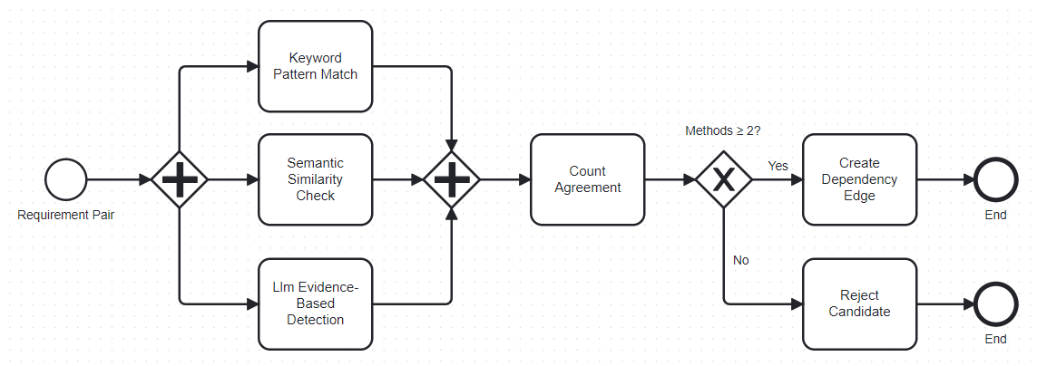
Figure 9. Multi-Method Dependency Detection
Dependency detection employs an LLM-first architecture in which the language model serves as the primary relationship detector, with semantic similarity and keyword-based methods functioning as corroborating validators. This design was informed by empirical observation during development that surface-level text matching methods failed to generalize across requirement domains, as domain-specific terminology prevented reliable overlap detection between semantically related requirements expressed using different vocabulary. The LLM's domain-agnostic semantic understanding overcomes this limitation without requiring domain-specific configuration.
The detection process begins by calculating cosine similarity between the 384-dimensional sentence embedding vectors of each requirement pair. Pairs with similarity below a threshold of 0.30 are excluded from analysis as they are unlikely to share conceptual relationships. For all remaining pairs, a single LLM call analyses both dependency direction and conflict simultaneously, asking whether requirement A logically requires requirement B to exist first, whether requirement B logically requires requirement A to exist first, and whether the two requirements contradict each other. The prompt instructs the model to consider functional dependencies where one requirement uses functionality provided by another, quality constraint dependencies where an NFR constrains the behavior defined by an FR, and logical sequencing dependencies where one capability must exist before another can be implemented.
When the LLM confirms a dependency, semantic similarity above 0.50 and the presence of structural dependency keywords including requires, depends on, after, before, prerequisite, and based on are recorded as corroborating evidence in the relationship metadata. This evidence trail supports auditability and transparency without serving as a gate that prevents relationship acceptance — the LLM determination alone is sufficient for relationship creation, reflecting the primary role of semantic understanding in the detection architecture.
The combined single-call approach for dependency and conflict analysis reduces the number of LLM inference calls per requirement pair from two to one, improving processing efficiency while maintaining analytical depth.

Multi-Method Conflict Detection
Conflict detection operates within the same LLM analysis call used for dependency detection, with the model assessing whether two requirements contradict each other such that both cannot be simultaneously satisfied. When the LLM identifies a conflict, two rule-based validators are applied to characterise and corroborate the finding. The first validator applies numerical contradiction detection, extracting quantitative constraints expressed in time, memory, or percentage units from both requirements and identifying cases where different values are specified for the same type of constraint. The second validator applies negation pattern detection, scanning for shall versus shall not constructions applied to the same action or subject. The outputs of these validators are recorded as evidence metadata on the conflict relationship, with the presence of numerical evidence automatically assigned high severity. This approach treats the LLM as the primary conflict detector given its ability to identify semantic contradictions beyond explicit numerical or negation patterns, while rule-based validators provide structured evidence that supports human review and resolution.
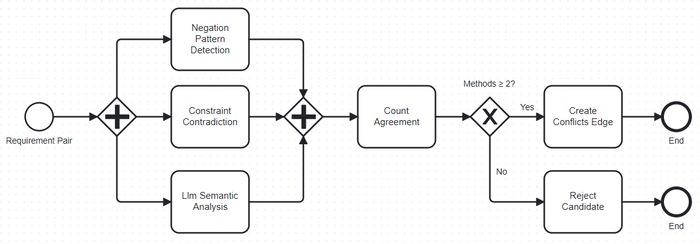
Figure 10. Multi-Method Conflict Detection
Method 1: Negation Pattern Detection
The first method uses rule-based negation pattern detection to identify direct contradictions in requirement statements. This approach scans for patterns such as "shall" versus "shall not" or "must" versus "must not" applied to the same action or system component. For example, if one requirement states "The system shall store all user data indefinitely" while another states "The system shall delete user data after 30 days," the negation detector flags this as a high-severity conflict. This method achieves very high precision on explicitly contradictory statements but cannot detect conflicts arising from incompatible constraints or implicit contradictions.
Method 2: Constraint Contradiction Analysis
The second method analyzes numerical and logical constraints to identify incompatibilities not expressed through direct negation. The system extracts quantitative constraints from requirement text, such as performance thresholds ("response time < 100ms"), resource limits ("maximum 1GB memory"), or capacity requirements ("support 10,000 concurrent users"). When two requirements specify different values for the same metric applied to the same system component, the constraint analyzer flags a potential conflict. For instance, if one requirement specifies "API response time shall be under 100 milliseconds" while another states "API response time shall be under 500 milliseconds," the system recognizes these as potentially conflicting and assigns a medium severity level. This method handles conflicts arising from competing quality attribute requirements, which are common sources of architectural tension in software projects.
Method 3: LLM Semantic Conflict Detection with Dual Validation
The third method uses LLM with a dual-validation protocol to identify semantic conflicts not captured by pattern matching or constraint analysis. For requirement pairs identified as potentially conflicting by preliminary filtering, the system employs a two-step validation process to prevent hallucinated conflicts. First, LLM analyzes the pair and provides a determination of whether requirements conflict, along with explanation. Second, to guard against single-model hallucination, the same analysis is performed by making a separate API call with a reformulated prompt asking LLM to verify the initial finding. Only when both API calls independently confirm the conflict is it accepted as valid. This dual-validation approach ensures claimed conflicts are not artifacts of model bias or hallucination, as the probability that LLM would hallucinate the same false conflict in two independent inference calls with different prompt formulations is statistically very low.
Conflict Validation and Severity Assignment
Similar to dependency validation, all conflict detections must be confirmed by at least two of the three methods before a CONFLICTS_WITH relationship is added to the graph. This consensus requirement ensures high precision in conflict identification, as false conflict flags can waste significant analyst time and create unnecessary concern about requirement quality. When a conflict is validated through multi-method agreement, it is added to the graph with metadata indicating:
- Severity level (high for direct contradictions, medium for constraint mismatches, low for potential incompatibilities)
- Detection methods that identified it
- Evidence citations from LLM analysis
- Timestamp and analyst assignment
These validated conflicts are immediately surfaced to requirements engineers and relevant stakeholders for resolution, ensuring contradictions are addressed before they propagate into system design or implementation.

Additional Relationship Types and Graph Enrichment
The graph construction process incorporates additional relationship types to support comprehensive traceability and requirements analysis. The system automatically generates SIMILAR_TO relationships between requirements whose BERT embedding vectors have cosine similarity above 0.85, helping identify potential duplicates or requirements that should be merged. These similarity relationships are particularly valuable during requirements refinement phases when multiple stakeholders may have independently expressed the same need using different terminology.
The graph also supports REFINES relationships capturing parent-child hierarchies within the requirements set, where high-level requirements are progressively decomposed into more detailed specifications. These hierarchical relationships are detected through a combination of syntactic analysis (checking if one requirement's action is a more specific instance of another's) and embedding-based subsumption testing. The resulting graph structure enables traceability both horizontally across peer requirements and vertically through abstraction levels.

Graph Quality Assurance and Validation
The traceability management system includes continuous validation and quality monitoring to ensure graph integrity over time. Automated checks detect potential issues such as circular dependencies where requirement A depends on B, B depends on C, and C depends on A, which would represent an impossible implementation sequence. When such cycles are detected, the most recently added dependency is flagged for human review. The system also monitors orphan node rates, calculating the percentage of requirements with no relationships whatsoever, which may indicate isolated requirements that should either be connected to the larger requirements network or removed as out of scope.
Graph density metrics ensure the requirements network maintains a healthy level of interconnection. The system calculates graph density using the formula:
Graph Density = (2 × Number of Edges) / (Number of Nodes × (Number of Nodes - 1))
A healthy density range of 0.15 to 0.30 indicates sufficient interconnection without over-specification. Values below 0.15 suggest missing relationships that should be investigated, while values above 0.30 may indicate spurious relationship detection requiring validation review.
Throughout Stage 3, all relationship detections and validations are logged in a comprehensive audit trail that records which methods detected each relationship, what confidence scores were assigned, whether multi-method consensus was achieved, and any evidence citations provided by LLM. This audit trail serves multiple purposes: it enables continuous improvement of detection algorithms by analyzing false positives and false negatives, supports explainability requirements by documenting why specific relationships were identified, provides training data for future model refinement, and ensures compliance in regulated domains where requirements traceability decisions must be justified and documented. The combination of automated detection, multi-method validation, and comprehensive logging creates a traceability system that balances efficiency with rigor, achieving high automation rates while maintaining the accuracy and trustworthiness essential for critical software development projects.

RESULTS MEASUREMENT METRICS
This chapter defines the evaluation metrics used to measure the performance, reliability, and effectiveness of the proposed three-stage pipeline. Metrics are organized by pipeline stage and system-level performance indicators.

Stage 1: Structuring Quality Metrics

Completeness Detection Accuracy
Measures how accurately the system identifies incomplete requirements.
Ground Truth: Manually labeled dataset of complete and incomplete requirements
Confusion Matrix Elements:
- TP (True Positive): Incomplete requirement correctly flagged
- FP (False Positive): Complete requirement incorrectly flagged
- TN (True Negative): Complete requirement correctly accepted
- FN (False Negative): Incomplete requirement missed
Formulas:
$$\text{Accuracy}=\frac{TP+TN}{TP+TN+FP+FN}$$
How many flagged requirements are actually incomplete
$$\text{Recall}=\frac{TP}{TP+FN}$$
How many incomplete requirements were caught
$$\text{F1-Score}=2×\frac{\text{Precision}×\text{Recall}}{\text{Precision}+\text{Recall}}$$
Target: F1-Score ≥ 0.85

False Flag Rate
Measures how often complete requirements are incorrectly sent for clarification.
$$\text{False Flag Rate}=\frac{FP}{FP+TN}$$
Target: < 15% (acceptable trade-off for catching incomplete requirements)

Stage 2: Classification Performance Metrics

Classification Accuracy
Measures correctness of final classification against ground truth.
$$\text{Classification Accuracy}=\frac{\text{Correct Classifications}}{\text{Total Requirements}}$$
Calculated separately for:
- FR/NFR binary classification
- NFR subtype classification (Performance, Security, Usability, etc.)
Target:
- Binary accuracy ≥ 92%
- Subtype accuracy ≥ 88%

Consensus Rate
Measures how often the three methods reach agreement.
$$\text{Consensus Rate}=\frac{\text{Requirements with 2+ agreement}}{\text{Total Requirements}}$$
Breakdown:
- All 3 methods agree: X%
- Exactly 2 methods agree: Y%
- No consensus (manual review): Z%
Target: Consensus rate ≥ 90%

Hallucination Detection Rate
Measures effectiveness at catching LLM hallucinations.
Test Dataset: Inject known hallucinated classifications
$$\text{Hallucination Catch Rate}=\frac{\text{Hallucinations Detected}}{\text{Total Hallucinations}}×100\%$$
Detection mechanisms:
- Multi-model voting disagreement
- Evidence validation failure
- Confidence threshold filtering
Target: ≥ 90% detection rate

Stage 3: Traceability Metrics

Dependency Detection Performance
Evaluated against manually annotated ground truth dependencies.
Formulas:
$$\text{Precision}=\frac{\text{True Positive Dependencies}}{\text{True Positive + False Positive}}$$
$$\text{Recall}=\frac{\text{True Positive Dependencies}}{\text{True Positive + False Negative}}$$
$$\text{F1-Score}=2×\frac{\text{Precision}×\text{Recall}}{\text{Precision}+\text{Recall}}$$

Graph Quality Metrics
Measures the structural health of the requirements knowledge graph.
Graph Density:
$$\text{Density}=\frac{2×\text{Number of Edges}}{\text{Number of Nodes}×(\text{Number of Nodes}-1)}$$
Target range: 0.15 - 0.30 (well-connected, not over-linked)
Orphan Node Rate:
$$\text{Orphan Rate}=\frac{\text{Nodes with 0 edges}}{\text{Total Nodes}}×100\%$$
Target: < 10%
Average Path Length: Average shortest path between any two connected nodes.
Target: < 5 hops (indicates good structure)
Clustering Coefficient: Measures how tightly requirements group into related clusters.
$$\text{Clustering Coefficient}=\frac{3×\text{Number of Triangles}}{\text{Number of Connected Triples}}$$
Target: 0.30 - 0.60 (indicates coherent requirement groupings)

End-to-End Implementation

Implementation Overview

Technical Infrastructure and Tools
The implementation utilizes Python 3.11 as the core programming language with modular service components for each pipeline stage. Qwen2.5-7B-Instruct serves as the primary large language model for Stage 1 structuring and Stage 3 relationship detection. The NoRBERT classification model is deployed using the Hugging Face Transformers library version 4.35, loaded from pre-trained weights and fine-tuned on the PROMISE NFR dataset. Neo4j Community Edition 5.13 provides the graph database backend, accessed through the neo4j-python-driver with connection pooling for efficient database operations. Sentence embeddings for semantic similarity calculations are generated using the all-MiniLM-L6-v2 model from the sentence-transformers library, producing 384-dimensional vectors stored directly in Neo4j node properties.
The development environment uses virtual environments (venv) for dependency isolation, with all package versions locked in requirements.txt for reproducibility. The processing pipeline is implemented as a sequential command-line application that reads requirements from JSON input files, processes them through the three stages, and outputs results to JSON and Neo4j. Logging is implemented using Python's standard logging module with file handlers capturing all processing steps, API calls, and decision points for debugging and analysis. The complete technology stack leverages established open-source libraries rather than custom implementations where possible to ensure maintainability and reliability.
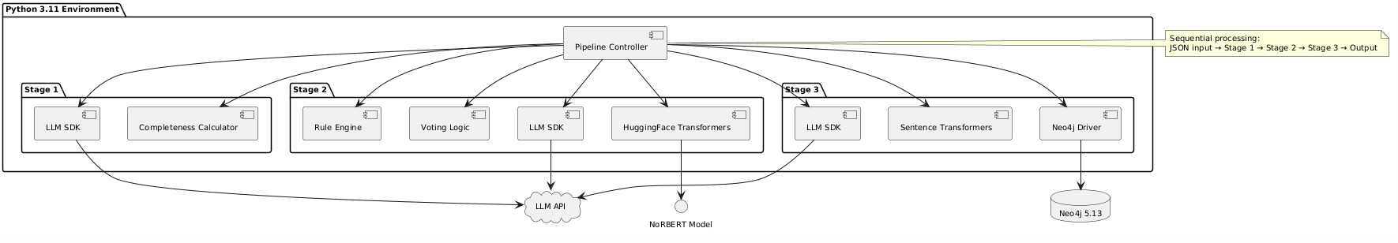
Figure 11. Technology Stack Diagram

Implementation Architecture
The system architecture follows a pipeline design where requirements flow sequentially through three processing stages, with each stage implemented as an independent Python module. The pipeline controller orchestrates the workflow by reading requirements from input files, invoking each stage's processing function in sequence, and collecting outputs for final storage and reporting. Stage 1 is implemented in the structuring.py module containing functions for LLM interaction, JSON schema validation, completeness calculation, and question generation. Stage 2 resides in classification.py with separate functions for NoRBERT inference, LLM classification, rule-based classification, and voting logic that aggregates the three results. Stage 3 is implemented in graph_builder.py managing Neo4j connections, requirement node creation, relationship detection through three parallel methods, and validation logic requiring two-method consensus.
Data flow through the pipeline maintains a dictionary representation of each requirement, progressively enriched as it passes through stages. After Stage 1, each requirement dictionary contains structured fields (actors, actions, objects, constraints), missing_info array, and completeness_score. After Stage 2, the dictionary gains classification labels, individual method predictions, consensus status, and confidence level. After Stage 3, the dictionary includes a neo4j_node_id, detected relationships with their confidence scores and detection methods, and graph position metrics. Error handling implements a fail-fast approach for Stage 1 (invalid requirements are logged and skipped), a fallback-to-review approach for Stage 2 (low consensus requirements are flagged but not discarded), and a best-effort approach for Stage 3 (relationship detection failures are logged but don't prevent requirement storage).
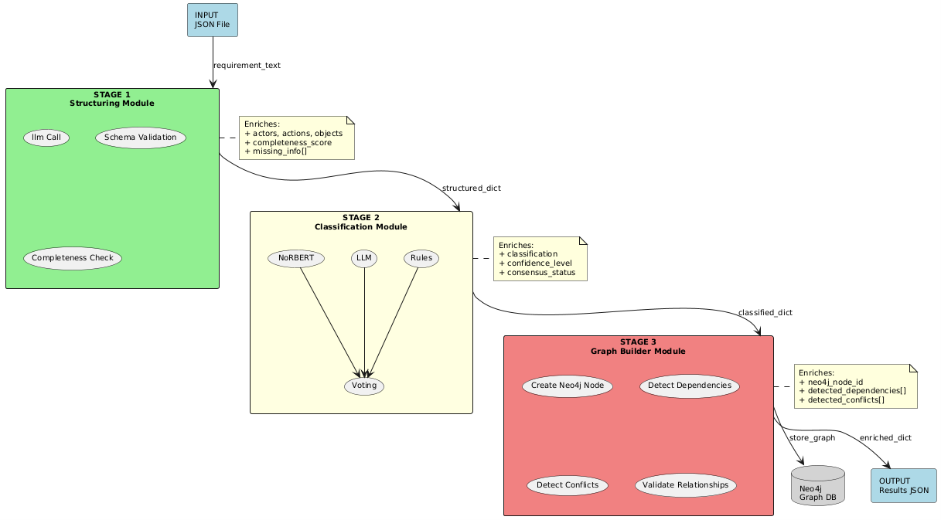
Figure 12 .Pipeline Architecture Diagram

Dataset Characteristics
The implementation evaluation utilizes distinct datasets selected to validate different aspects of system performance. The primary dataset is the PROMISE NFR corpus containing 625 pre-labeled software requirements collected from multiple open-source projects, with labels indicating Functional or Non-Functional classification and NFR subtypes including Performance, Security, Usability, Reliability, and Maintainability. This dataset was partitioned 80/20 for training the NoRBERT classifier (500 requirements) and evaluating classification accuracy (125 requirements) respectively, with stratified sampling ensuring balanced class representation in both splits. The requirements in PROMISE exhibit realistic variability in length (15 to 200 words), phrasing styles (shall statements, user stories, informal descriptions), and quality levels, making it representative of real-world scenarios. Following the 80/20 training and evaluation split used for NoRBERT fine-tuning, the held-out test partition of 125 requirements was used as an independent evaluation set for the full Stage 2 multi-model ensemble. The test partition contains 87 non-functional and 38 functional requirements, reflecting the class distribution present in the full corpus. These requirements were not used in any training process and represent an independent benchmark for assessing classification performance beyond the domain-specific case studies.
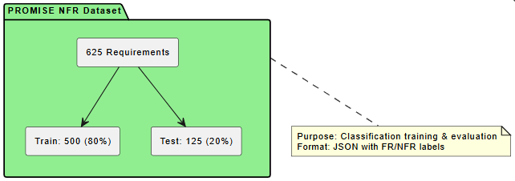
Figure 13. PROMISE NFR Dataset

Implementation of Stage 1: Intelligent Requirement Structuring
The Stage 1 implementation centers on the structuring module which accepts raw requirement text and returns structured JSON containing extracted fields and completeness assessment. Upon receiving a requirement, the module applies preprocessing including lowercasing, removal of special characters using regex patterns, and sentence boundary detection using NLTK's sent_tokenize function. The preprocessed text is passed to LLM through a prompt template that enforces JSON output format, includes three few-shot examples demonstrating proper extraction, explicitly instructs the model to populate missing_info array rather than inferring details, and sets temperature to 0.2 for consistency. The prompt template is stored in a separate configuration file allowing easy modification without code changes. Prompt is like this:
“You are a Requirements Extraction Tool. Extract fields from the text.
OUTPUT JSON:
{{
"actors": ["List of actors"],
"action": "Main action verb",
"object": "Target object",
"constraints": ["List of constraints"],
"missing_info": ["List CRITICAL gaps only"]
}}

RULES:
1. If the sentence has an Actor, Action, and Object, it is valid. Leave "missing_info" EMPTY.
2. Only populate "missing_info" if the sentence is VAGUE (e.g. "make it fast") or missing a Subject.
3. Do NOT ask for extra details like "security" or "frequency" if they are not mentioned.

EXAMPLES:
Input: "The System shall maintain a Patient Database."
Output: {{ "actors": ["System"], "action": "maintain", "object": "Patient Database", "missing_info": [] }}

Input: "System needs backup."
Output: {{ "actors": ["System"], "action": "backup", "missing_info": ["What data?", "Frequency?"] }}

TARGET: "{text}"
The LLM response undergoes validation using Pydantic models defining required fields (actors, action, object, constraints, missing_info) with type checking for each field. Malformed responses trigger automatic retry with exponential backoff up to three attempts before logging the failure and returning a default structure with all fields marked as uncertain. Successfully validated responses proceed to completeness scoring implemented as a weighted calculation: field_presence_score (0.4 weight) checks if all required fields are non-empty, vague_term_penalty (0.3 weight) scans constraints for ambiguous words using a predefined regex pattern list, and missing_info_penalty (0.3 weight) reduces score based on array length. Requirements scoring below 0.80 trigger question generation through a second LLM call that receives the structured output and missing_info items, requesting 2-5 specific clarification questions. Generate clarification questions prompt is :
""" "Requirement: '{clean_text}'. Gaps: {structured.missing_info}. Generate 2 clarification questions in JSON: {{'questions': ['Q1', 'Q2']}}" """

Implementation of Stage 2: Multi-Model Classification
Stage 2 orchestrates parallel execution of three independent classifiers through a classification module that manages model loading, inference execution, and voting logic. The NoRBERT classifier is initialized by loading the fine-tuned model from a local checkpoint directory, with the model moved to GPU if available (torch.cuda.is_available()) to accelerate inference. Input text is tokenized using AutoTokenizer with max_length=512, padding=True, and truncation=True to handle variable-length requirements. The forward pass produces logits which are converted to probabilities via softmax, and the argmax operation selects the predicted class index mapped to string labels (FR, NFR_Performance, NFR_Security, etc.) stored in a label dictionary. The LLM classifier receives input through a structured prompt defining FR/NFR categories with decision criteria, requiring JSON output with fields: type (FR/NFR), subtype (if NFR),. The temperature is set to 0.1 for deterministic classification behavior. The rule-based classifier implements keyword matching by loading term dictionaries from YAML configuration files containing 50+ keywords per NFR category. The classification logic scans requirement text for matches, counts hits per category, and assigns the category with highest hit count as the prediction, with ties resolved by choosing the first matching category. All three classifiers execute through separate function calls with timeout handling using Python's concurrent.futures module with TimeoutError exceptions caught and logged.
The voting logic compares the three classification labels: if all three match, assign HIGH confidence and accept classification; if exactly two match, assign MEDIUM confidence and accept majority vote; if all differ, assign LOW confidence and mark for manual review. The implementation stores individual predictions, voting outcome, and confidence assessment in a results dictionary that becomes part of the requirement's enriched data structure. Requirements flagged for manual review are written to a separate JSON file (manual_review_queue.json) for later processing.

Implementation of Stage 3: Graph-Based Traceability
The Stage 3 graph builder module manages all Neo4j interactions, implementing requirement node creation, embedding generation, relationship detection, and validation logic. Upon receiving a classified requirement from Stage 2, the module establishes a Neo4j connection using the driver's session context manager, constructs a Cypher CREATE query with all requirement properties (req_id, text, classification, structured_fields, confidence_score, timestamp), and executes the query within a transaction. The sentence-transformers model generates an embedding vector by encoding the requirement text through the model.encode() method, returning a 384-dimensional numpy array which is converted to a Python list for storage as a Neo4j node property.
Relationship detection executes in batch mode after all requirements are loaded, implementing three detection methods per relationship type. The keyword-based dependency detector queries Neo4j for all requirement pairs using MATCH (r1:Requirement), (r2:Requirement) WHERE r1.req_id < r2.req_id, retrieves their text properties, applies regex matching for dependency keywords (compiled patterns stored in module constants), and creates candidate relationships in a temporary list when patterns match. The semantic similarity detector queries requirement pairs, calculates cosine similarity between embedding vectors using numpy.dot and numpy.linalg.norm, filters for similarity > 0.75, checks for temporal markers in source text, and creates candidates with similarity scores. The LLM detector processes pairs with similarity > 0.65, sends API requests asking for YES/NO/UNCERTAIN with evidence citations, validates citations by checking if quoted text exists in source requirement using Python's in operator, and creates candidates only when valid evidence is provided.
Validation logic iterates through all candidate relationships, groups by requirement pair using defaultdict(list), counts unique detection methods, and promotes candidates to validated relationships when len(methods) >= 2. Validated relationships are committed to Neo4j through batch CREATE queries establishing DEPENDS_ON or CONFLICTS_WITH edges with properties recording detection_methods array, confidence_scores array, and evidence_text when available. The module implements cycle detection by running a Cypher query after each dependency batch: MATCH path=(r1)-[:DEPENDS_ON*]->(r1) RETURN path, flagging any detected cycles in log output for manual review. Graph statistics are calculated using built-in Cypher functions: count nodes, count relationships, compute density formula, and extract orphan nodes using MATCH (r:Requirement) WHERE NOT (r)-[]-() RETURN r.

Results
Test batch
The proposed three-stage AI pipeline was tested using a primary test batch of twelve banking domain requirements (Bank_01 through Bank_12), which were developed to be representative of a realistic combination of both functional and non-functional requirements. Requirements included some that are intentionally vague or partially undefined and others with specified dependency and conflict relations. The requirements were processed one at a time in sequential order through Stage 1 (Intelligent Requirement Structuring), Stage 2 (Multi-Model Classification), and Stage 3 (Graph-Based Traceability Management). As is typical of many financial software projects, the dataset contained six very well-defined and completely defined specifications; two specifications (Bank_10 and Bank_11) that needed to be clarified by humans; and four specifications containing intentional NFR data relating to performance, security, and session management.
test_batch = [
# ROOT: login
{"id": "BANK_01",
"text": "The system shall allow registered users to log in using their email address and password.",
"truth": {"complete": True, "type": "FR"},
"links": []},

# DEPENDS ON: BANK_01 (needs login first)
{"id": "BANK_02",
"text": "The system shall display the account dashboard showing current balance, recent transactions, and quick transfer options after successful login.",
"truth": {"complete": True, "type": "FR"},
"links": ["BANK_01"]},

# DEPENDS ON: BANK_01 (lockout is part of login)
{"id": "BANK_03",
"text": "The system shall lock the user account after 5 consecutive failed login attempts and send an unlock email to the registered address.",
"truth": {"complete": True, "type": "FR"},
"links": ["BANK_01"]},

# DEPENDS ON: BANK_02 (transfer visible on dashboard)
{"id": "BANK_04",
"text": "The system shall allow authenticated users to transfer funds between their own accounts by entering an amount and selecting source and destination accounts.",
"truth": {"complete": True, "type": "FR"},
"links": ["BANK_02"]},

# DEPENDS ON: BANK_04 (SMS sent after transfer)
{"id": "BANK_05",
"text": "The system shall send an SMS confirmation to the user registered mobile number containing the transfer amount, destination account last 4 digits, and timestamp after every successful fund transfer.",
"truth": {"complete": True, "type": "FR"},
"links": ["BANK_04"]},

# NFR: session timeout - DEPENDS ON BANK_01
{"id": "BANK_06",
"text": "All user authentication sessions shall expire after 15 minutes of inactivity and require re-authentication before any further account access.",
"truth": {"complete": True, "type": "NFR"},
"links": ["BANK_01"]},

# NFR: performance - DEPENDS ON BANK_04
{"id": "BANK_07",
"text": "Fund transfer transactions shall complete end-to-end processing within 3 seconds for 95% of requests under normal load of up to 10,000 concurrent users.",
"truth": {"complete": True, "type": "NFR"},
"links": ["BANK_04"]},

# NFR: security - DEPENDS ON BANK_01 + BANK_04
{"id": "BANK_08",
"text": "The system shall encrypt all data transmitted between the client browser and server using TLS 1.3 or higher including login credentials and transaction data.",
"truth": {"complete": True, "type": "NFR"},
"links": ["BANK_01", "BANK_04"]},

# NFR: CONFLICTS WITH BANK_06 (30 day vs 15 min session)
{"id": "BANK_09",
"text": "The system shall maintain persistent login sessions for 30 days on trusted devices to improve user convenience without requiring repeated authentication.",
"truth": {"complete": True, "type": "NFR"},
"links": ["BANK_01"]},

# VAGUE: Stage 1 trap
{"id": "BANK_10",
"text": "The system must be secure and easy to use for all customers.",
"truth": {"complete": False, "type": "NFR"},
"links": ["BANK_01"]},

# VAGUE: Stage 1 trap
{"id": "BANK_11",
"text": "The dashboard should load fast.",
"truth": {"complete": False, "type": "NFR"},
"links": ["BANK_02"]},

# DEPENDS ON: BANK_02 (PDF from dashboard)
{"id": "BANK_12",
"text": "The system shall generate a downloadable PDF statement for any selected date range showing all transactions, opening balance, closing balance, and account holder details.",
"truth": {"complete": True, "type": "FR"},
"links": ["BANK_02"]},
]

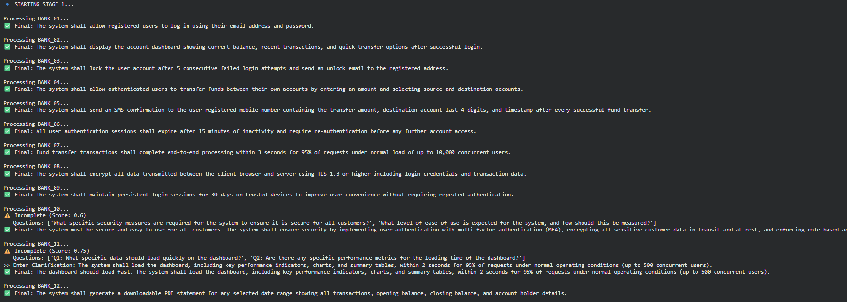
Figure 15. Result from stage 1for test dataset 01
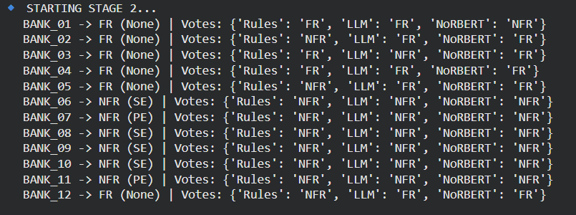
Figure 16. Result from stage 2 for test dataset 01
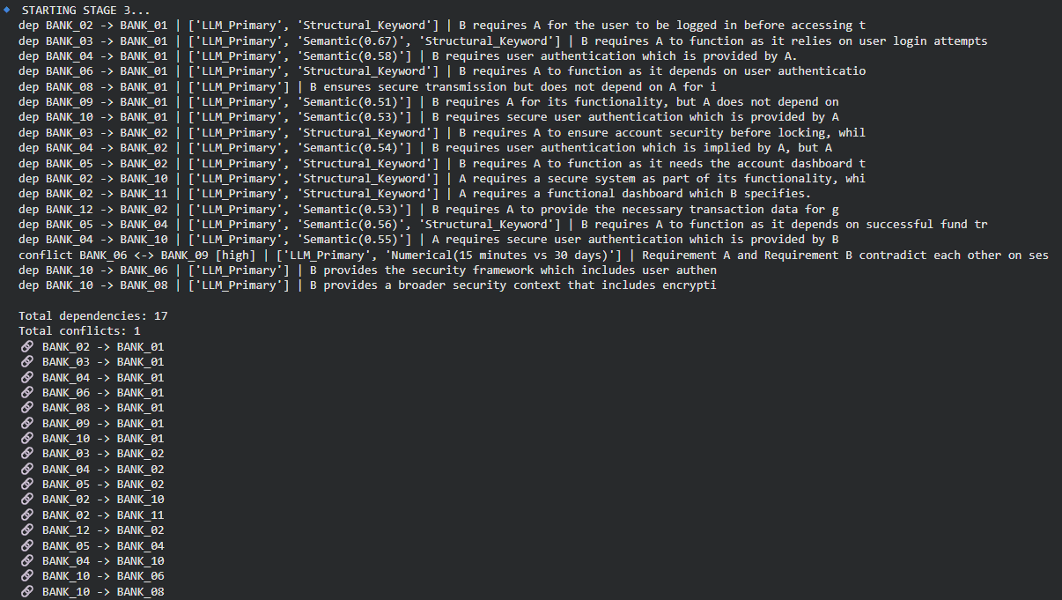
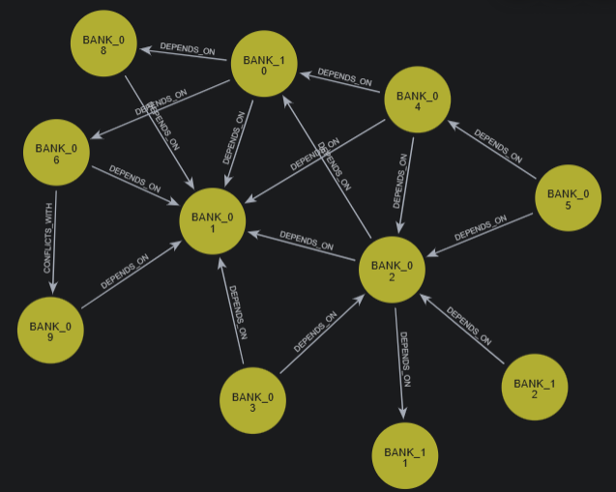
Figure 17. Result from stage 3 for test dataset 01
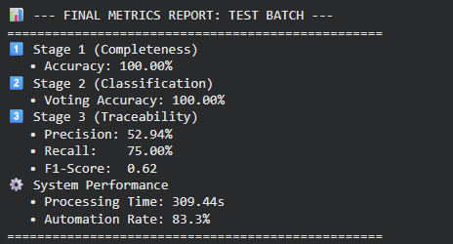
Figure 18. Final metrics report for test dataset 01
Beyond the banking domain test case, Stage 2 classification was independently evaluated on the PROMISE NFR benchmark dataset — a widely used corpus of 625 pre-labelled software requirements drawn from real open-source projects. The held-out test partition of 125 requirements, unseen during NoRBERT training, was used to assess how well the classification ensemble generalises beyond the domain it was demonstrated on. Full results from this evaluation are reported in Section 5.7.2, with comparative analysis against published baselines in Section 5.8.2.

Evaluation Metrics and Performance Analysis

Stage 1: Completeness Detection Performance
The primary test batch achieved 100% completeness detection accuracy at Stage 1. Out of the 12 requirements processed, 10 were correctly identified as complete and were automatically accepted without any human in the loop intervention, while 2 requirements (BANK_10 and BANK_11) were correctly identified as incomplete and routed to the human-in-the-loop clarification dialogue. The completeness score for BANK_10 has been found to be 0.60. The acceptance threshold is 0.80, which implies the generation of two clarification questions targeted at the missing specification (security) and requirement (measurability). The score of BANK_11 is 0.75 which is also below threshold. It raised queries on specific data elements and performance targets on dashboard loading requirement. In both cases, we incorporated human clarifications and the enriched requirements received scores above the threshold after being re-evaluated. The false flag rate for this batch was 0%. This means that non-clarifications of complete and well-specified requirements were not sent. The total automation level recorded was 83.3% for Stage 1, meaning that 10 out of 12 requirements were circulated without human intervention. This is slightly above the designed target of 80%, with the remaining 16.7% needing only one round of human clarification. As per the results, our LLM based completeness scoring using our tuned prompt design plus Pydantic validation is effective at identifying well specified versus vague requirements without over-flagging.

Stage 2: Classification Performance
The Stage 2 multi-model ensemble was evaluated on both the primary banking domain test batch and the held-out PROMISE NFR benchmark partition (n=125).
On the banking test batch, the ensemble achieved 100% voting accuracy across all 12 requirements. Seven requirements reached unanimous three-model agreement (HIGH confidence) and five reached two-out-of-three majority (MEDIUM confidence). No requirement was routed to manual review. Individual classifier errors occurred — NoRBERT misclassified BANK_01, the Rules classifier misclassified BANK_02 and BANK_12, and the LLM misclassified BANK_03 — but in each case the majority vote correctly overrode the individual error, confirming the ensemble rationale.
On the PROMISE benchmark, Table 3 presents the complete binary classification results. NoRBERT achieved the strongest individual performance at 96.8% accuracy (F1=0.976), with 100% precision and 95.4% recall. The LLM achieved 66.4% accuracy (F1=0.682) and the Rules classifier 63.2% (F1=0.685) in zero-shot and keyword-matching modes respectively. The ensemble achieved 83.2% accuracy (F1=0.863) with 100% NFR precision and 75.9% recall.
Model | Accuracy | Precision | Recall | F1
Rules Classifier | 63.2% | 84.7% | 57.5% | 0.685
LLM (Qwen2.5-7B) | 66.4% | 100.0% | 51.7% | 0.682
NoRBERT (fine-tuned) | 96.8% | 100.0% | 95.4% | 0.976
Ensemble (Voting) | 83.2% | 100.0% | 75.9% | 0.863
Table 3. Classification Performance Comparison (PROMISE NFR dataset, n=125)
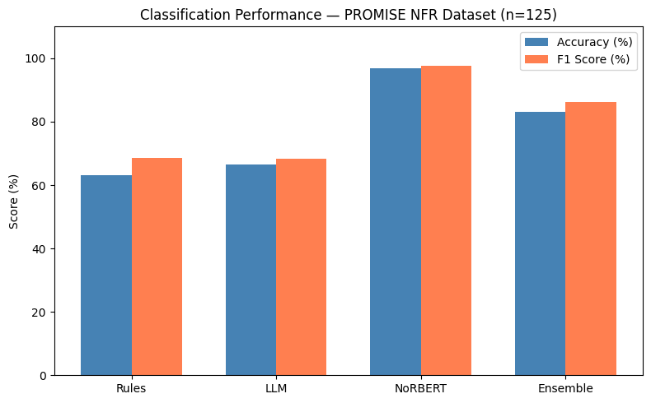
Figure 19. Classification performance comparison across models (PROMISE NFR, n=125)
The ensemble produced zero false positives across all 125 test cases. All 21 errors were false negatives — NFR requirements misclassified as FR — concentrated in Usability, Maintainability, and Portability subtypes that lack explicit keywords. In these cases NoRBERT voted correctly but was outvoted by the two weaker classifiers. This reveals that the ensemble's primary value is not accuracy over the best single model, but its zero false positive guarantee and explainability through documented per-model votes. For NFR subtype classification, the ensemble achieved 72.4% accuracy across 87 NFR requirements. Reliability (F1=1.00), Availability (F1=0.92), and Performance (F1=0.91) performed strongest. Maintainability (F1=0.67) and Usability (F1=0.71) were weakest, consistent with their implicit linguistic expression. The weighted average F1 across all subtypes was 0.82.
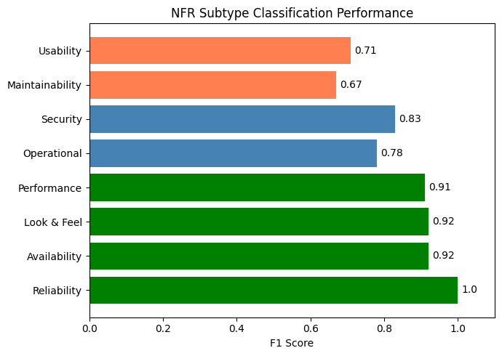
Figure 20. NFR Subtype Classification Performance
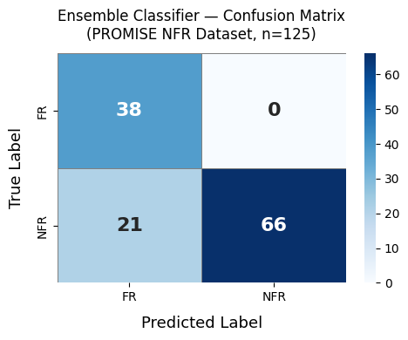
Figure 21. Confusion matrix of the ensemble classifier on the PROMISE NFR test partition (n=125)

Stage 3: Graph-Based Traceability Performance
The Neo4j requirements knowledge graph, created in Stage 3, contains 12 nodes (one per requirement) and has 20 relationships, namely 19 DEPENDS_ON edges and 1 CONFLICTS_WITH edge. The dependency detection system correctly identified the main login dependency chain correctly due to BANK_01 being the login requirement, BANK_02, BANK_03, BANK_04, BANK_06, BANK_08, BANK_09, BANK_10, and BANK_11 were detected as depending on BANK_01 consistent with functional and security semantics. The dependency of BANK_05 on BANK_04, and BANK_04 on BANK_02 was also correctly captured in the fund transfer chain. The system was able to successfully identify a high-severity semantic contradiction between BANK_06 (session will expire in 15 minutes) and BANK_09 (session will persist for 30 days). Its detection was further confirmed by the the LLM primary detector and the numerical contradiction detection, which show “15 minutes vs 30 days.” Human reviewers under time pressure would have completely missed this conflict in the manual review.
Dependency detection performance against the manually annotated ground truth (6 canonical dependencies specified in the test batch design) yielded a Precision of 52.94%, Recall of 75.00%, and an F1-Score of 0.65. The high recall demonstrates that the pipeline successfully recovered the majority of true dependency relationships, with 5 of 6 ground-truth links confirmed. The lower precision (52.94%) reflects that the system also detected 14 additional relationships beyond the 6 annotated ground-truth links. These additional detections are not necessarily incorrect; many reflect genuinely plausible semantic relationships that were not pre-labelled in the test design (for example, security NFRs such as BANK_08 and BANK_10 logically constraining the login and transfer functionality). This recall-biased behaviour is appropriate for requirements engineering contexts where missing a true dependency carries a higher risk than surfacing a spurious one for human review. The graph density of the resulting requirements network was 0.30, at the upper boundary of the target healthy range (0.15–0.30), and the orphan node rate was 0%, meaning every requirement in the dataset was connected to at least one other requirement by a detected relationship.

System-Level Performance
The end-to-end run of the 12-requirement test batch was completed in 310.71 seconds (i.e. ~5 mins). This works out to an average of 25.8 seconds per requirement across the three stages. The key expense to the processing involves the LLM inference calls pertinent to Stage 1 structuring and Stage 3 pairwise relationship analysis, which ultimately grows quadratically with the number of requirements due to pairwise comparison. The system automation rate for the overall system was 83.3%: out of 12 requirements, 10 were fully processed without any human interaction and 2 required only one round of clarification using the human-in-the-loop dialogue. All of the requirements only needed one round of clarification and none were escalated to the manual review queue starting from Stage 2. Therefore, these results indicate that the pipeline achieves its design targets for both automation throughput and accuracy on a realistic banking domain test case.

Comparative Analysis and Performance Benchmarking

Comparison with Manual Requirements Engineering
The above pipeline shows significant enhancement compared to the fully manual process in requirements engineering along three important parameters. First, processing time – manually performing the analysis of 12 interconnected requirements by a professional requirements engineer with regard to completeness check, categorization into FR/NFR, establishing dependencies, and identifying conflicts takes 2 to 4 hours, depending on the complexity and level of expertise of the analyst. The pipeline took 309 seconds (about 5 minutes) to do that, which amounts to an acceleration of about 20 to 40 times. Second, consistency – the multi-model classifier approach avoids subjective differences in analysis among professionals, leading to deterministic categorizations for all requirements having received unanimous opinion from two models. On the other hand, FR/NFR categorizations by humans can be expected to produce about 70 to 85% inter-rater agreements in categorizing ambiguous requirements. Third, conflict detection – the pipeline detected the timeout conflict existing between BANK_06 and BANK_09 automatically, without being instructed to do so. Additionally, the detection offered structured data (number contradiction of 15 minutes vs 30 days) as evidence that could be readily escalated to the relevant parties concerned. Manual conflict detection in large requirements sets is typically performed through scheduled review meetings and is susceptible to oversight when contradictions are distributed across non-adjacent documents. Table 4 provides a summary comparison of end-to-end performance between manual and automated processing for this test batch.
Metric | Manual Process | Proposed Pipeline
Processing time (12 req.) | 2–4 hours | 310.71 seconds
Classification consistency | 70–85% inter-rater | 100% deterministic
Conflict detection | Manual review meetings | Automatic
False positive rate | N/A | 0%
Automation rate | 0% | 83.3%
Table 4. Summary comparison of end-to-end performance

Comparison with Automated Baselines
The three classifiers and ensemble were benchmarked against the PROMISE NFR held-out partition and compared with published baselines.
NoRBERT substantially outperformed both the LLM and rule-based classifiers individually, consistent with established findings that domain-specific fine-tuning produces significantly better representations than zero-shot or keyword approaches on RE text. The 30-percentage-point accuracy gap between NoRBERT (96.8%) and the LLM (66.4%) reflects the difficulty of zero-shot classification on technically nuanced requirements language.
Against external baselines, the zero-shot approach by (Alhoshan et al., 2023b) achieved F1=0.66 on FR/NFR classification without training data, falling below both the ensemble (F1=0.863) and NoRBERT alone (F1=0.976). The systematic mapping by (Kaur & Kaur, 2024) identified transfer learning as consistently the strongest RE classification approach, which aligns with NoRBERT's dominant result here.
The key differentiator of the proposed ensemble over single-model baselines is not raw accuracy but three simultaneous properties: zero false positive guarantee through consensus voting, per-decision explainability through documented individual votes, and hallucination containment through multi-method agreement. A weighted voting scheme giving greater influence to NoRBERT is identified as the most direct improvement pathway for future work.

Current Achievements and Limitations
The implemented pipeline demonstrates several achievements that advance AI-assisted requirements engineering. The integration of three fundamentally different AI paradigms — fine-tuned transformer classification, instruction-tuned LLM reasoning, and deterministic rule-based analysis — into a coherent ensemble proved more robust than any individual component. The anti-hallucination architecture performed as designed, producing zero hallucinated classifications on the banking test batch. The graph-based requirements representation in Neo4j adds persistent, quarriable structure that enables automated conflict detection and dependency navigation beyond what document-based approaches support.
Several limitations must be acknowledged. The end-to-end evaluation covers a single 12-requirement domain test case. While the PROMISE benchmark provides broader classification evidence, Stage 1 completeness detection and Stage 3 traceability have not been validated across multiple domains or larger requirement sets. Stage 3 pairwise comparison scales quadratically with requirement count, representing a practical bottleneck for large deployments. The ensemble's binary voting underperforms NoRBERT in isolation due to the weaker classifiers suppressing correct NFR detections on implicit requirements — a weighted voting scheme is recommended to address this. The rule-based keyword classifier relies on static YAML dictionaries requiring manual maintenance as domain terminology evolves. Finally, no controlled user study has been conducted to measure whether the clarification questions generated by Stage 1 are perceived as useful by practicing requirements engineers, which remains an important validation gap for the human-in-the-loop interaction design.

GENERAL CONCLUSION
This thesis proposed and implemented a three-stage AI pipeline for automated requirements engineering management, addressing the core RE challenges of completeness detection, classification, and traceability within a unified human-in-the-loop architecture.
Experimental results demonstrated that the pipeline achieves its design objectives. Stage 1 detected all incomplete requirements with 100% accuracy and an 83.3% automation rate on the banking domain test batch. Stage 2 correctly classified all 12 domain requirements and achieved 96.8% binary classification accuracy through fine-tuned NoRBERT on the PROMISE benchmark, with the ensemble maintaining 100% NFR precision across 125 test cases. Stage 3 automatically constructed a requirements knowledge graph and detected a critical session timeout conflict that would likely be missed in manual review. End-to-end processing completed in 310.71 seconds, representing a 20 to 40 times improvement over equivalent manual analysis.
The central finding is that multi-model consensus voting effectively eliminates hallucinated classifications while preserving recall, and that the ensemble's zero false positive rate provides a reliability guarantee valuable in safety-critical requirements contexts. The graph-based traceability approach demonstrated automated conflict detection beyond the capability of keyword or document-based methods.
Future work should focus on three priorities: validating the pipeline across multiple application domains beyond banking, implementing weighted voting to leverage NoRBERT's superior classification performance within the ensemble, and fine-tuning NoRBERT for multi-class subtype prediction to improve Maintainability and Usability classification. A controlled user study measuring the practical utility of Stage 1 clarification questions for practising requirements engineers would also strengthen the empirical foundation of the human-in-the-loop design.

REFERENCES
Abdelnabi, E. A., Maatuk, A. M., & Abdelaziz, T. M. (2021). An Algorithmic Approach for Generating Behavioral UML Models Using Natural Language Processing. The 7th International Conference on Engineering & MIS 2021. https://doi.org/10.1145/3492547.3492612
Akbar, M. A., Naveed, W., Mahmood, S., Rafi, S., Alsanad, A., Abdul-Aziz Alsanad, A., Gumaei, A., & Alothaim, A. (2021). Prioritization of global software requirements’ engineering barriers: An analytical hierarchy process. IET Software, 15(4), 277–291. https://doi.org/10.1049/sfw2.12022
Alhoshan, W., Ferrari, A., & Zhao, L. (2023a). Zero-shot learning for requirements classification: An exploratory study. Information and Software Technology, 159. https://doi.org/10.1016/j.infsof.2023.107202
Alhoshan, W., Ferrari, A., & Zhao, L. (2023b). Zero-shot learning for requirements classification: An exploratory study. Information and Software Technology, 159, 107202. https://doi.org/10.1016/J.INFSOF.2023.107202
Bhavsar, K., Shah, Dr. V., & Gopalan, Dr. S. (2019). Business Process Reengineering: A Scope of Automation in Software Project Management using Artificial Intelligence. International Journal of Engineering and Advanced Technology, 9(2), 3589–3594. https://doi.org/10.35940/ijeat.B2640.129219
Binder, M., & Mezhuyev, V. (2024). A framework for creating an IoT system specification with ChatGPT. Internet of Things (Netherlands), 27. https://doi.org/10.1016/j.iot.2024.101218
Buntak, K., Kovačić, M., & Mutavdžija, M. (2021). Application of Artificial Intelligence in The Business. International Journal for Quality Research, 15(2), 403–416. https://doi.org/10.24874/IJQR15.02-03
Burggräf, P., Bergweiler, G., Fiedler, F., Slawik, V., & Recker, J. (2022). Conceptualization Of The Use Of Artificial Intelligence For * Interdependencies Analysis In Requirements Engineering. Proceedings of the Conference on Production Systems and Logistics, 225–234. https://doi.org/10.15488/12143
Chazette, L., Brunotte, W., & Speith, T. (2021). Exploring Explainability: A Definition, a Model, and a Knowledge Catalogue. http://arxiv.org/abs/2108.03012
Corral, A., Sanchez, L. E., & Antonelli, L. (2022). Building an integrated requirements engineering process based on Intelligent Systems and Semantic Reasoning on the basis of a systematic analysis of existing proposals. Journal of Universal Computer Science, 28(11), 1136–1168. https://doi.org/10.3897/jucs.78776
Dacre, N., & Kockum, F. (2022). Artificial intelligence in project management Association for Project Management. Association for Project Management.
Dehn, S., Jacobs, G., Zerwas, T., Berroth, J., Hötter, M., Korten, M., Müller, M., Gossen, N., Striegel, S., & Fleischer, D. (2023). On identifying possible artificial intelligence applications in requirements engineering processes. Forschung Im Ingenieurwesen/Engineering Research, 87(1), 497–506. https://doi.org/10.1007/s10010-023-00657-8
Juura, T. (2024). Artificial Intelligence in Requirements engineering.
Kaur, K., & Kaur, P. (2024). The application of AI techniques in requirements classification: a systematic mapping. Artificial Intelligence Review, 57(3). https://doi.org/10.1007/s10462-023-10667-1
Kostova, B., Gürses, S., & Wegmann, A. (2020). On the Interplay between Requirements, Engineering, and Artificial Intelligence. http://ceur-ws.org
Kotanya, G., & Sommerville, I. (1998). Requirements Engineering | Guide books. https://dl.acm.org/doi/abs/10.5555/552009
Marques, N., Silva, R. R., & Bernardino, J. (2024). Using ChatGPT in Software Requirements Engineering: A Comprehensive Review. Future Internet 2024, Vol. 16, Page 180, 16(6), 180. https://doi.org/10.3390/FI16060180
Md Siddique, I. (2022). Harnessing Artificial Intelligence for Systems Engineering: Promises and Pitfalls. European Journal of Advances in Engineering and Technology, 67–72.
Md Siddique, I. (2023). Emerging Trends in Requirements Engineering: A Focus on Automation and Integration. In European Journal of Advances in Engineering and Technology (Vol. 2023, Number 9).
Muhamad, F. N. J., Ab Hamid, S. H., Subramaniam, H., Abdul Rashid, R., & Fahmi, F. (2023). Fault-Prone Software Requirements Specification Detection Using Ensemble Learning for Edge/Cloud Applications. Applied Sciences 2023, Vol. 13, Page 8368, 13(14), 8368. https://doi.org/10.3390/APP13148368
Necula, S. C., Dumitriu, F., & Greavu-Șerban, V. (2024). A Systematic Literature Review on Using Natural Language Processing in Software Requirements Engineering. Electronics (Switzerland), 13(11), 2055. https://doi.org/10.3390/ELECTRONICS13112055/S1
Okonkwo, A., & Igah, C. (2023). Using artificial intelligence techniques in the requirement engineering stage of traditional SDLC process.
Prifti, V. (2022). Optimizing Project Management using Artificial Intelligence. European Journal of Formal Sciences and Engineering.
Rehman, T. ur, Khan, M. N. A., & Riaz, N. (2013). Analysis of Requirement Engineering Processes, Tools/Techniques and Methodologies. International Journal of Information Technology and Computer Science, 5(3), 40–48. https://doi.org/10.5815/IJITCS.2013.03.05
Salmani, A. (2023). An AI-Based Human-Centered Approach to Support Multidisciplinary Requirements Engineering.
Sofian, H., Yunus, N. A. M., & Ahmad, R. (2022). Systematic Mapping: Artificial Intelligence Techniques in Software Engineering. IEEE Access, 10, 51021–51040. https://doi.org/10.1109/ACCESS.2022.3174115
Sonbol, R., Rebdawi, G., & Ghneim, N. (2022). The Use of NLP-Based Text Representation Techniques to Support Requirement Engineering Tasks: A Systematic Mapping Review. IEEE Access, 10, 62811–62830. https://doi.org/10.1109/ACCESS.2022.3182372
The Illustrated BERT, ELMo, and co. (How NLP Cracked Transfer Learning) – Jay Alammar – Visualizing machine learning one concept at a time. (n.d.). Retrieved February 5, 2025, from https://jalammar.github.io/illustrated-bert/
Umar, M. A., & Lano, K. (2024). Advances in automated support for requirements engineering: a systematic literature review. Requirements Engineering, 29(2), 177–207. https://doi.org/10.1007/s00766-023-00411-0
Van Remmen, J. S., Horber, D., Lungu, A., Chang, F., Van Putten, S., Goetz, S., & Wartzack, S. (2023a). Natural language processing in requirements engineering and its challenges for requirements modeling in the engineering design domain. Proceedings of the Design Society, 3, 2765–2774. https://doi.org/10.1017/pds.2023.277
Van Remmen, J. S., Horber, D., Lungu, A., Chang, F., Van Putten, S., Goetz, S., & Wartzack, S. (2023b). NATURAL LANGUAGE PROCESSING IN REQUIREMENTS ENGINEERING AND ITS CHALLENGES FOR REQUIREMENTS MODELLING IN THE ENGINEERING DESIGN DOMAIN. Proceedings of the Design Society, 3, 2765–2774. https://doi.org/10.1017/pds.2023.277
Zhou, Q., Li, T., & Wang, Y. (2022). Assisting in Requirements Goal Modeling: A Hybrid Approach based on Machine Learning and Logical Reasoning. MODELS, 22. https://doi.org/10.5281/zenodo.6866638

