Company name : DIAL.N0000 : Dialog Axiata

Company type : Public Subsidiary

Industry : Telecommunications

Headquarters : Colombo

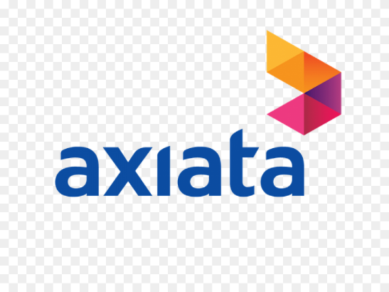

Headquarters

1. Liquidity Measurement ratios.

* Current ratio
* Quick ratio

**Current ratio**

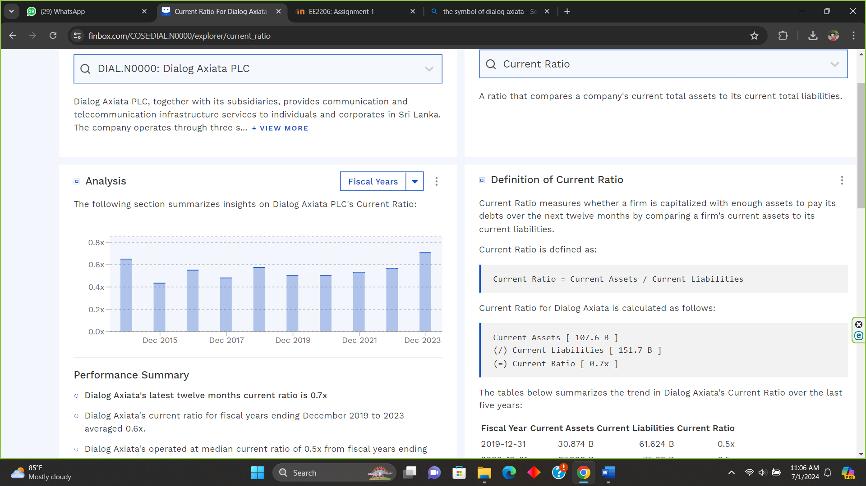

|  |  |
| --- | --- |
| Year | Current ratio |
| 2023 | 0.70 |
| 2022 | 0.58 |
| 2021 | 0.52 |
| 2020 | 0.50 |
| 2019 | 0.50 |
| 2018 | 0.58 |
| 2017 | 0.48 |
| 2016 | 0.55 |
| 2015 | 0.43 |
| 2014 | 0.65 |

**Quick ratio**

|  |  |
| --- | --- |
| Year | Quick ratio |
| 2023 | 0.55 |
| 2022 | 0.45 |
| 2021 | 0.39 |
| 2020 | 0.40 |
| 2019 | 0.32 |
| 2018 | 0.41 |
| 2017 | 0.52 |
| 2016 | 0.35 |
| 2015 | 0.28 |
| 2014 | 0.52 |

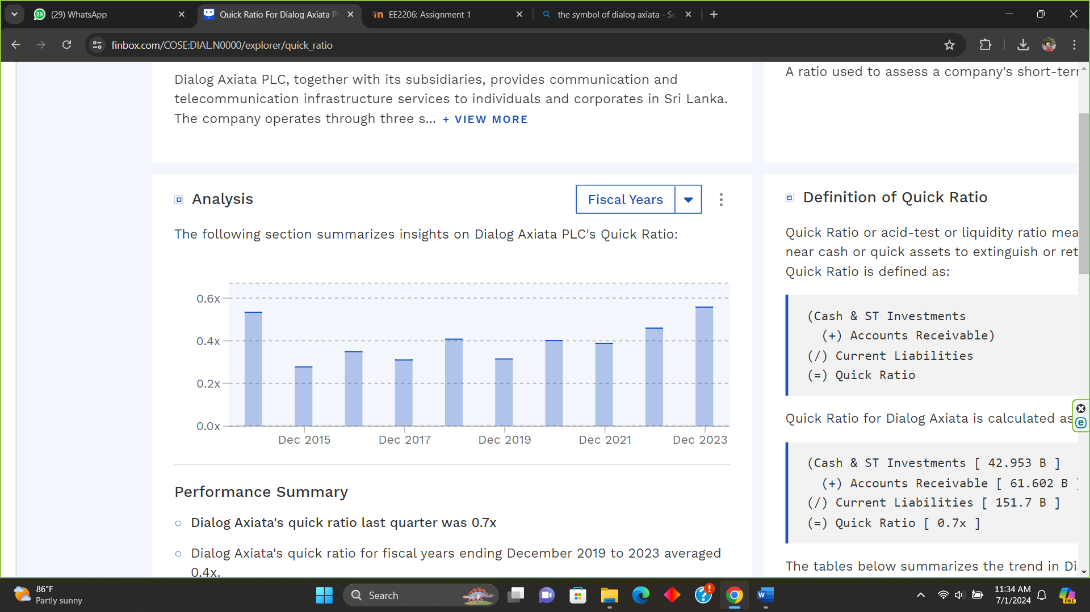

1. Profitability indicator ratios

* Profit margin analysis
* Return on assets
* Return on equity

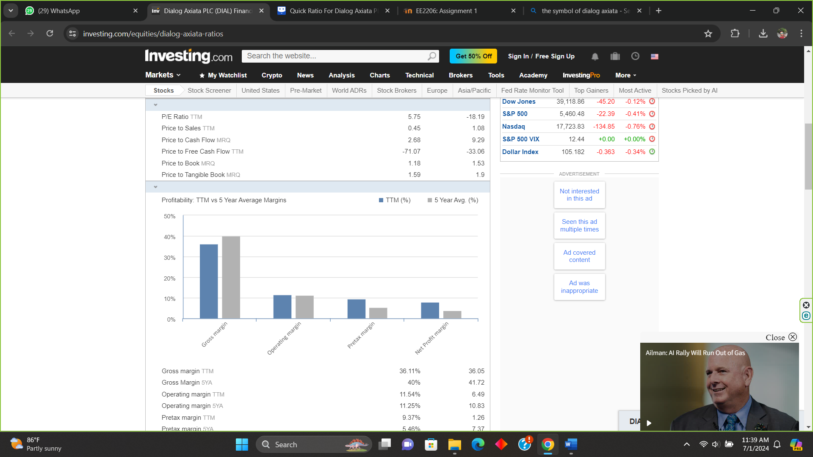**Profit margin analysis**

1. Gross profit margin
2. Operating profit margin
3. Pre-tax profit margin
4. Net profit margin

|  |  |  |
| --- | --- | --- |
| Profit margin | TTM (%) | 5-year average (%) |
| Gross profit | 36.11 | 40.00 |
| Operating profit | 11.54 | 11.25 |
| Pre-tax profit | 9.37 | 5.46 |
| Net profit | 7.85 | 3.93 |

**Return on assets and equity**

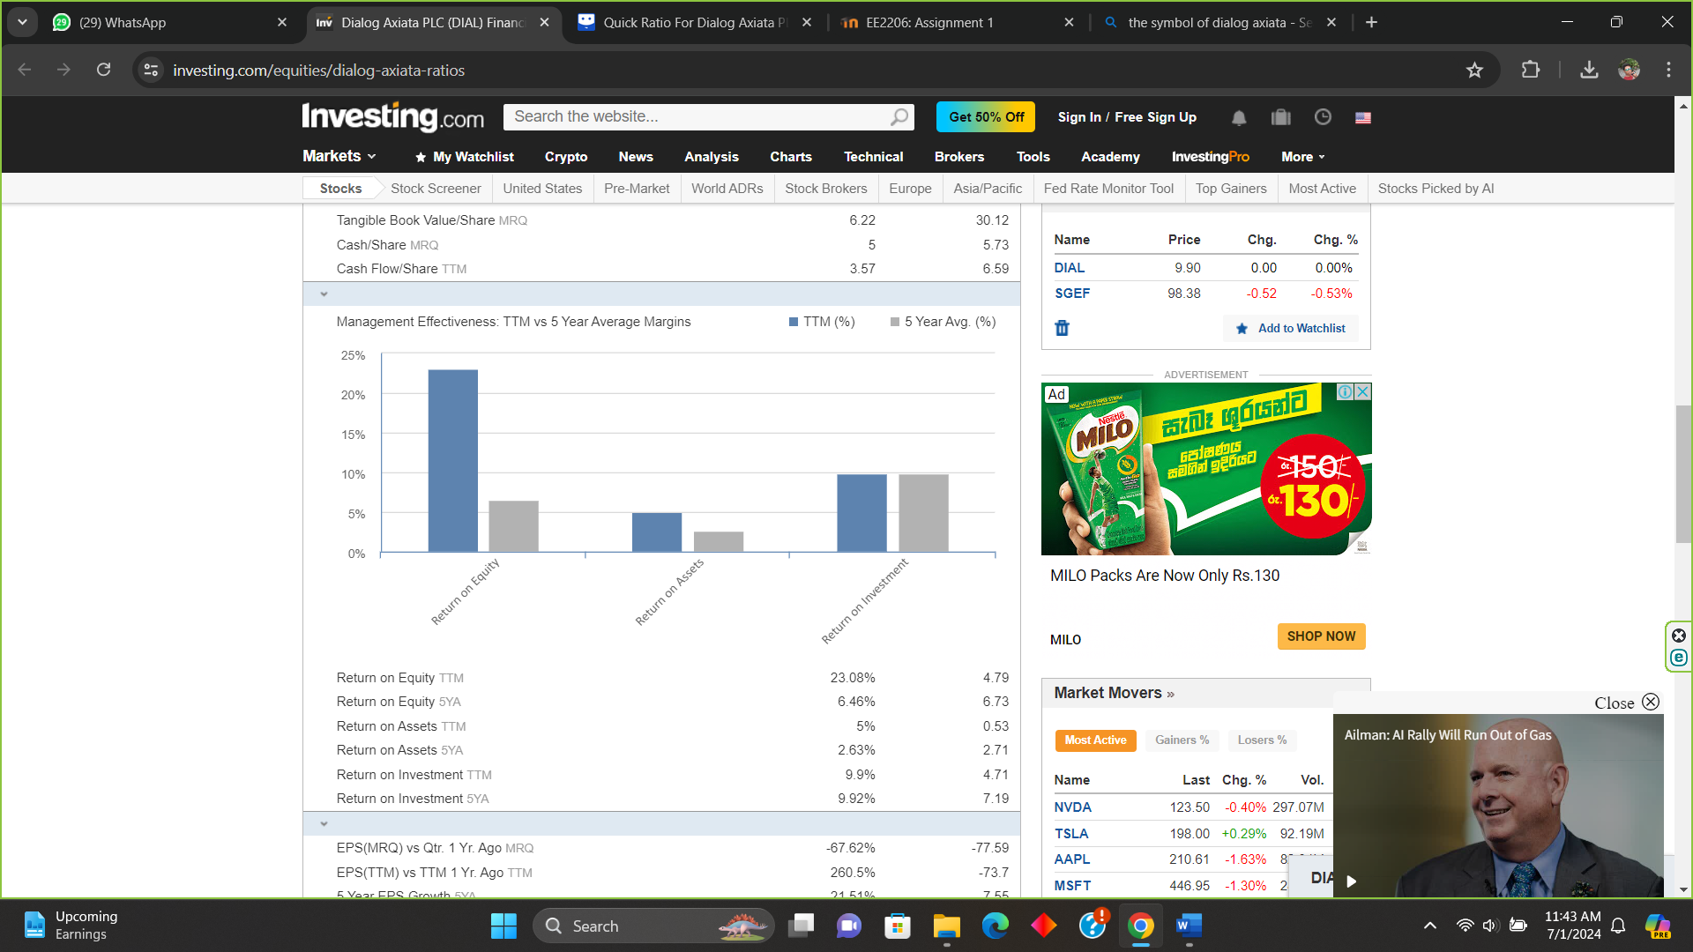

|  |  |  |
| --- | --- | --- |
|  | TTM (%) | 5-year average (%) |
| Return on assets | 5.00 | 2.63 |
| Return on equity | 23.08 | 6.46 |

1. Debt ratio

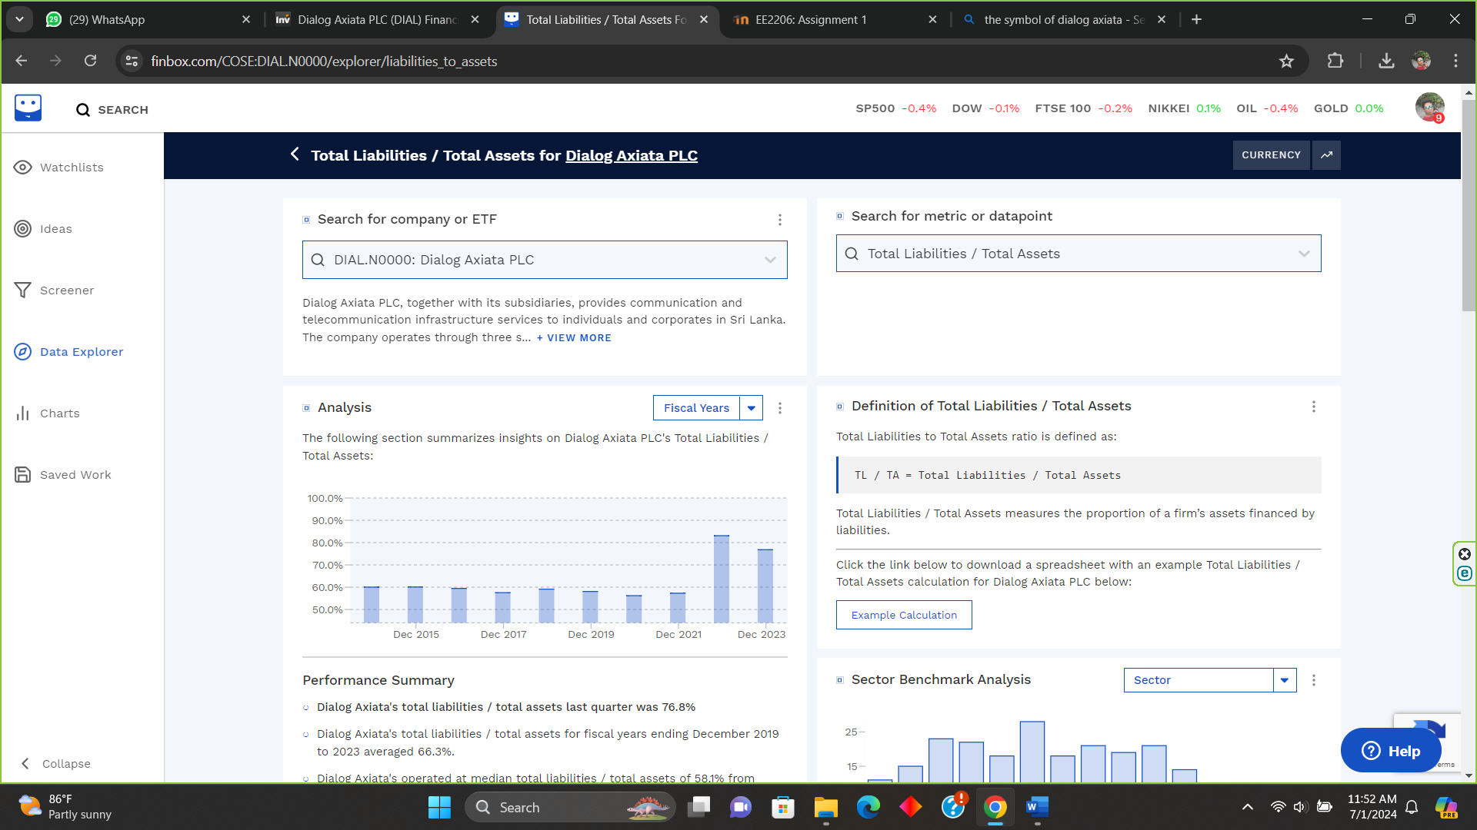

|  |  |
| --- | --- |
| Year | Debt ratio |
| 2023 | 0.768 |
| 2022 | 0.831 |
| 2021 | 0.573 |
| 2020 | 0.562 |
| 2019 | 0.581 |
| 2018 | 0.591 |
| 2017 | 0.576 |
| 2016 | 0.594 |
| 2015 | 0.610 |
| 2014 | 0.600 |

Company name : SLTL.N0000 : Sri Lanka Telecom

Company type : Public

Industry : Telecommunications

Headquarters : Colombo

Headquarters

1. Liquidity Measurement ratios.

* Current ratio
* Quick ratio

**Current ratio**

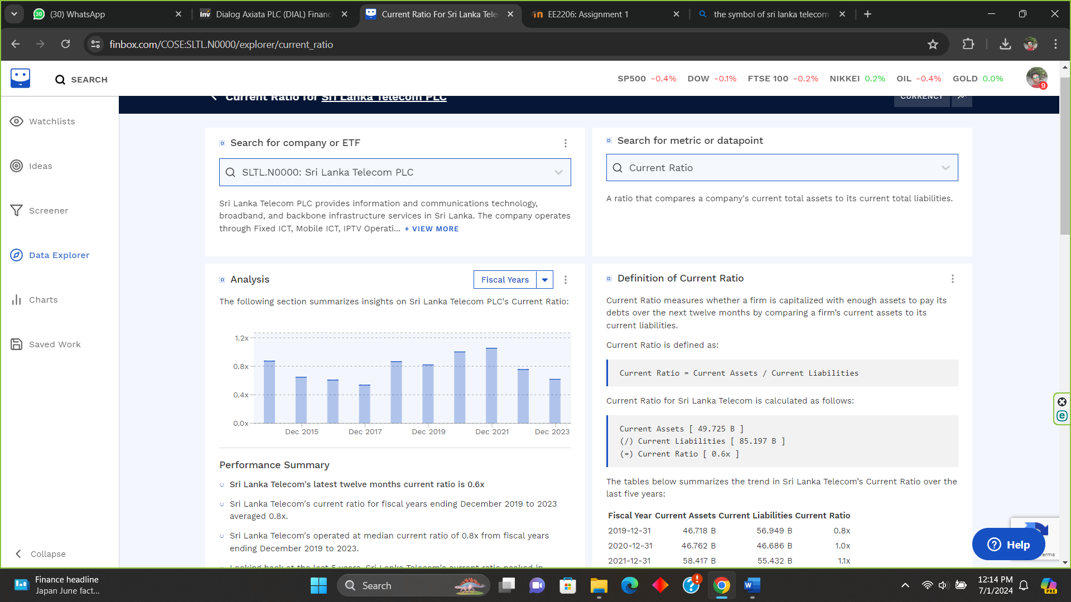

|  |  |
| --- | --- |
| Year | Current ratio |
| 2023 | 0.62 |
| 2022 | 0.75 |
| 2021 | 1.05 |
| 2020 | 1.00 |
| 2019 | 0.81 |
| 2018 | 0.84 |
| 2017 | 0.52 |
| 2016 | 0.60 |
| 2015 | 0.65 |
| 2014 | 0.85 |

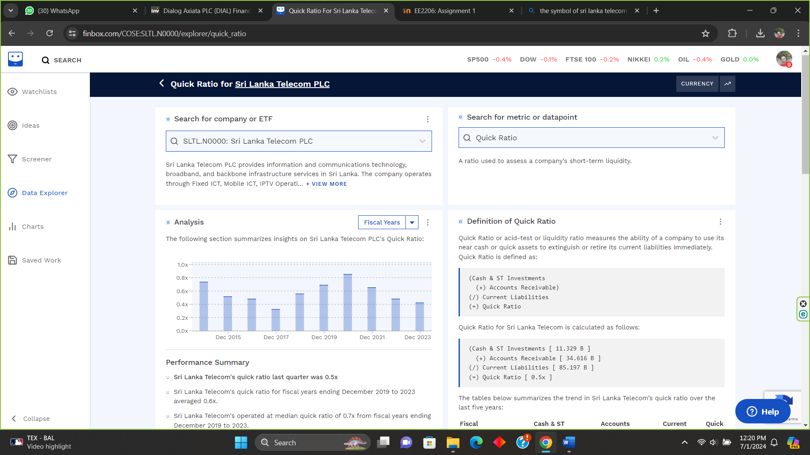**Quick ratio**

|  |  |
| --- | --- |
| Year | Quick ratio |
| 2023 | 0.42 |
| 2022 | 0.48 |
| 2021 | 0.65 |
| 2020 | 0.85 |
| 2019 | 0.68 |
| 2018 | 0.56 |
| 2017 | 0.32 |
| 2016 | 0.48 |
| 2015 | 0.52 |
| 2014 | 0.73 |

1. Profitability indicator ratios

* Profit margin analysis
* Return on assets
* Return on equity

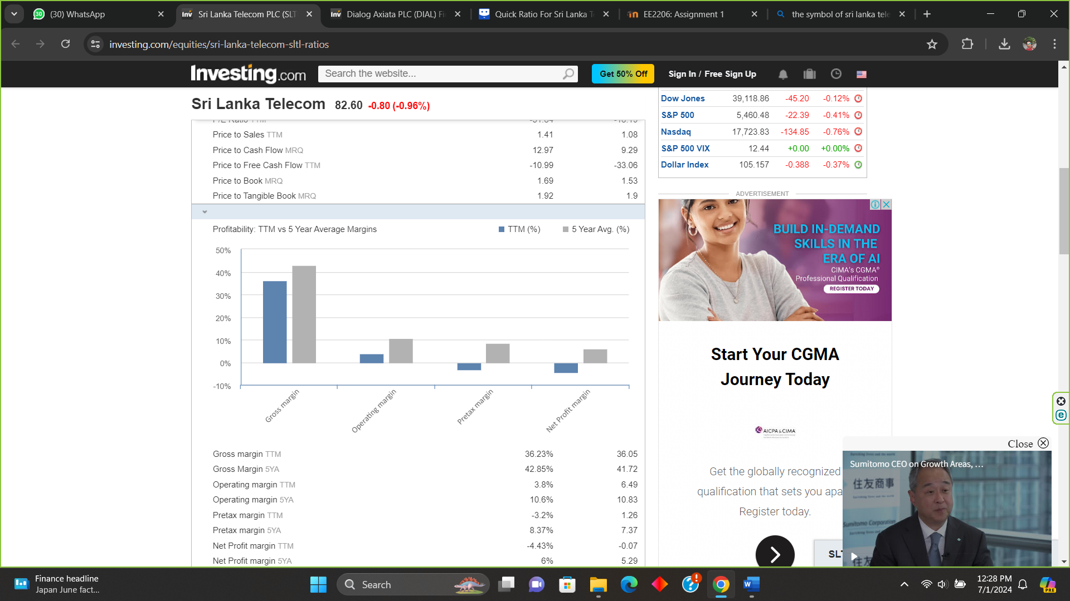**Profit margin analysis**

1. Gross profit margin
2. Operating profit margin
3. Pre-tax profit margin
4. Net profit margin

|  |  |  |
| --- | --- | --- |
| Profit margin | TTM (%) | 5-year average (%) |
| Gross profit | 36.23 | 42.85 |
| Operating profit | 3.80 | 11.60 |
| Pre-tax profit | -3.20 | 8.37 |
| Net profit | -4.43 | 6.00 |

**Return on assets and equity**

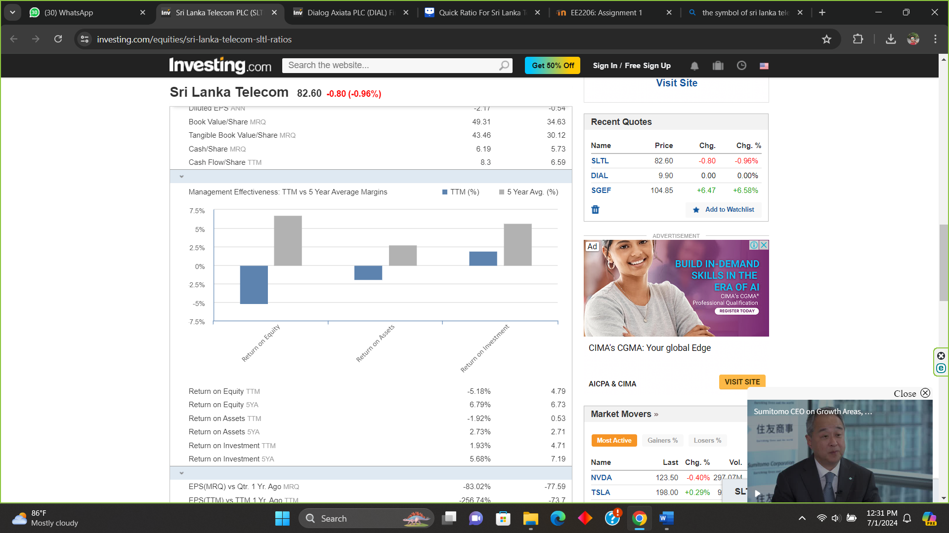

|  |  |  |
| --- | --- | --- |
|  | TTM (%) | 5-year average (%) |
| Return on assets | -1.92 | 2.73 |
| Return on equity | -5.18 | 6.79 |

1. Debt ratio

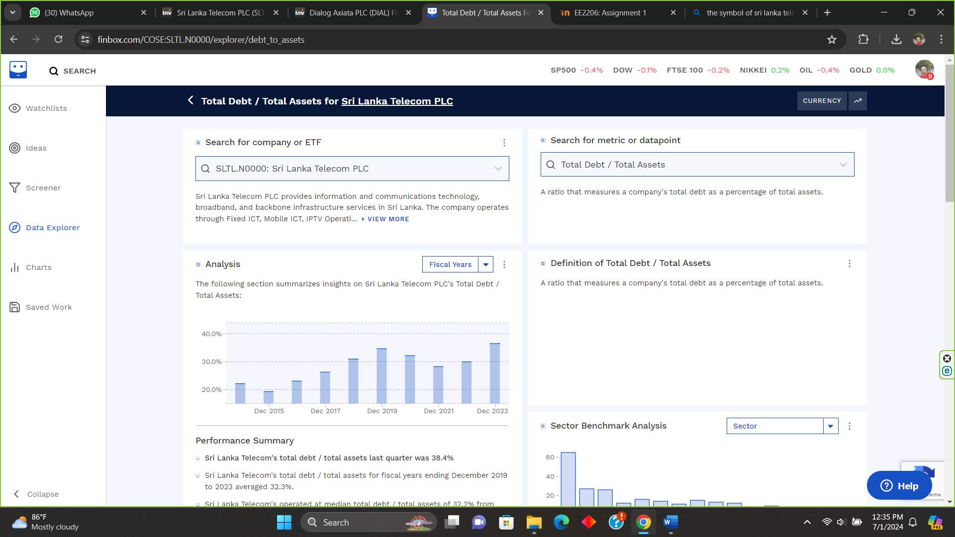

|  |  |
| --- | --- |
| Year | Debt ratio |
| 2023 | 0.365 |
| 2022 | 0.300 |
| 2021 | 0.282 |
| 2020 | 0.322 |
| 2019 | 0.346 |
| 2018 | 0.309 |
| 2017 | 0.263 |
| 2016 | 0.230 |
| 2015 | 0.193 |
| 2014 | 0.221 |