**NMR Spectra Data**

***(1R,2S)-2-(1-(pentan-3-yl)-2-(thiophen-2-ylmethyl)-1H-benzo[d]imidazole-5-carboxamido)cyclohexane-1-carboxylic acid* (AP-1)**

1H NMR(400 MHz, DMSO-*d*6) Spectrum of **AP-1**

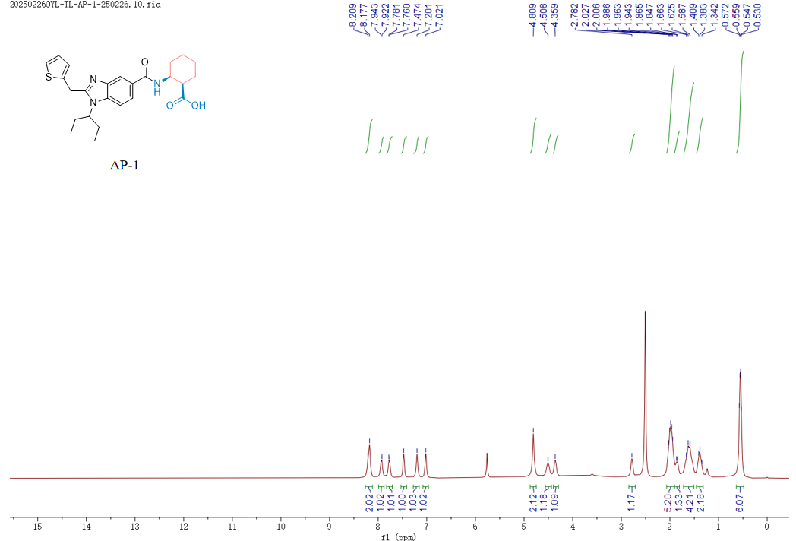

1H NMR (400 MHz, DMSO) δ 8.19 (d, *J* = 12.9 Hz, 2H), 7.93 (d, *J* = 8.6 Hz, 1H), 7.77 (d, *J* = 8.5 Hz, 1H), 7.47 (s, 1H), 7.20 (s, 1H), 7.02 (s, 1H), 4.81 (s, 2H), 4.51 (s, 1H), 4.36 (s, 1H), 2.78 (s, 1H), 2.00 (dd, *J* = 17.1, 8.7 Hz, 5H), 1.91 – 1.80 (m, 1H), 1.72 – 1.51 (m, 4H), 1.46 – 1.32 (m, 2H), 0.63 – 0.48 (m, 6H).

13C NMR(101 MHz, DMSO-*d*6) Spectrum of **AP-1**

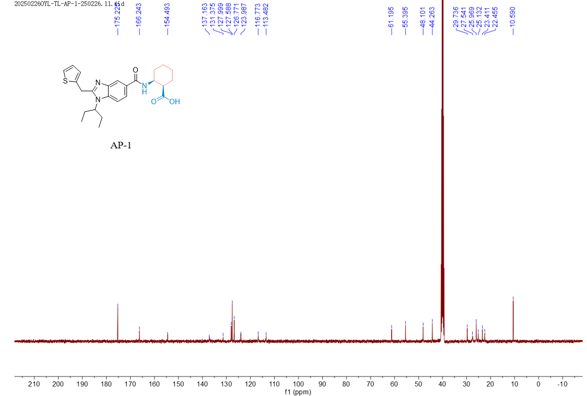

13C NMR (101 MHz, DMSO) δ 175.23 (2C), 166.24, 154.49, 131.37, 128.00, 127.59 (2C), 126.77, 123.99, 116.77, 113.48, 61.20, 55.39, 48.10, 44.26, 29.74, 27.54, 25.97, 25.13, 23.41, 22.45, 10.59 (2C).

***(1R,2S)-2-(1-(pentan-3-yl)-2-(thiophen-2-ylmethyl)-1H-benzo[d]imidazole-5-carboxamido)cyclopentane-1-carboxylic acid* (AP-2)**

1H NMR(400 MHz, DMSO-*d*6) Spectrum of **AP-2**

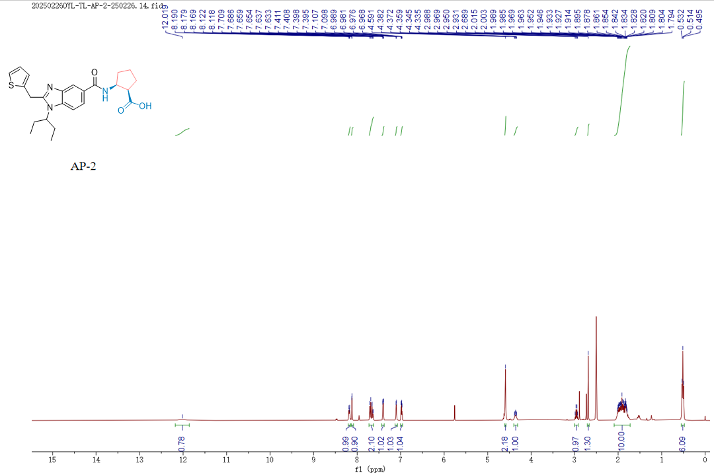

1H NMR (400 MHz, DMSO) δ 12.02 (s, 1H), 8.21 – 8.15 (m, 1H), 8.12 (d, *J* = 1.6 Hz, 1H), 7.73 – 7.62 (m, 2H), 7.40 (dd, *J* = 5.1, 1.3 Hz, 1H), 7.10 (d, *J* = 3.4 Hz, 1H), 6.98 (dd, *J* = 5.2, 3.4 Hz, 1H), 4.59 (s, 2H), 4.36 (p, *J* = 4.2 Hz, 1H), 2.96 (q, *J* = 7.6 Hz, 1H), 2.69 (s, 1H), 2.09 – 1.72 (m, 10H), 0.51 (t, *J* = 7.3 Hz, 6H).

13C NMR(101 MHz, DMSO-*d*6) Spectrum of **AP-2**

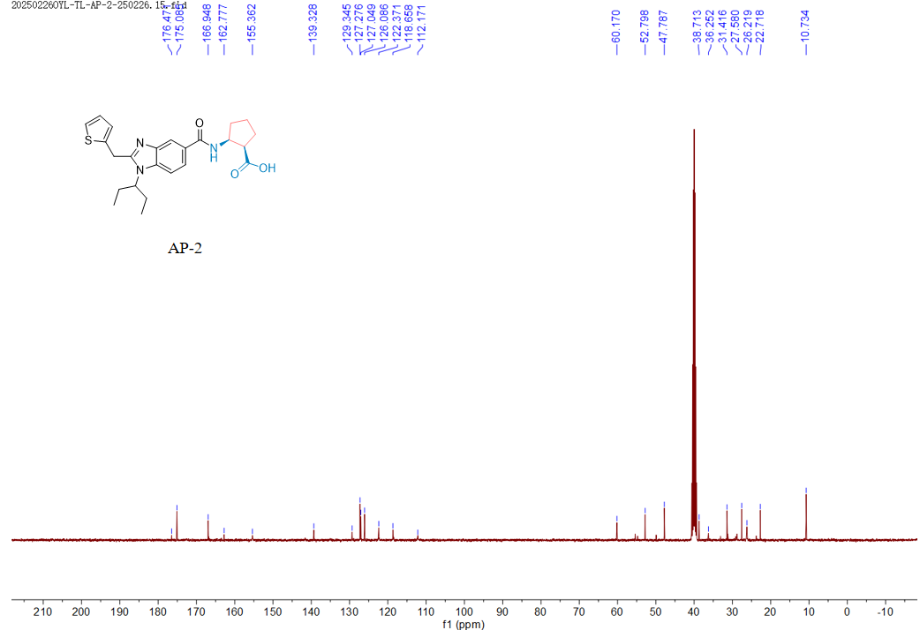

13C NMR (101 MHz, DMSO) δ 176.47, 175.09, 166.95, 162.78, 155.36, 139.33, 129.35, 127.28, 127.05, 126.09, 122.37, 118.66, 112.17, 60.17, 52.80, 47.79, 38.71, 36.25, 31.42, 27.58, 26.22, 22.72, 10.73 (2C).

***(R)-3-(1-(pentan-3-yl)-2-(thiophen-2-ylmethyl)-1H-benzo[d]imidazole-5-carboxamido)-3-phenylpropanoic acid* (AP-3)**

1H NMR(400 MHz, DMSO-*d*6) Spectrum of **AP-3**

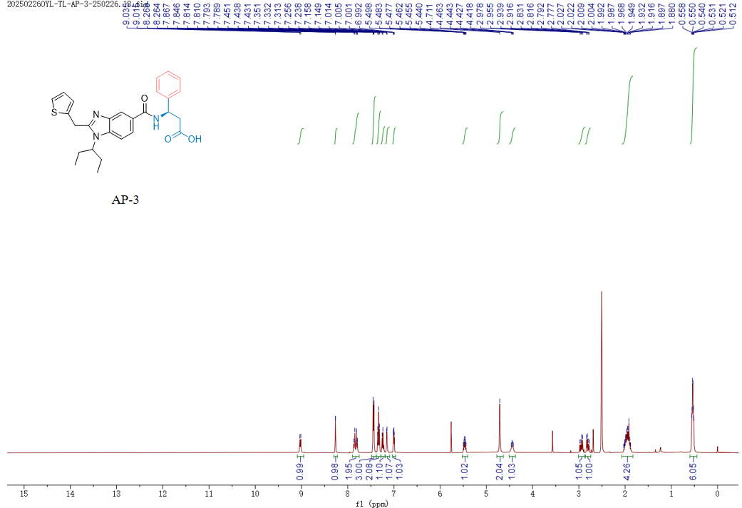

1H NMR (400 MHz, DMSO) δ 9.03 (d, *J* = 8.2 Hz, 1H), 8.27 (d, *J* = 1.6 Hz, 1H), 7.89 – 7.75 (m, 2H), 7.49 – 7.38 (m, 3H), 7.33 (t, *J* = 7.5 Hz, 2H), 7.25 (d, *J* = 7.2 Hz, 1H), 7.15 (d, *J* = 3.4 Hz, 1H), 7.00 (dd, *J* = 5.2, 3.4 Hz, 1H), 5.47 (td, *J* = 8.6, 6.0 Hz, 1H), 4.71 (s, 2H), 4.51 – 4.37 (m, 1H), 2.95 (dd, *J* = 15.7, 9.1 Hz, 1H), 2.80 (dd, *J* = 15.7, 6.0 Hz, 1H), 1.96 (m, *J* = 20.8, 14.0, 6.2 Hz, 4H), 0.54 (m, 6H).

13C NMR(101 MHz, DMSO-*d*6) Spectrum of **AP-3**

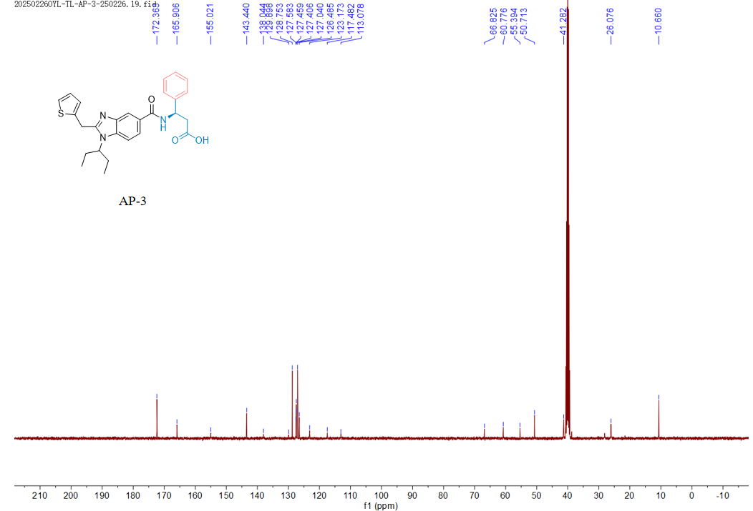

13C NMR (101 MHz, DMSO) δ 172.36 (2C), 165.91, 155.02, 143.44, 138.04, 129.90, 128.75 (2C), 127.58, 127.46 (2C), 127.41, 127.04 (2C), 126.48, 123.17, 117.48, 113.08, 66.82, 60.78, 55.39, 50.71, 41.28, 26.08, 10.66 (2C).

***(S)-3-(1-(pentan-3-yl)-2-(thiophen-2-ylmethyl)-1H-benzo[d]imidazole-5-carboxamido)-4-phenylbutanoic acid* (AP-4)**

1H NMR(400 MHz, DMSO-*d*6) Spectrum of **AP-4**

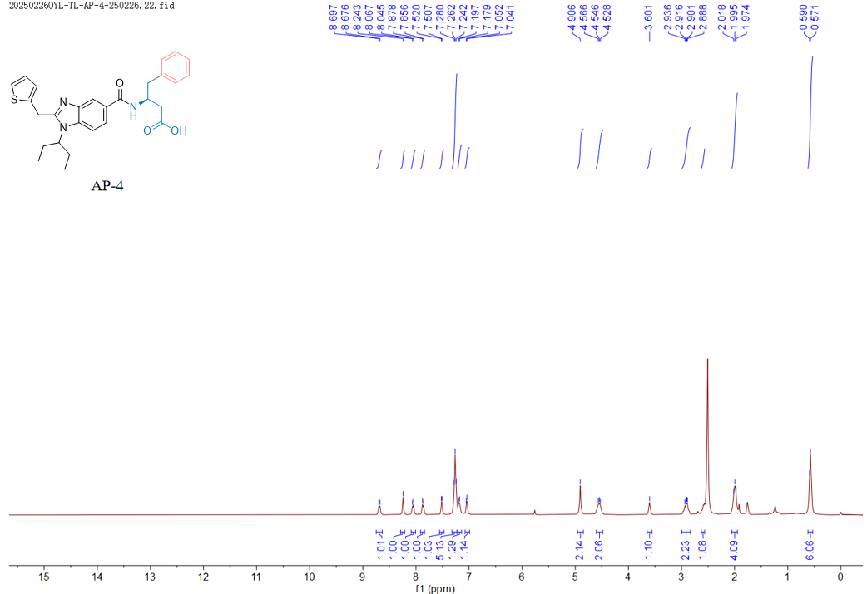

1H NMR (400 MHz, DMSO) δ 8.69 (d, *J* = 8.2 Hz, 1H), 8.24 (s, 1H), 8.06 (d, *J* = 8.8 Hz, 1H), 7.87 (d, *J* = 8.8 Hz, 1H), 7.51 (d, *J* = 5.2 Hz, 1H), 7.25 (d, *J* = 8.1 Hz, 5H), 7.19 (d, *J* = 7.1 Hz, 1H), 7.05 (d, *J* = 4.4 Hz, 1H), 4.91 (s, 2H), 4.61 – 4.48 (m, 2H), 3.60 (s, 1H), 2.91 (dd, *J* = 12.5, 6.6 Hz, 2H), 2.58 (d, *J* = 8.1 Hz, 1H), 1.98 (d, *J* = 8.4 Hz, 4H), 0.58 (d, *J* = 7.6 Hz, 6H).

13C NMR(101 MHz, DMSO-*d*6) Spectrum of **AP-4**

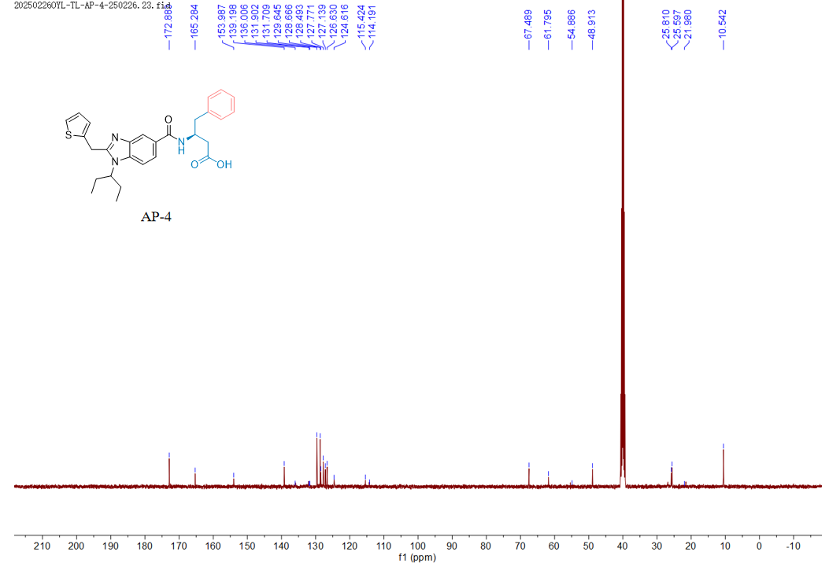

13C NMR (101 MHz, DMSO) δ 172.88 (2C), 165.28, 153.99, 139.20, 136.00, 131.90, 129.64 (2C), 128.67, 128.49 (2C), 127.77, 127.14, 126.63, 124.62, 115.42, 67.49, 61.79, 54.87, 48.91, 25.81, 25.60, 21.98, 10.54 (2C).

***(R)-5-methyl-3-(1-(pentan-3-yl)-2-(thiophen-2-ylmethyl)-1H-benzo[d]imidazole-5-carboxamido)hexanoic acid* (AP-5)**

1H NMR(400 MHz, DMSO-*d*6) Spectrum of **AP-5**

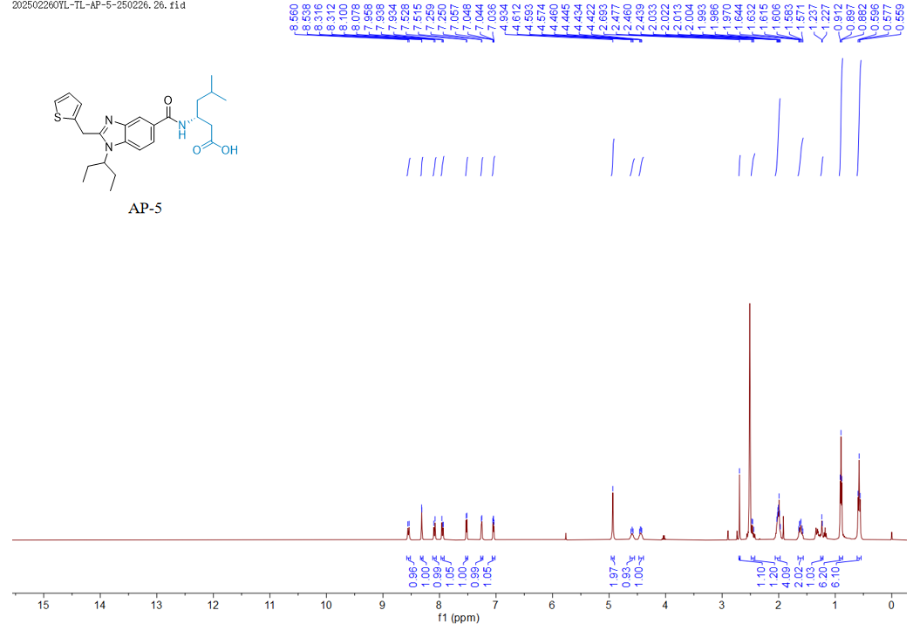

1H NMR (400 MHz, DMSO) δ 8.55 (d, *J* = 8.6 Hz, 1H), 8.34 – 8.29 (m, 1H), 8.09 (d, *J* = 8.8 Hz, 1H), 7.97 – 7.92 (m, 1H), 7.52 (d, *J* = 5.1 Hz, 1H), 7.25 (d, *J* = 3.5 Hz, 1H), 7.05 (dd, *J* = 5.2, 3.5 Hz, 1H), 4.93 (s, 2H), 4.63 – 4.55 (m, 1H), 4.47 – 4.39 (m, 1H), 2.69 (s, 1H), 2.49 – 2.42 (m, 1H), 2.01 (m, 4H), 1.62 (dt, *J* = 12.9, 7.0 Hz, 2H), 1.23 (d, *J* = 3.9 Hz, 1H), 0.90 (t, *J* = 6.0 Hz, 6H), 0.58 (t, *J* = 7.4 Hz, 6H).

13C NMR(101 MHz, DMSO-*d*6) Spectrum of **AP-5**

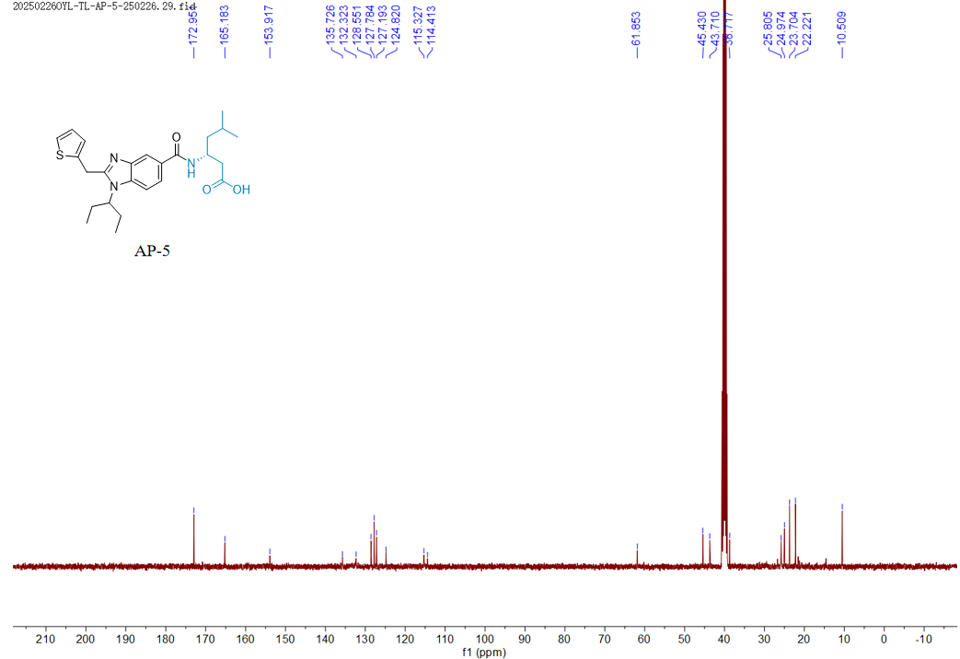

13C NMR (101 MHz, DMSO) δ 172.95 (2C), 165.18, 153.92, 135.73, 132.32, 128.55, 127.78 (2C), 127.19, 124.82, 115.33, 114.41, 61.85, 45.43, 43.71, 38.72, 25.80, 24.97, 23.70 (2C), 22.22 (2C), 10.51 (2C).

***(R)-3-(1-(pentan-3-yl)-2-(thiophen-2-ylmethyl)-1H-benzo[d]imidazole-5-carboxamido)-4-phenylbutanoic acid* (AP-6)**

1H NMR(400 MHz, DMSO-*d*6) Spectrum of **AP-6**

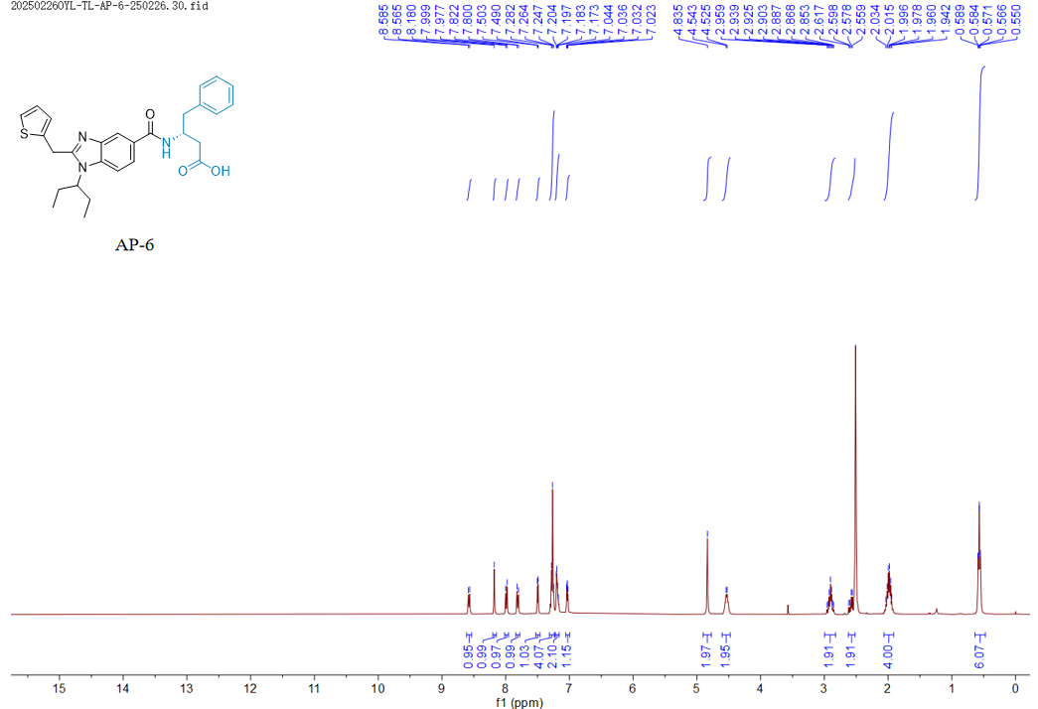

1H NMR (400 MHz, DMSO) δ 8.57 (d, *J* = 8.3 Hz, 1H), 8.18 (s, 1H), 7.99 (d, *J* = 8.7 Hz, 1H), 7.81 (d, *J* = 8.7 Hz, 1H), 7.50 (d, *J* = 5.1 Hz, 1H), 7.27 (d, *J* = 6.9 Hz, 4H), 7.19 (q, *J* = 3.3 Hz, 2H), 7.03 (dd, *J* = 5.2, 3.5 Hz, 1H), 4.84 (s, 2H), 4.53 (d, *J* = 7.2 Hz, 2H), 3.00 – 2.83 (m, 2H), 2.59 (dd, *J* = 15.5, 7.6 Hz, 2H), 1.99 (m, 4H), 0.64 – 0.47 (m, 6H).

13C NMR(101 MHz, DMSO-*d*6) Spectrum of **AP-6**

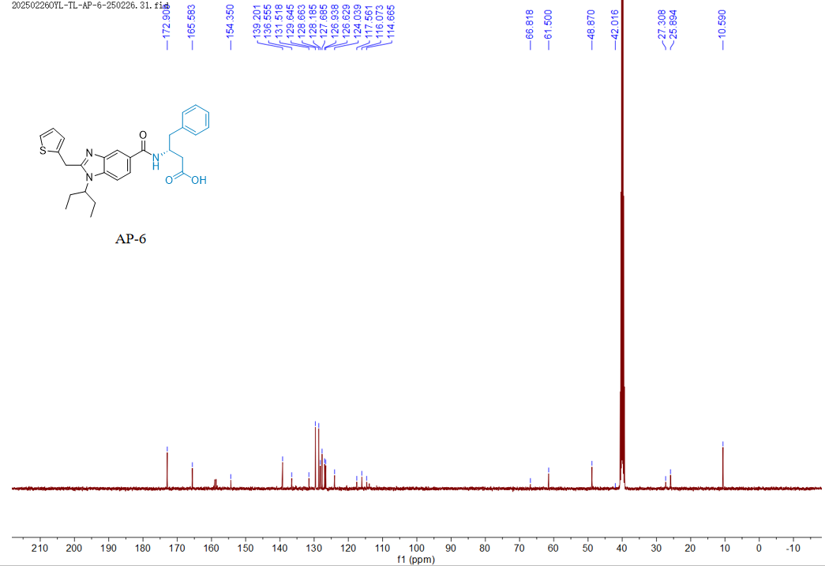

13C NMR (101 MHz, DMSO) δ 172.91 (2C), 165.58, 154.35, 139.20, 136.56, 131.52, 129.64 (2C), 128.66 (2C), 128.18, 127.69, 126.94, 126.63, 124.04, 117.56, 116.07, 114.67, 66.82, 61.50, 48.87, 42.02, 27.31, 25.89 (2C), 10.59 (2C).

***(S)-3-(1-(pentan-3-yl)-2-(thiophen-2-ylmethyl)-1H-benzo[d]imidazole-5-carboxamido)-3-phenylpropanoic acid* (AP-7)**

1H NMR(400 MHz, DMSO-*d*6) Spectrum of **AP-7**

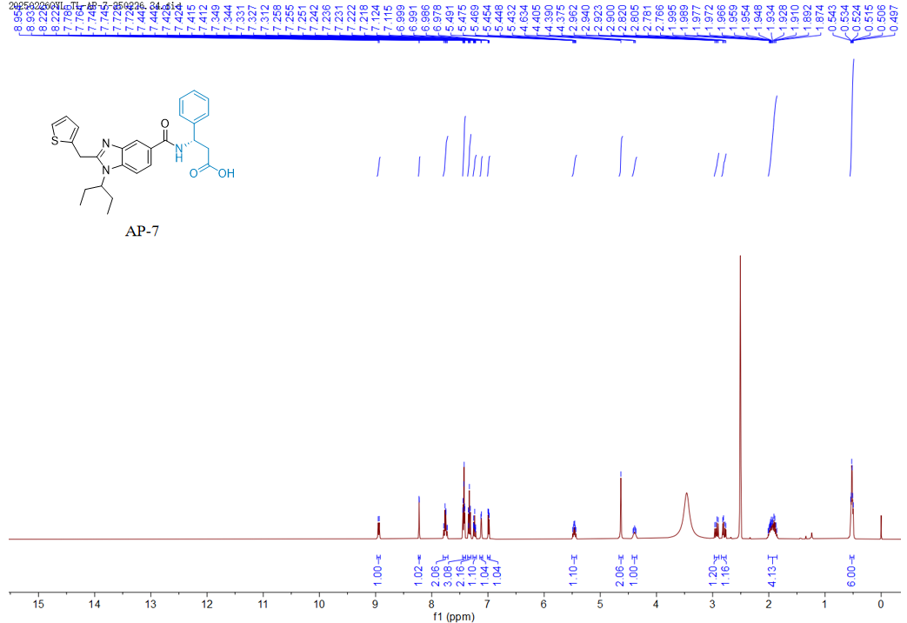

1H NMR (400 MHz, DMSO) δ 8.94 (d, *J* = 8.2 Hz, 1H), 8.22 (d, *J* = 1.5 Hz, 1H), 7.80 – 7.71 (m, 2H), 7.45 – 7.40 (m, 3H), 7.33 (t, *J* = 7.5 Hz, 2H), 7.27 – 7.21 (m, 1H), 7.12 (d, *J* = 3.5 Hz, 1H), 6.99 (dd, *J* = 5.1, 3.4 Hz, 1H), 5.46 (m, 1H), 4.63 (s, 2H), 4.43 – 4.35 (m, 1H), 2.93 (dd, *J* = 15.7, 9.1 Hz, 1H), 2.79 (dd, *J* = 15.7, 6.1 Hz, 1H), 2.01 – 1.85 (m, 4H), 0.52 (m, 6H).

13C NMR(101 MHz, DMSO-*d*6) Spectrum of **AP-7**

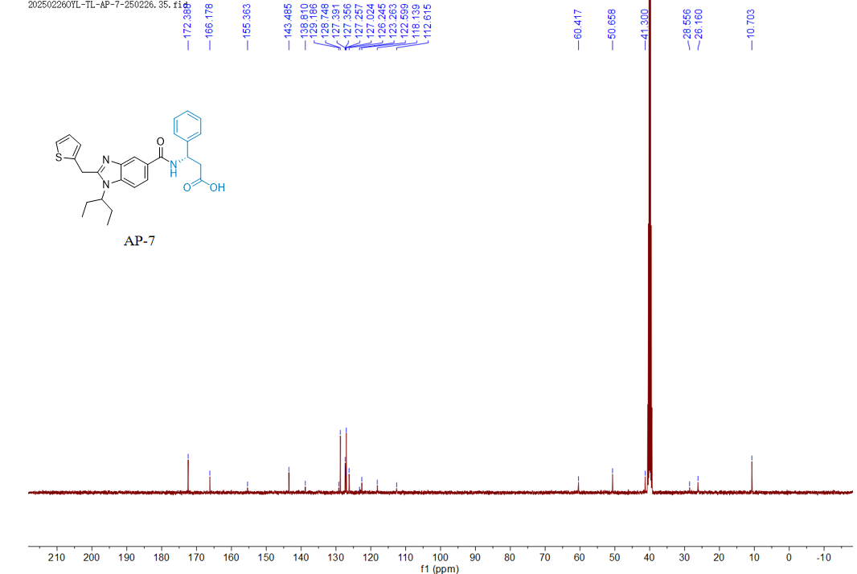

13C NMR (101 MHz, DMSO) δ 172.39 (2C), 166.18, 155.36, 143.48, 138.81, 129.19, 128.75 (2C), 127.39, 127.36, 127.26, 127.02 (2C), 126.25, 123.26, 122.60, 118.14, 112.62, 60.42, 50.66, 41.30, 28.56, 26.16 (2C), 10.70 (2C).

***(S)-3-(1-isopropyl-2-(thiophen-2-ylmethyl)-1H-benzo[d]imidazole-5-carboxamido)-3-phenylpropanoic acid* (AP-8)**

1H NMR(400 MHz, DMSO-*d*6) Spectrum of **AP-8**

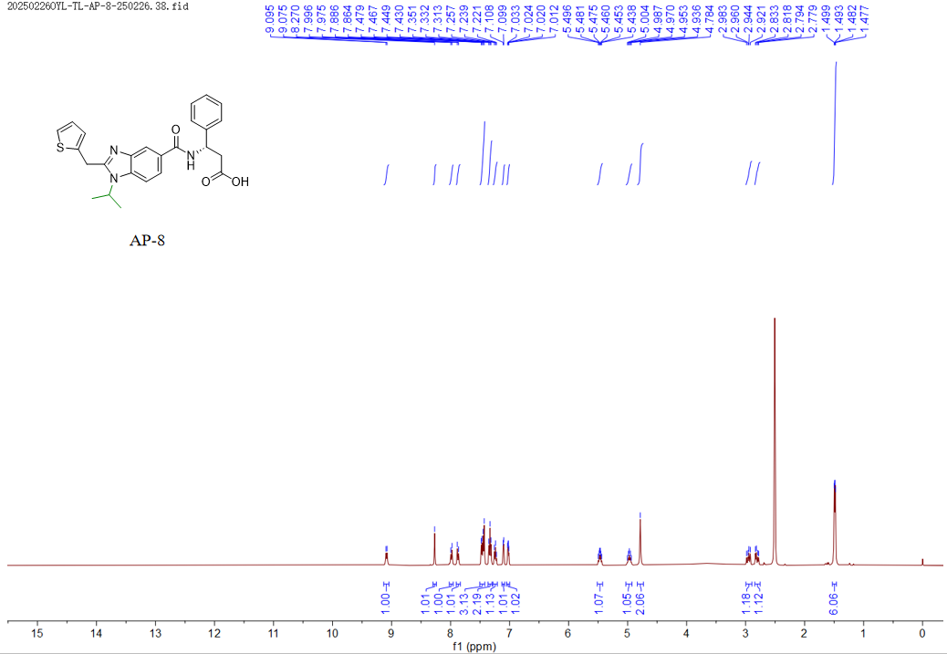

1H NMR (400 MHz, DMSO) δ 9.08 (d, *J* = 8.2 Hz, 1H), 8.27 (s, 1H), 7.99 (d, *J* = 8.7 Hz, 1H), 7.87 (d, *J* = 8.6 Hz, 1H), 7.46 (dd, *J* = 13.5, 6.3 Hz, 3H), 7.33 (t, *J* = 7.5 Hz, 2H), 7.24 (t, *J* = 7.3 Hz, 1H), 7.10 (d, *J* = 3.4 Hz, 1H), 7.02 (dd, *J* = 5.1, 3.5 Hz, 1H), 5.47 (m, *J* = 8.6, 5.9 Hz, 1H), 4.97 (m, *J* = 6.9 Hz, 1H), 4.78 (s, 2H), 2.95 (dd, *J* = 15.7, 9.1 Hz, 1H), 2.81 (dd, *J* = 15.7, 6.0 Hz, 1H), 1.49 (dd, *J* = 6.7, 2.4 Hz, 6H).

13C NMR(101 MHz, DMSO-*d*6) Spectrum of **AP-8**

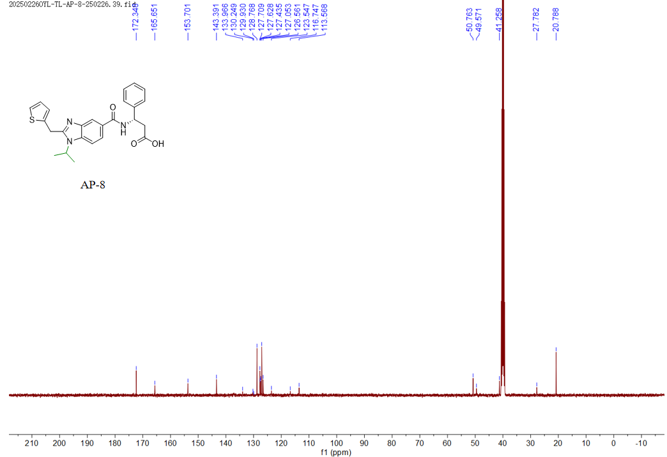

13C NMR (101 MHz, DMSO) δ 172.35 (2C), 165.65, 153.70, 143.39, 133.97, 130.25, 129.93, 128.77 (2C), 127.71, 127.63, 127.44, 127.05 (2C), 126.56, 123.55, 116.75, 113.57, 50.76, 49.57, 41.26, 27.78, 20.79 (2C).

***(S)-3-(1-ethyl-2-(thiophen-2-ylmethyl)-1H-benzo[d]imidazole-5-carboxamido)-3-phenylpropanoic acid* (AP-9)**

1H NMR(400 MHz, DMSO-*d*6) Spectrum of **AP-9**

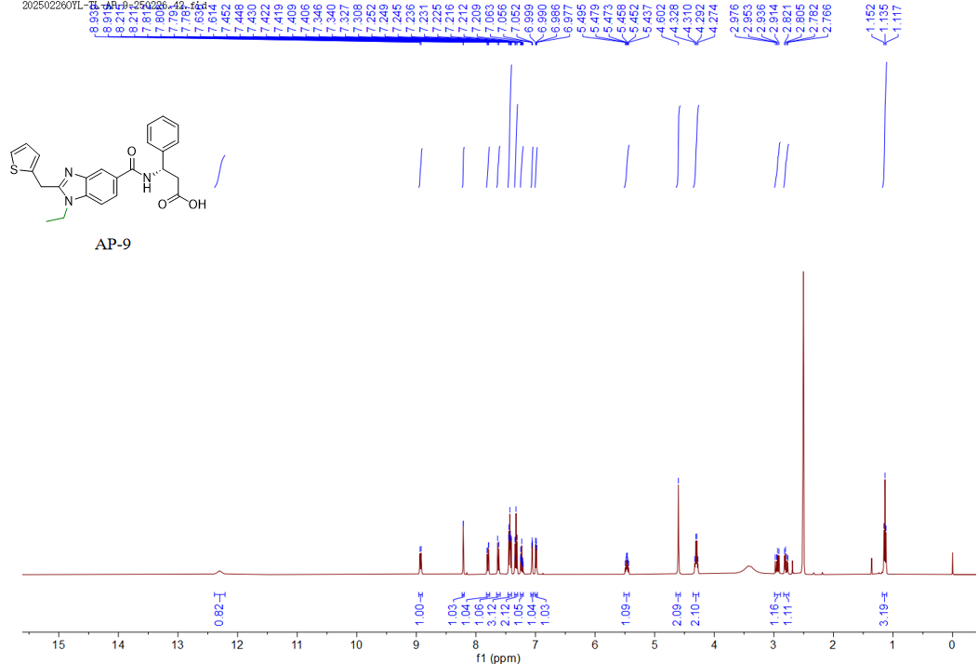

1H NMR (400 MHz, DMSO) δ 12.30 (s, 1H), 8.93 (d, *J* = 8.2 Hz, 1H), 8.21 (d, *J* = 1.5 Hz, 1H), 7.80 (dd, *J* = 8.5, 1.6 Hz, 1H), 7.62 (d, *J* = 8.5 Hz, 1H), 7.46 – 7.40 (m, 3H), 7.33 (t, *J* = 7.5 Hz, 2H), 7.25 – 7.21 (m, 1H), 7.08 – 7.04 (m, 1H), 6.99 (dd, *J* = 5.1, 3.4 Hz, 1H), 5.47 (m, *J* = 8.6, 6.1 Hz, 1H), 4.60 (s, 2H), 4.30 (q, *J* = 7.1 Hz, 2H), 2.94 (dd, *J* = 15.6, 9.0 Hz, 1H), 2.79 (dd, *J* = 15.7, 6.1 Hz, 1H), 1.13 (t, *J* = 7.1 Hz, 3H).

13C NMR(101 MHz, DMSO-*d*6) Spectrum of **AP-9**

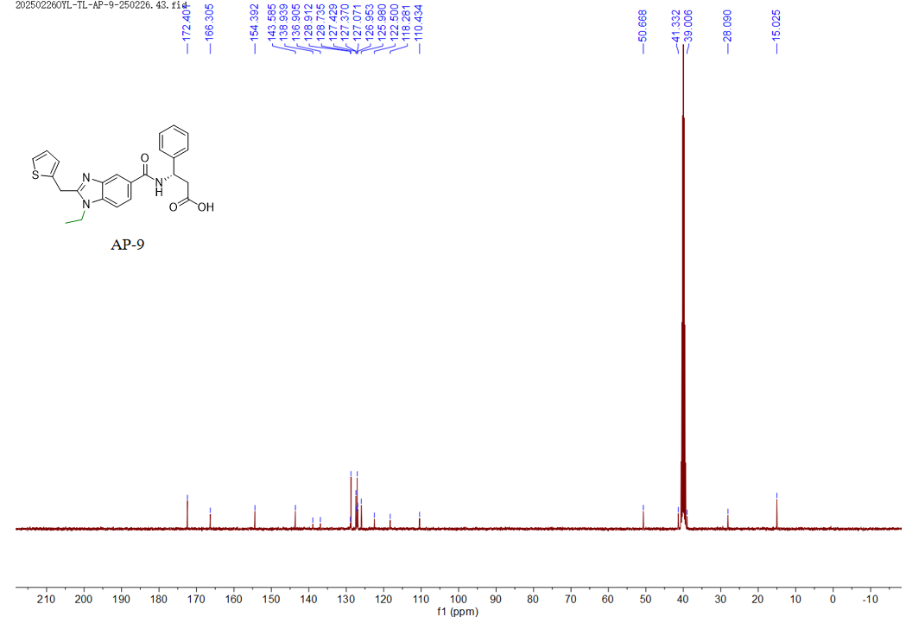

13C NMR (101 MHz, DMSO) δ 172.40 (2C), 166.30, 154.39, 143.58, 138.94, 136.91, 128.91, 128.74 (2C), 127.43, 127.37, 127.07 (2C), 126.95, 125.98, 122.50, 118.28, 110.43, 50.67, 41.33, 39.01, 28.09, 15.02.

***(S)-3-phenyl-3-(1-phenyl-2-(thiophen-2-ylmethyl)-1H-benzo[d]imidazole-5-carboxamido)propanoic acid* (AP-10)**

1H NMR(400 MHz, DMSO-*d*6) Spectrum of **AP-10**

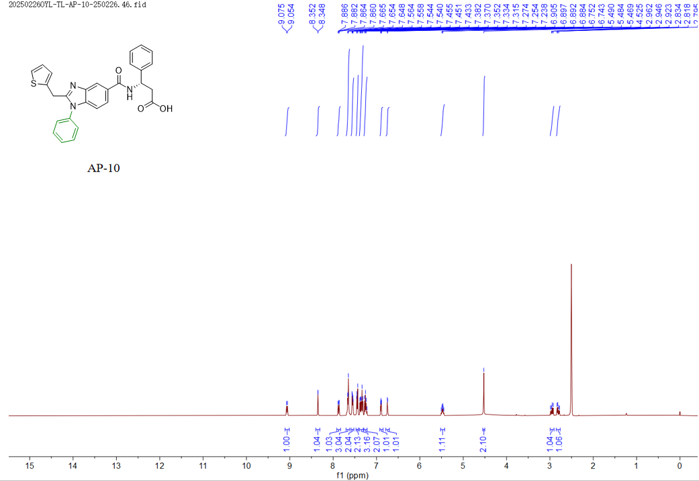

1H NMR (400 MHz, DMSO) δ 9.06 (d, *J* = 8.2 Hz, 1H), 8.35 (d, *J* = 1.5 Hz, 1H), 7.87 (dd, *J* = 8.6, 1.6 Hz, 1H), 7.66 (d, *J* = 7.1 Hz, 3H), 7.55 (dd, *J* = 7.5, 2.1 Hz, 2H), 7.44 (d, *J* = 7.2 Hz, 2H), 7.39 – 7.30 (m, 3H), 7.29 – 7.22 (m, 2H), 6.89 (dd, *J* = 5.2, 3.5 Hz, 1H), 6.75 (d, *J* = 3.5 Hz, 1H), 5.48 (m, *J* = 8.6, 6.1 Hz, 1H), 4.52 (s, 2H), 2.95 (dd, *J* = 15.7, 9.1 Hz, 1H), 2.81 (dd, *J* = 15.7, 6.1 Hz, 1H).

13C NMR(101 MHz, DMSO-*d*6) Spectrum of **AP-10**

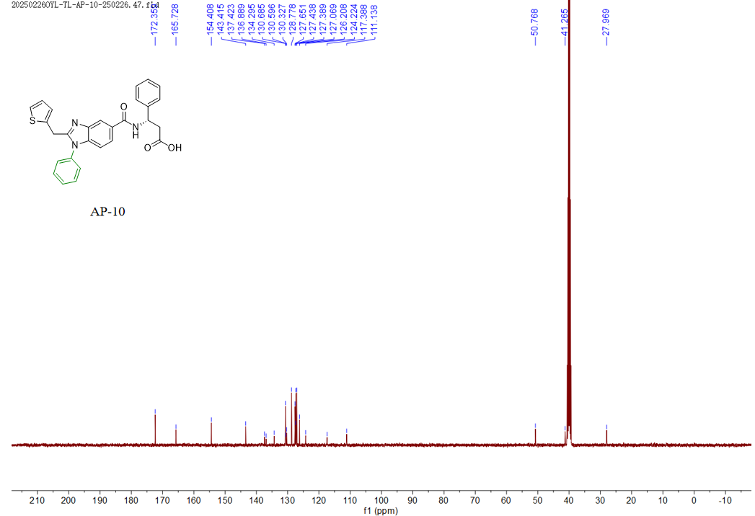

13C NMR (101 MHz, DMSO) δ 172.36 (2C), 165.73, 154.41, 143.42, 137.42, 136.89, 134.29, 130.68 (2C), 130.60, 130.33, 128.78 (2C), 127.65 (2C), 127.44, 127.39 (2C), 127.07 (2C), 126.21, 124.22, 117.39, 111.14, 50.77, 41.26, 27.97.

***(S)-3-(1-(pentan-3-yl)-2-(pyrazin-2-ylmethyl)-1H-benzo[d]imidazole-5-carboxamido)-3-phenylpropanoic acid* (AP-11)**

1H NMR(400 MHz, DMSO-*d*6) Spectrum of **AP-11**

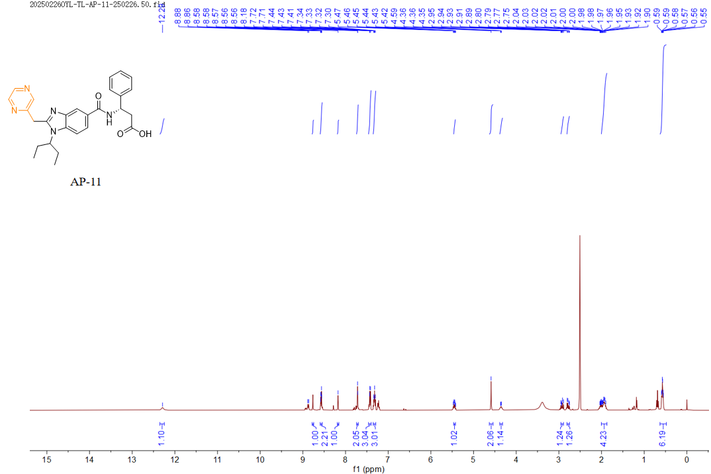

1H NMR (400 MHz, DMSO) δ 12.29 (s, 1H), 8.77 (d, *J* = 1.4 Hz, 1H), 8.59 – 8.55 (m, 2H), 8.18 (s, 1H), 7.72 (d, *J* = 2.1 Hz, 2H), 7.46 – 7.40 (m, 3H), 7.32 (t, *J* = 7.5 Hz, 3H), 5.47 – 5.42 (m, 1H), 4.59 (s, 2H), 4.39 – 4.32 (m, 1H), 2.95 – 2.89 (m, 1H), 2.81 – 2.75 (m, 1H), 1.95 (m, *J* = 24.5, 13.7, 7.2 Hz, 4H), 0.57 (m, 6H).

13C NMR(101 MHz, DMSO-*d*6) Spectrum of **AP-11**

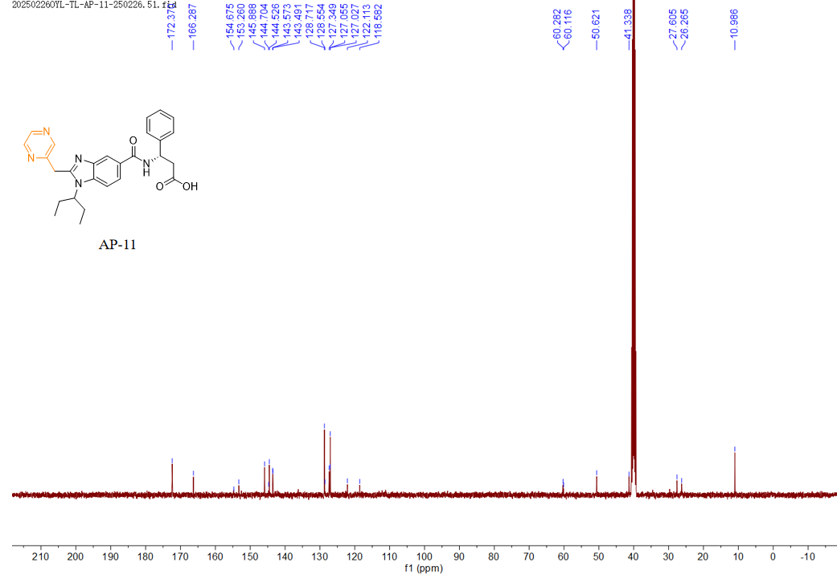

13C NMR (101 MHz, DMSO) δ 172.37 (2C), 166.29, 154.68, 153.26, 145.89, 144.70, 144.53, 143.57, 143.49, 128.72 (2C), 128.55, 127.35, 127.05, 127.03 (2C), 122.11, 118.58, 60.28, 60.12, 50.62, 41.34, 27.61, 26.26, 10.99 (2C).

***(S)-3-(1-(pentan-3-yl)-2-(pyridin-2-ylmethyl)-1H-benzo[d]imidazole-5-carboxamido)-3-phenylpropanoic acid* (AP-12)**

1H NMR(400 MHz, DMSO-*d*6) Spectrum of **AP-12**

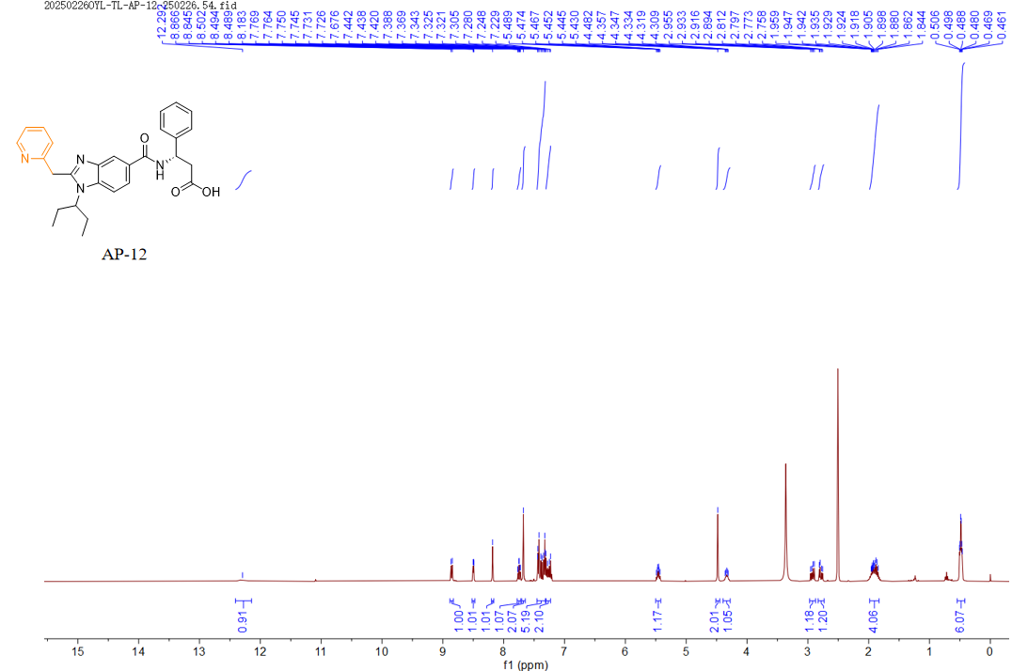

1H NMR (400 MHz, DMSO) δ 12.29 (s, 1H), 8.86 (d, *J* = 8.3 Hz, 1H), 8.52 – 8.47 (m, 1H), 8.18 (s, 1H), 7.75 (td, *J* = 7.7, 1.9 Hz, 1H), 7.68 (s, 2H), 7.45 – 7.32 (m, 5H), 7.30 – 7.23 (m, 2H), 5.46 (td, *J* = 8.7, 6.0 Hz, 1H), 4.48 (s, 2H), 4.33 (dt, *J* = 9.7, 4.0 Hz, 1H), 2.92 (dd, *J* = 15.7, 9.0 Hz, 1H), 2.78 (dd, *J* = 15.6, 6.1 Hz, 1H), 1.98 – 1.83 (m, 4H), 0.48 (td, *J* = 7.4, 3.3 Hz, 6H).

13C NMR(101 MHz, DMSO-*d*6) Spectrum of **AP-12**

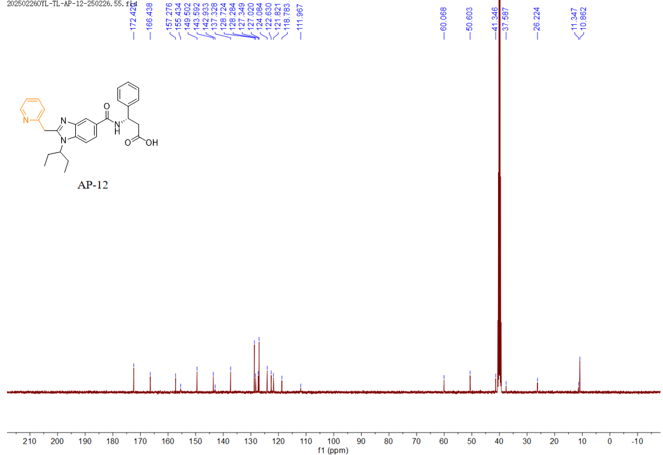

13C NMR (101 MHz, DMSO) δ 172.42 (2C), 166.44, 157.28, 155.43, 149.50, 143.59, 142.93, 137.33, 128.72 (2C), 128.28, 127.35, 127.02 (2C), 124.08, 122.63, 121.82, 118.78, 111.97, 60.07, 50.60, 41.35, 37.59, 26.22, 11.35, 10.86 (2C).

***(S)-3-(1-(pentan-3-yl)-2-(pyridin-3-ylmethyl)-1H-benzo[d]imidazole-5-carboxamido)-3-phenylpropanoic acid* (AP-13)**

1H NMR(400 MHz, DMSO-*d*6) Spectrum of **AP-13**

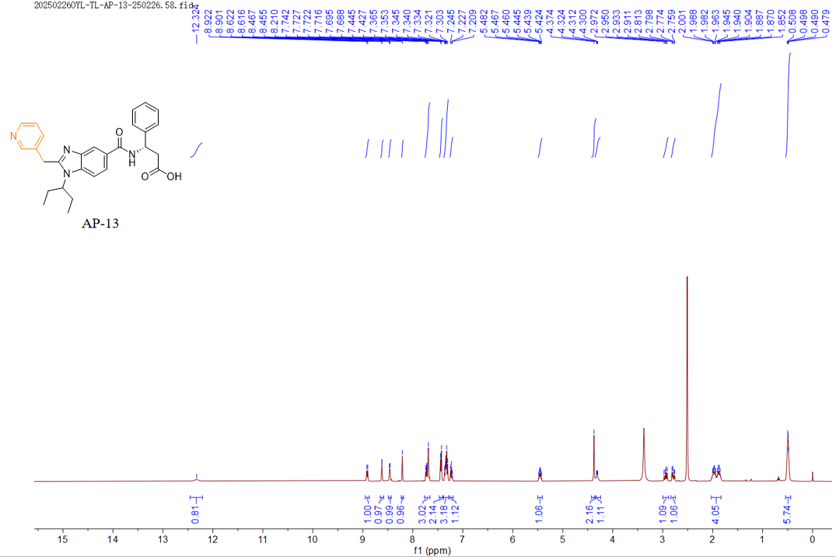

1H NMR (400 MHz, DMSO) δ 12.32 (s, 1H), 8.91 (d, *J* = 8.3 Hz, 1H), 8.62 (d, *J* = 2.3 Hz, 1H), 8.46 (d, *J* = 4.8 Hz, 1H), 8.21 (s, 1H), 7.76 – 7.66 (m, 3H), 7.44 (d, *J* = 7.5 Hz, 2H), 7.39 – 7.29 (m, 3H), 7.23 (t, *J* = 7.3 Hz, 1H), 5.45 (td, *J* = 8.6, 5.9 Hz, 1H), 4.37 (s, 2H), 4.36 – 4.24 (m, 1H), 2.94 (dd, *J* = 15.6, 9.0 Hz, 1H), 2.79 (dd, *J* = 15.7, 6.1 Hz, 1H), 1.93 (m, 4H), 0.49 (m, 6H).

13C NMR(101 MHz, DMSO-*d*6) Spectrum of **AP-13**

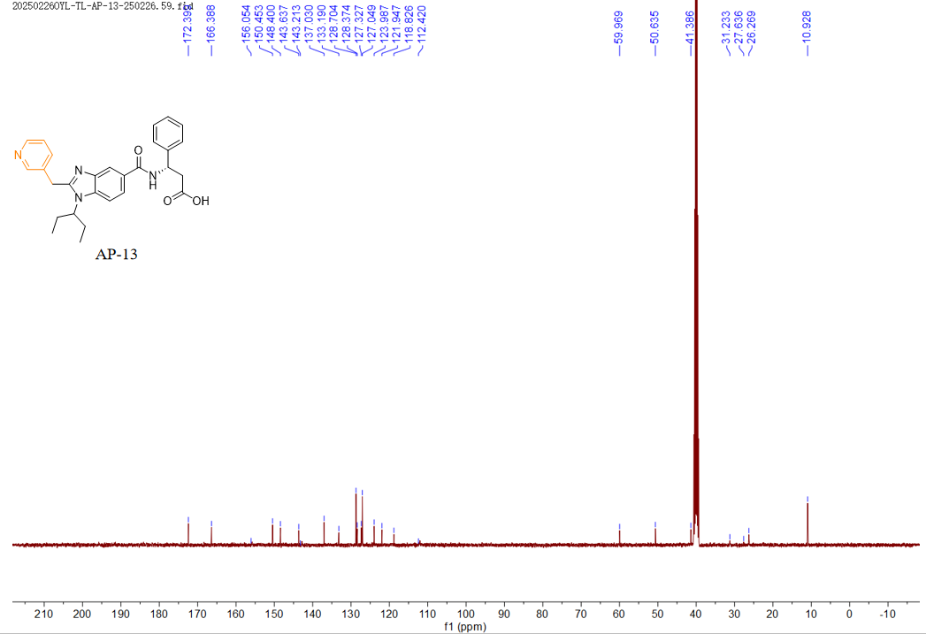

13C NMR (101 MHz, DMSO) δ 172.40 (2C), 166.39, 156.05, 150.45, 148.40, 143.64, 143.21, 137.03, 133.19, 128.70 (2C), 128.37, 127.33, 127.05 (2C), 123.99, 121.95, 118.83, 114.42, 59.97, 50.64, 41.39, 31.23, 27.64, 26.27, 10.93 (2C).

***(S)-3-(1-(pentan-3-yl)-2-(pyridin-4-ylmethyl)-1H-benzo[d]imidazole-5-carboxamido)-3-phenylpropanoic acid* (AP-14)**

1H NMR(400 MHz, DMSO-*d*6) Spectrum of **AP-14**

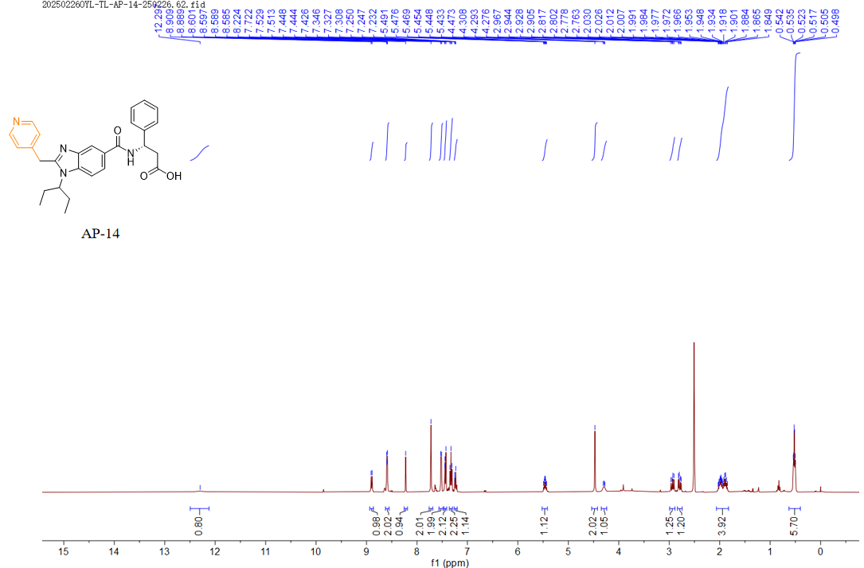

1H NMR (400 MHz, DMSO) δ 12.30 (s, 1H), 8.90 (d, *J* = 8.3 Hz, 1H), 8.63 – 8.55 (m, 2H), 8.22 (s, 1H), 7.72 (s, 2H), 7.52 (d, *J* = 6.3 Hz, 2H), 7.44 (d, *J* = 7.3 Hz, 2H), 7.33 (t, *J* = 7.6 Hz, 2H), 7.24 (d, *J* = 7.4 Hz, 1H), 5.46 (m, 1H), 4.47 (s, 2H), 4.35 – 4.24 (m, 1H), 2.94 (dd, *J* = 15.7, 9.1 Hz, 1H), 2.79 (dd, *J* = 15.6, 6.1 Hz, 1H), 2.07 – 1.83 (m, 4H), 0.52 (m, 6H).

13C NMR(101 MHz, DMSO-*d*6) Spectrum of **AP-14**

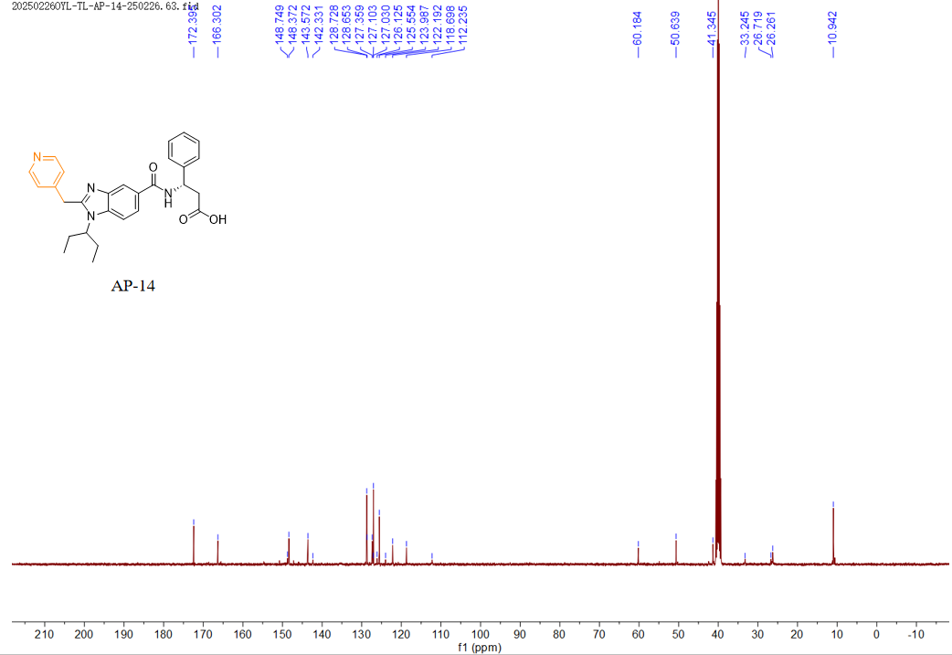

13C NMR (101 MHz, DMSO) δ 172.39 (2C), 166.30, 148.75, 148.37, 143.57, 142.33, 128.73 (2C), 128.65, 127.36, 127.10, 127.03 (2C), 126.13, 125.55, 123.99, 122.19, 118.70, 112.24, 60.18, 50.64, 41.35, 33.24, 26.72, 26.26, 10.94 (2C).

***(S)-3-(2-benzyl-1-(pentan-3-yl)-1H-benzo[d]imidazole-5-carboxamido)-3-phenylpropanoic acid* (AP-15)**

1H NMR(400 MHz, DMSO-*d*6) Spectrum of **AP-15**

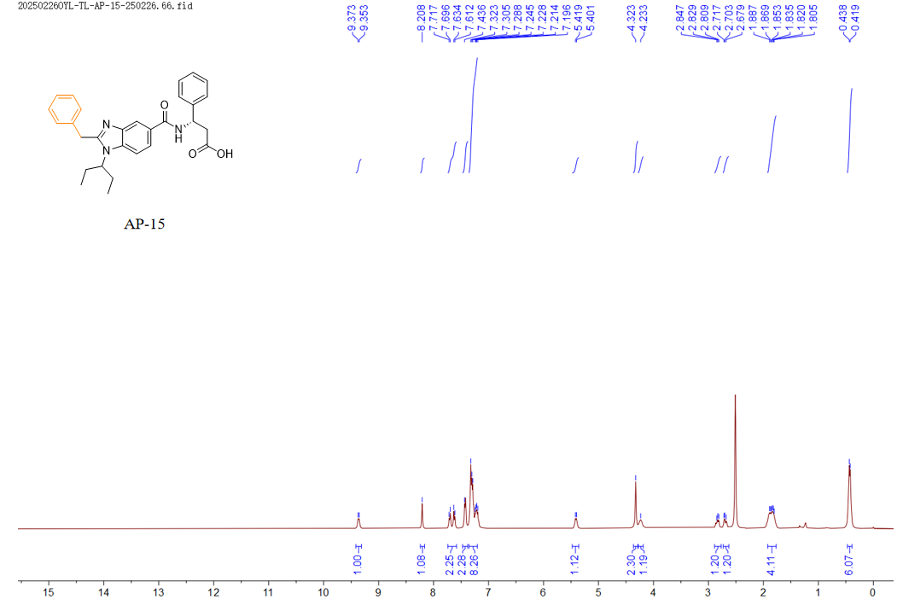

1H NMR (400 MHz, DMSO) δ 9.36 (d, *J* = 8.0 Hz, 1H), 8.21 (s, 1H), 7.74 – 7.58 (m, 2H), 7.44 (s, 2H), 7.35 – 7.21 (m, 8H), 5.41 (d, *J* = 7.2 Hz, 1H), 4.32 (s, 2H), 4.23 (s, 1H), 2.89 – 2.77 (m, 1H), 2.73 – 2.63 (m, 1H), 1.92 – 1.77 (m, 4H), 0.43 (d, *J* = 7.2 Hz, 6H).

13C NMR(101 MHz, DMSO-*d*6) Spectrum of **AP-15**

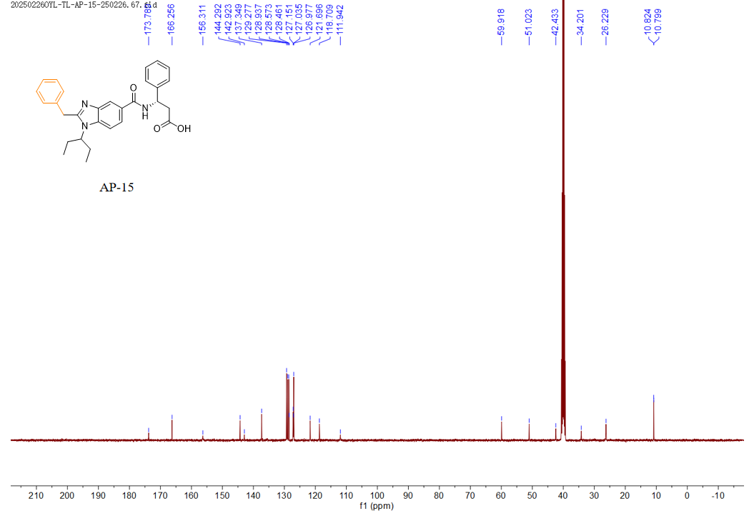

13C NMR (101 MHz, DMSO) δ 173.79 (2C), 166.26, 156.31, 144.29, 142.92, 137.35, 129.28 (2C), 128.94 (2C), 128.57 (2C), 128.46, 127.15, 127.03, 126.98 (2C), 121.70, 118.71, 111.94, 59.92, 51.02, 42.43, 34.20, 26.23, 10.82, 10.80 (2C).

***(S)-3-(2-(furan-2-ylmethyl)-1-(pentan-3-yl)-1H-benzo[d]imidazole-5-carboxamido)-3-phenylpropanoic acid* (AP-16)**

1H NMR(400 MHz, DMSO-*d*6) Spectrum of **AP-16**

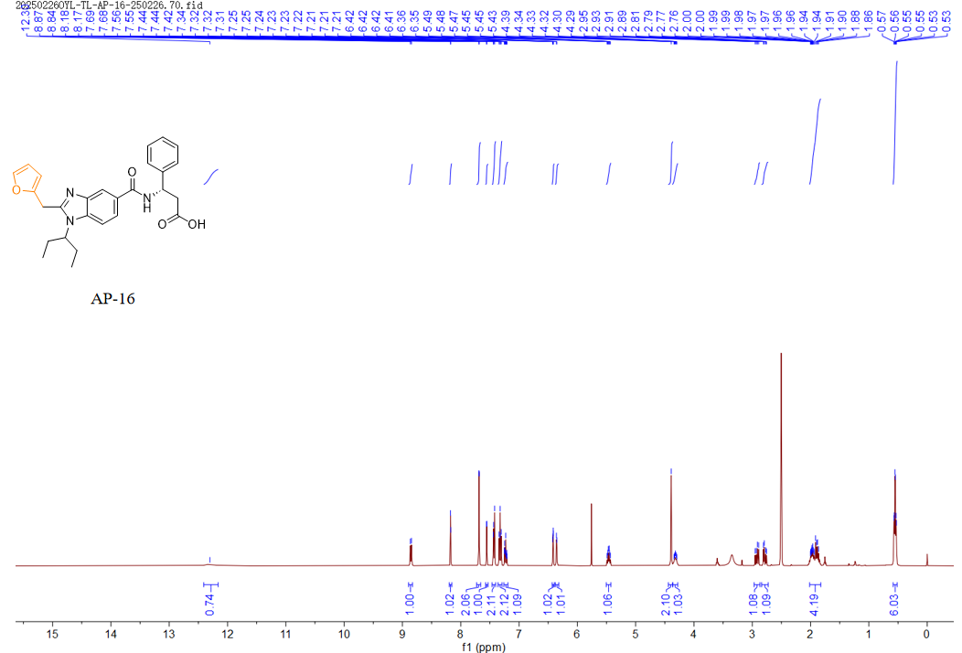

1H NMR (400 MHz, DMSO) δ 12.30 (s, 1H), 8.85 (d, *J* = 8.3 Hz, 1H), 8.17 (d, *J* = 1.5 Hz, 1H), 7.69 (d, *J* = 1.2 Hz, 2H), 7.56 (d, *J* = 1.8 Hz, 1H), 7.43 (d, *J* = 7.2 Hz, 2H), 7.32 (dd, *J* = 8.4, 6.8 Hz, 2H), 7.26 – 7.19 (m, 1H), 6.42 (dd, *J* = 3.2, 1.9 Hz, 1H), 6.36 (d, *J* = 3.2 Hz, 1H), 5.46 (m, 1H), 4.39 (s, 2H), 4.32 (m, 1H), 2.92 (dd, *J* = 15.6, 9.0 Hz, 1H), 2.78 (dd, *J* = 15.6, 6.1 Hz, 1H), 2.02 – 1.83 (m, 4H), 0.55 (m, 6H).

13C NMR(101 MHz, DMSO-*d*6) Spectrum of **AP-16**

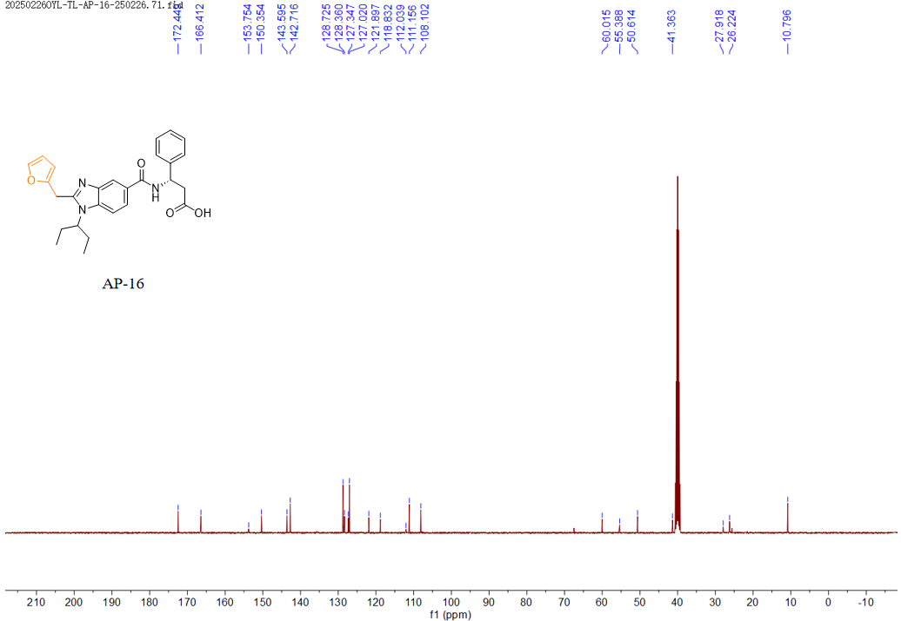

13C NMR (101 MHz, DMSO) δ 172.45 (2C), 166.41, 153.75, 150.35, 143.60, 142.72 (2C), 128.72 (2C), 128.36, 127.35, 127.02 (2C), 121.90, 118.83, 112.04, 111.16, 108.10, 60.02, 55.39, 50.61, 41.36, 27.92, 26.22, 10.80 (2C).

***(R)-3-(2-(furan-2-ylmethyl)-1-(pentan-3-yl)-1H-benzo[d]imidazole-5-carboxamido)-3-phenylpropanoic acid* (AP-17)**

1H NMR(400 MHz, DMSO-*d*6) Spectrum of **AP-17**

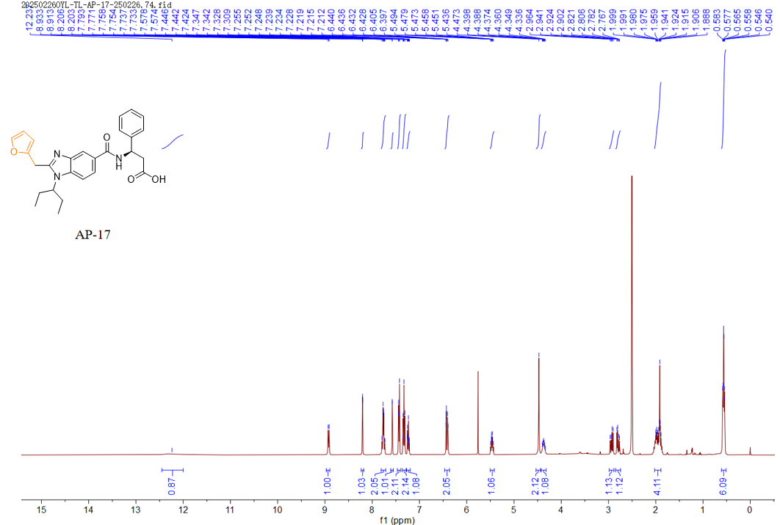

1H NMR (400 MHz, DMSO) δ 12.24 (s, 1H), 8.92 (d, *J* = 8.2 Hz, 1H), 8.20 (d, *J* = 1.5 Hz, 1H), 7.81 – 7.71 (m, 2H), 7.58 (d, *J* = 1.8 Hz, 1H), 7.43 (d, *J* = 7.2 Hz, 2H), 7.33 (t, *J* = 7.6 Hz, 2H), 7.27 – 7.20 (m, 1H), 6.47 – 6.36 (m, 2H), 5.47 (td, *J* = 8.6, 6.1 Hz, 1H), 4.47 (s, 2H), 4.37 (m, 1H), 2.93 (dd, *J* = 15.7, 9.1 Hz, 1H), 2.79 (dd, *J* = 15.7, 6.0 Hz, 1H), 2.02 – 1.89 (m, 4H), 0.56 (m, 6H).

13C NMR(101 MHz, DMSO-*d*6) Spectrum of **AP-17**

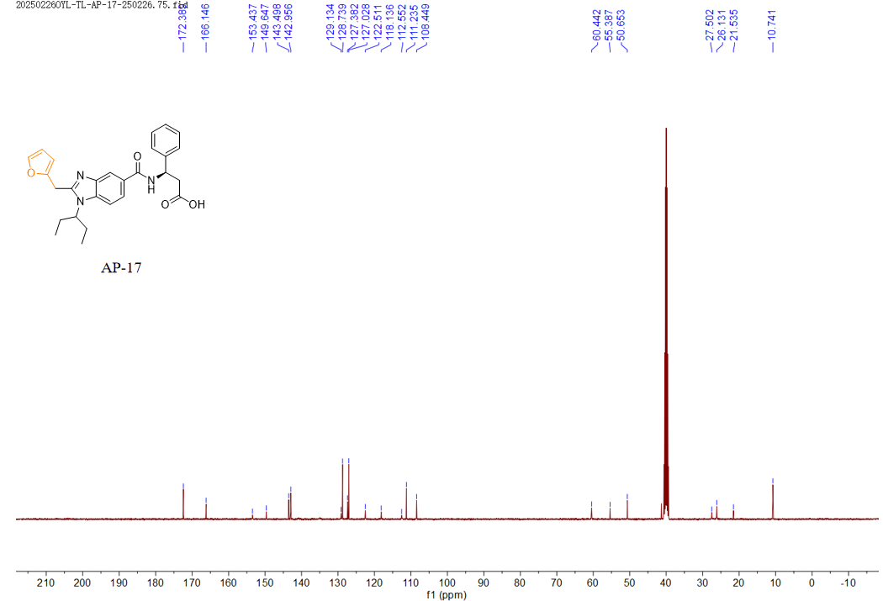

13C NMR (101 MHz, DMSO) δ 172.39 (2C), 166.15, 153.44, 149.65, 143.50, 142.96, 129.13, 128.74 (2C), 127.38, 127.03 (2C), 122.51, 118.14, 112.55, 111.24 (2C), 108.45, 60.44, 55.39, 50.65, 27.50, 26.13, 21.54, 10.74 (2C).

**HRMS(ESI)+ and HPLC purity**

***(1R,2S)-2-(1-(pentan-3-yl)-2-(thiophen-2-ylmethyl)-1H-benzo[d]imidazole-5-carboxamido)cyclohexane-1-carboxylic acid* (AP-1)**



HRMS(ESI)+ [C25H32N3O3S+]: calcd 454.2159, found 454.2157.

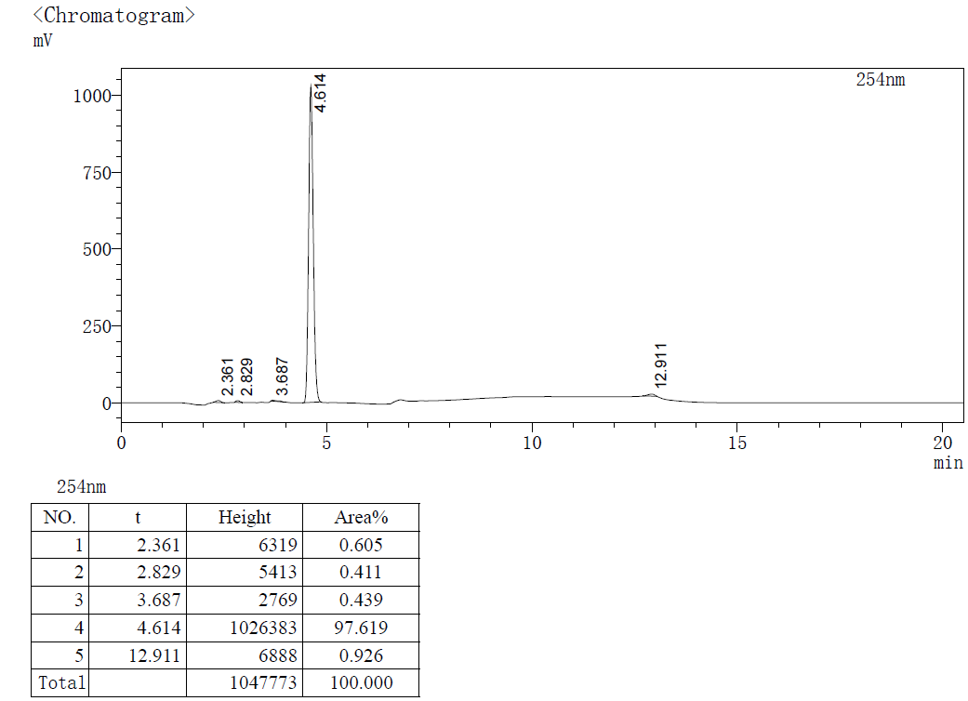

HPLC purity 97.619% (tR = 4.614 min).

***(1R,2S)-2-(1-(pentan-3-yl)-2-(thiophen-2-ylmethyl)-1H-benzo[d]imidazole-5-carboxamido)cyclopentane-1-carboxylic acid* (AP-2)**



HRMS(ESI)+ [C24H30N3O3S+]: calcd 440.2002, found 440.1993.

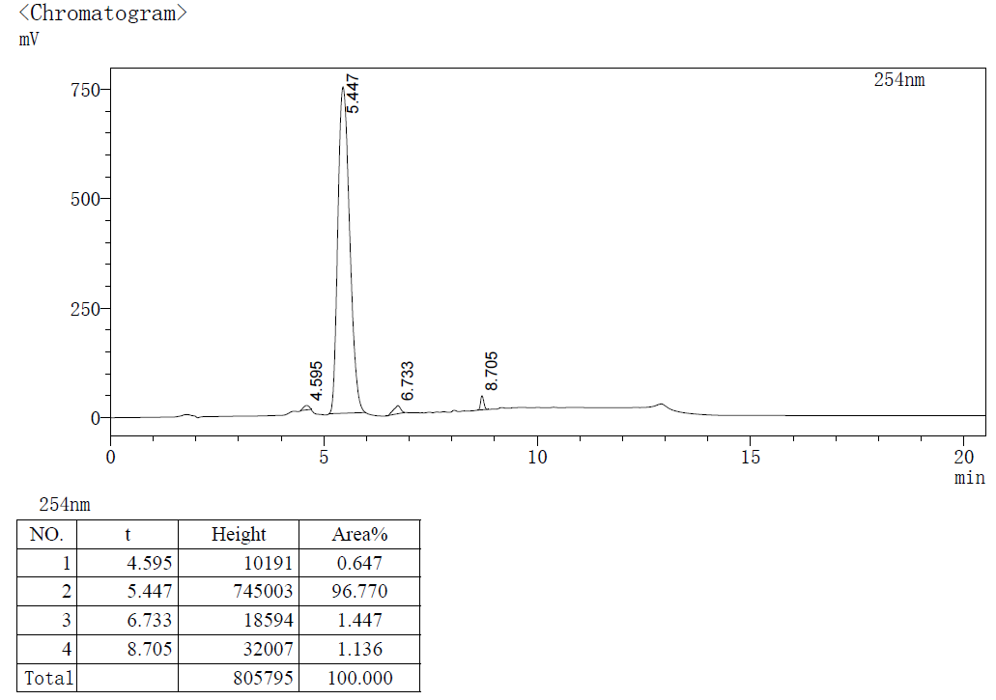

HPLC purity 96.770% (tR = 5.447 min).

***(R)-3-(1-(pentan-3-yl)-2-(thiophen-2-ylmethyl)-1H-benzo[d]imidazole-5-carboxamido)-3-phenylpropanoic acid* (AP-3)**



HRMS(ESI)+ [C27H30N3O3S+]: calcd 476.2002, found 476.1993.

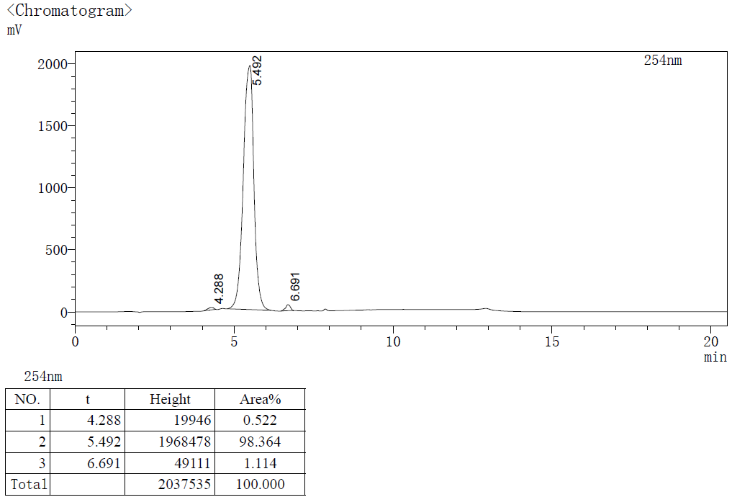

HPLC purity 98.364% (tR = 5.492 min).

***(S)-3-(1-(pentan-3-yl)-2-(thiophen-2-ylmethyl)-1H-benzo[d]imidazole-5-carboxamido)-4-phenylbutanoic acid* (AP-4)**



HRMS(ESI)+ [C28H32N3O3S+]: calcd 490.2159, found 490.2154.

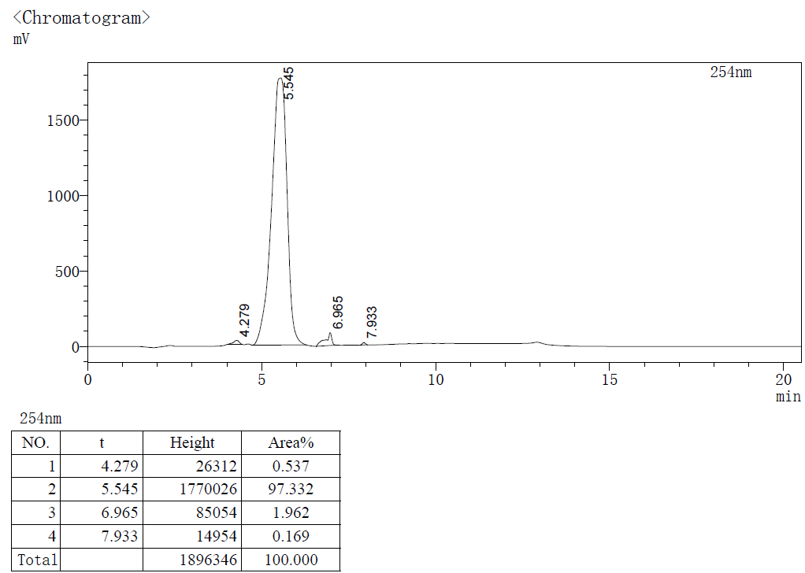

HPLC purity 97.332% (tR = 5.545 min).

***(R)-5-methyl-3-(1-(pentan-3-yl)-2-(thiophen-2-ylmethyl)-1H-benzo[d]imidazole-5-carboxamido)hexanoic acid* (AP-5)**



HRMS(ESI)+ [C25H34N3O3S+]: calcd 456.2315, found 456.2308.

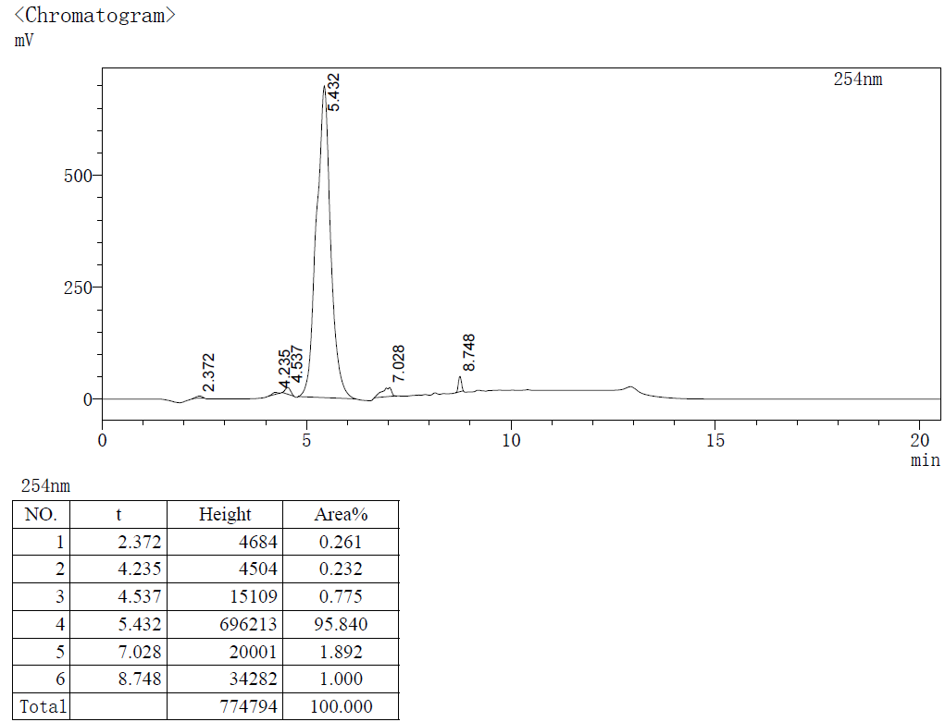

HPLC purity 95.840% (tR = 5.432 min).

***(R)-3-(1-(pentan-3-yl)-2-(thiophen-2-ylmethyl)-1H-benzo[d]imidazole-5-carboxamido)-4-phenylbutanoic acid* (AP-6)**



HRMS(ESI)+ [C28H32N3O3S+]: calcd 490.2159, found 490.2152.

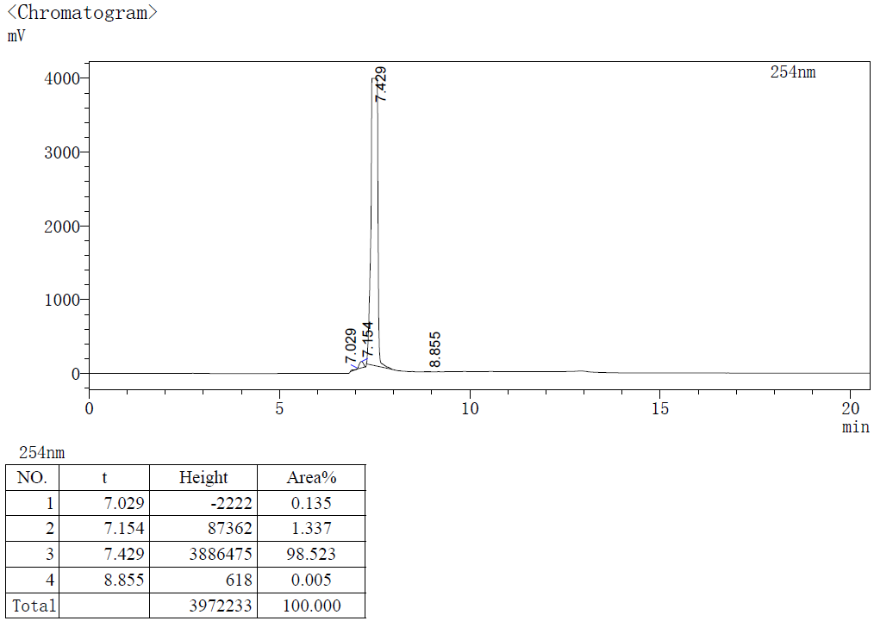

HPLC purity 98.523% (tR = 7.429 min).

***(S)-3-(1-(pentan-3-yl)-2-(thiophen-2-ylmethyl)-1H-benzo[d]imidazole-5-carboxamido)-3-phenylpropanoic acid* (AP-7)**



HRMS(ESI)+ [C27H30N3O3S+]: calcd 476.2002, found 476.1996.

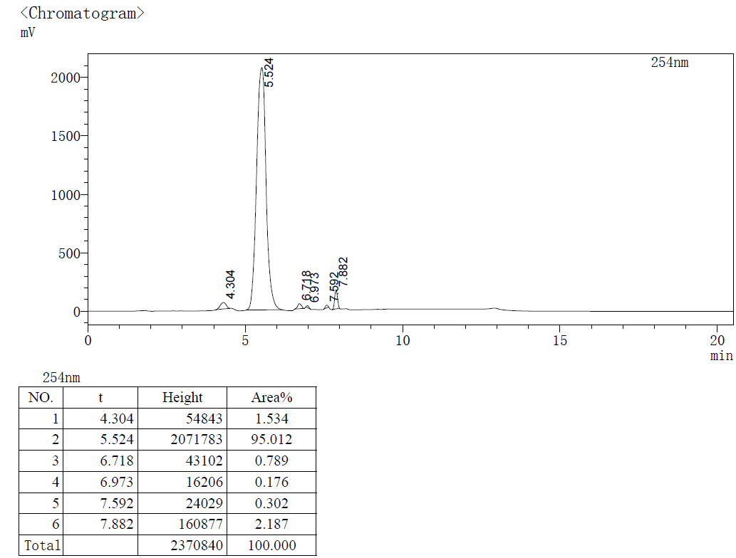

HPLC purity 95.012% (tR = 5.524 min).

***(S)-3-(1-isopropyl-2-(thiophen-2-ylmethyl)-1H-benzo[d]imidazole-5-carboxamido)-3-phenylpropanoic acid* (AP-8)**



HRMS(ESI)+ [C25H26N3O3S+]: calcd 448.1689, found 448.1686.

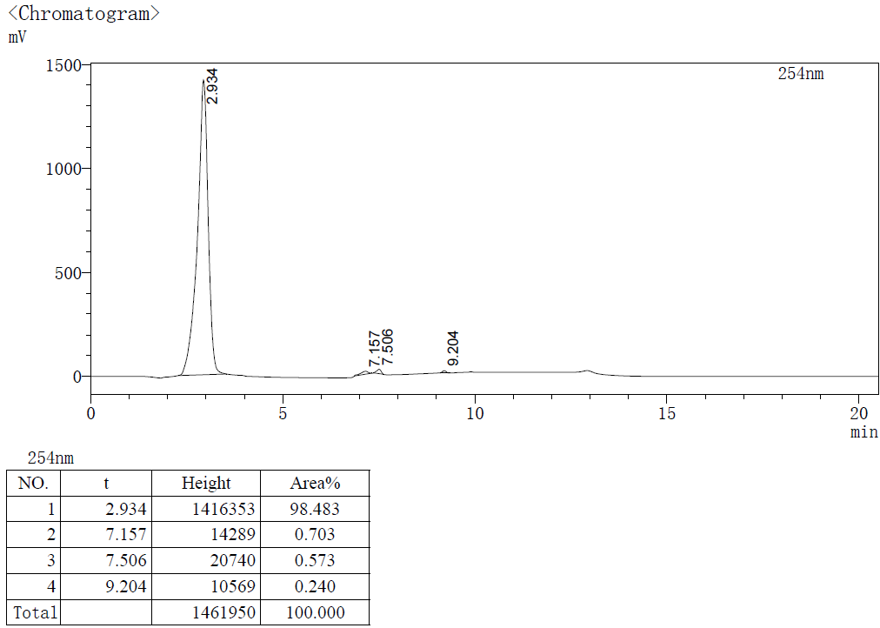

HPLC purity 98.483% (tR = 2.934 min).

***(S)-3-(1-ethyl-2-(thiophen-2-ylmethyl)-1H-benzo[d]imidazole-5-carboxamido)-3-phenylpropanoic acid* (AP-9)**



HRMS(ESI)+ [C24H24N3O3S+]: calcd 434.1532, found 434.1523.

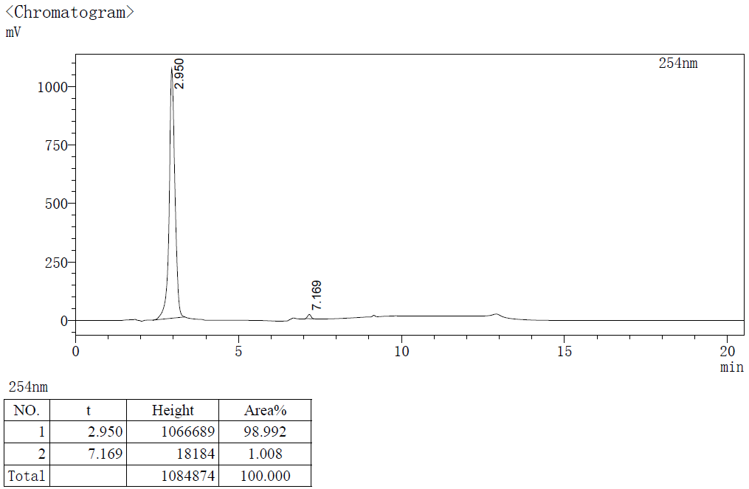

HPLC purity 98.992% (tR = 2.950 min).

***(S)-3-phenyl-3-(1-phenyl-2-(thiophen-2-ylmethyl)-1H-benzo[d]imidazole-5-carboxamido)propanoic acid* (AP-10)**



HRMS(ESI)+ [C28H24N3O3S+]: calcd 482.1533, found 482.1526.

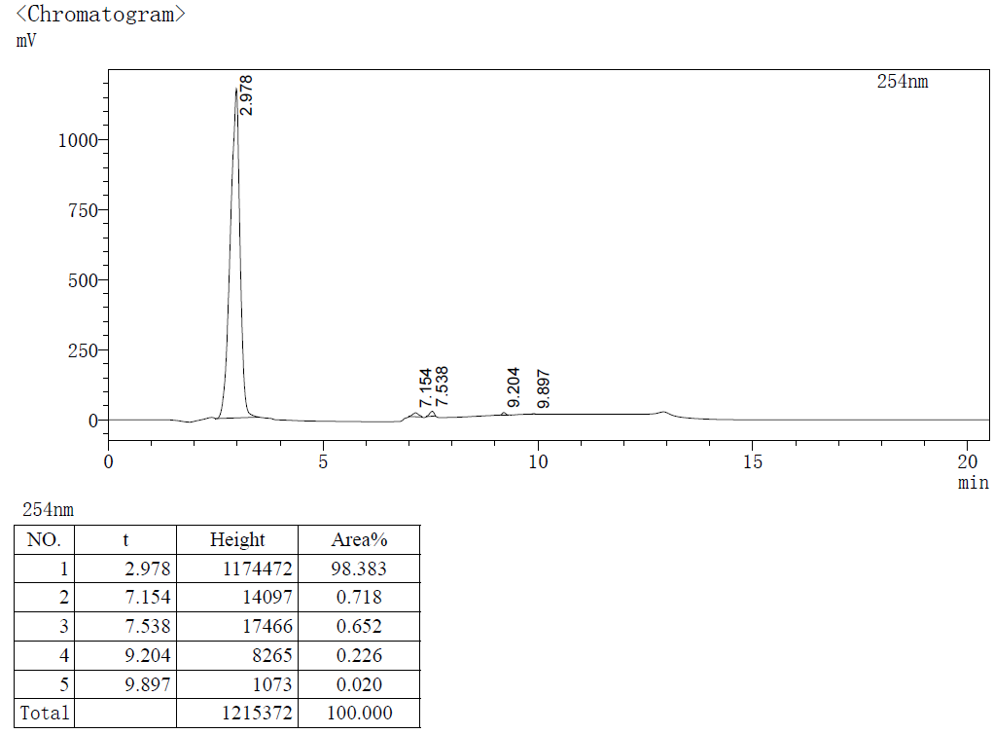

HPLC purity 98.383% (tR = 2.978 min).

***(S)-3-(1-(pentan-3-yl)-2-(pyrazin-2-ylmethyl)-1H-benzo[d]imidazole-5-carboxamido)-3-phenylpropanoic acid* (AP-11)**



HRMS(ESI)+ [C27H30N5O3+]: calcd 472.2343, found 472.2339.

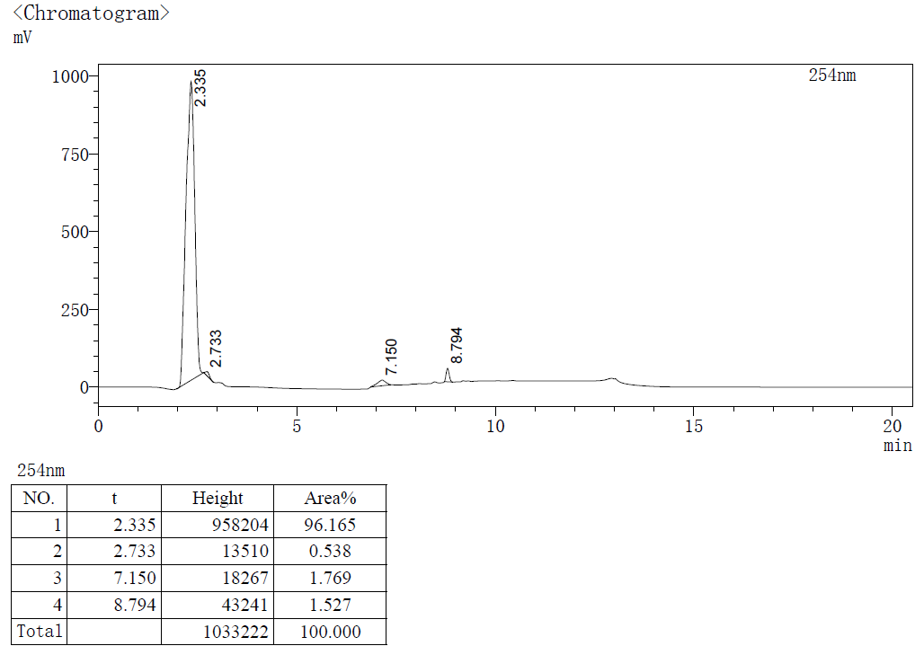

HPLC purity 96.165% (tR = 2.335 min).

***(S)-3-(1-(pentan-3-yl)-2-(pyridin-2-ylmethyl)-1H-benzo[d]imidazole-5-carboxamido)-3-phenylpropanoic acid* (AP-12)**



HRMS(ESI)+ [C28H31N4O3+]: calcd 471.2391, found 471.2386.

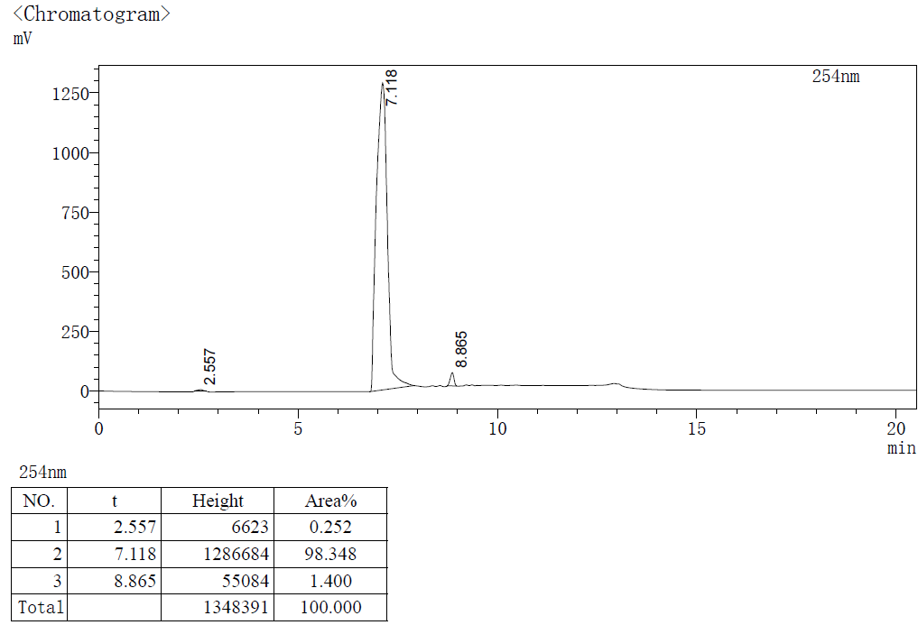

HPLC purity 98.348% (tR = 7.118 min).

***(S)-3-(1-(pentan-3-yl)-2-(pyridin-3-ylmethyl)-1H-benzo[d]imidazole-5-carboxamido)-3-phenylpropanoic acid* (AP-13)**



HRMS(ESI)+ [C28H31N4O3+]: calcd 471.2391, found 471.2383.

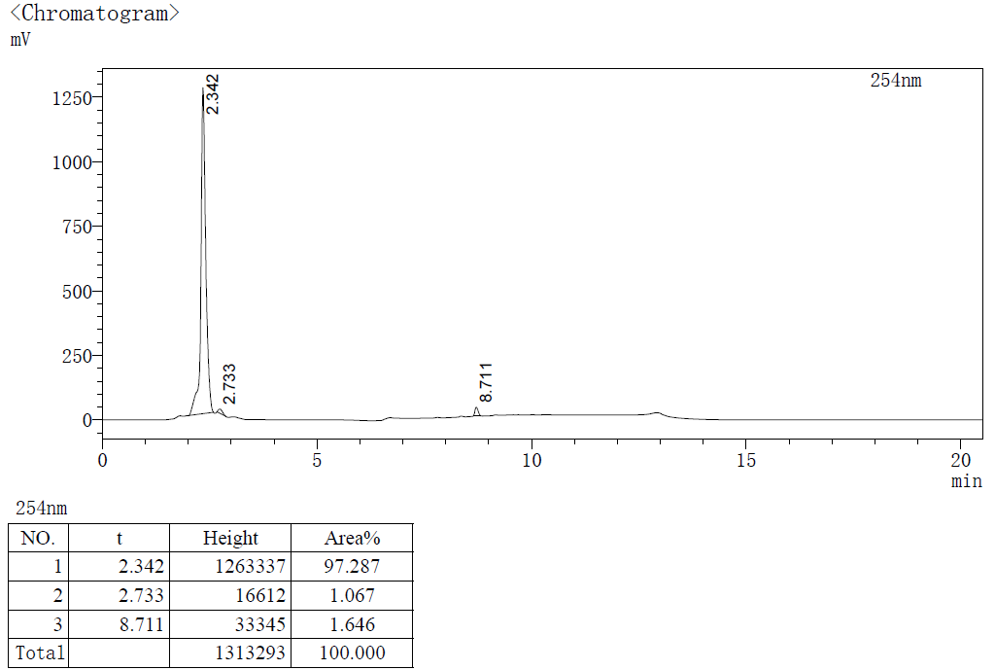

HPLC purity 97.287% (tR = 2.342 min).

***(S)-3-(1-(pentan-3-yl)-2-(pyridin-4-ylmethyl)-1H-benzo[d]imidazole-5-carboxamido)-3-phenylpropanoic acid* (AP-14)**



HRMS(ESI)+ [C28H31N4O3+]: calcd 471.2391, found 471.2392.

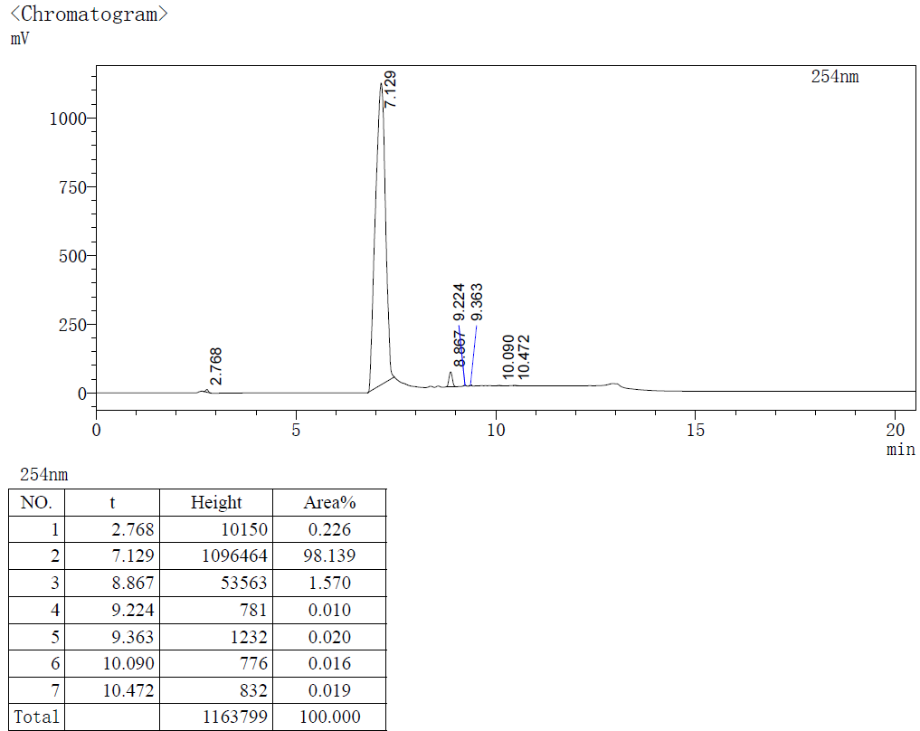

HPLC purity 98.139% (tR = 7.129 min).

***(S)-3-(2-benzyl-1-(pentan-3-yl)-1H-benzo[d]imidazole-5-carboxamido)-3-phenylpropanoic acid* (AP-15)**



HRMS(ESI)+ [C29H32N3O3+]: calcd 470.2438, found 470.2431.

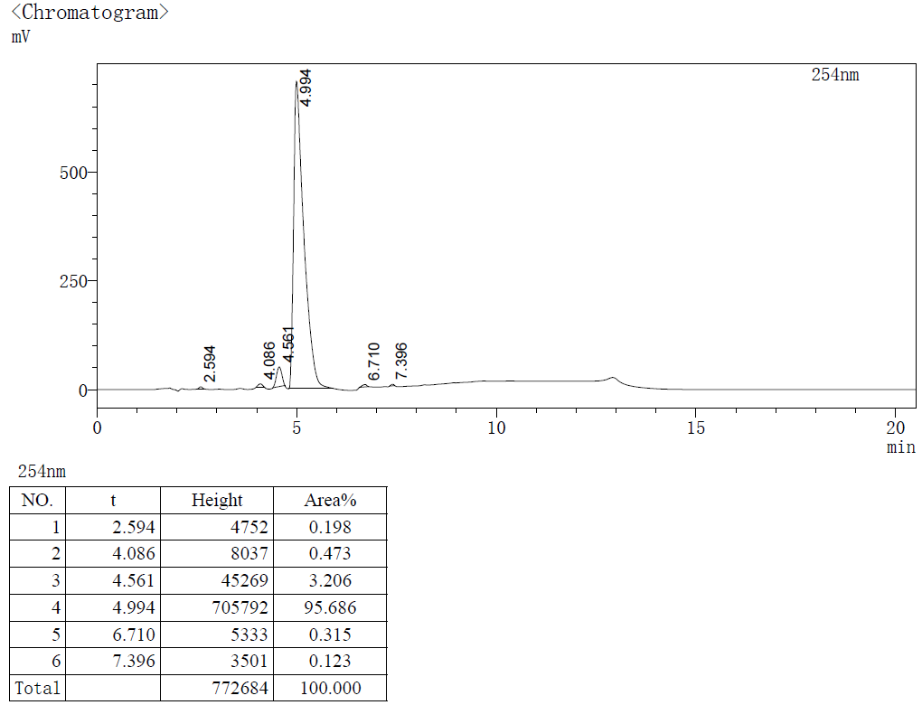

HPLC purity 95.686% (tR = 4.994 min).

***(S)-3-(2-(furan-2-ylmethyl)-1-(pentan-3-yl)-1H-benzo[d]imidazole-5-carboxamido)-3-phenylpropanoic acid* (AP-16)**



HRMS(ESI)+ [C27H30N3O4+]: calcd 460.2231, found 460.2222.

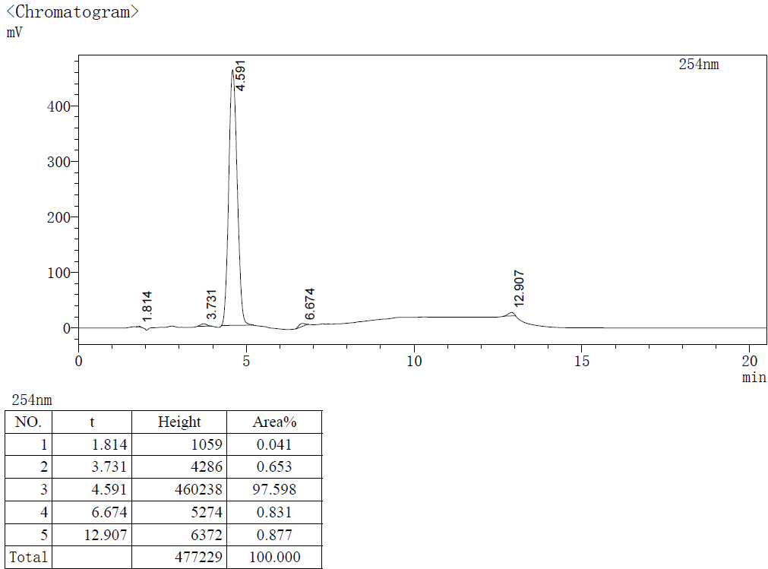

HPLC purity 97.598% (tR = 4.591 min).

***(R)-3-(2-(furan-2-ylmethyl)-1-(pentan-3-yl)-1H-benzo[d]imidazole-5-carboxamido)-3-phenylpropanoic acid* (AP-17)**



HRMS(ESI)+ [C27H30N3O4+]: calcd 460.2231, found 460.2223.

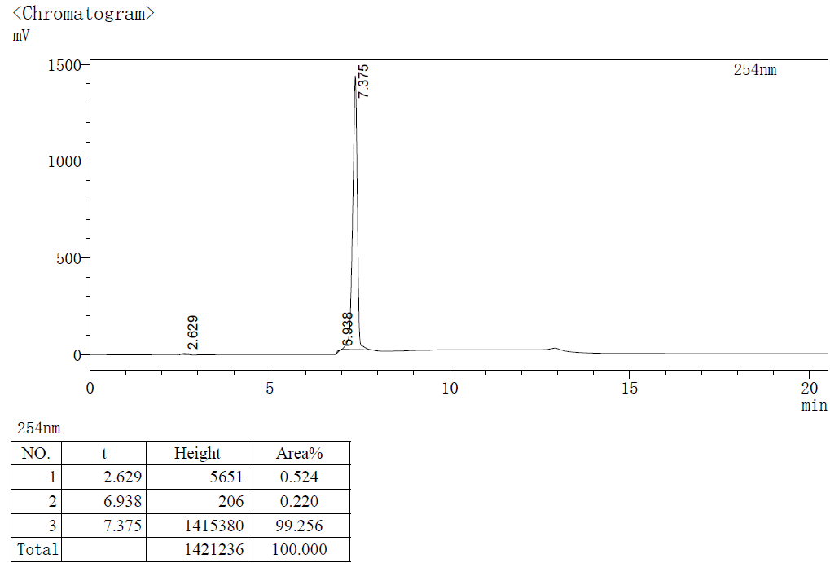

HPLC purity 99.256% (tR = 7.375 min).