FUNCTIONAL AND ARCHITECTURE REPORT
Pasyala Janith Distributor ERP
A single-business ERP for an Ayurveda products distributor in Sri Lanka: it buys from one supplier, Pasyale Ayurveda Osu, and sells to shops, medical centres, pharmacies and walk-in customers. This report describes what the system does, how it is built, how its numbers are calculated, and where its risks lie.
Item | Value
Report date | 9 November 2026
Application version | 2026.11.06-cheques
Repository history | 17 commits, 13 October to 9 November 2026
Source of truth | Code at commit a502868 plus the uncommitted working tree, surveyed read-only
Prepared for | The owner and any engineer who will maintain or extend the system

Contents
- Summary
- Business context
- Functional overview
- Business rules and maths
- Architecture
- Data model and integrity
- Security
- Deployment and operations
- Quality and testing
- Risks and recommendations
- Appendix: API endpoints, assistant tools, browser storage, glossary

1. Summary
The ERP is a TypeScript monorepo with three packages: a React single-page application, an Express API on PostgreSQL, and a shared package that holds every money, pricing and dues calculation so the browser preview and the server always agree. It runs on Vercel in Singapore against a Neon serverless Postgres database, with invoice photos in a private Vercel Blob store and an AI assistant that reads the ERP through 27 tools and can change nothing without the owner's approval.
Measure | Value | Detail
Code | 18.8k | lines of TypeScript in 98 files
API | 85 | endpoints in 7 route files
Screens | 25 | routes across 13 page files
Database | 17 | tables, 7 migrations
Tests | 138 | 119 backend + 19 shared; 2 need a real Postgres
Assistant | 27 | read tools, 1 approval-gated write
Services | 16 | backend service modules
Paper batches | 6 | JSON files of transcribed invoices

What stands out
- One source of maths. Line nets, invoice totals, landed cost, FIFO dues, price quotes and the Sri Lanka date all live in the shared package and are used unchanged by the server, the screens, the importers and the assistant.
- Stock is never stored. Stock on hand is always derived from opening stock, purchases, sales, restocked returns and adjustments in one aggregate query, so it cannot drift. Writes lock the affected products and refuse to go negative.
- Paper first. Supplier invoices and handwritten bill-book sales enter through camera scans (offline OCR in the browser or Claude vision), bulk JSON importers that refuse to write unless the printed totals match, and photo attachments deduplicated by hash.
- Thin margins made visible. The supplier gives 22% off list plus 8% off the bill; customers get 30% to 35%. The Net sales, Discount margin and Stock amount windows show this ladder invoice by invoice.
- A read-only assistant. Answers in English or Sinhala come from the same functions as the screens; the conversation is signed so it cannot be edited in the browser; the only write is a stock-count request the owner approves.

Where it is weakest
- No continuous integration, no automated database backup, and no frontend tests.
- List endpoints recompute stock and dues for every product or customer on every request; fine at today's size, a ceiling later.
- Database migrations run during the Vercel build, so a build against production applies schema changes before the new code is live.
Section 10 lists these with severity and a recommended fix.

2. Business context
Pasyala Janith Distributor buys Ayurveda products (oils, arishta, powders, tablets, pastes, honey) from Pasyale Ayurveda Osu on printed invoices numbered HOSI… with a 22% line discount and an 8% bill discount, often with free issues. It resells them on its own invoices numbered PJD-000001… to four customer types, each with a default discount and credit terms.
Aspect | Description
Actors | The owner (approves stock corrections), sales and office staff (enter sales, payments, photos), the supplier's sales person (named on each GRN), and the ERP assistant acting on a named user's behalf.
Customer types | SHOP, MEDICAL and PHARMACY on 30 credit days; WALKIN on 0. Each has a default discount; a customer can override discount and credit days and carry a credit limit.
Documents | Purchase invoice (GRN), sales invoice, sales return (credit note, numbered PJD-R000001…), payment (received or paid out), stock adjustment, invoice photo, assistant stock request.
Money conventions | Sri Lankan rupees to 2 decimals, en-LK formatting, amounts in words on invoices, "charged + free" quantities, dates in Asia/Colombo.
Scale today | 53 seeded products, one supplier, about 46 customers, 47 sales invoices, 2 returns and the October 2026 purchase invoices entered; a few thousand rows in total.

3. Functional overview
Every list page is paged on the server (10, 25, 50 or 100 rows), sortable, searchable, keeps its filters in the URL so Back and shared links work, turns into cards on phones, and has an Excel button that exports every page of the current filter.

Dashboard
- Attention chips: overdue customers, over credit limit, out of stock, running low.
- KPI tiles: today vs yesterday, month to date vs the same days last month with profit, to collect with overdue, stock value at cost and at sell price.
- 30-day sales chart, "Collect money" list with call and receive buttons, reorder list, recent sales, sales by type and top products. Refreshes every 60 s.

Sales invoices
- Create by hand or from a scanned photo; live pricing from the price engine; warnings for stock, credit limit, below cost, printed-total mismatch.
- Filters: photos, status (due, overdue, cheque not cleared, paid), payment method, type, customer, dates.
- Tiles for invoices, net sales, discount margin, gross profit, to collect; Net sales and Discount margin open invoice-by-invoice breakdown windows with their own Excel.
- Checkbox column with a selection bar (net, gross, paid, due, profit) and a column picker before every Excel download.
- View: print preview (A4, A5, Letter) or quick print, receive payment, mark cheque cleared, return items, photos, delete.

Sales returns
- Against a named invoice (only what was sold, never more than sold) or free-form priced by the engine.
- Restock or write off; refund in cash, cheque or transfer, remainder credited to the customer's balance FIFO.
- Credit-note print; reports and dues are net of returns.

Purchases (GRN)
- Enter or scan the supplier invoice; new GRNs start with the supplier's last bill discount; duplicate (supplier, number) refused.
- Bill discount tile with breakdown; FIFO usage trace shows which sales consumed a GRN and locks edits below what was used.
- Saving a GRN updates each product's list price and supplier discount from the newest line.

Customers and suppliers
- Balances, overdue and over-limit computed live; statement tab with running balance; Excel of filtered customers or a statement.
- Receive payment or pay supplier from the row; a party with history cannot be deleted (deactivate instead).

Prices and discounts
- Customer types; a price grid per type with in-place rules (type default, discount %, fixed price) and live net preview; printable and Excel price lists.
- Free issues: buy X get Y, optionally per type and date range, with Running / Starts / Ended / Off badges.
- Products: grouped variants, bulk price change, auto item codes (THMN0030 style), scan a price list to propose new products and price changes.

Stock
- On hand as charged + free, FIFO valuation by GRN layer, Amount tile with a ladder window and Excel; low and out filters.
- Adjustments: counted quantity or add/remove with reasons; "Exchange with distributor" records the given and received sides as two adjustments.
- Product page: refills on hand per GRN, price per type with its source, movements ledger with running balance.

Payments, photos and reports
- Payments received and paid out with method and reference; a shortcut to pay the full balance; FIFO allocation explained in the form.
- Invoice photos gallery with lightbox, rotation saved, missing-photo chips; each photo belongs to one invoice and duplicates are blocked by SHA-256.
- Reports by product, customer, type, day and aging (not due, 1–30, 31–60, 61–90, 90+), with presets and a two-sheet Excel.

Assistant and settings
- Chat over the whole ERP; quick questions; every reply has Report view (tiles, totals, bar charts), Excel and PDF; a "report" question opens the report view by itself.
- Stock-count requests from the chat wait for the owner's approval; decided requests are listed.
- Settings: business details, invoice prefix and counters, negative-stock switch, full Excel export of all 17 tables, notification bell for alerts, version mismatch warning.

4. Business rules and maths
All of these functions are in shared/src and are covered by the shared and backend test suites. Money is rounded to cents with round2 inside the validation schemas, so what is saved is exactly what prints.

Invoice totals
line net = round2(qty × unit price × (1 − line disc %)) per line, as the supplier prints it
sub total = Σ line net
bill discount = sub total × bill disc %
net total = sub total − bill discount
free units = Σ free qty on the invoice at Rs 0.00

Cost, stock value and the discount ladder
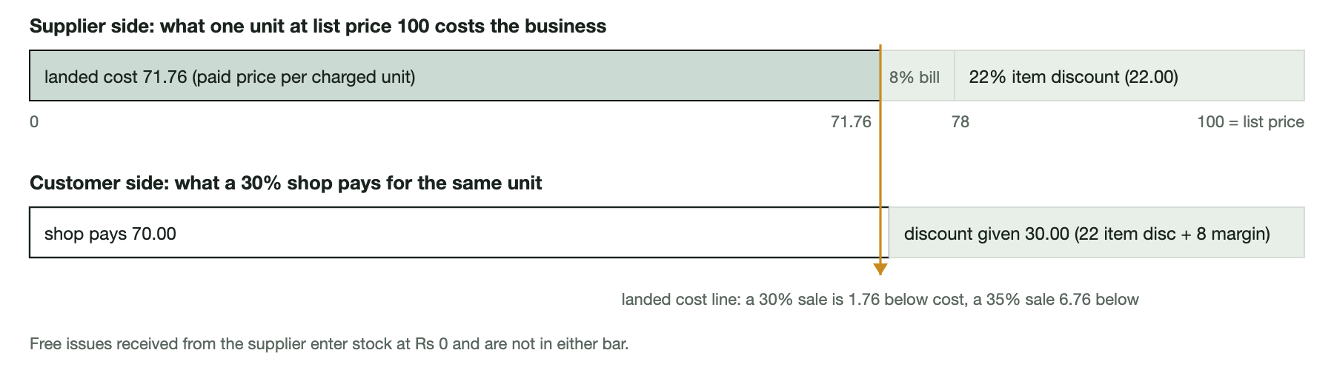
Why the editor warns "sold below cost" on most shop lines: the customer discount (30 to 35%) exceeds the supplier's combined 28.24%. The business treats this as expected; the supplier's free issues, carried at Rs 0, are where the margin on shop sales comes from.
Figure | How it is calculated
Landed unit cost | line net × (1 − bill disc %) ÷ paid quantity. Free units cost Rs 0 and never dilute the average.
Average cost | (opening stock at list less supplier discount + Σ purchase line net × (1 − bill disc)) ÷ paid units only, kept to 4 decimals.
Sale cost and profit | charged quantity × average cost at the time of sale, saved on each sales line; free units given cost Rs 0; profit = revenue − cost. db:recost-sales -- --apply re-costs older invoices at today's average.
Stock amount | Units on hand are taken to be the newest GRN layers (FIFO), each valued at qty × unit price × (1 − line disc) × (1 − bill disc); free units at 0; any excess from adjustments valued like the newest refill.
Net sales | gross − discount given. The breakdown ladder runs list → less 22% → less 8% (rate from the newest GRN) → less discount given → net.
Discount margin | discount given − the supplier's item discount on the same goods (8% of gross for a 30% customer, 13% for 35%), funded by the supplier's 8% bill discount shown on the Purchases list.

Stock on hand
on hand = opening + purchased (charged + free) − sold (charged + free given) + restocked returns ± adjustments
This is computed in one aggregate SQL query per request and never stored. Every write that changes stock runs in a transaction, locks the affected products in sorted id order with SELECT … FOR UPDATE, and returns 409 listing every short item unless the "allow negative stock" setting is on. A GRN cannot be deleted or reduced below what later sales consumed (a FIFO trace proves it), and a sale cannot be deleted while a return references it.

Pricing precedence
- A price rule for this product and customer type with a fixed price.
- A price rule for this product and type with a discount %.
- The customer's own discount %.
- The customer type's default discount %.
Then the best active promotion: one for this customer type beats an all-types one; ties go to the most generous free-to-buy ratio; free quantity = floor(qty ÷ buy) × free. Anything can be overridden on the line, and the override is kept when the customer or date changes.

Dues, overdue and cheques
- Money paid on the invoice, and returns credited against it, settle that invoice first. Separate payments, unlinked return credits and over-payments form a pool applied to the oldest open invoices first (FIFO by date, then id). A negative balance is credit held for the party.
- Due date = cheque date if there is one, else invoice date + credit days (customer, else type; supplier's own for payables). Overdue means more than Rs 0.004 still due after that date.
- A cheque "not yet paid" keeps the invoice due until the cheque date; "Cheque cleared" marks the invoice paid on the invoice itself rather than as a FIFO payment; "Paid" settles it at once.
- Aging buckets are computed as of today regardless of the report's date range.

Numbering and identity
- Sales invoices: settings prefix + 6 digits; the settings row is locked during numbering and collisions are skipped. Returns use the prefix + R + 6 digits with their own counter.
- Product codes: category prefix (TH, AR, CH, GL, LP, RS, HN, OT) + two letters from the name + the size in four digits of ml or g, e.g. THMN0030; suffixes -2, -3 on collision. Name + size must be unique; codes are immutable.
- Dates are stored as yyyy-mm-dd strings and never shifted by timezone; "today" is UTC + 5:30.

5. Architecture

Runtime topology
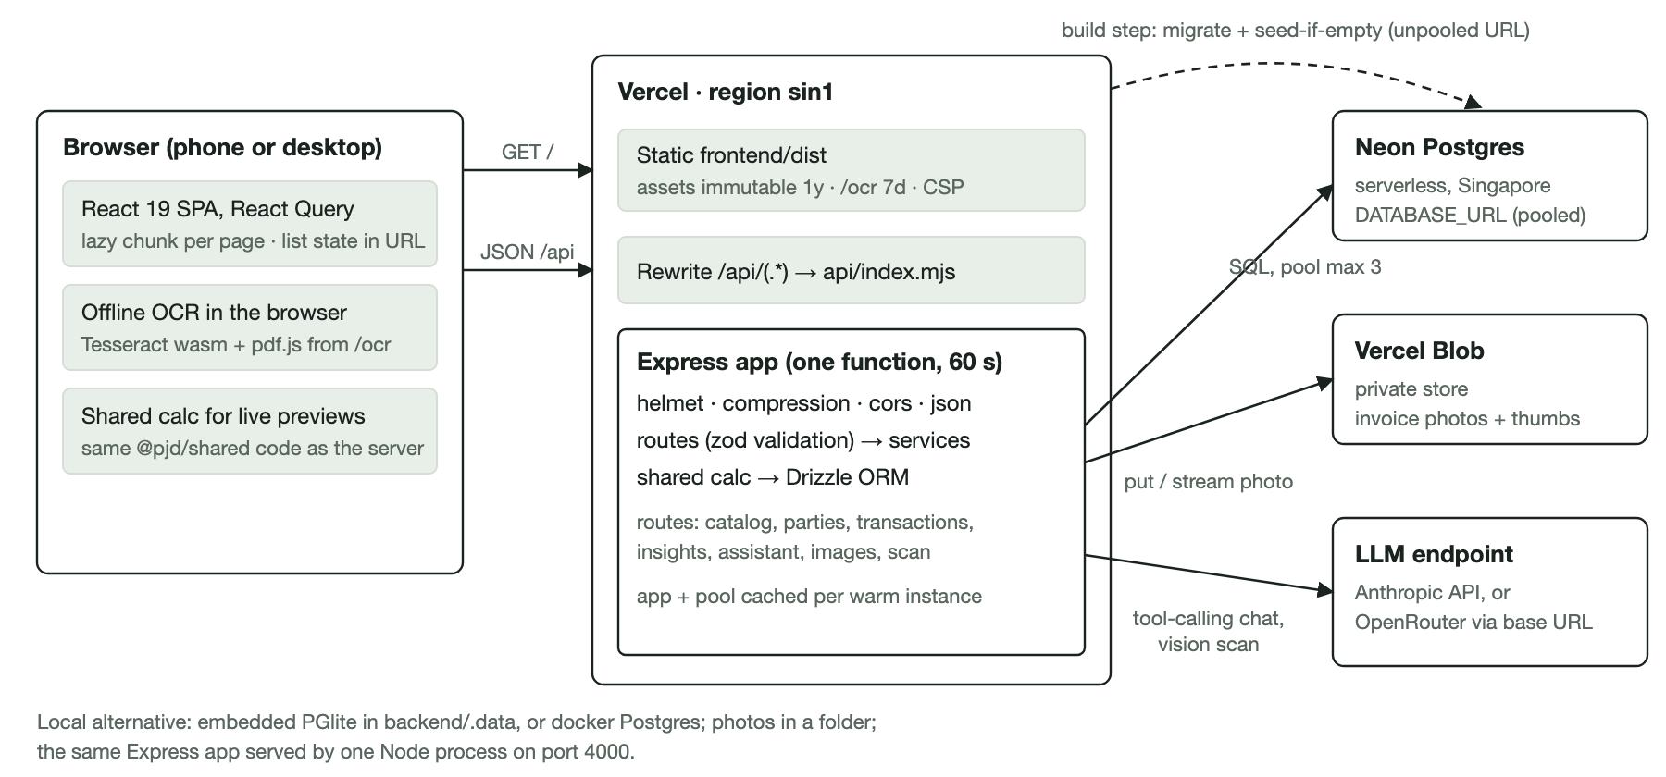
One deployable unit on Vercel: static files plus a single serverless Express function. Everything stateful sits in three external services. Locally the same code runs as one Node process with an embedded database.

Repository layout
Package | Role | Key technology | Lines
shared/ @pjd/shared | Types, zod schemas, all money and date maths, pricing engine, FIFO dues, item codes, offline OCR parser. Consumed as raw TypeScript and bundled into the backend. | TypeScript 6, zod 4, vitest | 1,592
backend/ @pjd/backend | Express 5 API, Drizzle ORM schema and migrations, services, assistant, scanners, importers and CLIs. Built with tsup to ESM for Node 22. | Express 5, Drizzle 0.45, pg, PGlite, helmet, Anthropic SDK, @vercel/blob | 8,473
frontend/ @pjd/frontend | React SPA: 13 page modules, 18 shared components, data and OCR libraries. Built with Vite 8; OCR assets copied to public/ocr before build. | React 19, react-router 7, React Query 5, Tailwind 4, tesseract.js 7, pdfjs-dist, write-excel-file | 8,752
api/index.mjs, vercel.json | One-line re-export of the built serverless handler; routing, caching and security headers. | Vercel | —
backend/drizzle/ | 7 SQL migrations, from the initial schema through invoice images and rotation, assistant requests, sales returns and invoice cheques. | drizzle-kit | —
backend/src/db/imports/ | 6 hand-transcribed JSON batches of paper invoices (2 purchase, 4 sales) consumed by the importers. | JSON | —

Backend request path
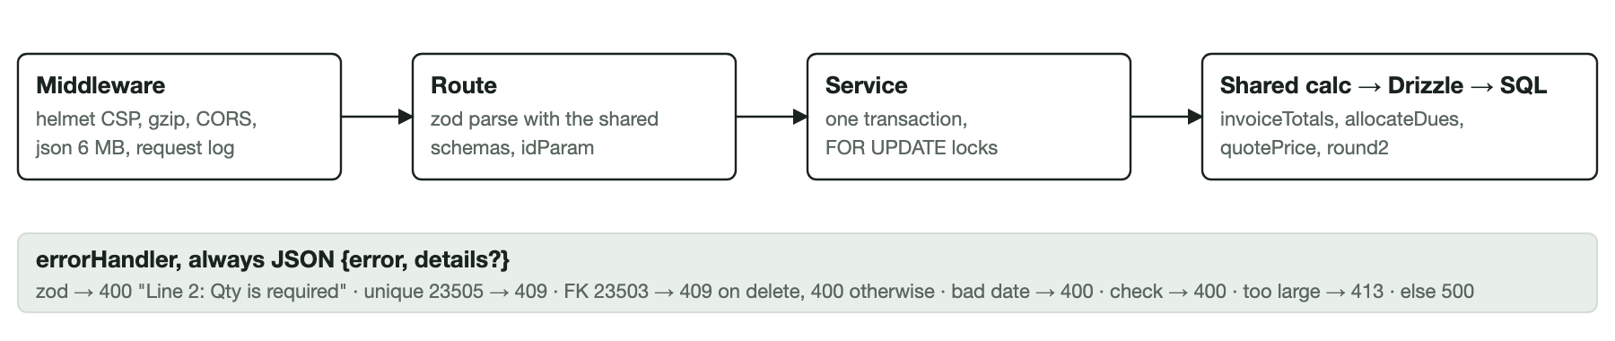
Validation happens at the edge of the route with the same zod schemas the forms use; business invariants are enforced inside service transactions; errors leave in one JSON shape.

Backend layering
- Entry points. index.ts for a local or self-hosted process (opens the database, migrates, seeds if empty, serves the API and the built frontend); vercel.ts for the serverless handler (app cached per warm instance, refuses to start without a database URL, never migrates at request time).
- Routes (7 files) parse and authorise, then call services. Some list logic, notably stock valuation in productsWithStock, lives in the catalog route file rather than a service.
- Services (16 modules): stock (derived stock, average cost, locks), invoices (sales and GRN save, edit, delete, cheque cleared), returns, dues (FIFO over shared allocateDues), usage (FIFO trace per GRN), reports (also feeds the dashboard, alerts and assistant), recost, files (Blob or local folder), scan and llm, assistant, assistant-data, assistant-approvals, import-purchases, import-sales, import-photos.
- Data access is Drizzle ORM with raw aggregate SQL where one query must do the stock maths. Numeric and bigint columns are parsed to JS numbers; dates stay strings.
- Pagination is in memory after a SQL pre-filter on dates and ids, because stock and dues are derived fields. Page size is capped at 200 (500 for price lists).

Frontend architecture
- Shell. StrictMode → QueryClientProvider → ConfirmProvider → router. Each route is a lazily loaded page with its own error element so the sidebar survives a page crash. A failed chunk load retries once, then shows a reload button.
- Data layer. A small fetch wrapper (api.ts) maps failures to ApiError and walks pages for exports. React Query defaults: 15 s stale time, refetch on focus, no retry on 4xx. Mutations invalidate every query because stock, balances and dues depend on each other.
- List state in the URL. useListState keeps page, size, sort, search and filters in the search params; usePaged keeps the old rows on screen only when the change was paging, sorting or searching, and shows "Loading…" when a filter changed so stale rows never appear.
- Shared components. DataTable (server-driven, phone cards, sortable headers, optional checkbox column), ClientTable, Modal (bottom sheet on phones), BreakdownModal, Combobox, InvoiceEditor (one form for sales and purchases), InvoiceDocument (print layout), PrintPreview, InvoiceScan, InvoiceImages with Lightbox, ExcelColumns picker, Markdown and AssistantReport.
- Printing uses the browser: a print preview sheet with paper size and orientation, @page { margin: 0 } to suppress browser headers, and the document title as the PDF file name. Nothing is rendered to PDF on the server.
- Phones. Cards below the md breakpoint, a bottom tab bar with a raised New sale button, sticky totals in the editors, camera inputs, 16 px inputs against iOS zoom, safe-area padding.

Scanning pipeline
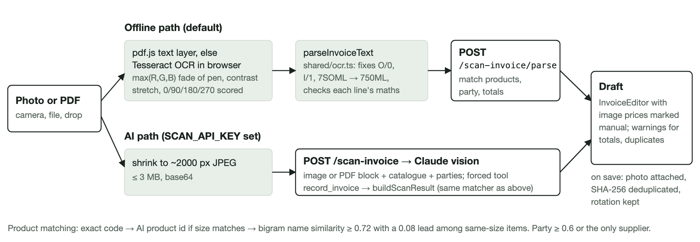
Both paths end in the same server-side matcher and the same editor draft. The offline path costs nothing and works without an AI key; the AI path reads handwriting and poor photos better.

Assistant architecture
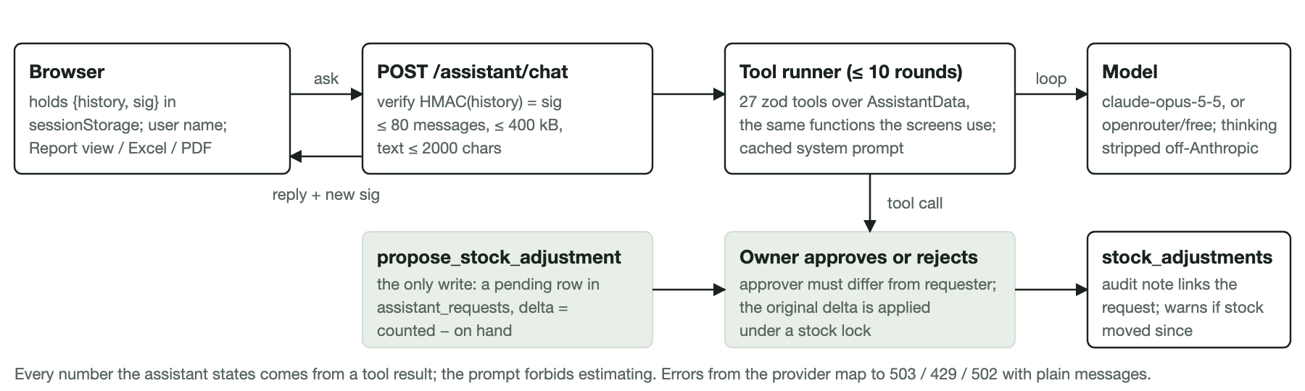
The conversation lives in the browser but cannot be edited there, the data layer is the ERP's own, and the single write path waits for the owner's decision.

Importers and CLIs
Paper batches are transcribed into JSON under backend/src/db/imports and run from backend/ with npm run db:import-purchases or db:import-sales. Both preview by default and only write with --apply. Purchases fail the whole run if any printed sub or net total differs by more than Rs 0.004; sales require the written gross exactly and tolerate a hand-rounded net within Rs 1, skip any bill that would take stock negative, match or create customers, and save a bill's return block (RTN goods) as a same-date sales return. Both are idempotent: entered documents are recognised by number in the notes or by customer, date and net. Photos attach from a folder, or through the live site's API when the Blob store only accepts OIDC. db:recost-sales previews or applies re-costing and reconciles purchases against cost of goods sold plus stock on hand.

6. Data model and integrity
Money is numeric(14,2), percentages numeric(5,2), unit costs numeric(14,4); dates are date columns held as strings. Enumerations (payment methods, return and adjustment reasons, categories, request status) are text validated by shared constants rather than Postgres enums. Lines cascade from their invoice; products, customers and suppliers are protected by restrict foreign keys.
Table | Holds | Notable constraints
settings | Business details, invoice prefix and counters, footer, negative-stock switch | Single row, id = 1
customer_types | Code, name, default discount, credit days, sort | Unique code; delete refused while customers use it
products | Code, name, size, category, list and sell price, supplier discount, reorder level, opening stock, active | Unique code; prices ≥ 0; code immutable; delete refused once used
price_rules | Fixed price or discount per product and customer type | Unique (product, type); cascades from both parents
promotions | Buy X get Y free, optional type, date range, active | Cascades from product
customers | Code, name, type, contact, area, own discount and credit days, credit limit, active | Unique code; type restrict; indexed by type
suppliers | Code, name, contact, credit days, active | Unique code
sales_invoices / sales_lines | Header money columns, cheque fields, cost total; lines with qty, free qty, price, discount, net, unit cost | Unique invoice_no; customer restrict; lines cascade; indexed by date, customer, product
sales_returns / sales_return_lines | Return number, reason, restock flag, totals, refunded amount and method, optional source invoice | 0 ≤ refunded ≤ net_total; invoice restrict
purchase_invoices / purchase_lines | Supplier invoice number, order number, sales person, money columns, lines | Unique (supplier, invoice_no); supplier restrict
payments | Date, party type, customer or supplier, amount, method, reference | Exactly one party id set; amount > 0
stock_adjustments | Signed quantity per product with reason and notes | Product restrict
assistant_requests | Proposed stock corrections with status, requester, approver, linked adjustment | Status index; adjustment set null on delete
invoice_images | Page number, storage kind, paths, mime, size, dimensions, rotation, hash | Unique sha256; exactly one invoice FK; cascades

Integrity rules enforced in code
- Stock is derived, never stored; writes lock products in sorted id order and refuse negative stock unless the setting allows it.
- A sale cannot be deleted while a return references it, or edited below quantities already returned. A GRN cannot be deleted or reduced below goods already consumed.
- Products, customers, suppliers and customer types in use cannot be deleted; the API answers 409 and says to deactivate.
- Invoice and return numbering lock the settings row; a duplicate supplier invoice is refused; a duplicate photo is refused with the invoice it already belongs to.
- Paid-on-invoice cannot exceed the net; refunds cannot exceed the return; a pending cheque must carry a cheque date.
- Soft warnings, not refusals: sold below cost, over credit limit, customer left holding credit, part paid, cheque pending, stock moved since a request was made.

7. Security
Area | Measures
Assistant history | Signed by the server on every turn; a tampered or stale history is rejected with 400; size limits stop prompt stuffing.
Transport and browser | HTTPS on Vercel with HSTS; CSP allows scripts from the app only (plus wasm and blob workers for OCR); frames same-origin; no referrer; camera permitted for self only; CORS refused unless CORS_ORIGIN lists an origin; JSON bodies capped at 6 MB and photos at 1.6 MB.
Input and output | zod on every body and query; uploaded images sniffed by magic bytes (JPEG, PNG, WebP); local file reads guarded against path traversal; storage status reports variable names, never values.
Secrets handling | All secrets are environment variables. backend/.env points at the live database and is treated as production by the team; it is git-ignored.

8. Deployment and operations

Environments
Environment | Database | Photos | How it runs
Vercel production (project pasyala-backend) | Neon serverless Postgres, Singapore, pooled URL at runtime | Private Vercel Blob | npm run build:vercel: build backend → run migrations and seed-if-empty over the unpooled URL → build frontend. One function, 60 s limit, pool max 3.
Vercel preview | Same project settings per environment | Same | Same build; environment variables are set per environment.
Local development | Embedded PGlite in backend/.data/pglite when no URL is set, or docker Postgres 16 | Folder backend/.data/uploads | npm run dev: API on 4000, Vite on 5173 proxying /api. First start seeds 53 products and 5 GRNs.
Self-hosted | Any Postgres | Folder or Blob | npm run build then npm start: one Node 22 process serving /api and the built frontend, behind Nginx or Caddy for TLS.
Tests | PGlite in memory, or TEST_DATABASE_URL (wiped) | Temp folder | env -u DATABASE_URL npm test from the repo root.

Operating procedures in use
- Deploy: vercel --prod from the repo root, run by the owner. Environment changes need a redeploy. The screens warn when their version differs from the server's.
- Paper batches: transcribe to JSON, preview the importer, fix unknown products or stock shortfalls, then --apply --photos from the owner's terminal (Blob uploads from other machines fail because the store is OIDC-only).
- Backups: manual pg_dump -Fc as the README recommends; Settings → Download full Excel export; GET /api/export JSON of all tables. Nothing is scheduled.
- Monitoring: none beyond Vercel's function logs. The API writes one JSON log line per assistant turn with token usage.

Configuration
Variable | Controls
DATABASE_URL / DATABASE_URL_UNPOOLED | Postgres connection; empty means embedded PGlite. The unpooled URL is used for build-time migrations.
DB_POOL_MAX, PGLITE_DIR, SEED_ON_EMPTY, TEST_DATABASE_URL | Pool size (10, 3 on Vercel), PGlite folder (memory:// in tests), seeding switch, real-Postgres test target.
PORT, STATIC_DIR, NODE_ENV, CORS_ORIGIN, TRUST_PROXY | Server port, built frontend folder, request logging off in tests, allowed browser origins, awareness of a reverse proxy.
ANTHROPIC_API_KEY, ANTHROPIC_BASE_URL, ASSISTANT_MODEL | Assistant on/off, provider endpoint (Anthropic or OpenRouter), model override. The live deployment uses an OpenRouter key and a free tool-capable model.
SCAN_API_KEY, ANTHROPIC_MODEL | AI invoice scanning on/off and its model; without a key the browser OCR path is used.
BLOB_READ_WRITE_TOKEN, BLOB_ACCESS, BLOB_STORE_ID, UPLOAD_DIR | Photo store token, private or public access, OIDC store id, local folder fallback.
VERCEL, VERCEL_ENV | Platform detection (trust proxy, Blob mode).
VITE_API_URL, API_URL | Frontend API origin when hosted apart; dev proxy target.

9. Quality and testing
Suite | Runs on | Tests | Covers
shared/src/shared.test.ts | vitest | 19 | Invoice maths reproducing printed invoice HOSI005942 to the cent, landed cost ignoring free issues, amount in words; pricing precedence and promotions; FIFO dues, overdue, returns against invoices, cheques, over-payment; validation; item codes.
backend/src/api.test.ts | supertest + PGlite | ~64 | Seed data; types, rules, promotions; sales, payments, balances, overdue; returns; cheques; purchases and stock safety; lists, paging, reports, payment-method filter, supplier bill discount; auto codes; dashboard; free items valued at 0; scan to draft; photos; product import; cost on charged units; re-costing.
backend/src/assistant.test.ts | mocked model | ~24 | Data layer, tools called directly, status and chat API, history signing and limits, provider detection and key mismatch.
backend/src/import.test.ts | PGlite | ~15 | Purchase import of the 21 Oct 2026 invoices with photos; handwritten sales import; RTN lines as returns; idempotence.
backend/src/ocr.test.ts, files.test.ts | fixtures | ~11 | Offline parser on real OCR output (headers, free lines, mix-ups, orientation); Blob versus local storage detection.
backend/src/race.test.ts | real Postgres only | 1 | Concurrent sale versus stock removal cannot oversell. Skipped on PGlite.

Last run on 9 November 2026: backend 117 passed and 2 skipped in 21 s on the in-memory database; shared 19 passed; tsc clean in all three packages; frontend oxlint clean and the production build succeeds. The frontend has no automated tests; its behaviour is verified by typecheck, lint, build and manual use. There is no CI pipeline, so these checks run on a developer's machine before vercel --prod.

Conventions worth keeping
- Business maths only in shared/; the backend is the source of truth and the frontend previews with the same functions.
- User-facing validation messages written in the zod schemas so forms and API agree.
- Comments in plain business English; README glossary kept in step with the numbers on screen.
- Importers and the recost CLI preview first and are idempotent, so a re-run is always safe.

10. Risks and recommendations
Severity | Finding | Recommendation
HIGH | No automated database backup. The only copies are manual pg_dump runs and ad-hoc Excel or JSON exports. | Enable Neon's point-in-time restore or schedule a nightly pg_dump to object storage; test a restore once.
HIGH | Migrations run inside the Vercel build against production before the new function is live, and a failed build after migrating leaves schema ahead of code. | Keep migrations additive and backward compatible (they are today), or move migration to a separate step run before deploy.
MEDIUM | No CI. Tests, typecheck and lint depend on being run by hand before deploy. | A GitHub Actions workflow running npm run typecheck, npm test and the frontend build on push; block deploy on red.
MEDIUM | List endpoints compute the stock map and dues for all products or customers on every request and paginate in memory. | Fine for thousands of rows. Before tens of thousands, cache the stock map per request burst or materialise per-product movement totals.
MEDIUM | The assistant runs on OpenRouter's free tier: about 20 requests a minute and a daily cap, shared across the model's users; quality varies by model. | Budget a paid Anthropic key for the assistant when it becomes part of daily routine; the code switches by environment variable.
LOW | Money is held as JavaScript numbers with explicit cent rounding. | Adequate at 2 decimals with round2 and 0.004 tolerances; keep every calculation in shared and tested.
LOW | Frontend has no tests and its tsconfig does not set strict explicitly (backend and shared do). | Add a few vitest tests for lib/markdown.ts, hooks.ts and the editor's totals; set strict: true.
LOW | Small inconsistencies: approvals use window.prompt instead of the app's modal; VersionWarning calls /api/health directly, ignoring VITE_API_URL; stock valuation logic sits in a route file; a stale code graph (graphify-out) is committed. | Tidy when touching those files; delete or git-ignore the graph output.
LOW | Photo uploads from a developer machine fail because the Blob store is OIDC-only; batch photos must be attached from the owner's terminal or via the site's API. | Already handled by the importer's --api uploader; document the step in the runbook.

Suggested next steps, in order
- Automated backups with a tested restore.
- CI on push with typecheck, tests and build.
- Finish the pending paper batches (two bills blocked on missing products and GRNs, three returns without item lists) so the ledgers match the bill book.
- Frontend unit tests for the markdown and report helpers now that Excel and PDF depend on them.

Appendix

A.1 API endpoints
All under /api. List endpoints accept page, pageSize, search, sort, dir and return {items, total, page, pageSize, summary}.
Group | Endpoints
Health | GET /health, returns ok and the app version
Products | GET /products, /products/options, /products/meta, /products/:id, /products/:id/movements · POST /products, /products/import, /products/bulk-price · PUT /products/:id · DELETE /products/:id
Pricing | GET /customer-types, /pricing/context, /price-list, /promotions · POST /customer-types, /promotions · PUT /customer-types/:id, /price-rules, /promotions/:id · DELETE /customer-types/:id, /promotions/:id
Customers | GET /customers, /customers/options, /customers/areas, /customers/:id · POST /customers · PUT /customers/:id · DELETE /customers/:id
Suppliers | GET /suppliers, /suppliers/options, /suppliers/:id · POST /suppliers · PUT /suppliers/:id · DELETE /suppliers/:id
Sales | GET /sales, /sales/:id · POST /sales, /sales/:id/cheque-cleared · PUT /sales/:id · DELETE /sales/:id
Sales returns | GET /sales-returns, /sales-returns/:id · POST /sales-returns · PUT /sales-returns/:id · DELETE /sales-returns/:id
Purchases | GET /purchases, /purchases/:id, /purchases/:id/usage · POST /purchases, /purchases/:id/cheque-cleared · PUT /purchases/:id · DELETE /purchases/:id
Payments and adjustments | GET /payments, /adjustments · POST /payments, /adjustments · DELETE /payments/:id, /adjustments/:id
Insights | GET /settings, /reports/summary, /reports/by-product, /reports/by-customer, /reports/by-type, /reports/daily, /reports/aging, /dashboard, /alerts, /export · PUT /settings
Assistant | GET /assistant/status, /assistant/requests · POST /assistant/chat, /assistant/requests/:id/approve, /assistant/requests/:id/reject
Photos | GET /images, /images/status, /images/:id/file, /sales/:id/images, /purchases/:id/images · POST /sales/:id/images, /purchases/:id/images · PATCH /images/:id · DELETE /images/:id
Scanning | GET /scan-invoice/status · POST /scan-invoice, /scan-invoice/parse

A.2 Assistant tools
Products and stock: search_products, get_stock, get_movements, get_last_receipt, get_purchase_history, get_sales_history, list_low_stock, stock_overview, reorder_suggestions, slow_moving_stock.
Parties: search_customers, get_customer, search_suppliers, get_supplier, list_receivables, list_payables, aging_report, list_customer_types.
Documents: list_sales_invoices, list_purchase_invoices, get_invoice, list_payments.
Reports and pricing: business_summary, sales_breakdown, list_alerts, price_quote.
Write (approval-gated): propose_stock_adjustment.

A.3 Browser storage
Key | Store | Contents
pp-paper | localStorage | Last paper size in print preview
excel-cols:sales | localStorage | Ticked Excel columns for the Sales list
pjd-assistant-name | localStorage | Name typed on the Assistant page
pjd-assistant-chat | sessionStorage | Current conversation with its server signature

A.4 Glossary
Term | Meaning
GRN | Goods received note: a supplier invoice entered as a purchase.
Free issue | Units the supplier gives at no charge (buy X get Y); carried at Rs 0; the same term for free units given to customers.
Landed cost | What one charged unit cost after both supplier discounts.
Discount given | Gross at list price less what the customer pays.
Discount margin | Discount given less the supplier's item discount on the same goods.
FIFO | First in, first out: payments settle the oldest invoices first; stock on hand is taken to be the newest refills.
RTN | Returned goods written on a handwritten bill, recorded as a sales return.
PGlite | Postgres compiled to WebAssembly, used as the embedded development and test database.

Prepared from a read-only survey of the repository on 9 November 2026. Figures such as line counts and test counts are as measured that day; counts marked ~ were taken by grep and may differ by a few.

