Московский авиационный институт

(национальный исследовательский университет)

Институт № 8 «Информационные технологии и прикладная математика»

**Лабораторная работа №2**

**по курсу «Теоретическая механика и компьютерное моделирование»**

**Анимация системы**

Выполнил студент группы М8О-207Б-20

Чекменев Вячеслав Алексеевич

Преподаватель: Чекина Евгения Алексеевна

Оценка:

Дата:

Москва, 2021

**Вариант №«25»**

**Задание:**

Реализовать анимацию движения механической системы используя язык программирования Python.

**Механическая система:**

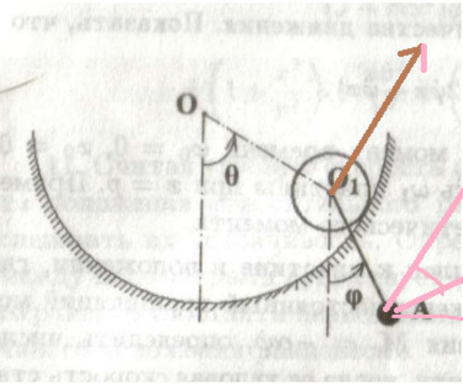

**Текст программы:**

import numpy as np

import matplotlib.pyplot as plt

import sympy as sp

from matplotlib.animation import FuncAnimation

import math

Steps = 1001

R_Ground = 6

R_Circle = R_Ground/6

l = R_Ground/2 # length of the palka between O1 and A

t = sp.Symbol('t')

thetta = sp.cos(10*t)

phi = sp.cos(16*t)

omega_phi = sp.diff(phi, t)

omega_thetta = sp.diff(thetta, t)

# Ground

alpha = np.linspace(-math.pi, 0, Steps)

X_Ground = R_Ground + R_Ground * np.cos(alpha)

Y_Ground = R_Ground + R_Ground * np.sin(alpha)

# Point O

X_O = R_Ground

Y_O = R_Ground

# circle

beta = np.linspace(0, 2*math.pi, Steps)

X_Circle = R_Circle * np.cos(beta)

Y_Circle = R_Circle * np.sin(beta)

# Point O1

X_O1 = -(R_Ground - R_Circle) * sp.sin(thetta) + R_Ground

Y_O1 = -(R_Ground - R_Circle) * sp.cos(thetta) + R_Ground

# point A

X_A = X_O1 + l*sp.sin(phi)

Y_A = Y_O1 - l*sp.cos(phi)

#constructing corresponding arrays

T = np.linspace(0, 10, Steps)

Thetta = np.zeros_like(T)

Phi = np.zeros_like(T)

Omega_phi = np.zeros_like(T)

Omega_thetta = np.zeros_like(T)

XO1 = np.zeros_like(T)

YO1 = np.zeros_like(T)

XA = np.zeros_like(T)

YA = np.zeros_like(T)

#filling arrays with corresponding values

for i in range(len(T)):

Thetta[i] = sp.Subs(thetta, t, T[i])

Phi[i] = sp.Subs(phi, t, T[i])

Omega_phi[i] = sp.Subs(omega_phi, t, T[i])

Omega_thetta[i] = sp.Subs(omega_thetta, t, T[i])

XO1[i] = sp.Subs(X_O1, t, T[i])

YO1[i] = sp.Subs(Y_O1, t, T[i])

XA[i] = sp.Subs(X_A, t, T[i])

YA[i] = sp.Subs(Y_A, t, T[i])

# graphs

fig_for_graphs = plt.figure(figsize=[13, 7])

ax_for_graphs = fig_for_graphs.add_subplot(2, 2, 1)

ax_for_graphs.plot(T, Phi, color='blue')

ax_for_graphs.set_title("Phi(t)")

ax_for_graphs.set(xlim=[0, 10])

ax_for_graphs.grid(True)

ax_for_graphs = fig_for_graphs.add_subplot(2, 2, 2)

ax_for_graphs.plot(T, Thetta, color='red')

ax_for_graphs.set_title('Thetta(t)')

ax_for_graphs.set(xlim=[0, 10])

ax_for_graphs.grid(True)

ax_for_graphs = fig_for_graphs.add_subplot(2,2,3)

ax_for_graphs.plot(T, Omega_phi, color='green')

ax_for_graphs.set_title("phi'(t) = omega_phi(t)")

ax_for_graphs.set(xlim=[0, 10])

ax_for_graphs.grid(True)

ax_for_graphs = fig_for_graphs.add_subplot(2, 2, 4)

ax_for_graphs.plot(T, Omega_thetta, color='black')

ax_for_graphs.set_title("thetta'(t) = omega_thetta(t)")

ax_for_graphs.set(xlim=[0, 10])

ax_for_graphs.grid(True)

# some settings

fig = plt.figure()

ax = fig.add_subplot(1,1,1)

ax.axis("equal")

ax.set(xlim=(0, 12), ylim=(0, 12))

# plot first zero state

Ground = ax.plot(X_Ground, Y_Ground, color='black', linewidth=2)

Point_O = ax.plot(X_O, Y_O, color='red', linewidth=4)

Draw_palka = ax.plot([X_O, XO1[0]], [Y_O, YO1[0]], 'r--')[0]

Draw_Circle = ax.plot(X_Circle + XO1[0], Y_Circle + YO1[0], color='blue', linewidth=1)[0]

Draw_point_O1 = ax.plot(XO1[0], YO1[0], color='blue', linewidth=3, marker='o')[0]

Draw_point_A = ax.plot(XA[0], YA[0], 'r', marker='o', markersize=15)[0]

Draw_palka_O1_A = ax.plot([XO1[0], XA[0]], [YO1[0], YA[0]], 'b')[0]

# function for updating state of the system

def kinoteatr_five_zvezd_na_novokuzneckoy(i):

Draw_point_O1.set_data(XO1[i], YO1[i])

Draw_Circle.set_data(X_Circle + XO1[i], Y_Circle + YO1[i])

Draw_palka.set_data([X_O, XO1[i]], [Y_O, YO1[i]])

Draw_point_A.set_data(XA[i], YA[i])

Draw_palka_O1_A.set_data([XO1[i], XA[i]], [YO1[i], YA[i]])

return [Draw_point_O1, Draw_Circle, Draw_palka, Draw_point_A]

anime = FuncAnimation(fig, kinoteatr_five_zvezd_na_novokuzneckoy,

frames=Steps, interval=1)

# show figure

plt.show()

# anime.save("cringe.gif")

**Результат работы:**

|  |
| --- |
|  |
|  |

