

Foundations of Programming
Assignment No. : 13

PROBLEM STATEMENT:
Write a program in C to accept a number from the user and print the digits of the number in reverse order.

OBJECTIVE:
• To understand number manipulation using loops
. • To learn the use of modulo (%) and division (/) operators.
• To implement logic for reversing digits of a number.
• To improve problem-solving skills using iterative structures.

THEORY:
• To understand number manipulation using loops. • To learn the use of modulo (%) and division (/) operators. • To implement logic for reversing digits of a number. • To improve problem-solving skills using iterative structures.

PLATFORM:
Linux

ALGORITHM:

C PROGRAM:
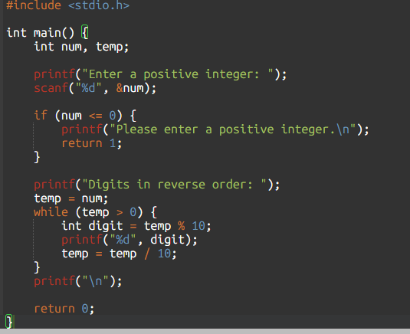

INPUT:
INPUT:
The user enters an integer number.
Example Input: Number: 4567

Paste Screen Shot of Input

OUTPUT:
The program prints the digits of the number in reverse order.
Example Output: Digits in reverse order: 7 6 5 4
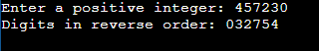
Paste Screen Shot of Output

CONCLUSION:
Thus, the program to print the digits of a number in reverse order was successfully implemented using C programming. The program demonstrates the effective use of loops, modulo operator, and division operator.

FAQs:
- Why is the modulo operator (%) used in this program?
- Why is division by 10 used after extracting each digit?
- What happens if the input number is zero?
- How will the program behave for negative numbers?
- Why is a while loop preferred for this operation?

