

Foundations of Programming

Assignment No.: 18
PROBLEM STATEMENT: Write a C program that accepts a string from the user and performs the following string operations: i) Calculate length of string ii) String reversal iii) Equality check of two strings iv) Check palindrome v) Check substring.

OBJECTIVE:

- To understand basic string operations in C.
- To learn how to manipulate strings using loops and functions.
- To perform comparison, reversal, and substring checking.
- To check whether a string is a palindrome.

THEORY:
In C programming, a string is a sequence of characters terminated by a null character ('\0'). Strings are commonly stored in character arrays. Various operations can be performed on strings such as calculating their length, reversing the characters, comparing two strings, checking whether a string is a palindrome, and finding a substring within another string. These operations can be implemented using loops and conditional statements or by using standard library functions from the string.h header file.
PLATFORM: Linux

INPUT: A string and another string for comparison and substring checking.
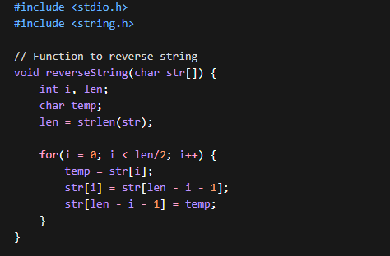

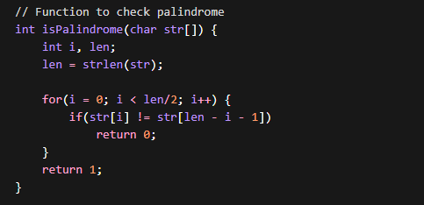
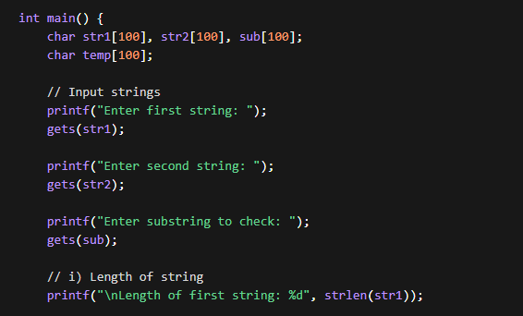
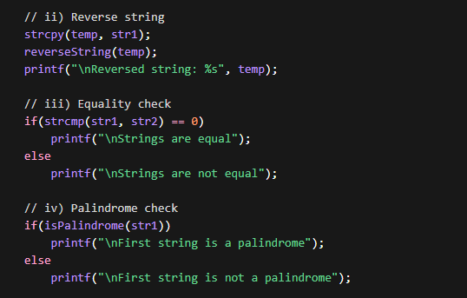
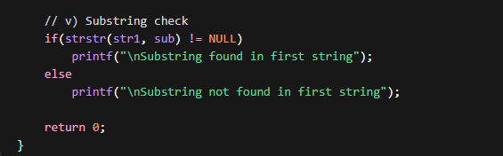

OUTPUT: Displays string length, reversed string, equality result, palindrome result, and substring check result.
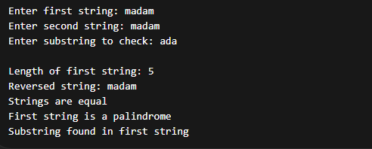

SAMPLE INPUT:

Enter a string: madam
Enter another string for equality check: mad
SAMPLE OUTPUT:
Length of string = 5
Reversed string = madam
The string is a Palindrome
Strings are not equal
Substring found in main string

CONCLUSION: Thus, the C program successfully performs different string operations such as length calculation, reversal, equality check, palindrome check, and substring detection.

FAQs:
- What is a string in C programming?
- Which header file is required for string functions?
- What function is used to find the length of a string?
- What is a palindrome string?
- Which function is used to check a substring in C?

