SPARQL QUERY PROCESSOR

Introduction:-

- SPARQL (SPARQL Protocol and RDF Query Language) is an RDF query language.

- RDF is a flexible and extensible way to represent information about World Wide Web resources.

- SPARQL allows for a query to consist of triple patterns, conjunctions, disjunctions, and optional patterns.

- The task of SPARQL Query Processor is to retrieve information from a RDF data stores according to a set of retrieval criteria but the RDF database itself remaining unchanged.

Functional Description: -

Query Execution Process is undertaken through following tasks:
    - A Query is logically broken in several parts :

  - Clause
  - Identifiers to be displayed
  - Source File name
  - Criteria Clause(if applicable)
  - Criteria Value(if applicable)

    - RDF Source File is read on the basis on Source File name.

    - RDF File is converted to simplified accessible model through JENA API1.
    - To access all the statements for a given resource from the converted model, we need to access the resource and specify the property.

    - By traversing the list of statements, the subject is accessed along with their namespace and local name, followed by the predicate and finally the object.

    - Now the query is parsed. To extract the desired output entire data store is traversed by an iterator and all the tuples who are matching the criteria and extracted from the database and is displayed to the user.

1] Jena is a Java framework for building Semantic Web applications.

Use Case Description: -

- Input Query by user

- Break Query

- Convert RDF Source File to Simplified Model

- Parse Query

- Match the given criteria along with the respective criteria value by iterating entire source document.

- All the tuples who fulfill the criteria are extracted and displayed to the user in the predefined format.

Class Diagram: -

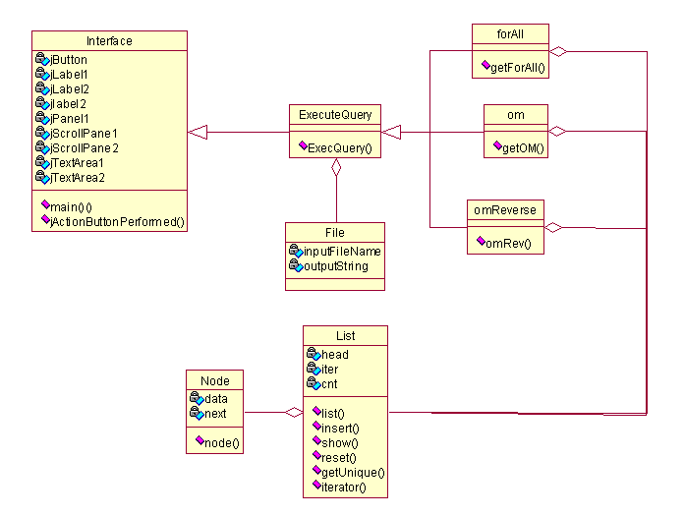

Sequence Diagram: -

