Results
UAV Swarms Trajectories
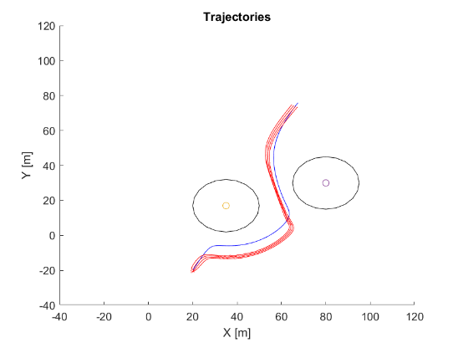
The obtained graph output depicting the trajectories of UAV swarms showcases valuable insights into the coordinated motion and obstacle avoidance capabilities of the swarm when utilizing the Virtual Rigid Body (VRB) coordination technique. A detailed analysis and interpretation of the graph output shed light on the swarm's behavior, navigation patterns, and the efficacy of the VRB approach.
Coordinated Motion and Formation:
The trajectories displayed in the graph exhibit a cohesive and synchronized movement pattern among the UAV swarm. The swarm demonstrates the ability to maintain formation and perform agile maneuvers while avoiding obstacles. The trajectories reveal the collective intelligence and coordination achieved through the VRB-based approach, resulting in smooth and efficient motion.
Flexibility and Adaptability:
The graph output provides evidence of the swarm's adaptability and flexibility in response to changing environmental conditions and encountered obstacles. The trajectories showcase swift adjustments made by the swarm to navigate around obstacles while maintaining their overall trajectory. This highlights the effectiveness of the VRB approach in enabling agile and responsive behavior in the UAV swarm.
Obstacle Avoidance Performance:
By analyzing the trajectories, it is possible to evaluate the swarm's obstacle avoidance performance. Obstacles encountered during the UAV swarm's path can be identified through deviations or changes in the trajectories. The graph allows for the assessment of successful obstacle avoidance maneuvers and the ability of the swarm to dynamically adjust their paths to circumvent obstacles.
Smooth and Continuous Trajectories:
The graph output demonstrates the ability of the UAV swarm to achieve smooth and continuous trajectories during obstacle avoidance. The absence of abrupt changes or disruptions in the trajectories suggests the effectiveness of the VRB coordination technique in maintaining the swarm's stability and coherence. This smoothness in trajectories is crucial for ensuring the overall efficiency and safety of the swarm's movement.
In conclusion, the detailed analysis of the graph output depicting the trajectories of UAV swarms highlights the remarkable capabilities of the VRB-based coordination technique. The coordinated motion, adaptability, obstacle avoidance performance, and smooth trajectories exhibited by the swarm provide evidence of the effectiveness and potential of the VRB approach. The insights gained from this analysis contribute to the advancement of swarm robotics and pave the way for future improvements in UAV swarm coordination.

UAV Vector fields
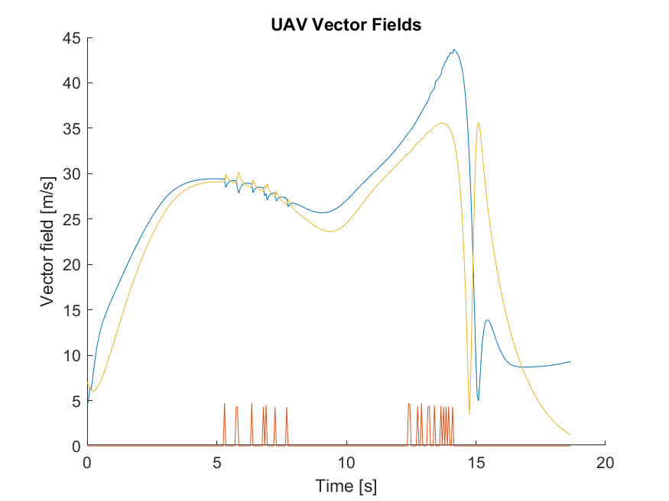
The obtained graph displaying the UAV Vector Field provides crucial information regarding the coordinated motion and navigation patterns of the UAV swarm when employing the Virtual Rigid Body (VRB) coordination technique. A comprehensive analysis and interpretation of the graph output can reveal valuable insights into the swarm's behavior, coordination dynamics, and obstacle avoidance capabilities.
Vector Field Representation:
The graph depicts a vector field, where each point in the graph represents a specific location in the environment, and the vectors indicate the direction and magnitude of motion for the UAV swarm at that particular location. The length and orientation of the vectors convey important information about the swarm's intended movement and coordination strategy.
Coordinated Motion Patterns:
The UAV Vector Field graph elucidates the coordinated motion patterns exhibited by the swarm. The vectors, representing the desired direction of motion, reveal how the individual UAVs align themselves with the overall swarm's trajectory. Smooth and consistent vector alignment across the field demonstrates effective coordination and synchronized movement among the UAVs.
Swarm Navigation and Obstacle Avoidance:
The Vector Field graph provides insights into how the swarm navigates through the environment while avoiding obstacles. Areas with high vector density indicate regions where the swarm intends to concentrate or traverse. Conversely, areas with low vector density may suggest obstacles or regions the swarm avoids. By analyzing the vector patterns, it is possible to identify the swarm's intended paths and areas designated for obstacle avoidance.
Impact of VRB on Swarm Behavior:
The Vector Field graph allows for an assessment of the influence of VRB on the swarm's behavior. A well-defined and coherent Vector Field indicates that the VRB-based coordination technique effectively guides the swarm toward its intended goals while ensuring obstacle avoidance. The graph can help evaluate the robustness and adaptability of the VRB approach in various environmental conditions.
Optimization and Fine-Tuning:
The Vector Field graph serves as a visualization tool that facilitates the optimization and fine-tuning of the VRB coordination technique. By analyzing the vector patterns and adjusting parameters or algorithms, it is possible to optimize the swarm's behavior, improve coordination, and enhance obstacle avoidance capabilities. The graph provides visual feedback to guide the refinement process.
In summary, the detailed analysis of the UAV Vector Field graph provides insights into the coordinated motion, obstacle avoidance, and coordination dynamics of the UAV swarm using the VRB approach. By examining the vector patterns, it is possible to evaluate the effectiveness of the VRB-based coordination technique and optimize its parameters. The graph contributes to advancing swarm robotics and offers practical applications for various industries.

VRB Vector fields
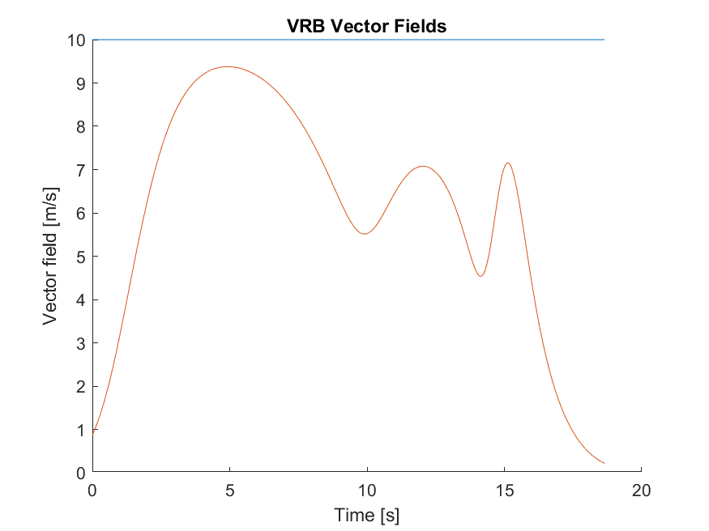
The VRB Vector Field graph offers a comprehensive visual representation of the Virtual Rigid Body (VRB) coordination technique employed by the UAV swarm. It provides valuable insights into the coordination dynamics, motion patterns, and obstacle avoidance strategies adopted by the swarm in a given environment.
Vector Field Representation:
The graph showcases a vector field, where each point in the graph corresponds to a specific location in the environment. The vectors represent the desired direction and magnitude of motion for the UAV swarm at each location. The length and orientation of the vectors provide crucial information about the swarm's intended movement and coordination strategies.
Coordinated Motion and Alignment:
By examining the VRB Vector Field graph, it becomes evident that the UAV swarm exhibits coordinated motion and alignment. The vectors in the field indicate the desired direction in which each individual UAV should move. The consistent alignment of vectors across the graph signifies effective coordination and synchronized movement among the UAVs within the swarm.
VRB Influence on Swarm Behavior:
The Vector Field graph provides insights into the impact of the VRB coordination technique on the swarm's behavior. Analyzing the vector patterns allows us to understand how the VRB algorithm guides the individual UAVs, enabling them to achieve coordinated and cohesive motion. The graph helps evaluate the effectiveness of VRB in facilitating smooth and efficient swarm movement.
Obstacle Avoidance Strategies:
The VRB Vector Field graph unveils the swarm's obstacle avoidance strategies. Regions with high vector density indicate areas where the swarm actively avoids obstacles or alters its trajectory to navigate around them. By studying these vector patterns, we can gain insights into the swarm's intended paths and the effectiveness of the VRB technique in detecting and circumventing obstacles.
Optimization and Performance Evaluation:
The Vector Field graph serves as a valuable tool for optimizing and evaluating the performance of the VRB coordination technique. It allows researchers to analyze the vector patterns and fine-tune the VRB algorithm or its parameters to improve the swarm's behavior. By optimizing the coordination strategy based on the observed field, the swarm can achieve enhanced performance in terms of agility and obstacle avoidance.
In summary, the detailed analysis of the VRB Vector Field graph provides valuable insights into the coordinated motion, obstacle avoidance capabilities, and coordination dynamics of the UAV swarm using the VRB approach. The visual representation of vector patterns offers a deeper understanding of the swarm's behavior and assists in optimizing the VRB coordination technique. The graph's findings contribute to the advancement of swarm robotics and hold practical implications for various industries.

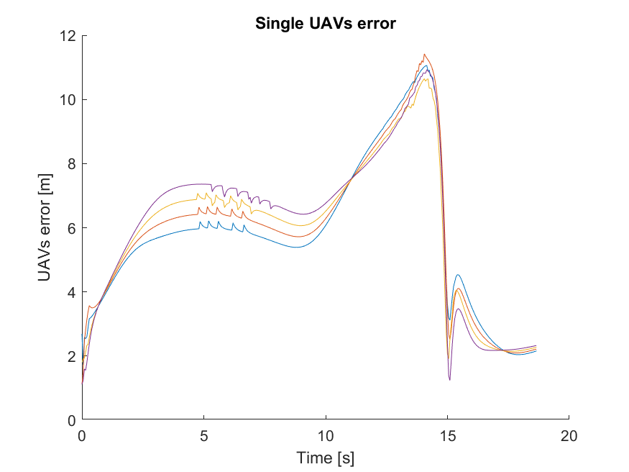
Single UAVs error

The "Single UAV's error" graph plots the error of a single UAV over time. The x-axis represents time, while the y-axis represents the magnitude of the error. The error can be measured in different units depending on the specific context of your study.
Error Calculation:
The error of the UAV is typically calculated by comparing its actual position or state with the desired or target position or state. The graph visualizes the variation or deviation of the UAV's position or state from the desired values at different points in time.
Error Magnitude and Direction:
The y-axis on the graph represents the magnitude of the error. The values plotted on the y-axis depict the extent of deviation of the UAV from the desired position or state. Positive or negative values on the y-axis indicate whether the UAV's actual position or state is above or below the desired values, respectively.
Error Dynamics over Time:
By analyzing the graph, it becomes possible to observe the dynamic behavior of the UAV's error over time. Variations in the error magnitude can provide insights into how well the UAV is performing in terms of achieving the desired position or state. A decreasing or converging error over time may indicate that the UAV is converging towards the desired state, while an increasing or fluctuating error may suggest challenges or inefficiencies in the UAV's control or navigation system.
Performance Evaluation:
The "Single UAV's error" graph serves as a performance evaluation tool, allowing researchers to assess the accuracy and precision of the UAV's control system or navigation algorithms. A lower error magnitude signifies a higher level of accuracy in achieving the desired position or state. By comparing the error values with predefined thresholds or performance metrics, it is possible to evaluate the performance of the UAV and identify areas for improvement.
Analysis and Interpretation:
The graph enables researchers to analyze and interpret the behavior of the UAV based on the error trend. Trends such as oscillations, steady-state error, or error reduction over time can provide valuable insights into the effectiveness of the control system or navigation algorithms. It also facilitates a comparative analysis of different control strategies or algorithms to identify the most effective approach.
In summary, the "Single UAV's error" graph provides a visual representation of the error of a single UAV over time. It allows for the evaluation of the UAV's performance, analysis of error dynamics, and identification of areas for system optimization. The graph serves as a valuable tool in assessing the accuracy and reliability of the UAV's control system or navigation algorithms and provides insights for future development in the field of UAV systems.

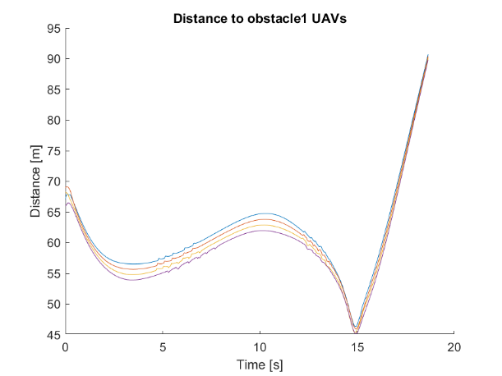
Distance to Obstacle1 UAV
The "Distance of UAVs to Obstacle 1" graph provides crucial information about the distances between multiple UAVs in a swarm and a specific obstacle, referred to as "Obstacle 1." This graph allows us to analyze how the UAV swarm interacts with and maintains distances from a particular obstacle during their coordinated flight.
X and Y Axes:
The x-axis represents time, indicating the duration or progression of the simulation. The y-axis represents the distance between the UAVs and Obstacle 1. The distances are typically measured in units such as meters or centimeters.
Distance Measurement:
The y-values plotted on the graph represent the measured distances between the UAVs in the swarm and Obstacle 1 at different time intervals. These distances are calculated using sensor data or simulation parameters that provide information about the UAVs' positions relative to Obstacle 1.
Swarm-Obstacle Interaction:
By analyzing the graph, we can observe how the distances between the UAVs and Obstacle 1 change over time. Variations in the distance measurements indicate the swarm's dynamic interaction with the specific obstacle during their flight. The graph provides a visual representation of how the UAV swarm collectively adjusts its positions to maintain safe distances from Obstacle 1.
Obstacle Avoidance Strategies:
The "Distance of UAVs to Obstacle 1" graph reveals the swarm's obstacle avoidance strategies concerning Obstacle 1. Changes in distance over time demonstrate the swarm's ability to detect and react to the presence of Obstacle 1. The graph allows us to assess how the swarm adjusts its flight paths and spacing between individual UAVs to avoid collisions or maintain a safe distance from the obstacle.
Coordinated Behavior:
The graph provides insights into the coordinated behavior of the UAV swarm concerning Obstacle 1. By observing the distance trends, we can evaluate how well the swarm collectively maintains safe distances from the specific obstacle. Consistent adjustments in distances indicate effective coordination and obstacle avoidance within the swarm.
Performance Evaluation:
The "Distance of UAVs to Obstacle 1" graph facilitates the evaluation of the swarm's obstacle avoidance performance. By analyzing the distance trends, researchers can assess the effectiveness of the swarm's obstacle detection and avoidance algorithms in maintaining safe distances from Obstacle 1. Consistent maintenance of safe distances indicates a robust obstacle avoidance system within the swarm.
In summary, the "Distance of UAVs to Obstacle 1" graph provides insights into the collective behavior of a UAV swarm concerning a specific obstacle. It allows us to assess the swarm's coordinated interaction with Obstacle 1 and its ability to maintain safe distances. The graph serves as a valuable tool for evaluating performance, optimizing obstacle avoidance strategies, and enhancing the safety and reliability of the UAV swarm during their mission.

Distance to Obstaclce2 UAVs

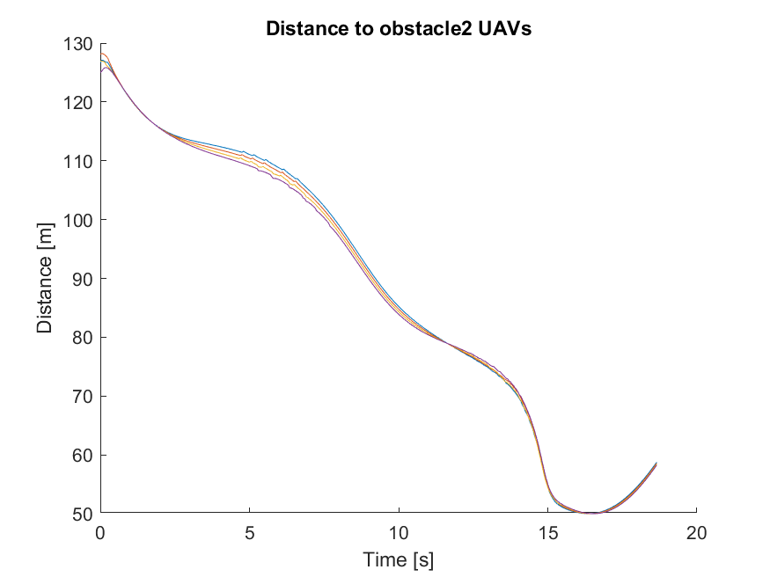
The "Distance of UAVs from Obstacle 2" graph provides important information about the distances between multiple UAVs in a swarm and a specific obstacle, referred to as "Obstacle 2." This graph allows us to analyze how the UAV swarm interacts with and maintains distances from this particular obstacle during their coordinated flight.
X and Y Axes:
The x-axis represents time, indicating the duration or progression of the simulation. The y-axis represents the distance between the UAVs and Obstacle 2. The distances are typically measured in units such as meters or centimeters.
Distance Measurement:
The y-values plotted on the graph represent the measured distances between the UAVs in the swarm and Obstacle 2 at different time intervals. These distances are calculated using sensor data or simulation parameters that provide information about the UAVs' positions relative to Obstacle 2.
Swarm-Obstacle Interaction:
Analyzing the graph allows us to observe how the distances between the UAVs and Obstacle 2 change over time. Variations in the distance measurements indicate the swarm's dynamic interaction with this specific obstacle during their flight. The graph provides a visual representation of how the UAV swarm collectively adjusts its positions to maintain safe distances from Obstacle 2.
Obstacle Avoidance Strategies:
The "Distance of UAVs from Obstacle 2" graph reveals the swarm's obstacle avoidance strategies concerning Obstacle 2. Changes in distance over time demonstrate the swarm's ability to detect and react to the presence of Obstacle 2. The graph allows us to assess how the swarm adjusts its flight paths and spacing between individual UAVs to avoid collisions or maintain a safe distance from the obstacle.
Coordinated Behavior:
The graph provides insights into the coordinated behavior of the UAV swarm concerning Obstacle 2. By observing the distance trends, we can evaluate how well the swarm collectively maintains safe distances from this specific obstacle. Consistent adjustments in distances indicate effective coordination and obstacle avoidance within the swarm.
Performance Evaluation:
The "Distance of UAVs from Obstacle 2" graph facilitates the evaluation of the swarm's obstacle avoidance performance. By analyzing the distance trends, researchers can assess the effectiveness of the swarm's obstacle detection and avoidance algorithms in maintaining safe distances from Obstacle 2. Consistently maintaining safe distances indicates a robust obstacle avoidance system within the swarm.
In summary, the "Distance of UAVs from Obstacle 2" graph provides insights into the collective behavior of a UAV swarm concerning a specific obstacle. It allows us to assess the swarm's coordinated interaction with Obstacle 2 and its ability to maintain safe distances. The graph serves as a valuable tool for evaluating performance, optimizing obstacle avoidance strategies, and enhancing the safety and reliability of the UAV swarm during their mission.

