**Lab program- Week 4**

**Perform the following DB operations using Cassandra.**

**1.Create a keyspace by name Employee**

create keyspace Employee with replication = {'class':'SimpleStrategy', 'replication_factor':1};

use Employee;

**2. Create a column family by name Employee-Info with attributes, Emp_Id Primary Key, Emp_Name, Designation, Date_of_Joining, Salary, Dept_Name**

create table EmployeeInfo(Emp_Id int primary key, Emp_Name text, Designation text, Date_of_Joining timestamp, Salary double, Dept_Name text);

**3. Insert the values into the table in batch**

begin batch

... insert into employeeinfo (emp_id, date_of_joining, dept_name, designation, emp_name, salary)

... values (121, '2024-03-25', 'KSC', 'Intern', 'Anoshor', 0)

... insert into employeeinfo (emp_id, date_of_joining, dept_name, designation, emp_name, salary)

... values (122, '2024-06-01', 'KSC', 'Intern', 'Rahul', 35000)

... apply batch;

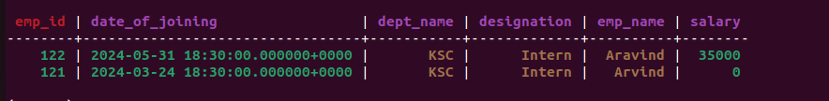

**4. Update Employee name and Department of Emp-Id 121**

update employeeinfo set emp_name='Blu is me', dept_name='Security' where emp_id=121;

