**WEEK-1**

I. Perform the following DB operations using MongoDB.

1. Create a database “Student” with the following attributes Rollno, Age, ContactNo, Email-

Id.

**ANS-db.createCollection("Student");**

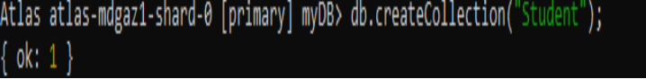

2. Insert appropriate values

**ANS-db.Student.insert({RollNo:1,Age:21,Cont:9876,email:"antara.de9@gmail.com"});**

**db.Student.insert({RollNo:2,Age:22,Cont:9976,email:"anushka.de9@gmail.com"});**

**db.Student.insert({RollNo:3,Age:21,Cont:5576,email:"anubhav.de9@gmail.com"});**

**db.Student.insert({RollNo:4,Age:20,Cont:4476,email:"pani.de9@gmail.com"});**

**db.Student.insert({RollNo:10,Age:23,Cont:2276,email:"**[**rekha.de9@gmail.com**](mailto:rekha.de9@gmail.com)**"});**

**db.Student.find()**

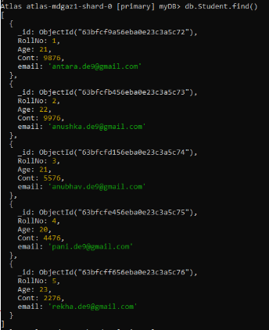

3. Write query to update Email-Id of a student with rollno 10.

**ANS-db.Student.update({RollNo:10},{$set:{email:"**[**Abhinav@gmail.com**](mailto:Abhinav@gmail.com)**"}})**

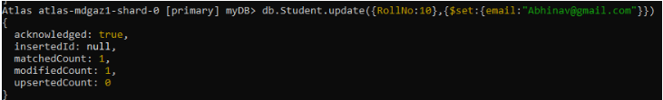

4. . Replace the student name from “ABC” to “FEM” of rollno 11

**ANS-db.Student.insert({RollNo:11,Age:22,Name:**

**"ABC",Cont:2276,email:"**[**rea.de9@gmail.com**](mailto:rea.de9@gmail.com)**"});**

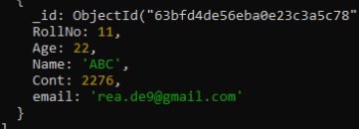

**db.Student.update({RollNo:11,Name:"ABC"},{$set:{Name:"FEM"}})**

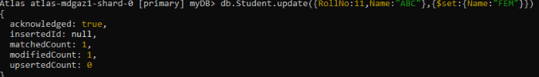

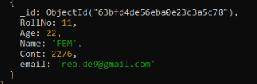

5. Display Student Name and grade(Add if grade is not present)where the _id column is 1.

**db.students.aggregate([**

**{ $match: { _id: 1 } },**

**{ $project: { Name: 1, grade: { $ifNull: ["$grade", "A"] } } }**

**])**

6. Update to add hobbies

**db.students.updateMany(**

**{},**

**{ $set: { hobbies: ["Reading", "Swimming"] } }**

**)**

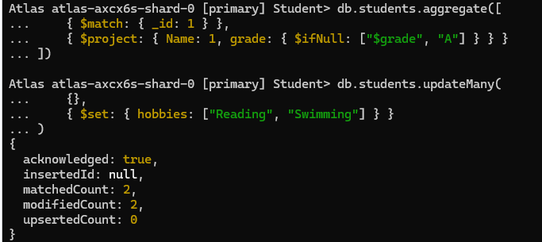

7. Find documents where hobbies is set neither to Chess nor to Skating

**db.students.find({ hobbies: { $nin: ["Chess", "Skating"] } })**

8.Find documents whose name begins with A

**db.students.find({ Name: /^A/ })**

II. Perform the following DB operations using MongoDB.

1. Create a collection by name Customers with the following attributes.

Cust_id, Acc_Bal, Acc_Type

**ANS-1.db.createCollection(“Customer”);**

2. Insert at least 5 values into the table

**ANS-2.db.Customers.insert({Cust_id:1,Acc_Bal:2000,Acc_Type:"Savings"});**

**db.Cusotmers.insert({Cust_id:2,Acc_Bal:3000,Acc_Type:"Savings"});**

**db.Customers.insert({Cust_id:3,Acc_Bal:1500,Acc_Type:"Savings"});**

**db.Customers.insert({Cust_id:4,Acc_Bal:1000,Acc_Type:"Current"});**

**db.Customers.insert({Cust_id:5,Acc_Bal:2000,Acc_Type:"Current"});**

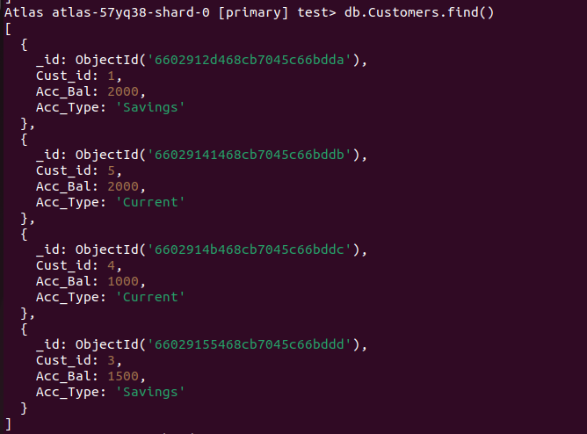

3. Write a query to display those records whose total account balance is greater than

1200 of account type ‘Z’ for each customer_id.

**ANS-3. db.Customers.find({**

**Acc_Bal: { $gt: 1200 },**

**Acc_Type: "Current"**

**})**

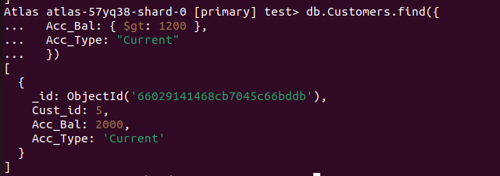

4. Determine Minimum and Maximum account balance for each customer_i

**ANS-4 db.Customers.aggregate([ { $group: { _id: "$Cust_id", min_balance: { $min: "$Acc_Bal" }, max_balance: { $max: "$Acc_Bal" } } }] )**

5. Sort the documents based on Customer ID in ascending order and Account Balance in descending order

**db.Customers.aggregate([**

**{**

**$match: {**

**Acc_Type: "Current"**

**}**

**},**

**{**

**$group: {**

**_id: "$customer_id",**

**min_balance: { $min: "$Acc_Bal" },**

**max_balance: { $max: "$Acc_Bal" }**

**}**

**},**

**{**

**$sort: {**

**"_id": 1,**

**"max_balance": -1**

**}**

**}**

**])**



6.Display only 2nd and 3rd records from the collection

**db.Customers.find().skip(1).limit(2)**

