**WEEK-2**

Perform the following DB operations using MongoDB

Create a collection by the name **blogPosts**and it has **3 fields id, title and comments**.

In the collection the **comments**field is an array which consists of user details. Each collection consists of two user details inside the **comments array**- user name and text

db.createCollection("blogPosts")

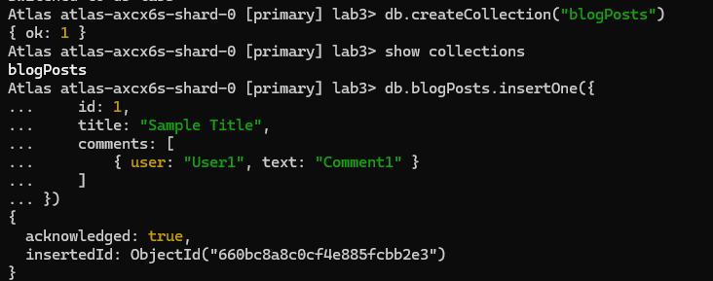

Demonstrate the following

1. Adding an element into array

**db.blogPosts.insertOne({**

**id: 1,**

**title: "Sample Title",**

**comments: [**

**{ user: "User1", text: "Comment1" }**

**]**

**})**

**(Similarly, Insert 4 ids)**

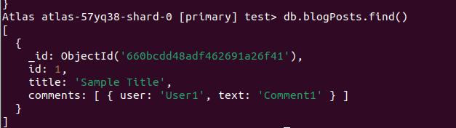

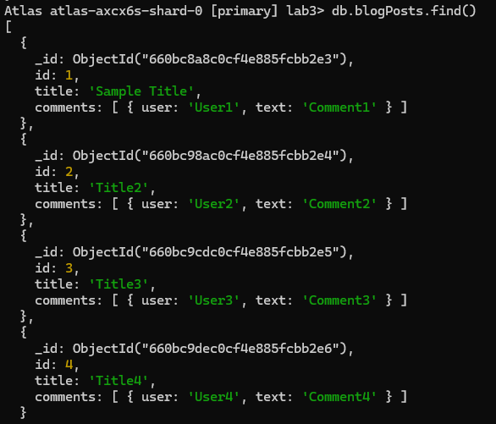

1. Display second element

**db.blogPosts.find().skip(1).limit(1)**

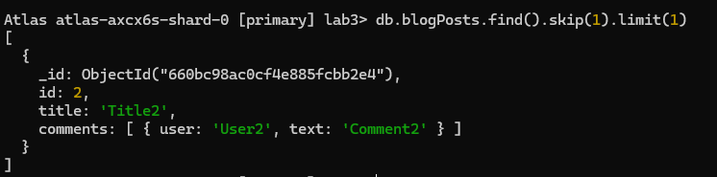

1. Display size of the array

**db.blogPosts.aggregate([**

**{ $project: { commentsCount: { $size: "$comments" } } }**

**])**

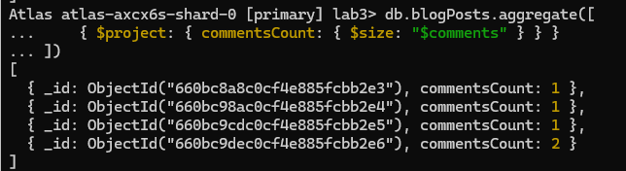

1. Display first two elements of the array

**db.blogPosts.aggregate([**

**{ $project: { firstTwoComments: { $slice: ["$comments", 2] } } }**

**])**

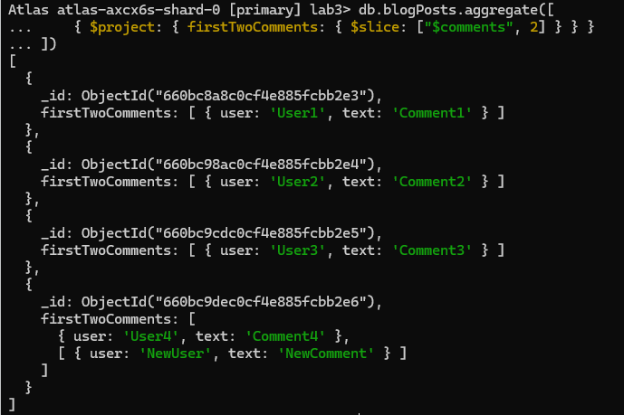

1. Update the document with id 4 and replace the element present in 1st index position of the array with another array

**db.blogPosts.updateOne(**

**{ id: 4 },**

**{ $set: { "comments.1": [{ user: "NewUser", text: "NewComment" }] } }**

**)**

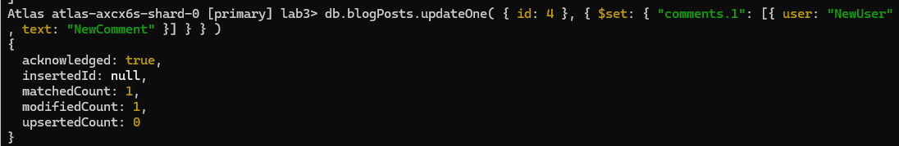

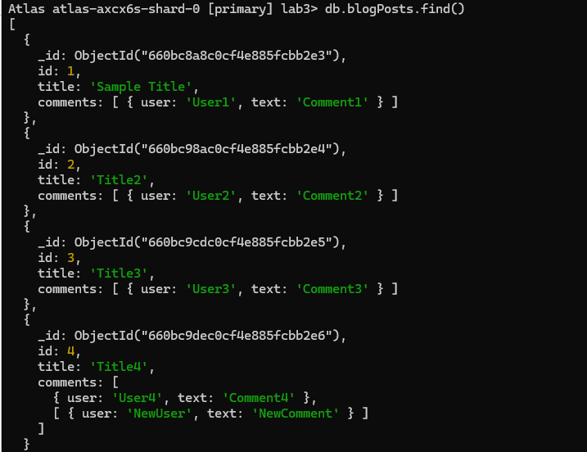

**Cassandra basics**

[Learn Cassandra Tutorial - javatpoint](https://www.javatpoint.com/cassandra-tutorial)

1. Execute the following

**Create KeySpace :**

CREATE KEYSPACE Students WITH REPLICATION = {'class':'SimpleStrategy','replication_factor':1};

**Describe the existing Keyspaces:**

DESCRIBE KEYSPACES;

**For More details on existing keyspaces:**

SELECT * FROM system.schema_keyspaces;

**use the keyspace “Students”:**

USE Students;

**To create table (column family) by name Student_Info:**

CREATE TABLE Students_Info (Roll_No int PRIMARY KEY, StudName text, DateOfJoining timestamp, last_exam_Percent double);

**Lookup the names of all tables in the current keyspaces**

DESCRIBE TABLES;

**Describe the table information**

DESCRIBE TABLE <Table_Name>;

**CRUD**

**Insert :**

BEGIN BATCH

INSERT INTO Students_Info(Roll_No, StudName, DateOfJoining, last_exam_Percent)

VALUES (1,'Asha','2012-03-12',79.9)

INSERT INTO Students_Info(Roll_No, StudName, DateOfJoining, last_exam_Percent)

VALUES (1,'Krian','2012-03-12',89.9)

INSERT INTO Students_Info(Roll_No, StudName, DateOfJoining, last_exam_Percent)

VALUES (1,'Tarun','2012-03-12',78.9)

INSERT INTO Students_Info(Roll_No, StudName, DateOfJoining, last_exam_Percent)

VALUES (1,'Samrth','2012-03-12',90.9)

INSERT INTO Students_Info(Roll_No, StudName, DateOfJoining, last_exam_Percent)

VALUES (1,'Smitha','2012-03-12',67.9)

INSERT INTO Students_Info(Roll_No, StudName, DateOfJoining, last_exam_Percent)

VALUES (1,'Rohan','2012-03-12',56.9)

APPLY BATCH;

**View data from the table “Students_Info”**

SELECT * FROM Students_Info;

**View data from the table “Students_Info” where RoolNo column either has a value 1 or 2 or 3**

SELECT * FROM Students_Info WHERE Roll_No IN (1,2,3);

**To execute a non primary key - will throw an error**

select * from students_info where Studname= 'Asha';

**So create an INDEX on the Column as below:**

**To create an INDEX on StudName Column of the Students_Info column family**

CREATE INDEX ON Students_Info ( StudName);

**Now execute the query based on the INDEXED Column:**

select * from students_info where Studname= 'Asha';

**To specify the number of rows retured in the output**

select Roll_No, StudName from students_info LIMIT 2;

**Alias for Column:**

Select Roll_No as “USN” from Students_info;

**UPDATE**

UPDATE students_info SET StudName='David Sheen' WHERE RollNo=2;

Lets try to update the primary key

UPDATE students_info SET rollno=6 WHERE rollno=3;

DELETE

DELETE LastExamPercent FROM students_info WHERE RollNo=2;

Delete a Row

DELETE FROM student_info WHERE RollNo=2;