ShopNest Store
Power BI Capstone - Dashboard Report
Sales & Customer Insights Dashboard
Prepared by: Suraguru R
Date: 03/08/2026

1. Dashboard Overview
This report documents the ShopNest Sales & Customer Insights Dashboard, built in Power BI on a single page. The dashboard includes slicers for Year, Customer City, and Order Status, plus KPI cards for Average Product Rating (4.09), Total Orders (99K), and Total Revenue (16M), alongside visuals addressing all eight required analytical questions.
DASHBOARD SCREENSHOT
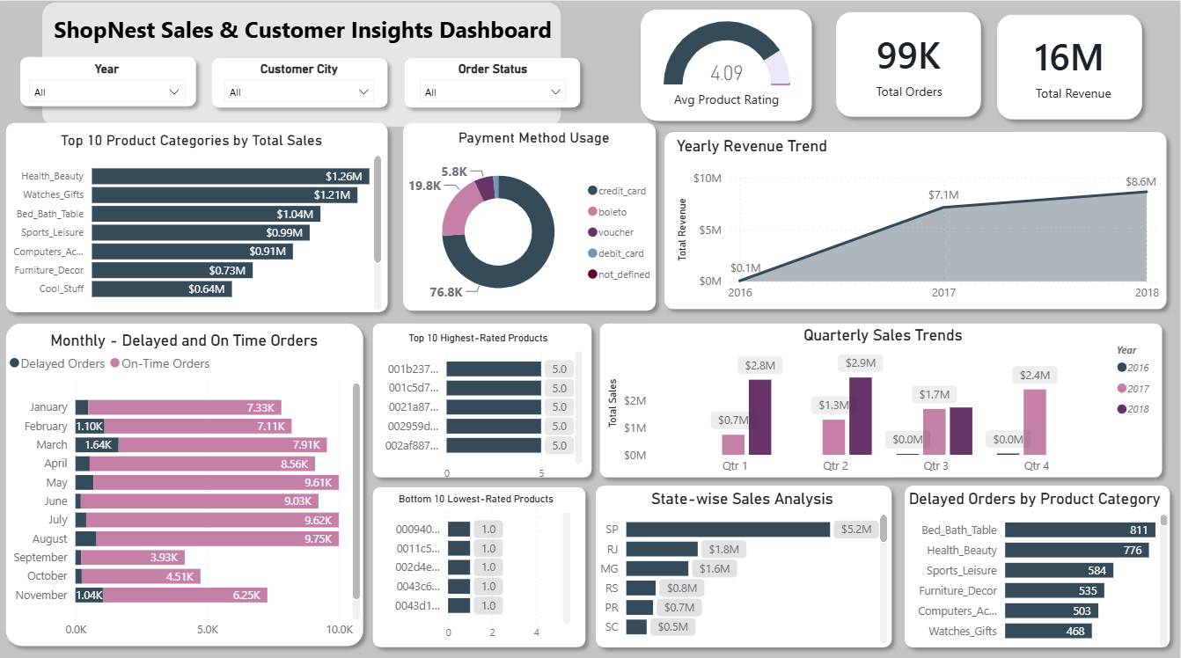

2. Data Notes
The source dataset does not include a product-name field; products are identified by a unique product_id. Where relevant (Question 5), large number of products are tied at the maximum (5.0) and minimum (1.0) rating, so the top/bottom 10 shown are representative samples of much larger tied groups rather than a strict Top-10 ranking.

3. Technical Notes
A star schema was used to model the data, with a central Fact_Orders / Fact_Order_items table connected to dimension tables including Dim_Customers, Dim_Products, Dim_Sellers, Dim_Geolocation, and Dim_Product_category_translation.
Standard one-to-many relationships were created between the fact and dimension tables to support filtering and aggregation across the dashboard.
The TREATAS() function was used in specific DAX measures, notably Average Product Rating, to apply a virtual relationship between Fact_Order_items and Fact_Order_reviews where no direct physical relationship existed (both tables relate to order_id but are not directly joined in the model). This ensures correct filter propagation from product and category level slicers through review scores, producing accurate rating figures instead of an unfiltered or incorrect average.

4. Analysis by Question

Question 1: Top Categories by Total Price
QUESTION STATEMENT
Identify and visually represent the top 10 product categories by total sales.
VISUALIZATION
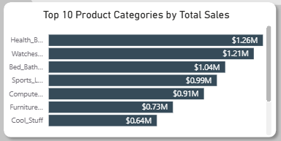

EXPLANATION
The Stacked bar chart presents the top 10 product categories based on total sales.
Health & Beauty is the top-selling category at $1,258,681, narrowly ahead of Watches & Gifts at $1,205,006 - a gap of about 4.4%.
Bed_Bath_Table ($1,036,989) and Sports_Leisure ($988,049) round out the top four, together with the top two accounting for roughly 30% of the combined top 10 total.
The top 10 categories range from Health_Beauty at the top down to Garden_Tools at $485,256 — the top category outsells the tenth by a factor of about 2.6x, showing sales are concentrated in a handful of categories rather than spread evenly.

Question 2: Delayed Orders Analysis
QUESTION STATEMENT
Determine the number of delayed orders in each category. An order is considered delayed if the actual delivery date is later than the estimated delivery date.
VISUALIZATION
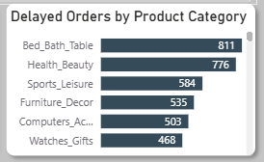

EXPLANATION
The clustered bar chart compares the number of delayed orders across different product categories.
Bed_Bath_Table has the most delayed orders overall (811), even though it ranks only third in total sales suggesting a fulfillment bottleneck specific to this category rather than simply higher order volume.
Health_Beauty (776) and Sports_Leisure (584) also see a disproportionate share of delays relative to categories with similar sales volume, such as Computers_Accessories (503 delays).
Delays drop off sharply outside the top categories: Garden_Tools (274) and Baby (258) see far fewer delays despite reasonable order volumes, pointing to inconsistent delivery performance rather than delays being purely volume driven.

Question 3: Monthly Comparison of Delayed and On-Time Orders
QUESTION STATEMENT
Create a dynamic visual that compares the number of delayed orders to the number of orders received earlier for each month. Utilize the drill-through cross-report feature to provide a detailed analysis of late and on-time deliveries.
VISUALIZATION
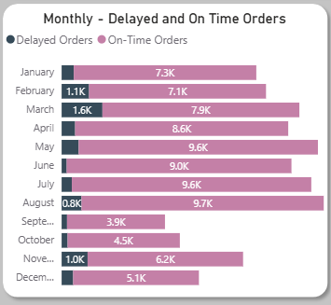

EXPLANATION
The Stacked bar chart compares monthly delayed and on-time orders.
March has by far the highest delayed-order count (1,638), followed by November (1,043)- the November spike likely aligns with Black Friday order surges outpacing logistics capacity.
June has the fewest delays (204) despite high on-time volume (9,027), making it the best-performing month for delivery reliability in the dataset.
On-time order volume climbs steadily from January through August, then drops sharply in September and October, this dip should be checked against the drill-through detail, as it may reflect incomplete data for those months rather than an actual demand drop.

Question 4: Payment Method Analysis
QUESTION STATEMENT
Analyze the most frequently used payment methods by customers using a visually appealing representation, such as a pie chart or other suitable visuals.
VISUALIZATION
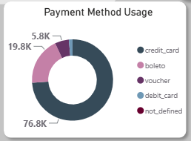

EXPLANATION
The Donut chart displays the distribution of customer payment methods.
Credit card is the dominant payment method, used in about 73.9% of transactions (76,795 of ~103,886 payment records), far ahead of any alternative.
Boleto (a Brazilian bank-slip payment method) is the clear second choice at 19.0% (19,784), reflecting its popularity as a card-free option in the Brazilian market this dataset is drawn from.
Voucher (5.6%) and debit card (1.5%) are minor contributors, and 'not defined' payments are negligible (3 records), credit card and boleto together cover roughly 93% of all payments.

Question 5: Product Rating Analysis
QUESTION STATEMENT
Determine the top 10 highest-rated products and the bottom 10 lowest-rated products using a bar or column chart.
VISUALIZATION
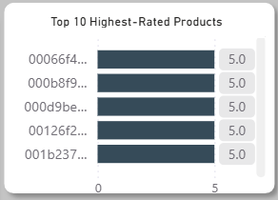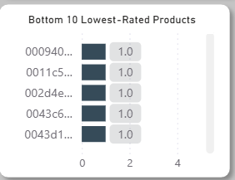

EXPLANATION
The Clustered bar charts compare the Top 10 highest-rated and Bottom 10 lowest-rated products based on average customer ratings.
The dataset does not include product names, products are identified only by product_id, so the chart labels IDs rather than descriptive names.
A large number of products are tied at the maximum rating of 5.0 (hundreds of products), so the 'top 10' is effectively a sample from a much larger tied group rather than 10 uniquely top-ranked products.
Similarly, the 'bottom 10' are tied at the minimum rating of 1.0 from an equally large group, with this many ties at both extremes, the ranking within the top/bottom 10 is arbitrary and the finding to report is the existence of large tied clusters at both ends, not a specific order among them.

Question 6: State-wise Sales Analysis
QUESTION STATEMENT
Identify and visually represent states with high and low sales, providing a clear understanding of regional sales performance.
VISUALIZATION
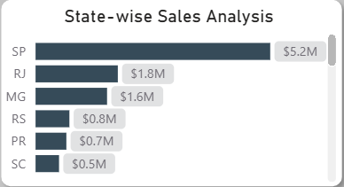

EXPLANATION
The Stacked bar chart compares total sales across customer states.
Sao Paulo (SP) dominates with $5,202,955 in sales, nearly 2.9x higher than the second-place state, Rio de Janeiro (RJ) at $1,824,093.
Minas Gerais (MG, $1,585,308) rounds out the top three; together SP, RJ, and MG account for a large majority of total state-level sales, reflecting Brazil's population and commercial concentration in its southeast region.
At the other end, Roraima (RR, $7,829), Amapá (AP, $13,474), and Acre (AC, $15,983) have the lowest sales, all northern states with much smaller populations, indicating regional demand (not just fewer sellers) is the likely driver.

Question 7: Seasonal Sales Patterns
QUESTION STATEMENT
Investigate and visualize any seasonal patterns (Quarterly) or trends in sales data over the course of the year.
VISUALIZATION
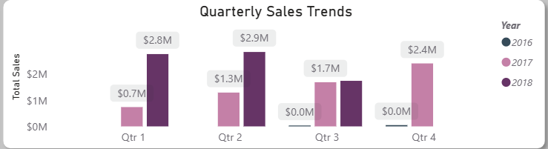

EXPLANATION
The Clustered column chart compares quarterly sales across different years.
2017 shows consistent quarter-over-quarter growth: Qtr1 ($741,960) → Qtr2 ($1,299,037) → Qtr3 ($1,696,405) → Qtr4 ($2,418,405), roughly tripling across the year.
2018 continues this growth into Qtr1 ($2,777,423) and Qtr2 ($2,858,290), the two highest quarters in the dataset, before Qtr3 drops to $1,750,339, this is most likely a data-coverage cutoff (the dataset ending mid-quarter) rather than a genuine seasonal decline.
2016 data is minimal (Qtr3: $267, Qtr4: $49,519), consistent with this being the marketplace's early launch period rather than a meaningful comparison point.

Question 8: Revenue Analysis
QUESTION STATEMENT
Determine the total revenue generated by ShopNest Store and analyze how it changes over time (Yearly). Represent this information through suitable visuals to highlight trends and patterns.
VISUALIZATION
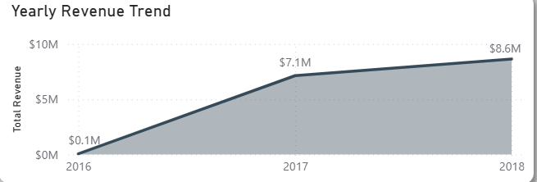

EXPLANATION
The Area chart illustrates the yearly revenue trend, showing how total revenue changes over time and highlighting overall business growth.
Total revenue across the full dataset is $15,843,553, built from 99,441 orders at an average product rating of 4.09.
Revenue grew from a negligible ~$49,786 in 2016 (launch period) to roughly $6.16M in 2017, and continued climbing to approximately $7.39M in the partial-year 2018 data reflecting strong year-over-year growth even before accounting for freight revenue.
The consistent upward trend from 2016 through the available 2018 data suggests the marketplace was in a healthy growth phase throughout the period covered by this dataset.

5. Summary of Key Insights
Health & Beauty leads all categories in sales ($1.26M), but Bed_Bath_Table has the worst delivery performance (811 delayed orders) despite ranking only third in sales.
March and November are the highest-risk months for delivery delays (1,638 and 1,043 delayed orders respectively), November likely tied to Black Friday demand spikes.
Credit cards dominate payments at 73.9%, with boleto a distant but meaningful second at 19.0%.
Sao Paulo (SP) alone generates more sales ($5.2M) than the next two states combined, reflecting Brazil's southeast commercial concentration.
Revenue grew consistently from the 2016 launch period through 2017 and into the available 2018 data, reaching a cumulative total of $15.84M across 99,441 orders.

