UNIVERSITY OF BARISHAL



Assignment

Course Title : Numerical Methods

Course Code : CSE-3107

Topic : Newton’s Forward Interpolation: Representation of Numerical Data by a Polynomial Curve

Submitted to

Md. Erfan

Assistant Professor,

Department of Computer Science and Engineering,

University of Barishal.

Submitted by

Name : Suraia Akter

Roll : 17CSE026

Session : 2016-2017

Semester : First

Year : Third

Department: Computer Science and Engineering

Date of Submission: 18-10-2021

Paper title:

Newton’s Forward Interpolation: Representation of Numerical Data by a Polynomial Curve

What:

1. **Newton’s forward interpolation formula:**

Newton’s forward interpolation formula is a finite difference identity giving an interpolated value between tabulated points{f_p} in terms of the first value  f_0 and the powers of the forward difference Δ.

Let us consider a function, y= f(x) and let,



Be the values of y = f(x) corresponding to the values x0, x1, x2… xn of x.

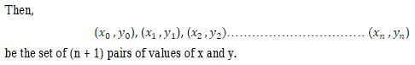

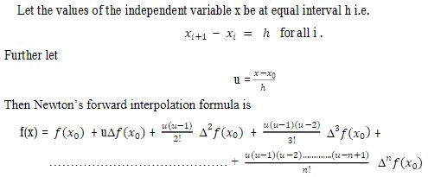……………………. (1)

1. **Valid conditions:**

1. The given values of the independent variable are at equal interval.

2. The value of the independent variable corresponding to which the value of the dependent variable is to be estimated lies in the first half of the series of the given values of the independent variable.

Why :

Newton’s forward interpolation formula is used for\_

1. Reduce the numerical computations associated to the repeated application
2. Compute a large number of interpolated values

How:

After researching limitation(s) and get rid of these (repeated numerical computations from the given data and computing a large number of interpolated values) think of an approach which consists of the representation of the given numerical data by a suitable polynomial and then compute the value of the dependent variable from the polynomial corresponding to any given value of the independent variable.

Above equation (1) can be written as

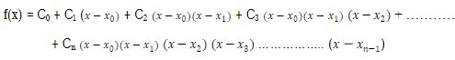 ………………………….... (2)



Now equation (2) can be expressed as

……………………………………………… (3)

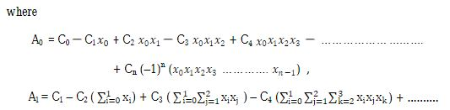

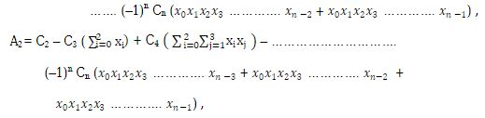

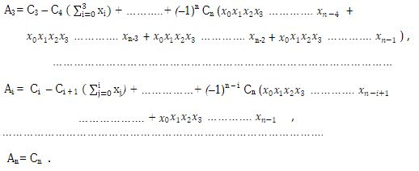

Equation (3) with the coefficients



As defined above, is one formula for representing a given set of numerical data on a pair of variables by a suitable polynomial.

**Limitation**

a)Although mentioned about the necessity of this new approach for computing a large number of interpolated values and reduce the numerical computations associated to the repeated application but not show the exact error point with any mathematical example of a large number of interpolated values and it’s repetition of calculation.

**Future Activities**

Any kinds of estimation with a large number of interpolated values we can find out our predicted value (approx.) by this new approach. Among them

1. Annual financial budget of our parliament
2. Personal or family related annual cost