**Archaeological Material Currency**

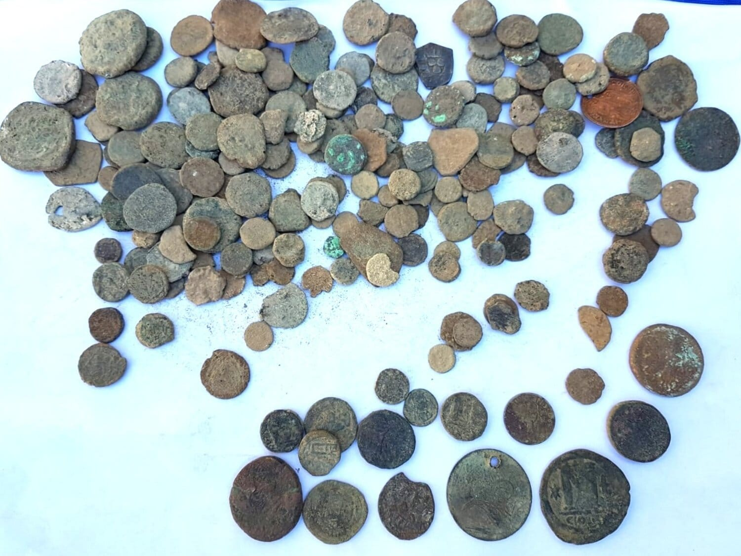

Course Name:Information and communication technology

**Presented BY**

Name: Suraiya Akter

Batch: 12

Semester: 2nd

Department: History

**Presented To**

Md. Erfan

Assistant Professor and Chairman

Department of CSE.

University of Barishal

**Slide 1:Title slide**

* Title: Archaeological material currency
* Subtitle: Exploring the Material Culture of the Past.

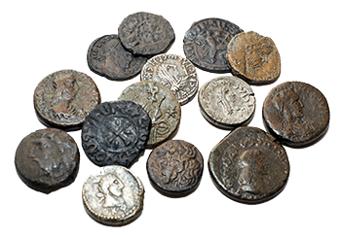

**Slide 2: introduction to coins**

Coins are invaluable artifacts that provide a unique glimpse into the economic, cultural, and political aspects of ancient civilizations. As tangible forms of currency, they offer insights not only into the financial systems of their time but also into the societal values, beliefs, and historical events that shaped those societies.

* Materials: Usually made of metals like gold, silver, bronze, or copper.
* Medium of Exchange: Coins facilitated trade and commerce in ancient societies.
* Cultural Symbols: They reflect the political, social, and religious beliefs of the time.

**Slide 3: The Origins of Coinage**

Overview: The invention of coins revolutionized trade and commerce in ancient societies.

* First Coins: Introduced by the Lydians in the 7th century BCE in what is now modern Turkey.
* Electrum Coins: Made from a natural alloy of gold and silver, featuring simple stamps.
* Spread of Coinage: The concept quickly spread to Greece, Persia, India, and beyond.

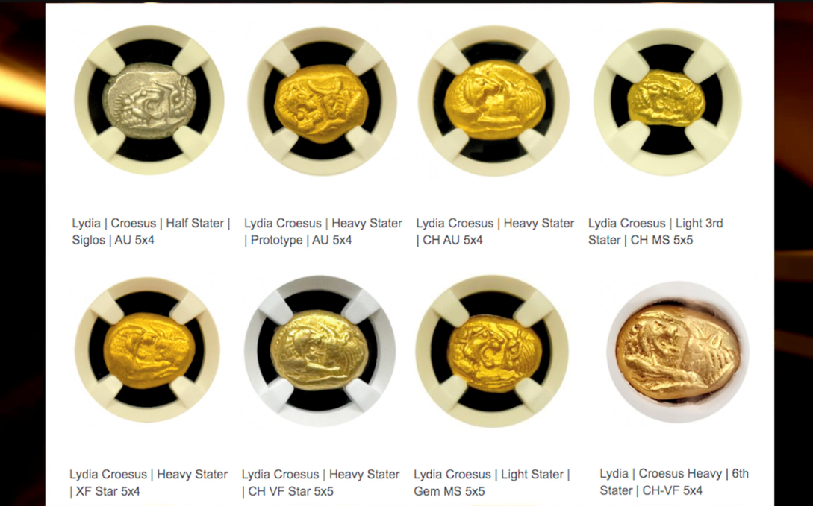

**Slide 4: coins as economic evidence**

* Facilitating Trade: Coins standardized transactions and promoted trade networks.
* Economic Value: The materials (gold, silver, bronze) indicate the wealth and economic status of a civilization.

Examples:

* Athenian Tetradrachm: Widely circulated and used in trade throughout the Mediterranean.

* Roman Denarius: Standard currency that facilitated commerce across the Roman Empire.

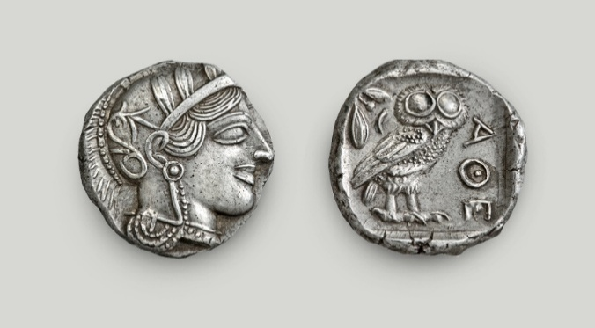

**Slide 5: Coins as Cultural Artifacts**

* Depictions of Rulers and Deities: Coins often featured images of leaders and gods, illustrating the political and religious hierarchies.
* Cultural Insights: Designs and inscriptions provide insights into the values and beliefs of a society.

Examples:

* Persian Daric: Featured the image of the king, symbolizing imperial power.

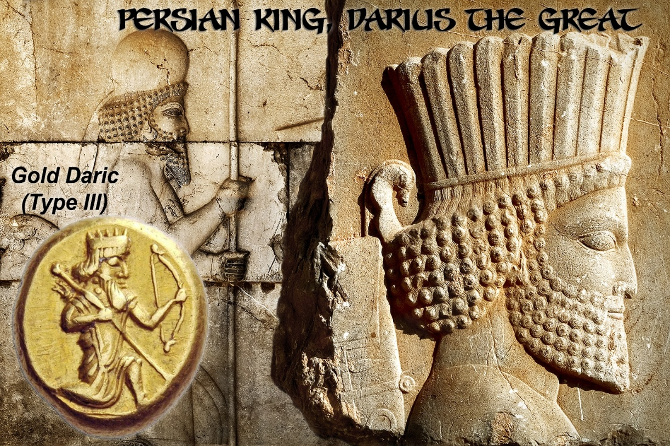

* Indian Gupta Coins: Depicted Hindu deities, reflecting the religious practices of the time.

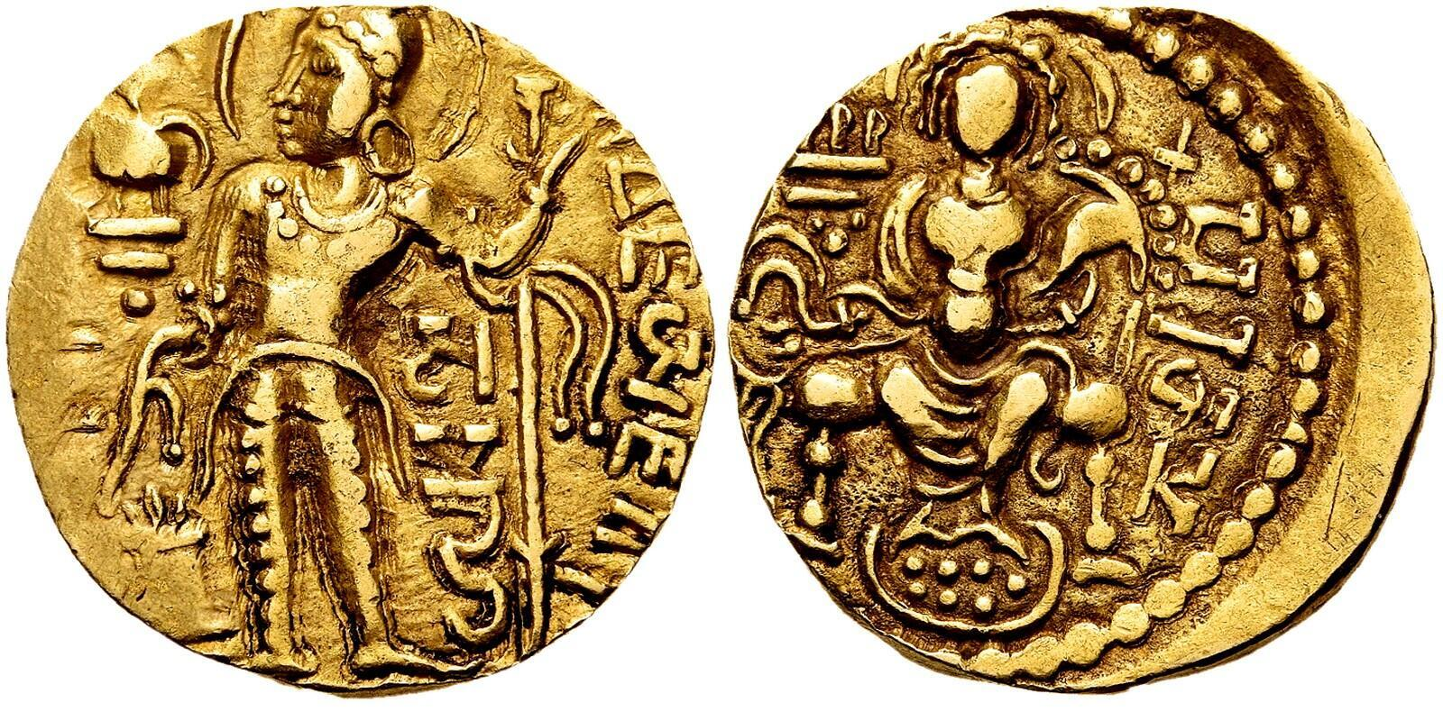

**Slide 6:Coins and Historical Events**

* Commemorative Coins: Issued to mark significant events or achievements.
* Historical Chronology: Coins can help establish timelines based on their inscriptions and designs.

Examples:

* Coins of Alexander the Great: Used to commemorate his conquests and spread of Hellenistic culture.
* Roman Victory Coins: Celebrated military victories and were often minted shortly after a successful campaign.

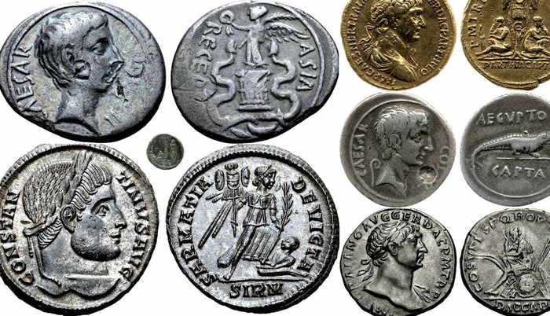

**Slide 7: Archaeological and Numismatic Evidence:**

* Excavation Finds: Coins found in archaeological sites provide context about trade routes, migration, and cultural exchanges.
* Numismatic Analysis: Study of coins helps historians understand economic systems and social hierarchies.

Examples:

* Treasure Hoards: Discovery of hoards, like the Hoxne Hoard in England, offers insights into late Roman Britain.
* Trade Coins: Coins from one civilization found in another indicate trade relationships.

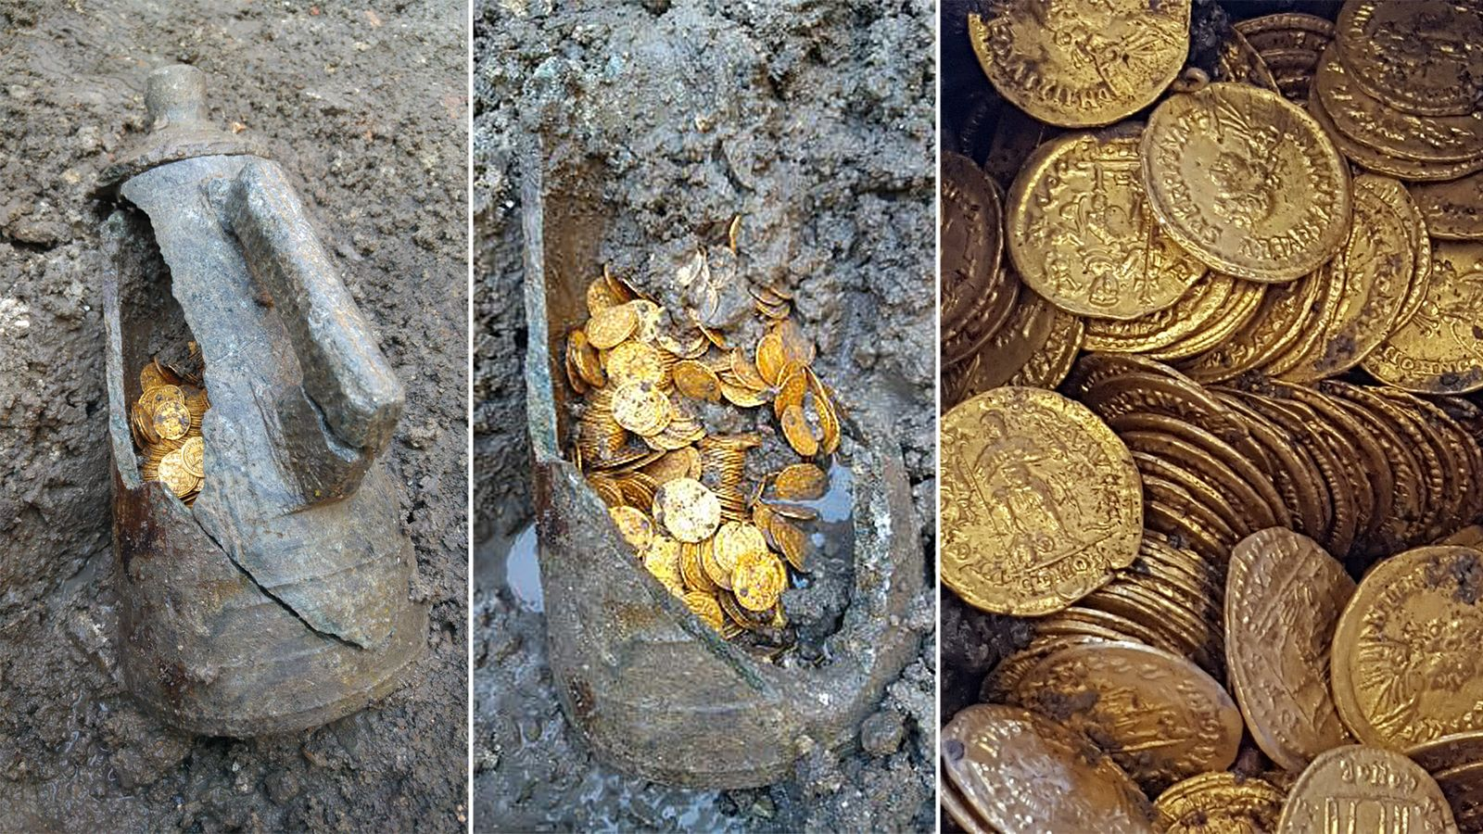

**Slide 8:Relationship between IT(Information technology)and ancient coins**

The relationship between information technology (IT) and historical coins encompasses various aspects, from the study and preservation of numismatic artifacts to their collection and trading. Here’s a detailed overview of how IT interacts with historical coins:

* Online forums, social media, and virtual exhibitions foster community interaction among collectors and enthusiasts, sharing knowledge about ancient coins.
* IT provides access to online courses, webinars, and digital archives, enhancing education and awareness of ancient numismatics.
* IT allows for comprehensive databases to manage and preserve information about ancient coins, including their historical context, minting details, and characteristics.
* Advanced technologies such as spectroscopy and blockchain help authenticate ancient coins and prevent counterfeiting.

**Slide 9: Conclusion**

* Summary: Coins are invaluable as historical evidence, offering insights into economic systems, cultural values, and significant historical events.
* Importance: The study of coins (numismatics) provides a unique lens through which to examine and understand ancient societies.
* Final Thought: Coins not only represent currency but also encapsulate the essence of human civilization throughout