Experiment No: 02

Course Code: CSE-406
Course Title: Digital Image Processing Labratory
4th Year 1st Semester Examination 2023

Date of Performance: 01-09-2024
Date of Submission: 08-09-2024


Submitted to-

Dr. Morium Akter
Professor
Dr. Md. Golam Moazzem
Professor

Department of Computer Science and Engineering
Jahangirnagar University
Savar, Dhaka-1342

Sl | Class Roll | Exam Roll | Name
01 | 364 | 202176 | Suraiya Mahmuda

Experiment Name: Take an image as input and display it’s negative image.

Objectives:
• Read the Input Image: Load the image into MATLAB.
• Convert the Image to Negative: Transform the pixel values to their negative counterparts.
• Display the Original and Negative Images: Show the images for comparison.
Source Code:
% Read the image
originalImage = imread('C:\Users\CSELAB-2\Desktop\GIPLab02\negativeimage1.jpg');

% Check if the image is grayscale or RGB
if size(originalImage, 3) == 1
% Grayscale image
maxValue = 255; % Maximum value for 8-bit images
negativeImage = maxValue - originalImage;
else
% RGB image
maxValue = 255; % Maximum value for 8-bit images
% Apply the negative transformation to each channel
negativeImage = maxValue - originalImage;
end

% Display the original and negative images
figure;
subplot(1, 2, 1);
imshow(originalImage);
title('Original Image');

subplot(1, 2, 2);
imshow(negativeImage);
title('Negative Image');

Input and Output:
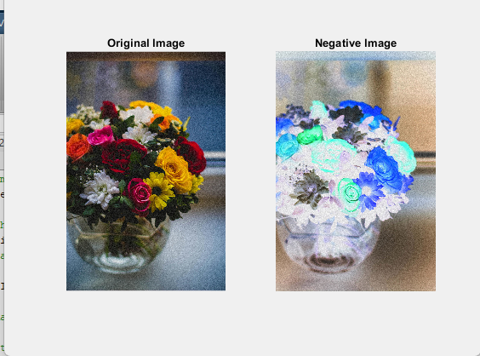

Experiment Name: Take an image as input and enhance it’s contrast stretching image.

Objectives
- Read the Input Image: Load the image into MATLAB.
- Define the Contrast Stretching Parameters: Determine the minimum and maximum values for both the original and stretched image.
- Apply Contrast Stretching: Transform the pixel values based on the defined parameters.
- Display the Original and Enhanced Images: Show both the original and contrast-stretched images for comparison.
Source Code:
% Step 1: Read the RGB image
img = imread('C:\Users\CSELAB-2\Desktop\GIPLab02\contast.jpg'); % Replace 'your_image.jpg' with your image filename

% Step 2: Define the stretching parameters
min_out = 0; % Minimum intensity of the output image
max_out = 255; % Maximum intensity of the output image

% Initialize the stretched image
img_stretched = img;

% Process each channel separately
for c = 1:size(img, 3)
% Get the current channel
channel = img(:,:,c);

% Define the input range for the current channel
min_in = double(min(channel(:)));
max_in = double(max(channel(:)));

% Apply contrast stretching
channel_double = double(channel);
channel_stretched = ((channel_double - min_in) / (max_in - min_in)) * (max_out - min_out) + min_out;

% Store the result in the output image
img_stretched(:,:,c) = uint8(channel_stretched);
end

% Step 3: Display the original and stretched images
figure; % Open a new figure window

subplot(1,2,1);
imshow(img);
title('Original RGB Image');

subplot(1,2,2);
imshow(img_stretched);
title('Contrast Stretched RGB Image');

Input and Output:
