Experiment No: 03

Course Code: CSE-406
Course Title: Digital Image Processing Labratory
4th Year 1st Semester Examination 2023

Date of Performance: 08-09-2024
Date of Submission: 15-09-2024


Submitted to-

Dr. Morium Akter
Professor
Dr. Md. Golam Moazzem
Professor

Department of Computer Science and Engineering
Jahangirnagar University
Savar, Dhaka-1342

Sl | Class Roll | Exam Roll | Name
01 | 364 | 202176 | Suraiya Mahmuda

Experiment Name:
- Histogram equalization of a given image to show the histogram of original image and equalized image.
- Cumulative Distribution Function(CDF) graph of pixel intensity of original vs equalized image.
- Histogram specification using Bimodal Gaussian Function to show the histogram of original and modified image.

a. Objectives:
• Display the original image.
• Compute the histogram of the original image.
• Perform histogram equalization to improve contrast.
• Display the equalized image.
• Compute the histogram of the equalized image.
Source Code:
% Read the input image
input_image = imread('C:\Users\CSELAB-2\Desktop\New folder\beautiful-flower-nature.jpg'); % Replace 'example.jpg' with your image file
% Convert to grayscale if it's a color image
if size(input_image, 3) == 3
input_image = rgb2gray(input_image);
end
% Display the original image
figure;
subplot(2, 2, 1);
imshow(input_image);
title('Original Image');
% Compute and display the histogram of the original image
subplot(2, 2, 2);
imhist(input_image);
title('Histogram of Original Image');
% Perform histogram equalization
equalized_image = histeq(input_image);
% Display the equalized image
subplot(2, 2, 3);
imshow(equalized_image);
title('Equalized Image');
% Compute and display the histogram of the equalized image
subplot(2, 2, 4);
imhist(equalized_image);
title('Histogram of Equalized Image');
% Optional: Save the results
imwrite(equalized_image, 'equalized_image.jpg'); % Save the equalized image

Input:
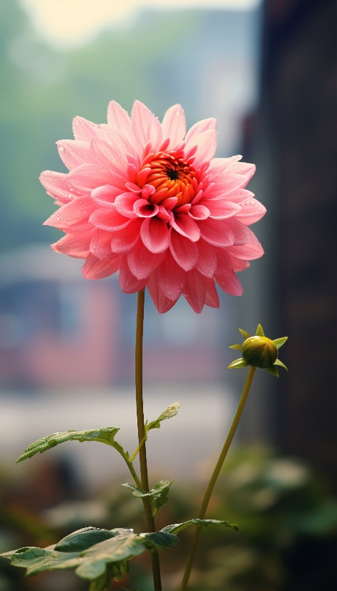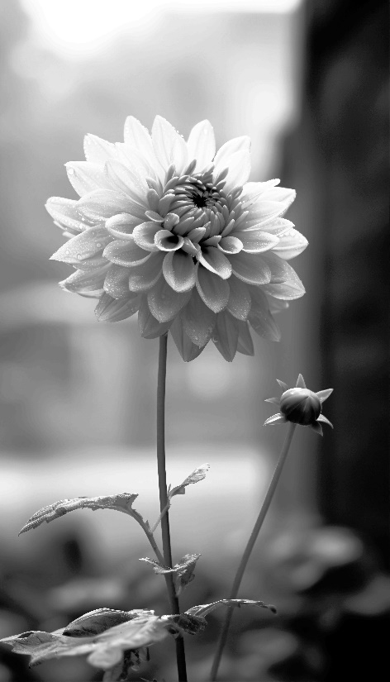
Output:
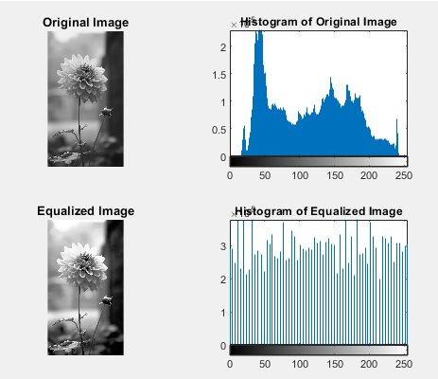

b. Objectives:
• Compute and plot the CDF of the original image.
• Perform histogram equalization.
• Compute and plot the CDF of the equalized image.
Source Code:
% Define the input image and transformation parameters
inputImageFile = 'C:\Users\CSELAB-2\Desktop\New folder\beautiful-flower-nature.jpg'; % Replace with your image file
% Read the image
img = imread(inputImageFile);
% Convert to grayscale if the image is RGB
if size(img, 3) == 3
img = rgb2gray(img);
end
% Convert image to double for processing
img = double(img) / 255; % Normalize to [0, 1]
% Define the linear transformation parameters
a = 1.5; % Scaling factor
b = 0.2; % Offset
% Apply the linear transformation
transformed_img = a * img + b;
% Clip values to [0, 1] range
transformed_img = min(max(transformed_img, 0), 1);
% Convert back to uint8
transformed_img = uint8(255 * transformed_img);
% Display the original and transformed images
figure;
subplot(1, 2, 1);
imshow(img);
title('Original Image');
subplot(1, 2, 2);
imshow(transformed_img);
title('Transformed Image');

Input:
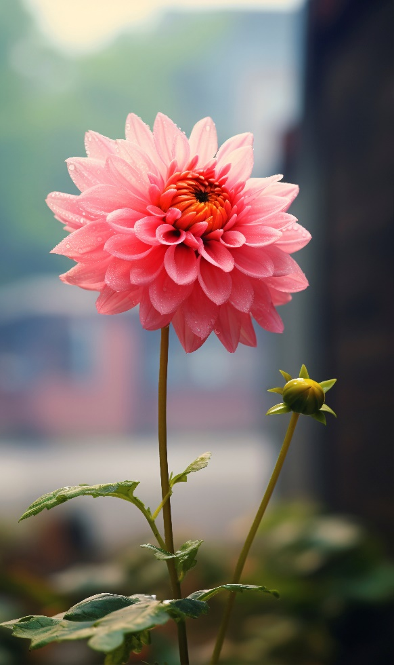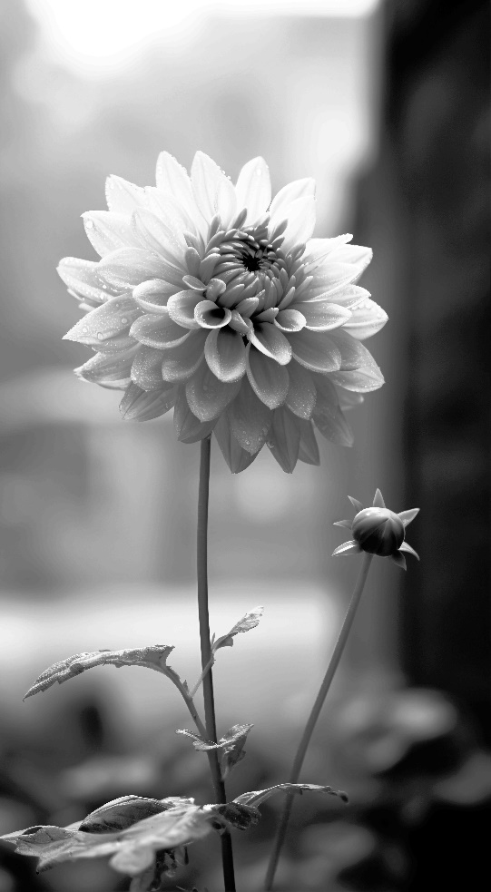
Output:
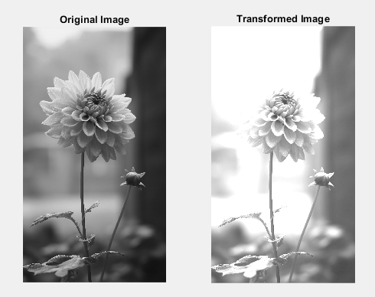

C. Objectives:
• Display the original image and its histogram.
• Define a target histogram based on a bimodal Gaussian function.
• Perform histogram specification (matching) to make the original image's histogram resemble the target bimodal distribution.
• Display the modified image and its histogram.
Source Code:
% Read the source and target images
I_source = imread('C:\Users\CSELAB-2\Desktop\New folder\Source.jpg'); % Replace with your source image file
I_target = imread('C:\Users\CSELAB-2\Desktop\New folder\Target.jpg'); % Replace with your target image file
% Convert images to grayscale if needed
I_source_gray = rgb2gray(I_source);
I_target_gray = rgb2gray(I_target);
% Compute histograms
[counts_source, gray_levels_source] = imhist(I_source_gray);
[counts_target, gray_levels_target] = imhist(I_target_gray);
% Compute cumulative histograms
cdf_source = cumsum(counts_source) / numel(I_source_gray);
cdf_target = cumsum(counts_target) / numel(I_target_gray);
% Create an empty mapping array
mapping = zeros(256, 1);
% Mapping source CDF to target CDF
for i = 1:256
[~, idx] = min(abs(cdf_source(i) - cdf_target));
mapping(i) = gray_levels_target(idx);
end
% Apply the mapping to the source image
I_source_mapped = uint8(arrayfun(@(x) mapping(x + 1), I_source_gray));
% Display the results
figure;
subplot(1, 3, 1);
imshow(I_source_gray);
title('Original Source Image');
subplot(1, 3, 2);
imshow(I_target_gray);
title('Target Image');
subplot(1, 3, 3);
imshow(I_source_mapped);
title('Histogram-Matched Image');

Input:
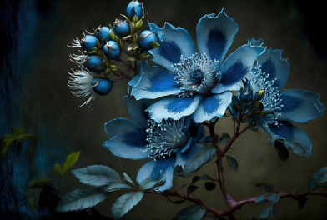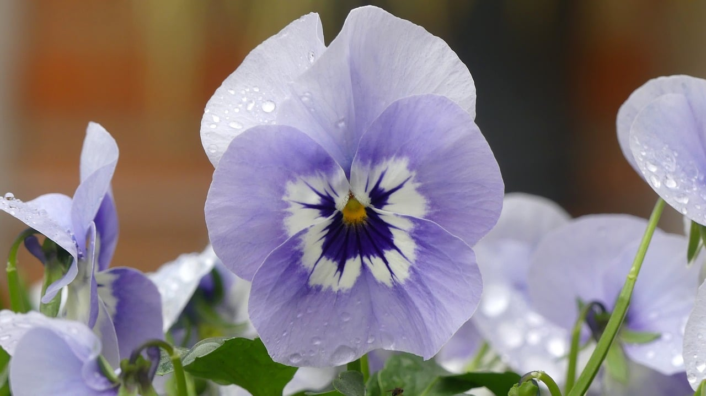
Output:
