Experiment No: 04

Course Code: CSE-406
Course Title: Digital Image Processing Labratory
4th Year 1st Semester Examination 2023

Date of Performance: 15-09-2024
Date of Submission: 22-09-2024


Submitted to-

Dr. Morium Akter
Professor
Dr. Md. Golam Moazzem
Professor

Department of Computer Science and Engineering
Jahangirnagar University
Savar, Dhaka-1342

Sl | Class Roll | Exam Roll | Name
01 | 364 | 202176 | Suraiya Mahmuda

Experiment Name:
- Image filtering using Mean, Median and Gaussian techniques.
- Image resizing using Replication method, Linear Interpolation method and Pixel Skipping method.

a. Objectives:
Mean Filter:
- Objective: Reduce overall noise by averaging pixel values, but it may blur edges due to uniform smoothing.
Median Filter:
- Objective: Remove impulse noise (salt-and-pepper noise) while preserving edges and avoiding blurring.
Gaussian Filter:
- Objective: Achieve a smooth image by using a Gaussian function to weigh neighboring pixels, providing more natural blurring and reducing Gaussian noise.
Source Code:
% Read the color image
colorImage = imread('C:\Users\CSELAB-2\Desktop\Lab04\Filters.jpg');
% Separate the color channels
redChannel = colorImage(:,:,1);
greenChannel = colorImage(:,:,2);
blueChannel = colorImage(:,:,3);
% Mean Filter
meanFilter = fspecial('average', [3 3]);
meanFilteredRed = imfilter(redChannel, meanFilter);
meanFilteredGreen = imfilter(greenChannel, meanFilter);
meanFilteredBlue = imfilter(blueChannel, meanFilter);
meanFilteredImage = cat(3, meanFilteredRed, meanFilteredGreen, meanFilteredBlue);
% Median Filter
medianFilteredRed = medfilt2(redChannel, [3 3]);
medianFilteredGreen = medfilt2(greenChannel, [3 3]);
medianFilteredBlue = medfilt2(blueChannel, [3 3]);
medianFilteredImage = cat(3, medianFilteredRed, medianFilteredGreen, medianFilteredBlue);
% Gaussian Filter
gaussianFilter = fspecial('gaussian', [3 3], 0.5);
gaussianFilteredRed = imfilter(redChannel, gaussianFilter);
gaussianFilteredGreen = imfilter(greenChannel, gaussianFilter);
gaussianFilteredBlue = imfilter(blueChannel, gaussianFilter);
gaussianFilteredImage = cat(3, gaussianFilteredRed, gaussianFilteredGreen, gaussianFilteredBlue);
% Display the original and filtered images
figure;
subplot(2,2,1), imshow(colorImage), title('Original Image');
subplot(2,2,2), imshow(meanFilteredImage), title('Mean Filtered Image');
subplot(2,2,3), imshow(medianFilteredImage), title('Median Filtered Image');
subplot(2,2,4), imshow(gaussianFilteredImage), title('Gaussian Filtered Image');

Input:
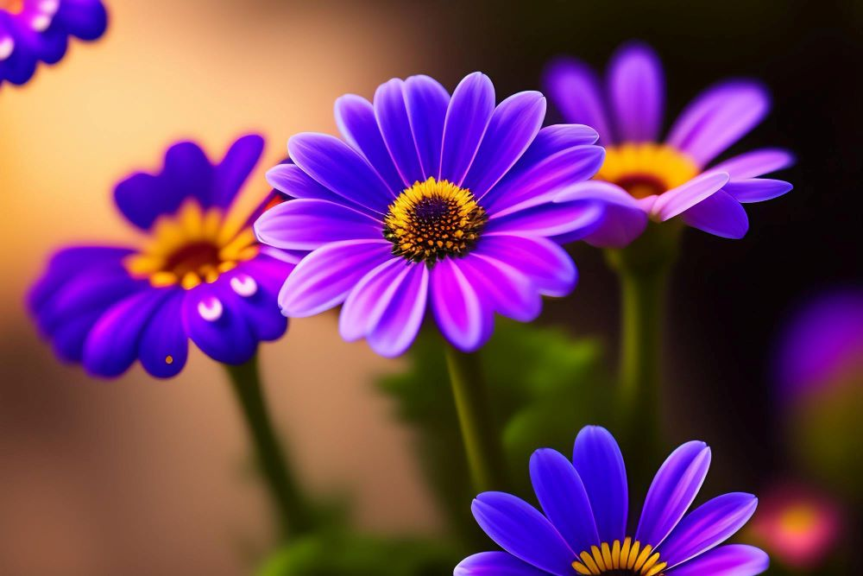
Output:
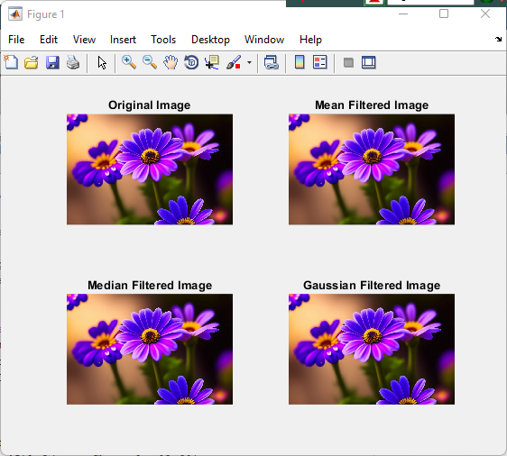

b. Objectives:
Replication: Retain simplicity and speed but risk blockiness.
Linear Interpolation: Preserve smoothness and visual quality with balanced performance.
Pixel Skipping: Maximize speed in downsizing but risk losing detail and introducing aliasing artifacts.

Source Code:
% Read the color image
colorImage = imread('C:\Users\CSELAB-2\Desktop\Lab04\Filters.jpg');
% Display original image size
originalSize = size(colorImage);
disp('Original Image Size:');
disp(originalSize);
% Resize the image using nearest-neighbor interpolation
scaleFactor = 0.5; % Example scale factor for downscaling
nearestNeighborResizedImage = imresize(colorImage, scaleFactor, 'nearest');
% Display nearest-neighbor resized image size
nearestNeighborSize = size(nearestNeighborResizedImage);
disp('Nearest-Neighbor Resized Image Size:');
disp(nearestNeighborSize);
% Resize the image using linear interpolation
linearResizedImage = imresize(colorImage, scaleFactor, 'bilinear');
% Display linear interpolation resized image size
linearSize = size(linearResizedImage);
disp('Linear Interpolation Resized Image Size:');
disp(linearSize);
% Resize the image using pixel skipping method
skipFactor = 1.0/scaleFactor; % Example skip factor
pixelSkippedImage = colorImage(1:skipFactor:end, 1:skipFactor:end, :);
% Display pixel skipping resized image size
pixelSkippedSize = size(pixelSkippedImage);
disp('Pixel Skipping Resized Image Size:');
disp(pixelSkippedSize);
% Display the original and resized images with dimensions
figure;
subplot(2,2,1), imshow(colorImage), title(['Original Image (' num2str(originalSize(1)) 'x' num2str(originalSize(2)) ')']);
subplot(2,2,2), imshow(nearestNeighborResizedImage), title(['Replication Resized (' num2str(nearestNeighborSize(1)) 'x' num2str(nearestNeighborSize(2)) ')']);
subplot(2,2,3), imshow(linearResizedImage), title(['Linear Interpolation Resized (' num2str(linearSize(1)) 'x' num2str(linearSize(2)) ')']);
subplot(2,2,4), imshow(pixelSkippedImage), title(['Pixel Skipping Resized (' num2str(pixelSkippedSize(1)) 'x' num2str(pixelSkippedSize(2)) ')']);

Input:

Output:
