Experiment No: 06

Course Code: CSE-406
Course Title: Digital Image Processing Labratory
4th Year 1st Semester Examination 2023

Date of Performance: 29-09-2024
Date of Submission: 06-09-2024


Submitted to-

Dr. Morium Akter
Professor
Dr. Md. Golam Moazzem
Professor

Department of Computer Science and Engineering
Jahangirnagar University
Savar, Dhaka-1342

Sl | Class Roll | Exam Roll | Name
01 | 364 | 202176 | Suraiya Mahmuda

Experiment Name:
- Converting RGB image to HIS image.
- Converting RGB image to Grayscale image.
- Converting RGB image to Red, Green, Blue image.

a. Objectives:
The objective of converting an RGB image to an HSI (Hue, Saturation, Intensity) image is to represent the image in a way that separates color information (Hue and Saturation) from intensity information (brightness), which can be beneficial for various image processing tasks.

Source Code:
function [H, S, I] = rgb2hsi_image(input_path)
% Function to convert an RGB image to HSI
% Input: input_path - the file path of the input RGB image
% Output: H - the Hue component
% S - the Saturation component
% I - the Intensity component
% Read the RGB image from the input path
rgb_image = imread('C:\Users\CSELAB-2\Desktop\LAB06\InputPicture.jpg');
% Convert the RGB image to double for accurate calculations
rgb_image = im2double(rgb_image);
% Separate the RGB channels
R = rgb_image(:,:,1);
G = rgb_image(:,:,2);
B = rgb_image(:,:,3);
% Compute the intensity component (I)
I = (R + G + B) / 3;
% Compute the saturation component (S)
min_RGB = min(min(R, G), B);
S = 1 - (3 ./ (R + G + B + eps)) .* min_RGB;
% Compute the hue component (H)
theta = acos(0.5 * ((R - G) + (R - B)) ./ sqrt((R - G).^2 + (R - B) .* (G - B) + eps));
H = theta;
H(B > G) = 2 * pi - H(B > G);
H = H / (2 * pi); % Normalize to [0, 1]
% Display the original RGB image and H, S, I components
figure;
subplot(2,2,1);
imshow(rgb_image);
title('Original RGB Image');
subplot(2,2,2);
imshow(H);
title('Hue Component');
subplot(2,2,3);
imshow(S);
title('Saturation Component');
subplot(2,2,4);
imshow(I);
title('Intensity Component');
end
Input and Output:
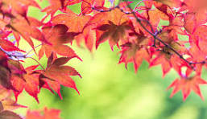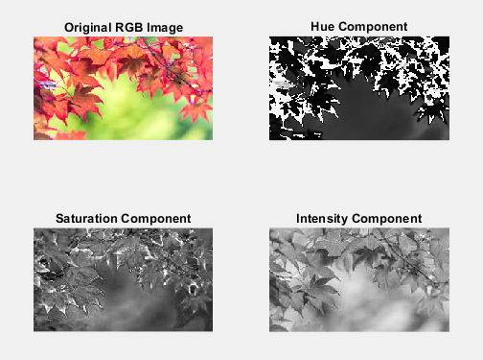
b. Objectives:
The objective of converting an RGB image to a grayscale image is to reduce the image to its intensity values, eliminating color information while retaining structural and brightness details.

Source Code:
function grayscale_image = rgb_to_grayscale(input_path)
% Function to convert an RGB image to grayscale
% Input: input_path - the file path of the input RGB image
% Output: grayscale_image - the grayscale image
% Read the RGB image from the input path
rgb_image = imread('C:\Users\CSELAB-2\Desktop\LAB06\InputPicture.jpg');
% Convert the RGB image to grayscale using the built-in function
grayscale_image = rgb2gray(rgb_image);
% Display the original RGB image and the grayscale image
figure;
subplot(1,2,1);
imshow(rgb_image);
title('Original RGB Image');
subplot(1,2,2);
imshow(grayscale_image);
title('Grayscale Image');
end

Input and Output:
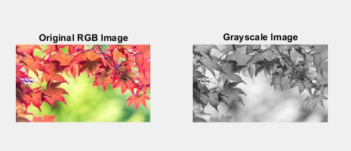
c. Objectives:
The objective of converting an RGB image into separate Red, Green, and Blue channel images is to isolate and analyze the contribution of each individual color channel to the overall image.

Source Code:
function [R_colored, G_colored, B_colored] = rgb_to_colored_channels(input_path)
% Function to separate an RGB image into colored Red, Green, and Blue channels
% Input: input_path - the file path of the input RGB image
% Output: R_colored - Red channel as a colored image
% G_colored - Green channel as a colored image
% B_colored - Blue channel as a colored image
% Read the RGB image from the input path
rgb_image = imread('C:\Users\CSELAB-2\Desktop\LAB06\InputPicture.jpg');
% Initialize colored channel images
R_colored = zeros(size(rgb_image)); % Red channel image
G_colored = zeros(size(rgb_image)); % Green channel image
B_colored = zeros(size(rgb_image)); % Blue channel image
% Assign the R, G, B values to the respective channels
R_colored(:,:,1) = rgb_image(:,:,1); % Keep Red channel
G_colored(:,:,2) = rgb_image(:,:,2); % Keep Green channel
B_colored(:,:,3) = rgb_image(:,:,3); % Keep Blue channel
% Convert channel images to uint8 for proper display
R_colored = uint8(R_colored);
G_colored = uint8(G_colored);
B_colored = uint8(B_colored);
% Display the original RGB image and colored R, G, B channel images
figure;
subplot(2,2,1);
imshow(rgb_image);
title('Original RGB Image');
subplot(2,2,2);
imshow(R_colored);
title('Red Channel (Colored)');
subplot(2,2,3);
imshow(G_colored);
title('Green Channel (Colored)');
subplot(2,2,4);
imshow(B_colored);
title('Blue Channel (Colored)');
end
Input and Output:
