Experiment No: 05

Experiment Name: Edge Detection using Prewitt operator, Roberts operator, Sobel operator and Isotropic operator

Course Code: CSE-406
Course Title: Digital Image Processing Labratory
4th Year 1st Semester Examination 2023

Date of Performance: 22-09-2024
Date of Submission: 29-09-2024


Submitted to-

Dr. Morium Akter
Professor
Dr. Md. Golam Moazzem
Professor

Department of Computer Science and Engineering
Jahangirnagar University
Savar, Dhaka-1342

Sl | Class Roll | Exam Roll | Name
01 | 364 | 202176 | Suraiya Mahmuda

Objectives:

Prewitt operator: Detect edges by calculating the gradient of the image intensity at each pixel using a simple approximation of the derivative.

Roberts operator: Detect edges by calculating the approximate gradient of the image using a 2x2 matrix, which highlights diagonal edges.
Sobel operator: Detect edges by calculating the gradient magnitude and direction using a larger convolution kernel, which offers more robustness to noise.
Isotropic operator: Detect edges in an image while being rotation-invariant (i.e., it detects edges irrespective of their direction), using second-order derivatives.
Source Code:
% Read the input image
img = imread('C:\Users\CSELAB-2\Desktop\LAB05\EdgeDetection.jpeg');
gray_img = rgb2gray(img); % Convert to grayscale if it's an RGB image
% Prewitt operator
prewitt_edges = edge(gray_img, 'Prewitt');
% Roberts operator
roberts_edges = edge(gray_img, 'Roberts');
% Sobel operator
sobel_edges = edge(gray_img, 'Sobel');
% Isotropic operator (Approximation using Canny operator for isotropic behavior)
isotropic_edges = edge(gray_img, 'Canny');
% Displaying results
figure;
subplot(2,2,1), imshow(prewitt_edges), title('Prewitt Edge Detection');
subplot(2,2,2), imshow(roberts_edges), title('Roberts Edge Detection');
subplot(2,2,3), imshow(sobel_edges), title('Sobel Edge Detection');
subplot(2,2,4), imshow(isotropic_edges), title('Isotropic (Canny) Edge Detection');

Input:
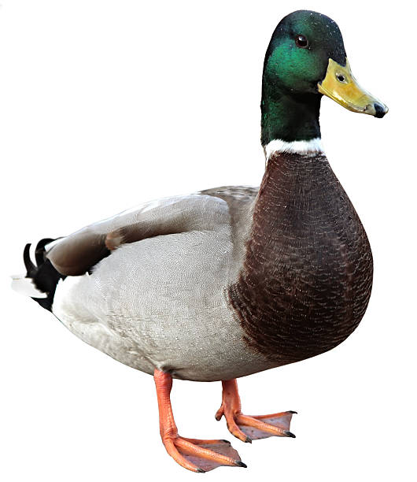
Output:
