Experiment No: 09

Course Code: CSE-406
Course Title: Digital Image Processing Labratory
4th Year 1st Semester Examination 2023

Date of Performance: 27-10-2024
Date of Submission: 03-11-2024


Submitted to-

Dr. Morium Akter
Professor
Dr. Md. Golam Moazzem
Professor

Department of Computer Science and Engineering
Jahangirnagar University
Savar, Dhaka-1342

Sl | Class Roll | Exam Roll | Name
01 | 364 | 202176 | Suraiya Mahmuda

Experiment Name:
- Hough Transformation for Straight Line Detection.
- Hough Transformation for Circle Detection.

a. Objectives:
The objective of the Hough Transform for straight line detection is to accurately identify and localize straight lines within an image, even in noisy, cluttered, or low-contrast environments. This approach is robust against partial occlusions and discontinuities, allowing for the detection of multiple lines with varying orientations. By accumulating evidence in parameter space, the Hough Transform enables efficient and precise line detection, making it valuable for applications such as computer vision, robotic navigation, and automated analysis in fields where accurate and adaptable line detection is essential.

Source Code:
% Read an image
img = imread('C:\Users\CSELAB-2\Desktop\Lab09\Input.jpg'); % Replace with your image file path
gray_img = rgb2gray(img); % Convert to grayscale
% Apply edge detection
edges = edge(gray_img, 'canny'); % Use Canny edge detector
% Apply the Hough Transform
[H, theta, rho] = hough(edges);
% Detect peaks in the Hough Transform
peaks = houghpeaks(H, 5, 'threshold', ceil(0.3 * max(H(:))));
% Find lines based on Hough peaks
lines = houghlines(edges, theta, rho, peaks, 'FillGap', 5, 'MinLength', 7);
% Display the results
figure, imshow(img), hold on
for k = 1:length(lines)
% Get endpoints of each line segment
xy = [lines(k).point1; lines(k).point2];
% Plot each line in red
plot(xy(:,1), xy(:,2), 'LineWidth', 2, 'Color', 'red');
% Mark the beginnings and ends of each line with a green circle
plot(xy(1,1), xy(1,2), 'x', 'LineWidth', 2, 'Color', 'green');
plot(xy(2,1), xy(2,2), 'x', 'LineWidth', 2, 'Color', 'yellow');
end
title('Detected Lines')
hold off

Input and Output:
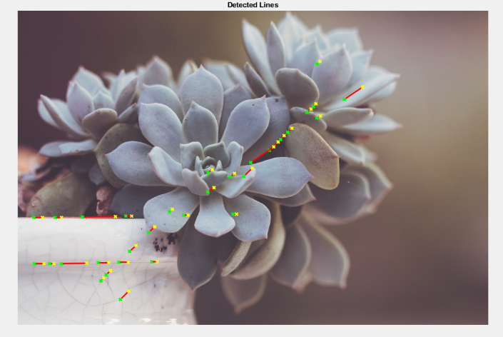
b. Objectives:
The objective of the Hough Transform for circle detection is to accurately and efficiently identify and localize circular shapes within an image by determining their centers and radii, even in noisy or cluttered backgrounds. This method enables robust detection across varying circle sizes, partial occlusions, and image quality variations, making it highly applicable in fields like medical imaging, industrial inspection, and automated object recognition where precise, adaptable, and automated circle detection is essential.
Source Code:
% Read the input image
img = imread('C:\Users\CSELAB-2\Desktop\Lab09\Input.jpg'); % Replace with your image file path
gray_img = rgb2gray(img); % Convert to grayscale if necessary
% Define the radius range for the circles (adjust based on your image)
min_radius = 20;
max_radius = 50;
% Perform Hough Transform to find circles
[centers, radii, metric] = imfindcircles(gray_img, [min_radius max_radius], ...'Sensitivity', 0.9, 'EdgeThreshold', 0.1);
% Display the original image
figure, imshow(img), hold on
% Plot detected circles
viscircles(centers, radii, 'EdgeColor', 'b');
% Plot the centers of the circles
plot(centers(:,1), centers(:,2), 'x', 'LineWidth', 2, 'Color', 'r');
title('Detected Circles');
hold off

Input and Output:
