Online-Doctor Visit Appointment Web App

Wireframe Documentation

Home Page

We have divided the home page into two sections.

1. Login

First thing anyone will see is the login window, which will ask the user for username and password to login. Sign Up toggler will redirect to signup window.

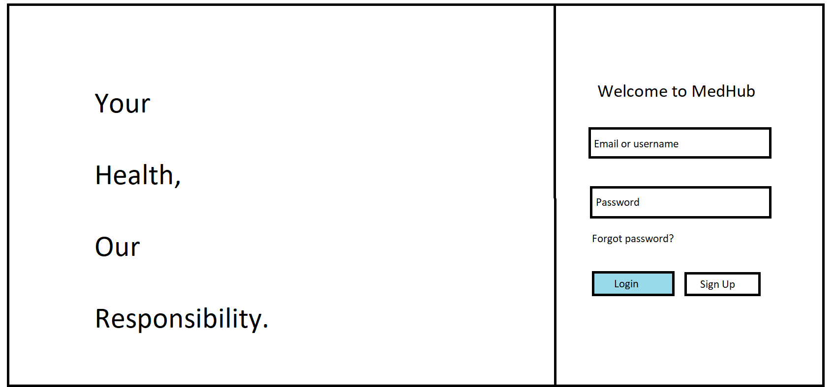

1. SignUp

The signup window opens when you click the signup button at the login page. Sign up page is different for both doctor and patients.

There is a dropdown menu where one can select whether user is doctor or patient.

* Doctor signup page

If a user selects doctor the following options are shown

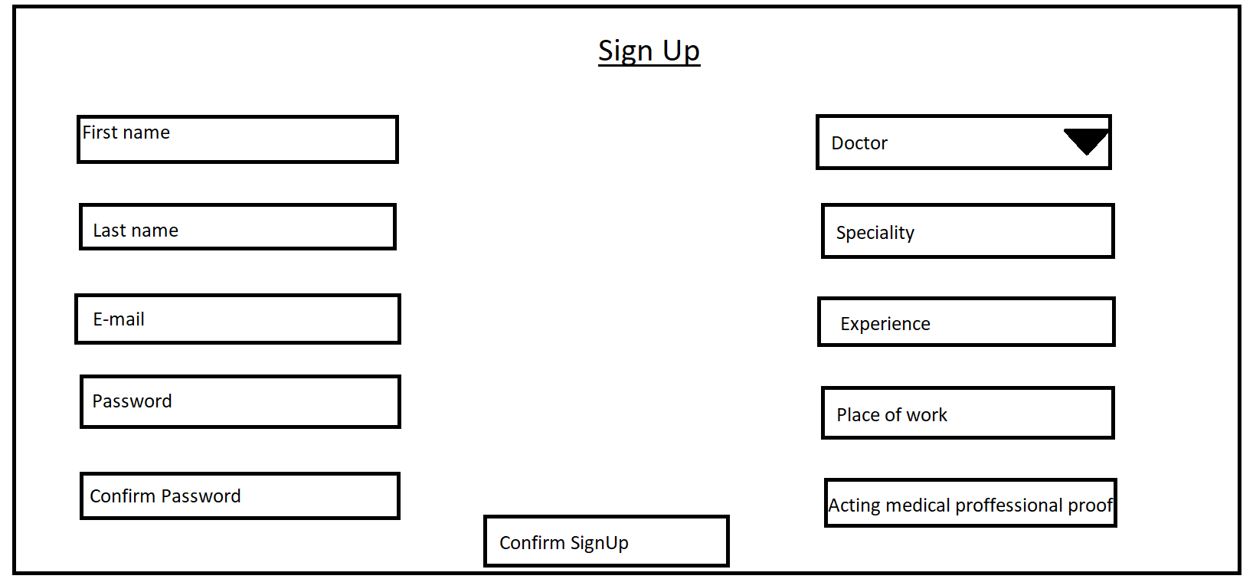

* Patient signup page

If a user selects patient the following options are shown

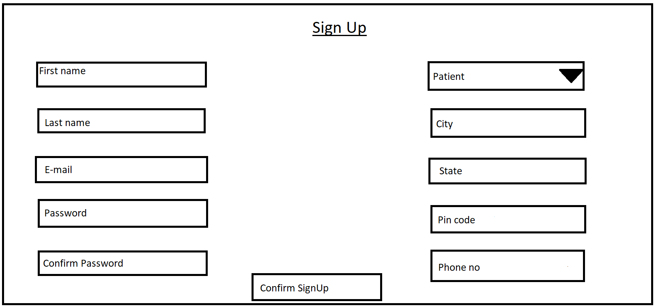

Doctor’s Dashboard

Doctor’s dashboard has four sections –

1. Appointments section :

This page will show the appointments for upcoming 15 days along with patient details. We have also added filter appointments.

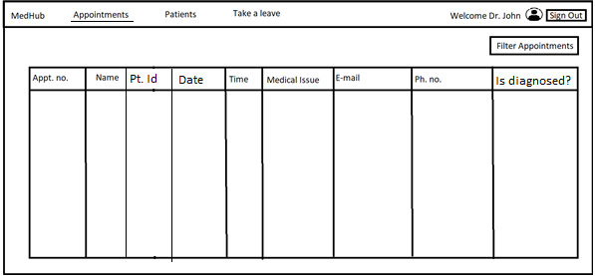

The filter option when clicked will allow doctor to filter the appointments for a

* specific date
* Specific patient id
* Specific appointment no.

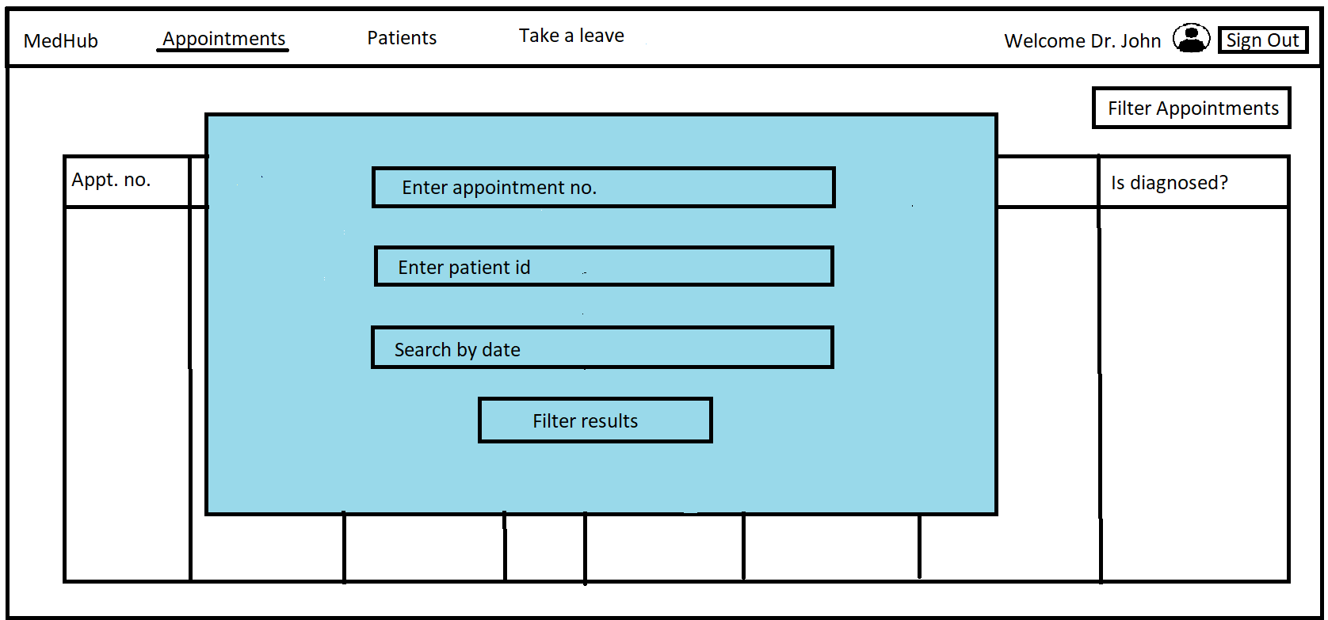

1. Patient’s section :

This section allows the doctor to see the past patient details whom they have diagnosed. The filter option added in the appointment’s section is also active here so that the doctor can easily filter out a specific criteria.

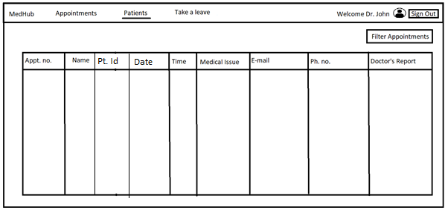

1. Take a leave section:

Doctor can take a leave for a specific period of time. During that time all the appointments will be rescheduled to the nearest possible opening and the patients will be notified.

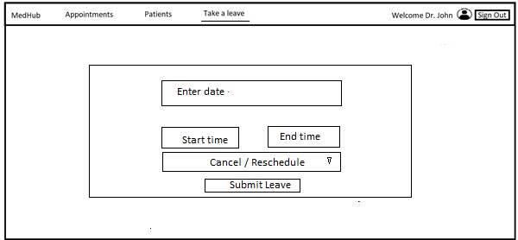

1. My Profile:

Doctor can visit their profile for setting up payment details and edit their initial information. This is achieved by clicking the avatar icon at the top-right corner of the doctor’s dashboard.

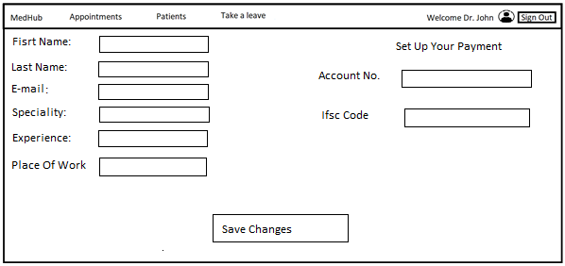

Patient’s dashboard

Patient dashboard has four sections

1. Home section:

This section allows patients to search for a doctor by name or speciality and allows them to book an appointment.

This window shows a list of doctors. On clicking doctor image the booking window opens.

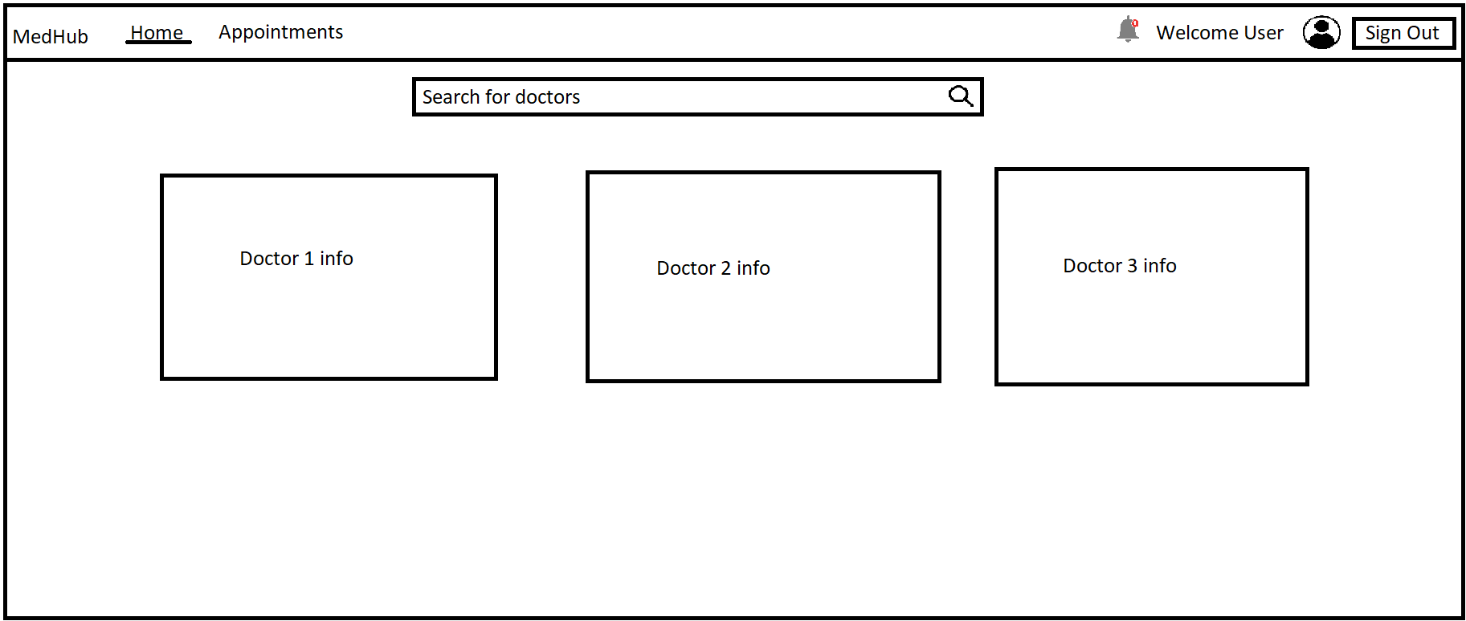

Below is the booking window that will allow the patient to book a date and time slot. On clicking confirm booking the patient will be redirected to payment page.

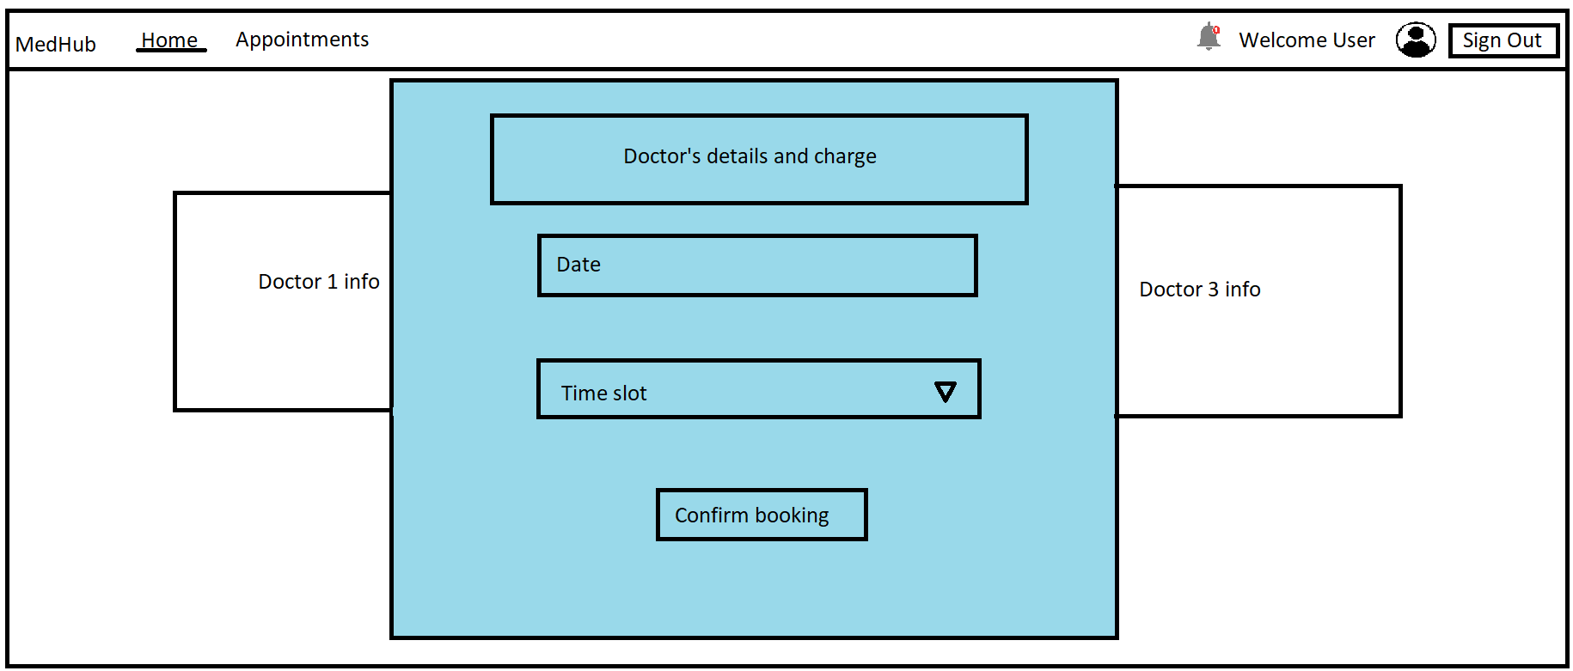

1. Appointment section:

This allows patients to see their past as well as upcoming appointments. We have also added a filter option which will allow the patient to filter results(same as filter option in the doctor page). The option for cancellation is also added under is diagnosed column.

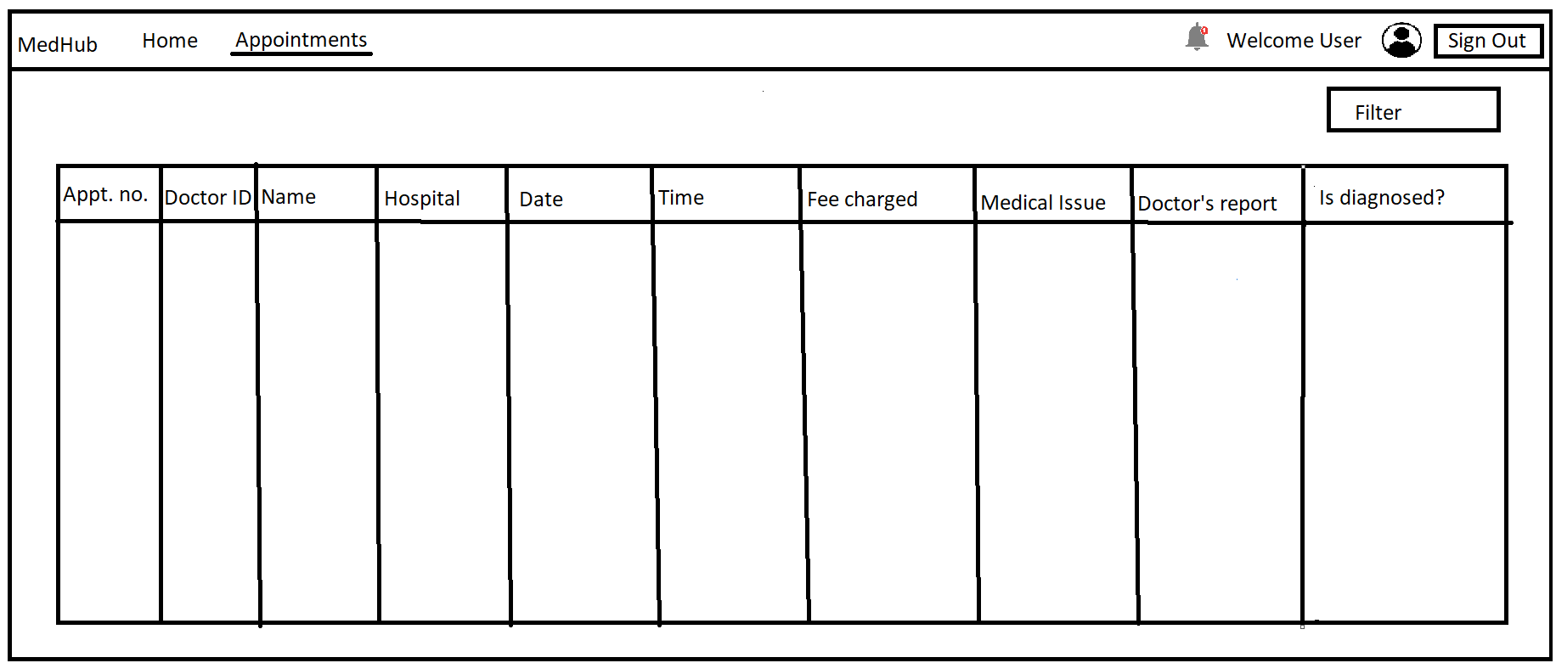

1. Notification section:

This section displays reminder, rescheduling and cancellation of appointments.

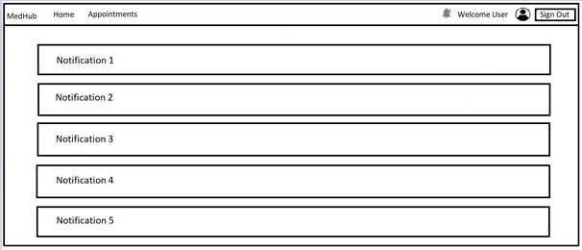

1. Profile section:

Patients can visit their profile for setting up payment details and edit their initial information. This is achieved by clicking the avatar icon at the top-right corner of the patient’s dashboard.

