**NAME: SURAJ**

**DATE: 28-02-2023**

**1 ) Dos attack using nmap:**

Nmap is used by hackers to gain access to uncontrolled ports on a system. Dos attack typically function by flooding a target machine with requests until normal traffic is unable to be processed, resulting in denial of service to addition users adobe’s attack is categorized by using a single computer to launch the attack.

**Command:**

$ msfconsole

use auxiliary/dos/tcp/synflood

set RHOSTS mitkundapura.com

run

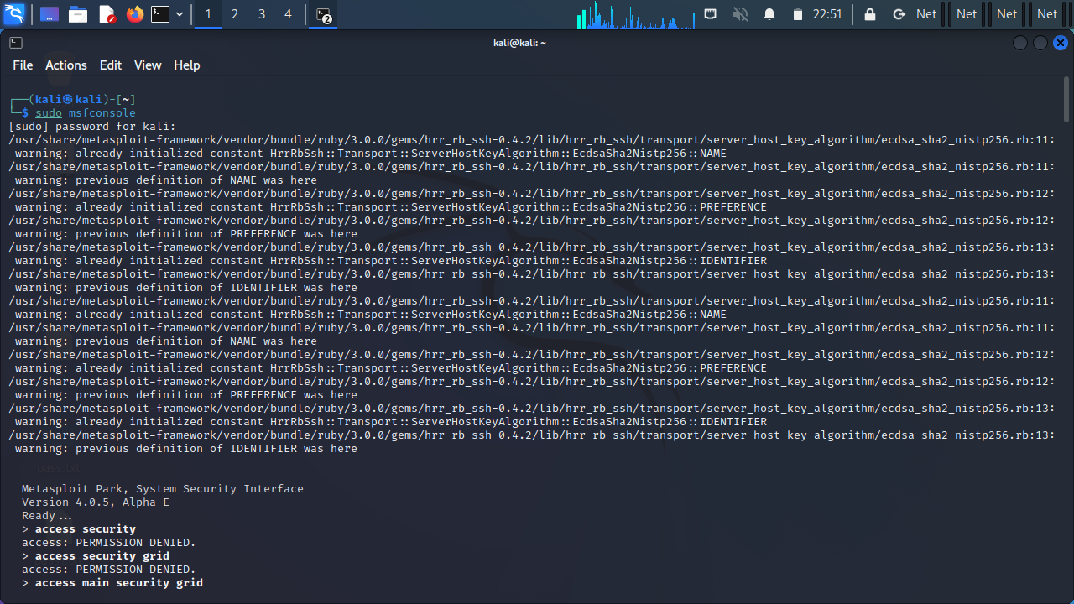

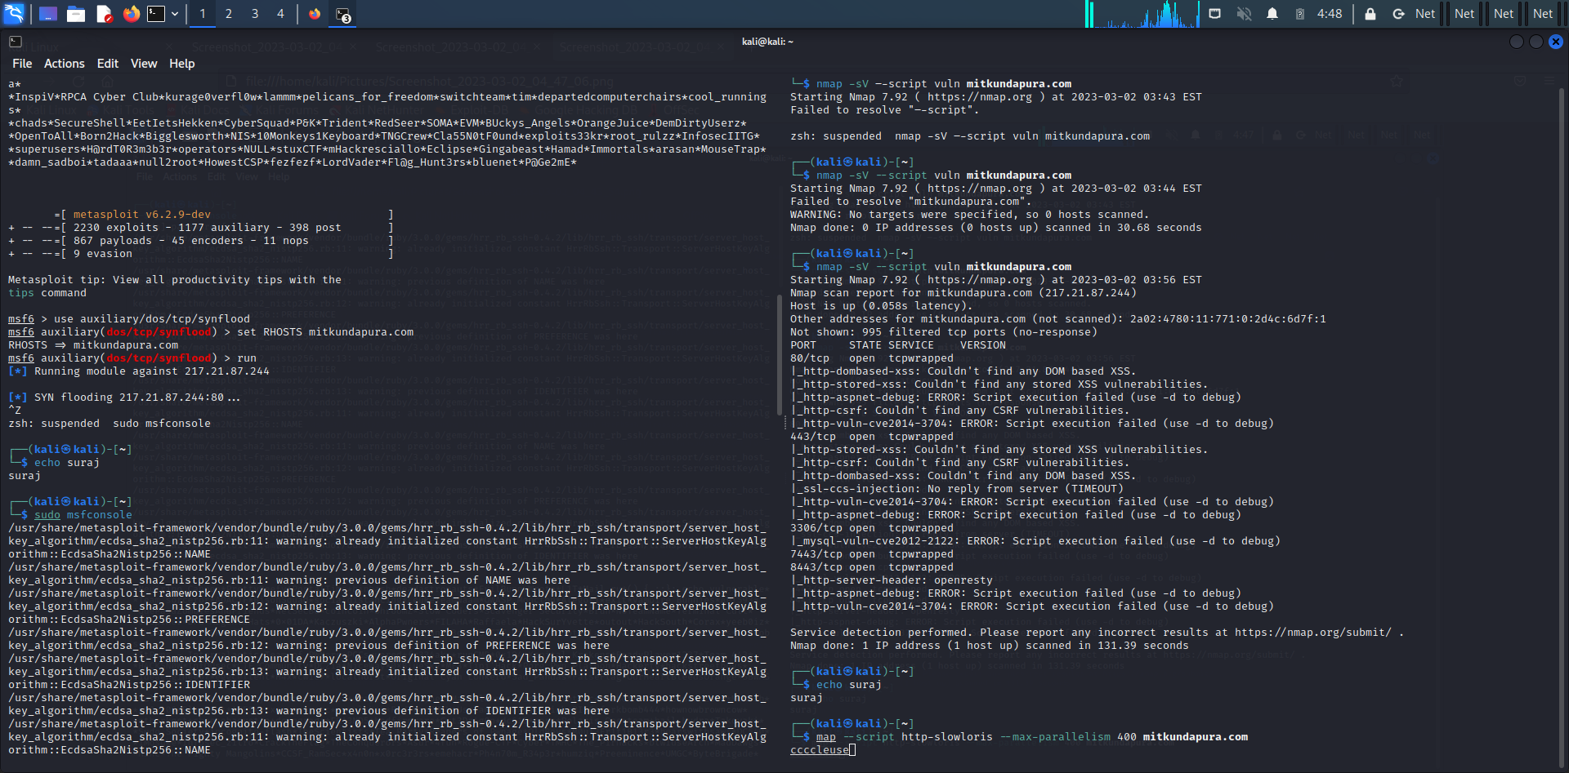

2**. sql empty password enumeration scanning using nmap:**

Week or blank password are an invitation security breaches. We can use the PWDCOMPARE security function to find these types of login and reset them with strong complex passwords to avoid any types of security breach.

**Command:**

$nmap -p 1433 --script ms-sql-info --script-args mssql.instance-port=1433 mitkundapura.com

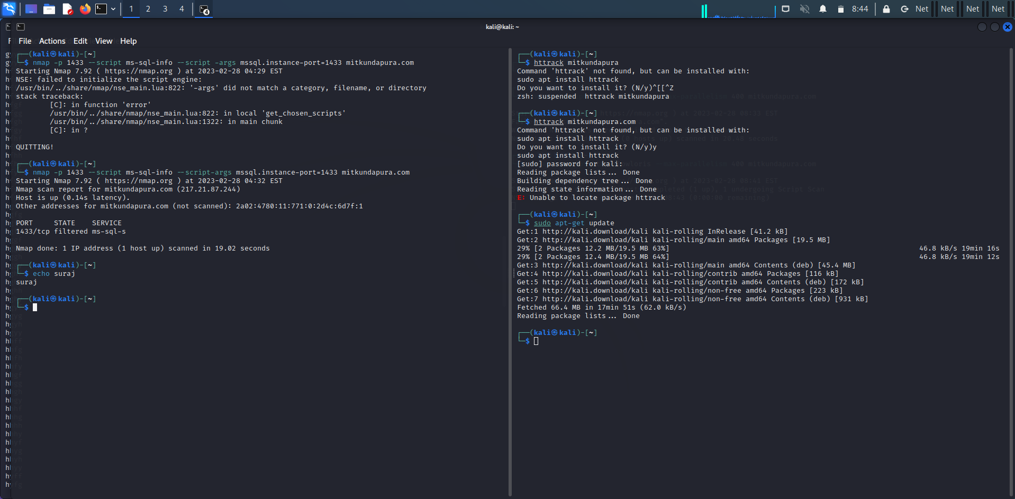

3. **vulnerability scan using nmap:**

A vulnerability scan is automated high level test that looks for potential

security vulnerabilities, while a penetration test is an executive examination that includes a live person actually digging into your network’s complexities to exploit the weakness in your system

**Command:**

$nmap -sV –script vuln mitkundapura.com

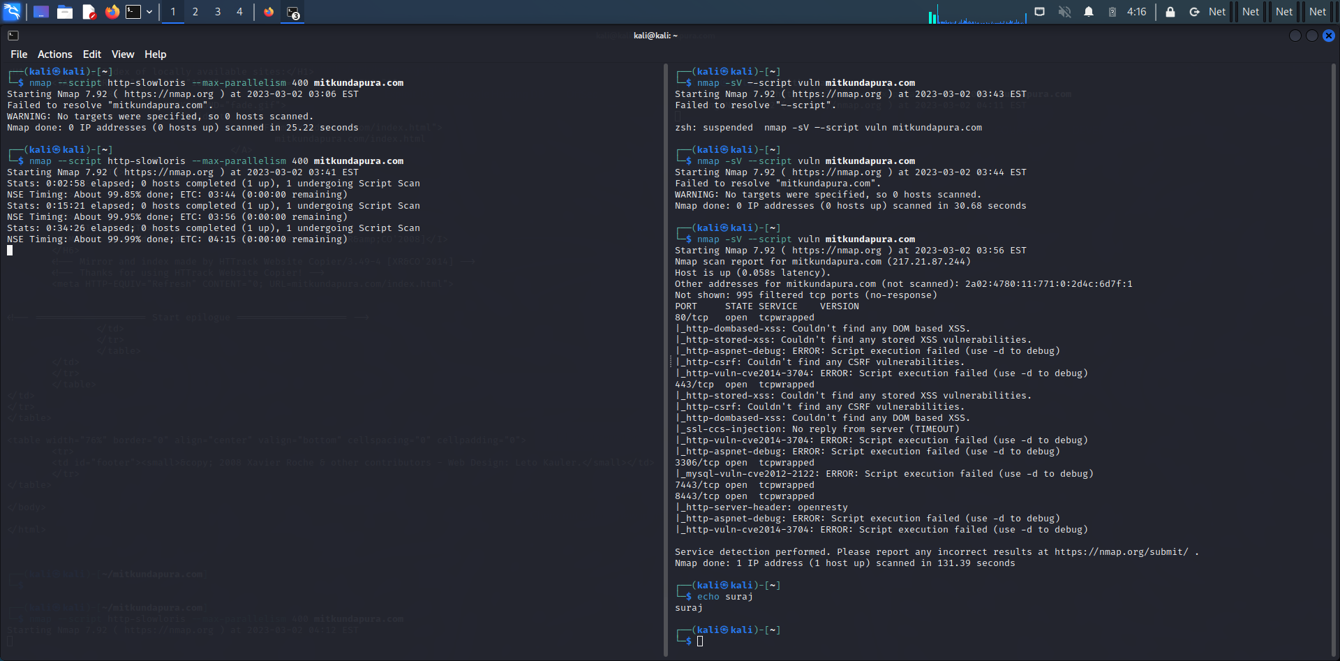

4.**create a password list using characters “fghy” the password should be minimum and maximum length 4 letters using tool crunch:**

Crunch is the world list generation tool that comes pre installed with Kali Linux It is used to generate custom keywords based on world list generates a world list with the permissions and combinations we could use some specific pattern and symbols to generate our list.

**Command:**

$Crunch 4 4 fghy -o pass.txt

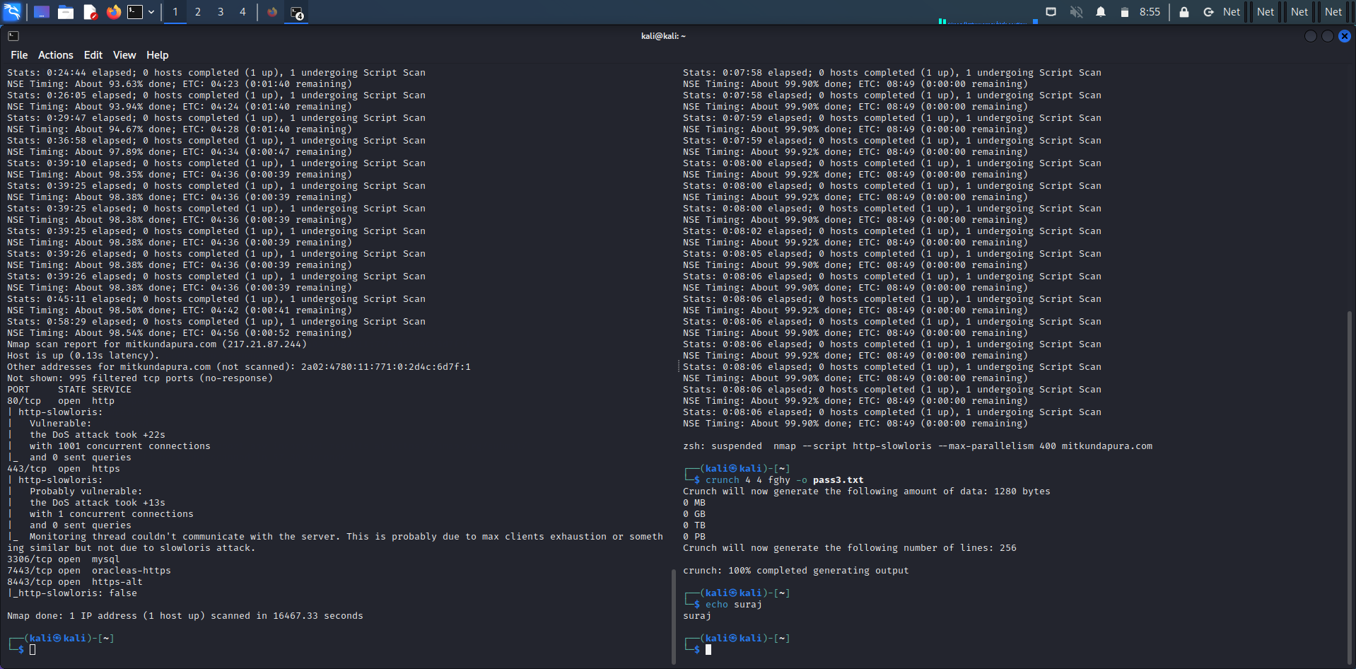

**5.Wordpress scan using nmap:**

Wpscan is a WordPress security scanner used to test word press installationand wordpress-powered website . This is a command line tool used in Kali Linux.

**Command:**

$nmap -sV --script http-wordpress-enum mitkundapura.com

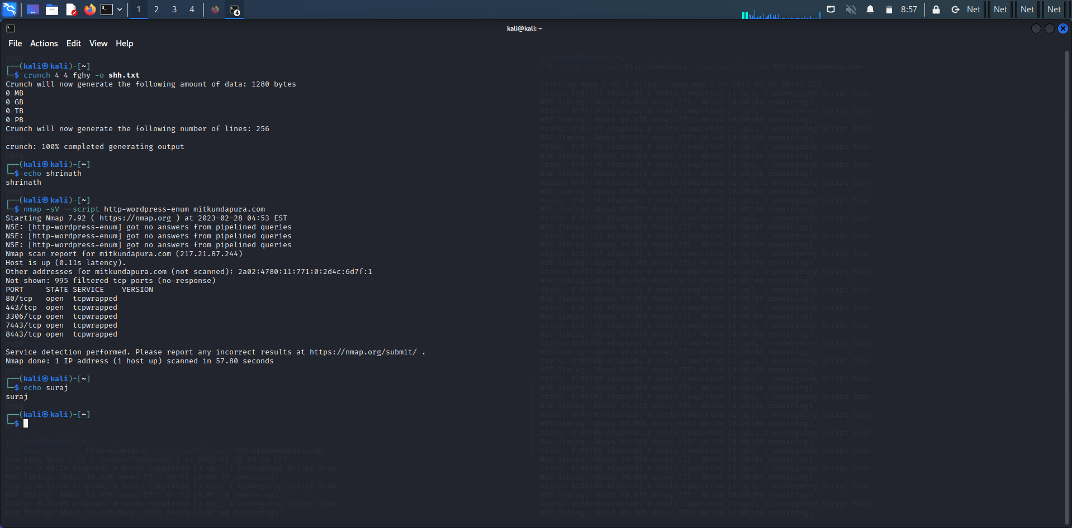

**6) What is the use of HTTRACKS? Command to copy website?**

HTTRACK allows user to download world wide website from the internet to a local computer. By default, HTTRACK arranges the downloaded site by the original site. Relative link -structure. The downloaded website can be browsed by opening a -page of the site in a browser.

**Command:**

httrack https://www.mitkundapura.com /

