**Detailed Design Document**

|  |  |
| --- | --- |
| **Project Name** | **FlightCoach-TKCS** |
| **Client Name** | **JEFF** |

##### Chetu Contacts

This section should list all Chetu team members.

Note: All Chetu emails are of the format: FirstnameLastnameinitial@chetu.com

Note: Chetu (US) team works normal hours EDT and can be reached at: 954-342-5676.

Note: Chetu (India) team works 5am-2pm EDT and can be reached at: 954-862-3901.

|  |  |  |  |
| --- | --- | --- | --- |
| Name | Role | Location | Responsibility |
| Shashi Das | Technical Project Manager | UK | Overall Project Management |
| Sanjeev Kota | DO | USA | Managing project delivery and operations |
| Suraj Pandit | Team Lead(Embedded developer) | India | Design Document, Requirement Understanding, Helping team on application development |
| Satish Kumar | Team Lead(UI/UX) | India | Helping team on Designee &D development |
| Manish Kumar | Embedded developer | India | Development |
| Anshu Singh | UI/UX | India | Designee &D development |

##### Client Contacts

This section should list all customer contacts including project champion and business users.

|  |  |  |  |
| --- | --- | --- | --- |
| Name | Email | Entity | Responsibility |
| Jeff | Jeff@jeffcass.com |  | PM POC, DO POC |
|  |  |  |  |

##### Revision Chart

A new record should be added in this section every time a user updates this document.

|  |  |  |  |
| --- | --- | --- | --- |
| Ver. # | Date | Author | Change |
| v.04132023 | 04/13/2023 | Suraj Pandit | Initial Draft |
|  |  |  |  |
|  |  |  |  |
|  |  |  |  |
|  |  |  |  |
|  |  |  |  |
|  |  |  |  |
|  |  |  |  |

##### Document Conventions

* *Notations in Italics contain Document instructions and should be preserved*.
* Sections highlighted in **yellow** shall be provided by Client.
* Sections highlighted in **grey** are questions or open items that need to be discussed further.

Contents

1.0 Introduction 5

1.1 Overview 5

1.2 Project Objectives 5

1.3 Approach Summary 5

2.0 FUDs [Fears, Uncertainties and Doubts] 6

3.0 Environment 7

3.1 Overview 7

3.2 Development Environment 7

3.2.1 QA Testing Environment 7

3.3 Staging Environment 7

3.4 Production Environment 7

4.0 Requirements recap 8

4.1 Overview 8

4.2 Block Diagram/ Circuit Diagram 8

4.3 Mode Of Operations 9

5.0 Design Details 17

5.1 SYSTEM ARCHITECTURE 17

5.2 Embedded System Programming Architechture 18

5.2.1 Flow Chart 19

6.0 User Interface 20

6.1 Overview 20

6.2 Main Page 20

6.2.1 Interface 20

6.2.2 Description 20

6.3 Results Page 20

6.3.1 Interface 20

6.3.2 Description 20

7.0 Change/Update Track Record. (According to Date) 21

# Introduction

## Overview

FlightCoach is a new customer in IOT Industry. Customer is working on his own custom Thermostat that will solve many of the issues like controlling and monitoring Temperature, Humidity, CO2 (Carbon Dioxide) and CO (Carbon Monoxide). He is still in the process of creating a prototype that will have a 7” Touchscreen Display to control these parameters and involves relevant sensors and devices.

## Project Objectives

* Initial phase of the project involves operating below sensors with ATMega4808 controller board.
  + SCD30 (humidity ,temperature and Co2 sensor)
  + Nextion display
  + Fan, first and second stage cooler and heater.
  + Aux 1, 2 output
  + ATSAMD11D14A(Wi-Fi) module
* Collect data from the sensor SCD30.
* Automate the system and take decision.
* Show data in Nextion Display using UI/UX.
* Control setup and send data to remote

## Approach Summary

*Write the immediate approach will be to analyze current application and provide a tabular representation of each field in the UI, with the database field it goes to and the business logic used on it. The table will be presented to client and seek a go forward or advise on modifications that would need to be done in the new application. Additionally, a proposed enhancement to the UI needs to be implemented to allow end users be able to enter “like” match criteria. Upon client feedback the application will be implemented.*

# FUDs [Fears, Uncertainties and Doubts]

*Not yet*

# Environment

## Overview

* Window 10
* Arduino Ide
* Nextion Editor
* 3rd Parties Libraries

## Development Environment

* Language: C or Embedded C
* UI /UX
* Repository for code back: SVN (internal)
* Issue Tracking: backbone (internal)

### QA Testing Environment

* Language: C or Embedded C
* UI /UX
* Repository for code back: SVN (internal)
* Issue Tracking: backbone (internal)

## Staging Environment

*NA*

## Production Environment

*NA*

# Requirements recap

## Overview

FlightCoach is a new customer in IOT Industry. Customer is working on his own custom Thermostat that will solve many of the issues like controlling and monitoring Temperature, Humidity, CO2 (Carbon Dioxide) and CO (Carbon Monoxide). He is still in the process of creating a prototype that will have a 7” Touchscreen Display to control these parameters and involves relevant sensors and devices.

## Block Diagram/ Circuit Diagram

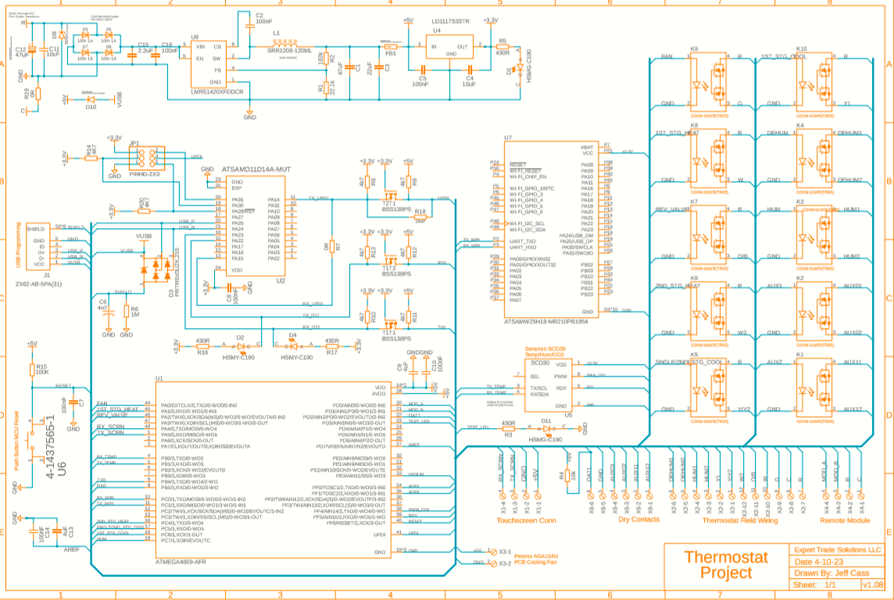

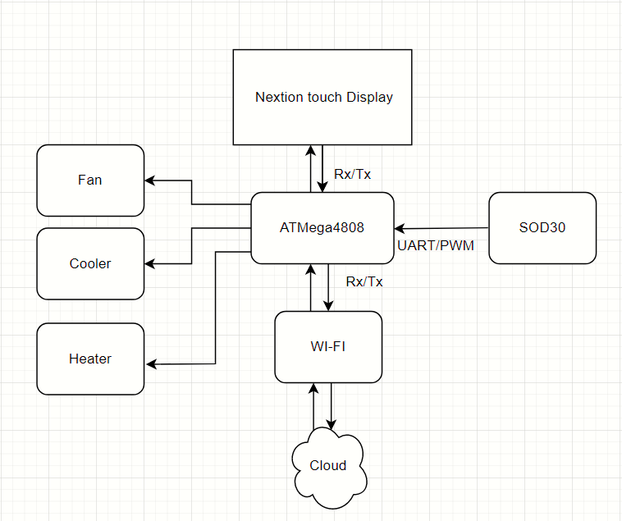

## Mode Of Operations

Basically 4 system mode of operations which will change the control of thermostat unit.

1. Heat pump with auxiliary heat
2. Heat pump with Gas heat
3. Straight cool with electric heat
4. Straight cool with Gas heat

There are (2) main control “Select buttons”. ***FAN*** and ***SYSTEM***. Following is a breakdown of each. Additionally (2) Select buttons can be turned on for control of Humidity, ***HUMIDIFY*** and ***DE-HUMIDIFY***

*Fan* Modes are **AUTO** and **ON**

**Auto** In this position the indoor fan is energized with any call for Heat, Cool, Emergency Heat, De-Humidify, Humidify, and CO2 air change.

**ON** In this position the indoor fan is energized to run continuously.

*System* Modes are **OFF**, **COOL**, **HEAT**, **EMERGENCY HEAT**, **CRUISE**

**CONTROL, DE-HUMIDIFY,** and **HUMIDIFY**

**OFF** This will command the whole system to shut down. (Fan can still run in the ON position) The detailed sequence will be outlined in more detail.

**COOL** This will energize the Cooling and Fan contacts based on the actual temp vs. the set temp. There are two stages of cooling, if that option has been selected in the installer setup menu. The detailed sequence will be outlined in more detail.

**HEAT** This will energize the Heating and Fan contacts. The detailed sequence will be outlined in more detail.

**EMERGENCY HEAT** This is only available if the HEAT PUMP option is selected in the installer setup menu. This will energize the fan and only the electric heating system. The detailed sequence will be outlined in more detail.

**CRUISE CONTROL** This will simply command the system to energize the associated contacts as needed for any “out of parameter” condition. This is only available if selected from the installer set up menu.

**DE-HUMIDIFY** This will energize the Cooling, Fan and electric heating. This is only available if selected from the installer set up menu. Additional contacts are used for a stand-alone dehumidifier.

**HUMIDIFY** This will energize the fan and auxiliary contacts. This is only available if selected from the installer set up menu. The auxiliary contacts are used for a stand-alone humidifier.

Sequence of operation (1) Main control buttons set to **Fan AUTO/ON** and **System OFF**.

If the Fan select button is OFF and the system select button is OFF, all air monitoring remains active, but no action will be initiated regardless of temperature/humidity/CO2.

If the Fan select button is in the ON position and the system select button is in the OFF position, all air monitoring remains active, but no action will be initiated regardless of temperature/humidity. If the CO2 rises above 600ppm the *AUX1* CO2 contacts are energized to allow for an outside air damper to open, introducing fresh air into the space. Once the CO2 reaches 500ppm the *AUX1* CO2 contacts are de-energized. DIFY simply remain energized since the Fan control button is in the ON position.

(The COOL temp set point is referenced for de-humidify if the system is in the **OFF** position)

If “**DE-HUMIDIFY**” is turned on, humidity is controlled in this mode as well.

If the actual humidity rises more than 7% above the humidity set point, The *Y/Y2* compressor contacts, the *G* fan contacts, the *W* electric heating contacts, the *DEHUM* contacts, and the O/B reversing valve contacts will be energized. This will command the system to cool while reheat is introduced by electric heat to allow the space to dehumidify. Temperature must not go out of range while dehumidifying. Therefore, the *W* electric heat contacts are energized when the actual temp reaches the temp set point -5deg F and are de-energized when the actual temp reaches the set point +5deg F. This modulation will continue until the humidity reaches the humidity set point -3% AND the temperature is within 5deg F of the COOL temp set point. Hard parameters are needed to keep the system from “Running away” in the event of a mechanical failure or lack of heating capacity. When/if the actual temp reaches the set point -6deg F, the system will de-energize the *Y/Y2* contacts while maintaining the *W* electric heat, *G* fan, and *DEHUM* contacts. Once the actual temp reaches the set point temp +6deg F then the *Y/Y2 contacts* can be energized again to commence the modulation. If the temperature is within 5deg F above or below set point AND the humidity is within 5% of the set point, the system simply cycles to “idle”. The *Y/Y2* compressor contacts, the *G* fan contacts, the *W* electric heat contacts and the *DEHUM* are all de-energized. The *G* fan contacts will remain energized if the fan control button is in the ON position.

If “**HUMIDIFY**” is turned on, a humidifier can be turned on from this mode. If the actual humidity is 7% below the humidity set point, the *G* fan contacts, and the *Hum* contacts are energized to allow a humidifier to increase space humidity. Once Actual humidity is 3% above humidity set point, the *Hum* contacts and the *G* fan contacts are de-energized. The *G* fan contacts will remain energized if the fan control button is in the ON position.

Sequence of operation (2) Main control buttons set to **Fan AUTO/ON** and **System COOL**.

The thermostat monitors the actual temp inside the space and compares it to the set point selected by the user. Should the actual temperature rise above the set point by .5deg F, the *Y/Y2* compressor contacts, the *G* fan contacts, and the O/B reversing valve contacts will be energized allowing the system to cool. When the actual temp falls below the set point by .5deg F then the *Y/Y2* and *G* contacts will be de-energized, and system will go back to idle. (Assuming humidity is in range). O/B reversing valve contacts remain energized anytime the System Select button is set to COOL. This small temp offset from set point prevents the system from short cycling while still maintaining close control of the desired temp. Once the contacts are de-energized a short minimum off timer begins a countdown to prevent mechanical short cycling. (timer set in user set up menu)

If “**DE-HUMIDIFY**” is turned on, humidity is controlled in this mode as well.

If the actual humidity rises more than 7% above the humidity set point, The *Y/Y2* compressor contacts, the *G* fan contacts, the *W* electric heating contacts, the *DEHUM* contacts, and the O/B reversing valve contacts will be energized. This will command the system to cool while reheat is introduced by electric heat to allow the space to dehumidify. Temperature must not go out of range while dehumidifying. Therefore, the *W* electric heat contacts are energized when the actual temp reaches the temp set point -.75deg F and are de-energized when the actual temp reaches the set point +.75deg F. This modulation will continue until the humidity reaches the humidity set point -3% AND the temperature is within .5 deg F of the temperature set point. Hard parameters are needed to keep the system from “Running away” in the event of a mechanical failure or lack of heating capacity. When/if the actual temp reaches the set point -1deg F, the system will de-energize the *Y/Y2* contacts while maintaining the *W* electric heat, *G* fan, and *DEHUM* contacts. Once the actual temp reaches the set point temp +.75deg F then the *Y/Y2 contacts* can be energized again to commence the modulation. If the temperature is within .5deg F above or below set point AND the humidity is within 5% of the set point, the system simply cycles to “idle”.

The *Y/Y2* compressor contacts, the *G* fan contacts, the *W* electric heat contacts and the *DEHUM* are all de-energized. The *G* fan contacts will remain energized if the fan control button is in the ON position.

If “**HUMIDIFY**” is turned on, a humidifier can be turned on from this mode. If the actual humidity is 7% below the humidity set point, the *G* fan contacts, and the *Hum* contacts are energized to allow a humidifier to increase space humidity. Once Actual humidity is 3% above humidity set point, the *Hum* contacts and the *G* fan contacts are de-energized. The *G* fan contacts will remain energized if the fan control button is in the ON position.

Carbon Dioxide detection is always active and operates independently/simultaneously with the above sequence.

If the CO2 rises above 600ppm the *AUX1* CO2 contacts and the *G* fan contacts are energized to allow for an outside air damper to open, introducing fresh air into the space. Once the CO2 reaches 500ppm the *AUX1* CO2 contacts and the G fan contacts are de-energized. The *G* fan contacts simply remain energized if the Fan control button is in the ON position.

Sequence of operation (3) Main control buttons set to **Fan AUTO/ON** and **System HEAT**.

The thermostat monitors the actual temp inside the space and compares it to the set point selected by the user. Should the actual temperature fall below the set point by .5deg F, the *Y/Y2* compressor contacts, the *G* fan contacts, will be energized allowing the system to Heat. When the actual temp rises above the set point by .5deg F then both contacts will be DE energized, and the system will go back to idle. (Assuming humidity is in range). This small temp offset from set point prevents the system from short cycling while still maintaining close control of the desired temp. Once the contacts are de-energized a short minimum off timer begins a countdown to prevent mechanical short cycling. (Timer set in user set up menu) There are two conditions that would require the addition of the *W* electric heat while heating with the heat pump. First if the actual temp is > 1.5 deg below the set point. And the other is extended heating run time. In either case the *Y/Y2* Contacts, the *G* fan Contacts and the *W* electric heat contacts are energized to allow for heat pump and supplemental electric heat to operate simultaneously. If the heating run time duration exceeds 12 minutes, this sequence would be initiated. System would return to idle once the actual temp reached the set point +.5deg F.

If “**DE-HUMIDIFY**” is turned on, humidity is controlled in this mode as well.

If the actual humidity rises more than 7% above the humidity set point, The *Y/Y2* compressor contacts, the *G* fan contacts, the *W* electric heating contacts, the *DEHUM* contacts, and the O/B reversing valve contacts will be energized. This will command the system to cool while reheat is introduced by electric heat to allow the space to dehumidify. Temperature must not go out of range while dehumidifying. Therefore, the *W* electric heat contacts are energized when the actual temp reaches the temp set point -.75deg F and are de-energized when the actual temp reaches the set point +.75deg F. This modulation will continue until the humidity reaches the humidity set point -3% AND the temperature is within .5 deg F of the temperature set point. Hard parameters are needed to keep the system from “Running away” in the event of a mechanical failure or lack of heating capacity. When/if the actual temp reaches the set point -1deg F, the system will de-energize the *Y/Y2* contacts while maintaining the *W* electric heat, *G* fan, and *DEHUM* contacts. Once the actual temp reaches the set point temp +.75deg F then the *Y/Y2 contacts* can be energized again to commence the modulation. If the temperature is within .5deg F above or below set point AND the humidity is within 5% of the set point, the system simply cycles to “idle”. The *Y/Y2* compressor contacts, the *G* fan contacts, the *W* electric heat contacts and the *DEHUM* are all de-energized. The *G* fan contacts will remain energized if the fan control button is in the ON position.

If “**HUMIDIFY**” is turned on, a humidifier can be turned on from this mode. If the actual humidity is 7% below the humidity set point, the *G* fan contacts, and the *Hum* contacts are energized to allow a humidifier to increase space humidity.

Once Actual humidity is 3% above humidity set point, the *Hum* contacts and the *G* fan contacts are de-energized. The *G* fan contacts will remain energized if the fan control button is in the ON position.

Carbon Dioxide detection is always active and operates independently/simultaneously with the above sequence.

If the CO2 rises above 600ppm the *AUX1* CO2 contacts and the *G* fan contacts are energized to allow for an outside air damper to open, introducing fresh air into the space. Once the CO2 reaches 500ppm the *AUX1* CO2 contacts and the G fan contacts are de-energized. The *G* fan contacts simply remain energized if the Fan control button is in the ON position.

Sequence of operation (4) Main control buttons set to **Fan AUTO/ON** and **System EMERGENCY HEAT**.

The thermostat monitors the actual temp inside the space and compares it to the set point selected by the user. Should the actual temperature fall below the set point by .5deg F, the *W* electric heat contacts, and the *G* fan contacts, will be energized allowing the system to heat with electric heat ONLY. When the actual temp rises above the set point by .5deg F then both contacts will be de-energized, and the system will go back to idle. (Assuming humidity is in range). This small temp offset from set point prevents the system from short cycling while still maintaining close control of the desired temp. Once the contacts are de-energized a short minimum off timer begins a countdown to prevent mechanical short cycling. (Timer set in user setup menu).

If “**DE-HUMIDIFY**” is turned on, only the *G* fan contacts and the *DEHUM* contacts will be energized. (Dehumidify with the *system* is not available in Emergency Heat mode, it can only energize the *DEHUM* contacts for a standalone dehumidifier).

If the actual humidity rises more than 7% above the humidity set point, The the *G* fan contacts and the *DEHUM* contacts will be energized allowing a stand-alone dehumidifier to decrease space humidity. The contacts remain energized until the humidity reaches the humidity set point -3%. The *G* fan contacts will remain energized if the fan control button is in the ON position.

If “**HUMIDIFY**” is turned on, a humidifier can be turned on from this mode. If the actual humidity is 7% below the humidity set point, the *G* fan contacts, and the *Hum* contacts are energized to allow a humidifier to increase space humidity. Once Actual humidity is 3% above humidity set point, the *Hum* contacts and the *G* fan contacts are de-energized. The *G* fan contacts will remain energized if the fan control button is in the ON position.

Carbon Dioxide detection is always active and operates independently/simultaneously with the above sequence.

If the CO2 rises above 600ppm the *AUX1* CO2 contacts and the *G* fan contacts are energized to allow for an outside air damper to open, introducing fresh air into the space. Once the CO2 reaches 500ppm the *AUX1* CO2 contacts and the G fan contacts are de-energized. The *G* fan contacts simply remain energized if the Fan control button is in the ON position.

Sequence of operation (5) Main control buttons set to **Fan AUTO/ON** and **System CRUISE CONTROL**.

The thermostat monitors the actual temp inside the space and compares it to both the Cooling and Heating set points selected by the user. Should the actual temperature rise above the cooling set point by .5deg F, the *Y/Y2* compressor contacts, the *G* fan contacts, and the O/B reversing valve contacts will be energized allowing the system to cool. When the actual temp falls below the cooling set point by .5deg F then the *Y/Y2* and *G* contacts will be de-energized, and system will go back to idle. (Assuming humidity is in range). O/B reversing valve contacts remain energized. This small temp offset from set point prevents the system from short cycling while still maintaining close control of the desired temp. Once the contacts are de-energized a short minimum off timer begins a countdown to prevent mechanical short cycling. (Timer set in user setup menu)

Additionally, if the actual temp inside the space falls below the heating set point by .5deg F, the *Y/Y2* compressor contacts, the *G* fan contacts, will be energized (O/B contacts are de-energized) allowing the system to Heat. When the actual temp rises above the set point by .5deg F then both contacts will be de-energized, and the system will go back to idle. (Assuming humidity is in range). This small temp offset from set point prevents the system from short cycling while still maintaining close control of the desired temp. Once the contacts are de-energized a short minimum off timer begins a countdown to prevent mechanical short cycling. (Timer set in user setup menu) There are two conditions that would require the addition of the *W* electric heat while heating with the heat pump. First if the actual temp is > 1.5 deg below the set point. And the other is extended heating run time. In either case the *Y/Y2* Contacts, the *G* fan Contacts and the *W* electric heat contacts are energized to allow for heat pump and supplemental electric heat to operate simultaneously. If the heating run time duration exceeds 12 minutes, this sequence would be initiated. System would return to idle once the actual temp reached the set point +.5deg F.

If “**DE-HUMIDIFY**” is turned on, humidity is controlled in this mode as well.

If the actual humidity rises more than 7% above the humidity set point, The *Y/Y2* compressor contacts, the *G* fan contacts, the *W* electric heating contacts, the *DEHUM* contacts, and the O/B reversing valve contacts will be energized. This will command the system to cool while reheat is introduced by electric heat to allow the space to dehumidify. Temperature must not go out of range while dehumidifying. Therefore, the *W* electric heat contacts are energized when the actual temp reaches the COOL temp set point -.75deg F and are de-energized when the actual temp reaches the COOL set point +.75deg F. This modulation will continue until the humidity reaches the humidity set point -3% AND the temperature is within .5 deg F of the temperature COOL set point. Hard parameters are needed to keep the system from “Running away” in the event of a mechanical failure or lack of heating capacity. When/if the actual temp reaches the COOL set point -1deg F, the system will de-energize the *Y/Y2* contacts while maintaining the *W* electric heat, *G* fan, and *DEHUM* contacts. Once the actual temp reaches the COOL set point temp +.75deg F then the *Y/Y2 contacts* can be energized again to commence the modulation.

If the temperature is within .5deg F above or below COOL set point AND the humidity is within 5% of the set point, the system simply cycles to “idle”. The *Y/Y2* compressor contacts, the *G* fan contacts, the *W* electric heat contacts and the *DEHUM* are all de-energized. The *G* fan contacts will remain energized if the fan control button is in the ON position.

If “**HUMIDIFY**” is turned on, a humidifier can be turned on from this mode. If the actual humidity is 7% below the humidity set point, the *G* fan contacts, and the *Hum* contacts are energized to allow a humidifier to increase space humidity. Once Actual humidity is 3% above humidity set point, the *Hum* contacts and the *G* fan contacts are de-energized. The *G* fan contacts will remain energized if the fan control button is in the ON position.

Carbon Dioxide detection is always active and operates independently/simultaneously with the above sequence.

If the CO2 rises above 600ppm the *AUX1* CO2 contacts and the *G* fan contacts are energized to allow for an outside air damper to open, introducing fresh air into the space. Once the CO2 reaches 500ppm the *AUX1* CO2 contacts and the G fan contacts are de-energized. The *G* fan contacts simply remain energized if the Fan control button is in the ON position

# Design Details

## SYSTEM ARCHITECTURE

## 

The presented smart thermostat is part of an internet of things (IOT) system of distributed modules and sensors. The architecture was defined to ensure ease of integration and scalability of the solution. These modules communicate via Message Queuing Telemetry Transport (MQTT).

The main purpose of the smart thermostat is to monitor and control air quality and thermal comfort inside rooms, as well as to be integrated into the building microgrid and pursue energy efficiency and demand control measures. The control software of the smart thermostat can be programmed to schedule the heating or cooling of a room, as well as to maintain air quality by keeping a CO2 concentration below a defined threshold. The system can include multiple smart thermostats installed in the same building, and is connected to the building management system that coordinates operation to ensure energy demand flexibility, for instance, in response to a high (or low) tariff period, a PV generation surplus period or a peak demand period. The smart thermostat is constituted by several modules with different tasks, as presented in above diagram.

## Embedded System Programming Architechture

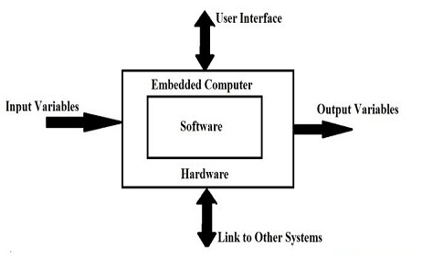

### Flow Chart

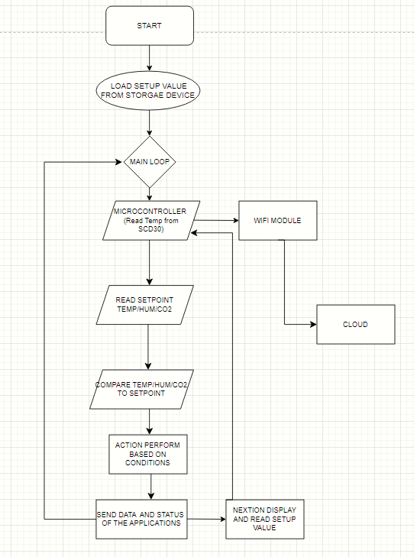

# User Interface

## Overview

Nextion is a Human Machine Interface （HMI） solution combining an onboard processor and memory touch display with Nextion Editor software for HMI GUI project development.

Using the Nextion Editor software, we can quickly develop the HMI GUI by drag-and-drop components (graphics, text, button, slider, etc.) and ASCII text-based instructions for coding how components interact on the display side.

Nextion HMI display connects to peripheral MCU via TTL Serial (5V, TX, RX, GND) to provide event notifications that peripheral MCU can act on, the peripheral MCU can easily update progress, and status back to Nextion display utilizing simple ASCII text-based instructions.

## Main Page

Not yet available

### Interface

Not yet available

### Description

Not yet available

## Results Page

### Interface

Not yet available

### Description

Not yet available

# Change/Update Track Record. (According to Date)

04/13/2023 – Created Suraj Pandit (Initial draft)