# Operational Mode

There are (6) main operational modes of heating/cooling/dehumidifying and (2) modes for fan operation. Listed are the operational modes followed by a more detailed sequence of operation for each.

There are two main control Select Button.

1. **FAN**
2. **SYSTEM**

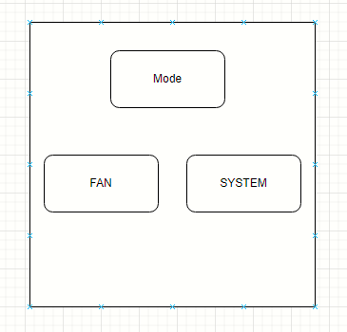

# Fan Modes are AUTO and ON

**Auto** In this position the indoor fan is energized with any call for heat, cool, dehumidify, Humidify, CO2 air change and CO monitoring. (CO High condition will activate an alarm sequence and fan shut down).

**ON** In this position the indoor fan is energized to run continuously. (Except in alarm condition.

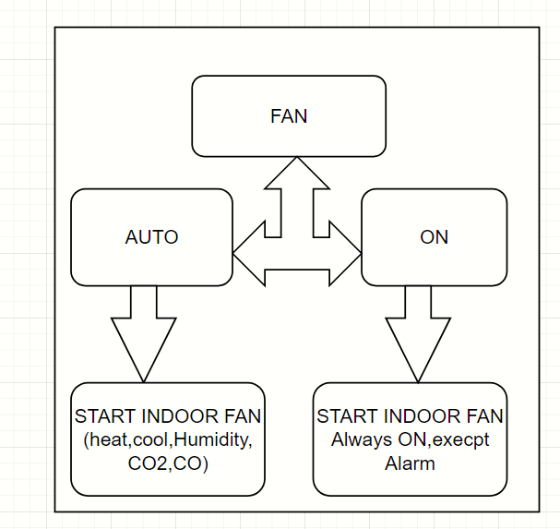

# System Modes are OFF, COOLING, HEATING, EMERGENCY HEAT, DEHUMIDIFY, and CRUISE CONTROL

**OFF** This will command the whole system to shut down. (Fan can still run in the ON position) The detailed sequence will be outlined in more detail.

**COOLING** This will energize the Cooling and Fan contacts based on the actual temp vs. the set temp. There are two stages of cooling, if that option has been selected in the installer setup menu. The detailed sequence will be outlined in more detail.

**HEATING** This will energize the Heating and Fan contacts. There are up to three stages of heating, if that option has been selected in the installer set up menu. The detailed sequence will be outlined in more detail.

**EMERGENCY HEAT** This is only available if the HEAT PUMP option is selected in the installer setup menu. This will energize the fan and only the electric heating system. The detailed sequence will be outlined in more detail.

**DEHUMIDIFY** This will energize the Cooling, Fan and electric heating. This is only available if selected from the installer set up menu. Additional contacts are used for a stand-alone dehumidifier.

**CRUISE CONTROL** This will simply command the system to energize the associated contacts as need for any “out of parameter” condition. This is only available if selected from the installer set up menu

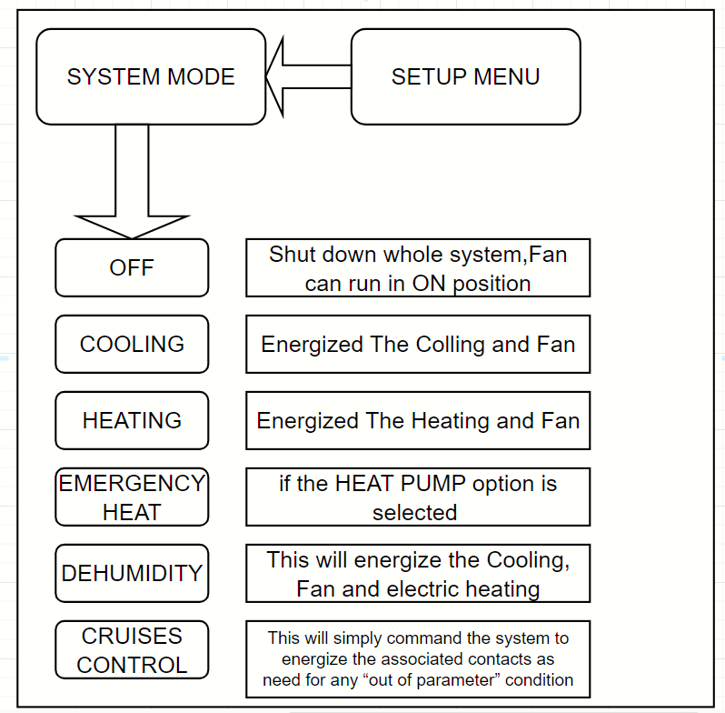

# Sequence of operation (1) Main control buttons set to Fan AUTO/ON and System OFF.

If the Fan select button is OFF and the system select button is OFF, all air monitoring remains active but no action will be initiated regardless of temperature/humidity/CO2. One exception is the CO monitoring.

If the CO rises above ____ ppm, a “HIGH CARBON MONOXIDE WARNING” alarm event will de-energize all contacts and put the system in idle mode including the *G* fan contacts. This should command a “Push Notification” to the user and will present an on-screen alarm warning. Once CO falls below _____ ppm, the system may return to the modes required to maintain space comfort as outlined above while indicating an alarm event has taken place. A record of re-settable alarm events should be available in a diagnostic screen.

If the Fan select button is in the ON position and the system select button is in the OFF position, all air monitoring remains active, but no action will be initiated regardless of temperature/humidity. If the CO2 rises above 600ppm the *AUX3* CO2 contacts are energized to allow for an outside air damper to open, introducing fresh air into the space. Once the CO2 reaches 500ppm the *AUX3* CO2 contacts are de-energized. The *G* fan contacts simply remain energized since the Fan control button is in the ON position.

