We have to use this tech stack:
.jsp for frontend
Java mvc for backend
MySQL for database
I have added some pages which we have to create, First one is sign up or create account page, after that user should be able to sign in the website, after completing sign in, user need to fill complete profile where I have added some screenshots for the various sections which we have to add and also some more section I have instructed you to do, please refer the screenshots and create sections in profile accordingly.

Login Page:
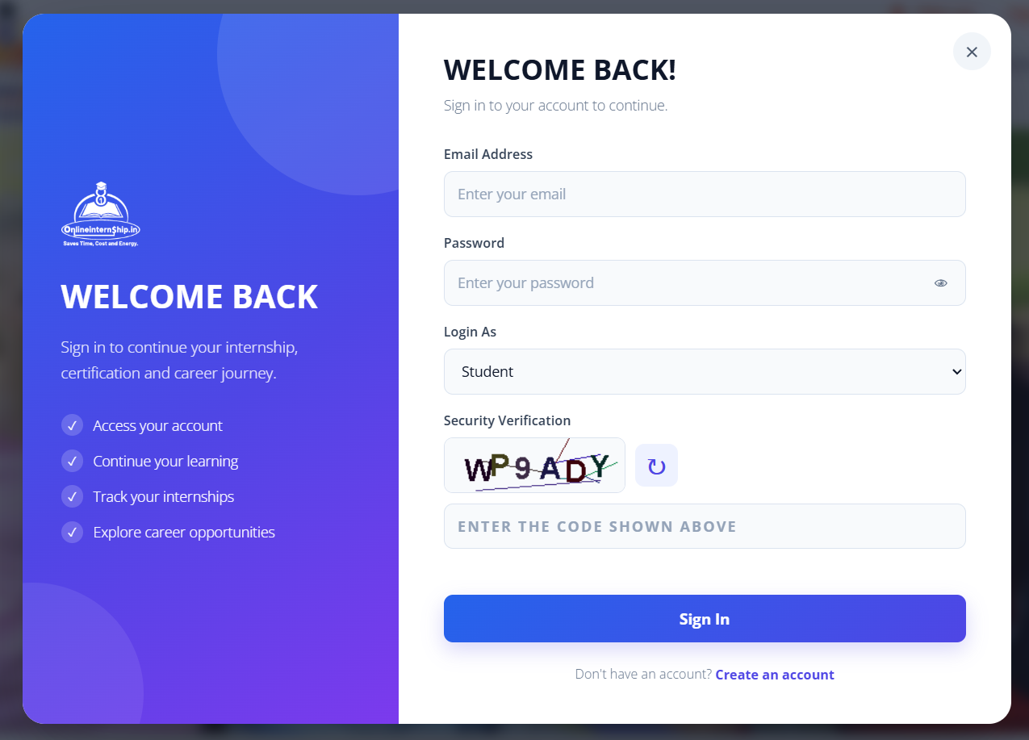

Register or Signup page:
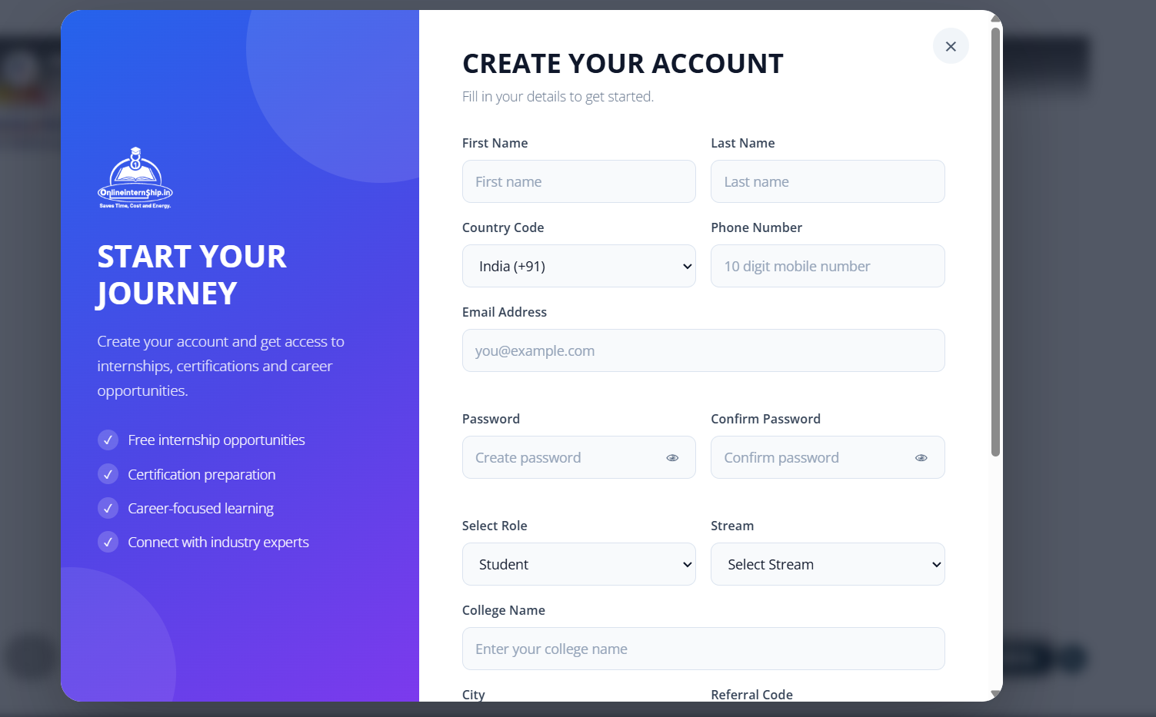

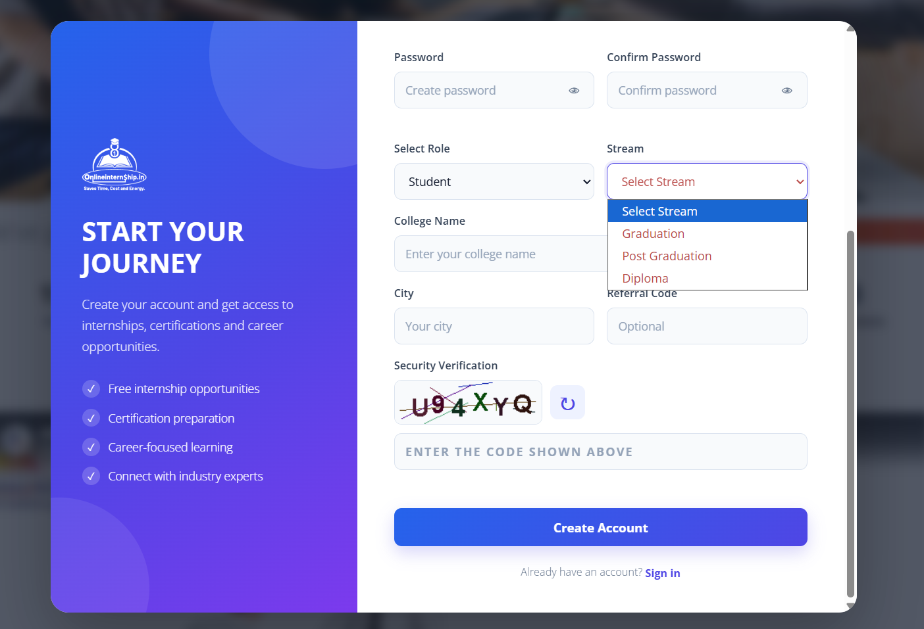

Student Profile:
- Personal Details:

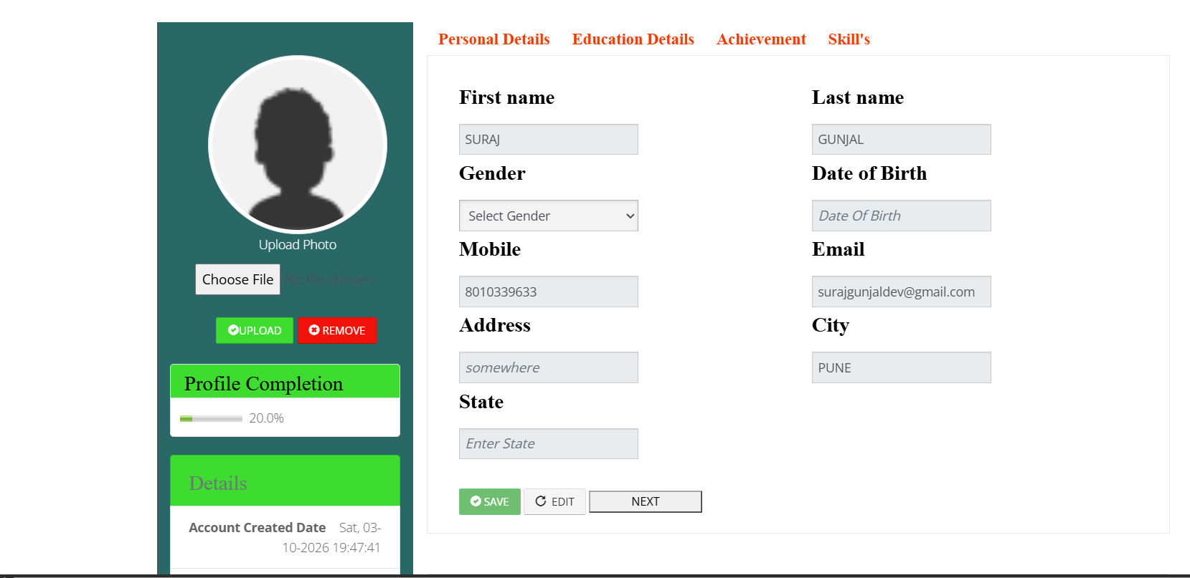

- Education Details:
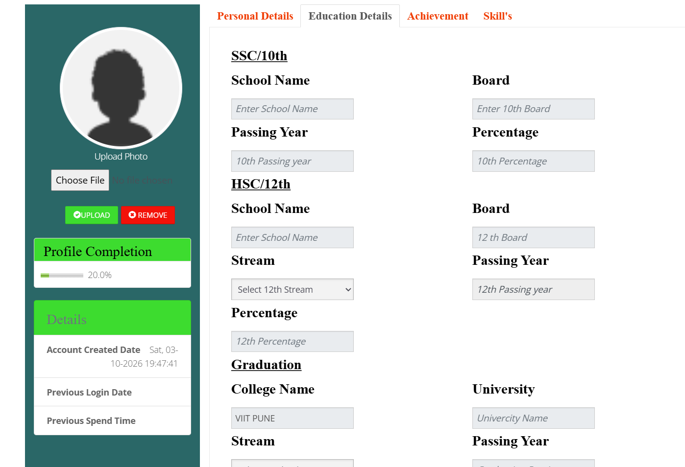
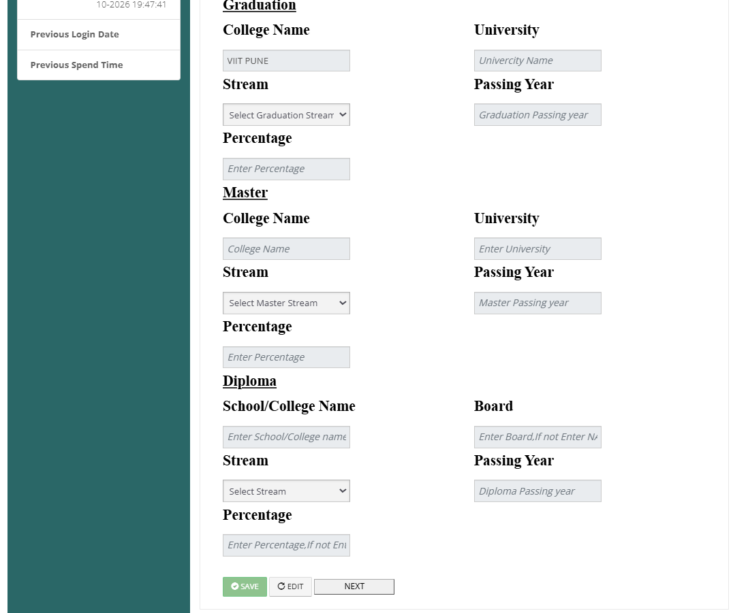

- Achivements:
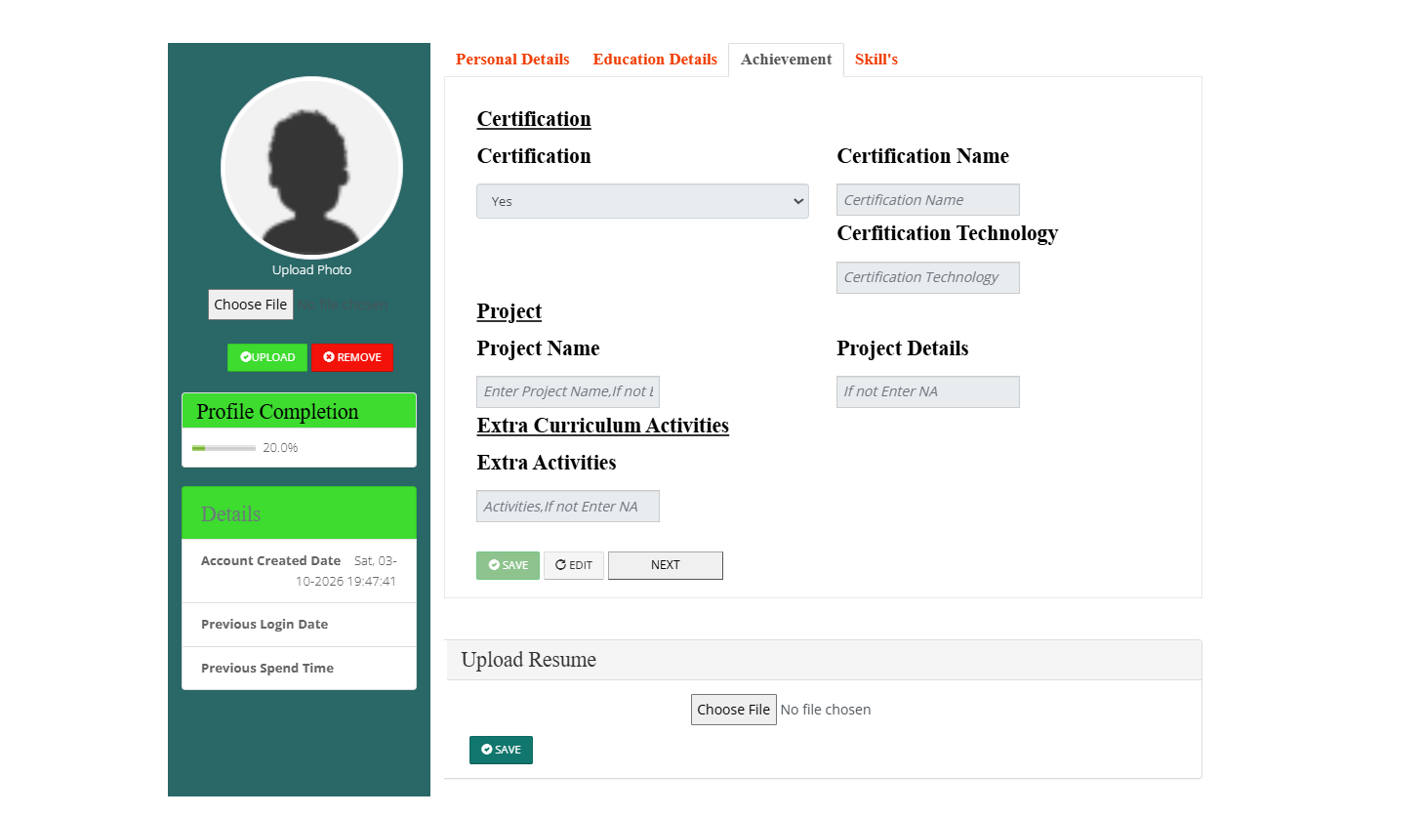

- Skills:

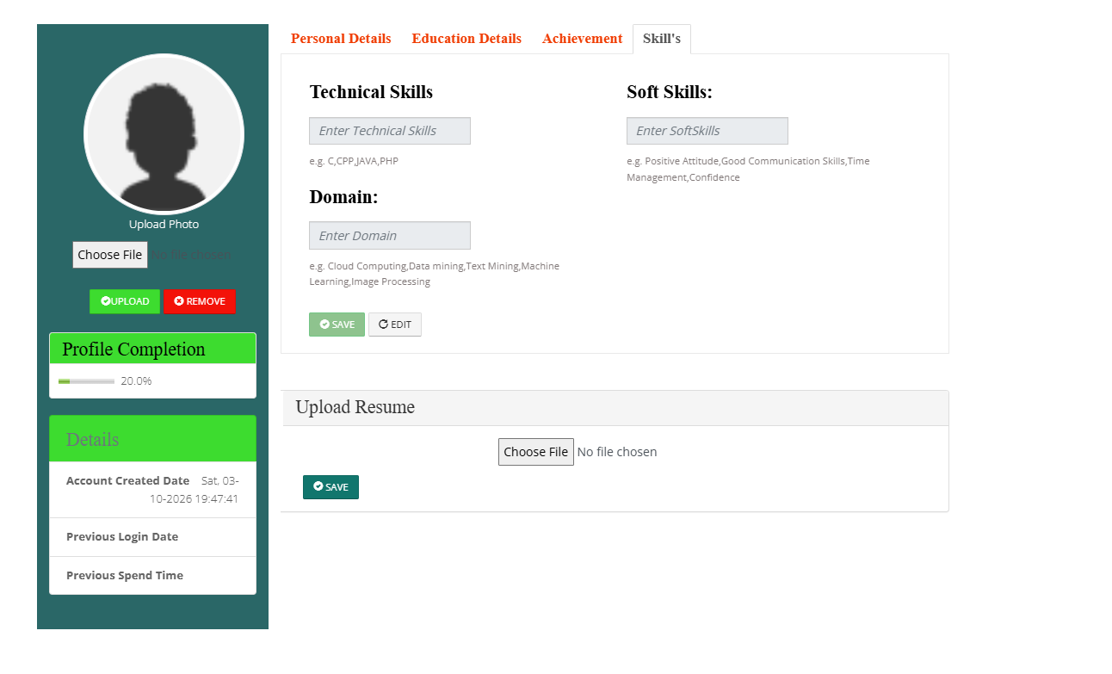

Also wanted to add this sections:
Certification
Project
Additional Activities

* Hackathons
* Inter-College Project Competitions

