**DMAIC Project Report**

**Project Title:** Shortening Diagnosis Time for Returned Defective Phones.

Define Phase :

* Tool Used :- Project Charter

**Q: What is the name of your project?**  
- *Shortening Diagnosis Time for Returned Defective Phones.*  
This project addresses the delays in determining faults in defective phones, aiming to deliver quicker results for both customers and the business.

**Q: Why does this project matter? How does it meet business objectives?**  
- The diagnosis stage currently causes significant delays, leading to:

* Customer dissatisfaction
* Repair center congestion  
  By reducing this time, the project directly supports the company’s goal of quick, high-quality service that keeps customers loyal.

**Q: What specific problem are you resolving (measurable)?**  
- On average, it takes **72 hours** to diagnose a returned phone. This slows the repair process and causes missed service targets.

**Q: What is your measurable goal or target?**  
- Reduce diagnosis time to < 24 hours within 3 months (a 66.7% reduction).

Calculation :

Reduction : 72 -24 = 48 hours

Percentage : 48 / 72 * 100 = 66.7 %

**Q: What is inside and outside of the project scope?**

**In Scope (things we will cover):**  
- This project will only look at the diagnosis stage of returned phones. This means from the time a phone comes to the service center until the problem in the phone is found and written down.

The work we will include:

* Taking the phone from the customer and writing the details in the system (logging).
* Checking and testing the phone to see what fault it has.
* Recording the results of the test.
* Using the available technicians and test equipment in a better way to save time.

These steps are included because they are the main reason why it now takes **72 hours** to complete diagnosis.

**Out of Scope (things we will not cover):**  
This project will not focus on other activities outside diagnosis. These are:

* The **actual repair** of the phone.
* **Ordering or keeping spare parts**.
* **Talking with the customer** about the status of the repair.
* Any **billing or warranty** process.

These are not included because they do not directly change the **time taken to find the fault**.

**Q: Who are on the project team and their roles?**

* Project Lead → Oversees DMAIC progress
* Quality Engineer → Tracks metrics
* Technician → Performs diagnosis
* Data Analyst → Studies timings & reports
* Support Representative → Handles intake docs

**Q: What is your estimated schedule with milestones?**

* Week 1: Define
* Weeks 2–3: Measure
* Weeks 4–5: Analyze
* Weeks 6–7: Improve
* Week 8: Control

**Q: What are the benefits you anticipate?**

* **Time Savings:** 72 hrs → <24 hrs (saving 48 hrs/phone)
* **Annual Savings:** ~$50,000 from labor efficiency
* **Customer Satisfaction:** Faster returns, improved trust

**Q: What risks or limitations can you anticipate?**

* Limited test equipment
* Technician availability
* Resistance to new processes

Measure Phase :

* Tools Used : Process Maps and Flow Charts

In this phase, the main goal is to **understand the current process performance** by measuring how long each step takes and where delays are happening.

**What is measured:**

* Average diagnosis time
* Time per sub-step (logging, testing, documentation)
* Output: phones diagnosed per day

**Current State Process Flow (Process Map)**

**Steps in the process today:**

1. **Phone Arrives** at the service center.
2. **Logging (Manual):** Customer and phone details are entered into the system manually.
3. **Queue for Equipment:** Phone waits for available test equipment.
4. **Diagnosis Testing:** Technician checks the phone using tools and testing stations.
5. **Documentation:** Technician writes down the fault report.
6. **Confirmed Fault:** Final diagnosis is shared with the repair team.

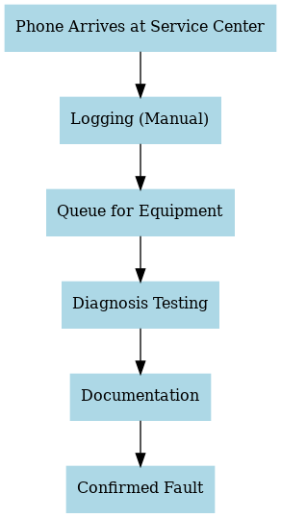

**Process Baseline Performance :**

|  |  |
| --- | --- |
| **Metric** | **Value** |
| Average Diagnosis Time | 72 hours |
| Range (best–worst case) | 48–96 hours |
| Phones Diagnosed per Day | ~15 |

* **Step-wise Timing Breakdown**

|  |  |
| --- | --- |
| **Process Step** | **Average Time (hrs)** |
| Logging (Manual) | 15 |
| Queue for Equipment | 20 |
| Diagnosis Testing | 30 |
| Documentation | 7 |
| **Total** | **72** |

The average diagnosis time of **72 hours** is far too long and is the **bottleneck** in the entire repair cycle.

**Delays Found in Process Mapping**

1. **Logging (Manual entry):**
   * Takes too long because details are entered manually.
   * In some cases, customers must wait while staff finish paperwork.
   * Accounts for a **large chunk of wasted time**.
2. **Queue for Equipment:**
   * Not enough testing equipment for the number of returned phones.
   * Phones sit idle waiting for an open test station.
   * Leads to **long waiting periods** before testing even begins.

The bar chart illustrates the average time taken for each major process step in the current phone service workflow. Among the steps, **Diagnosis Testing (30 hrs)** and **Queue for Equipment (20 hrs)** are the most time-consuming, indicating potential bottlenecks. Logging (15 hrs) also contributes significantly to delays, while Documentation takes the least time (7 hrs). This visual highlights where process improvements can have the greatest impact.

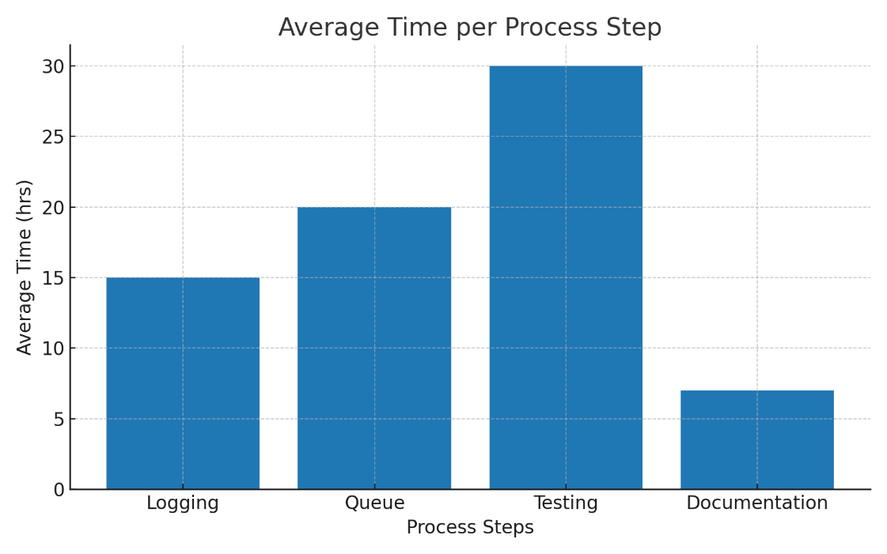

**Observations:**

* “Most time is lost in manual logging and equipment waiting.”
* “Technicians spend more time idle than actually testing.”

Analyze Phase

* Tool Used : Tool: Cause-and-Effect & Pareto Analysis

**Purpose:** Identify root causes of diagnosis delays.

1. **Cause-and-Effect (Fishbone) Diagram :**

We used a Fishbone diagram to brainstorm all possible causes of delay. The causes are grouped into four categories:

* **Man (People):**
  + Technicians have different levels of skill.
  + Some need more time to handle complex phones.
* **Machine (Equipment):**
  + Limited number of test devices, so phones wait in queue.
* **Method (Process):**
  + No fixed standard procedure for diagnosis.
  + Every technician follows their own way.
* **Material (Support/Resources):**
  + Manual paperwork and slow data entry at the start.

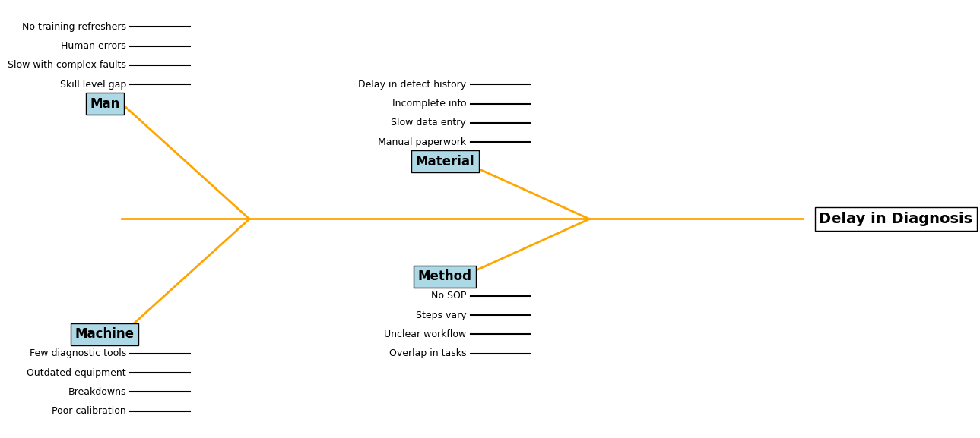

Fig . fishbone diagram

**2 ) Pareto Analysis**

We then calculated how much each cause contributes to total delay:

|  |  |
| --- | --- |
| **Cause** | **Contribution %** |
| Manual intake (data entry) | 40% |
| Shortage of test equipment | 25% |
| Technician variability | 20% |
| Lack of SOPs | 15% |

* According to the **Pareto principle (80/20 rule)**, the biggest delays come from:
  + **Manual intake** (40%)
  + **Shortage of test equipment** (25%)
* Together, these two make up **65% of total delays**.
* This means if we fix these two problems, we can remove most of the delay.

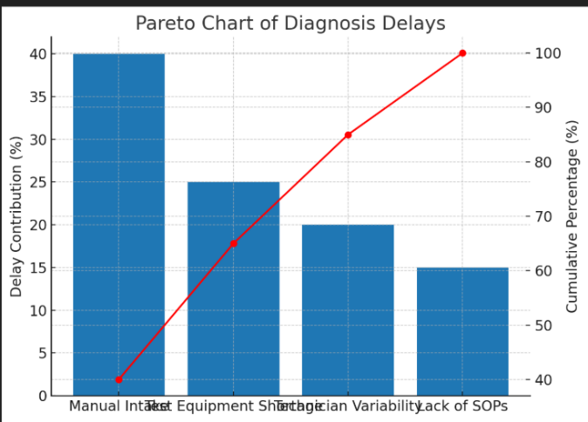

**Insights from Analyze Phase**

* The diagnosis process is delayed mainly because of **manual entry** and **limited equipment**.
* Smaller but still important causes are **technician variability** and **lack of proper SOPs**.
* The analysis gives us a **clear focus** for the Improve phase:
  + Automate or speed up data entry.
  + Add more test equipment or optimize its usage.

Improve Phase :

* Tool Use : Designed Experiments – DOE

**Objective:** Test solutions to reduce time.

**Steps Taken:**

1. **Identify possible improvements:**
   * Use a **barcode scanner** for intake instead of manual entry.
   * Create **Standard Operating Procedures (SOPs)** so every technician follows the same method.
   * Add **extra testing bays** so more phones can be checked in parallel.
2. **Run an experiment (DOE):**
   * Took a **sample of 50 phones**.
   * Divided them between old process and new process.
   * Measured the time taken in both cases.
3. **Results:**
   * Old process = **72 hours average**.
   * New process (Barcode + SOP + extra bay) = **22 hours average**.
   * **Time saved = 50 hours per phone batch.**
   * **Percentage reduction = 69.4%.**

**Experiment Results (50 phones sample)**

|  |  |
| --- | --- |
| **Method** | **Avg Time (hrs)** |
| Old process | 72 |
| New (Barcode + SOP + Bay) | 22 |

**Time Saved = 72 – 22 = 50 hrs**

**Percentage reduction = 69.4%.**

**Final Selected Solutions:**

* Barcode scanner for intake
* SOPs for testing
* Additional testing bays

Control Phase :

* Tool Used : SPC & Control Plans

Objective : Sustain improvements & prevent regression.

Once the improvements were implemented and diagnosis time successfully reduced from 72 hours to 22 hours, the focus shifted towards **maintaining these gains**. The Control phase ensures that the new process does not revert to old inefficiencies and that the improvements remain consistent in the long run.

**1. Control Plan Development**

A structured **control plan** was created to define how the process would be monitored:

* **Daily tracking of average diagnosis time** to verify it remains close to the new benchmark of 22 hours.
* **Technician compliance monitoring** to check if all employees are following the new Standard Operating Procedures (SOPs).
* **Equipment monitoring** (barcode scanners, diagnostic tools, and testing bays) to ensure machines remain functional and downtime is minimized.

**2. Standardization of Procedures**

To ensure consistency, the improved methods were converted into **formal SOPs**. These included:

* Mandatory use of **barcode scanning** during intake to eliminate manual data entry errors.
* **Checklist-based diagnosis** for each technician to avoid missed steps.
* **Daily reporting logs** to track diagnosis times per device.

By standardizing the process, variability between technicians was reduced, leading to predictable and repeatable results.

3 **Statistical Process Control (SPC)**

To ensure early detection of process deviations, **SPC tools** were introduced:

* An **X-bar control chart** was prepared with:
  + **Centerline (CL): 22 hours** (new process average)
  + **Upper Control Limit (UCL): 30 hours**
  + **Lower Control Limit (LCL): 15 hours**
* Any point above 30 hours or unusual patterns (such as consecutive increases in time) would act as an **early warning signal**, prompting root cause analysis and corrective action.

This statistical monitoring ensures that process variations remain within acceptable limits.

