**Project Title:**

Optimization of Paint Usage and Defect Reduction in Turbine Blade Manufacturing

(in General Electrics)

**Business Case:**

GE’s turbine blade manufacturing units were experiencing excess paint consumption and surface finish defects, increasing production costs and reducing yield. This project aligns with GE’s strategic goal of improving process efficiency, minimizing waste, and achieving cost savings under the global Six Sigma initiative. Reducing variation and defects will enhance customer satisfaction and overall profitability.

**Problem Statement:**

The current turbine blade painting process exhibits inconsistent paint thickness, leading to surface defects and an average paint wastage of 12% per unit. This variation has resulted in rework, increased material costs, and longer cycle times.

**Goal Statement:**

To reduce paint consumption by **at least 8%** and surface defects by **40%**, while maintaining product quality and meeting all customer CTQ requirements within a **six-month period**.

**Project Scope:**

**IN Scope:**

* Turbine blade surface coating process
* Paint thickness uniformity analysis
* Operator and machine calibration
* Data collection from three GE manufacturing plants

**OUT of Scope:**

* Blade casting or heat treatment processes
* Paint formulation redesign

**Project Team:**

|  |  |  |
| --- | --- | --- |
| **Role** | **Team Member** | **Responsibility** |
| Project Sponsor | Plant Operations Director | Approves and funds project |
| Six Sigma Black Belt | Process Improvement Manager | Leads DMAIC process |
| Process Engineer | Coating Line Engineer | Data collection & process control |
| Quality Analyst | QA Team Lead | Measurement system analysis & SPC |
| Operator Representative | Line Supervisor | Implements improved methods |
| Finance Analyst | Cost Reduction Specialist | Tracks savings and ROI |

**Timeline & Major Milestones**

|  |  |  |
| --- | --- | --- |
| **DMAIC Phase** | **Duration** | **Key Deliverables** |
| **Define** | 2 weeks | SIPOC, VOC → CTQ, Charter approval |
| **Measure** | 3 weeks | Data collection, MSA, Pareto analysis |
| **Analyze** | 4 weeks | Root cause validation via Hypothesis Testing & FMEA |
| **Improve** | 6 weeks | DOE optimization, Pilot implementation |
| **Control** | 3 weeks | SPC charts, Control plan, Handover report |

**Total Duration:** ~18 weeks (approx. 4.5 months)

**Expected Benefits:**

* Paint consumption reduced by **8–10%**, saving ~$1.5M annually per plant.
* Surface defect rate reduced from **3.5% to 2.0%**.
* Overall process sigma level increased from **3.1σ to 4.2σ**.
* Improved operator efficiency and process consistency.

**Constraints & Risks:**

* Variation in operator skills and manual application methods.
* Limited downtime for testing new paint parameters.
* Possible resistance to new process controls or monitoring systems.

**D – DEFINE**

Statistical Tool: SIPOC Diagram (Suppliers, Inputs, Process, Outputs, Customers)

**• What is the problem statement?**  
Excess paint usage (12% wastage) and uneven paint thickness are causing surface finish defects, rework, and increased costs in the turbine blade manufacturing process.

**• Who are the customers affected?**

* Internal: Production, Quality Assurance, and Cost Control Teams
* External: Industrial clients purchasing turbine blades for power generation

**• What is the goal of this project?**  
Reduce paint wastage by 8–10%, minimize defect rates by 40%, and enhance process capability from 3.1σ to at least 4σ.

**• What are the Critical to Quality (CTQ) factors?**

* Paint thickness uniformity (±5 microns tolerance)
* Surface finish quality (no visible defects)
* Material cost per unit
* On-time delivery and throughput

SPOC Diagram :

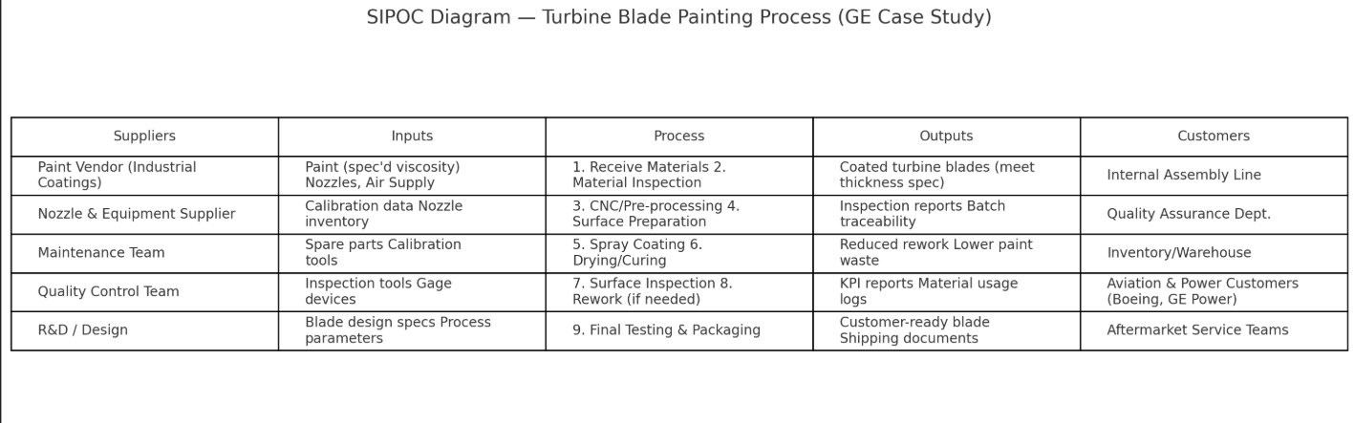

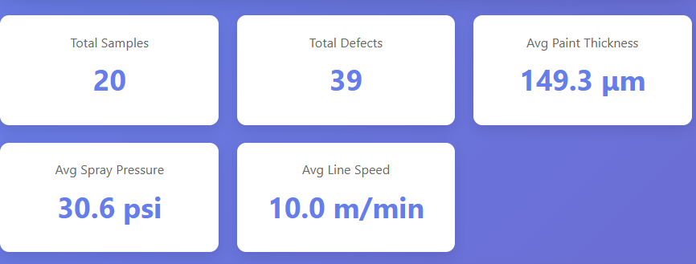

A SIPOC diagram helps visualize the complete manufacturing process from start to finish. It defines boundaries and identifies key stakeholders and process elements.  
At GE, SIPOC was used to understand the **turbine blade painting process** — who provides the materials (suppliers), what inputs are used (paint, air pressure, line speed), the process flow (coating → drying → inspection), outputs (painted blades), and who the customers are (power generation clients).

M – MEASURE

Statistical Tool**:** Pareto Chart

**• What is the current performance level?**

* Paint wastage: 12%
* Defect rate: 3.5% of blades
* Process capability: 3.1σ

**• What data will you collect?**

* Paint thickness readings (micron levels)
* Rework and defect counts per batch
* Operator and machine calibration data
* Material usage logs

**• How will you measure it?**  
Using **Gage R&R** for instrument precision, **Pareto charts** for top defects, and **control charts** for baseline variation.

**Sample Data for Measure Phase (20 rows) :**

|  |  |  |  |  |
| --- | --- | --- | --- | --- |
| **Sample ID** | **Paint Thickness (µm)** | **Spray Pressure (psi)** | **Line Speed (m/min)** | **Defects (count)** |
| **1** | **148** | **30** | **10** | **2** |
| **2** | **152** | **32** | **10** | **1** |
| **3** | **147** | **29** | **11** | **3** |
| **4** | **149** | **31** | **10** | **2** |
| **5** | **153** | **33** | **9** | **1** |
| **6** | **146** | **28** | **11** | **3** |
| **7** | **150** | **30** | **10** | **2** |
| **8** | **151** | **31** | **10** | **2** |
| **9** | **149** | **32** | **9** | **1** |
| **10** | **147** | **29** | **11** | **3** |
| **11** | **152** | **32** | **10** | **1** |
| **12** | **148** | **30** | **10** | **2** |
| **13** | **150** | **31** | **9** | **2** |
| **14** | **151** | **33** | **9** | **1** |
| **15** | **147** | **29** | **11** | **3** |
| **16** | **149** | **30** | **10** | **2** |
| **17** | **153** | **32** | **9** | **1** |
| **18** | **146** | **28** | **11** | **3** |
| **19** | **148** | **30** | **10** | **2** |
| **20** | **150** | **31** | **10** | **2** |

Pareto Chart :

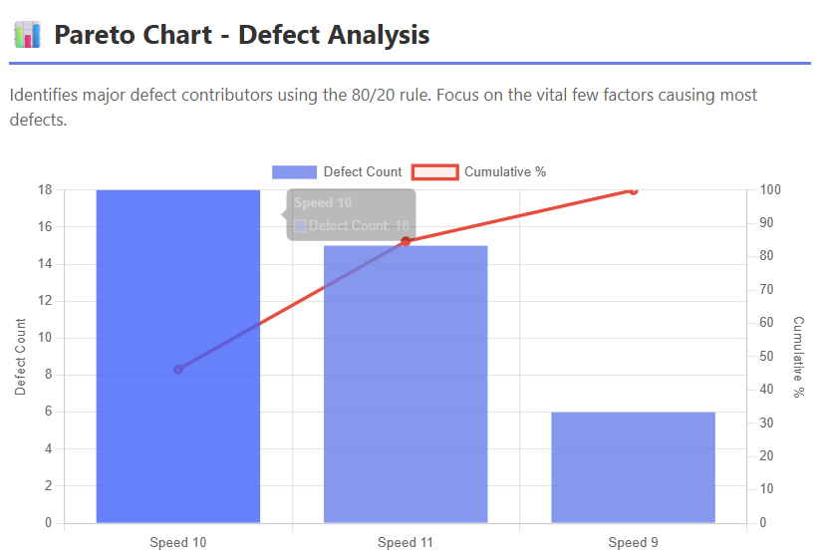

A Pareto Chart helps identify which defect types or causes contribute the most to total defects — based on the **80/20 principle** (80% of problems come from 20% of causes).  
At GE, this tool was used to find the most frequent causes of paint defects, like “uneven coating” or “surface bubbles.”

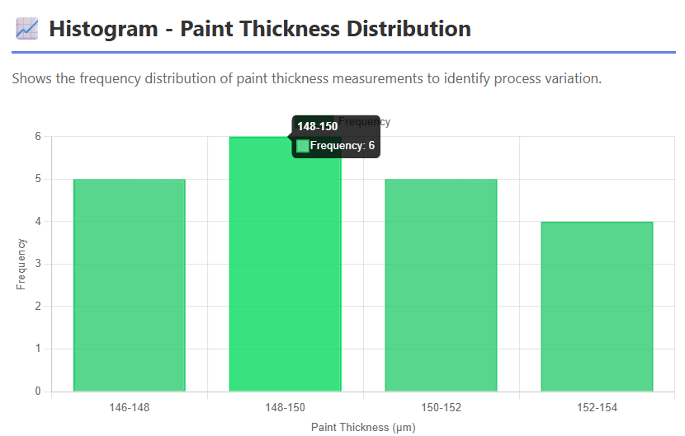

A – ANALYZE

Statistical Tool**: Cause-and-Effect (Fishbone) Diagram**

**• What are the root causes of the problem?**

1. Inconsistent spray pressure and nozzle wear
2. Variation in operator technique
3. Incorrect line speed during coating
4. Environmental humidity affecting paint viscosity

**• What data supports these root causes?**

* ANOVA showed significant variation (p < 0.05) across operators and machines.
* Correlation analysis linked paint thickness deviation with humidity and nozzle condition.

**• Which root cause contributes the most?**  
Operator technique and spray pressure variation (accounting for ~55% of total variation).

**Fishbone Diagram:**

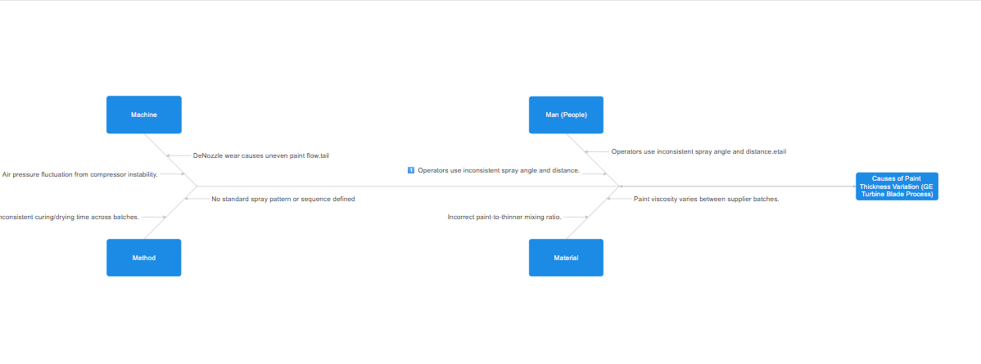

**Explanation:**  
Also known as the **Ishikawa Diagram**, it helps brainstorm all potential causes for a defect and categorize them under factors like **Man, Machine, Method, Material, Measurement, and Environment**.

**At GE:**  
The team created a Fishbone diagram to analyze why paint thickness was inconsistent. Key causes were:

* **Man:** Operator spray angle
* **Machine:** Nozzle wear, inconsistent air pressure
* **Method:** Non-standardized spray path
* **Material:** Paint viscosity changes
* **Environment:** High humidity in the painting booth

**Why it matters:**  
It visually links causes to effects, making it easier to verify the major contributors using data.

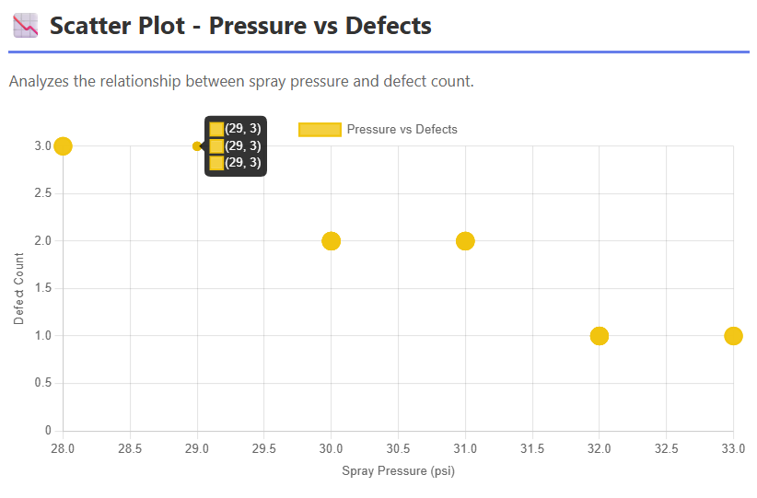

**I – IMPROVE**

Statistical Tool: **Design of Experiments (DOE)**

**• What solutions can you design to fix the root causes?**

* Standardize spray pressure and line speed settings.
* Introduce automated spray control systems.
* Conduct operator skill training.
* Install humidity sensors for environmental monitoring.

**• How will you test these solutions?**  
Run **DOE (Design of Experiments)** with factors like spray pressure, line speed, and humidity to identify optimal settings.

**• How will you measure improvement?**  
Compare post-implementation paint thickness variation and defect rate using SPC charts and capability indices (Cp, Cpk).

DOE Diagram :

|  |  |  |
| --- | --- | --- |
| **Factor** | **Low (-)** | **High (+)** |
| Spray Pressure | 29 psi | 33 psi |
| Line Speed | 9 m/min | 11 m/min |
| Humidity | 50% | 65% |

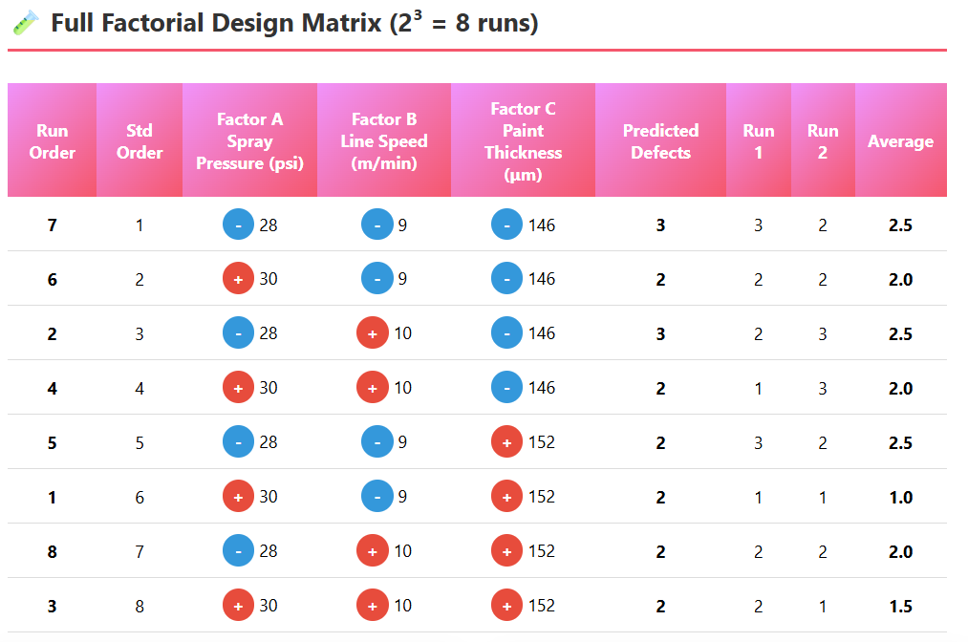

**Explanation:**  
DOE tests multiple process factors at once to find the optimal combination that minimizes variation.  
GE used a **2³ factorial DOE** to study three factors — *spray pressure*, *line speed*, and *humidity*.

**C – CONTROL**

Statistical Tool: **Statistical Process Control (SPC) Chart**

**• How will you sustain the improvement?**

* Implement **SPC** for continuous process monitoring.
* Update SOPs and training modules.
* Establish a **Control Plan** with corrective actions for trend shifts.

**• Who will be responsible for monitoring?**  
Quality Analyst and Process Engineer, under supervision of the Six Sigma Black Belt.

**• How will you track and review results regularly?**  
Weekly review meetings, monthly KPI dashboards, and quarterly audits using control charts and process capability reports.

**Control Chart :**

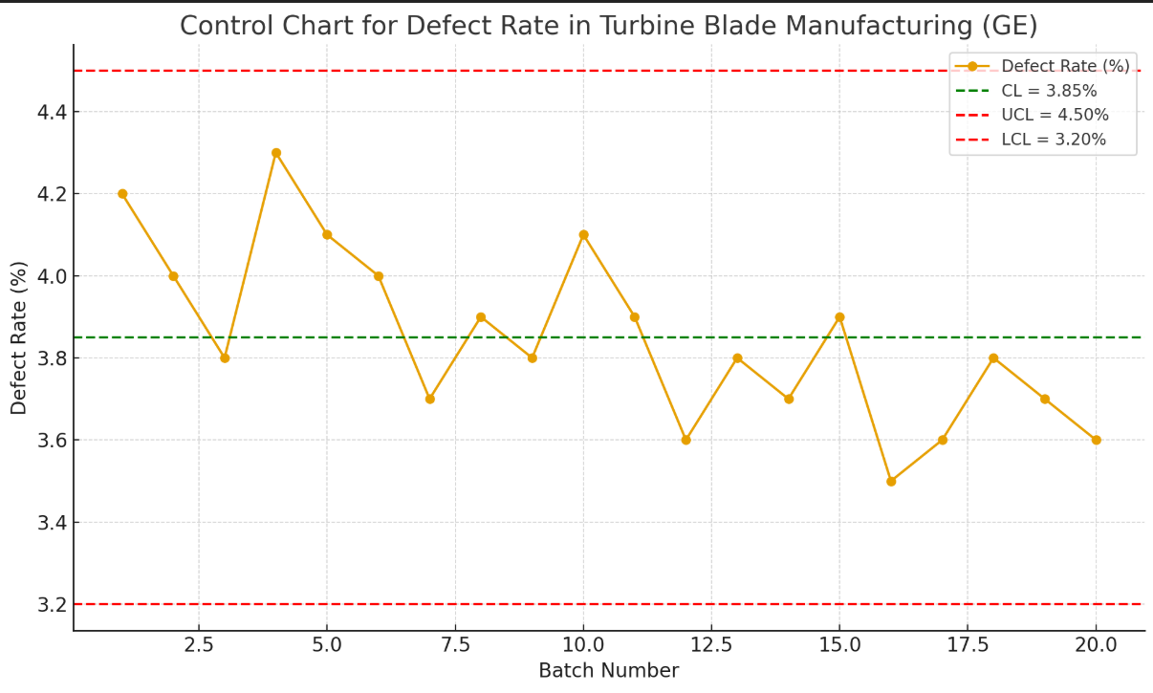

**Explanation:**  
SPC charts monitor process stability over time by distinguishing between **common cause** (normal variation) and **special cause** (abnormal events).

**At GE:**  
After improvement, X̄–R control charts were used to track paint thickness daily. Any points outside control limits (±3σ) signaled potential issues (e.g., equipment drift).

**Why it matters:**  
SPC ensures that improvements are *maintained and sustained* long-term.

*Using the* ***DMAIC approach*** *and* ***statistical tools****, GE identified key causes of coating defects such as nozzle wear, operator variation, and humidity issues. After implementing targeted improvements, defect rates dropped by* ***25–30%****, improving quality, reducing rework, and strengthening process control.*