Low-level architecture (LLD)

End-to-End Sequence & Event-Driven Flow -
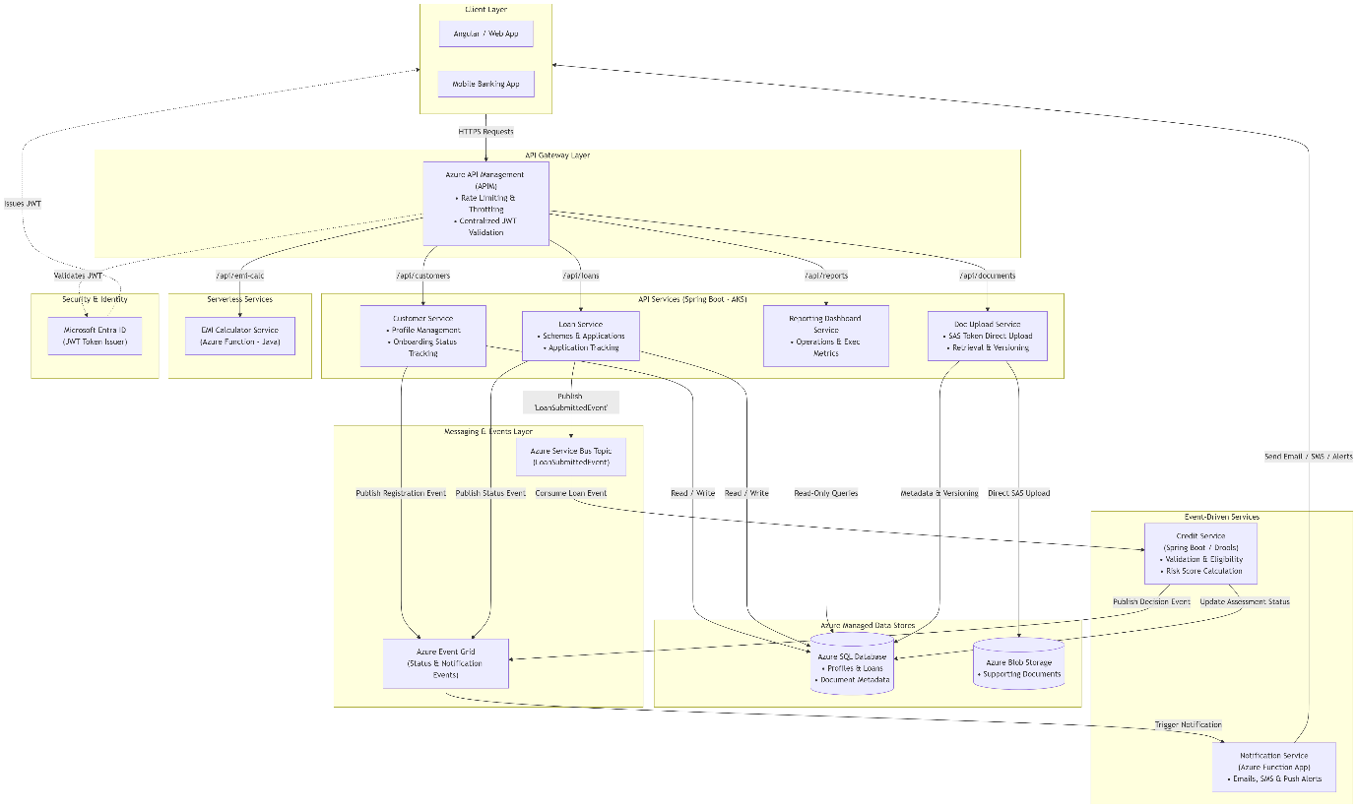

Microservice-Level Technical Architecture
1. Customer Service (API Service)
- Responsibilities: Account creation, personal info registration, profile management, onboarding status tracking.
- Tech Stack: Spring Boot (REST API), Spring Data JPA, Azure SQL.
- Core API Endpoints:
  - POST /api/v1/customers — Create customer profile.
  - GET /api/v1/customers/{customerId} — Fetch profile details.
  - PUT /api/v1/customers/{customerId} — Update personal info/address.
  - GET /api/v1/customers/{customerId}/onboarding-status — Track onboarding status.
- Class Design (Data Layer & Controller):
  - CustomerController $→$ CustomerService $→$ CustomerRepository
  - Entity: CustomerEntity (customerId, fullName, dob, nationalId, mobile, email, onboardingStatus).

2. Document Upload Service (API Service)
- Responsibilities: Uploading identity/address/supporting documents, version control, metadata index, secure pre-signed SAS URL retrieval.
- Tech Stack: Spring Boot, Azure Blob Storage SDK, Azure SQL (for metadata).
- Core API Endpoints:
  - POST /api/v1/documents/upload-url — Generates a temporary Azure Blob SAS URL for direct frontend client uploads.
  - POST /api/v1/documents/metadata — Saves metadata after successful Blob upload.
  - GET /api/v1/documents/{documentId} — Fetches document download link.
  - GET /api/v1/documents/versions/{applicationId} — Retrieves version history.
- Data Schema (DocumentMetadata Table):
  - doc_id (PK), application_id (FK), doc_type (IDENTITY, INCOME, ADDRESS), blob_uri, version_number, created_at.
3. Loan Service (API Service)
- Responsibilities: Fetching loan schemes, application creation and submission, status lifecycle management.
- Tech Stack: Spring Boot, Azure SQL, Azure Service Bus SDK (JMS/AMQP).
- Core API Endpoints:
  - GET /api/v1/loans/schemes — View available loan schemes.
  - POST /api/v1/loans/apply — Apply and submit loan application.
  - GET /api/v1/loans/applications/{applicationId}/status — Track progress.
- Workflow: Upon application submission, writes record to Azure SQL with status SUBMITTED and emits a JSON payload LoanSubmittedEvent to azure-servicebus://loan-events-topic.

4. EMI Calculator Service (Azure Function - Serverless)
- Responsibilities: Stateless, high-speed calculation of EMI options based on principal, tenure, and dynamic interest rates.

- Tech Stack: Java / Spring Cloud Function hosted on Azure Functions (Consumption Plan for auto-scaling).
- Endpoint: POST /api/v1/calculate-emi
- Execution Logic:
  - Uses standard loan amortization equation:

$$E=P⋅r⋅\frac{{\left(1+r\right)}^{n}}{{\left(1+r\right)}^{n}-1}$$
(where $P$ is principal, $r$ is monthly interest rate, and $n$ is tenure in months).

5. Reporting Dashboard Service (API Service)
- Responsibilities: Serves aggregated views for operations staff, managers, and executive metrics (application volumes, approval ratios, pending reviews).
- Tech Stack: Spring Boot, Azure SQL Read-Replicas / Redis Cache, PowerBI Embedded (optional).
- Core API Endpoints:
  - GET /api/v1/reports/operations/summary — Aggregated counts by status (APPROVED, REJECTED, PENDING_REVIEW).
  - GET /api/v1/reports/executives/metrics — Monthly acquisition & loan volume trends.
6. Credit Service (Event-Driven Service)
- Responsibilities: Listens asynchronously to incoming loan applications, runs automated validation checks, computes credit/risk score, updates loan decision.
- Tech Stack: Spring Boot Application / Azure Container Apps, Drools Rule Engine, Service Bus Listener.
- Event Handlers & Processing:
  - Consumer listens to LoanSubmittedEvent from Azure Service Bus.
  - Runs validation logic (Income vs. Liabilities ratio check).
  - Executes Drools Rules to compute Risk Score:

    - Score $≤$ 30: Marks application as APPROVED.
    - Score $≥$ 70: Marks application as REJECTED.
    - Score 31–69: Marks application as MANUAL_REVIEW_REQUIRED and triggers Logic App workflow.
  - Updates database state and emits ApplicationStatusUpdatedEvent to Azure Service Bus / Event Grid.

7. Notification Service (Event-Driven Service)
- Responsibilities: Consumes status change events and fires off user alerts (OTP, registration confirmation, loan decisions, missing documents).
- Tech Stack: Azure Functions triggered by Azure Event Grid / Azure Communication Services (Email & SMS).
- Triggers:
  - Listens to UserRegisteredEvent $→$ Sends welcome email / SMS OTP.
  - Listens to ApplicationStatusUpdatedEvent $→$ Sends loan decision email / SMS notification.

Low-Level Azure Services Mapping
Functional Module | Implementation Technology | Primary Azure Component
API Gateway & JWT Auth | Azure APIM + Spring Security | Azure API Management & Entra ID
Customer Service | Spring Boot Microservice | Azure Kubernetes Service (AKS)
Document Service | Spring Boot + Blob SDK | Azure Blob Storage (Private Containers)
Loan Service | Spring Boot Microservice | Azure Kubernetes Service (AKS)
EMI Calculator | Java Function App | Azure Functions (Serverless)
Reporting Service | Spring Boot Read-Only API | Azure SQL Database (Read Replica)
Credit Service | Event-Driven Spring Boot / Drools | Azure Service Bus + Container Apps
Notification Service | Event Handler Functions | Azure Event Grid + Communication Services

Microservices Breakout & Responsibilities
- Gateway Layer (Azure APIM)
  - Role: Single ingress, SSL termination, dynamic routing, request throttling, and central edge validation of JWT signed by Microsoft Entra ID.
- Customer Onboarding Service (Spring Boot)
  - Domain: Customer registration, profile CRUD, identification data (PAN, Aadhaar/ID).
  - Datastore: Azure SQL Database (Relational integrity for profiles).
- Loan Application Management Service (Spring Boot)
  - Domain: Loan catalog, EMI estimation engine, application submission, state management.
  - Datastore: Azure SQL Database (Transactional ledger for loan requests).
- Document Service (Spring Boot)
  - Domain: File processing, metadata tagging, generating pre-signed SAS URLs for high-throughput direct uploads.
  - Datastore: Azure Blob Storage (Document files with Immutable WORM policies) + Azure SQL (Metadata).
- Credit Assessment Engine (Spring Boot / Drools)
  - Domain: Real-time eligibility checks, risk score calculations, decision routing (Approved, Rejected, Manual Review).
- Notification Microservice (Azure Functions)
  - Domain: Decoupled serverless consumers triggering email, SMS (Azure Communication Services), and push notifications.

Data Models & Schema Design (Azure SQL DB)
-- Customer Table
CREATE TABLE Customers (
Customer_ID VARCHAR(36) PRIMARY KEY,
Full_Name VARCHAR(100) NOT NULL,
DOB DATE NOT NULL,
National_ID VARCHAR(50) UNIQUE NOT NULL, -- Encrypted via Azure Key Vault Key
Mobile_Number VARCHAR(15) NOT NULL,
Email VARCHAR(100) NOT NULL,
Address NVARCHAR(MAX),
Employment_Details NVARCHAR(MAX),
Income_Details DECIMAL(18, 2),
Onboarding_Status VARCHAR(20) DEFAULT 'PENDING',
Created_At DATETIME2 DEFAULT CURRENT_TIMESTAMP
);

-- Loan Applications Table
CREATE TABLE Loan_Applications (
Application_ID VARCHAR(36) PRIMARY KEY,
Customer_ID VARCHAR(36) FOREIGN KEY REFERENCES Customers(Customer_ID),
Loan_Type VARCHAR(30) NOT NULL, -- Personal, Home, Vehicle, Education
Loan_Amount DECIMAL(18, 2) NOT NULL,
Tenure_Months INT NOT NULL,
Interest_Rate DECIMAL(5, 2),
Status VARCHAR(30) NOT NULL, -- SUBMITTED, IN_REVIEW, APPROVED, REJECTED
Assigned_To_Manager VARCHAR(50),
Created_At DATETIME2 DEFAULT CURRENT_TIMESTAMP
);

-- Document Metadata Table
CREATE TABLE Documents (
Document_ID VARCHAR(36) PRIMARY KEY,
Application_ID VARCHAR(36) FOREIGN KEY REFERENCES Loan_Applications(Application_ID),
Doc_Type VARCHAR(50) NOT NULL, -- Identity, Income, Address Proof
Blob_Storage_Path VARCHAR(500) NOT NULL,
Version INT DEFAULT 1,
Uploaded_At DATETIME2 DEFAULT CURRENT_TIMESTAMP
);

