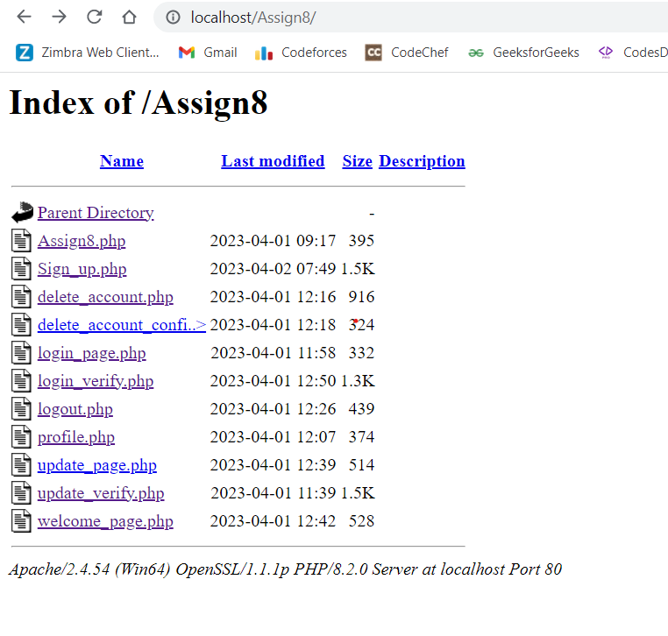

Fig.1: Index showing all the files present in the project directory

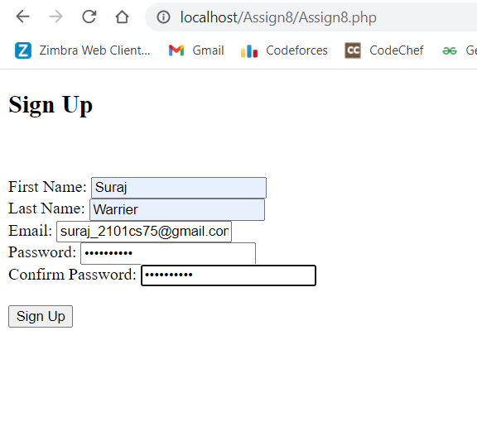

Fig.2: Assign8.php

Assign8.php contains the form for sign up. Every field except password and confirm password are of type ‘text’ while those two are ‘password’. The form accepts all names of max length 20, whereas it only accepts valid iitp email ids. The password too needs to be sufficiently strong, with atleast 8 characters, including 1 special, 1 uppercase and 1 lowercase character.

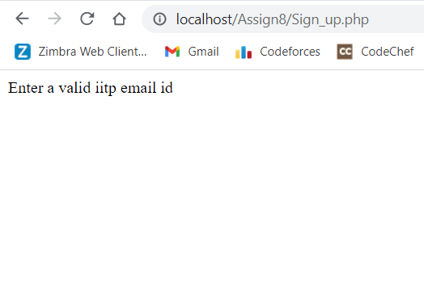

If the email id is not valid, it prints out the above message.

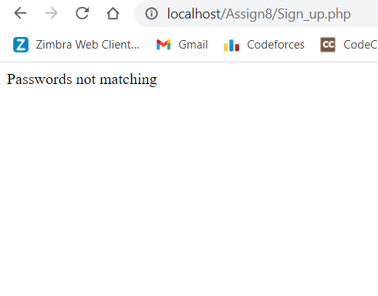

If the ‘Password’ and ‘Confirm Password’ fields don’t match, it prints out the above message.

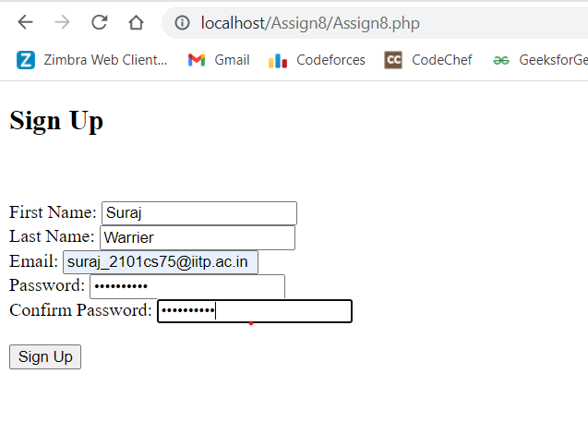

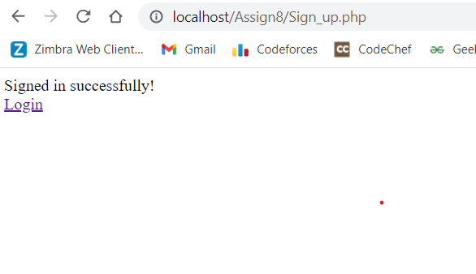

If all the fields are valid, then the above message is printed. We also get a Login page link along with it.

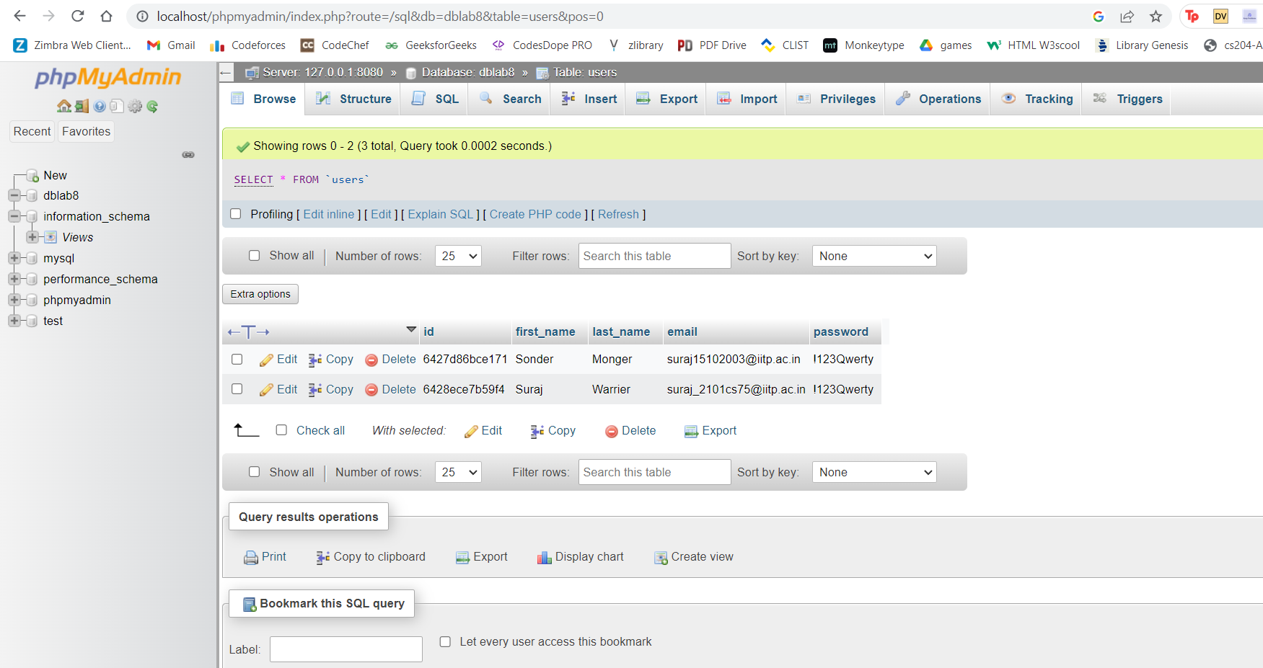

We can see that the user data is updated in the database server, in the ‘users’ table of dblab8 database.

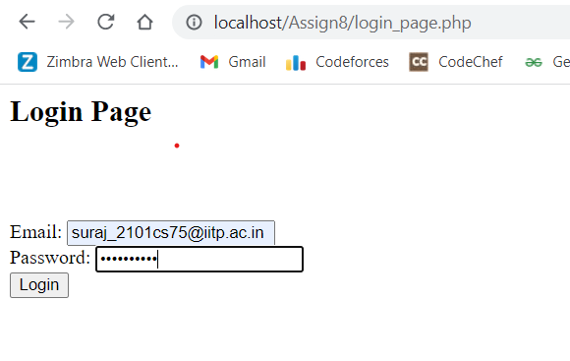

The login page link takes you to a login page where you are supposed to enter the credentials with which you have signed up.

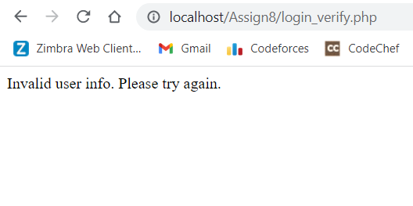

But if the credentials are wrong, the above message is printed.

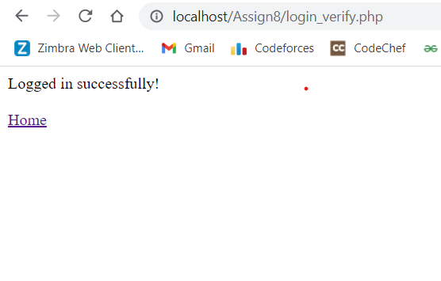

If the credentials are right, then it prints the above message and also provides a link to the home page.

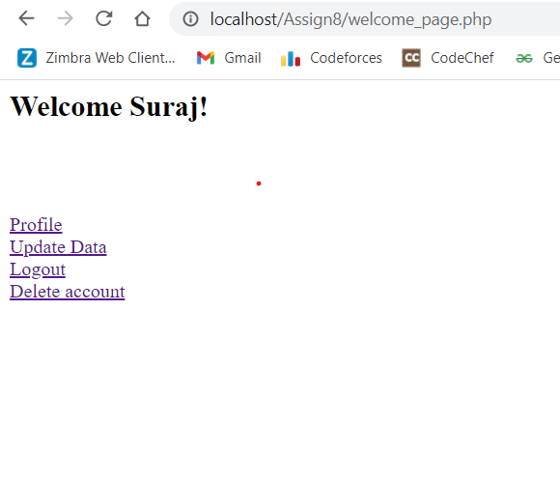

The home page contains a title saying “welcome [first name]”. It also contains 4 link options:

Profile

Update Data

Logout

Delete account

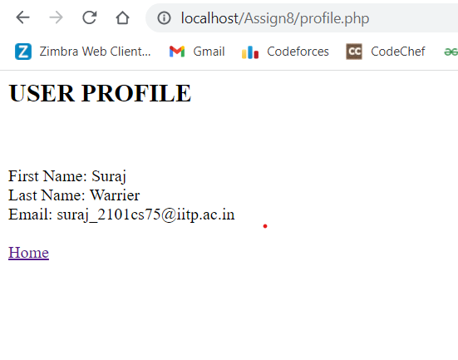

When we click on the profile link, our user data, including first name, last name and email are printed. We also get a Home page link on the site.

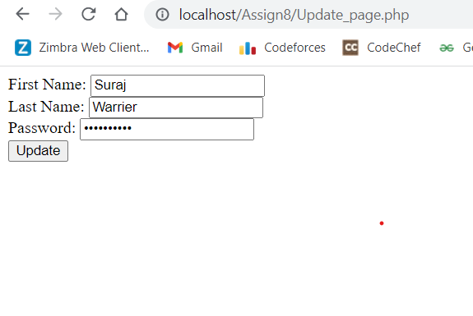

The second option takes you to the update_page webpage, where your first name, last name and password are pre-loaded and are editable.

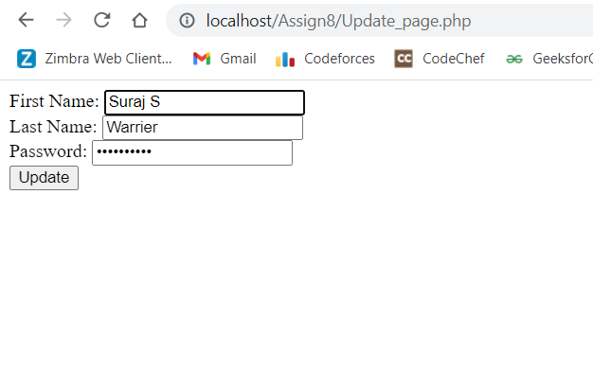

After making suitable changes, the user can click update, upon which the user data is updated in the mysql ‘users’ table. Session variables also get changed.

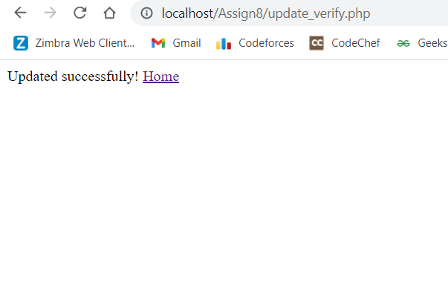

Once we click update, the info is updated and the above message is printed. We also get the Home button link. If user has updated first name, then the change is immediately visible when the user gets back to the home page where “Welcome [first name]” has the updated first name.

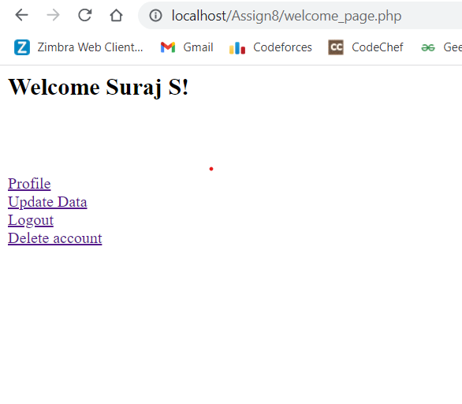

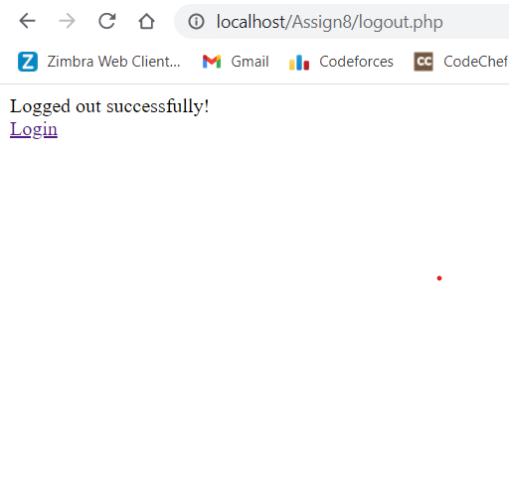

If we click on the logout button, all the session variables are cleared and the above message is printed. Also, since we have deleted the session variables, the user wont be able to get back to the previous page simply by clocking the back button and have to actually login again using the link provided in the same page.



After logging in, we come back to the home page. Then on trying the 4th option:

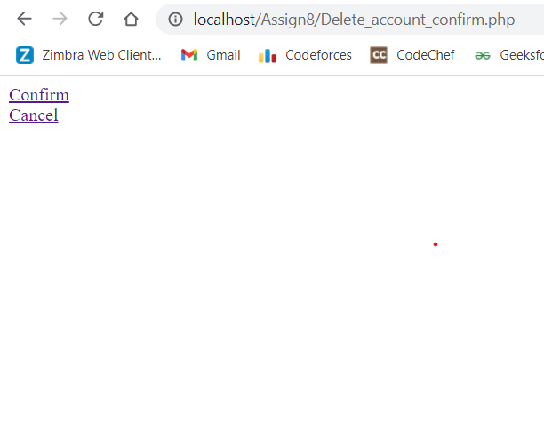

We are taken to a site asking confirmation for deletion of account. If we click cancel, we are simply taken back to the home page. If we click confirm, the user data is deleted from the ‘users’ table and the session variables are also terminated.

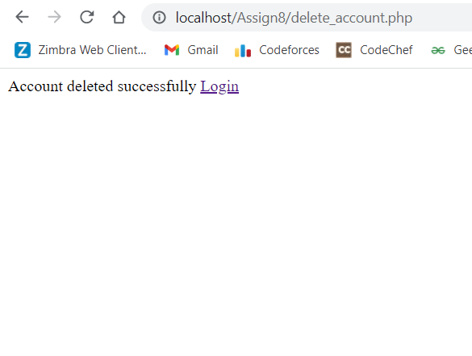

The above message is also printed, along with the Login page link.

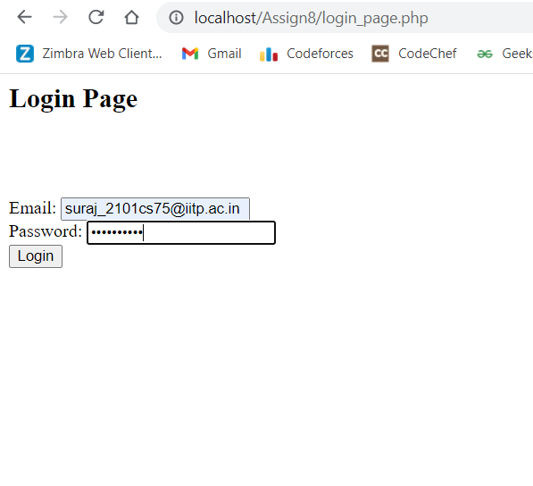

If we try logging in again using the same credentials this time, we get the following error, since the user doesn’t exist anymore.

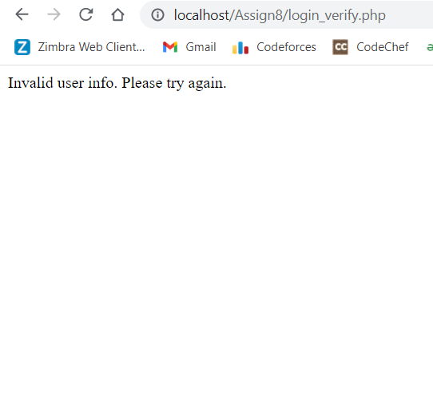

CODES:

All the codes are uploaded in GitHub. The link for the code: