Assignment2 :- Every time I hit public ip of instance need to get perticular output for the perticular branches but same index.html file can use….

Prerequisite:- git repository having 3 branches

3 different jobs for each branch consisting index.html file

Configuration on Terminal:-

Create a Folder at /mnt/git-repo

Yum install git -y

git init

vi index.html-----> contnt is “this is 23Q1 branhc”

git add index.html

Git commit -m “23Q1 branch”

#Now master branch is created that’s why create new branch

Git branch 23Q1

Git checkout 23Q1

#add remote repo

Git remote add repo url

Git push origin 23Q1

#change branch

Git checkout master

#create new branch n checkout there

Git branch 23Q2

Git checkout 23Q2

Vi index.htmll-----> contnt is “this is 23Q2 branhc”

git add index.html

Git commit -m “23Q2 branch”

Git remote add repo url

Git push origin 23Q2

#change branch

Git checkout master

#create new branch n checkout there

Git branch 23Q2

Git checkout 23Q2

Vi index.htmll-----> contnt is “this is 23Q2 branhc”

git add index.html

Git commit -m “23Q2 branch”

Git remote add repo url

Git push origin 23Q2

#here I created all non-default branches from Master

master

23Q3

23Q1 23Q2

Github:-

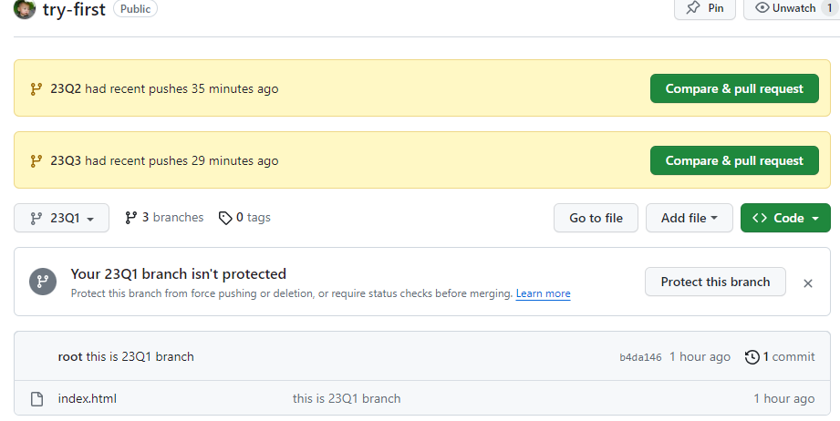

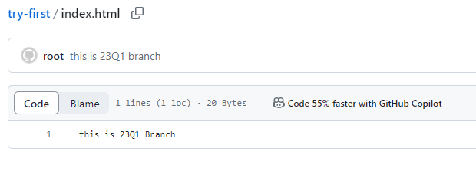

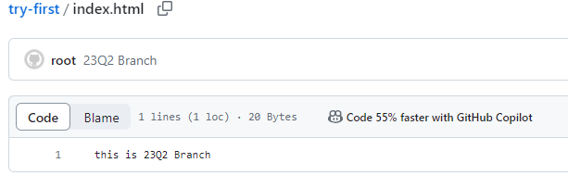

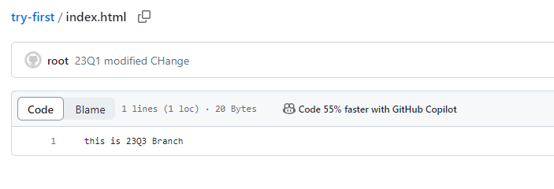

Jenkins Configuration:-

Job-1

Name-Branch-1

1.Custom workspace -----> /mnt/workingspace/gitproject

2.git clone---------->https://github.com/Suraj-Sangde/try-first.git

3.branch-----> 23Q1

4.Credential:---> username and git token as a 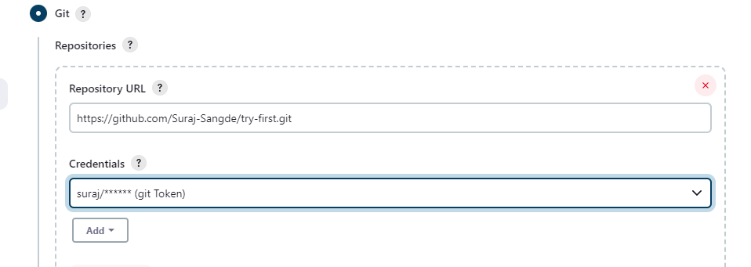

5.Delete workspace before build starts------very very imp

6.Execute shell:-

cp /mnt/workingspace/gitproject/index.html /var/www/html

chmod 777 /var/www/html/index.html

service httpd start

Apply and save

#same Configuration for Job 2 and Job 3

FInal Output:-

Job1-build 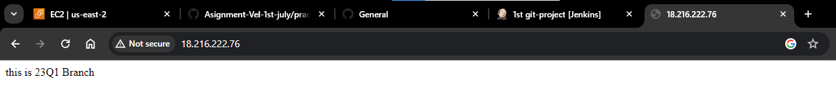

Job2-build

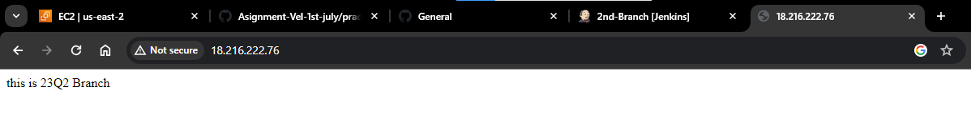

Job3build