Assignment 3 :- Every time I hit public ip of instance need to get perticular output for the perticular repository but same index.html file can use….

Prerequisite:- 3 different git repositories named as 23Q1,23Q2,23Q3..

        3 different jobs for each repository consisting index.html file….

Configuration on Terminal:-

Create a Folders at /mnt/git-repo named as 23Q1,23Q2,23Q3 for each repository

#1st repository

Cd /mnt/git-repo/23Q1

Yum install git -y

git init

vi index.html-----> contnt is “this is 23Q1 repository”

git add index.html

Git commit -m “23Q1:branch”

#Now master branch is created that’s why I can create new branch

Git branch 23Q1

Git checkout 23Q1

#add remote repo (23Q1)

Git remote add repo url (23Q1 repository)

#pushing the changes in 23Q1 and not in master

Git push origin 23Q1

------------------------------

#change Directory,now same procedure at 23Q2 for 23Q2 repository

Cd 23Q2

 git init

vi index.html-----> contnt is “this is 23Q2 repository”

git add index.html

Git commit -m “23Q2:branch”

#create new branch n checkout there

Git branch 23Q2

Git checkout 23Q2

#add remote repo (23Q2)

Git remote add repo-url (23Q2 repository)

Git push origin 23Q2

-------------------------------------------------------------------------

#change directory,again same changes for 23Q3 repository

Cd 23Q3

 git init

vi index.html-----> contnt is “this is 23Q3 repository”

git add index.html

Git commit -m “23Q3:branch”

#create new branch n checkout there

Git branch 23Q3

Git checkout 23Q3

#add remote repo (23Q3)

Git remote add repo-url (23Q3 repository)

Git push origin 23Q3

--------------------------------------------------------------

Github :-

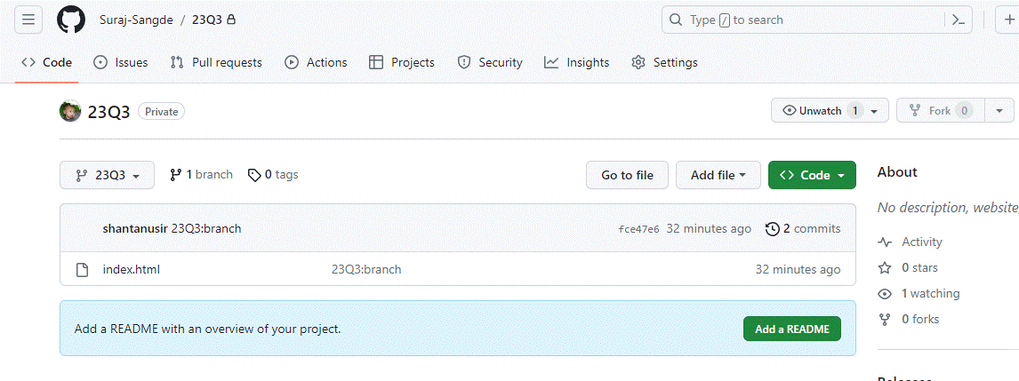

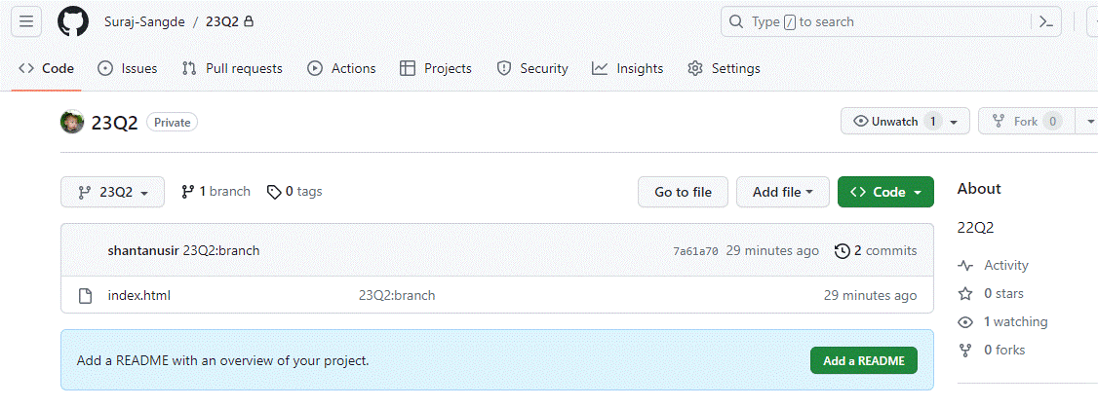

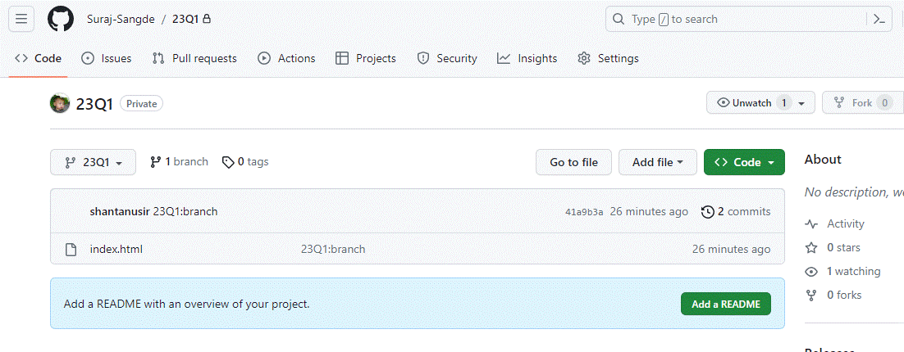

Jenkins:-

Dashboard

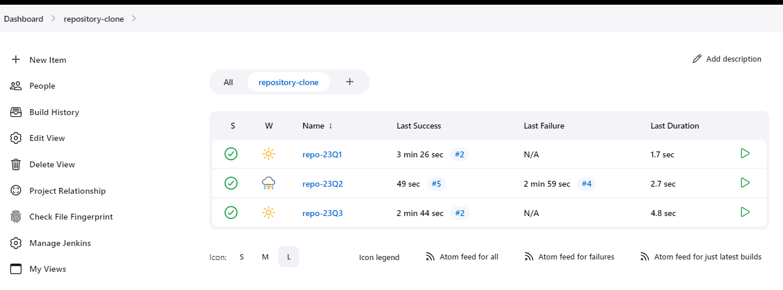

Job-1 Configuration:-for 23Q1

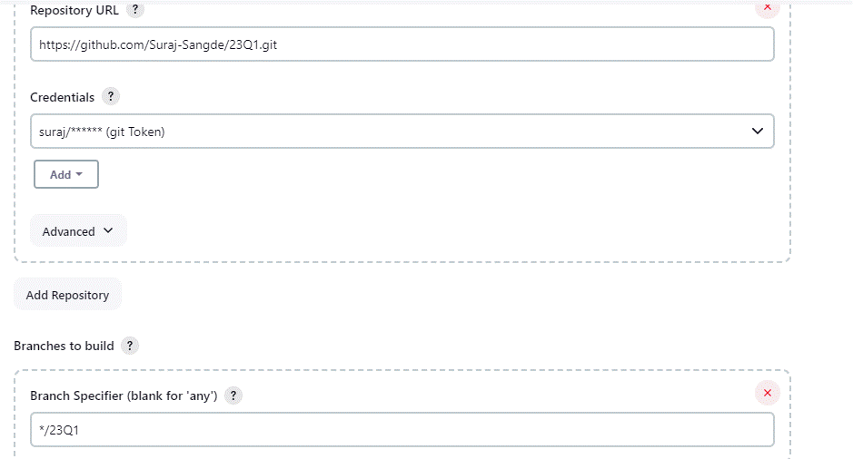

Job-2 Configuration:-for 23Q3

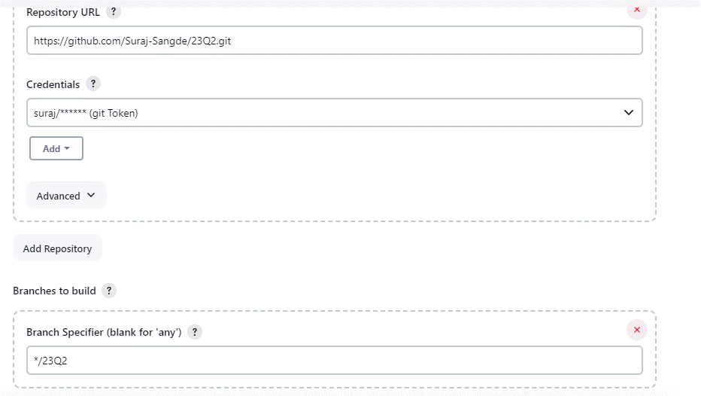

Job-3 Configuration:-for 23Q3

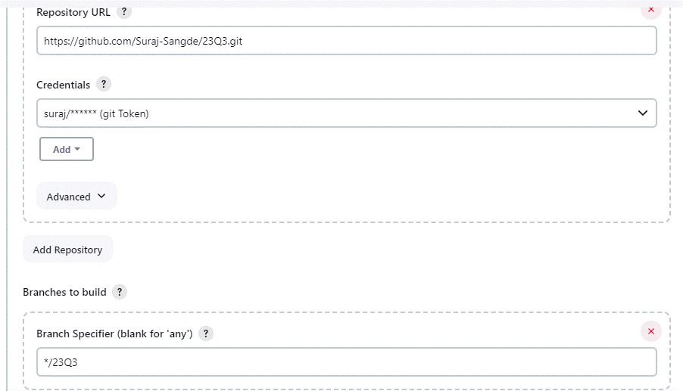

Final Output:-

Job-1

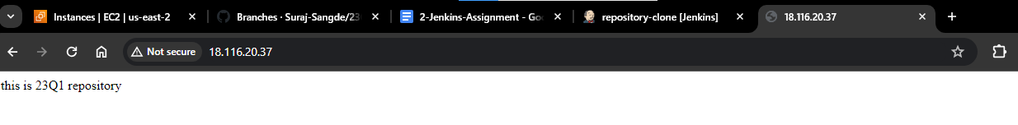

Job-2

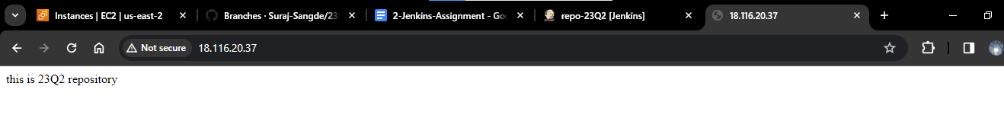

Job-3

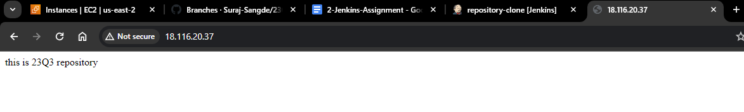

----------------------------------------------END----------------------------------------------