**Shubhamkar Bhattacharya  
7A**

**Q1)**

**Code :**

vec <- c(7, 4, NA, 9, 10, NA)

med <- median(vec, na.rm = TRUE)

imputed_vec <- ifelse(is.na(vec), med, vec)

imputed_vec

Med

**Output :**

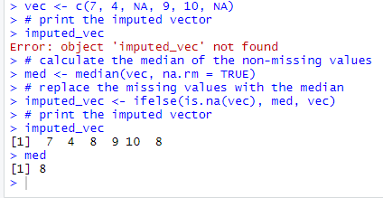

**Q2A)**

**TRANSFORMATIONS:**

**1. SORT ROWS**

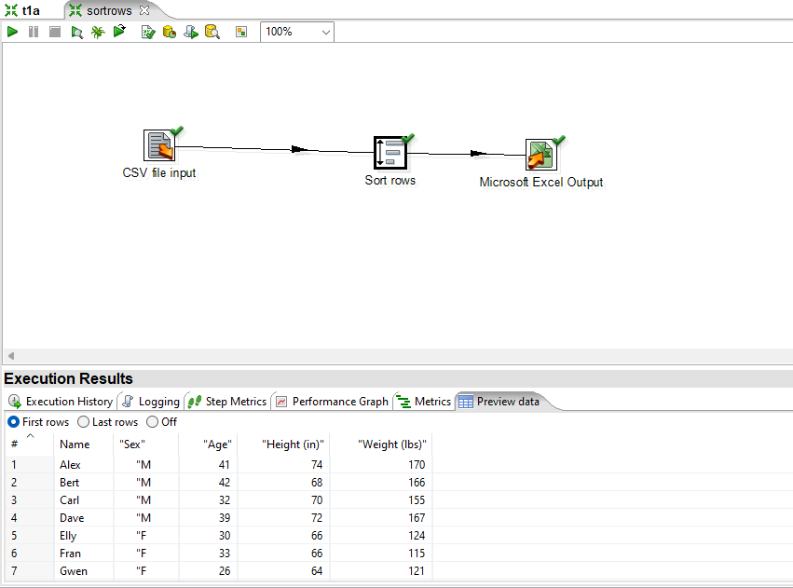

**2. CONCAT FIELDS**

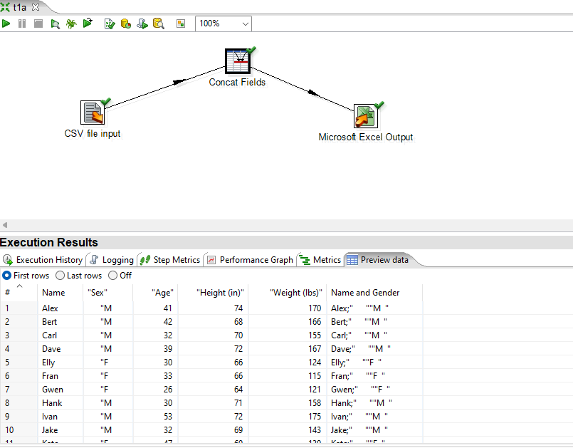

**3. CALCULATOR**

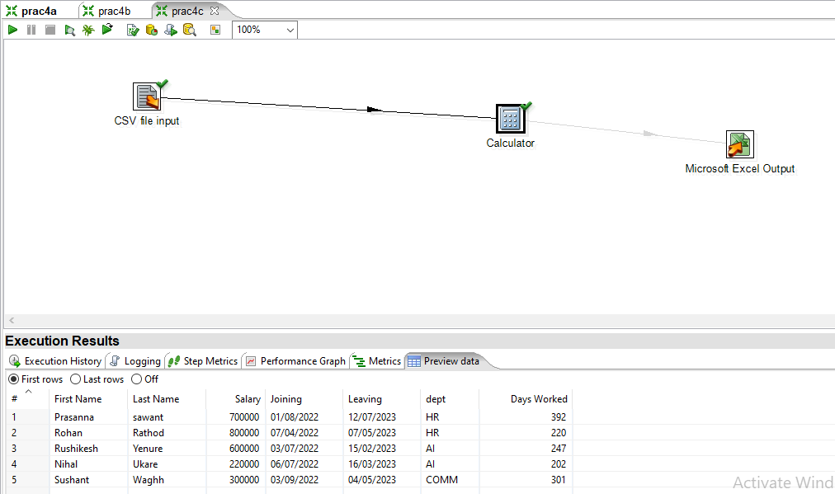

**Q2B)**

**Code :**

CREATE TYPE pasenger_type_type AS OBJECT (

Pid NUMBER(5),

PName VARCHAR(10),

Address VARCHAR(10),

Destination VARCHAR(10),

Age NUMBER(5)

);

CREATE TABLE passenger_dtle (

detail pasenger_type_type

);

insert into passenger_dtle values( pasenger_type(1,'Prasanna','Mumbai','kurla',43));

insert into passenger_dtle values( pasenger_type(2,'Prasad','Jalgaon','Andheri',43));

insert into passenger_dtle values( pasenger_type(3,'Pranav','Nashik','Chembur',7));

insert into passenger_dtle values( pasenger_type(4,'Shiv','Nagpur','Mahim',44));

insert into passenger_dtle values( pasenger_type(5,'Diviesh','Pune','Matunga',43));

**Output :**

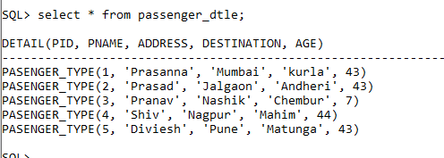

**Q3A)**

**Code :**

SQL> create table sale(

2 sid NUMBER(5),

3 ssname VARCHAR(30),

4 salesregion varchar(30)

5 )

6 PARTITION BY LIST (salesregion)

7 (

8 PARTITION sales_west VALUES ('Mumbai','Pune'),

9 PARTITION sales_east VALUES ('Kolkata'),

10 PARTITION sales_south VALUES ('Chennai'),

11 PARTITION sales_other VALUES (Default)

12 ) enable row movement;

Table created.

SQL> SELECT TABLE_NAME, PARTITION_NAME FROM USER_TAB_PARTITIONS;

TABLE_NAME PARTITION_NAME

------------------------------ ------------------------------

SALE SALES_WEST

SALE SALES_EAST

SALE SALES_SOUTH

SALE SALES_OTHER

SQL> insert into sale values(1,'Kapil Dev','Mumbai');

1 row created.

SQL> insert into sale values(2,'ghanhsyam patel','Pune');

1 row created.

SQL> insert into sale values(3,'abhishek singh','Delhi');

1 row created.

SQL> insert into sale values(4,'amey mhatre','Kolkata');

1 row created.

SQL> insert into sale values(5,'pranav deshmukh','Chennai');

1 row created.

SQL> insert into sale values(6,'dishank gawas','Allahabad');

1 row created.

**Output :**

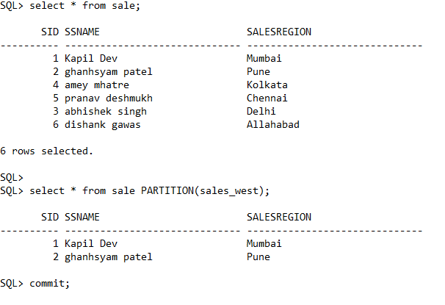

**Q3B)**

**Code :**

create table emp

(

passenger_dtleno number(5),

depno number(5),

salary number(6),

job varchar(30)

);

insert into emp values(1,12,3000,'SDE');

insert into emp values(1,12,3000,'SDE1');

insert into emp values(1,12,3000,'SDE2');

**Output :**

